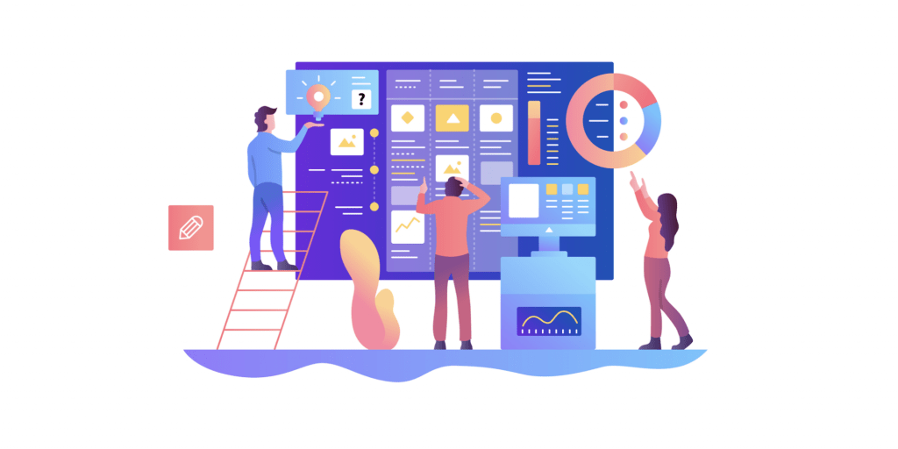  Project management  Assignment 1 | Student: 1807552  Module code: BMSP5008  Module title: Project Management for Sustainability  Title: Personal Digital Identity Management  Lecturer: Glenn Behenna  Date of submission: 28th November 2019

Table of Contents
Introduction 1
Principles of Project Management 2
Role of a Project Manger 3
Communications in Project Management 4
Methodologies 5
Lean 6
PRINCE 2 7
Waterfall 8
Agile 9
Stakeholder Analysis 10
Methodologies 11
Lifecycle of a Project 12
Conclusion 13

1.Introduction
What is project management? According to Dr Martin Barnes President of the Association of Project Managers (APM) from 2003 to 2012 it is "at its most fundamental, about people getting things done”. The Project Management Institute define it as “the application of knowledge, skills, tools, and techniques to project activities to meet the project requirements”. It has also been described as “ a critical practice that applies knowledge of process, skills, tools, deliverables, and techniques to project activities to ensure a solid path to project success by meeting goals and requirements” (Harned, 2019). There is however an expectation on businesses and organisations to operate sustainably and incorporate best practice into their policies and procedures. Effective project management can act as an enabler to achieve the aims of sustainability. Project management differs from standard management practices in that its objective is to deliver a change to a business or organisation (Naybour, 2014). This report will outline some of the fundamental practices used in project management today. It will cover the role of a project manager and some of the main principles, methodologies and tools of project management.

2.Principles of Project Management
Project management can generally be broken down into several key principles. To execute a successful project the project manager should have in mind the product. This is known as Vision and Mission. By having a result in mind at the beginning of a project the project manager and the project management team will gain clarity on the expected outcome and how that outcome will be achieved. It should also be clear on what the objectives of the project are for example, to increase efficiency, sales or quality. To accurately quantify the benefit of the outcome of the project will support a sound decision making process. A project manager will also need to consider the selection of the project team, key stakeholders, and the project owner. Communication of information will need to be established and meeting schedules agreed and documented. The successful execution of the project will depend on a thorough root cause analysis of the issue. By identifying and understanding the requirements of the project and the expected outcomes the project manager can direct the team in effectively executing each task. To achieve success and sustainability of a new process or initiative each person who is directly impacted must be informed and involved. This is where effective communication is critical between the project team, project owner and stakeholders. To achieve a successful outcome each project team member will need to be accountable for their individual performance. This can be measured and analysed and can identify where support or coaching may be required whilst also making clear specific expectations of each team member (Gilbert-Jamison, 2010)

3. Role of a Project Manager
The role of a project manager requires a variety of skills. They hold the overall responsibility for the successful completion of a project from the initiation to planning, design, execution, monitoring and through to closure. In addition to general management acumen a competent project manager will be able to engage with stakeholders and team members effectively, resolve conflict and be mindful of assumptions. The project manager will also be skilled in making sound risk assessments including an impact assessment should any negative events arise; this will need to be continually assessed through the lifecycle of the project. The project manager will also be responsible for making critical decisions as well as minor ones. Each decision made will have to make a positive impact on the project. A successful project manager will prioritise risk management and will engage effectively with team members and stakeholders to minimise uncertainty and reduce risk. (Haughey, 2019)

4. Communications in Project Management
The success or failure of a project could depend on the effectiveness of the communication between the project manager, the project team and the stakeholders. The word communication is derived from the Latin word communis which translates to common. To communicate is to establish a common connection with and individual or group It must not be assumed that the recipient of a message will fully understand what the sender is attempting to communicate. To communicate effectively a project manager will need to understand the possible variables such as differing realities, the environment the message is sent in and non- verbal communication. The key to achieving effective communications is to devise a communications plan. Following the stakeholder analysis, the project manager can develop a communications plan which will ensure information is shared only to those who need to know. There are only certain aspects of a project that stakeholders will be interested in and to compile and provide unnecessary information is inefficient and a draw on resources. The communications plan will set methods of communication and establish the expectations for how and who will want what information and how that information will be relayed to the project team and stakeholders (Sivasankari, 2010)
5. Methodologies
Project management methodologies differ from project management frameworks. A framework gives a project structure with a definitive end goal. A framework also provides direction whilst enabling some degree of flexibility. A methodology is by contrast is defined by being specific in its approach to delivering a project. A methodology can be applied to a specific need and adheres to a set path of action points. Methodologies can provide a defined, scrutinised and repeatable method of delivery (Project Management Methodologies and Frameworks, 2019).

6. Lean
Most widely used in the manufacturing industry but can also be applied to other projects. Developed during the 1950’s by car manufacturer Toyota, Lean Project Management focuses on limiting the waste of labour, materials, equipment and space which it categorises as the 3 M’s Muda, Muri and Mura. Muda are processes which require resources but fail to add value to the product or outcome. Muri deals with inefficient use of equipment or manhours and Mura is the reduction of efficiency and productivity due to operational peaks and troughs. To quote the Project Management Institute “To be Lean is to provide what is needed, when it is needed, with the minimum amount of materials, equipment, labour, and space.”
PRINCE2
PRINCE2 is an acronym for a project management methodology which can be used when managing projects in controlled enviroments. Worlwide it is reported to be the most practiced methodology which is used by project management teams in over 150 countries (Slate, 2019). PRINCE2 began as a concept which developed during the later part of the 1980’s. Its purpose at that time was to support the United Kingdom government organisations with information technology projects. During 1996 the methodology was reviewed and updated by a group of project management specialists and was re-launched as PRINCE2. Organisation and control are the key elements of PRINCE2 with a focus on a process-based approach. Projects are planned in their entirety prior to deployment ensuring each phase of the project is clearly defined. Once the project is complete PRINCE2 allows for any outstanding tasks to be completed (Slate, 2019) A PRINCE2 methodology incorporates a step by step process towards a projects objective. There are a basic seven key steps which each incorporate additional actions to support the management of a project to its conclusion.
Step 1. The Start Up
This initial step will analyse in detail if a project is viable. This may involve a detailed project breakdown including a business case. If approved by the project board a stage plan is produced to illustrate the execution of the project and tasks that need to be completed during the initiation phase.
Step 2. The Initiation of the Project
During this phase specific areas need to be addressed including (but not limited to) risk analysis, what is required? what are the reasons? What are the benefits? And how issues or obstacles can be identified and resolved. To enable delivery of the project to time and without negatively impacting quality, the project will require monitoring throughout its lifecycle. A project initiation document and project plan would also be completed during this stage.

Step.3 Project Direction
A project will need to be directed to ensure accountability is taken during any decision making process. This role may be carried out by a project board who will have the authority to initiate, deliver and close the project
Step 3. Control
During the control phase of the project the project manager will delegate tasks to the project team. The project manager will also monitor progress of the project and report back to the project board. Other activities that will take place during this phase will include risk assessment, quality control and time management of the project.
Step 4. Delivery
This step is key in ensuring that the delivery of the project product is managed to control the tasks delegated by the project manager to the project team. This stage will also facilitate the execution and delivery of the work package upon completion.
Step 6. Manage Stage Boundary
Two processes are carried out during this phase. The project manager will produce a report containing an overview including updates on the current performance of the plan and business case. Progression to the next stage of the plan will be reviewed as will the current stage. Following the approval of the project managers reports to the project board the project can then progress to the next phase.
Step 7. Closure
Once the project has achieved all its planned targets and objectives within the agreed timescale preparations can be made to hand over the product to the customer. A recommendation will be made by the project manager to the project board to officially close the project.
8. Waterfall
A Waterfall approach to project management can be defined by its logical progression through planned stages. Each stage is clearly defined as the project is driven forward to its conclusion. A Waterfall project plan is made and is then executed from start to finish, however with Waterfall there is limited scope for unforeseen changes as the project progresses (Olic, 2017). As a Waterfall project advances through a sequence of linear processes, it can only progress to the next stage once the previous stage is complete. Once a stage is complete it is terminal and cannot be revisited. There is only one route to revise a terminal stage and that is to return to the start of stage one (Lucidchart, 2017). The stages of a Waterfall project are generally termed as phases. Each phase can differ depending on the requirements of the project but would generally consist of the following:
Phase 1:Information, documentation and requirement compilation
This is a key phase where the needs of the customer are explored and understood. Expected outcomes and timescales are agreed and documented. This information can be collected by means of interviews, questionnaires and group meetings. Once all the objectives of the project are understood they can be shared with the wider team (Lucidchart, 2017) During this phase the plan will be reviewed by not only the project manager but also by the project sponsor and other stakeholders (Icasas, 2019)
Phase 2: Design
During the design phase all aspects of phase 1 are drawn up in a ‘design document’. This is where procedures, processes, testing criteria and specifications are documented and show how the project will come to fruition.
Phase 3: Implementation
During the implementation phase the project manager will execute the project to comply with the design document with the project team. Procedures, Specifications and times lines specified during the initial stages will need to be adhered to if the project is to succeed within the timescales agreed. If a project has additional complexities an additional Waterfall sequence may be required to execute certain phases
Phase 4: Testing
During this critical phase any failure in quality or specification may require the project to be reverted to the beginning of phase one. The standards will be contained within the design document determined by the stakeholders. The testing phase ensures that all the required standards and metrics have been delivered by the project team.
Phase 5: Deployment
On completion of the project it is delivered or deployed by the project management team to the customer.
Phase 6:
Maintenance
During this phase the product of the complete project is monitored whilst it is operational. A support team may be put in place during this phase. Any issues with the running of the product can be addressed by a support team. The maintenance phase would also facilitate any modifications or upgrades.
9. Agile
Agile project management is essentially a flexible working approach which can respond effectively to changes during the lifecycle of the project. Its main objective is to deliver optimum value for the requirements of a business whilst prioritising time and budget restraints. This is of importance when risk outweighs the drive to deliver. Agile project management operates on four key principles.
Collaboration and Negotiation
A team working collaboratively with the customer will drive the project forward with the focus being the main deliverable and is repeated over time. With the end user effectively driving the projects design it can have a substantial positive impact on the product. Agile can accommodate the benefits of collaborate working with the end user whilst retaining a focus on the management of the project team, and quality.
Effective Interaction
Agile can incorporate the benefits of a team working in harmony as opposed to being controlled. The value of effective communication, sharing of knowledge, candid appraisal and regular feedback can be harnessed using an Agile approach. A project manager may have to lead from within the team to promote a culture of commitment whist also remaining accountable for the product.
Reacting to Change
An assessment is carried out on the available resources and time frames which will drive the foundations of the project plan. As the project progresses there will be fluctuations in the delivery time scale and cost. With Agile a minimum viable product (MVP) will be established which identifies the core project deliverable which will initiate the delivery of the project. This may also change as the project team manages variables and opportunities during the project lifecycle.

10. Project Management Plan
Essentially project management is to manage multiple tasks and the team responsible in carrying out those tasks. A project management plan is an essential document to illustrate how a project will be executed. It will also contain information detailing planning, costs, schedule, budget control and how a. project will be delivered within agreed timescales. Expected outcomes and advantages will be detailed in the plans summary which will also include any possible limitations or restrictions. Risk management and plans to address diversions and status reports will be documented within the plan. A time critical plan may also contain a Gantt Chart ( Fig.1) which will provide a visual tool displaying an overview, timescales, targets and 1)activities of the project. Each individual task is represented by a bar which extends from the start point to the end point representing the duration of each task. By using a Gantt chart (Fig.1) multiple tasks can be displayed on a clear timeline. The Gantt chart will also show an overall picture of the project which provide the project schedule (Zilicus, 2019).
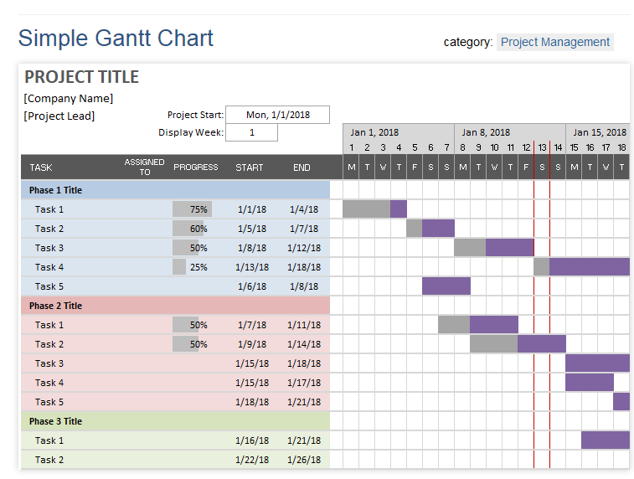
Fig. 1 (Zilicus, 2019)

11. Stakeholder Analysis
A stakeholder can be defined as a group, organisation or individual who has an interest or an influence on the outcome of a project It is critical that a project manager fully understands the needs and expectations of each stakeholder. In terms of project risk and viability stakeholders are key to a project’s success, therefore each stakeholder must be carefully managed. To understand the needs and expectations of stakeholders there needs to be a clear understanding of the project objectives and expected outcomes. The needs, expectations, objectives and expected outcomes between the project manager and the stakeholders will have to be aligned and communicated to all interested parties. In general terms stakeholders can be (but are not limited to) the project manager, the project team members, the project sponsor and the customer or end user (Smith, 2000).
To facilitate this the use of a Power and Interest grid (Fig.2) can support the project managers stakeholder management.
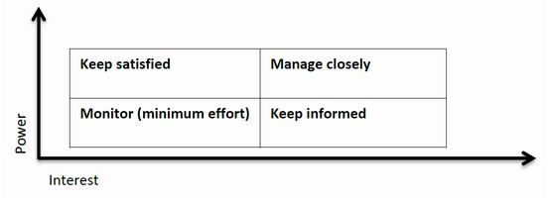
Fig.2
High power - High interest: these stakeholders will be decision makers and will have a significant influence on the project succeeding. They will require close managing.

High power - Low Interest: these stakeholders should to be kept satisfied. They should also be managed closely as they will possess high influence and power but will not require a high level of information.

Low power – High interest: these stakeholders need to be kept informed. Maintain regular contact and ensure that issues they may rise are dealt with.

Low power - low interest: these stakeholders will not require unnecessary communication, but they will need monitoring.

12. Lifecycle of a Project
A project manager and the project management team have one common objective and that is to deliver a project to time and to meet all the project objectives. Typically, a project has four key phases: initiation, planning, implementation and closure. These key phases create a route which takes a project from it beginning through to its conclusion. This is commonly termed as the lifecycle of the project. During the initiation phase the objectives of the project are identified along with the project’s actual viability. The project then moves forward to the planning phase where a more detailed analysis of the project’s objectives is undertaken, and the project plan is created. The third phase will drive the implementation of the project. It is important during this phase that communications, monitoring of progress and control are carried out effectively (Fig.3). Key stakeholders and project sponsors will expect to keep updated so it is important that the project plan is updated and current. The closing phase will encompass all the deliverable to the end user or customer. During this phase the project will be handed over, which will include project documentation. External supplier contracts will be terminated, and closure of the project will be communicated to all stakeholders. (Watt, n.d.)

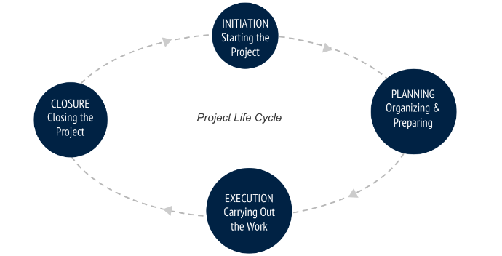
Fig.3

13.Conclusion
Projects are something that are encountered on daily basis during our work life and home life. From a simple holiday booking to a complex home improvement project management is the activity that makes thing happen or change. Applying the correct methodology to a project could define its eventual outcome, applying an unsuitable methodology could ultimately lead to a project failure. In studying four methodologies for this report Lean, PRINCE2, Waterfall and Agile it is clear that there is a method fit for most, if not all types of project. One common factor has been evident and that is the critical importance of communication with all stakeholders. If the communication plan fails, the project is likely to also. The use of tools such as Gantt Charts and Power and Interest grids can support the project manager in making critical decisions. The complexities of project management theories seem to be boundless however, as alluded to in the introduction to this report, project management in its simplest terms is about getting things done.

References
Gilbert-Jamison, T. (2010, September 26). The Six Principles of Project Management. Retrieved from Project Smart: https://www.projectsmart.co.uk/the-six-principles-of-project-management.php
Harned, B. (2019). Project Management Defined. Retrieved from Team Gantt: https://www.teamgantt.com/guide-to-project-management/what-is-project-management
Haughey, D. (2019). The Role of the Project Manager. Retrieved from Project Smart : https://www.projectsmart.co.uk/the-role-of-the-project-manager.php
Icasas, P. (2019). What are the Six Phases of Waterfall Project Management? Retrieved from Easyprojects: https://explore.easyprojects.net/blog/six-phases-waterfall-project-management#agree
Lucidchart. (2017, August 23). What the Waterfall Project Management Methodology Can (and Can’t) Do for You. Retrieved from Lucidchart: https://www.lucidchart.com/blog/waterfall-project-management-methodology
Naybour, P. (2014, Dec 9). The basics of an effective project plan. Retrieved from Association for Project Management: https://www.apm.org.uk/blog/the-basics-of-an-effective-project-plan/
Olic, A. (2017, May 24). Waterfall Project Management Methodology. Retrieved from Active Collab: https://activecollab.com/blog/project-management/waterfall-project-management-methodology
Project Management Institute. (2019). What is Project Management? Retrieved from Project Management Institute: https://www.pmi.org/about/learn-about-pmi/what-is-project-management
Project Management Methodologies and Frameworks. (2019). Retrieved from Active Collab: https://activecollab.com/project-management-guides/project-management-methodologies-and-frameworks
Sivasankari, R. (2010, July 14). Art of communication in project management. Retrieved from Project Management Institute: https://www.pmi.org/learning/library/effective-communication-better-project-management-6480
Slate, A. (2019, April 24). PRINCE2: The Reigning Project Management Methodology. Retrieved from Wrike: https://www.wrike.com/blog/project-management-basics-prince2-explained/
Smith, L. W. (2000, September 7). Stakeholder analysis. Retrieved from Project Management Institute: https://www.pmi.org/learning/library/stakeholder-analysis-pivotal-practice-projects-8905
Watt, A. (n.d.). The Project Life Cycle. Retrieved from BC Campus: https://opentextbc.ca/projectmanagement/chapter/chapter-3-the-project-life-cycle-phases-projec
Zilicus. (2019). Zilicus. Retrieved from What is a Gantt chart: http://blog.zilicus.com/what-is-a-gantt-chart-advantages-limitations-gantt-chart/

