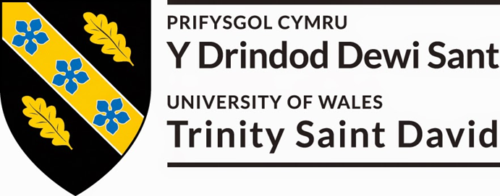
Author: Hannah Eve Thomas-Peters
Date: 11th May 2018
this dissertation is to be submitted as part of the requirements for the award Masters in Tourism and Events Management.
An Investigation to determine the motivations of millennial travellers in the pursuit of unique and authentic cultural experiences.
Declaration
I, Hannah Eve Thomas-Peters, declare that I am the sole author of this Masters Dissertation; that all references that have been cited have been consulted; that I have conducted all the work of which this is a record, and that the finish work lies within the prescribed work limits.

This has not previously been accepted as part of any other degree submission.

Singed: ________________________________

Date: _________________________________

Acknowledgements
My entire academic pursuit of a master’s degree has been a lifelong goal of mine which I am finally realising and making a reality and I would like to thank the following people for their continued support during this whole process.
I would firstly like to thank my Mother and Father, Melanie Richards and Allan Thomas, who have both been there for me in some of the most difficult and happiest times of my life, for having the constant belief that anything that I set out to do I could accomplish along with being a continuous spout of encouragement and support you both helped me in showering me with love and acceptance. Mum when you raised me single handily for so many years doing your best for me and Dad when you struggled in making the decision between food and electric.

Abstract

Table of Contents

Table of Figures
Tables

Abbreviations
US – United States
GenX - Generation X

Chapter 1

Introduction

Chapter 2

Introduction
The literature review is crucial in delivering a competent and accurate dissertation topic it will help within current literature and to help deliver and showcase background knowledge to help towards answering the research question, therefore in this chapter of the dissertation the existing and pertinent literature for the research study will be reviewed critically.
The focus of the dissertation will be to identify the millennial generation’s characteristics, and how these characteristics have an effect on their decisions to travel and how companies market to the age group as compared to other generations before them. The literature review will also discuss consumer behaviour theories in the tourism industry along with motivations and decision-making processes.
Then finally, the dissertation will look into the millennials thoughts of the cultural tourism industry from their own experiences, to identify what is meant by ‘authentic cultural experience’ to help enhance industry knowledge and getting a better understanding of what could motivate millennials to interact with different cultural experiences and improve products within the industry.

Tourism
Tourism, as defined by the Concise English Dictionary (2008, page 1524), is said to be “the commercial organization and operation of holidays and visits to a place of interest” this statement is correct, however, it could be argued that it seems to be too simple to be a true definition of the industry and all it offers. Youell (1999) would support this statement as he states that it is difficult to provide a universally accepted definition of the term tourism because “the study of tourism impinges on such disciplines as geography, psychology, sociology, economics, anthropology, planning, business studies, politics and economics” however despite being over 20 years old, the World Tourism Organisation (1994) as stated by Cooper et al (2008) it is still relevant and considers more elements of the term and defines tourism as “activities of persons travelling to and staying in places outside their usual environment for not more than one consecutive year for leisure, business, and other purposes” The quote makes reference to travelling, visitation outside normal parameters and individual environments, as well as duration and purpose of tourism to the individuals.
Tourism is important
Tourism is said to have been developed in the 1980’s and 1990’s and is considered by many, a modern concept however the origins of hospitality and tourism can be dated back to primitive and archaic societies according to Gorman (2010), hospitality, during this time was natural, vital and integral to societies of these times “hostels and inns in Mesopotamia can be dated as far back to at least 2000BC” with Commercial hotels being traced back to accommodate official government and religious travellers as well as expedite trade or mail delivery, Yoyotte (1960) states that in Egypt the Egyptians adopted a standard practice for all those on official business such as “priests or those on government assignments had everything provided for them… whilst traveling they would be cared for at temples and government depots”.
The tourism industry is said to have been 2,000 years old in Britain, and began when the wealthy citizens of ancient Rome, decided that they would rather spend their summers in the English countryside and on the coast away from the cities. A tourist industry soon sprang up to cater for the Romans market with their travel and accommodation needs, however, it is said that Roman tourism ended with its empire, and for the hundreds of years, the turbulent economic, social and military situation in Europe made frequent, safe travel out of the question. (No author, 2017)
The early years of the 20th century saw a consolidation of domestic tourism activities in the UK, punctuated by the two world wars and the recession of the 1930’s, world war one saw a growth in ownership of cars which began the decline in the use of the railways for holidays which in turn saw the increase in popularity of the British seaside holiday resorts such as Bournemouth, Southend, Blackpool and Colwyn Bay. (Youell, 1998)
The development of 'Mass Tourism' happened immediately in the period after the end of the second world war in 1945, collectively the world saw a rise in standards of living, increased leisure time and developments in transport resulting in an increase in demand for international travel (Youell, 1998). After the world saw large advancement in aircraft technology it is said that the surplus of aircrafts in the immediate post-war years along with the business flair of entrepreneurs such as Eagle Airways Chief Executive Harold Bamberg, began to make air travel a reality for the masses. This form of tourism has significantly and steadily grown into the industry that is known by all today.
The travel and tourism industry is a hugely influential industry with contribution from both direct and indirect impacts on the global economic climate, In 2016, the tourism industry accounted for over "7.6 trillion US dollars" to the global economy with direct economic impacts of the industry including accommodation, transportation, entertainment and attractions accounting for "2.3 trillion US dollars in that year. All countries benefit from developing tourism countries, such as France and the United States, are consistently popular tourist destinations, but other less well-known countries are quickly emerging in order to reap the economic benefits of the industry. (Statisica, 2017)
A vast majority of tourism today involves the participation of niche markets, Niche tourism refers to how a tourism product can be altered and tailored to meet the needs of a particular audience or a target market and it is believed that places with niche products are able to establish and place themselves, as niche tourism destinations. Niche tourism, helps destinations to differentiate their tourism products and compete in an increasingly competitive tourism environment. (Ali-Knight, 2011) Niche tourism products include gastronomy tourism, wine Tourism, spa tourism, wedding tourism, accessible tourism, adventure tourism and culture and heritage tourism.

Travel Characteristics of millennials
The Millennial Generation also referred to as “Generation Y” is the generation theorists describe and believe is said to have reached “adulthood around the 21st century” (Rouse, 2015) However there are many theorists who have contradicting view of the millennials and what ages they are such as Farrington (2018) believes that the millennials are born between the mid-1980s- 1990s. This means that it is hard to know a definitive number of millennials which can lead to the overgeneralisation of the cohort however for the purpose of this study the author will use the age range According to Howe and Strauss as sited by Rouse (2015) states that the Millennial cohort is “consisting of individuals born between 1982 and 2004” (Rouse, 2015)
According to McCaffrey (2017) the millennial cohort are the largest generation by far, where currently the global population stands at 7.4 billion people the millennial generation accounts for 27 percent of the global population or roughly 2 billion people worldwide. According to Rouse (2015) the generation is considered to have grown up in an “Electronic filled and increasingly online and socially-networked world” (Rouse, 2015). The millennial generation can be seen as immoral, lazy and narcissistic, this is enforced by Howe and Strauss (2009) claiming that the millennial generation are accused of being everything “From mass murderers, hate criminals, and binge drinkers to test failures, test cheaters, drug users and just all round spoilt Brats” (Howe and Strauss, 2000, page 3). However, McCaffrey (2017) believes that the Millennials are fast becoming the world’s most important generational cohort will become even more important for global consumer spending growth, sourcing of employment opportunities as well as overall economic prospects. As their predecessors move into a new life stage of lower consumption and retire, therefore it is believed that engaging in the millennial market is seen as a logical investment for all industry marketing especially tourism.
Benckendorff (2010) implies that a number of sources of information and insight into the generation seems to be unreliable and contradictory in places between authors however the generations characteristics according to Benckendorff et al (2010) are said to be set by “both the events and social conditioning” around them, this includes, technology and social media, childhood and development this has led to attitudes to education, consumer behaviour and work life balance and also including traumatic events such as 9/11.
Millennials in employment are said to be redefining business travel according to Landrum (2017) the saying “work hard, play hard” millennials aren’t following as other generations previously and are incorporating business with leisure. According to “New research suggests that millennials aren’t falling in line with the old adage, and a new line of thought has emerged. Business and pleasure are meant to be together.” And it is said that 81% of millennials associate business travel with overall happiness and job satisfaction, according to Cohen’s (2016) MMGY Global survey on American travellers. Where Millennials are taking the greatest number of trips out of all age groups a total of eight trips annually.

Today Digital marketing is considered ever present in all industries and no more so the travel and tourism industry, according to Chaffey (2012) Digital Marketing is “achieving marketing objectives through applying digital technologies” this can include; managing a company’s online presence via their website, social media, search engine marketing, online advertising and E-mail marketing. This means applying a digital strategy to a marketing plan for a company to meet objectives.
It is believed that the internet has completely taken over everything and individuals have had their lives consumed both positively and in some ways negatively, However, in the last decade of technology, digital technology has transformed the way individuals live, work and communicate and has become more important in the lives of individuals with individual’s dependent on devices such as their smart phones, tablets and laptops. (ITV, 2012) Chaffey (2016) explains that “with over 3 billion people around the world regularly using the web to find products, entertainment and friends, consumer behaviour and the ways companies market to both customers and businesses have changed dramatically” this means that in spirit products and services are easier to get and make and has made the need for businesses to change how they market products and services, this has gone from traditional marketing which is market centric which includes emotionless and cold emails, cold calling and interruptive and intrusive ads to a more consumer centric way of inbound marketing which includes, Search engine optimisation, blogging and attracting. (Chaffey, 2016)
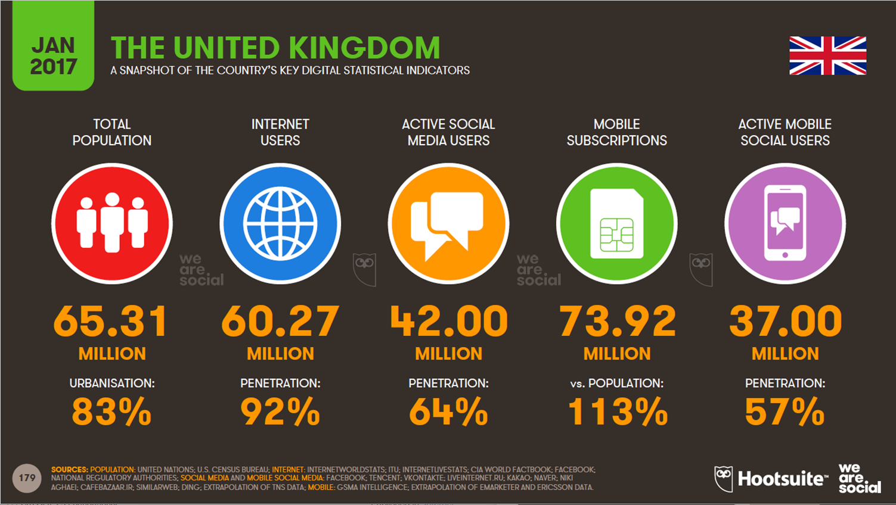
In the United Kingdom, according to Hootsuite (2017) there are “65.31 million people living in the United Kingdom” and “60.27 million use the internet” making a Market penetration of 92% with 42 million active social media users. (Hootsuite, 2017) so it could be thought that marketing online may be vital to a business’s survival and being present on social media could help a business or destination develop as Sanfilippo (2017) “20% of travellers now use social media to help them plan and organize their trips”.
As previously stated the Millennial is According to Rouse (2015) the generation grew up with technology is considered to be progressively more online and socially-networked driven generation (Rouse, 2015). Which a number of academics believe such as Yeoman (2012) who would suggest that the millennials are the first generation to grow up with technology directly at their fingertips (Yeoman, 2012) this suggest how the millennial Traveller approach travel and tourism, especially the likes of social media, Rohampton (2017) states that the generation “aren’t just looking at social media to enjoy pictures and stories about exotic destination but are using it to find where to go and what to do when they arrive” and generation Rohampton (2017) expresses that social media is a heavy influencer in travel choice as compared to travel agents (Rohampton 2017).
Generation Y also referred to as the ‘Millennials’ are considered to be more educated than those of previous generations, according to Morrison-Williams (2017) states that according to Research, some “63% of [US] Millennials value a college education and plan to get one”. 19% of those have already graduated from college and the residual 44% plan to graduate from college along with some “27% of millennial females and 21% of millennial males have college degrees” this in comparison to the previous generation “where only “20% of Gen X females and 18% of Gen X males” have college degrees. (Morrison-Williams, 2017).
Due to this a high volume of gap years are being taken by the generation According to the Leap (2013) Claiming that since the birth of the gap year over forty years ago, the gap year has increased in popularity from a rarity to everyday occurrence for university students in the UK with 2.5 Million young people planning a gap year before university and even some universities across the UK providing a deferral policy for prospective students planning on taking a gap year.
It is reported that the Millennial cohort spend in excess as compared it its predecessors and would prefer to spend on experience rather than major purchases, for example, Hendriksz (2017) states that Millennials “attitudes towards consumption and ownership are shifting” this is also suggested by market research conducted by Future Cast The age group spends around £153bn on travel alone each year (Harrison, 2017).
Inkling (2016) declared that 53% of UK Millennials would much rather prefer to spend their money on an experience versus spending money on personal possessions, expecting millennials to spend much more on travel than their previous generational cohorts. There is also research constantly suggesting that this generation 'works to live' not 'live for work'.
Barton et al (2013) declared that the millennial cohort compared to other generations previously wish to travel to every continent and desire to travel abroad as much as they can. Barton et al (2013) they also show that the younger millennials from the generation are more interested in travelling internationally and are more diverse in interests such as global cultural experiences. Cultural tourism will be further discussed in more detail in this chapter of the study. (Barton et al, 2013).
Generation X
Whist studying the millennial Cohort and their characteristics and even though the study will focus almost exclusively on the millennial cohort, it is beneficial to comprehend the characteristics of the previous generations before to gain a further understanding of how different or similar they may be.
Generation X (GenX) are the generation born between the years 1961 and 1981 (Howe and Strauss, 2000). It is said that this generation are deeply rotted with negativity and a sense of entitlement According to Wallop (2014) “This generation has been characterised as being saddled with permanent cynicism. Too young to have fought in any major war, old enough to have enjoyed a free education – they have spent too much of their adulthood sitting around in coffee shops trying to set the world to rights. And failing” However, the Generation are said to highly enjoy travelling, however are considered less daring or and travel for relaxation, their holidays are generally Family orientated and the timing of their trips closely coordinated around academic calendars, their destination of choice tends to be closer to home with destinations that are said to be mainly beach oriented (Goldberg, 2016).

Theoretical Perspectives
There are many different theories available and would be regarded relevant to this study. However, the most relevant and pertinent of theories will be used to achieve the aim set out by the researcher, these tourist typology theories would be able to compare with the characteristics of the millennial cohort. Along with other noteworthy theories to use in the literature review such as motivational theories to find incentives for those who travel for culture and also decision-making theories such as push and pull factors.

Academic Tourist typologies
Within academic research of tourism typology there was one very prominent model which has been used within both tourism research and industry this includes, Stanley Plog's 1977 psychographics model for tourist typologies and Erik Cohen's 1972 typology of four tourist roles are the two main theories which have been used extensively within the tourism industry and within tourism research and be used in this study to characterise the millennial cohort.
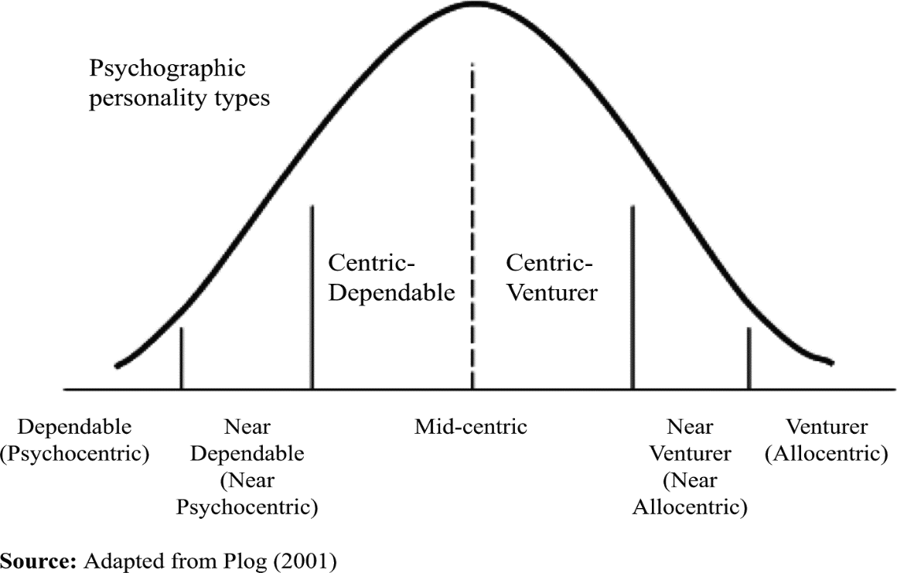

Plog's psychographic model has a personality scale to determine what type of traveller they are The scale varies from the ‘psychocentric’, which are individuals who favour the 'familiar' in travel destinations to those that are outgoing and want to see and do new things in travel which are referred to as ‘allocentric’ (Litvin, 2006) Plog’s psychographic model is considered the initial model to separate tourists into personality or behavioural groupings. (Plog, 1977)
Another Theory is Erik Cohen's typology of the four tourist roles, which he split into the organised mass tourist, which is an individual who tends to buy a package holiday and follows a regimented and inflexible itinerary, the individual mass tourist, who buys a holiday package with flexibility that allows more independence and choice, the explorer will create their own dynamic package while travelling and finally the drifter, will completely immerse themselves into the host community and is unlikely to experience any tourist situation. It is even said that drifters shun all contact with the formal travel and tourism industry, the drifter has no fixed itinerary, or goals set out for their travel. (Swarbrooke and Horner, 2007)
However both theories have drawbacks for example Plog’s psychographic model is to categorise tourists on the nature of the holiday they choose, mainly due to the location, the theory is very linear and doesn’t take into consideration the practical application, for example, individuals going through life cycles change and may not stay in the same category their entire life a classic example would be someone travelling during their youth they would fall into the allocentric category and later on in life once settling down may be more reluctant to travel like they had with a family or later in life again when elderly and would fall into the psychocentric category (Horwood 2014).
Cohen’s theory of typologies it could be argued that the concept of the drifter is heavily flawed For example, the drifter is said to have “no goals of travel”, which is clearly false as someone could ask what actually motivated this person to travel in the first place? Especially when parting with a great sum of money on travelling, the traveller should have an anticipated goal for their travel experience.

Cultural Tourist typology
Determining different types of cultural tourists will aid the researcher in finding specific motivations to travel for culture with millennials. Mckercher and du Cros (2003) defined five types of cultural tourists ranging from purposeful cultural tourist to incidental tourist (See figure 2.2). As Mckercher and du Cros (2003 pg. 46) also stated that cultural tourism is not defined by one reason, "different people will engage with cultural tourism at different levels, depending on level of knowledge, number and type of travel partners, own interests, etc. "Definitions of these types of tourists are needed to examine the researcher’s respondents. The figure is based on deep or shallow experience and low too high in motivation to visit a cultural tourism attraction. Despite having notable flaws within the theories being used in this study, these typology theory model will help in the discovery of what type of cultural traveller is the millennial traveller truly is.

Motivational theories
There are several different views of motivational theories that Psychologists and behavioural scientists have developed and examined these theories have been developed by researchers. Some of these theories include Abrahams Maslow’s hierarchy of needs and Herzberg’s Two Factor Theory.

Maslow’s Hierarchy of needs
Maslow’s hierarchy of needs, is a theory model developed in 1943 by Abraham Maslow, the model is a key motivational theory model and is considered the best identifier of motivation the model consists of five key areas starting at the bottom these areas the model starts with the Physiological Needs which is the rudimentary needs that every individual requires to survive such as food, air, shelter and water. If these basic needs are not adhered to, then the individual will not be able to go onto the other levels all the way up to the last level, which is the Self-Actualization level where an individual feel as though they are realising their potential. And this is the level that employees will work at their optimum for an organisation. (Bradley, 2003) Maslow’s hierarchy of needs can be regarded as the best identifier of motivation within the workplace because of its simplicity yet identifying key aspects of individual’s lives which can be incorporated to the millennials motivations.
Maslow (1962) as cited by McLeod (2014) expressed that self-actualization could be measured through the concept of peak experiences. This can occur genuinely when a person experiences the world totally for what it is, and there are feelings of euphoria, joy and wonder (Maslow, cited in McLeod 2014), a common concept when individuals experience new cultures. Maslow’s hierarchy of needs model does have criticisms from many authors in the validity of the hierarchy.
However, a theory that has been developed that is based on Maslow’s hierarchy of needs specifically for tourism called the Travel Career Ladder by Pearce (1991) The model functions in the same way as Maslow’s Hierarchy of needs, whereas, by meeting the primary needs of the model can an individual meet the higher needs.
Pearce (2005a) also suggested such as Maslow and the hierarchy of needs stated that that in the fourth need (self-development), experiencing different cultures was an important factor to more experienced travellers than others.
Both theories have notable draw backs to them, naturally, within Maslow’s hierarchy of needs, Maslow (1970) announced that self-actualization cannot be reached by the young, Therefore, suggesting that the model is unreliable, out-of-date and needs drastic revision. There have also been criticisms on Pearce’s (1991) travel career ladder model by numerous authors. Woodside and Martin (2007) explain that the framework for the model is appealing, but it has no experiential evidence to support the theory. Therefore with no evidence to argue its that travellers do not show an increase in intellectual motivation to travel based on past visits to a destination.
Decision making and destination image
As no two individuals are alike the decision-making process is considered a vital aspect of the tourism industry as it helps industry professionals and differences in consumer attitudes, perceptions, motivation and images contribute to the decision-making process. It is central for the tourism industry professionals to research and understand how tourism consumers make their travel decisions and feel in relation to the consumption of tourism products. Pizam and Mansfeld, (1999 pg.112) declared that the “decision-making processes are characterised by a logic of reason that encourages thought, discussion, and personal judgement.”
Many authors have thought that the decision-making processes within the tourism industry to be judged on Dann’s (1977) push or pull factors of destinations. Dann (1977) referred to ‘pull’ factors as in what attract a tourist to the destination (e.g. climate, landscape etc.) and ‘push’ factors as those that are general motivations for people to travel such (escape, nostalgia). However, decision-making can very likely be affected by the tourist’s perceived image of a destination and can link in many aspects. A definition of destination image has been widely disputed and analysed with no one agreed definition. However, one that would be useful in this study explains that destination image is.

Cultural and Heritage Tourism
According to Concise English dictionary (2008b) which explains that Heritage is derived from the French word “Heriter” meaning to inherit, this is supported by many theorist definitions such as Hewison (1989) stating “That which a past generation has preserved and handed on to the present and which a significant group of people or population wishes to hand on to the future”, this definition shows that heritage is seen as something to be handed on down to generation to generation and heritage tourism allows visitors to observe that heritage to learn more about it whilst also giving the reverence of what each generation feels they should preserve for the next for example when heritage tourism was developed it only considered heritage tourism products to be those kept in museums and old buildings however today tourism departments also makes reference to include contemporary heritage and culture such as music, fashion and traditions, Today Heritage is understood to be a pertinent part of the tourism industry, as heritage has the potential to interest and entertain the populace predominantly for its educational value. McCannel (1992) states that tourism is not just an aggregate of merely commercial activities, it is also an ideological framing of history, nature and traditions.
The World Tourism Organisation (2012) defines the expression “Cultural Tourism” as “all aspects of tourism that can teach visitors about their past and inheritance, as well as their contemporary lifestyles” this definition shows cultural tourism can teach visitors of the host communities about the treasured past traditions and the host communities current means of life. ‘Cultural Tourism’ has in recent years developed and become more of a travel desire within the industry for travellers, due to continuous innovation of products and community development, in response to demands for new experiences by travellers and the progression of cultural management research, cultural tourism can be considered as one of the most important and diverse phenomena of current tourism. (World Tourism Organization, 2012). Maccarrone-Eaglen (2009) believes that Travellers are looking for diverse experiences outside of their everyday lives. This is supported via surveys devised by Visit Britain where 57% of respondents across 20 countries “agreed that history and culture are strong influences on their holiday destination” (Visit Britain, 2016) shows that Heritage and Culture Tourism is seen as a crucial aspect to tourism and may be the reason as to why many strategy plans now have a cultural tourism aspect to them.

Cultural Motivators
Ivanovic (2008) believes that the main motivation for cultural tourism is the overwhelming need to escape from the everyday routine and replacing it with something that is different from the norm, the researcher is looking specifically at the millennials and knowing their motivations for travelling culturally will be helpful to understand why and where the generation when they travel for culture tourism.

Chapter 3

Introduction
This chapter refers to the need of research to this study along with an analysis of the process of research taken place by the author and explain the particular methodology that has been chosen for this study.
Research Methodology, according to Jankowicz (1995) who believes that Research is central to further expand upon and understand a topic area or an issue in greater depth, “People undertake research in order to find things out in a systematic way, thereby increasing their knowledge” (Jankowicz, 1995, page 5). In this chapter, the appropriate methodology will be identified and assessed and the researcher will justify their decision to use this approach in the research study.
The sampling process and strategy of the research and methods of analysis is justified and assessment of the research ethics and code of ethics, limits of the study and issues concerning the research is clarified and analysed further.
The researcher within the study has used both primary and secondary research. Primary research involving the collection of data first hand via surveys and focus group and therefore is the collection of original data along with secondary data from chapter two, in secondary research however, there is no new data obtained by t6he author but a collection of pre-existing information collected from other sources. (Naoum, 2013; Clark et al., 1998).
The option to utilise only secondary research was also an option, however the author decided on primary as well. The reasons for this are that primary research made the study more specific and in-depth than secondary data alone.

Dissertation Title
To determine the motivations of the millennial market when considering authentic and unique cultural experiences.
Aims and Objectives
The overall Aim of this research dissertation is to explore what motivational factors influence the millennial generation has to travel for authentic and unique cultural experiences. Standard misconceptions of the millennial generation believe the cohort are just interested in partying however more and more millennials suggest they are after culture and experiences outside the norm. (ref) As a result of guaranteeing the aim of the study is attained the subsequent objectives will be carried through.
Objectives:
1. To identify what the term ‘authentic culture’ is from both the industry standpoint and the generation’s standpoint and whether they differ in definition.
2. To critically evaluate the characteristics of the millennial traveller in order to understand their need for travel.
3. To analyse and evaluate the generations experiences and opinion of culture and cultural experiences of both who have gone or planning to go travelling via questionnaires and a focus group
4. To make valuable recommendations to strengthen industry knowledge of cultural tourism and cultural experiences – to attract more of the age group

Paradigms and Research methodology
According to Collis and Hussey (2009) research is fundamental to both business and academic studies, however there is no one definition for the term but believe that amongst the many definitions from theorists there is a recognised agreement that any definition includes;
• A process of enquiry and investigation
• Systematic and methodical approach
• Increases knowledge
(Collis and Hussey, 2009)
This is shown in a definition provided by Jankowicz (1995) which explains that Research is central to further expand upon and understand a topic area or an issue in greater depth, “People undertake research in order to find things out in a systematic way, thereby increasing their knowledge” (Jankowicz, 1995).
The research onion model proves to be an effective way to discover which research path should be chosen can be designed according to Sahay (2016) who states “Though most researchers design their research to answer a question or address a problem, they begin by working out what data are needed and what method, tools or techniques should be used”.
It is considered that it is vital that a research paradigm must be decided before research is undertaken. Collis and Hussey (2009) concludes that a research paradigm is a philosophical framework that serves as a guide to how scientific research should be carried out
Collis and Hussey (2009) state that Philosophy is considered “the use of reason and argument in seeking truth and knowledge, especially of ultimate reality or of general causes and principles”
The individual’s preconceived ideas about knowledge that have developed over time and therefore new research paradigms materialise in response to the alleged shortfalls of previous forms of paradigms.
The assumptions of the main paradigms is where the author Creswell (1994) provides an overall summary of the philosophical expectations that underpins the two main paradigms which are positivism and interpretivism.
This chapter follows the research onion which enables researchers to determine an appropriate philosophy, which is an important step in planning and carrying out research. Whilst also highlighting the main reasons behind electing particular research philosophies, and the researcher’s approaches, strategies, method, time scale and techniques as well as procedures for this research dissertation.
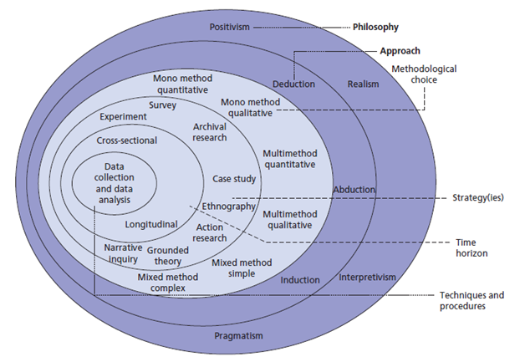

Research Philosophy
The Term ‘Philosophy’ is defined as “the study of the fundamental nature of knowledge, reality and existence” (Concise Oxford English Dictionary, 2008c, page 1077). It can be seen that a research philosophy is a confidence about the way in which data should be collected, evaluated and used. Two major research philosophies have been identified as positivist and interpretivist.

Positivism and interpretivist
The University of Derby (no date) states that “Positivism generates hypotheses (or research questions) that can be tested and allows explanations that are measured against accepted knowledge of the world we live in”. It is believed that this stance of philosophy fashions a body of research that can be imitated by other researchers to generate the same results time and time again. The emphasis is on measurable results that lend themselves to numerical and statistical analysis. (University of Derby, no date)
Positivists trust that reality is unchanging and can be observed from an impartial perspective without interfering with the study (Levin, 1988), whilst interpretivist contend that only through subjective interpretation of and intervention in reality can that reality be fully understood. The study of phenomena in their natural environment is key to the interpretivist philosophy. A positivism philosophy was essential for this purpose, for example as the study is to understand the thoughts and motivations of the millennial generation, it adapts itself to a phenomenological approach which is qualitative, humanistic and interpretivist in approach (Collis and Hussey, 2003). Positivism is a paradigm adopted by natural sciences it rests on the assumption that social reality is singular and objective, and cannot be affected by the act of investigation, positivism aims to separate people from their social contexts which is considered impossible as they are one and the same. A phenomenological approach provides a more relevant and suitable measure for research and looks at the feelings of individual participants in the study (Collis and Hussey, 2003) whereas a study that uses a positivist paradigm are usually quantitative and traditionalist in approach.
Research Approaches
The second layer of Saunders (2009) research onion model contains the research approaches referred to as deductive and inductive. Creswell and Plano Clark (2007) stated that the deductive researcher works from what’s referred to as the top down, from a theory to hypothesis to data to add to or contradict the theory. Therefore, according to the University of Derby (no date) Deductive means that you begin with a declaration or question and an individual’s research sets out to answer the statement thus “the aim would be to conclude with a yes or no response to the question”. (University of Derby, no date) Whereas, In contrast, Creswell and Plano Clark (2007) define the inductive researcher as someone who works from the bottom-up, using the participants’ view to build broader themes and generate a theory interconnecting the themes.
In research, the two main types of analysis that are drawn upon typically are quantitative and qualitative, quantitative refers to deductive approach and qualitative refers to inductive approach to research methodology, this study has used a more deductive approach to research the topic of motivations in the millennial cohort, as it moves from the broad discussion to the particular. The study has focused on theories of motivation and consumer behaviour studies and these topics lend themselves to
Data collection
Saunders et al (2009) defined research methods as a procedure that can be used to obtain and analyse data.
This study has used a mixed method approach, which is a general term for an approach that uses both qualitative and quantitative data collection techniques and a method that crosses the two paradigms.
The approaches used in this study was surveys and a Focus Group. Collis and Hussey (2009) identified that the use of two or more independent sources of data or data collection is this as technique called triangulation. The design of the focus group and survey questions concentrated on the themes that arose from the literature review;
• Consumer Behaviour and shopping habits
• Marketing
• Authentic Culture
In the dissertation the author used a mixture of both Qualitative and Quantitative research, Quantitative research to calculate how the Millennial cohort shops and what they are drawn to this will help to accurately count and identify what and how the millennial shops when purchasing a holiday or experiences, the author did this by sharing her online questionnaires to target The Millennials and the author will use Qualitative data to underpin and understand the attitudes of the millennial generation and why they have those thoughts this will give the author and in-depth analysis of the generation and their shopping trends and what potential impact this could have on the industry. this information will also back up the Quantitative Research taken place prior to this, The Author will be conducting the Qualitative research by holding a focus groups with individuals from the millennial generation who have either been on a cultural trip or are planning to gain knowledge why and how they went through the motivations of their decisions and the author will also conduct structured interview question for respondents who attend the focus group attendees will be from the millennial cohort to give a deeper understanding from topics drawn from survey answers with important industry, relevant and informed individuals who have knowledge about the topic area of travel and tourism sector these people the author intends to talk to millennials about their travel habits and procedure.
Sampling
According to Saunders et al (2007) Sampling techniques provide researchers a choice of approaches that empower researchers to collect a more manageable set of data whilst providing reliable data, as a census would not necessarily provide a more useful data. (Saunders, 2007) as Saunders et al (2007) also describes that the need for sampling is because of the impracticality of surveying the entire population along with budget and time constraints. This means that sampling can assist with timely data collection without compromising on results.
Saunders (2007) believes that Sampling is equally important to focus group, questionnaires as well as other data collection techniques that is why a sample was done for each of the data collection methods for this study. Whereas, Veal (2011) states that the process of sampling is an indispensable course of action to questionnaires researches.
For the purpose of this study, the ideal sample audience are the millennial cohort who are interested in travel the Sample members were collected from those who the researcher knows mainly millennials; as millennials are the same generation as the researcher her social media accounts reach out to over 700 millennials, however the survey will not be exclusively for millennials as an array of respondents are needed to compare and contrast between generations to gain further analysis.
The study had a sample size of 4 interviewees in the focus group and 94 survey respondents, which a non-probability approach to data collection and convenience sampling were considered the most effective way of sampling data, selected interviewees were chosen due to their wide knowledge and experience of the travel industry whilst respondents in the survey and focus group participants were conveniently able to contribute to the study and were reliable to the researcher by immediacy and location along with their ability to provide reliable information on the topic at hand.

Survey
The Survey Strategy is usually associated with the deductive approach. It is a popular and common strategy in research and its most frequently used to answer who, what, where, how many and how much questions. It therefore tends to be used for exploratory and descriptive research survey are also popular as they allow the collection of a large amount of data from a sizeable population in a highly economical way (Saunders, 2007)
A piloted survey was distributed to the researcher’s fellow classmates and family members and professionals that she trusted and based on their feedback the survey was redrafted before it finally went you. The suggestions made after the pilot were as follows;
• Re-phrasing and re-structure of questions to be easily understood.
A questionnaire is a number of structured questions with the aim to find out what a group of participants think or feel about a topic (Collis and Hussey, 2014).
A positivistic approach to surveys and questionnaires advocates that questions should be closed, whereas, a phenomenological approach proposes open-ended questions. This study incorporated both approaches in its data collection, however, with a more emphasis on the positivistic approach as this would provide more with quantifiable information to analyse and with respondents from the focus group would be able to give me a better understanding of the what millennials motivation towards travel, however, it is understood that a positivistic approach is always the more suitable to a large-scale survey.
The survey was designed with efficiency in mind focusing on general questions at the start with more specific questions related to the themes touched upon in the literature review towards the end along with only to take a maximum of 2 minutes to complete and broke up into sections as to not seem as long of a process.
The survey was created using Google Forms as it allowed the researcher to conduct primary research by not having to purchase a costly subscription, and included almost the same functions paid subscription packages such as Survey monkey which still allowed for detailed analysis and didn’t disadvantage the researcher in anyway. All questions were made mandatory to fill in. some questions invited users to supply the researcher with additional qualitative feedback that was used for content analysis.
A notice to participate in the researcher’s survey was sent on the researchers personal Facebook and multiple groups on Facebook that the researchers apart of. The survey also went out on the researcher’s personal LinkedIn, Snapchat and Reddit accounts multiple times a day.

Focus Group
The Author also conducted a focus group to collect additional qualitative data to analyse a focus group according to Saunders (2007) is a Group interview that is composed with a small number of participants that is facilitated by a moderator this therefore allows a topic to be clearly and precisely whilst simultaneously interactive discussion is enabled between participants.
This Focus Group was conducted face-to-face. Overall 7 Participants took part in the focus group that ages range across the millennial generation as stated by xxx – and had a ratio of 4 men and 4 Women to allow an equal distribution and to be fair. for the focus group the questions concentrated on what millennials feel about mass marketing and the representation of their age group in said campaigns However the focus group were conducted and covered the following topics;
- Millennial travel habits
- Booking methods
- Thoughts on mass marketing
These topics were identified through the comments that arose in the survey and were chosen to assist in close research gaps as they represented the different marketing areas within the millennial cohort.
The focus group took between 15-30 minutes participants were asked permission if the interviewer to record their responses as this would expel the need for note taking and solely focus on the interviewee and their responses thus benefitting the analysis of qualitative content as no words or statements would be missed during the transcribing process.

Ethics
Research Ethics according to Saunders et al (2007, 610) is classed as the “appropriateness of the researcher’s behaviour in relation to the rights of those who become the subject of a research project, or who are affected by it” this therefore means that a code of ethics needs to be put in place to set up to conduct any research that doesn’t put any respondents in jeopardy or make them uncomfortable during the process.
For the purpose of this study, careful consideration was given to the prominence of ethics throughout the research stage of this study, due to the highly sensitive nature of the content of information requested by the interviewer from the interviewees and respondents of both the surveys and focus group participants procedures were put in place to ensure that respondents were safe. A copy of the ethics form can be found in appendix X. However even though it is supported that ethics is important to a research study it is Coolican (1992, page 249) explains that it can be considered ‘difficult to conduct much research at all without running into ethical arguments’ however suggests that the focus group and surveys should be made voluntary and should lend itself to anonymity and confidentiality. That is why each focus group respondent was supplied with a consent form, which they signed and returned to the researcher, providing the participants with information regarding the aim of the study and underlining their right to withdraw from the study at any time.
All focus group responses were transcribed and protected on a memory stick with an encrypted username and password to access the content. The Surveys were made voluntary to respondents and were informed on the purpose and importance of the study, methods used along with addressing their ability to drop out at any stage. All research responses were made anonymous and confidential. By guaranteeing that the respondent’s individual’s names were not stated throughout the documents as well as survey respondents were asked basic demographic questions and were not able to state their name.

Limitations
The main limit of this study included the time scale in which the study was conducted and completed which therefore restricted access to resources and a number of respondents that were taking part in the focus group that could take place, thus making it a small scale cross-sectional research study, which are designed to obtain the relevant research data in different contexts but over the same period of time.
Because of lack of responses from industry professionals when contacting for interviews meant the author was unable to collect data from an industry standpoint this meant the author had to change the approach of the study to all consumer based, having interviews would have Interviews given the study a deeper understanding of the factors affecting millennials motivation regarding travelling for Cultural Tourism that could have been analysed further.
The author would have used a Semi-structured approach towards the interviewing process and focused on the marketing and advertising approach towards cultural tourism to assist in closing research gaps as they represented the different motivations areas within the millennial cohort.

Reliability and Validity
Reliability refers to the extent to which data collection techniques or analysis procedures will yield consistent findings. (Saunders, 2007) There are four threats to reliability Robson (2002) asserts that these are;
- Subject or participant error
- Subject or participant bias
- Observer Error
- Observer Bias
Validity is concerned with whether the findings are really what they appear to be about. (Saunders, 2007) Robson also stated that there are some threats to Validity also which include the following;
- History
- Testing
- Instrumentation
- Morality
- Maturation
The threats to this study concerning reliability and validity are the collection of the data because the survey needed to go out on as many platforms as possible for example the researchers personal Facebook and multiple groups on Facebook that the researchers apart of. The survey also went out on the researcher’s personal LinkedIn, Snapchat and Reddit accounts multiple times a day. The limitation of this being that the public may not be able to supply accurate knowledge of what the researcher is trying to achieve. The collection of data proved to be difficult as the respondents weren’t guaranteed the researcher made an incentive for those who completed her survey. Also as the survey will be completed by some of the researches closest friends they will be biased however to ensure this isn’t the researcher never indulged in the results I wanted as to limit bias in my answers.

Data Analysis
This study used a content analysis on qualitative forms of the data collected, and it was systematically read to recognise key issues, concepts and thoughts. Quantitative Data that was found from the survey answers were imported into Excel for and cross tabulated using ‘count if’ formulae in excel for further analysis. The researcher was therefore able to highlight key themes during the analysis stage which are discussed as motivational factors in the Data Analysis chapter of this study.

Chapter 4

Results
Introduction

This chapter will disclose the findings of both the qualitative and quantitative data found in the research carried out by the researcher, research applied in the methods highlighted in the research methodology chapter. These include the thematic analysis of the Focus group and the analysis of the 94 responses collected from the survey. The numerical data that was collected through the survey also highlighted themes for the Focus group questions were set out by the researcher from overall findings found through in the literature review. These themes include motivation, cultural tourism, and marketing and social media.

Survey Results
In this section of the results chapter, the researcher will look at and analyse the 94 online survey responses as well as performing a cross tabulation between data. The questionnaire results were broken down into sections in order to reflect certain themes but also providing respondents with the illusion of the survey taking, which draw a parallel to the literature. These included background and characteristics of individuals when travelling, marketing and cultural tourism. All question responses are available in the appendix.

Survey limitations
The Author understands that some results may be skewed because of the unequal representation in some categories such as the representation of Non-binary or in the 39-43 age group because only one respondent of each responded for each group the researcher can only imagine that if the research had more respondents in these categories, that it would be a more accurate representation. This means that when doing any two way cross tabulations the results will not be one hundred percent accurate when it came to working out percentages, for example, in excel to work out the percentages the formulae works out that 100% of non-binary would travel spontaneously when if there was more non-binary respondents there

Demographics
One of the sections of the researcher’s survey determined first questions asked included age, gender, occupation and location. The participation in the questionnaire saw more females answering the survey compared males and considerably less than Non-binary for example 64% of respondents were female, 35% were male and 1 respondent was Non-Binary this is not the desired results of respondents as the researcher needed an equal representation between the three categories.
The majority of the researcher’s survey was completed by the millennial which in the survey researcher categorised ‘18-23’ (19%) and ‘24-32’ (35%) the least respondents the researcher found were from the ‘39-43’ age group with only one respondent whereas all the other age groups had equal amount of respondents.
The Majority of respondents stated they lived in Wales, however the researcher didn’t receive any respondents from Scotland but did some get overseas respondents.
The Author understands that some results may be skewed just because of the unequal representation in some categories such as the representation of Non-binary or in the 39-43 age group that if the research had more respondents in there categories that it would be a more accurate representation.
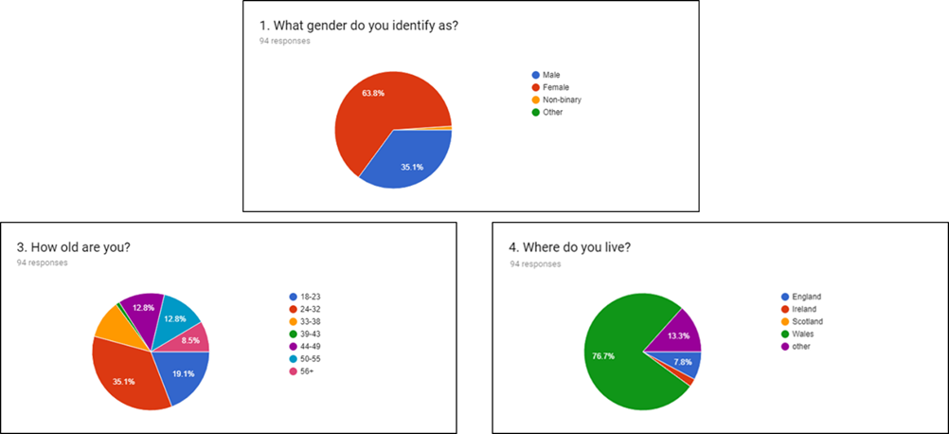

A three way cross tabulation was created to illustrate the respondents that completed the survey, which was done through excel.
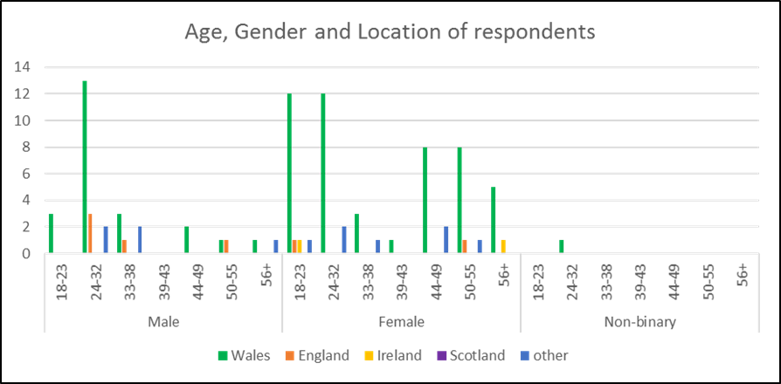
This demonstrates the spectrum of the respondents the researcher’s survey reached. As previously stated and illustrated in the bar chart the majority of respondents came from wales. Breakdown found in appendix

Travel characteristics
The ‘Travel Choices’ section of the survey was to gain understanding about the respondents and how and where they are likely to travel whether they look for new exotic places or whether they look for the same holiday every time. A cross tabulation was created with questions 2 and 3 of the ‘Travel Choices’ section which can be seen in the appendix.
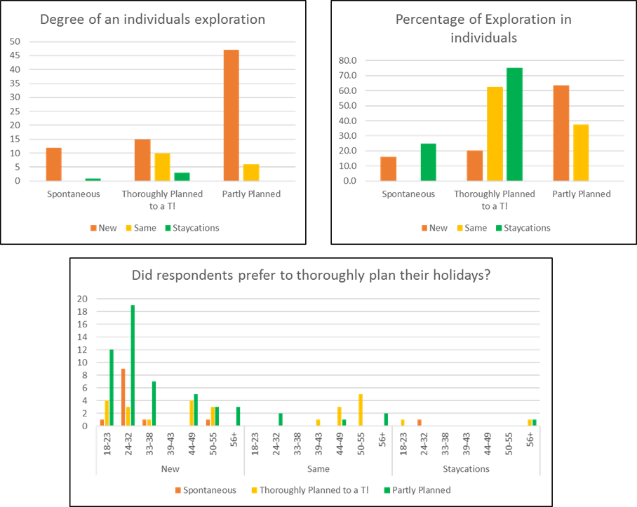
The first two bar charts illustrate the degree of an individual’s level exploration and the percentage whether they would prefer to travel for new exotic destinations, the same destination or whether they don’t travel too far and prefer to go on staycations. The preconceived idea the researcher believed that individuals would prefer to go to new destinations and partly planned but that spontaneity would be high in individuals. However, The researcher found that the first thought of New destinations being the most popular turned out accurate with 74 respondents stating they would prefer to travel to new destination and 47 of those respondents stating they partly plan their trips however, from the research it shows that more respondents preferred to thoroughly plan their trips than spontaneously travel.
the Last bar chart is a cross tabulation that shows three sets of data which shows the degree of planning between the varying age groups towards new destinations this chart demonstrates that the millennial generation are a lot more fluid and when it comes to planning that they leave a little flexibility when they travel as compared to the older generations when travelling. This reflects the literature found in chapter 2 where Barton (2013) stated that “the millennial cohort compared to other generations previously wish to travel to every continent and desire to travel abroad as much as they can.” As the research shows that the millennial is more motivated to travel to new places. The researcher then wanted to test whether either genders were more inclined to plan their trips ahead of time or whether they were equal, to understand general travel characteristics.
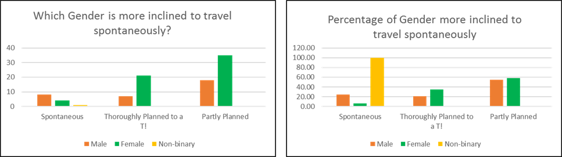
The research shows that women are more inclined to plan ahead whether that is partly or thoroughly whereas the male respondents tend to be more flexible and travel more spontaneously that their female and non-binary counterparts.

Cultural tourism
The ‘Culture’ section of the survey investigated whether individuals who answered the survey travel for culture and why and whether they considered their cultural experiences were authentic or not.
From the literature review Barton (2013) suggests the “millennials from the generation are more interested in travelling internationally and are more diverse in interests such as global cultural experiences”. To test this theory a cross tabulation was created to test age and whether they would like to travel for culture, this was done by testing the age against the “
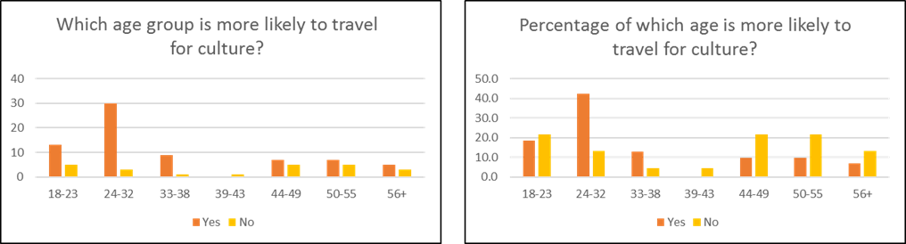

These charts showcase which age groups are more motivated to travel for culture the expected result before any research was carried out was that the older generation would be more inclined to travel for culture however since research from the literature review states that the millennial age groups are likely to travel for culture but the researcher expected that the result will be tied between the ages however the results from the primary research shows that the millennial is far more motivated to travel for culture than their predecessors.
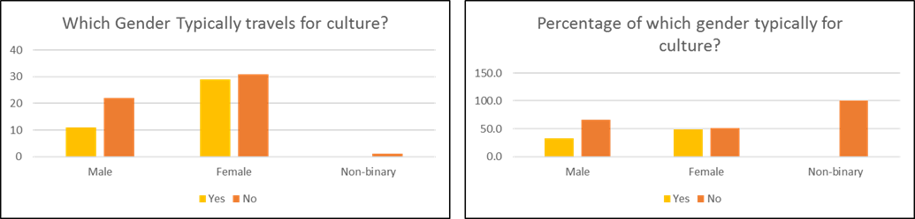
Then the researchers tested whether either genders were more inclined to travel for culture over one another or whether they equally travelled for culture, to understand general travel characteristics. As seen in the above results females are more inclined to travel for culture over their counterparts.
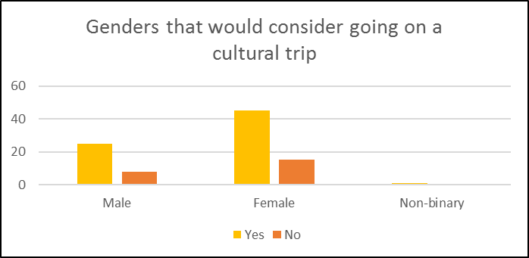

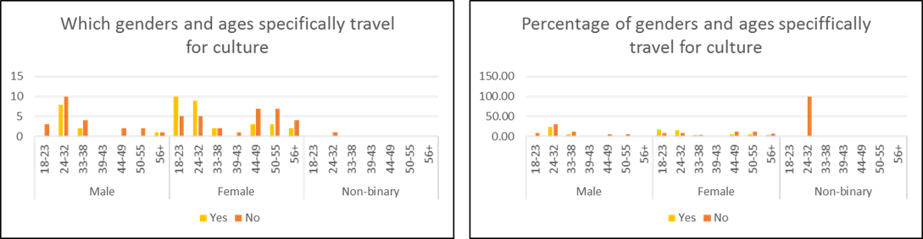
Females were equally have and haven’t travelled for culture, with 52% saying no they don’t typically travel for culture and 48% saying they do. However, the following bar chart displays that females want to travel for culture specifically.
The researcher then felt the need to clarify age, gender and whether individuals specifically travel for culture so a three way cross tabulation was created.
The results showcase that Females between the ages of 18-32 are more likely to specifically travel for culture than men or non-binary individuals, this result inspired a question topic of discussion in the focus group as to why.

Marketing
According to the literature review the millennial generation grew up with technology and according to Rouse (2015) is considered to be progressively more online and socially-networked driven generation compared to the other generation. (Rouse, 2015) Because Yeoman (2012) suggested that the millennials are the first generation to grow up with technology directly at their fingertips (Yeoman, 2012) Rohampton (2017) states that the generation “aren’t just looking at social media to enjoy pictures and stories about exotic destination but are using it to find where to go and what to do when they arrive” and generation Rohampton (2017) expresses that social media is a heavy influencer in travel choice as compared to travel agents (Rohampton 2017). Because of this the researcher asked the questions that addressed social media and whether the cohort feel they are represented within mainstream media in the tourism advertising due to the millennial cohort being the largest generation by far, where currently the global population stands at 7.4 billion people the millennial generation accounts for 27 percent of the global population or roughly 2 billion people worldwide. This was deemed important to provide sound advice to the industry.
The first test regarding marketing was calculating whether the age groups felt represented overall. The key findings were as follows
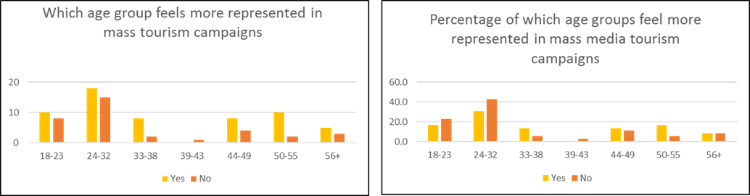

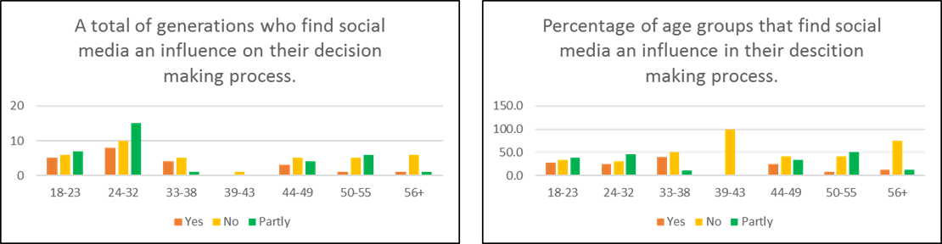
as shown above a high percentage of millennials feel as though they are underrepresented in tourism campaigns this was reflected in comments that were asked in the survey following where respondents were asked ‘Do you feel that your age group is well represented in tourism marketing campaigns?’ and then went on to ask ‘Please explain your answer’ where common answers were ‘Partly but not specifically just mass’ and ‘Most holidays seem to be aimed at the ‘middle age’ market’ and also ‘The age group that I am currently in is mostly to do with sun, sex and alcohol while I enjoy visiting new locations whatever the weather and to learn the culture, heritage and the history of the location.’ These comments have negative connotations against the industry regarding advertising and the holidays that the age group would like.

These charts demonstrate the variation between Age groups and how likely they are to be influenced by social media according to secondary research found in chapter two the millennial cohort are more likely to be influenced by social media as they grew up surrounded by technology despite this being the case more participants only said they were only partly influenced by social media stating in the follow up in the qualitative question "It's nice to see people's photos of places they've visited and if they've had a good experience of that location. But it doesn't make me 100% want to go there because of one person's experience. On the other hand, if everyone is going to the same location for holidays, it makes me want to go somewhere else." whereas the older generation really didn’t find social media an influence this could be from a lack of knowledge on how to use social media or not being the target audience for paid ads on social media sites such as Facebook.

Focus Group
Focus group Summary
The focus group consisted of four people ranging from the ages 22-32 and consisted of 2 men and 2 women, this meant an equal representation between the two genders however, the perfect scenario would have consisted of Non-binary respondents to develop an insight that the survey wasn’t able to offer the researcher, however, the focus group did provide the researcher with information regarding the millennial cohort and what they believe to be correct when regarding marketing and advertising and the literature that is about them to clarify for industry purposes due to the cohort potentially being the largest group and approaching their prime spending years as according to
the focus group was conducted on the findings that arose from the survey regarding women being more likely to want to go on cultural trips far greater than men, underrepresentation of the cohort in tourism marketing and advertising media and social media and internet.

Limitations
The researcher found many limitations within the focus group that developed flaws in the primary research of the study.
Firstly, because of the majority of the researcher’s survey was 64% completed by female respondents and only 35% were male as a result there would never be an equal representation between the genders so this means the data was flawed and not accurate to start with.
Secondly, the researcher had to ask participants she knew in order to answer her questions and whoever was available this meant that the researcher asked fellow classmates because they were conveniently able to attend this means they weren’t able to give accurate non- biased information and also because they are currently undergoing the dissertation process this means they thought too objectively instead of providing answers that could help the researcher to draw to a conclusion.

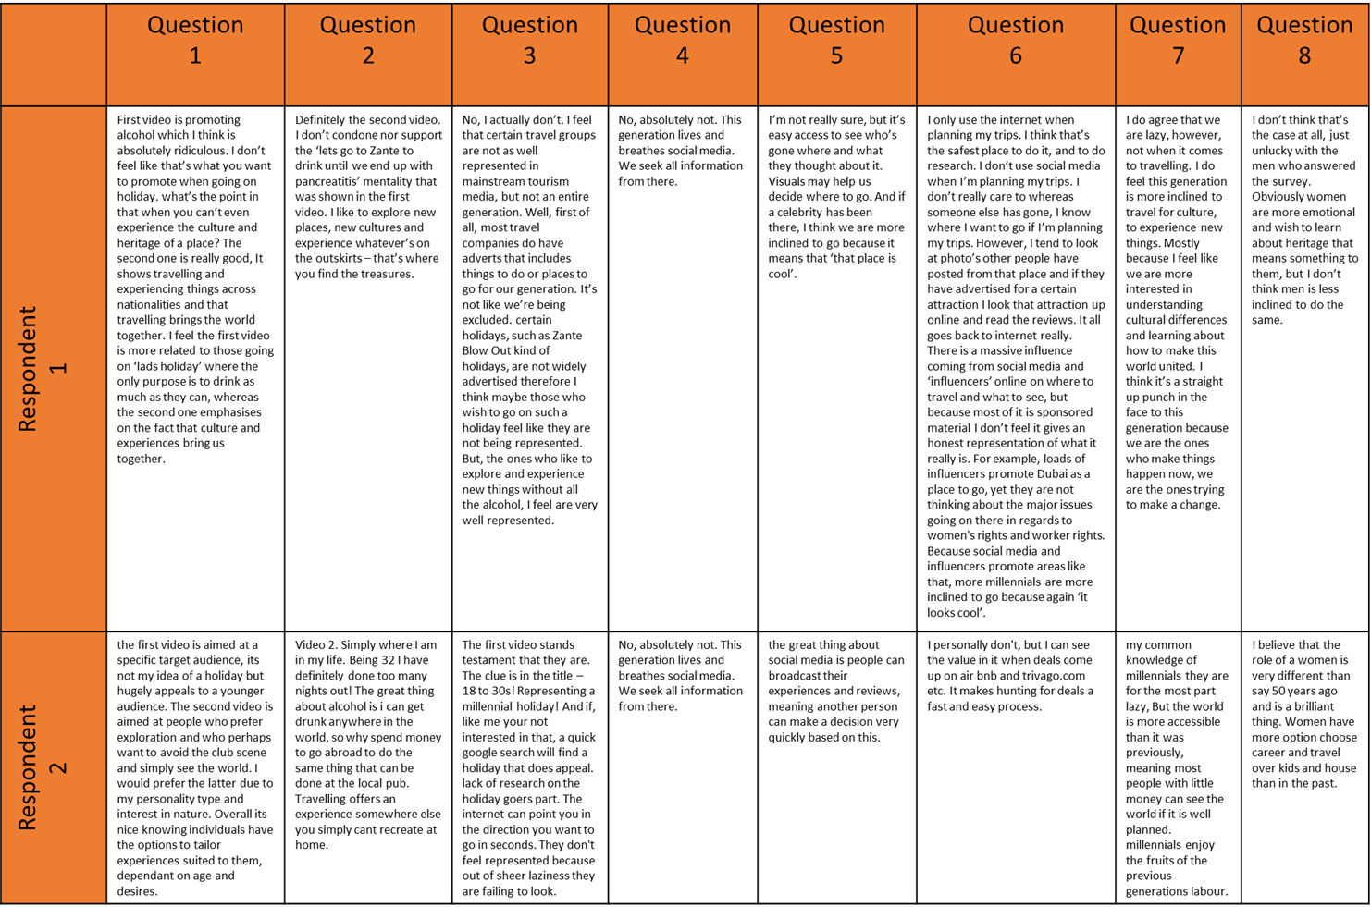
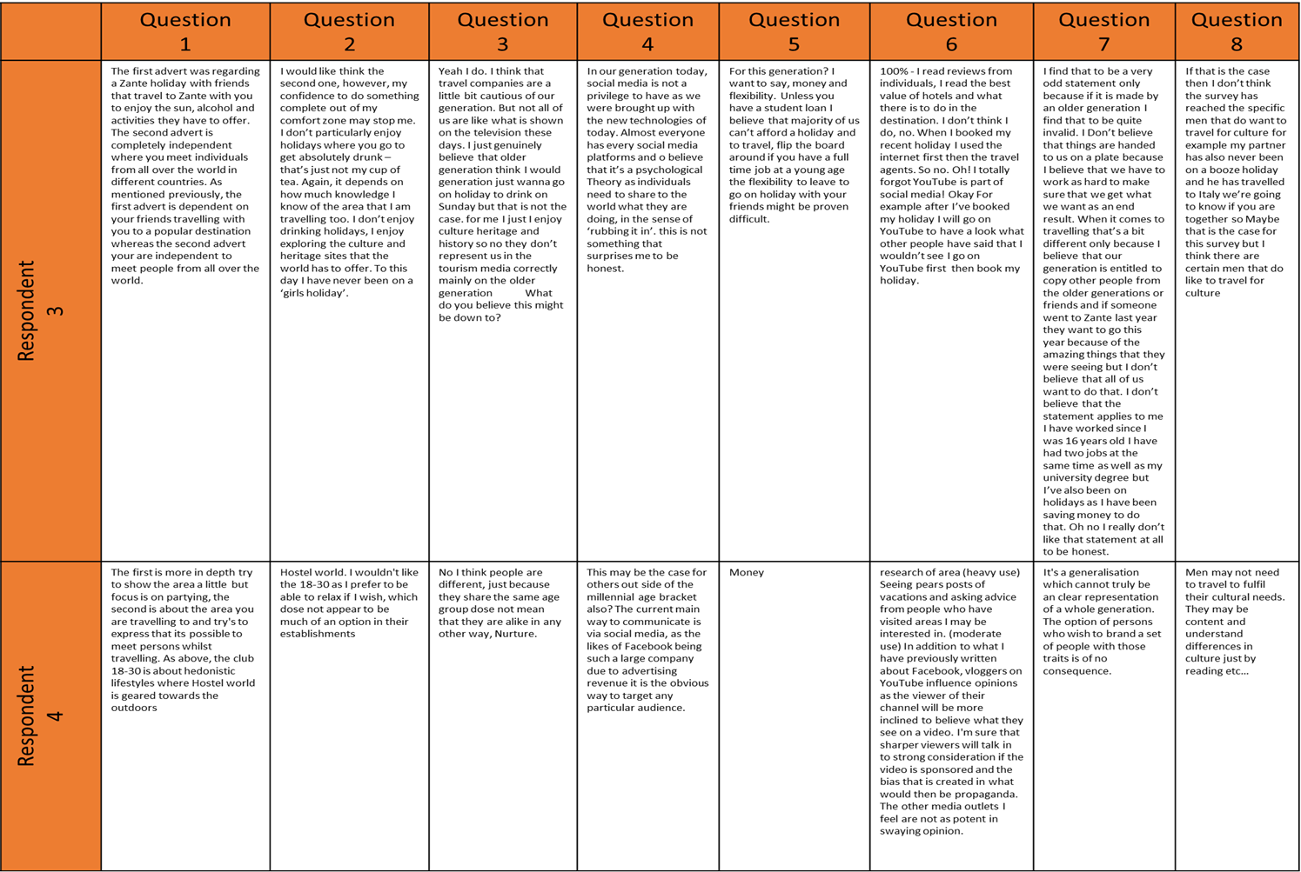

Focus group findings
Underrepresentation of the cohort in tourism advertising media
Questions one, two and three and the follow up questions of the focus group was to do with the underrepresentation of the cohort in tourism advertising media, all these questions can be found in the appendix.
Question one included an analysis of two videos one an ‘18 -30’s’ holiday in Zante and the second a ‘Hostel World’ advert even though the video is not clear on the location it shows outdoors areas, two videos that were undeniably different the author had the respondents state what they thought of the two adverts, and how they made them feel. All respondents saw the differences between the both of them, respondent one stated that “First video is promoting alcohol which I think is absolutely ridiculous” which shows a negative connotation to this type of holiday and that their opinion is that these holidays are a waste of time and that there is no depth to them they explain this by continuing to state “I don’t feel like that’s what you want to promote when going on holiday” respondent 1 also went on to say that the second video “is really good, It shows travelling and experiencing things across nationalities and that travelling brings the world together” which was the general consensus of all respondents. For example, respondent four stated “The first is more in depth try to show the area a little but focus is on partying, the second is about the area you are travelling to and try’s to express that it is possible to meet persons whilst travelling, the club 18-30 is about hedonistic lifestyles where Hostel world is geared towards the outdoors”.
Question two followed up with which out of the two adverts they’d prefer and would be more inclined to go on and why, all respondents unanimously stated that they would prefer to go on the second holiday because they felt that they did not see the appeal of the first video respondent two stated that “The great thing about alcohol is I can get drunk anywhere in the world, so why spend money to go abroad to do the same thing that can be done at the local pub” this shows that respondent two believes that it’s a waste of time and that they would rather do something more productive.
Question three asked the respondents whether they felt underrepresented in tourism advertising and marketing according to the survey results with a combined percentage of 67% of both 18-23 and 24-32 age groups that cover the millennial cohort found they were underrepresented compared to 48% that did feel represented, however, the majority of the focus group agreed that it wasn’t in fact that they were underrepresented as a generation but the fact that certain travel groups are not, however, respondent three did state that they feel that they are not represented well but only because travel companies are cautious of the generation.
social media and the internet.
Questions four and six concentrated on the use of social media and the internet in the process of planning, research and buying trips away. Because of literature stated in the literature review, that the millennial cohort its very much ruled by social media and the internet this had to be a topic within the focus group to establish the presence of social media within the generation.
Question 4 asked respondents whether they were surprised that the survey found that social media was partly an influencer for travel amongst the cohort, respondents one and two said exactly the same comments that were no that is didn’t surprise them that social media was considered an influencer in peoples decisions respondents one and two said “No, absolutely not. This generation lives and breathes social media. We seek all information from there.” Respondent three said that “in our generation today social media is not a privilege” suggesting that they’ve grown up with and have easy access to technology.
Question six enquired about the respondents personal uses of the internet and social media regarding personal travel this was to get a deeper understanding of the use of internet and social media amongst the cohort that was not addressed in the survey responses, the focus group stated that the use of social media was used for inspiration and influencing their decisions however did not persuade them on their decisions respondent one stated that “I don’t use social media when I’m planning my trips. I don’t really care to whereas someone else has gone, I know where I want to go if I’m planning my trips. However, I tend to look at photo’s other people have posted from that place and if they have advertised for a certain attraction I look that attraction up online and read the reviews. It all goes back to internet really”. This showcases that the cohort is only partly influenced by social media.

Female travellers
Question 8 addressed the topic of female travellers from the survey results more females were keen to travel for cultural purposes and wanted to know whether this was accurate.
Respondent 2 addressed the rise of feminism and said that the role of the modern-day women isn’t the same as it was fifty years ago and now women feel they can truly express themselves and do as they like to an extent by stating “I believe that the role of a women is very different than say 50 years ago and is a brilliant thing. Women have more option choose career and travel over kids and house than in the past”. And respondent four stated that maybe women need to feel and experience these differences where as men do not “Men may not need to travel to fulfil their cultural needs. They may be content and understand differences in culture just by reading etc” and respondents one and three expressed that the researcher may have just been unlucky when collecting results and not an equal amount of men were asked in the survey.

Conclusion

Bibliography
Concise English dictionary (2008a) 11th Edition. Oxford: Oxford university press. page 1524
Concise English dictionary (2008b) 11th Edition. Oxford: Oxford University press.
Concise Oxford English Dictionary (2008c) 11th Edition. Oxford: Oxford University Press. Page 1077
Youell, R. (1999) Tourism: An Introduction. Second edition. Harlow: Addision Wesley Longman.
World Tourism Organisation (1994)
Cooper, C., Fletcher, J., Fyall, A., Gilbert, D., and Wanhill, S. (2008) Tourism: Principles and Practice. Forth edition. Harlow: Prentice Hall.
Rouse, M. (2015) Millennials (Generation Y). Available at: https://whatis.techtarget.com/definition/millennials-millennial-generation [accessed 17th November 2017]
Farrington, R. (2018) WHAT IS THE MILLENNIAL AGE RANGE AND WHAT DOES THAT MEAN FINANCIALLY?. Available at: https://thecollegeinvestor.com/19793/millennial-age-range/ [accessed 15th November 2017]
McCaffrey, C. (2017) Where are the Global Millennials?. Available at: https://www.atkearney.com/web/global-business-policy-council/article?/a/where-are-the-global-millennials- [accessed 13th October 2017]
Howe, N., and Strauss, W. (2009) Millennials Rising: The Next Generation. First Edition US: Vintage Book.
Benckendorff, p., Moscardo, G., and Pendergast, D. (2010) Tourism and generation Y. 1st ed. Cambridge, MA: CAB International.
Landrum, S. (2017) How millennials are redefinig business Travel. Avalible at: https://www.forbes.com/sites/sarahlandrum/2017/10/27/how-millennials-are-redefining-business-travel/#25c7aae77a88 [accessed 15th March 2018]
Cohen, S. (2013). A portrait of Erik Cohen. Anatolia, 24(1), pp.104-111
Cohen, S. (2016) News – MMGY releases results of first portrait of business travellers survey. Available at: https://www.mmgyglobal.com/news/news-mmgy-global-releases-results-of-first-portrait-of-business-travelers-survey [accessed 18th March]
Chaffey, D. (2012) Digital Marketing: Strategy, Implementation and Practice. Fifth Edition, pearson Essex.
ITV (2012) Tonight: Is Technology Taking Over Our Lives?. Available at: http://www.itv.com/news/2012-10-18/tonight-is-technology-taking-over-our-lives/ [accessed 17th March 2018]
Chaffey (2016) Digital Marketing, strategy, implementation and practice, sixth ed. Pearson, Harlow
Hootsuite (2017) Pico graph available at: MTOUR lecture 1new
Sanfilippo (2017) 5 Ways to Make an Impact on Travel Social Media Marketing. Available at: https://www.socialmediatoday.com/marketing/5-ways-make-impact-travel-social-media-marketing [accessed on 23rd March]
Rohampton, J. (2017) Does social media make millennials want to travel more?. Avaible at: https://www.forbes.com/sites/jimmyrohampton/2017/03/26/does-social-media-make-millennials-want-to-travel-more/#433132f25c17 [accessed on 15th January 2018]
Yeoman, I. (2012) 2050 - tomorrow’s tourism. Buffalo: Channel View Publications.
Morrison-Williams (2017) who are the millennials? Available at: http://educationinitiative.thepacificinstitute.com/articles/story/millennials-changing-the-face-of-higher-education [Accessed on 12th November 2017]
The Leap. (2013). Gap Year Statistics to Broaden Your Mind. Available at: http://theleap.co.uk/gap-year-statistics-broaden-mind/ [Accessed 28th March. 2018].
Hendriksz, V. (2017) 2017: The Rise of Millennials and the Sharing Economy. Available at: https://fashionunited.uk/news/retail/2017-the-rise-of-millennials-and-the-sharing-economy/2017010422996 [accessed 23rd April 2018]
Harrison, V. (2017) Why millennials are the next tourism frontier. Avalibale at: http://www.bbc.co.uk/news/business-40701934 [accessed 14th April 2018]
Inkling, (2016). UK Millennials Report. Available at: http://static1.squarespace.com/static/566824117086d7d425e48806/t/569676aabfe87364f0160540/1452701360518/Inkling_UK_Millennial_Report.pdf [Accessed 8th March 2018].
Barton, C., Haywood, J., Jhunjhunwala, P. and Bhatia, V. (2013). Travelling with Millennials. The Boston Consulting Group. Available at: http://www.bcg.com/documents/file129974.pdf [Accessed 23rd January. 2018].
Goldberg, B. (2016). HOW THESE 9 QUALITIES SHAPE GENERATION X TRAVEL CHOICES. [Blog] The Virtuoso Life. Available at: http://blog.virtuoso.com/traveler_trends/9-qualities-shape-generation-x-travelchoices/ [Accessed 19th March. 2018].
Litvin (2006) Revisiting Plog's Model of Allocentricity and Psychocentricity One More Time. Cornell Hotel and Restaurant Administration Quarterly, 47(3), pp.245-253.
Plog, S. (2001). Psychographic Personality Types. Available at: http://www3.tjcu.edu.cn/wangshangketang/lyxgl/yuedu/25.pdf [Accessed 17 Mar.
2016].
Swarbrooke, J., and Horner, S. (2007) Consumer Behaviour in tourism. Second edition New York: Butterworth-heinemann
Horwood (2014)
Mckercher and du Cros (2003) Testing a cultural tourism typology. International Journal of Tourism Research, pp.45-58. Available at: http://onlinelibrary.wiley.com.ezproxy.cardiffmet.ac.uk/doi/10.1002/jtr.417/epdf [Accessed 26 January. 2018].
Bradley (2003)
McLeod (2014) Maslow's Hierarchy of Needs. Simply Psychology. Available at: http://www.simplypsychology.org/maslow.html [Accessed 23 January. 2018].
Pearce, P. (1991) Analysing Tourist Attractions. Journal of Tourism Studies 2(1):46-55.

Pearce, P. (2005a). Developing the Travel Career Approach to Tourist Motivation. Journal of Travel Research, [online] 43(3), pp.226-237. Available at: http://journals.sagepub.com/doi/pdf/10.1177/0047287504272020 [Accessed 20th January 2018].
Woodside, A. and Martin, D. (2007). Tourism management. 1st ed. Wallingford, Oxfordshire: CABI Publishers.
Pizam, A. and Mansfeld, Y. (1999). Consumer behavior in travel and tourism. 1st ed.
New York: Haworth Hospitality Press. page 112
Dann, G. (1977). Anomie, ego-enhancement and tourism. Annals of Tourism Research, pp.184-194. Available at: http://file:///C:/Users/g09560204/Downloads/Anomie_egoenhancement_and_tourism.pdf [Accessed 28 January. 2018].
McCannel (1992)
Hewison (1989)
World tourism organisation (2012) tourism and intangible culture heritage, UNWTO, Madrid Available at: https://pub.unwto.org/WebRoot/Store/Shops/Infoshop/50B8/AA74/FFA9/31D4/CE96/C0A8/0164/14DB/121130_intangilbe_cultural_heritage_excerpt.pdf [accessed 13th November 2017]
Maccarrone-Eaglen (2009) An Analysis of Culture as a Tourism Commodity. Tourism Culture & Communication, pp.151-163. Available at: http://usir.salford.ac.uk/19099/1/tcc1561.pdf [Accessed 25th February. 2018].
Visit Britain, (2016) Culture and heritage topic profile, Available at: https://www.visitbritain.org/sites/default/files/vb-corporate/Documents-Library/documents/Culture_and_Heritage_Topic_Profile_Full.pdf [accessed 10th October 2017]
Ivanovic (2008) Cultural tourism. 1st ed. Cape Town, South Africa: Juta.

