Task 01 A
Essential skills required for academic studies and future employment
- Essential skills required for academic studies (use at least 2 credible sources which talk about Essential skills required for academic studies (apply IEEE referencing) (150 words)
Ability to think outside the box and meet deadlines without falling behind. Reading text with understanding and taking notes. Communication is also key involment in discussions/Presentations and Group work.
Time Management
“Prior Proper Planning Prevents Poor Performance”, you’ve likely heard this before but it is completely true. Effective time management is essential for university and it is something that will stay with you when you graduate.
Time will become very valuable when lectures begin and the assignments start piling up. The way to cope with less time and a larger workload is through managing your time more effectively. It is completely normal to become overwhelmed when you first start university. Do not worry if you find this, it is now the time to start implementing time management strategies to stay on track and prevent yourself from becoming overly stressed. [1]
Reading Skills
Like writing, reading will dominate your time at university.
It is important to develop effective reading techniques to improve your speed and to choose the right content to read. When finding reading materials, as part of your active academic reading, there are questions to ask yourself to determine if it is relevant to you: [1]

- Essential skills required for future employment (use at least 2 credible sources which talk about Essential skills required for academic studies (apply IEEE referencing) (150 words)
In today's ever-evolving world, Skills like creativity, adaptability, and emotional intelligence is essential. Strong digital literacy and ability to work with emerging technologies such as artificial intelligence. You will also need critical thinking and complex problem solving to navigate solutions.
DIGITAL ACCESS
Broadening digital access is expected to be the most transformative trend – both across technology-related trends and overall – with 60% of employers expecting it to transform their business by 2030. Advancements in technologies, particularly AI and information processing (86%); robotics and automation (58%); and energy generation, storage and distribution (41%), are also expected to be transformative. These trends are expected to have a divergent effect on jobs, driving both the fastest-growing and fastest-declining roles, and fueling demand for technology-related skills, including AI and big data, networks and cybersecurity and technological literacy, which are anticipated to be the top three fastest- growing skills. [2]

- analyse 3-5 current popular AI assistants and briefly document the best use for each. use several screenshots of 3 – 5 AI assistants. ( 200 words)

Criteria | ChatGPT | Copilot | Gemini
Generating answers
creative work, code/diagram generation | Writes code across dozens of programming lanuages. Through built in tools like Data Analysis | Helps turn ideas into finished creative assets.  Things like documents , presentations , flyers , posters and designs | Gemini is used for image generation and editing. It creates high quality images from text.
data analysis | Has a built in feature that lets you up load files run code and generate charts or tables directly in a conversarion | Its main feature is mircosoft 365 copilot acts like a virtual data scientist. Turns raw data into customer purchasing patterns / revenue projections. Compare sales performances. | Produces insights and visuals , text summaries with specific numbers. It can output full reports , excel files and interactive explorers.
problem-solving | Predicts step by step logic and external tools or code execution | Generates tables / charts all in one place. Its solves problems by analyzing data with python and writing and testing code. Producing diagrams and creative assets. | Through a combination of thinking. Plans like an agent. Handles quick questions and multi day engineering.

- Identify a course available in LinkedIn which talks about AI assistance.

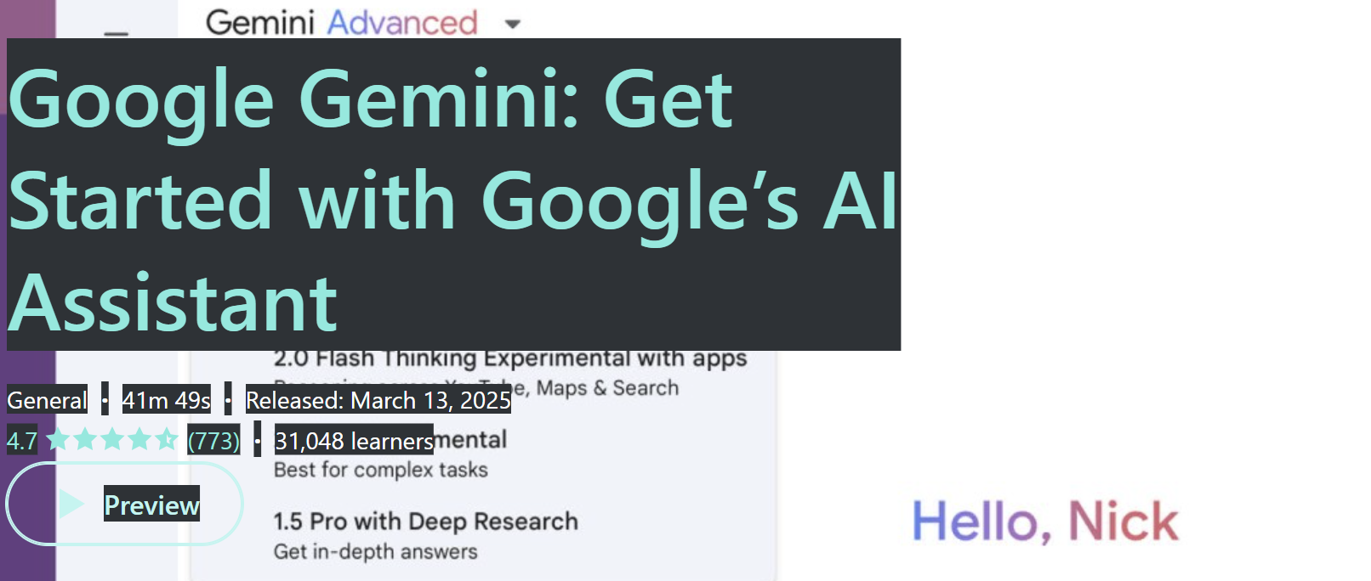
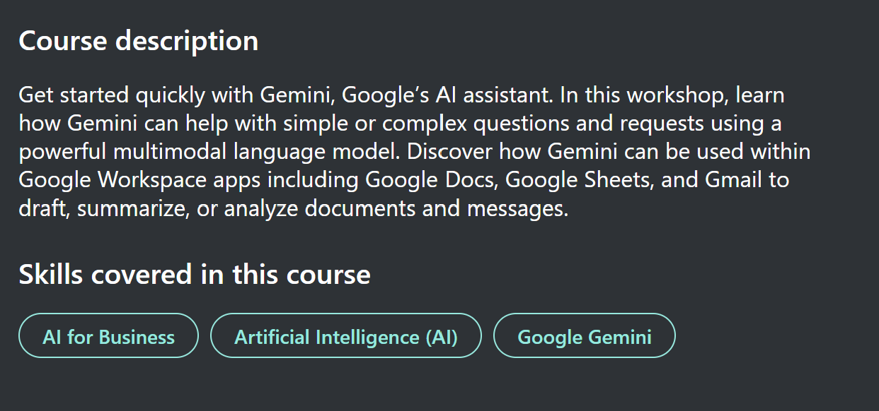

- Submit this document to Turnitin and generate the similarity report and take a screenshot of your similarity report and paste it here. Please evaluate your similarity percentage. (200 words) – self evaluation

References

[1] | A. Sen, “Uni Admissions,” 4th August 2025. [Online]. Available: https://www.uniadmissions.co.uk/application-guides/6-essential-skills-for-university-students/#TIME. [Accessed 8th october 2026].
[2] | W. e. forum, “weforum.org,” 7 January 2025. [Online]. Available: https://www.weforum.org/publications/the-future-of-jobs-report-2025. [Accessed 22 october 2026].

