

Programme: BA (Hons) Leadership and Management Skills for the Workplace
Module code and name: BMSW6101_ Emergent Leadership Skills in the Workplace
Lecturer Name: Samuel Ofori
Name of the Student: Aneliya Kirkova-Georgieva
ID Number: 2125657
Part 1_Academic Report

Table of contents:
1. Introduction...………………………………………………………………………………………3
2. Theory X, Y, and Z in Leadership………………………………………………………………..4
2.1. Explanation of the theories…………………………………………………………………4
2.2. Similarity and differences…………………………………………………………………..6
2.3. Advantages and disadvantages of the theories X, Y, and Z ……………………...……7
2.4. Influence of culture and personal differences……………………………………………8
3. Situational leadership………………………………………………………………………….....9
4. Situational Leadership in a Dynamic and Complex Organizational Environment: A Gas Station Example……………….……………………………………………………………………11
5. Conclusion………………………………………………………………………………………..12
6. References……………………………………………………………………………………….14

Introduction

Leadership is generally defined as the ability to influence and inspire individuals toward achieving common goals. It focuses on vision, motivation, and the broader perspective of guiding an organization or group. Key attributes of leadership include interpersonal skills, visionary thinking, and the capacity to drive change (Northouse, 2021).
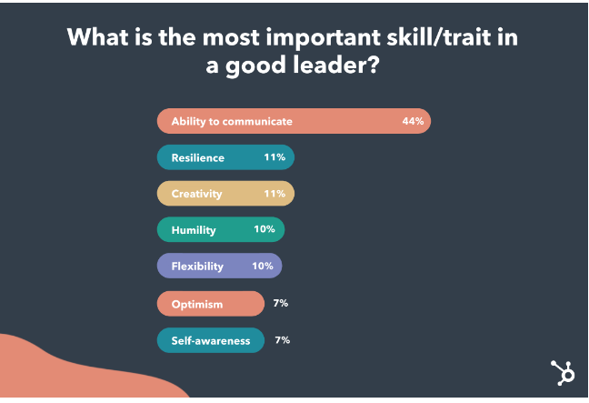
(Source: HubSpot, 2023)
This report delves into three prominent leadership theories—Theory X, Theory Y, and Theory Z—each presenting unique perspectives on leadership and management. It also aims to elucidate the similarities and differences among these theories, providing a comprehensive understanding of their core principles and practical applications.
Additionally, the report examines the advantages and disadvantages inherent in each leadership style, considering factors such as employee motivation, productivity, and job satisfaction. The influence of cultural and personal differences on leadership effectiveness is also scrutinized, recognizing that varying cultural contexts and individual traits can significantly impact the success of a particular leadership approach.
Central to this discussion is the assertion that a leader may not always use the same style for all situations; instead, the situation may determine the style of leadership applied. This contingency perspective underscores the importance of situational awareness and adaptability in leadership. By evaluating how different scenarios necessitate different leadership approaches, the report provides a nuanced understanding of how effective leadership is often a dynamic and context-dependent endeavor. This thorough exploration aims to equip leaders with the insights necessary to navigate the complexities of managing diverse teams in an ever-evolving organizational landscape.

2. Theory X, Y, and Z in Leadership
Developed by Douglas McGregor in the 1960s, Theory X and Theory Y offer two contrasting views of management and workforce motivation. McGregor introduced these theories in his book, "The Human Side of Enterprise," to highlight different assumptions managers can hold about their employees (Figure 1).

Figure 1. Leadership Theory X, Y, and Z
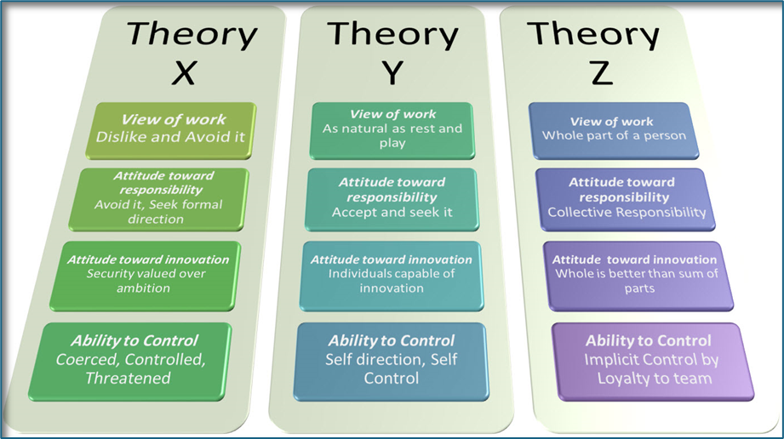
(Source: Mercure AACE, 2013)
2.1. Explanation of the theories
Theory X suggests that employees dislike work, they are lazy and unambitious, and are motivated by only one thing - money. According to this perspective, workers prefer to be directed, avoid responsibility, and need close supervision and punishment to achieve organizational goals. Managers who adopt Theory X tend to employ a more authoritarian style, emphasizing strict oversight, rigid rules, and a top-down approach to management (Enriquez, 2023).
Conversely, Theory Y posits that employees could be self-motivated and ambitious, they are proud of their work and enjoy it and they regard the work as a normal part of life. It suggests that, given the right conditions, employees will seek out responsibility, be creative, and work towards organizational objectives without needing constant supervision. Managers who believe in Theory Y are more likely to use a participative leadership style, encouraging collaboration, delegating authority, and fostering a work environment that supports employee development and motivation (Galani and Galanakis, 2022).
Regardless, Theory Z, introduced by William Ouchi in the late 20th century, synthesizes elements of both and underlines a holistic approach, where the well-being of employees, both professionally and personally, is dominant. It integrates loyalty and job security, often seen in Japanese companies, with some aspects of the individualism and innovation prevalent in American firms. Theory Z key aspects include long-term employment, consensus-based decision-making, slow evaluation and promotion processes, and a strong emphasis on company culture and shared values. By combining these elements, Theory Z aims to create a more stable and committed workforce, resulting in higher productivity and job satisfaction (Westney, 2020).
The development of these theories reflects an evolving understanding of human motivation and organizational dynamics. McGregor's Theory X and Theory Y challenged the conventional wisdom of the time, which often leaned towards a more autocratic, Theory X approach. By proposing Theory Y, McGregor emphasized the potential benefits of treating employees as self-motivated and capable individuals, thus advocating for more democratic and participative management styles. Ouchi's Theory Z emerged in response to the economic success of Japanese companies in the 1970s and 1980s, offering insights into how cultural differences influence management practices and employee motivation.
The evolution of these theories underscores the importance of understanding and adapting to different motivational drivers and cultural contexts in leadership. Recognizing and applying the principles of these theories of leadership would better align their leadership styles with the needs and expectations of their employees, ultimately fostering a more motivated, productive, and cohesive workforce.

2.2. Similarity and differences
The X, Y, and Z approaches to leadership offer distinct paradigms on how leaders interact with their subordinates and how they view human motivation and organizational dynamics. While these theories stem from different perspectives, they also share commonalities that can be insightful when juxtaposed.
Firstly, all three approaches recognize the importance of human behaviour and motivation in the workplace (Lawter et al., 2015). They acknowledge that understanding what drives employees is crucial for effective leadership and organizational success. The theories also emphasize the role of the leader in shaping organizational culture and influencing employee performance. Another similarity is their application across different organizational contexts, suggesting that elements from each approach can be blended or adapted to suit specific organizational needs.
In the X approach the assumption is that employees are inherently lazy, lack ambition, and require constant supervision and direction; the key to employees' productivity is the punishments and awards; they could be motivated only by money. It is characterized by a more autocratic and control-oriented style. It often results in a top-down management style where decision-making is centralized, and strict rules and regulations are enforced to ensure compliance and productivity (Okechukwu and Nwosu, 2020).
In contrast, the Y approach adopts a more democratic and participative leadership style and accepts that in the pursuit of organizational objectives, people will use self-control and self-direction. Rewarding achievements fosters commitment to objectives, as the most important reward is the satisfaction of their own ego. Responsibility is generally accepted and sought by most people and most of them are creative, ingenious, and imaginative. Theory Y leaders encourage employee involvement in decision-making, foster a collaborative work environment and focus on creating conditions that allow employees to fulfill their potential. This style is more flexible and adaptive, promoting innovation and a positive organizational climate (Head, 2011).
The Z approach, meanwhile, accepts that employees prefer cooperation and intimacy, and have an extremely strong feeling of discipline, order, and moral obligation to work hard, in addition to a strong sense of friendship with their coworkers. It also places a significant emphasis on long-term employment, collective decision-making, and the well-being of employees both inside and outside the workplace, and promotes a strong company culture, mutual trust, and a sense of community within the organization (Aithal and Kumar, 2016). It is less hierarchical than the X approach but still maintains a degree of structure and discipline.
When comparing the X and Y approaches, the fundamental difference lies in their assumptions about human nature and motivation. The X approach is more pessimistic, focusing on control and supervision, which can lead to a rigid and possibly demotivating work environment. In contrast, the Y approach is optimistic, empowering employees and fostering a more dynamic and engaging workplace. This difference significantly affects leadership behaviour, employee satisfaction, and overall organizational effectiveness. The Z approach serves as a middle ground, blending elements of control and freedom while adding a unique dimension of long-term commitment and holistic management.
Unlike the X approach, which can lead to high turnover and dissatisfaction, or the Y approach, which might struggle with consistency and coherence in large organizations, the Z approach aims for stability and deep-rooted loyalty. However, it might be challenging to implement in cultures that do not traditionally value long-term employment or in industries that require rapid adaptation and flexibility.
In essence, the X approach may be more suitable for environments requiring strict compliance and clear hierarchical structures, while the Y approach is ideal for creative industries that thrive on innovation and employee autonomy. The Z approach, on the other hand, would fit well in contexts where long-term strategic goals and employee retention are paramount. Leaders must, therefore, consider the specific needs and culture of their organization when choosing or blending these approaches to optimize their leadership effectiveness.
In both Theory Y and Theory Z, the manager appears to maintain the majority of power and authority. In Theory Y, the manager solicits input from workers but retains the final decision-making power. Theory Z suggests the manager's ability to wield power and authority comes from workers trusting the manager to support them and allow them to do their jobs; workers have significant input and influence in the decision-making process while the leader could be like a “coach”, that lets people make the decisions.
2.3. Advantages and disadvantages of the theories X, Y, and Z
In a small business, all theories of leadership could have both advantages and disadvantages. On the positive side, the X approach may instill a sense of discipline and structure, ensuring that tasks are completed efficiently. However, it could also create a negative work environment, where employees feel mistrusted and demotivated, leading to decreased productivity and high turnover (Davison and Smothers, 2015).
On the other hand, the Y Theory of leadership might be more suitable for a small business. By empowering employees and fostering a collaborative environment, the Y Theory can unlock their full potential, leading to increased creativity, innovation, and job satisfaction (Choi et al., 2016). This, in turn, could result in higher customer satisfaction and a stronger competitive edge (Kurdi et al., 2020). However, this approach may require more investment in employee development and may not be as effective if the business has a diverse workforce with varying levels of motivation and engagement.
Finally, the Z Theory of leadership, which emphasizes a more holistic approach to employee well-being and work-life balance, could be particularly beneficial for a small business. By prioritizing employee health and happiness, the Z Theory can help build a reliable and motivated workforce, which is crucial for the success of a small business (Nanjundeswaraswamy et al., 2020). This approach not only enhances organizational performance, but builds a resilient and adaptive company culture capable of thriving in a dynamic and competitive business landscape. It also could foster a sense of community and loyalty, making it easier to attract and retain top talent. However, implementing the Z Theory may require significant resources and a cultural shift within the organization, which could be challenging for a small business with limited resources.
To illustrate these points, let's consider the example of a small family-owned bakery. The owner, who subscribes to the X Theory of leadership, may implement strict rules and close supervision to ensure that employees are productive. While this approach may lead to efficient operations in the short term, it could also result in high employee turnover, as the employees feel micromanaged and unappreciated.
In contrast, the owner who adopts the Y Theory might empower their employees to experiment with new recipes and make decisions, leading to innovative products and improved customer satisfaction. However, this approach may require more training and development, which could be challenging for a small business.
Alternatively, the owner who embraces the Z Theory might offer flexible work schedules, team-building activities, and wellness programs to support their employees' well-being. This could result in a more engaged and loyal workforce but might require additional financial resources and a shift in the business's culture.
The choice of leadership style for each business should consider the unique needs, resources, and culture of the organization. While each theory has its own merits, a thoughtful and balanced approach that combines elements of different theories may be the most effective in ensuring the long-term success of a small business.

2.4. Influence of culture and personal differences
When considering the role of culture and personal differences in leadership, the theoretical approaches of Theory X, Theory Y, and Theory Z can provide valuable insights:
- Theory X approach may be less effective in modern, diverse workplaces where individuals have varying cultural backgrounds, values, and personal preferences. Employees from different generations, genders, or cultural contexts may not respond well to the authoritarian and controlling nature of the theory.
- Theory Y may be more suitable for organizations that embrace diversity and seek to create an inclusive culture of mutual respect and understanding, where employees feel valued for their unique perspectives and contributions, and where individuals can thrive.
- Theory Z emphasis on the importance of culture and personal relationships can be particularly relevant in today's diverse workplace, where fostering a sense of belonging and community can be crucial for employee engagement and productivity.
Taking the generational differences into account, we could conclude that the experiences and expectations of Gen Z and millennial employees may differ significantly from those of older generations, requiring a more flexible and adaptable approach to leadership. Millennials and Gen Z often value work-life balance, flexible schedules, and opportunities for growth and development. A Theory Y or Theory Z approach that emphasizes empowerment and work-life integration may be more effective while older generations may respond better to a more structured, hierarchical approach (Theory X) with clear expectations and job security.
Ultimately, the most useful theoretical approach will depend on the specific organizational context, the composition of the workforce, and the desired outcomes. A blend of elements from these theories, tailored to the unique needs and challenges of the organization, could be the most effective approach. By recognizing and embracing the diversity of their workforce, leaders can create an environment that fosters creativity, collaboration, and mutual understanding, leading to enhanced organizational performance and employee well-being (Kuknor and Bhattacharya, 2022).

3. Situational leadership
Situational Leadership Theory, developed by Paul Hersey and Ken Blanchard posits that effective leadership is contingent on the situation. The notion is that a leader should adapt their leadership style to the specific situation they are facing based on the readiness and development stage of employees (Deshwal and Ali, 2020).
According to this theory, there is no single "best" leadership style that can be universally applied, but rather, effective leaders must be able to draw from a repertoire of different styles and flexibly apply them based on the demands of the particular context (Benmira and Agboola, 2021). There are four main leadership styles (Figure 2) identified in Situational Leadership Theory:
- Directing/Telling: This style of leadership involves leading a team with almost total control; leaders guide their employees' goals and establish exactly how they will be able to achieve them, with clear instruction and strong monitoring. The approach is mostly used in the military field and less common in the office, but could be used successfully in new teams (Lynch, 2015).
- Coaching/Selling: Leaders guide the team members by providing support and direction tailored to their development needs. They focus on building skills, boosting confidence, encouraging autonomy, guiding people along their journey, and encouraging them to take ownership of their own development. The approach works best when subordinates are highly motivated and interested in expanding their skill set (education, sport, healthcare, selling teams).
Figure 2. Situational leadership
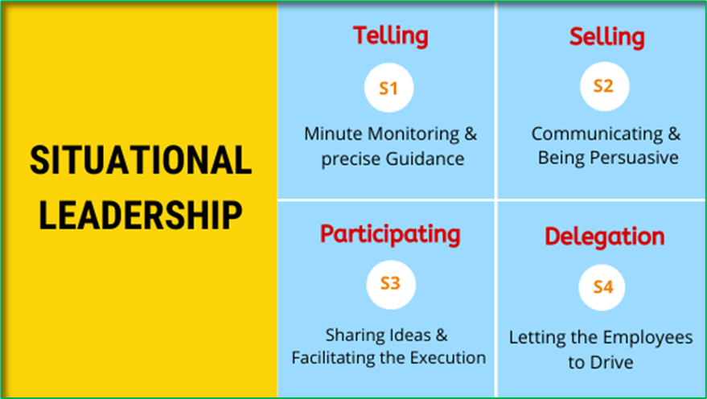
(Source: Medium, 2020)
- Supporting/Participating: High level of support and encouragement from the leader, coupled with a moderate level of directive behaviour. The leader provides guidance and feedback and allows the followers a significant degree of autonomy in decision-making and problem-solving. Allowing workers to shape the future enhancing their commitment. This style is suitable when workers are assigned highly stressful tasks because while the employees feel supported by their colleagues and management, they perform better (Rahman et al.,2020).
- Delegating/Empowering: leaders providing minimal guidance to highly skilled and motivated team members, fostering autonomy. They trust employees to make decisions and manage tasks independently, promoting confidence and growth. This approach is ideal when followers are capable and committed to achieving goals without needing constant encouragement. It is recommended for businesses that thrive on innovation, creativity, and autonomy (Walter, 2018).

4. Situational Leadership in a Dynamic and Complex Organizational Environment: A Gas Station Example
Rapid Fuel is a growing gas station chain that recently opened a new location in a busy urban area. The new location is staffed primarily by young, inexperienced employees who are just entering the workforce. Effectively leading this team will require a situational leadership approach that adapts to the changing needs of the employees.
In the beginning, the majority of the staff are brand new to the gas station industry. They have little to no prior experience handling cash transactions, operating the fuel pumps, stocking the convenience store shelves, or providing customer service. In this initial phase, a more directive leadership style would be most appropriate.
The leader of the team Tom should take an active role in training the new employees, provide clear instructions and guidelines on operational procedures, demonstrate the proper techniques, and closely monitor their performance to ensure tasks are being completed correctly. Regular one-on-one check-ins would allow him to identify areas where individuals need additional support or clarification. This high-directive, low-supportive approach is necessary to get the new team members up to speed and establish basic competencies (Dull, 2010).
Over the next few months begins to be observed gradual improvements in the team's skills and confidence. Certain employees start taking more initiative, proposing ideas for enhancing efficiency, and independently troubleshooting minor issues. Recognizing this transition, Tom might shift his leadership style to be more supportive, while still maintaining a moderate level of direction.
In this second phase, Tom might encourage the employees to share their perspectives and take on more ownership of their responsibilities. He also could provide positive feedback to reinforce desired behaviors and offer guidance when challenges arise but give the team more autonomy to make decisions and implement solutions. This balanced approach of some direction combines with ample encouragement and support helps to further develop the employees' competence and commitment (Shin et al., 2016).
Over the following year, when many of the once-inexperienced employees have grown into more confident, high-performing team members, they start to demonstrate a stronger understanding of their roles, make effective judgments, and proactively contribute to the gas station's success. At this stage, Tom should change his leadership style once again - this time to a low-directive, high-supportive(participating) approach.
In this more mature phase, the employees are empowered to lead various initiatives and problem-solve with minimal intervention from Tom. His role became more of a facilitator, providing resources, removing obstacles, and offering advice when needed, but allowing the team to take the lead. This delegating style capitalized on the employees' high competence and motivation, freeing the leader up to focus on higher-level strategic priorities. (Mohanty and Chatterjee, 2017).
Throughout these phases, the situational leadership approach evolves to match the changing needs of the team. When they were new and inexperienced, were provided a clear structure and close guidance. Subsequently, when they gained competence, Tom shifted to a more supportive role that empowered them to take on greater ownership. And finally, as they mature into high performers, he could delegate more responsibility and empower them to drive results with minimal direction.
This adaptable leadership style allows the leader to effectively lead a dynamic of the gas station’s team for long-term success. By recognizing the varying developmental needs of the employees and adjusting the leadership approach accordingly, the leader will be able to unlock their full potential and create an engaged, high-functioning work environment.

5. Conclusion
To summarise, leadership is crucial in achieving workplace objectives as it provides direction and motivation, and fosters a collaborative environment. It is related to envisioning the future and strategic thinking, guiding teams toward goals with clarity and inspiration, fostering innovation, cultivating resilience, and making informed decisions to navigate challenges and seize opportunities.
The analysis of leadership theories X, Y, and Z in this report, revealed both similarities and key differences between these main approaches, their advantages and disadvantages. While X theory emphasizes a hierarchical, authoritarian style focused on tight control and supervision, Y theory promotes a more participative model that trusts employees and empowers them to be self-directed. Z theory combines elements of both, calling for a balance between structure/control and autonomy/collaboration.
The central finding is that no one leadership style is universally superior - the optimal approach depends heavily on the situational context. The successful leader should adapt his leadership style to fit the demands of the specific circumstance. In some high-pressure, time-sensitive scenarios, a more directive X-style may be warranted while in other cases, requiring innovation and employee buy-in, a Y or Z approach may be more appropriate.
However, each theory acknowledges that effective leadership requires flexibility, emotional intelligence, and a nuanced understanding of contextual factors. Effective leaders should assess the context, including the nature of the task, team dynamics, and organizational goals, to determine the most appropriate leadership style. This adaptability would not only enhance leadership effectiveness but also ensure that the diverse needs of the organization and its members are met, fostering a resilient and dynamic workplace environment. Thus, understanding and integrating these theories with a situational perspective might significantly bolster leadership effectiveness and organizational success.

References
Aithal, P.S. and Kumar, P.M., (2016). Comparative analysis of theory X, theory Y, theory Z, and Theory A for managing people and performance. International Journal of Scientific Research and Modern Education (IJSRME), 1(1), pp.803-812.
Benmira, S. and Agboola, M., (2021). Evolution of leadership theory. BMJ leader, pp. leader-2020.
Choi, S.L., Goh, C.F., Adam, M.B.H. and Tan, O.K., (2016). Transformational leadership, empowerment, and job satisfaction: the mediating role of employee empowerment. Human resources for health, 14, pp.1-14.
Davison, H.K. and Smothers, J., (2015). How Theory X style of management arose from a fundamental attribution error. Journal of Management History, 21(2), pp.210-231.
Deshwal, V. and Ali, M.A., (2020). A systematic review of various leadership theories. Shanlax International Journal of Commerce, 8(1), pp.38-43.
Dull, M., (2010). Leadership and organizational culture: Sustaining dialogue between practitioners and scholars. Public Administration Review, 70(6), pp.857-866.
Enriquez, J.A., (2023). Employee’s Preference Toward Leadership Style of Selected Companies in the Kingdom of Bahrain. KEPES, 21(2), pp.277-286. Available at: https://www.researchgate.net/profile/Jonas-Enriquez/publication/372951856_Employee's_Preference_Toward_Leadership_Style_of_Selected_Companies_in_the_Kingdom_of_Bahrain/links/64d0a25291fb036ba6d40b10/Employees-Preference-Toward-Leadership-Style-of-Selected-Companies-in-the-Kingdom-of-Bahrain.pdf (Accessed: 22/06/24).
Galani, A. and Galanakis, M., (2022). Organizational Psychology on the Rise—McGregor’s X and Y Theory: A Systematic Literature Review. Psychology, 13(5), pp.782-789. Available at: 10.4236/psych.2022.135051
Head, T.C., (2011). Douglas McGregor's legacy: lessons learned, lessons lost. Journal of Management History, 17(2), pp.202-216.
Kuknor, S.C. and Bhattacharya, S., (2022). Inclusive leadership: new age leadership to foster organizational inclusion. European Journal of Training and Development, 46(9), pp.771-797.
Kurdi, B., Alshurideh, M. and Alnaser, A., (2020). The impact of employee satisfaction on customer satisfaction: Theoretical and empirical underpinning. Management Science Letters, 10(15), pp.3561-3570.
Lawter, L., Kopelman, R.E. and Prottas, D.J., (2015). McGregor's theory X/Y and job performance: A multilevel, multi-source analysis. Journal of Managerial Issues, pp.84-101.
Lynch, B., (2015). Partnering for performance in situational leadership: a person-centred leadership approach. International Practice Development Journal, 5.
McGregor, D., (1989). The human side of enterprise. Readings in managerial psychology, 4(2), pp.314-324.
Mohanty, M. and Chatterjee, M., (2017). Relationship between demographical variables and leadership and motivational styles of bank managers in Kolkata. International Management Review, 13(1), p.59.
Nanjundeswaraswamy, T.S., Swamy, D.R. and Nagesh, P., (2020). LEADERSHIP STYLES IN MEDIATING THE RELATIONSHIP BETWEEN QUALITY OF WORK LIFE AND EMPLOYEE COMMITMENT. International Journal for Quality Research, 14(2).
Okechukwu, N. and Nwosu, P.D.M.F.O., (2020). The Role of Leadership in The Empowerment of Nigerian Employees. Education, 4(1), pp.1-23.
Ouchi, W.G. (1982). Theory Z: how American business can meet the Japanese challenge. New York, N.Y.: Avon.
Rahman, A., Björk, P. and Ravald, A., (2020). Exploring the effects of service provider’s organizational support and empowerment on employee engagement and well-being. Cogent Business & Management, 7(1). Available at: https://www.tandfonline.com/doi/full/10.1080/23311975.2020.1767329 (Accessed: 29/06/24)
Shin, Y., Oh, W.K., Sim, C.H.S. and Lee, J.Y., (2016). A multilevel study of supportive leadership and individual work outcomes: The mediating roles of team cooperation, job satisfaction, and team commitment. Journal of Applied Business Research, 32(1), p.55.
Walter, S.F., (2018). Integrating Empowerment into Project Management to Enable Effective Delegation of Decision-Making Authority to Project Managers and Teams (Doctoral dissertation, Northcentral University). Available at: https://www.proquest.com/openview/140473092450c07ae00639982c6ab243/1?pq-origsite=gscholar&cbl=18750 (Accessed: 29/06/24)
Westney, E., (2020). Reflecting on Japan’s contributions to management theory. Asian Business & Management, 19, pp.8-24. Available at: https://dspace.mit.edu/bitstream/handle/1721.1/128613/41291_2019_79_ReferencePDF.pdf?sequence=1&isAllowed=y (Accessed:22/06/24)

