Student name : Anamaria Gabriela Tocila
Student id : 2120101

BMIH6008
Maggie-Lan Zhang
Hotel Placement Research Project
Delta By Marriott Northampton

I acknowledge the use of Grammarly App and Microsoft Word Editor on 15th November 2024 to check my grammar, syntax and misspellings

Introduction
To examine the impact of leadership strategies at Delta by Marriott Northampton on team collaboration, employee engagement, and operational efficiency, with the aim of proposing best practices in hospitality leadership.
This study aims to examine Delta's management strategies by Marriott Northampton and their impact on employee performance and teamwork, focusing on the relationship between effective leadership and organisational success in the hospitality industry.
Delta by Marriott Northampton, a four-star hotel strategically located near major attractions and transport links, offers a comprehensive range of services catering to business and leisure travellers. Recently renovated, the hotel features modern accommodations, a fully equipped fitness centre, and the Cast Iron Bar & Grill, a restaurant known for its British-inspired menu. These facilities are designed to meet guests' diverse needs, reflecting Marriott’s commitment to high-quality service and a comfortable guest experience. The placement program at Delta by Marriott Northampton was structured to provide practical exposure to hotel operations, covering important areas of guest services and team management, focusing on understanding the impact of leadership in each department.
The report’s objectives focus on examining leadership themes and operational management practices across four essential areas: the restaurant, housekeeping, front desk, and general management. By observing leadership styles, the placement provided insights into how different approaches - such as transformational, transactional, laissez-faire, and servant leadership- affect team consistency, productivity, and customer satisfaction. Each department's distinctive demands require tailored leadership approaches, central to this analysis. For instance, while the restaurant setting benefits from decentralised, team-driven management, the front desk needs a more structured, bureaucratic style to maintain consistency in guest interactions.
The scope of this report includes an essential review of the leadership styles implemented by key managers, such as Emma Coen, General Manager, whose blend of
transformational and servant leadership fosters a supportive work culture. Additionally, the report examines how various leadership methods within each department contribute to operational efficiency and high service standards. Through reflective analysis and supported by relevant leadership theories, this report explores the implications of these practices, offering insights into how adaptable leadership can improve team dynamics and ultimately improve guest satisfaction in the hospitality industry.
This report sheds light on the interconnectedness of leadership and operational success in hospitality, accentuating the importance of adaptable, responsive management in a complex hotel environment.

Literature Review
Leadership in Hospitality: Theoretical Perspectives and Practical Applications
Leadership is a cornerstone of success in the hospitality industry, influencing team dynamics, operational efficiency, and guest satisfaction. Research identifies that leadership styles significantly impact employees' performance and well-being. The following review draws on studies related to leadership approaches observed at Delta by Marriott Northampton to understand how different styles affect organisational success.
Transformational and Servant Leadership in Hospitality
Transformational leadership is characterised by the ability to inspire and motivate employees toward shared goals (Bass & Riggio, 2006). Leaders who employ this style, like Emma Coen at Delta by Marriott Northampton, foster a supportive, collaborative culture that increases team engagement and productivity. Studies have demonstrated that transformational leadership improves employee motivation, satisfaction, and performance, ultimately leading to higher guest satisfaction (Ali, 2023; Kara et al., 2013).
Servant leadership focuses on prioritising employee well-being and development. Greenleaf (1977) proposed this model to empower employees and encourage professional growth. Research supports the idea that servant leadership creates a positive workplace environment, which enhances team cohesion and operational consistency (Ling et al., 2017; Chon & Zoltan, 2019). At Delta by Marriott Northampton, this leadership approach was evident in Emma’s commitment to staff mentoring and skill development, aligning with findings that servant leadership fosters employee trust and loyalty (Mayer et al., 1995).
Laissez-Faire Leadership and Autonomy
Laissez-faire leadership, which offers minimal intervention and grants autonomy to teams, was observed in Delta’s restaurant operations. This approach allows employees to take ownership of their responsibilities and develop creative solutions independently (Lewin, Lippitt, & White, 1939). Studies highlight that laissez-faire leadership can be effective in environments where employees are experienced, and roles are clearly defined, as it promotes accountability and adaptability (Huertas-Valdivia et al., 2019).
However, excessive autonomy without guidance can lead to confusion, particularly for new employees or high-pressure scenarios. Effective laissez-faire leadership requires a balance of independence and oversight, ensuring employees remain aligned with organisational objectives (Brownell, 2010). At Delta, peer mentoring within the restaurant eased potential challenges, demonstrating the importance of informal leadership in decentralised settings.
Transactional Leadership in Structured Environments
Transactional leadership was prominent in Delta's housekeeping operations, defined by its focus on task completion and adherence to procedures (Bass, 1981; Burns, 1978). This style is effective in environments requiring precision and consistency, as it establishes clear expectations and rewards compliance (Huo, 2019). At Delta, the Housekeeping Manager’s structured approach ensured operational efficiency, which is critical for maintaining high room turnover and cleanliness standards.
While transactional leadership promotes discipline and task orientation, it may limit creativity and reduce flexibility in responding to unexpected challenges (Kumar, 2023). As seen in Delta’s housekeeping department, incorporating empathetic elements can balance structure with employee morale, leading to improved team resilience and job satisfaction.
Bureaucratic Leadership in Guest-Facing Roles
Bureaucratic leadership, characterised by rule-based management and hierarchical decision-making, was observed in Delta’s front desk operations. This style confirms consistency and professionalism in guest interactions, essential for maintaining service quality (Weber, 1922; Minett et al., 2009). The Reception Manager’s focus on protocol adherence minimised errors and upheld operational standards, aligning with research suggesting that structured environments are effective for high-demand roles (Clark et al., 2009).
However, the rigidity of bureaucratic leadership can hinder flexibility and limit personalisation in guest service. Studies indicate that incorporating elements of transformational leadership can address this limitation, fostering a more engaging and adaptable workforce (Raub, 2008).
Cross-Departmental Leadership Implications
The interplay between different leadership styles across departments at Delta by Marriott Northampton highlights the importance of adaptability in hospitality management. As Emma Coen demonstrated, Transformational and servant leadership provide a foundation for motivating teams and maintaining a consistent organisational culture. These approaches complement task-oriented styles like transactional and bureaucratic leadership, ensuring operational demands are met without compromising employee engagement.
The research underscores the benefits of integrating diverse leadership styles to address the unique challenges of each department. For instance, cross-training initiatives and interdepartmental collaboration enhance operational fluidity and foster a unified approach to guest service (Sumaneeva et al., 2019; Larsson et al., 2012). By blending structured and people-oriented leadership methods, organisations can create a balanced framework supporting employee development and service excellence.

Conclusion
Leadership in the hospitality industry is more than just a one-size-fits-all approach. The Delta by Marriott Northampton case illustrates that a leadership style's effectiveness depends on the specific demands of each department. Transformational and servant leadership principles are essential for fostering a positive work culture, while transactional and bureaucratic styles ensure operational consistency. By adopting a flexible and employee-centred approach, hospitality leaders can improve team dynamics, operational efficiency, and guest satisfaction.
This review underscores the importance of adaptable leadership strategies aligning with organisational goals and employee needs. Integrating theory and practice at Delta provides valuable insights for advancing leadership in the hospitality sector.

Methods
The methodology of this study applies a case study approach, reflective writing, and ethnography to gain insights into real-world leadership dynamics at Delta Hotels by Marriott Northampton. A case study approach was chosen for its capacity to analyse complex, real-life situations within their specific context, providing a complete perspective on leadership in a hospitality setting (Yin, 2018). Case studies help explore managerial behaviours and organisational practices, capturing the nuances of human interactions and organisational structures (Simons, 2009). The in-depth analysis allowed by this method helps reveal the impacts of different leadership styles on employee motivation and customer satisfaction, which are necessary factors in the hospitality sector (Ali, 2024). Focusing on Delta by Marriott, this study examined leadership in a highly customer-centred environment, illustrating how theory is translated into practice.
Complementing the case study, reflective writing was employed to capture subjective insights and personal observations on leadership experiences. Reflective writing allows deeper engagement with the observed experiences, encouraging critical thinking and self-awareness (Moon, 2004). This reflective approach facilitates a systematic examination of interactions and decisions observed during the placement, allowing for a personal yet analytical recount of the roles and behaviours of different managers. By recording thoughts and reactions, reflective writing adds a personal layer to the analysis, allowing the researcher to identify patterns and discrepancies that may go unnoticed (Schön, 1983).
Netnography, a research method that analyses social interactions in digital or online communities, was also integrated to expand the scope of observation beyond direct experiences (Bowler, 2010). In this context, ethnography facilitated an understanding broader guest and employee interactions through online reviews and feedback. This approach is valuable for hospitality studies, providing insights into the customer experience and employee satisfaction from multiple perspectives (Torres, 2016). This study assessed how leadership decisions resonate with guests and staff by examining online feedback, providing an additional dimension to the in-person observations and reflective notes.
However, this methodology has certain limitations. The single-case study approach restricts the findings to Delta Hotels by Marriott Northampton, limiting generalisability to other hospitality contexts (Flyvbjerg, 2006). Furthermore, while insightful, reflective writing is naturally subjective, as it reflects personal perceptions and may introduce bias (Williamsa and Walker, 2003). Netnography, despite providing valuable external insights, can also be deformed by the extreme nature of online feedback, where customers may primarily share either highly positive or negative experiences, potentially overlooking the more moderate views (Bowler, 2010).
In conclusion, combining case study methodology, reflective writing, and ethnography offers a robust framework for exploring leadership in a hotel environment despite limitations in generalisability and potential biases. These methods allow for a rich, complex understanding of leadership's impact on employee satisfaction and customer experience, providing valuable insights for managers in the hospitality sector.

Case Study
Delta by Marriott Northampton
1Delta by Marriott, 2024. Facebook Official Page
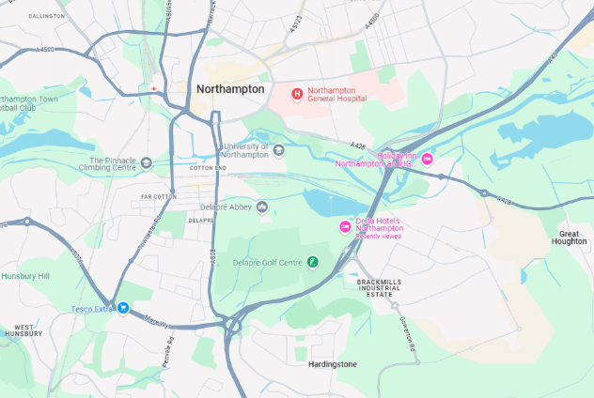
Delta Hotels by Marriott Northampton is strategically located at Eagle Drive, Northampton, England, NN4 7HW, offering simple access for business and leisure travellers. Situated near Junction 15 of the M1 Motorway, the hotel provides easy connectivity to major transport routes, making it an ideal choice for guests seeking accessibility and comfort (Marriott International, 2024a).
The hotel has recently been renovated to improve the guest experience (Toledo.com, 2024). The fully renovated rooms feature premium bedding, modern technology, and improved lighting, ensuring a comfortable and productive stay(Marriott International, 2024b).
Amenities include a well-equipped fitness centre, serving guests' wellness needs, and the Cast Iron Bar & Grill, which offers a menu inspired by traditional British dishes prepared with locally sourced ingredients (Marriott International, 2024c).
In addition to its closeness to the M1 Motorway, Delta Hotels by Marriott Northampton is located near the Silverstone Circuit, a renowned motorsport location, making it a convenient accommodation option for motorsport enthusiasts (Marriott International, 2024a).
The hotel's location also provides easy access to local attractions such as the Northampton Museum and Art Gallery and Delapre Golf Club, improving its appeal to diverse customers (Booking.com, 2024).
Overall, Delta Hotels by Marriott Northampton combines a strategic location with modern facilities and amenities, catering to the needs of both business and leisure travellers seeking comfort and convenience in the Northampton area.
Operational Insights
Turnover and Financial Performance
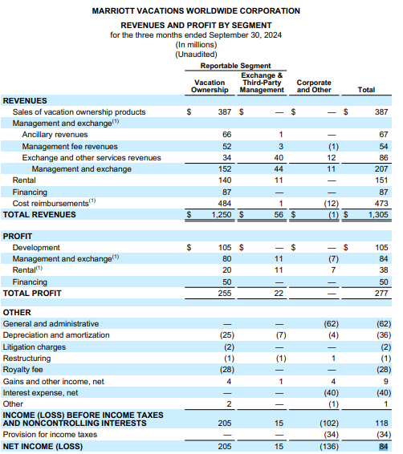
Delta Hotels by Marriott Northampton is part of Marriott International's Delta Hotels brand, which provides streamlined, efficient services for business and leisure travellers (Delta Hotels Northampton, 2024). Specific financial data for individual hotels Delta Hotels by Marriott Northampton is typically private (Guilding, 2014). However, as a franchisee of Marriott International, the hotel's financial performance contributes to the overall financial health of the parent company.
2Marriott Vacations Worldwide Reports, Third Quarter 2024
Marriott International, a global leader in the hospitality industry, reported a total revenue of $84 billion for the third quarter of 2024 (Marriot Vacations Worldwide reports, 2024). This figure reflects the combined performance of its portfolio, which includes over 8,500 properties worldwide (Marriott, 2024). While individual hotel revenues are not specified, the performance of properties like Delta Hotels by Marriott Northampton plays a role in these consolidated financial results.
In the UK, Marriott has been expanding its Delta Hotels brand, and in August 2022, Marriott announced plans to rebrand 23 UK regional Marriott hotels under the Delta by Marriott brand, including the Northampton property. This strategic move aims to improve the brand's presence and appeal in the UK market (Caswell, 2024).
The financial performance of Delta Hotels by Marriott Northampton is influenced by different factors, including occupancy rates, average daily rates, and revenue per available room (RevPAR). These metrics are standard in the hospitality industry for evaluating a hotel's financial health. While specific figures for this property are not publicly available, its performance aligns with Marriott International's broader financial trends.
Staffing and Organisational Structure
3Delta Marriot Northampton Team, 2024. Emma Coen LinkedIn
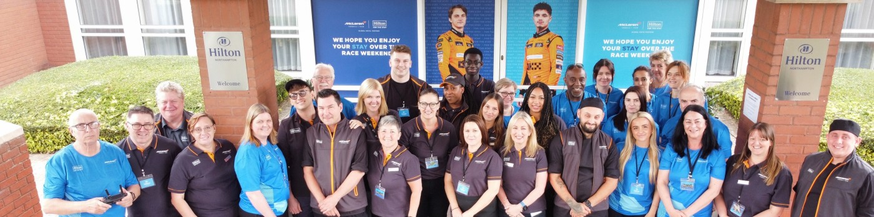Delta Hotels by Marriott Northampton operates with a dedicated team across various departments to provide seamless guest experiences. The staffing structure includes:
- Management
General Manager Emma Coen brings over two decades of experience in the hospitality industry. Emma's leadership is committed to employee development and guest satisfaction, encouraging a collaborative and service-oriented work environment.
- Front Desk
Managed by a Reception Manager who oversees daily operations, assures efficient check-in and check-out processes, handles guest inquiries, and coordinates with other departments to meet guest needs.
- Housekeeping
Led by a Housekeeping Manager, this team is responsible for maintaining cleanliness and comfort in guest rooms and public areas. The department accentuates commitment to protocols and standards to guarantee a high-quality guest experience.
- Food and Beverage
The hotel's restaurant team includes chefs, servers, and support staff who work together to provide dining services. The team operates cohesively, with each member understanding their roles and contributing to smooth operations.
The hotel's staffing levels are designed to accommodate varying occupancy rates and event demands, ensuring that guest services remain consistent and of high quality. Training and development are essential to the hotel's operations, with managers like Emma Coen focusing on employee growth and satisfaction.
This organisational structure reflects Marriott International's commitment to delivering exceptional service through well-trained and motivated staff, contributing to the overall success and reputation of Delta Hotels by Marriott Northampton (Marriott Vacations Worldwide Corporation, 2024).
Key Leadership Roles
4 Emma Coen, 2024. LinkedIn Profile
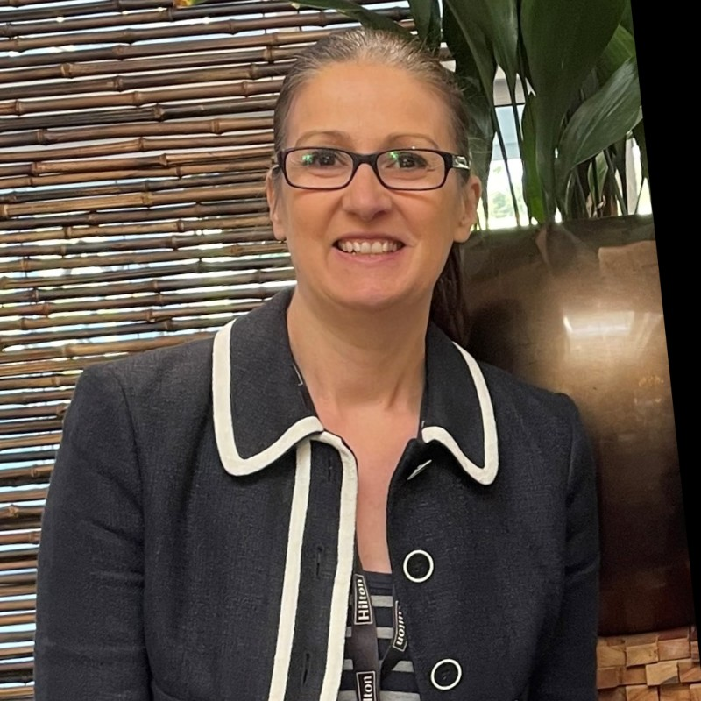
Emma Coen brings over 20 years of hands-on experience in the hospitality industry, working with major brands like Hilton and Marriott. Known for her focus on employee growth and guest satisfaction, Emma’s career reflects a solid commitment to creating high-quality experiences. At Hilton Northampton, she was involved in selecting Jordan Swain as Head Chef, reflecting her dedication to raising service standards and investing in team talent (Northampton Chronicle, 2024). Studies show that transformational leadership (Burns, 1978; Bass, 1985), like Emma’s, significantly improves employee motivation and job satisfaction, which is essential for delivering high-quality guest experiences (Ali, 2023).
Emma’s leadership blends transformational and servant leadership principles, prioritising employee development as key to a successful hotel environment. Servant leadership (Greenleaf, 1970), which Emma stands for, promotes employee engagement and commitment, improving service quality and customer satisfaction (Ling, Liu & Wu, 2017). This people-focused approach, seen in her efforts to support and develop her team, aligns with research that links these leadership styles with high guest satisfaction and team effectiveness (Chon & Zoltan, 2019).
At Delta by Marriott Northampton, Emma continues to shape a positive, collaborative culture, encouraging employees to reach their potential and contributing to the hotel’s success. This approach, prioritising people and quality, has made a lasting impact on the workplace atmosphere, underscoring her value as a leader in hospitality (LinkedIn, 2024). Transformational and servant leadership principles have been shown to drive employee well-being and satisfaction, positively impacting guest experience and hotel performance (Kara et al., 2013).

Organisational Analyses
SWOT Analysis for Delta by Marriott Northampton
The SWOT analysis of Delta by Marriott Northampton highlights the internal and external factors influencing the hotel’s operations. Strengths include its strategic location near the M1 Motorway, making it accessible for business and leisure travellers. The hotel has fully renovated rooms, its own restaurant - Cast Iron Bar & Grill (Delta Hotels Northampton Dining, 2023), and modern amenities like a fitness centre, improving guest satisfaction (Panteleiev, 2023). However, weaknesses emerge in its dependency on a limited number of high-traffic events to sustain occupancy, which may lead to inconsistencies in revenue flow. Staffing challenges, such as turnover or reliance on seasonal workers, can impact service quality, especially during peak periods (Kiritharannair & Amresh, 2016).
Opportunities include the potential to capitalise on nearby attractions like Silverstone Circuit and Franklin's Gardensthat can attract more sports and leisure guests. The trend of “staycations” also presents an opportunity for the hotel to target local guests seeking convenient getaways (de Bloom et al., 2017). In opposition, threats involve competition from budget and luxury hotels in the area and economic fluctuations that may affect guests’ flexible spending on travel (Prajayanti et al., 2021). This SWOT analysis provides insight into how Delta by Marriott Northampton can capitalise on its strengths while addressing internal challenges and directing external pressures to stay competitive in the hospitality industry.

PEST Analysis for Delta by Marriott Northampton
The PEST analysis examines the external factors impacting Delta by Marriott Northampton’s operational landscape. Political factors include regulations related to health and safety, significantly heightened by post-COVID-19 standards, which have influenced the hotel’s operational protocols. Additionally, ongoing Brexit-related changes in immigration policy could affect staffing, as hotels often rely on a diverse workforce (Sahir & Dachyar, 2021).
Economic conditions, particularly inflation and fluctuating exchange rates, impact operational costs and influence guests’ travel decisions (Greenwood, 2007). Hotels must adjust pricing and services to accommodate economic changes without deterring guests (Blengini and Heo, 2020). Social trends, such as the growing preference for eco-friendly and wellness-focused travel, allow the hotel to integrate sustainable practices and wellness amenities to appeal to a conscientious demographic (Pereira et al., 2021). Technological advancements in digital check-ins, mobile booking platforms, and AI-driven customer service solutions present avenues to improve guest convenience and operational efficiency (Pickton & Wright, 199 8).
This PEST analysis shows how Delta by Marriott Northampton can adapt its operations and marketing strategies to align with these political, economic, social, and technological shifts, thus improving its competitiveness in a dynamic hospitality market.
Competitor Analysis
Delta Hotels by Marriott Northampton operates in a competitive market alongside several local hotel companies. The Park Inn by Radisson Northampton Town Centre offers rooms starting at £70 per night, featuring amenities like free Wi-Fi, a fitness centre, and an on-site restaurant. Guest reviews highlight its central location and friendly staff, but some reviews mention that the facilities are slightly dated (Tripadvisor.co.uk, 2024-a)
The Hilton Northampton provides rooms for £80 per night, with amenities such as a health club, indoor pool, and multiple dining options. Guests appreciate the spacious rooms and attentive service, but some reviews also mention that the hotel is situated a bit farther from the town centre (Tripadvisor.co.uk, 2024-b)
Delta Hotels by Marriott Northampton offers rooms starting at £75 per night, featuring modern accommodations, a fitness centre, and the Cast Iron Bar & Grill. Guests commend the hotel's cleanliness and professional staff, though some suggest that certain areas could benefit from updates and more attention from the staff (Tripadvisor.co.uk, 2024-a)
Overall, while all three hotels provide a range of amenities and services, Delta Hotels by Marriott Northampton distinguishes itself with its combination of modern facilities and competitive pricing.
Netnographic Observations throughout the 10-week placement
The nethnographic observations at Delta Hotels by Marriott Northampton reveal insights into employee dynamics, teamwork, and guest interactions. Staff members demonstrated a collaborative and supportive approach, encouraging a positive working environment, as was seen in the restaurant, where the team members coordinated smoothly, with servers and kitchen staff communicating efficiently to guarantee timely service. This cooperation was observed during peak hours, when chefs and servers adjusted their workflow to accommodate the demands of high guest volume, ensuring that each order was accurately prepared and promptly delivered. The teamwork displayed in this department highlighted a shared commitment to maintaining service quality, even during busy periods.
Housekeeping staff interactions further reflected a well-coordinated team structure. The Housekeeping Manager assigned specific roles for daily tasks, making sure that each employee knew their responsibilities and could work independently while contributing to the overall team objectives. Housekeepers maintained a professional, respectful attitude and supported one another, particularly when completing room turnovers under tight schedules. This consistency allowed the team to handle large check-outs seamlessly, creating a comfortable guest experience.
Interactions with guests varied across departments but generally reflected Marriott’s focus on attentive and personalised service (QuestionPro, 2023). The reception staff were polite and welcoming, engaging with guests professionally and handling inquiries and complaints calmly and effectively. Receptionists were observed addressing guest needs promptly, displaying empathy and patience, particularly during peak check-in and check-out times.
Overall, observations suggest Delta Hotels by Marriott Northampton maintains a customer-centric culture. Each department's teamwork and professionalism reflect an organisational commitment to guest satisfaction and operational efficiency, driven by effective leadership and employee consistency.

Theme Exploration
Leadership Style in the Restaurant Department (Weeks 1-2)
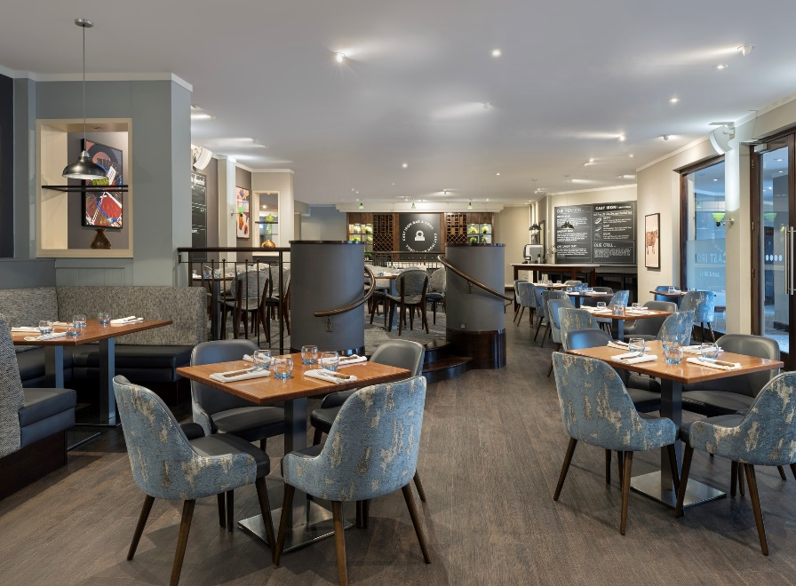
In the initial weeks of restaurant training, Emma Coen's leadership, observed through the lens of transformational and servant leadership theories, set the tone for a dynamic learning experience in hospitality management. Transformational leadership, as outlined by Bass and Riggio (2006), involves motivating and inspiring employees toward shared goals. Emma’s approach reflected this, engaging the student in discussions about career aspirations and departmental insights, thus instilling a sense of purpose and commitment. This focus on individual growth is confirmed by conclusions drawn from hospitality research, where transformational leadership significantly improves job satisfaction and engagement (Ali, 2023).
In contrast to Emma’s direct engagement, the Restaurant Manager demonstrated a laissez-faire style (Lewin, Lippitt and White, 1939) with limited intervention and high autonomy for team members. Laissez-faire leadership though often criticised for its lack of guidance, can be effective in established teams with clear roles and responsibilities. The team’s structure, supported by peer-led mentoring, allowed for smooth operation without direct supervision. This approach aligns with the findings by Huertas-Valdivia et al. (2019), who note that empowering employees through autonomy improves their adaptability and commitment (Huertas-Valdivia, 2019).
Within this setting, the team dynamics flourished. The senior colleague who assumed the ‘buddy trainer’ role acted as an informal servant leader, aiding the student’s adaptation while ensuring consistency among staff. This peer mentorship illustrates the effectiveness of servant leadership, where leaders prioritise employee well-being over formal authority. Studies confirm that servant leadership in hospitality improves team morale and productivity (Chon & Zoltan, 2019). The camaraderie among the team, encouraged by decentralised leadership, mirrors findings that employees, when trusted, often self-manage with heightened accountability (Chris and Feeney, 2022).
Emma’s indirect yet supportive involvement during the student’s restaurant placement exemplified servant leadership, where she created a work culture focusing on support and recognition by maintaining a presence in the background and monitoring progress through senior colleagues. In her indirect leadership style, the leader empowers others to succeed without imposing authority (Stone et al., 2004).
From a broader perspective, the combination of transformational, servant, and laissez-faire styles illustrated a flexible leadership approach within hospitality. While effective here, the restaurant manager’s delegation may contrast with more structured leadership approaches suited to high-precision environments like the front desk (González-Torres et al., 2023). However, in the restaurant’s fast-paced environment, the autonomy granted to team members encouraged quick decision-making and efficient operations.
This experience highlights that leadership in hospitality is not one-size-fits-all; instead, the adaptability to meet the needs of different operational contexts and team dynamics is crucial. The case further supports findings that varied leadership styles foster a responsive, team-centred culture in hospitality (Ali, 2023). In this instance, the autonomy and mentorship empowered the team to function seamlessly, representing a culture where respect and collaboration go before formal supervision.
Housekeeping Department (Weeks 3-5)
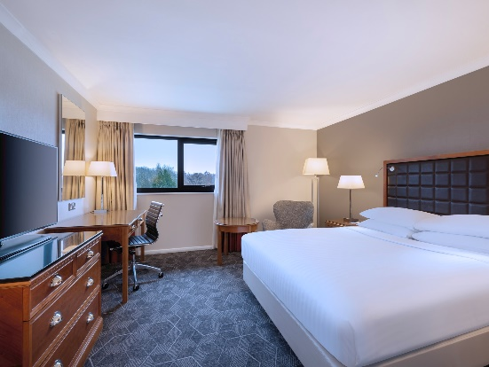
In the Housekeeping Department at Delta by Marriott Northampton, the Housekeeping Manager exemplified a distinctive combination of transactional leadership (Burns, 1978; Bass, 1981; Weber, 1947) infused with empathy, encouraging efficiency and morale. Adhering strictly to established procedures, she categorised daily tasks as “stayovers” or “check-outs,” confirming a predictable structure that allowed team members to manage their responsibilities effectively. This approach reflects the principles of transactional leadership, where evident, structured roles can improve operational effectiveness, particularly in roles requiring precision and consistency (Huo, 2019). Yet, unlike purely transactional leaders, the Housekeeping Manager balanced her strict approach with empathy, checking in regularly with staff and granting breaks as needed. This compassionate approach aligned with findings that empathy in transactional leadership can improve employee morale and productivity, even in task-focused environments (Kumar, 2023).
The collaboration between the housekeeping and maintenance teams further improved operational fluidity. With two rotating maintenance technicians addressing immediate issues like broken fixtures, the collaboration between departments highlighted the value of interdependence in hotel operations. Studies show that such cross-functional teamwork in hospitality raises service standards and minimises disruptions, which is particularly beneficial in ensuring seamless guest experiences (Larsson et al., 2012). The Housekeeping Manager’s coordination with the maintenance team aligns with the “organisational agility” concept, which suggests that agile, responsive management strategies promote guest satisfaction and operational resilience (Khairy et al., 2023).
The manager’s leadership style also displayed transformational leadership elements by encouraging respect and collaboration. Although transactional by nature, her empathetic approach bridged transactional and transformational strategies, promoting employee well-being, a factor often linked to higher job satisfaction and reduced turnover in hospitality (Kara et al., 2013). This nurturing environment resonates with servant leadership theories, where leaders prioritise employees’ needs, creating a more engaged and loyal workforce (Rabiul et al., 2021).
Through this blend of structured management and empathy, the Housekeeping Manager ensured that daily operations ran smoothly while supporting team members' well-being. Such a balanced approach shows the importance of adaptable leadership in hospitality, showing that effective management often requires a fusion of transactional rigour and empathetic flexibility (Kara et al., 2013).
Front Desk Operations (Weeks 6-9)
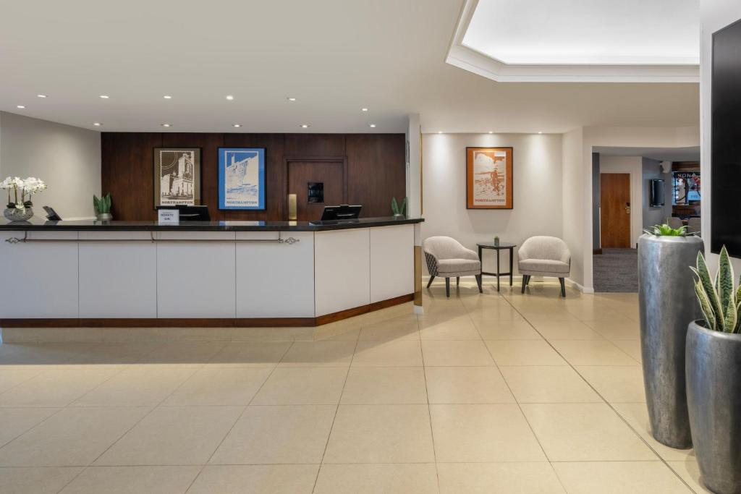
During the four-week placement in front desk operations, the Reception Manager demonstrated a bureaucratic leadership style (Weber, 1922), strengthened strict compliance to standard procedures and maintained a highly organised and efficient environment. Bureaucratic leadership, often characterised by a hierarchical structure and rule-based management, plays a significant role in guest-facing roles within the hospitality industry. In this setting, consistency is essential for delivering reliable and standardised service, particularly in high-pressure environments where errors could impact guest satisfaction (Minett et al., 2009).
A significant aspect of the Reception Manager's approach was her dedication to training and reinforcing protocols among staff. Weekly sessions focused on specific check-in and check-out processes, payment verifications, and guest request protocols. This regular training reinforced precision, making srue each receptionist held to a standardised routine aligned with departmental objectives (Shin et al., 2019). Her consistency contributed to maintaining high service standards and minimising errors in daily tasks, such as room assignments and billing, which are crucial for a positive guest experience (Ahmad & Scott, 2014).
However, while the bureaucratic style proved effective in maintaining consistency, it also revealed certain limitations. The Reception Manager’s distant approach, focusing on operational efficiency over interpersonal engagement, occasionally led to a less personal experience for guests and staff. Bureaucratic structures, as observed, can restrict spontaneous problem-solving abilities, especially when front-line employees feel constrained by rigid protocols (Raub, 2008). This can be particularly challenging in hospitality, where guest interactions often demand flexibility and empathy (Hossny, 2019).
In handling guest complaints, the Reception Manager’s approach showed the strengths and weaknesses of a bureaucratic style. While her structured escalation process ensured that complex issues were swiftly addressed, it sometimes delayed response times for simpler matters that receptionists could have handled directly. While improving accountability, the structured process limited the team’s autonomy in addressing guests' needs on the spot, possibly hindering immediate conflict resolution (Carvalho et al., 2016).
Moreover, her systematic approach fostered clear communication between the front desk and other departments, such as housekeeping and maintenance, illustrating the value of interdepartmental collaboration in maintaining operational efficiency. When guest requests involved multiple teams, a clear protocol guaranteed that requests were fulfilled promptly, a crucial factor for guest satisfaction (Ling et al., 2016). Yet, the overly procedural nature of her leadership style sometimes left employees feeling disconnected from the overall guest service experience, highlighting a need for balanced flexibility in the hospitality industry (Huertas-Valdivia et al., 2019).
In summary, while the bureaucratic leadership style adopted by the Reception Manager provided stability and high operational standards, it also showed the limitations of excessive structure in guest interactions. The experience illustrated that while rule-based approaches are valuable for consistency, incorporating elements of flexibility could further improve service delivery and employee engagement in guest-facing roles (Kong & Baum, 2006).

Emma’s Role in Overall Operations (Final Week)
During the final week of the placement, Emma Coen’s approach to leadership demonstrated the impact of combining servant and transformational leadership in hotel management. Her servant leadership style was evident in her deep commitment to staff development and well-being, aligning with Greenleaf’s foundational concepts of servant leadership, which accentuate prioritising employee growth and fulfilment (Greenleaf, 1977). Emma’s support of team morale and her dedication to encouraging a positive workplace culture made her an admired figure among the staff, embodying the principles of transformational leadership defined by Burns (1978), which focuses on inspiring employees toward personal and collective goals.
Emma engaged in mentoring practices that highlighted her investment in employee growth. For instance, she took a personalised approach during the hiring process, ensuring that candidates aligned with the hotel’s culture and that their roles suited their strengths and motivations. This strategy aligns with Bass's (1985) transformational leadership model, which advocates individualised consideration to improve employee motivation and productivity. Emma’s approach to onboarding reflected her belief that employee satisfaction correlates with performance and job satisfaction, an idea supported by organisational behaviour studies linking employee alignment with organisational culture to improved motivation and productivity (Ramlall, 2004).
Beyond recruitment, Emma actively supported internal mobility by creating opportunities for employees interested in role changes or growth within the organisation. Her detailed organisation of employees' files and follow-ups on their aspirations demonstrated a structured, caring approach to talent management, which Bolman and Deal (2000) describe as essential for building cohesive, high-functioning teams in hospitality. Emma’s engagement with the author’s learning, which included assigned readings and quiz feedback, showed her dedication to mentorship -a fundamental element in transformational leadership that fosters loyalty and professional development (Scandura and Williams, 2004).
Emma’s transparent leadership extended to explaining hotel operations, even in departments with limited access, accentuating her commitment to comprehensive staff development. Such openness and willingness to educate reflect servant leadership principles and reinforce employee trust, an essential factor for organisational loyalty, as highlighted by Mayer et al. (1995). On the final day, Emma’s meticulous collection of feedback and reflections showed her commitment to nurturing staff potential, providing an invaluable resource for future career pursuits.
Emma’s balanced servant and transformational leadership approach created a respectful and supportive environment, reinforcing that influential hospitality leaders prioritise individual and organisational goals. Her focus on employee development and operational transparency illustrated that impactful leadership in hospitality transcends task management, focusing instead on cultivating an empowered, motivated workforce.

Conclusions and Recommendations
Observations on Leadership Styles
The leadership at Delta Hotels by Marriott Northampton utilises a diverse array of management styles, each influencing staff dynamics and customer service outcomes. Key leaders display transformational, transactional, laissez-faire, and bureaucratic leadership approaches across departments. General Manager Emma Coen, known for her transformational and servant leadership styles, promotes employee growth and guest satisfaction, encouraging an inclusive, motivated environment (Bavik, 2023). This style has been linked to increased employee commitment and improved service quality in hospitality settings (Chon & Zoltan, 2019).
The restaurant manager’s laissez-faire approach allows staff autonomy, encouraging adaptability and collaborative dynamics. Studies suggest this style can be effective in well-defined teams with clear roles, as it promotes flexibility without constant oversight (Huertas-Valdivia et al., 2019). However, laissez-faire leadership might benefit from greater structure to moderate potential drawbacks, such as lack of guidance.
In the Housekeeping Department, the manager employs a transactional approach, focusing on task adherence and efficiency. This style proves effective in high-precision roles but could be improved by integrating more empathetic elements to support staff well-being (Kumar, 2023). Lastly, the Front Desk employs bureaucratic leadership, focusing on order and consistency. While this ensures a stable workflow, it can reduce team engagement, indicating a need for balance (Clark et al., 2009).
Recommendations for Improvement
- Strengthened Team Mentorship and Development Programs
Introducing mentorship programs led by senior staff such as Emma Coen could foster skill development and improve team consistency. Research highlights mentorship’s role in increasing employee satisfaction and performance in hospitality, as it offers guidance and growth opportunities (Tracey & Hinkin, 1996). Structured development could benefit departments like the restaurant, where laissez-faire leadership offers autonomy but may lack essential feedback loops.
- Regular Management Presence and Communication Initiatives
More frequent check-ins and transparent communication from leadership could address some limitations of laissez-faire and bureaucratic styles. Regular management engagement can bridge gaps in guidance and improve employee motivation, particularly in departments requiring solid procedural adherence. A practical example of this approach is the combination of structured oversight with transactional and transformational elements, which has improved accountability and motivation (Kara et al., 2013).
- Cross-Departmental Training and Synergy Programs
Initiating cross-training programs could promote collaboration across departments. Research shows that integrated teamwork improves service delivery, as employees understand various operational aspects and provide seamless support across roles (Sumaneeva et al., 2019). This could particularly benefit areas like housekeeping and front desk, where collaboration is essential to maintain operational fluidity and meet guest needs promptly.

- Integrating Servant Leadership in Transactional and Bureaucratic Contexts
Incorporating servant leadership principles into departments with transactional and bureaucratic leadership would improve employee satisfaction and reduce turnover. Managers in these roles could support employee autonomy while addressing personal development needs. Studies reveal that servant leadership can be successfully merged with task-oriented styles, balancing efficiency with staff engagement (Kara et al., 2013).
- Implementing Feedback Loops from Reflective Writing and Netnography
Delta by Marriott Northampton could utilise insights from reflective writing and netnography to continuously assess and refine leadership effectiveness. Reflective writing offers personal insights into daily challenges and accomplishments, while nethnography provides data on broader guest interactions and satisfaction trends (Bowler, 2010). Regular analysis of these insights can inform leadership adjustments, aligning management approaches with employee and guest expectations.
Practical Implementation
To apply these recommendations, Delta by Marriott Northampton should start with a pilot mentorship program, establishing senior team members as mentors for new or junior staff. This initiative could be structured around monthly skills development and employee engagement meetings. Cross-departmental training sessions, held quarterly, would facilitate skill sharing and reinforce teamwork across departments, particularly between housekeeping and the front desk.
Management should also incorporate monthly feedback sessions, where employees can share observations from reflective writing. This approach would allow leadership to address concerns proactively and improve workflows. Integrating these feedback loops provides a data-driven basis for refining leadership strategies and ensuring they align with real-time needs. Finally, encouraging a balanced leadership approach by blending servant and transformational elements into transactional and bureaucratic settings could improve employee satisfaction without compromising structure.

Conclusion
The leadership strategies at Delta Hotels by Marriott Northampton, encompassing transformational, transactional, laissez-faire, and bureaucratic styles, shape team dynamics and directly impact guest experiences. The observed strengths and limitations suggest a need for balanced approaches integrating mentorship, structured feedback, and cross-departmental collaboration. Transformational and servant leadership principles could improve staff motivation and consistency, particularly when incorporated into transactional and bureaucratic contexts (Gui et al., 2020).
By implementing mentorship and encouraging cross-functional understanding, Delta by Marriott Northampton could strengthen its internal culture and ensure service quality remains high. Embracing continuous feedback through reflective practices would allow leadership to adapt to evolving needs, reinforcing a customer-centric approach. These recommendations aim to create an empowered and cohesive workforce ready to deliver exceptional guest experiences and sustain Delta Hotels by Marriott’s reputation for hospitality excellence.

Reflection Using Gibbs’ Reflective Cycle
Gibbs’ Reflective Cycle (1988) is a structured model that encourages reflective learning through six stages: description, feelings, evaluation, analysis, conclusion, and action plan. This framework is highly relevant for analysing my 10-week placement experience at Delta by Marriott Northampton. I observed diverse leadership styles across different departments, including transformational, servant, laissez-faire, transactional, and bureaucratic approaches. This experience offered insight into the importance of flexible and employee-centred leadership within the hospitality industry.
Description
In my placement at Delta by Marriott Northampton, I rotated through the restaurant, housekeeping, and front desk departments, culminating with a week of shadowing Emma Coen, General Manager. Emma’s leadership style stood out due to its blend of transformational and servant qualities. Her leadership set the tone for a positive work culture, where employees felt valued and motivated to perform at their best. Each department I worked in demonstrated a different leadership style: laissez-faire in the restaurant, transactional in housekeeping, and bureaucratic at the front desk. This range of approaches provided a practical foundation for understanding how different leadership methods shape team dynamics and influence guest satisfaction (Bass & Riggio, 2006).
Feelings
Initially, I felt overwhelmed, particularly in the restaurant environment, where the laissez-faire style of the manager left much of the work structure to the team’s organisation. I was unfamiliar with such autonomy and found it difficult to adapt initially, especially since I was ready for guidance and reassurance. However, with time, I came to appreciate this style for encouraging trust and teamwork, which reinforced my self-confidence and allowed me to actively engage with my tasks (Huertas-Valdivia, Rojo Gallego-Burín, & Lloréns-Montes, 2019).
In contrast, I felt more secure in the structured environments of housekeeping and the front desk. The transactional approach of the Housekeeping Manager remained on predictability, which was reassuring when learning tasks that required meticulous attention to detail. This sense of structure extended to the front desk, where the Reception Manager’s bureaucratic style promoted consistency. However, the bureaucratic style sometimes felt rigid, leaving limited room for personalisation in guest interactions. I realised it could be challenging for employees who value creativity and engagement in their work (Øgaard, Marnburg, & Larsen, 2008). Working with Emma later in my placement provided a different experience altogether, as her servant leadership approach nurtured my personal development, encouraging me to reflect on my career goals. Emma’s commitment to individual growth left me feeling genuinely supported, and I recognised the power of employee-centred leadership in creating a motivated and engaged workforce (Agusta and Azmy, 2023).
Evaluation
Reflecting on this placement experience, I see that each department’s leadership style had strengths and limitations. The laissez-faire approach in the restaurant was practical for a team with well-defined roles and responsibilities. The team functioned with minimal intervention, and I observed a strong sense of camaraderie. However, this style also created occasional confusion, as there was no direct guidance from the manager, which could be challenging for new employees unfamiliar with the team’s processes (Brownell, 2010). Emma’s influence, though indirect, was felt across all departments and improved the laissez-faire structure by creating a background of accountability.
The transactional leadership style in housekeeping provided clear instructions and a reliable structure. Tasks were carefully assigned, which helped maintain high standards in a labour-intensive environment. Yet, this style limited flexibility in unexpected situations, as each role was highly defined, and deviation from standard procedures was discouraged. The structure allowed us to meet the department’s efficiency needs but lacked a personal touch, which could be essential in encouraging a more adaptive and resilient team (Huo, 2019).
The front desk’s bureaucratic style reinforced consistency and professionalism in guest interactions, a vital aspect of maintaining the hotel’s reputation. However, it occasionally restricted interpersonal connections with guests, as the focus on following protocols sometimes overshadowed the opportunity for personalised service. While this approach was practical for high-demand tasks, I noted that it could be detrimental to team morale if employees felt constrained by procedural expectations (Clark, Hartline, & Jones, 2009). Through this, I appreciated the value of Emma’s flexible leadership, which balanced structure with a focus on personal well-being and growth.
Analysis
Gibbs’ reflective cycle underlines understanding the underlying factors that shape an experience (Gibbs, 1988), which relates to the different leadership styles I encountered. Reflecting on Emma’s servant and transformational leadership, it became clear that her approach was rooted in a genuine commitment to employee growth. Emma’s leadership aligns with the theory of transformational leadership, where leaders work to inspire and motivate employees by encouraging a supportive environment (Bass & Riggio, 2006). Her approach also reflected servant leadership principles, focusing on the well-being and development of her team, as evidenced by her regular check-ins with each department (Chon & Zoltan, 2019). This dedication encouraged employees to take pride in their roles and contributed to a cohesive organisational culture.
In the restaurant, the laissez-faire style of the manager allowed team members to self-manage, reinforcing autonomy and mutual support. This approach works well in settings where team members are familiar with their roles, as independence can increase job satisfaction and engagement (Huertas-Valdivia et al., 2019). However, the absence of guidance can be challenging for new employees or in fast-paced environments, where clarity and direction are important for maintaining consistency.
The transactional approach in housekeeping created a stable work environment for a role involving repetitive tasks. Transactional leadership focuses on task completion and adherence to established rules, effectively ensuring high performance in structured roles (Huo, 2019). While this approach effectively maintained high operational standards, I recognised that it limited opportunities for employees to contribute creatively or suggest improvements.
Finally, the front desk’s bureaucratic style accentuated consistency in service delivery, suitable for guest-facing roles requiring strict protocol adherence (Clark et al., 2009). This approach reinforced professionalism but occasionally lacked the flexibility needed for personalised guest service. Emma’s influence in setting high standards across departments bridged this gap, encouraging a balance between structure and personalisation.
Conclusion
This placement experience reinforced that leadership styles must be adaptable to the needs of specific departments within hospitality. Emma’s servant and transformational leadership styles fostered a culture of trust, motivation, and engagement, creating a foundation where different approaches could coexist effectively. Each leadership style I encountered—laissez-faire, transactional, and bureaucratic -was appropriate for the different demands of its respective departments. Yet, each also had limitations that highlighted the value of flexibility in leadership. Observing Emma’s adaptable approach taught me that effective leadership in hospitality involves more than managing tasks; it requires creating a supportive culture where employees feel valued and encouraged to grow.
Through reflection, I realised that a blend of leadership styles, focusing on employee development, can improve operational efficiency and foster a positive work environment. Emma’s adaptability and focus on team well-being showed the importance of balancing task-oriented approaches with people-centred leadership.
Action Plan
I plan to emulate Emma’s adaptable leadership approach in future management roles, focusing on servant leadership principles prioritising employee development. This means actively supporting team members’ growth, providing mentorship, and creating an inclusive environment where everyone feels valued. Reflecting on my challenges, particularly in the restaurant, I recognise the importance of clear communication and providing guidance when needed. I aim to balance autonomy with sufficient support, adapting to the team’s needs and experience levels (Gibbs, 1988).
I also intend to use transactional methods in task-oriented environments, where structure and predictability are essential for operational efficiency, as I observed in housekeeping. However, I will integrate a more flexible approach to encourage team resilience and adaptability in unforeseen situations. Continuing with reflective practice, I will regularly assess and refine my leadership style, using frameworks like Gibbs’ reflective cycle to guide my professional development.
In conclusion, this placement experience has shaped my understanding of effective leadership in hospitality. By encouraging a supportive culture that values employee well-being and operational excellence, I aim to create an environment where team members feel motivated, respected, and capable of achieving their full potential.

References
- Agusta, N., & Azmy, A. (2023). Servant Leadership and Career Development: Supporting Employee Growth. International Journal of Multicultural and Multireligious Understanding. https://doi.org/10.18415/ijmmu.v10i12.5320.
- Ahmad, R., and Scott, N., 2014. Managing the front office department: staffing issues in Malaysian hotels. Anatolia, 25, pp. 24 - 38. https://doi.org/10.1080/13032917.2013.822010.
- Ali, B., 2023. What we know about transformational leadership in tourism and hospitality: a systematic review and future agenda. The Service Industries Journal, 44, pp. 105 - 147. https://doi.org/10.1080/02642069.2023.2250302.
- Bass, B. M., and Riggio, R. E., 2006. Transformational leadership. Mahwah, NJ: Lawrence Erlbaum Associates. https://ebookcentral.proquest.com/lib/trinity/detail.action?docID=274519
- Bass, B.M. (1981) Stogdill's Handbook of Leadership: A Survey of Theory and Research. Revised and expanded edition. New York: Free Press
- Bass, B.M. (1985) Leadership and performance beyond expectations. New York: Free Press.
- Blengini, I. and Heo, C.Y., 2020. How do hotels adapt their pricing strategies to macroeconomic factors? Ecole hôtelière de Lausanne, HES-SO/University of Applied Sciences and Arts Western Switzerland, Lausanne, Switzerland. Available at: https://doi.org/10.1016/j.ijhm.2020.102522
- Bolman, L.G. and Deal, T.E., 2000. Reframing organizations: Artistry, choice, and leadership. National Association of Secondary School Principals. NASSP Bulletin, 84(612), p.88. https://www.proquest.com/scholarly-journals/reframing-organizations-artistry-choice/docview/216044643/se-2?accountid=130472
- Booking.com, 2024. Delta Hotels by Marriott Northampton. https://www.booking.com/hotel/gb/northampton-marriott.html
- Bowler Jr, G.M, 2010. Netnography: A Method Specifically Designed to Study Cultures and Communities Online. The Qualitative Report, 15, pp. 1270-1275. https://doi.org/10.46743/2160-3715/2010.1341.
- Brownell, J., 2010. Leadership in the service of hospitality. Cornell Hospitality Quarterly, 51(3), pp.363-378. https://doi.org/10.1177/1938965510368651
- Burns, J. M. (1978). Leadership. New York: Harper & Row.
- Carvalho, J., Bartholo, R., and Duarte, F., 2016. Hospitality experience: Creating value by the front-desk work analysis and organizational innovation. Tékhne, 14, 104–112. from https://doi.org/10.1016/j.tekhne.2016.07.001
- Caswell, M. (2022) 'Marriott to reflag 23 UK regional properties under Delta brand', Business Traveller, 22 August. https://www.businesstraveller.com/business-travel/2022/08/22/marriott-to-reflag-23-uk-regional-properties-under-delta-brand/
- Chon, K. & Zoltan, J., 2019. Role of servant leadership in contemporary hospitality. International Journal of Contemporary Hospitality Management. https://www.proquest.com/scholarly-journals/role-servant-leadership-contemporary-hospitality/docview/2283794455/se-2?accountid=130472
- Clark, R.A., Hartline, M.D. and Jones, K.C., 2009. The effects of leadership style on hotel employees' commitment to service quality. Cornell hospitality quarterly, 50(2), pp.209-231. https://doi.org/10.1177/1938965508315371
- de Bloom, J., Nawijn, J., Geurts, S., Kinnunen, U., and Korpela, K., 2017. Holiday travel, staycations, and subjective well-being. Journal of Sustainable Tourism, 25(4), 573–588. https://doi.org/10.1080/09669582.2016.1229323
- Delta Hotels Northampton Dining, 2023. Marriott. https://www.marriott.com/en-us/hotels/lonnd-delta-hotels-northampton/dining/
- Delta Hotels Northampton, 2024. Delta Hotels Northampton Facebook Page. https://www.facebook.com/DeltaHotelsNorthampton/
- Flyvbjerg, B., 2006. Five misunderstandings about case-study research. Qualitative inquiry, 12(2), pp.219-245. https://doi.org/10.1177/1077800405284363
- Gibbs, G., 1988. Learning by Doing: A Guide to Teaching and Learning Methods. Oxford: Oxford Polytechnic. https://stephenp.net/wp-content/uploads/2015/12/learning-by-doing-graham-gibbs.pdf
- González-Torres, T., Nájera-Sánchez, J.J., Huertas-Valdivia, I. and Pérez-Pérez, C., 2023. Understanding leadership styles and effects in hospitality: A co-word analysis. Tourism and Hospitality Research, p.14673584231215731. https://doi.org/10.1177/14673584231215731
- Greenleaf, R. K., 1977. Servant Leadership: A Journey into the Nature of Legitimate Power and Greatness. New York: Paulist Press. https://www.urbanleaders.org/620Leadership/92Readings/articles/Greenleaf-Servant%20Leadership.pdf
- Greenwood, C., 2007. How do currency exchange rates influence the price of holidays? Journal of Revenue and Pricing Management. https://link.springer.com/article/10.1057/palgrave.rpm.5160095
- Gui, C., Zhang, P., Zou, R. and Ouyang, X., 2021. Servant leadership in hospitality: A meta-analytic review. Journal of Hospitality Marketing & Management, 30(4), pp.438-458. https://doi.org/10.1080/19368623.2021.1852641
- Guilding, C., 2014. Accounting Essentials for Hospitality Managers. 3rd ed. London: Routledge. https://www.proquest.com/legacydocview/EBC/1596977?accountid=130472
- Hosni, M., 2019. Impact of Leadership Style on Employee Job Satisfaction in the Hospitality Industry. International Journal of Heritage, Tourism and Hospitality. https://doi.org/10.21608/IJHTH.2019.35101.
- Huertas-Valdivia, I., Gallego-Burín, A.R. and Lloréns-Montes, F.J., 2019. Effects of different leadership styles on hospitality workers. Tourism management, 71, pp.402-420. https://doi.org/10.1016/j.tourman.2018.10.027
- Huo, Y., 2019. Employee retention: relationship among housekeeper’s job satisfaction, organizational workforce, and racial-ethnicity within the global hospitality industry in Utah, U.S.A. finding stability in a volatile hospitality industry. Arts & Humanities Open Access Journal. https://doi.org/10.15406/ahoaj.2019.03.00101.
- Kara, D., Uysal, M., Sirgy, M., and Lee, G., 2013. The effects of leadership style on employee well-being in hospitality. International Journal of Hospitality Management, 34, pp. 9-18. https://doi.org/10.1016/J.IJHM.2013.02.001.
- Kara, D., Uysal, M., Sirgy, M., and Lee, G., 2013. The effects of leadership style on employee well-being in hospitality. International Journal of Hospitality Management, 34, 9-18. https://doi.org/10.1016/J.IJHM.2013.02.001.
- Khairy, H., Baquero, A., and Al-Romeedy, B., 2023. The Effect of Transactional Leadership on Organizational Agility in Tourism and Hospitality Businesses: The Mediating Roles of Organizational Trust and Ambidexterity. Sustainability. https://doi.org/10.3390/su151914337.
- Kiritharannair, C., & Amresh, P., 2016. Development of Strategic Plan for Hotel Industries through Swot Analysis. Indian Journal of Medical Ethics, 3, pp. 6-10. https://doi.org/10.14445/23488360/ijme-v3i3p103.
- Kong, H., & Baum, T., 2006. Skills and work in the hospitality sector: The case of hotel front office employees in China. International Journal of Contemporary Hospitality Management, 18, pp. 509-518. https://www.proquest.com/scholarly-journals/skills-work-hospitality-sector/docview/228323627/se-2?accountid=130472
- Kumar, P., 2023. Influence of Transactional Leadership Styles on Employee Motivation. Tuijin Jishu/Journal of Propulsion Technology. https://doi.org/10.52783/tjjpt.v44.i3.570.
- Larsson, A., Johansson, M., Bååthe, F., & Neselius, S., 2012. Reducing throughput time in a service organisation by introducing cross-functional teams. Production Planning & Control, 23, pp. 571 - 580. https://doi.org/10.1080/09537287.2011.640074.
- Lewin, K., Lippitt, R. and White, R.K. (1939) ‘Patterns of aggressive behavior in experimentally created social climates’, The Journal of Social Psychology
- Ling, Q., Lin, M., and Wu, X., 2016. The trickle-down effect of servant leadership on frontline employee service behaviors and performance: A multilevel study of Chinese hotels. Tourism Management, 52, pp. 341-368. https://doi.org/10.1016/J.TOURMAN.2015.07.008.
- Ling, Q., Liu, F., and Wu, X., 2017. Servant Versus Authentic Leadership. Cornell Hospitality Quarterly, 58, pp. 53 - 68. https://doi.org/10.1177/1938965516641515.
- LinkedIn. (2024). Emma Coen. https://www.linkedin.com/in/emma-coen-019b236a/
- Marriott International, 2024a. Hotel near Silverstone Circuit | Delta Hotels Northampton. https://www.marriott.com/en-gb/hotels/lonnd-delta-hotels-northampton/overview/
- Marriott International, 2024b. Family Hotel Rooms | Delta Hotels Northampton. https://www.marriott.com/en-gb/hotels/lonnd-delta-hotels-northampton/rooms/
- Marriott International, 2024c. Hotel Near Silverstone | Delta Hotels Northampton. https://www.marriott.com/en-gb/hotels/lonnd-delta-hotels-northampton/experiences/
- Marriott Vacations Worldwide Corporation (2024) 'Marriott Vacations Worldwide Reports Third Quarter 2024 Financial Results'. https://ir.marriottvacationsworldwide.com/static-files/83cd498b-0bac-4333-9e87-07bdd5cbdc2c
- Marriott, 2024. https://www.marriott.com/marriott/aboutmarriott.mi
- Mayer, R.C., Davis, J.H. and Schoorman, F.D., 1995. An integrative model of organizational trust. Academy of management review, 20(3), pp.709-734. https://doi.org/10.5465/amr.1995.9508080335
- Minett, D., Yaman, H., & Denizci, B., 2009. Leadership styles and ethical decision-making in hospitality management. International Journal of Hospitality Management, 28, pp. 486-493. https://doi.org/10.1016/J.IJHM.2009.01.003.
- Moon, J. A. (2004). A Handbook of Reflective and Experiential Learning: Theory and Practice. Routledge. https://research-ebsco-com.ezproxy.uwtsd.ac.uk/c/onvpsy/search/details/ettr5okb75?db=nlebk
- Northampton Chronicle. (2024). Hilton Northampton appoints Jordan Swain as new head chef. https://www.northamptonchron.co.uk/business/hilton-northampton-appoints-jordan-swain-as-new-head-chef-4697155
- Øgaard, T., Marnburg, E., and Larsen, S., 2008. Perceptions of organizational structure in the hospitality industry. Tourism Management. https://doi.org/10.1016/j.tourman.2007.07.006
- Panteleiev, V., 2023. Application of SWOT analysis to justify the strategy of hotel business enterprises. Technology audit and production reserves. https://doi.org/10.15587/2706-5448.2023.274918.
- Parolini, J., Patterson, K. and Winston, B., 2009. Distinguishing between transformational and servant leadership. Leadership & Organization Development Journal, 30(3), pp.274-291. https://www.proquest.com/scholarly-journals/distinguishing-between-transformational-servant/docview/226918498/se-2?accountid=130472
- Pereira, V., Silva, G., and Dias, Á., 2021. Sustainability Practices in Hospitality: Case Study of a Luxury Hotel in Arrábida Natural Park. Sustainability, 13, pp. 3164. https://doi.org/10.3390/SU13063164.
- Pickton, D., and Wright, S., 1998. What's swot in strategic analysis?. Strategic Change, 7, pp. 101-109. 3.0.CO;2-6" target="_blank">https://doi.org/10.1002/(SICI)1099-1697(199803/04)7:2<101::AID-JSC332>3.0.CO;2-6.
- Prajayanti, N., Sudana, I., and Karma, I., 2021. SWOT Analysis As A Determiner Of Marketing Strategy At b Hotel Bali & Spa Denpasar. Journal of Applied Sciences in Accounting, Finance, and Tax. https://doi.org/10.31940/jasafint.v4i1.2409.
- QuestionPro. (2023). The Marriott Customer Experience Strategy: Analysis & Review. from https://www.questionpro.com/blog/marriott-customer-experience/
- Rabiul, M., Patwary, A., Mohamed, A., & Rashid, H., 2021. Leadership Styles, Psychological Factors, and Employee Commitment to Service Quality in the Hotel Industry. Journal of Quality Assurance in Hospitality & Tourism, 23, pp. 853 - 881. https://doi.org/10.1080/1528008X.2021.1913695.
- Ramlall, S., 2004. A review of employee motivation theories and their implications for employee retention within organizations. Journal of American academy of business, 5(1/2), pp.52-63. https://www.academia.edu/download/55461861/Review_of_Employee_Motivation_Theories_-_Journal_of_American_Academy_of_Business.pdf
- Raub, S., 2008. Does bureaucracy kill individual initiative? The impact of structure on organizational citizenship behavior in the hospitality industry. International Journal of Hospitality Management, 27, pp. 179-186. https://doi.org/10.1016/J.IJHM.2007.07.018.
- Sahir, A., & Dachyar, M., 2021. Hotel Revival Strategy Planning with SWOT-Fuzzy AHP-TOPSIS: A Case Study of 4-star Hotel. Proceedings of the International Conference on Industrial Engineering and Operations Management. https://doi.org/10.46254/an11.20210302.
- Scandura, T., and Williams, E., 2004. Mentoring and Transformational Leadership: The Role of Supervisory Career Mentoring.. Journal of Vocational Behavior, 65, pp. 448-468. https://doi.org/10.1016/J.JVB.2003.10.003.
- Schön, D. A., 1983. The Reflective Practitioner: How Professionals Think in Action. https://doi.org/10.4324/9781315237473
- Shin, H., Perdue, R., and Kang, J., 2019. Front desk technology innovation in hotels: A managerial perspective. Tourism Management. https://doi.org/10.1016/J.TOURMAN.2019.04.004.
- Simons, H., 2009. Case Study Research in Practice. https://research-ebsco-com.ezproxy.uwtsd.ac.uk/c/onvpsy/search/details/emcn5ophjf?db=nlebk
- Stone, A., Russell, R. F., and Patterson, K., 2004. Transformational versus servant leadership: A difference in leader focus. Leadership & Organization Development Journal, 25(4), 349-361. https://www.proquest.com/scholarly-journals/transformational-versus-servent-leadership/docview/226919360/se-2?accountid=130472
- Street, C., & Feeney, J., 2022. Turnover and Recommendation Intentions in the Post-Implementation Period of Radical Decentralization. Journal of Behavioral and Applied Management. https://doi.org/10.21818/001c.37162.
- Sumaneeva, K., Eluwole, K., & Avcı, T., 2019. Cross-Functional Training of Front-Line Hotel Employees, In-Role and Extra-Role Job Performance, Customer Satisfaction, and Customer Loyalty: A conceptual Model Proposal. Journal of Environmental Management and Tourism. https://journals.aserspublishing.eu/jemt/article/download/2656/1818
- Toledo.com, 2024 'Delta Hotels by Marriott Toledo announces completion of multi-million dollar renovation', 7 October. https://www.toledo.com/news/2024/10/07/daily-dose/delta-hotels-by-marriott-toledo-announces-completion-of-multi-million-dollar-renovation/
- Torres, E., 2016. Guest Interactions and the Formation of Memorable Experiences: An Ethnography. International Journal of Contemporary Hospitality Management, 28, 2132-2155. https://www.proquest.com/scholarly-journals/guest-interactions-formation-memorable/docview/1827863406/se-2?accountid=130472
- Tracey, J. & Hinkin, T.R., 1996. How transformational leaders lead in the hospitality industry. International Journal of Hospitality Management, 15(3), pp.165–176. https://doi.org/10.1016/0278-4319(95)00059-3
- TripAdvisor.co.uk-a, 2024. Delta Hotels by Marriott Northampton - https://www.tripadvisor.co.uk/Hotel_Review-g186349-d282603-Reviews-Delta_Hotels_Northampton-Northampton_Northamptonshire_England.html
- TripAdvisor.co.uk-b, 2024. Hilton Northampton https://www.tripadvisor.co.uk/Hotel_Review-g186349-d192654-Reviews-or1590-Hilton_Northampton-Northampton_Northamptonshire_England.html
- Weber, M. (1922) Economy and Society. Translated by G. Roth and C. Wittich. Berkeley: University of California Press.
- Weber, M. (1947) The Theory of Social and Economic Organization. Translated by A.M. Henderson and T. Parsons. New York: Oxford University Press.
- Williams, B., & Walker, L., 2003. Facilitating perception and imagination in generating change through reflective practice groups.. Nurse education today, 23 2, pp. 131-7 . https://doi.org/10.1016/S0260-6917(02)00167-3.
- Yin, R. K., 2018. Case Study Research and Applications: Design and Methods. https://www.academia.edu/download/106905310/Artikel_Yustinus_Calvin_Gai_Mali.pdf

