Academic and Employability Skills
Term 2

Name:Iuliana Tender
Student Number:1912282
Module Title:Academic and Employability Skills
Module Lecture’s:Anita Nan

Table of Contents
Introduction 3
Report writing 3
Paraphrasing 4
Summarising 5
Referencing and Plagiarism 7
Reflective writing 8
Conclusion 9
References 10
Appendix 11
Reflective writing 11
Report Writing 12

Introduction
Academic and Employability skills are significantly important to acquire to me as a student, the global market of any field is unexpectedly oversaturated and competitive. Most of the employers are in search of people who can be flexible to any changes and challenges and possess the ability to undertake any challenge. In this report, I will express my views and opinions with context to the subjects and topics I learned related to academic and employability skills. I will be reflecting upon subjects such as report writing, paraphrasing, summarising, reflective writing, referencing and plagiarism by explaining how and what I learned from these subjects and other personal opinions by making subtle use of the Kolb’s model of reflection.

Report writing
Report writing is the compilation of a written document that specifically defines and discusses an event or incident. A report is a text that is short, sharp and specifically written for a limited audience and objective (Melgo, 2016).
Applying Kolb's model to describe the active experimentation area which I had while learning report writing, I found that the acquisition of this skill is quite important in recent times because of numerous reasons. I found out that report writing helped me to create consolidated and updated information for various subjects (Rotaru, 2018). I also occasionally experimented and used report writing as a means of internal communication among my friends and teachers when I wanted to communicate a subject in a structured way. Thus, I can say that report writing significantly facilitated me on making decisions and planning things professionally.
Applying Kolb's model is useful to state the concrete experience I gained while learning report writing, I observed that report writing is useful in both academics as well as professional fields. Students like me use it to better understand the subjects they are studying with the help of reports. Business professionals use this form of writing when they are required to make decisions on big areas and are informed by making unbiased use of factual data and recommendations (Eldabi et al., 2019).
According to Kolb's model of reflection my abstract conceptualisationstates that before learning report writing in this module I had very little knowledge of the academic and professional uses of this form. I just knew about its casual and shorter variant which media reporters use most of the time.
In context to Kolb's model my reflective observation states that, while I was learning report writing in my module, there were many occasions when I made appropriate use of this form of writing to better communicate with my teachers and colleagues. There was once a surprise seminar organised by my institute and the hosts were unexpectedly asking if we knew about the correct way of writing reports for professional use. I went ahead and demonstrated one of the reports to the host, which was appreciated by them as well as my teachers. After this activity, I would like to give reflective feedback to my teachers who taught me report writing in the best way possible by providing the strategy of planning any report which includes the following elements: gathering information, processing information, evaluating information and planning the written document.
Although my teachers made sure I grasped the skill of writing a professional report, I used Gravett and Steve’s book - ‘The Right Way to Write Reports’ and ‘Kingswood: Right Way’ to confirm my skill and knowledge.

Paraphrasing
Paraphrasing can be defined as the process of using one’s own words to describe or explain the words of another individual while maintaining the original intended idea and meaning of the source (Kinden, 2018).
Applying Kolb's model to describe the active experimentation area which I had while learning to paraphrase. After studying the concept of report writing I found that the acquisition of this skill is quite important in recent times because of various reasons. I found out that paraphrasing is important as it effectively demonstrates my ability to understand the source of information in a way so I can explain the same in my own words (Mori, 2019). I practiced this skill numerous times and experimented my skills by trying to paraphrase information belonging from unique subjects.
Applying Kolb's model to state the concrete experience I gained while learning to paraphrase information, I observed that paraphrasing is useful mostly in academics than in professional fields. Paraphrasing is useful for students like me who use it to test their level of understanding of the subjects or any provided information by effectively paraphrasing them in their own words. Business professionals rarely use this form of writing as the professional fields require accurate and direct expression of facts and information.
According to Kolb's model, of reflection my abstract conceptualisationstates that before learning to paraphrase information in this module, I had very little knowledge of the appropriate procedures and techniques to effectively paraphrase provided information of any subject without disturbing its true meaning. I just had minor knowledge of the concept of paraphrasing, not the ways in which it can be effectively done.
In context to Kolb's model my reflective observation states that, while I was learning to paraphrase in my module, there were many occasions when I made appropriate use of this technique of expressing someone else’s ideas and concepts in my own words to better demonstrate my understanding. There was once a surprise seminar organised by my institute and the hosts were unexpectedly asking if any of us could explain a certain theory in their own words while avoiding plagiarism. I went ahead and demonstrated my ability to paraphrase orally to the host, which was appreciated by them as well as my teachers. After this activity I would like to give reflective feedback to my teachers who taught me efficient ways of paraphrasing as quickly as possible which includes the effective use of synonyms, changing order of words and changing class of words.
Although my teachers made sure I grasped the skill of paraphrasing efficiently, I used Shannon McGregor’s video on YouTube explaining the various ‘paraphrasing exercises’ to confirm my skill and knowledge.

Summarising
Summarising can be defined as the creation of a significantly condensed variant of information, which covers all the key points of the subject from a relatively large chunk of information (Potter, 2017).
Applying Kolb's model to describe the active experimentation area I can state that after studying the concept of summarising, I found that the acquisition of this skill is quite important in our field because of various reasons. I found out that summarising effectively demonstrates my ability to identify the most important concepts in the document, deciding and figuring out how to ignore the information, which might not be required in the summary (Hassan, 2016). I practiced this skill numerous times and experimented my skills by trying to summarise many huge essays and thesis belonging from unique subjects in the best way possible.

Applying Kolb's model to state the concrete experience I gained while learning to summarise provided information, I observed that summarising is useful not just for academics but also in professional fields. It is useful for students like me to use it to test their ability to decode and discern the most important parts of information in any provided document to summarise effectively them while ignoring the irrelevant portions. Business professionals use this technique to summarise big business reports and conclude to the best possible solution after considering the most important data related to business.
According to Kolb’s model of reflection, my abstract conceptualisation states that before learning to summarise information in this module, I had a confused knowledge of summarising information in terms of judging what was required and what was not with respect to a specific subject. I just had minor knowledge of writing causal précis, which I learned in school.
In context to Kolb's model, my reflective observation states that, while I was learning to summarise provided information in my module, there were many occasions when I made appropriate use of this technique of summarising my personally written academic reports to demonstrate additionally my summarising skills. There was once a surprise test organised by my module teacher, which asked students to present a well-written academic report and shuffle it among each other and the students, were supposed to summarise each other’s reports efficiently. I accepted the challenge and demonstrated my ability to summarise my colleagues' reports, which was appreciated, by my friends as well as my teachers. After the activity I would like to give positive reflective feedback to my teachers who taught me efficient ways of summarising, which includes reading sources carefully, understanding difficult/unknown vocabulary, selecting key points, making notes of the key points, reorganising the structure, and finally proofing if the meaning has been retained.
Although my teachers made sure I grasped the skill of summarising efficiently, I used Howcast’s video on YouTube explaining ‘how to write a summary’ to confirm my skill and knowledge.

Referencing and Plagiarism
Referencing can be defined as the phenomenon of acknowledging the source or sources of information used for any research or thesis in an efficient way with effective use of citations and structured bibliography (Pears, 2019). Plagiarism can be defined as the act of acquiring somebody else's effort or concepts and carrying them on as one's own (Ronai, 2020).
Applying Kolb's model to describe the active experimentation area, which I had while learning to reference in order to avoid any plagiarism. I found out that referencing is important to learn as it provides the solution to the problem of plagiarism, learning to reference allowed me to acknowledge the writers and original sources of information in an ethical way which is important to avoid plagiarism apart from using summarising and paraphrasing skills collectively (Santini, 2018). I practiced referencing numerous times and experimented my skills of avoiding plagiarism by making use of the online plagiarism detector ‘turnitin’ to continuously evaluate the efficiency of my referencing, paraphrasing and summarising skill.
Applying Kolb's model to state the concrete experience I gained while learning to reference in order to avoid plagiarism, I observed that referencing is useful and required not just for academics but in professional fields. It is useful for students like me to make their academic reports and assignments ethical and plagiarism free. Business professionals need to make efficient use of referencing to avoid any form of plagiarism too, which could escalate to legal level of copyright infringements of content.
According to Kolb's model of reflection, my abstract conceptualisation states that before learning to reference properly in this module, I had no idea that referencing and plagiarism can be interdependent. I had an idea that to avoid plagiarism only techniques such as summarising and paraphrasing could be used.
In context to Kolb's model, my reflective observation states that, while I was learning to summarise provided information in my module, I made use of appropriate referencing and combined effort to avoid plagiarism on my personally written academic reports. Once, there was a surprise inspection by our institutional authority. It was done as an anti-plagiarism initiative in order to make sure all our works were plagiarism free or contained minimal percentages of plagiarism. After this activity, I would like to give positive reflective feedback to my teachers and thank them for teaching me efficient ways of referencing, the differences between reference list and bibliography, and many other relevant points.

Although my teachers made sure I grasped the skill of referencing and avoiding plagiarism efficiently, I used Coventry University’s Harvard Referencing Guide to confirm my skill and knowledge.

Reflective writing
Reflective writing can be defined as the description of any event, incident or subject while adding a personal reflection of opinions to it (Schneider et al., 2017).
Applying Kolb's model to describe the active experimentation experience which I had while learning to write reflective writing. I found out that writing reflective reports is crucially important as it helped me to gain the ability to express in my own words the practical experience I gained from a particular task and get conscious about my knowledge and progress (Nereim, 2019). I practiced writing individual reflective reports of my academic journey as well as few of my academic reports in this module including this current module. Writing reflective reports, I experimented with my skills of expressing myself honestly, and this current report itself is an active experimentation and demonstration of my reflective writing development throughout this module.
Applying Kolb's model to state the concrete experience I gained while learning to honest reflective reports, I observed that reflective writing is mostly required and is useful academically and had next to none applicative uses in the professional fields. It is useful for students like me to recall and understand what they learnt and honestly reflect their opinions on all aspects of their experience. This not only makes the student self-conscious about their progress but also helps institutions and teachers to gain valuable and honest feedback from their student’s perspective about their experience. Business professionals rarely require such forms of reflective report; feedback is usually collected directly or by means of surveys.
According to the Kolb’s model of reflection my abstract conceptualisation states that before learning to write reflective reports in this module, I had no idea about writing any form of reflective report. I had a notion of this being an extremely difficult task as I lacked expression skill but this module made me capable enough to write honest reflective reports.

In context to Kolb's model my reflective observation states that, while I was learning to write reflective reports in my module, I made sure I paid special attention to this topic as this was an area where I was significantly weak at. In summary, I learned that there are three major frameworks, which were recommended to me by my teachers. The three models include, Gibb’s Reflective Cycle, Kolb’s Experiential Learning Cycle and finally the Driscoll’s Model. Out of these three, I found Kolb's model to be most efficient and relatable to use and apply to my reflective reports. I made use of Kolb's model to reflect on this report and found it to be quite efficient. After this activity I would like to give positive reflective feedback to my teachers and thank them for teaching me the efficient models and frameworks of writing reflective reports
Although my teachers made sure I grasped the skill of writing honest and professional reflective reports, I used Cambridge Community’s online article by the name of ‘Getting Started with Reflective Practice (Cambridge International Education – Teaching and Learning Team)’ along with an online workshop on reflective writing conducted by Sewell C. to confirm my skill and knowledge.

Conclusion
After briefly reflecting on the subject of Academic and Employability skills, I can conclusively state that the topics, which were covered in this module, were indeed appropriate and required for any individuals to possess. Skills such as summarising, paraphrasing, referencing, avoiding plagiarism, and reflective report form up a basic fundamental skill set for both academic personnel as well as business professionals. Overall, this whole module was quite enlightening for me to learn specially the reflective writing skills, which I acquired, as this skill is what made me much more self-conscious about what I was learning and what was my progress honestly.

References
Eldabi, M., Weerakkody, V., Hindi, N. and Osmani, T., 2019. Graduates employability skills: A review of literature against market demand. Journal of Education for Business, 94(7), pp.423-432.
Hassan, S.A. and Kareem, D.K., 2016. Teaching Reading and Summarising; a Lesson Focus on Reading and Summary Writing Aimed to EAP Intermediate Students. Humanities Journal of University of Zakho, 4(2), pp.25-34.
Mligo, E.S., 2016. Introduction to research methods and report writing: A practical guide for students and researchers in social sciences and the humanities. Wipf and Stock Publishers.
Mori, M., 2019. Pluralizing the paraphrase: Reconsidering meaning via a typology of linguistic changes. Tesol Quarterly, 53(3), pp.885-895.
Nereim, P., 2019. Building Critical Thinking in Adult Learners through Reflective Writing.
Pears, R. and Shields, G.J., 2019. Cite them right: the essential referencing guide. Macmillan International Higher Education.
Potter, M., 2017. How to Summarise Longer Texts-TASKS.
Prentice, F.M. and Kinden, C.E., 2018. Paraphrasing tools, language translation tools and plagiarism: an exploratory study. International Journal for Educational Integrity, 14(1), p.11.
Ronai, K., 2020. Plagiarism Defined?: A multiple case study analysis of institutional definitions. Apples: Journal of Applied Language Studies, 14(1).
Rotaru, M.C., 2018. The Importance of Visual Literacy: An Analysis of Potential Obstacles for Romanian Students in the Completion of IELTS Academic Writing Task 1. In Foreign Language Teaching in Romanian Higher Education (pp. 61-82). Springer, Cham.
Santini, A., 2018. The importance of referencing. The Journal of Critical Care Medicine, 4(1), pp.3-4.
Tsingos-Lucas, C., Bosnic-Anticevich, S., Schneider, C.R. and Smith, L., 2017. Using reflective writing as a predictor of academic success in different assessment formats. American journal of pharmaceutical education, 81(1).

Appendix

Reflective writing
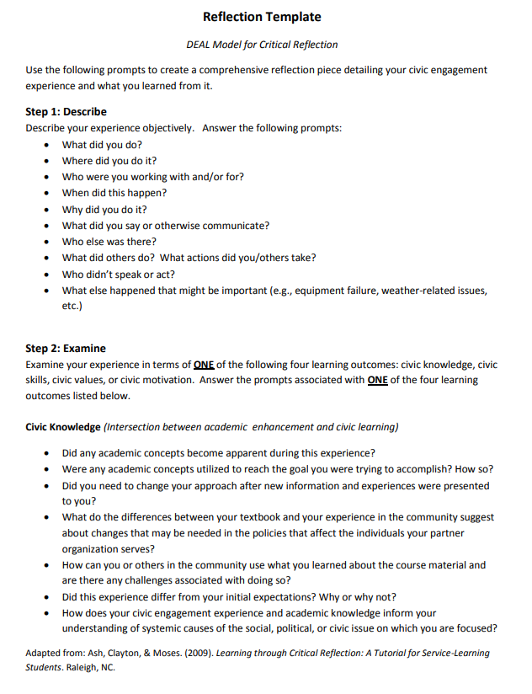

Report Writing


