Project Initiation Document
Circus Eruption – Network Solution

Paul M Lawrence (P152216) Undergraduate Student, Mcomp Computer Networks
University of Wales Trinity St David, Swansea, Mount Pleasant Campus
plawrence.152216@student.uwtsd.ac.uk

INTRODUCTION TO ‘CIRCUS ERUPTION’
Circus Eruption are a non-profit youth charity located in Swansea, South Wales. They have been operating since 1991 and were founded by Phil Burton. Their mission statement is to provide “a safe, playful, accessible and creative environment, free from discrimination and prejudice”[1] by teaching circus skills “as a vehicle to challenge self-perceived and imposed limits; enabling young people to realise and believe in their own potential and the potential of others”. [1] The age of the children and young adults who attend the circus range from 11-19 years old. They currently have over 50 volunteers and 75 youths attending their facility. [2]

Business Case
The charity has grown within the last 26 years and hasn’t caught up to modern business practises and technology’s that are an essential part of any organisation in 2017; due to lack of expertise and funding within IT.

My team and I have been tasked with providing a ‘Network Solution’ for the offices and facility of the charity so that the day-to-day administration and project/event planning can be streamlined more efficiently, effectively and securely for the volunteers who operate the charity and the young adult’s data whom will be stored within the network. The team have been given a deadline of 27/03/18 to complete the project. [2]

Organisation and Project hierarchy
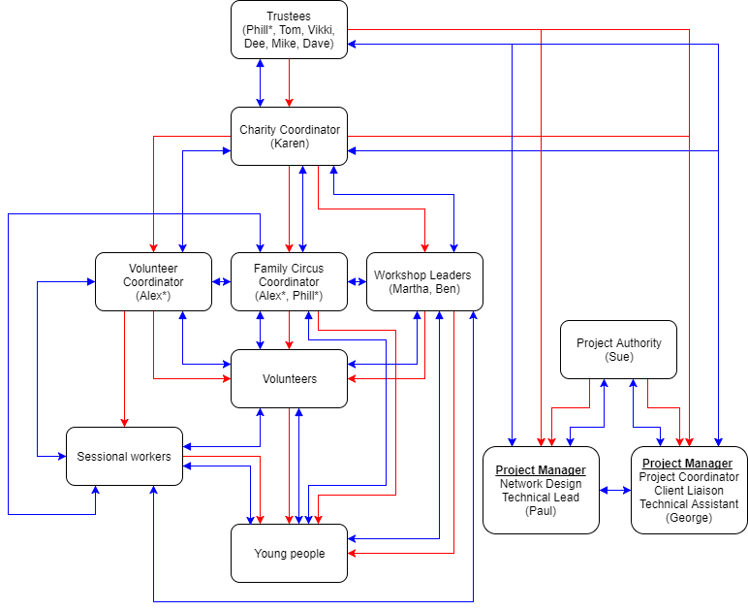
Figure 1: Organisation and Project Hierarchical Flow Diagram [2][3]

Project Scope
The ‘Network Solution’ should include a ‘Logical’ and ‘Physical’ topology [4] that should be designed with security, efficiency and budget constraint considerations.

Minimum Objectives:

- Design a segregated Local Area Network (LAN) with minimum budget constraints.

- Provide wireless access to LAN for staff and guests.

- Secure the network with budget constraint limitations.

- Centralised access of documents locally and remotely.

- Internet Access for Staff and Guests.

A basic network design will be sufficient for the end user’s current requirements and budget, so a ‘A Router on a Stick’ physical topology [5] will be implemented within the final design of the network. The network should also be; self-sufficient and secure, with minimal installation setup/costs, that will only require intermittent administration as there will be a small amount of end users and a volunteer administrator.

Constraints
The main project constraint is the budget, due to the nature of the business i.e. charity there is not any funds available for the project.

The completion of the project relies heavily on donations from local businesses and expertise from local volunteers i.e. network engineers/administrators.

The completion date is also a factor which will depend on hardware arrival (donations) and the availability of the volunteers.

Deliverables
The outcome of the project will include a fully functioning small mobile LAN network with wireless capabilities that’s moderately secure, economical and efficient that will meet the requirements of the end users effectively.

The Network Infrastructure will comprise of a maximum of 3 managed layer 2 switches, 1 router with ISP WAN interface and 1 gigabit ethernet LAN interface and a wireless access point (AP). [6][7]

The network will also be segmented using Virtual Local Area Network (VLAN’S) for security and higher throughput (broadcast domains). Also, Access Control Lists (ACL) will be utilised for added security within the LAN.[8][9]

The proposed network will require a centralised ‘Ubuntu Server’ (Opensource (free) Server Operating System software) [10][11] that will provide intermediate services and be responsible for: -

- The storage of sensitive data.

- AAA; Authentication (User names and passwords), Authorisation (user privileges within the network) and Accounting (log files) for network security which will all be managed through RADIUS service. [12][13]

- HTTP (Apache) for the charity’s intranet.[14]

- Dynamic Internet Protocol (IP) addressing using Dynamic Host Configuration Protocol (DHCP). [15]

- FTPS (encrypted) for accessing and transferring sensitive files remotely and securely over the internet. [16]

- Domain Name System (DNS) for host name to IP resolution.[17]

- E-Mail service for internal secure e-mail between staff members with ‘Circus Eruption’ domain name.[18]

The network will have Internet access for staff and guests.

The network will also have wireless capabilities which will be connected securely to the LAN and will utilise the ‘Bring Your Own Device’ (BYOD) ethos [19] that will be used by staff and guests. Security management of BYOD will include Access Control Lists (ACL) and AAA (RADIUS) for staff and WPA2- PSK [20] authentication for guests to access the internet.

Resources
The resources required to complete the project are:

- A technical team who can design, build and manage the project to completion.

- Network Simulation/Architecture Software i.e Packet Tracer (Cisco) to create the logical and physical topology of the network.[21]

- Internetworking Hardware i.e. Router, Switches, Server, Wireless Access Point (AP), Category 5e cables [22].

- End user/client input to tailor the network for their operational requirements. [1][2]

- A part time volunteer network administrator to manage the network once installed.

Project Team and Roles
The project team consists of two members: -

- Paul Lawrence; Network Designer and Technical Lead.

- George Searle; Project Coordinator and Client Liaison.

Time Management
A GHANT chart has been created to organise the resources and tasks of the project shown in figure 2:

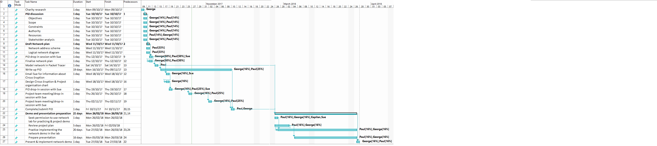
Figure 2: GHANT chart of Network Solution for Circus Eruption [3]

Task Assignments
A PERT chart has been created for more granular detail of tasks assigned to individual members within the project team, so that milestones and deadlines can be managed more efficiently. Shown in figure 3:-

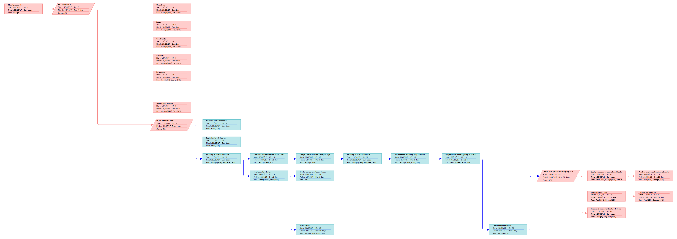
Figure 3: PERT Chart for Task Assignments (A3 available on request)[3]

Stakeholders
The stakeholders who have a direct and indirect interest within the project are;

- Client; Circus Eruption. (direct)

- Project Team developing solution. (direct)

- Project Authority; Sue Maw. (direct)

- Charity Members. (direct)

- Donors to the project i.e. Local businesses, sponsors. (indirect)

Reporting
During the development of the project a reporting structure has been put in place for regular meetings between the ‘Technical Lead’ and the ‘Project coordinator’ for progress reporting. Also, meetings with the project authority and client will be scheduled for milestone dates within the project.

Risk Management
The main risk that the project faces is the donation of the hardware that is a key requirement to the completion of the project. If hardware donations can’t be found, a charity fundraiser will be organised to raise the required funds needed which is estimated at £700 for refurbished equipment. [23] [24]

The charity’s premises are currently temporary, and there’s a high risk that the facility may change in the near future. [2] Therefore, the hardware will need to be easily transported from one facility to the next, so a mobile rack to house the hardware will be implemented into the final design of the physical topology to combat this potential problem, example shown in figure 4.

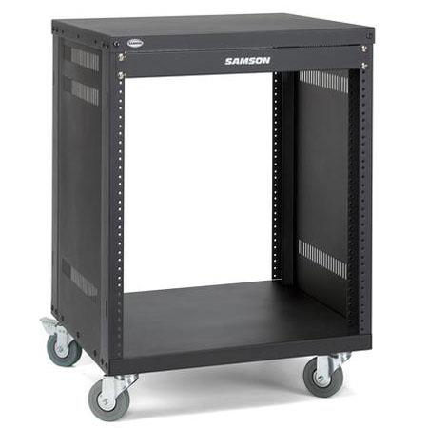
Figure 4: Mobile Network Hardware Rack [25]

Future Considerations
The proposed ‘Network Solution’ is based on the current budget, amount of end users and client requirements. If the organisation was to grow larger with more end users and additional requirements, the network would have to be upgraded further which would require a much larger budget: -

- Layer 3 switches to prevent bottle neck at router as the end users grow within the organisation (scalability). [26]

- ASA Firewall (hardware) added security at gateway to the WAN (Internet).[27] [28]

- Failover: Redundancy for internetworking devices to increase network availability. [29] (Extra router and two additional layer 3 switches for a full mesh design). [30]

- Additional Access Points for roaming of facility to accommodate additional end devices.

Agreement to proceed
Signatures:

Project Authority |  | Date:
Client |  | Date:

References
[1] Circus Eruption, “Circus Eruption,” Web, 2017. [Online]. Available: http://www.circuseruption.co.uk/. [Accessed: 01-Nov-2017].
[2] Sue Maw, “Course: L5 - Project Management (M5X00615),” UWTSD - Moodle, 2017. [Online]. Available: http://moodle.uwtsd.ac.uk/course/view.php?id=2230. [Accessed: 01-Nov-2017].
[3] G. (Project C. Searle, “Flow, Ghant and Pert Diagrams.” 2017.
[4] LearnCisco, “Network Topologies | Functions of Networking | ICND1 100-105,” learncisco.net, 2017. [Online]. Available: http://www.learncisco.net/courses/icnd-1/building-a-network/the-functions-of-networking.html. [Accessed: 03-Nov-2017].
[5] CiscoPress, “The Router on a Stick Concept: Cisco CCENT ICND1 100-101 Complete Video Course &gt;,” CiscoPress.com, 2013. [Online]. Available: http://www.ciscopress.com/articles/article.asp?p=2169749. [Accessed: 03-Nov-2017].
[6] Cisco, “What You Need to Know about Routing and Switching - Cisco,” cisco.com. [Online]. Available: https://www.cisco.com/c/en_my/solutions/small-business/products/routers-switches/routing-switching-primer.html. [Accessed: 03-Nov-2017].
[7] linksys, “What is an Access Point,” linksys.com, 2017. [Online]. Available: https://www.linksys.com/us/r/resource-center/what-is-a-wifi-access-point/. [Accessed: 03-Nov-2017].
[8] Cisco, “Overview of VLANS,” cisco.com. [Online]. Available: https://www.cisco.com/c/en/us/td/docs/switches/lan/catalyst4500/12-2/25ew/configuration/guide/conf/vlans.html. [Accessed: 03-Nov-2017].
[9] Cisco, “Information about Access Control Lists,” cisco.com. [Online]. Available: https://www.cisco.com/c/en/us/td/docs/switches/datacenter/nexus5000/sw/configuration/guide/cli/CLIConfigurationGuide/sec_ipacls.html. [Accessed: 03-Nov-2017].
[10] Ubuntu Opensource, “Ubuntu Server | Download | Ubuntu,” 2017. [Online]. Available: https://www.ubuntu.com/download/server. [Accessed: 03-Nov-2017].
[11] techtarget, “What is server?,” techtarget.com. [Online]. Available: http://whatis.techtarget.com/definition/server. [Accessed: 03-Nov-2017].
[12] techtarget, “What is authentication, authorization, and accounting (AAA) and RADIUS,” searchsecurity.techtarget.com, 2017. [Online]. Available: http://searchsecurity.techtarget.com/definition/authentication-authorization-and-accounting. [Accessed: 03-Nov-2017].
[13] Cisco, “How Does RADIUS Work? - Cisco,” cisco.com, 2006. [Online]. Available: https://www.cisco.com/c/en/us/support/docs/security-vpn/remote-authentication-dial-user-service-radius/12433-32.html. [Accessed: 03-Nov-2017].
[14] techtarget, “Apache HTTP server project,” techtarget.com. [Online]. Available: http://whatis.techtarget.com/definition/Apache-HTTP-server-project. [Accessed: 03-Nov-2017].
[15] U. U. Indian, “What is DHCP?,” kb.iu.edu. [Online]. Available: https://kb.iu.edu/d/adov. [Accessed: 03-Nov-2017].
[16] Interserver by Jithin, “About FTP, FTPS and SFTP,” Interserver.net, 2016. [Online]. Available: https://www.interserver.net/tips/kb/understanding-ftp-ftps-sftp/. [Accessed: 03-Nov-2017].
[17] Cisco, “Understanding the Domain Name System,” cisco.com. [Online]. Available: https://www.cisco.com/c/en/us/support/docs/ip/domain-name-system-dns/12683-dns-descript.html. [Accessed: 03-Nov-2017].
[18] V. Beal, “What is Email Server?,” webopedia.com. [Online]. Available: https://www.webopedia.com/TERM/E/e_mail_server.html. [Accessed: 08-Nov-2017].
[19] Cisco, “Security Is Maximum.”
[20] Mitchell Bradley, “Understanding WPA-2 PSK,” 2017. [Online]. Available: https://www.lifewire.com/what-is-wpa2-818352. [Accessed: 03-Nov-2017].
[21] Cisco, “Cisco Packet Tracer Data Sheet.”
[22] firefold, “What Are the Differences Between Cat5 and Cat5e Cables? - FireFold.com Blog,” firefold.com, 2017. [Online]. Available: https://www.firefold.com/blog/differences-cat5-cat5e-cables/. [Accessed: 03-Nov-2017].
[23] ebay, “CCNP Lab: Computers/Tablets &amp; Networking | eBay,” ebay.com, 2017. [Online]. Available: http://www.ebay.co.uk/bhp/ccnp-lab. [Accessed: 03-Nov-2017].
[24] ebay.co.uk, “HP ProLiant DL180 G6 2x Quad Core Xeon E5620 48GB RAM 12x 3.5 LFF Bays Configure | eBay,” ebay.co.uk, 2017. [Online]. Available: https://www.ebay.co.uk/itm/HP-ProLiant-DL180-G6-2x-Quad-Core-Xeon-E5620-48GB-RAM-12x-3-5-LFF-Bays-Configure/401323348267?hash=item5d70bc512b:m:mt6uUH_OXyxfWIWv7-poTDQ. [Accessed: 03-Nov-2017].
[25] Adorama, “sasrk12.jpg (450×450),” 2017. [Online]. Available: https://www.adorama.com/images/Large/sasrk12.jpg. [Accessed: 03-Nov-2017].
[26] B. Mitchell, “Layer 3 Switches for Network Routing,” lifewire.com, 2017. [Online]. Available: https://www.lifewire.com/layer-3-switch-817583. [Accessed: 03-Nov-2017].
[27] R. Zonealram - May, “What Is the Difference between Hardware and Software Firewalls? |Firewall Internet Security Tips,” zonealarm.com, 2014. [Online]. Available: http://www.zonealarm.com/firewall-blog/blog/difference-hardware-software-firewalls/. [Accessed: 03-Nov-2017].
[28] Cisco, “Cisco Adaptive Security Appliance (ASA) Software - Cisco,” cisco.com, 2017. [Online]. Available: https://www.cisco.com/c/en/us/products/security/adaptive-security-appliance-asa-software/index.html. [Accessed: 03-Nov-2017].
[29] NetworkLessons, “Introduction to Gateway Redundancy | NetworkLessons.com,” netwroklessons.com, 2016. [Online]. Available: https://networklessons.com/cisco/ccie-routing-switching/introduction-gateway-redundancy/. [Accessed: 03-Nov-2017].
[30] M. Rouse, “Full mesh network topology (mesh network)? - Definition from WhatIs.com,” techtarget.com. [Online]. Available: http://internetofthingsagenda.techtarget.com/definition/mesh-network-topology-mesh-network. [Accessed: 03-Nov-2017].

Bibliography
Odom, Wendell CCNA ‘Routing and Switching’ 200-105 official cert guide cisco press (2016)
ISBN-10: 1-58720-580-7

Bruno, Anthony; Jordan, Steve CCDA ‘Cisco Network Design’ 200-310 official cert guide (2016)
ISBN-10: 1-58714-454-9

Hucaby, David CCNA ‘Wireless’ 200-355 official cert guide (2016)
ISBN-10: 1-58714-457-3

Santos O, Stuppi J, Cisco CCNA security 210-260 official cert guide (2016)
ISBN: 1587205661

Horine, Gregg Project Management Absolute Beginners Guide, Fourth Edition (2017)
ISBN-10: 0-7897-5675-7

