

APPENDIX GA36c

LEVEL 6 ASSESSMENT SPECIFICATION

Student name: | Joshua Hanbury | Student ID number:
Programme: | BSc Applied Computing
Module: | Big Data
Module code: |  | Contribution to Overall Module Assessment (%): | 50%
Lecturer: | John Williams | Internal Verifier: | Jeanette Adams
Assignment Title: | Big Data Report | Word count (or equivalent): | 3000
Submission deadline: | 19/04/2020 | Return date of provisional marks & written feedback: | 26/04/2020
Submission method: | All written assessments, where practical and possible, must be submitted via Turnitin unless otherwise instructed by the Lecturer. (Please DO NOT put this assessment specification into Turnitin or it will match many similarities with other students’ submissions.)  Alternative submission method (if applicable):  Late submission of the assessment will result in a late penalty mark. Penalties for late submission: Up to one week late, maximum mark of 40%. Over one week late, 0%. Only the Extenuating Circumstances Panel may approve a change to submission dates.
Academic honesty / referencing: | Academic honesty is required. In the main body of your submission you must give credit to authors on whose research and ideas your work is based. Append to your submission a reference list that indicates the books, articles, etc. that you have used, cited or quoted in order to complete this assessment.

Module Learning Outcomes
(from module syllabus)
Upon the successful completion of this module, the student should be able to demonstrate the ability to:

1. Develop a systematic understanding of the concepts, architecture and technologies required to manage and process Big Data.

2. Critically evaluate the technologies and applications of Big Data.

TASK DESCRIPTION

NPTC Power is a fast growing, welsh based power company. We are the leading provider of reliable, flexible and low carbon power units to the UK electricity market. With a portfolio of over 1GW of small-scale, local thermal power generation and battery storage units, we help keep the country’s electricity system running.
NPTC Power have a contract to supply 700 homes in the Neath Port Talbot area with electricity. The current project consists of three Bio fuelled units each providing 1GW of electricity per hour. Each home is fitted with smart meters that record power usage. Usage Data is calculated hourly and at the end of each day uploaded to the NPTC Power systems. Power demand varies considerably throughout the day and throughout the week, and in different weather conditions. All these elements have an effects on power usage and in-turn demand.
As it stands, all three power units are working to full capacity, irrespective of day, hour or weather conditions. As a consequence the power units often generate surplus power, incurring extra fuel costs and unnecessary were and tear on the units. In order to reduce costs the manager would like to analyse the data so that they can more accurately predict the days, times when power usage will be low, and therefore turn off some of the power units.
There are three systems used by NPTC power:
- Customer Database with customers address postcode, wards etc.
- Smart Meter Data: date address Id, 24 hourly data usage.
- Weather Data: Daily average temperature, Precipitation.
All three systems have very different data storage and data formats. As a result the Business analyst has requested that they develop a data warehouse to order to analyse the data and accurately predict times when units can be switched on and off.
Using this data you should do the following:
- Design and develop an appropriate data warehouse structure to store the data provided.
- You should justify all of your design decisions.
- Upload the data into your data warehouse, documenting the ETL process in a professional manner.
Design, develop and critically evaluate reports that can be run to retrieve and display the
Following data:
- Report: Power usage over time for each day of the week and by hour, highlighting peaks and troughs.
      - Tabular Data Report
      - Line graph
- Dashboard: Power usage
    - Ward,
    - District,
    - Postcode
- Report: The impact that weather has on power usage
    - Rain
    - Temperature
The reports should be appropriately referenced and should include the appropriate tables of contents, tables of figures and tables of tables. Any figures should have titles and identification labels. The document should also be spellchecked and grammar-checked.
The report should be submitted via Turnitin.

Student FEEDBACK FORM
This section details the extent to which the assessment criteria are demonstrated by you, which in turn determines your mark. The marks available for each category of skill are shown. Lecturers will use the space provided to comment on the achievement of the task(s), including those areas in which you have performed well and areas that would benefit from development/improvement.
Generic Assessment Criteria | Marks available | Marks  awarded
1. Engagement with Literature Skills | 0
2. Knowledge and Understanding Skills | 10 | 7
Excellent coherent and detailed knowledge and systematic understanding of the principles and theories of current research and scholarship. Clear awareness of challenges to established views and the limitations of the knowledge base.
3. Cognitive and Intellectual Skills | 20 | 15
Excellent critical thinking, analysis, synthesis and evaluation. Ability to investigate contradictory or incomplete information and make strong, persuasive, arguments and judgements. Some evidence of independent thought and ability to ‘see beyond the question’, suggesting a grasp of the broader field and wider concepts.
4. Practical Application Skills | 60 | 45
An advanced application of a range of methods, materials, tools and techniques. The context of the application is well considered, and insightful. Can identify complex problems and propose excellent solutions. Innovation and creativity evident.
5. Transferable Skills for Life and Professional Practic | 10 | 8
Can communicate professionally confidently and consistently in a suitable format. Work is coherent, very fluent and is presented professionally. Demonstrates excellent graduate employment skills and an appetite for further development.

Assessment Mark (Assessment marks are subject to ratification at the Exam Board. These comments and marks are to give feedback on module work and are for guidance only until they are confirmed. ) | Late Submission Penalties (tick if appropriate) |  | 75%
 | Up to 1 week late (40% Max) |  | 75%
 | Over 1 week late (0%) |  | 75%

Joshua Hanbury
119560
Data Warehousing
Assignment 2

Contents
Data warehousing steps 2
Business Objectives 3
Data collection and analysis 4
Business Process 5
Data Model Construction 6
Data Warehouse Schema Proposal 7
ETL 8

Data warehousing steps
Data warehousing is a crucial tool for organisations when analysing data held. All of the data gathered by the organisation can be centralised and displayed in different formats, with many different sources of data being analysed. For this to be a reality there needs to be steps set on how to acquire and use a data warehouse.
To begin, a plan of the data warehouse system would need to be created so that the questions and queries asked of the data warehouse by staff and users can be dealt with. Data warehousing will be used as a tool by decision-makers or problem solvers where the results acquired from the data warehouse can have a large effect on the business or organisation.
For the plan of the data warehouse system there were many steps outlined, as seen below:
- The business objectives for the data warehouse needed to be appointed
- Next, information was collected and analysed on the organisation
- Then the business processes were outlined followed by data model construction
- The data warehouse schema was then designed through data sources and data transformations.

Business Objectives
The company, NPTC Power, is growing quickly in their field of providing units to the UK electricity market. NPTC Power are currently running non-stop at full power to delivery electricity to 700 homes in the Neath Port Talbot area where the power units are generating a surplus amount of power which is leading to more costs and running expense when it is not needed. For cost reduction purposes the manager of NPTC Power wishes to analyse the data to make valid predictions on times and days where power usage is lower thus leading to some of the power generators / units being switched off to save costs.
The relevant reports which NPTC Power require are:
- Power usage by ward
- Power usage by district
- Power usage by postcode
- Power usage by day
- Power usage by hour
NPTC Power wish for these reports to be displayed in the form of a tabular data report, line graph and other visual displays of data which can be used to assist in their decision making.

Data collection and analysis
The data provided by NPTC Power is retrieved from the three systems used by NPTC power. Firstly, data from the customer database will provide data on addresses, postcodes and wards. Data such as dates, address id and power usage are all provided through smart meter data which is provided. Thirdly, weather data is also provided to provide daily average temperature and precipitation.
Below is a diagram example of how the Smart Meter collects data.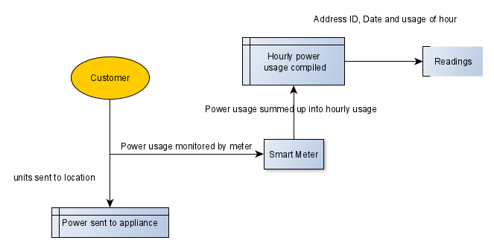

Core Business Processes
From previous sections I have been able gather clear insights on what business processes need to be corresponded to. Key performance indicators such as the power usage and hourly updates will assist in what the business processes will outline. We know the entities which provide the key performance indicators, which are gathered from NPTC Power’s smart meter data. Below is a diagram which will show what information the smart meters will provide which can be used.
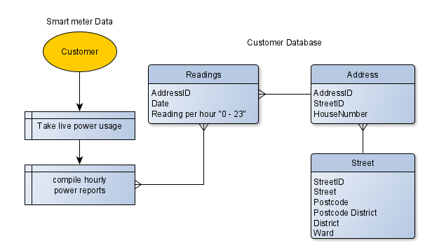
Below are some data definitions of each of the entities of the database.
Data Definition
Application Name  Data Source Name  Primary Key |  | NPTC Power Database  Address  AddressID
Connection | Details |  |  |  | Comments
Database Location  Database Platform  Dataset  SQL  Access Method | C:\NPTCPowerDB  Access  Address  Select * from Address  Select |  |  |  | The address table holds the addresses of customers of NPTC Power
File Name | Type |  | Size | Format |  | Description | Validation | Key
AddressID | AutoNumber |  | Integer | # |  | Primary Key | Must be Unique | P
StreetID | Number |  | Integer |  |  |  |  | F
HouseID | Number |  | Integer
City | Text |  | 20
Post Code | Text |  | 20

Data Definition
Application Name  Data Source Name  Primary Key |  | NPTC Power Database  Street  StreetID
Connection | Details |  |  |  | Comments
Database Location  Database Platform  Dataset  SQL  Access Method | C:\NPTCPowerDB  Access  Street  Select * from Street  Select |  |  |  | The street table holds information on all of the streets and postcodes of NPTC Power customers
File Name | Type |  | Size | Format |  | Description | Validation | Key
StreetID | AutoNumber |  | Integer | # |  | Primary Key | Must be Unique | P
Street | Short Text |  | 100
Postcode | Short Text |  | 20 |  |  |  | LL09 9LL
Postcode District | Short Text |  | 20
District | Short Text |  | 50
Ward | Short Text |  | 50

Data Definition
Application Name  Data Source Name  Primary Key |  | NPTC Power Database  PowerReadings  ReadingID
Connection | Details |  |  |  | Comments
Database Location  Database Platform  Dataset  SQL  Access Method | C:\NPTCPowerDB  Access  Power Readings  Select * from Street  Select |  |  |  | The address tables hold all Uk addresses.
File Name | Type |  | Size | Format |  | Description | Validation | Key
ReadingID | AutoNumber |  | Integer | # |  | Primary Key | Must be Unique | P
AddressID | Short Text |  | 100
RDate | Short Text |  | 20 |  |  |  | LL09 9LL
“1:00” | Short Text |  | 20
^^ - “23:00” | Short Text |  | 50

Data Model Construction
The data model concept can now be constructed as the business processes have been identified. Next, the fact table and dimension tables need to be determined so that the facts can be outlined and set. The key indicators as mentioned before which relate to the businesses processes will decide how the facts will be stored. Consistency between the data in the fact table is required to ensure a manageable and usable data warehouse is constructed.
Each dimension table has to relate to the key performance indicators. All of the dimension tables need to be populated fully to be useful in the fact table. In older systems there may be incomplete or mismatching data which requires cleansing. The fact table itself will be made up of foreign keys from the dimension tables.

Data Warehouse Schema Proposal
Fact Table: FactReading (FactID, AddressID, DateID, HourID, DayID, MonthID, WardID, PostCodeID, Fact)

Dimension Table: DimDate(DateID, RDate)
Dimension Table: DimDayOW (DayID, Day)
Dimension Table: DimMonth (MonthID, Month)
Dimension Table: DimPostCode (PostCodeID, PostCode)
Dimension Table: DimStreet (StreetID, Street)
Dimension Table: DimWard (WardID, Ward)
Dimension Table: DimYear (YearID, Year)

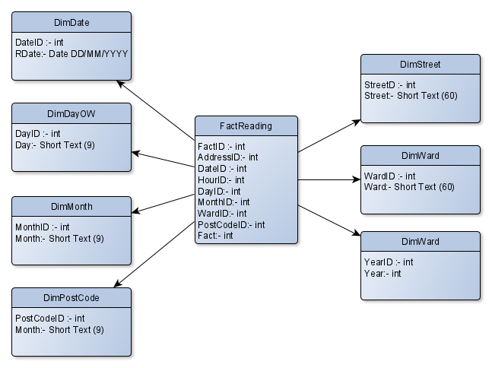

Data Definition
Application Name  Data Source Name  Primary Key |  | Power Reading Data Warehouse  DimDate  DateID
Connection | Details |  |  |  | Comments
Database Location  Database Platform  Dataset  SQL  Access Method | Oracle Apex hyperlink  Oracle  DimDate  Select * from DimDate  Select |  |  |  | Date dimension table
File Name | Type |  | Size | Format |  | Description | Validation | Key
DateID | AutoNumber |  | Integer | # |  | Primary Key | Must be Unique | P
Date | Date |  |  | DD/MM/YYYY

Data Definition
Application Name  Data Source Name  Primary Key |  | Power Reading Data Warehouse  DimDayOW  DayID
Connection | Details |  |  |  | Comments
Database Location  Database Platform  Dataset  SQL  Access Method | Oracle Apex hyperlink  Oracle  DimDayOW  Select * from DimDayOW  Select |  |  |  | Day of week dimension table
File Name | Type |  | Size | Format |  | Description | Validation | Key
DayID | AutoNumber |  | Integer | # |  | Primary Key | Must be Unique | P
Day | Text |  | 9

Data Definition
Application Name  Data Source Name  Primary Key |  | Power Reading Data Warehouse  DimMonth  MonthID
Connection | Details |  |  |  | Comments
Database Location  Database Platform  Dataset  SQL  Access Method | Oracle Apex hyperlink  Oracle  DimMonth  Select * from DimMonth  Select |  |  |  | Month dimension table
File Name | Type |  | Size | Format |  | Description | Validation | Key
MonthID | AutoNumber |  | Integer | # |  | Primary Key | Must be Unique | P
Month | Text |  | 9

Data Definition
Application Name  Data Source Name  Primary Key |  | Power Reading Data Warehouse  DimPostCode  PostCodeID
Connection | Details |  |  |  | Comments
Database Location  Database Platform  Dataset  SQL  Access Method | Oracle Apex hyperlink  Oracle  DimPostCode  Select * from DimPostCode  Select |  |  |  | Post Code dimension table
File Name | Type |  | Size | Format |  | Description | Validation | Key
PostCodeID | AutoNumber |  | Integer | # |  | Primary Key | Must be Unique | P
PostCode | Text |  | 9

Data Definition
Application Name  Data Source Name  Primary Key |  | Power Reading Data Warehouse  DimStreet  StreetID
Connection | Details |  |  |  | Comments
Database Location  Database Platform  Dataset  SQL  Access Method | Oracle Apex hyperlink  Oracle  DimStreet  Select * from DimStreet  Select |  |  |  | Street dimension table
File Name | Type |  | Size | Format |  | Description | Validation | Key
StreetID | AutoNumber |  | Integer | # |  | Primary Key | Must be Unique | P
Street | Text |  | 90

Data Definition
Application Name  Data Source Name  Primary Key |  | Power Reading Data Warehouse  DimWard  WardID
Connection | Details |  |  |  | Comments
Database Location  Database Platform  Dataset  SQL  Access Method | Oracle Apex hyperlink  Oracle  DimWard  Select * from DimWard  Select |  |  |  | Ward dimension table
File Name | Type |  | Size | Format |  | Description | Validation | Key
WardID | AutoNumber |  | Integer | # |  | Primary Key | Must be Unique | P
Ward | Text |  | 90

Data Definition
Application Name  Data Source Name  Primary Key |  | Power Reading Data Warehouse  DimYear  YearID
Connection | Details |  |  |  | Comments
Database Location  Database Platform  Dataset  SQL  Access Method | Oracle Apex hyperlink  Oracle  DimYear  Select * from DimYear  Select |  |  |  | Year dimension table
File Name | Type |  | Size | Format |  | Description | Validation | Key
YearID | AutoNumber |  | Integer | # |  | Primary Key | Must be Unique | P
Year | Text |  | 90

ETL
There needs to be an identification of the origin and method in which each item of the data warehouse extracts data, transforms it and loads it into the data warehouse.

Dimension: Date
The date dimension pulls the date data from the readings table. Every individual date is gathered and entered into the DimDate dimension to display all of the dates where a reading is taken for NPTC Power.
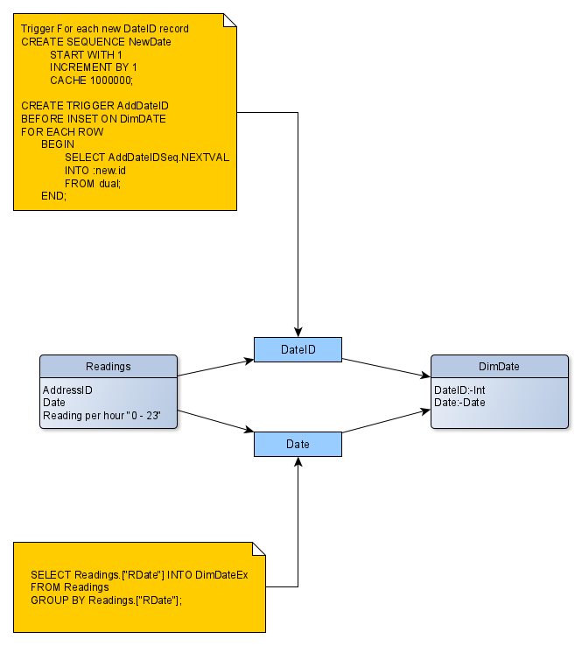

Dimension: DayOW
The DayOW dimension is created by assigning an ID to each day of the week. As the weekdays are set factors this dimension was created manually and will be used for the fact table to show what day of the week each date belongs to. This data relates to the day data held in the date table.
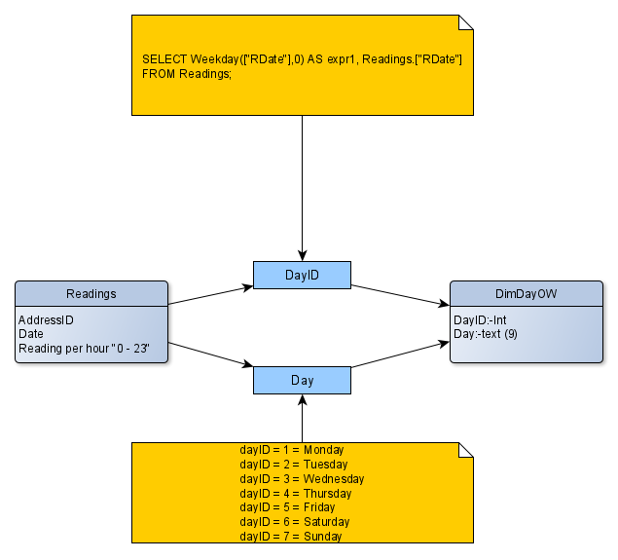

Dimension: Month
The month dimension was constructed in the same manner of the day of week dimension. The table consists of the 12 months which will then be set in the fact table to identify monthly figures. This data relates to the month data held in the date table.
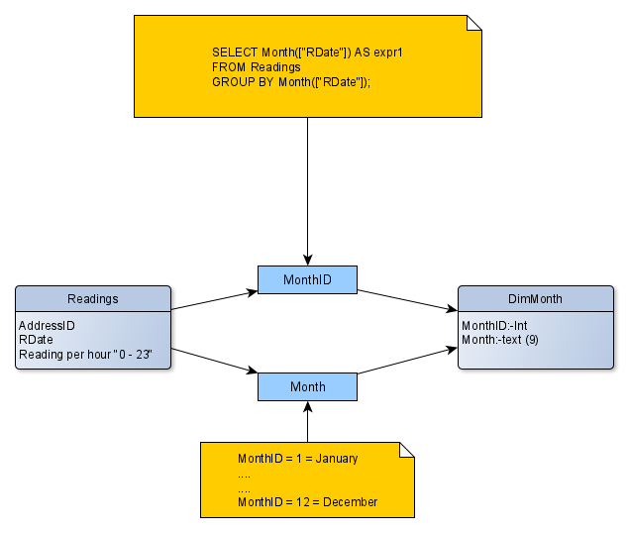

Dimension: PostCode
The PostCode dimension is gathered from the street table, with the postcodes being striped and used to append the DimPostCode dimension. Each postcode will have an individual ID to identify what postcode relates to the data which will be held in the fact table.
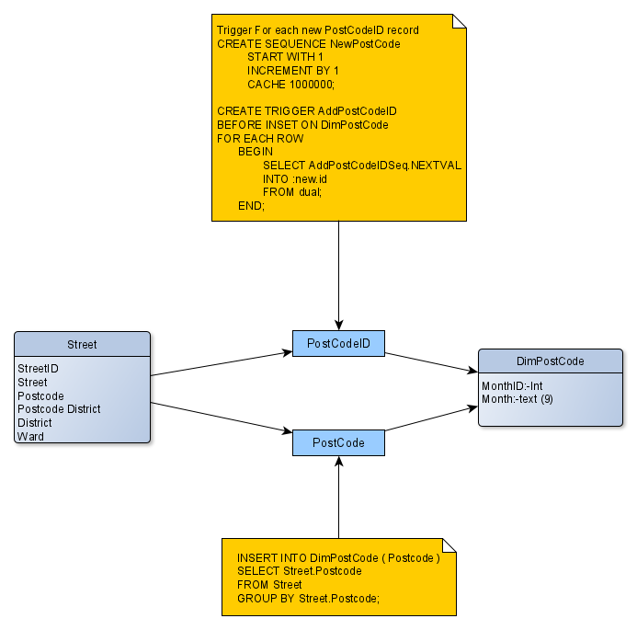

Dimension: Street
The street dimension was created through the street table where the StreetID and Street names were selected and used to create the DimStreet dimension table. StreetID is the primary key in the Street Table and joins with Street ID in the Address table which links directly to the Address ID in the Fact table to ensure referential integrity and accurate data.
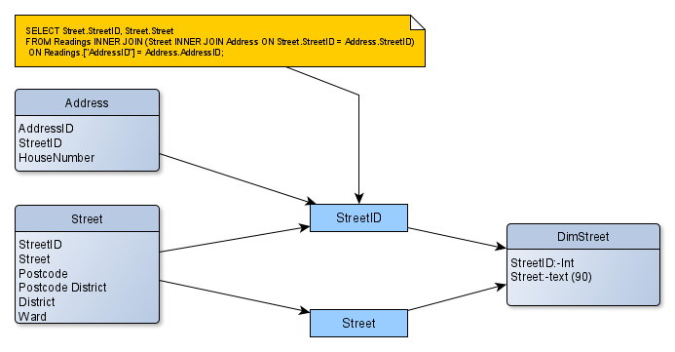

Dimension: Ward
This Dimension table, like the two before it, utilised only one table for the extraction of data. The street table was used to select the Wards that are within the street table and assign an ID to each of them.
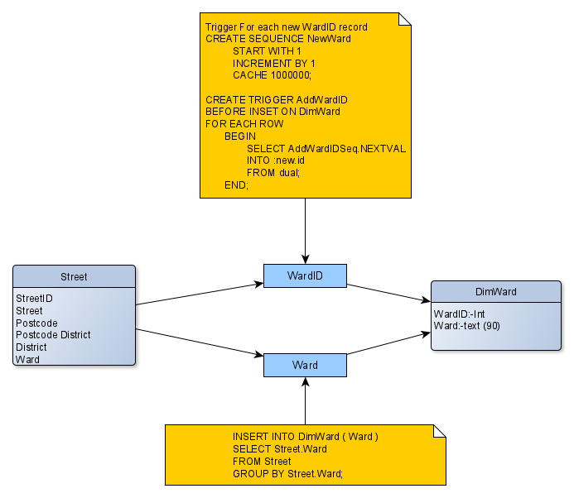

Dimension: Year
The year dimension was created manually to provide data on the years in which the readings have data for. As NPTC Power is a new company, there is only 2019 data currently in the system, which makes only 1 ID in year dimension; 2019.
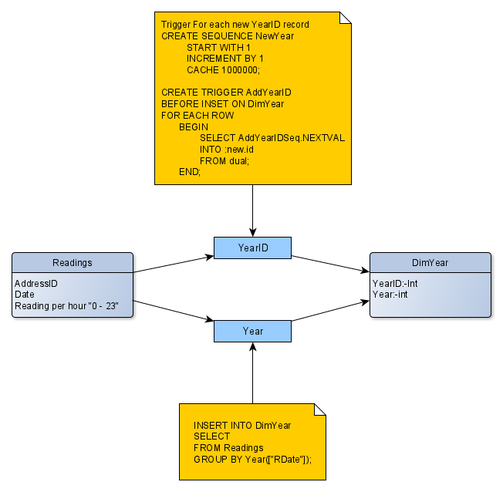

Fact Table
The fact table contains all of the IDs from the Dimensions as foreign keys with the FactID combining them all together to provide valid data which can be analysed thoroughly by NPTC Power to provide useful charts, graphs and data formats. Each ID includes all of the dimension foreign keys and the reading value for each FactID. The fact table begins with a simple Fact ID column. The number of columns are then extended through the Dimension tables being appended to the Fact Table to create the warehouse.
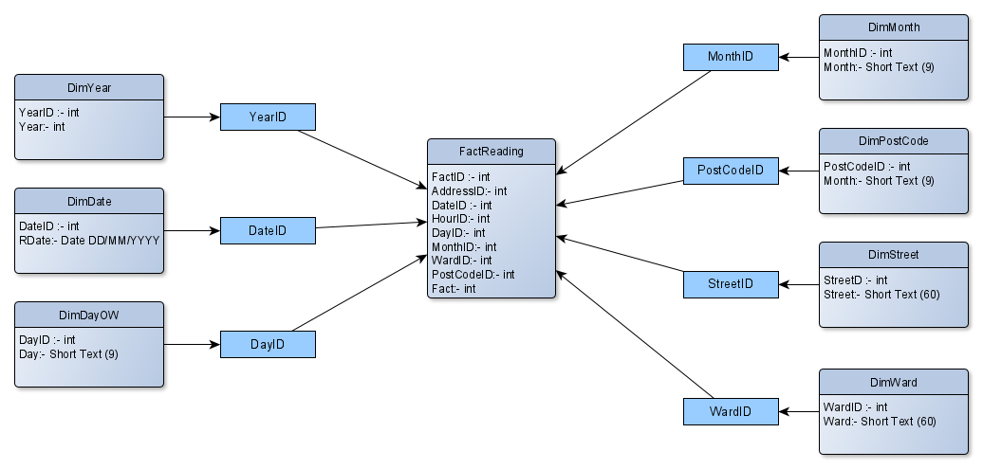

Data Warehouse
This section is displaying the data warehouse that has been created for the solution.

Dimensions
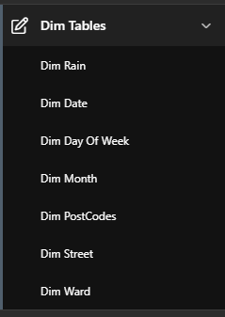
Each dimension table can be accessed in the warehouse. The data tables are included in the user dashboard for viewing or for including more data.
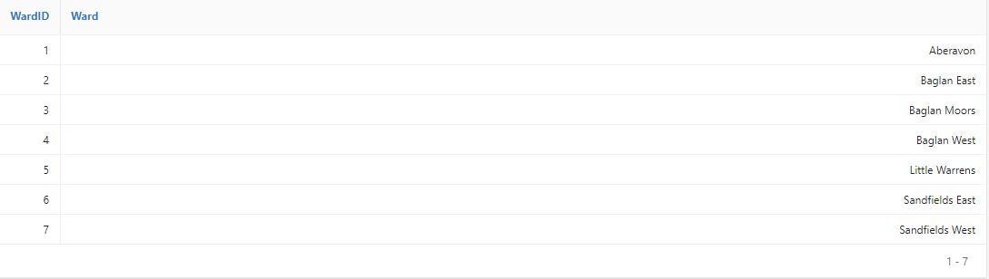

Fact Table
The fact table, as shown below, is contained in the data warehouse where it can be viewed to show all of the foreign keys included in it which are gathered from all of the dimensions created previously.
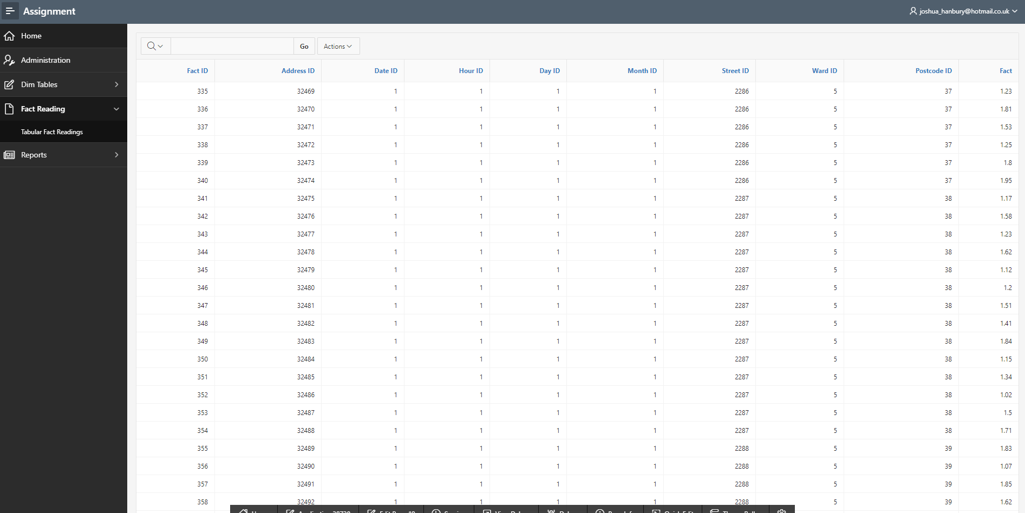

Tabular Fact Reading
The tabular fact reading is a useful analysis viewing of data which shows the readings of data compiled into days and hours containing the reading results as a total per day. There is a data view showing precise numbers per day, per hour. The bottom half of this screen contains a graph view, showing the total readings per day in the form of a bar chart. This is a very useful analysis technique allowing for users to see the totals of the readings per days to determine the most popular days and times. This alone is a useful analysis screen that will aid NPTC Power in their search to find the least popular or busy hours of readings where they can potentially switch off generators at quieter times, so they are not making excess power, thus requiring higher costs.
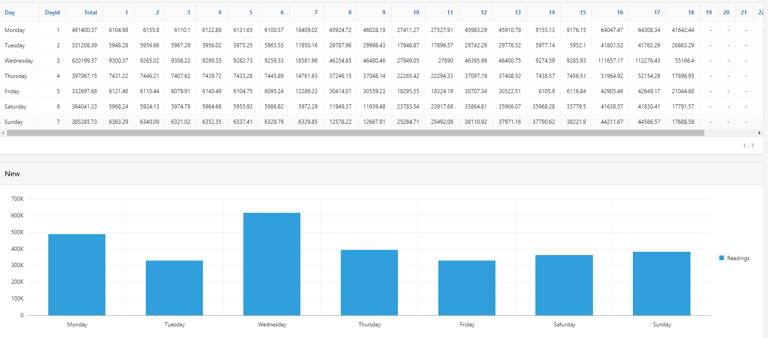
Below is the code snippet which was used to acquire the data from the Tabular Fact Reading tables.
select
DIMDAYOW.DAY as DAY,
FACTREADING2.DAYID,
SUM(FACTREADING2.FACTID) AS "Total",
SUM(CASE FACTREADING2.HOURID WHEN 1 THEN FACTREADING2.FACT END) AS "1",
SUM(CASE FACTREADING2.HOURID WHEN 2 THEN FACTREADING2.FACT END) AS "2",
SUM(CASE FACTREADING2.HOURID WHEN 3 THEN FACTREADING2.FACT END) AS "3",
SUM(CASE FACTREADING2.HOURID WHEN 4 THEN FACTREADING2.FACT END) AS "4",
SUM(CASE FACTREADING2.HOURID WHEN 5 THEN FACTREADING2.FACT END) AS "5",
SUM(CASE FACTREADING2.HOURID WHEN 6 THEN FACTREADING2.FACT END) AS "6",
SUM(CASE FACTREADING2.HOURID WHEN 7 THEN FACTREADING2.FACT END) AS "7",
SUM(CASE FACTREADING2.HOURID WHEN 8 THEN FACTREADING2.FACT END) AS "8",
SUM(CASE FACTREADING2.HOURID WHEN 9 THEN FACTREADING2.FACT END) AS "9",
SUM(CASE FACTREADING2.HOURID WHEN 10 THEN FACTREADING2.FACT END) AS "10",
SUM(CASE FACTREADING2.HOURID WHEN 11 THEN FACTREADING2.FACT END) AS "11",
SUM(CASE FACTREADING2.HOURID WHEN 12 THEN FACTREADING2.FACT END) AS "12",
SUM(CASE FACTREADING2.HOURID WHEN 13 THEN FACTREADING2.FACT END) AS "13",
SUM(CASE FACTREADING2.HOURID WHEN 14 THEN FACTREADING2.FACT END) AS "14",
SUM(CASE FACTREADING2.HOURID WHEN 15 THEN FACTREADING2.FACT END) AS "15",
SUM(CASE FACTREADING2.HOURID WHEN 16 THEN FACTREADING2.FACT END) AS "16",
SUM(CASE FACTREADING2.HOURID WHEN 17 THEN FACTREADING2.FACT END) AS "17",
SUM(CASE FACTREADING2.HOURID WHEN 18 THEN FACTREADING2.FACT END) AS "18",
SUM(CASE FACTREADING2.HOURID WHEN 19 THEN FACTREADING2.FACT END) AS "19",
SUM(CASE FACTREADING2.HOURID WHEN 20 THEN FACTREADING2.FACT END) AS "20",
SUM(CASE FACTREADING2.HOURID WHEN 21 THEN FACTREADING2.FACT END) AS "21",
SUM(CASE FACTREADING2.HOURID WHEN 22 THEN FACTREADING2.FACT END) AS "22",
SUM(CASE FACTREADING2.HOURID WHEN 23 THEN FACTREADING2.FACT END) AS "23",
SUM(CASE FACTREADING2.HOURID WHEN 0 THEN FACTREADING2.FACT END) AS "0"

from DIMDAYOW DIMDAYOW, FACTREADING2 FACTREADING2
where FACTREADING2.DAYID=DIMDAYOW.DAYID
group by FACTREADING2.DAYID, DIMDAYOW.DAY
ORDER BY FACTREADING2.DAYID

Reports
The report dashboard is the first screen that is shown when clicking the reports tab within the data warehouse. It contains 4 tabs all holding different data displayed using different types of charts. The data, going from the top pane then across left to right is:
- Reading totals by date
- Reading totals per ward
- Reading totals per day of week
- Reading totals per hour
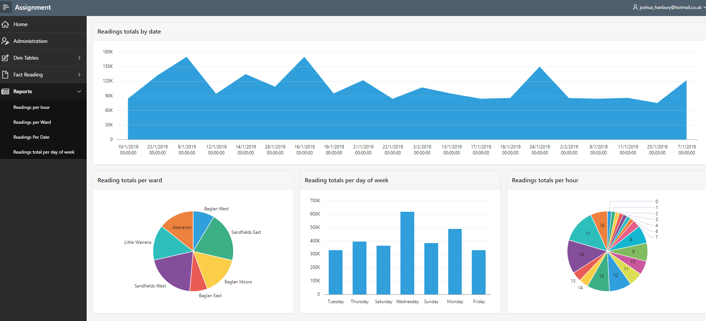This data is all which is asked of by NPTC Power for assisting them in their decision making. The data has been displayed in the best forms for viewing and the charts have been carefully selected to ensure users can effectively see how the reading data correlates to different factors such as per day, per ward and per hour. This is a very useful technique and will definitely aid NPTC Power with their decision making. There may be the issue of data not being precise due to the use of charts, but through further investigation via hovering the mouse over areas of the charts, the precise figures will be shown to the user if they require it.

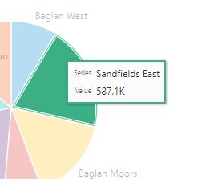

SQL for Readings per Ward
select DIMWARD.WARD as WARD,
sum(FACTREADING2.FACT) as FACT
from DIMWARD DIMWARD,
FACTREADING2 FACTREADING2
where FACTREADING2.WARDID=DIMWARD.WARDID
group by DIMWARD.WARD

SQL for Readings per Day
select FACTREADING2.HOURID as HOURID,
sum(FACTREADING2.FACT) as FACT
from FACTREADING2 FACTREADING2
group by FACTREADING2.HOURID

SQL for Readings per Hour
select FACTREADING2.HOURID as HOURID,
sum(FACTREADING2.FACT) as FACT
from FACTREADING2 FACTREADING2
group by FACTREADING2.HOURID
SQL for Readings per Date
select DIMDATE.RDATE as RDATE,
sum(FACTREADING2.FACT) as FACT
from DIMDATE DIMDATE,
FACTREADING2 FACTREADING2
where DIMDATE.DATEID=FACTREADING2.DATEID
group by DIMDATE.RDATE

Link to Data Warehouse

URL: https://apex.oracle.com/pls/apex/f?p=38738:LOGIN_DESKTOP:11418391359227:::::

Username: admin

Password: password
(case sensitive)

