Programme: BSc Cloud Computing
Module: Changemakers: Creativity and Value Creation
Lecturer: Dr Aliyu Sambo
Assignment Title: PowerPoint Presentation Part 2
Student Name: Carol Cernea
Student Number: 2113437

PowerPoint presentation link
https://web.microsoftstream.com/video/920c68e8-0ef5-4719-a124-a38079eae1bf



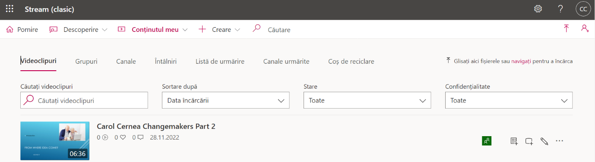

https://web.microsoftstream.com/video/920c68e8-0ef5-4719-a124-a38079eae1bf

