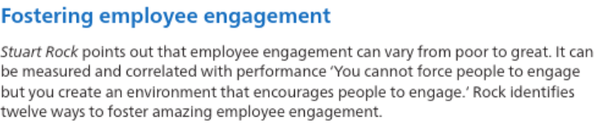
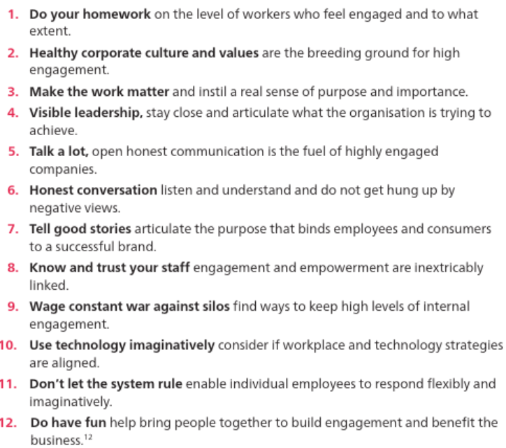
To what extent can YOU identify with Stuart Rock’s twelve ways to foster amazing employee engagement?
Consider yourself as an individual as well as individuals in an organisation you are familiar with.

