UNIVERSITY OF WALES TRINITY SAINT DAVID
LONDON CAMPUS
Assignment 2
Learning in the Digital Era
Video Link: A presentation on Self-Evaluation, Professional Development Plan and Topic Summary.pptx
Please be sure to give unrestricted access to your video presentation so that your work can be marked by the examiner.
Module Name: Learning in the Digital Era
Module Code: ACCA 4025

Student Name: Lihadi Deen-Alhadi
Student ID: 2519142
Group: 1

Lecturer’s Name: Koushik Modak

Table of Contents
Introduction 2
Main Body 2
Conclusion 9
References 9

Introduction
A general introduction for this word document (Briefly in a few sentences explain what this report is going to be about)

Main Body
Write one/two sentences.
Video Link: A presentation on Self-Evaluation, Professional Development Plan and Topic Summary.pptx
Slide 1 COVER PAGE

Slide 2 CONTENTS

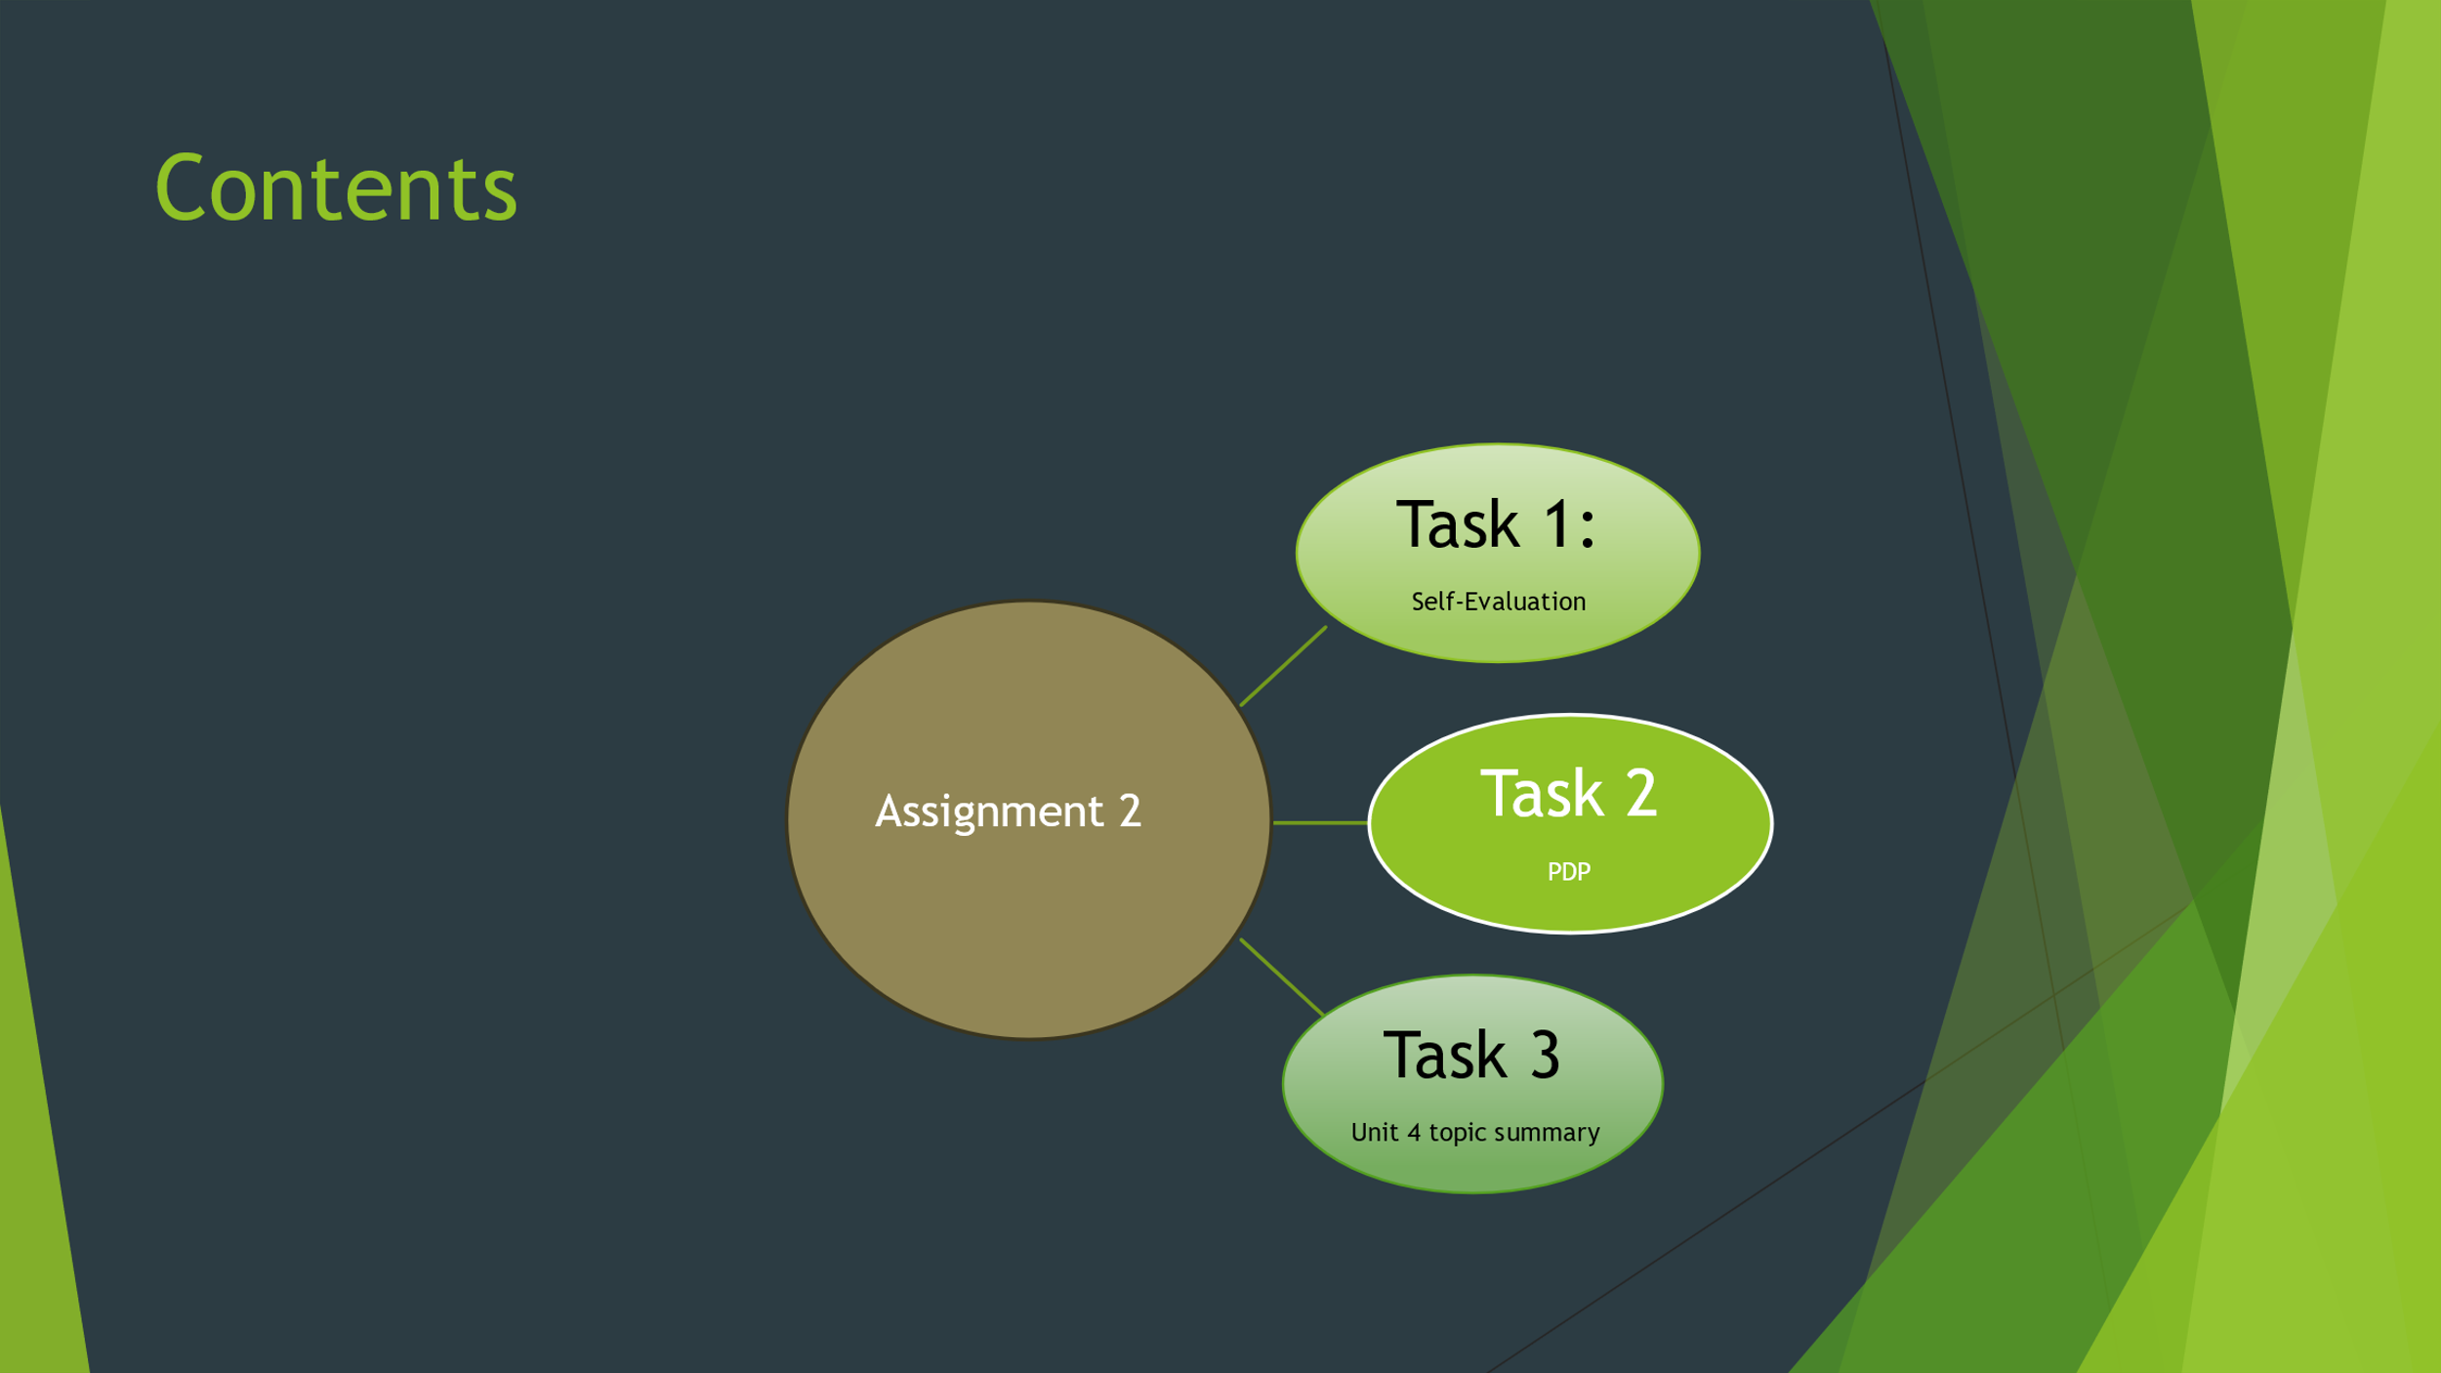
Slide 3 INTRODUCTION


Slide 4 MAIN BODY


Slide 5 GIBB’s REFLECTIVE MODEL
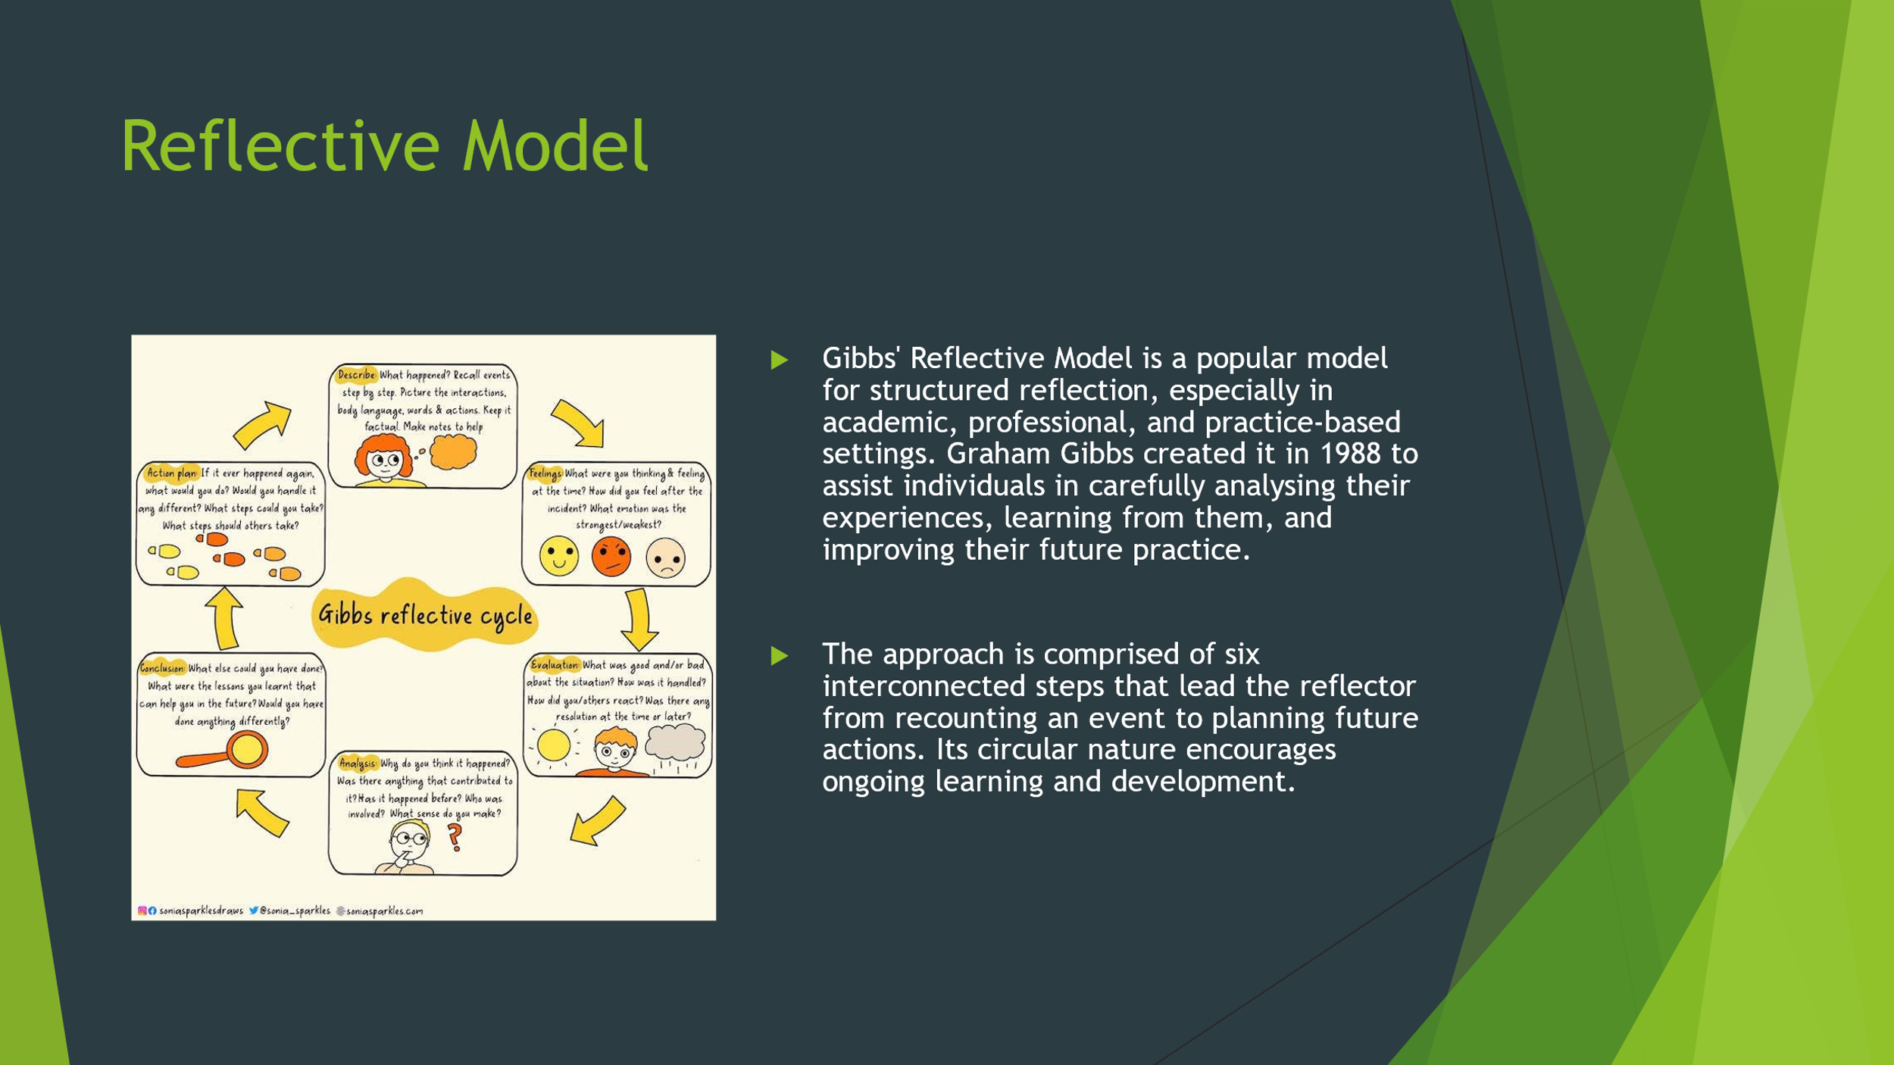
Gibbs’ Reflective Cycle is a structured model developed to support systematic reflection on experiences, enabling individuals to learn from practice and improve future performance (Gibbs, 1988). The model consists of six stages: description, feelings, evaluation, analysis, conclusion, and action plan. Each stage encourages critical thinking and deeper understanding of an experience [1].
This Model will be used in Assignment 2 to consider a particular learning or professional experience. By outlining the circumstances in detail, examining individual reactions, and critically assessing results, the cycle will direct an organized reflection. To increase the depth of thought, the analysis stage will be used to connect pertinent theory and scholarly literature to practice. Lastly, the action plan will show learning and growth by outlining doable strategies for future progress. Gibbs' Reflective Model guarantees that the reflection is methodical, analytical, and constant improvement focused.

Slide 6 TASK 1: SELF EVALUATION
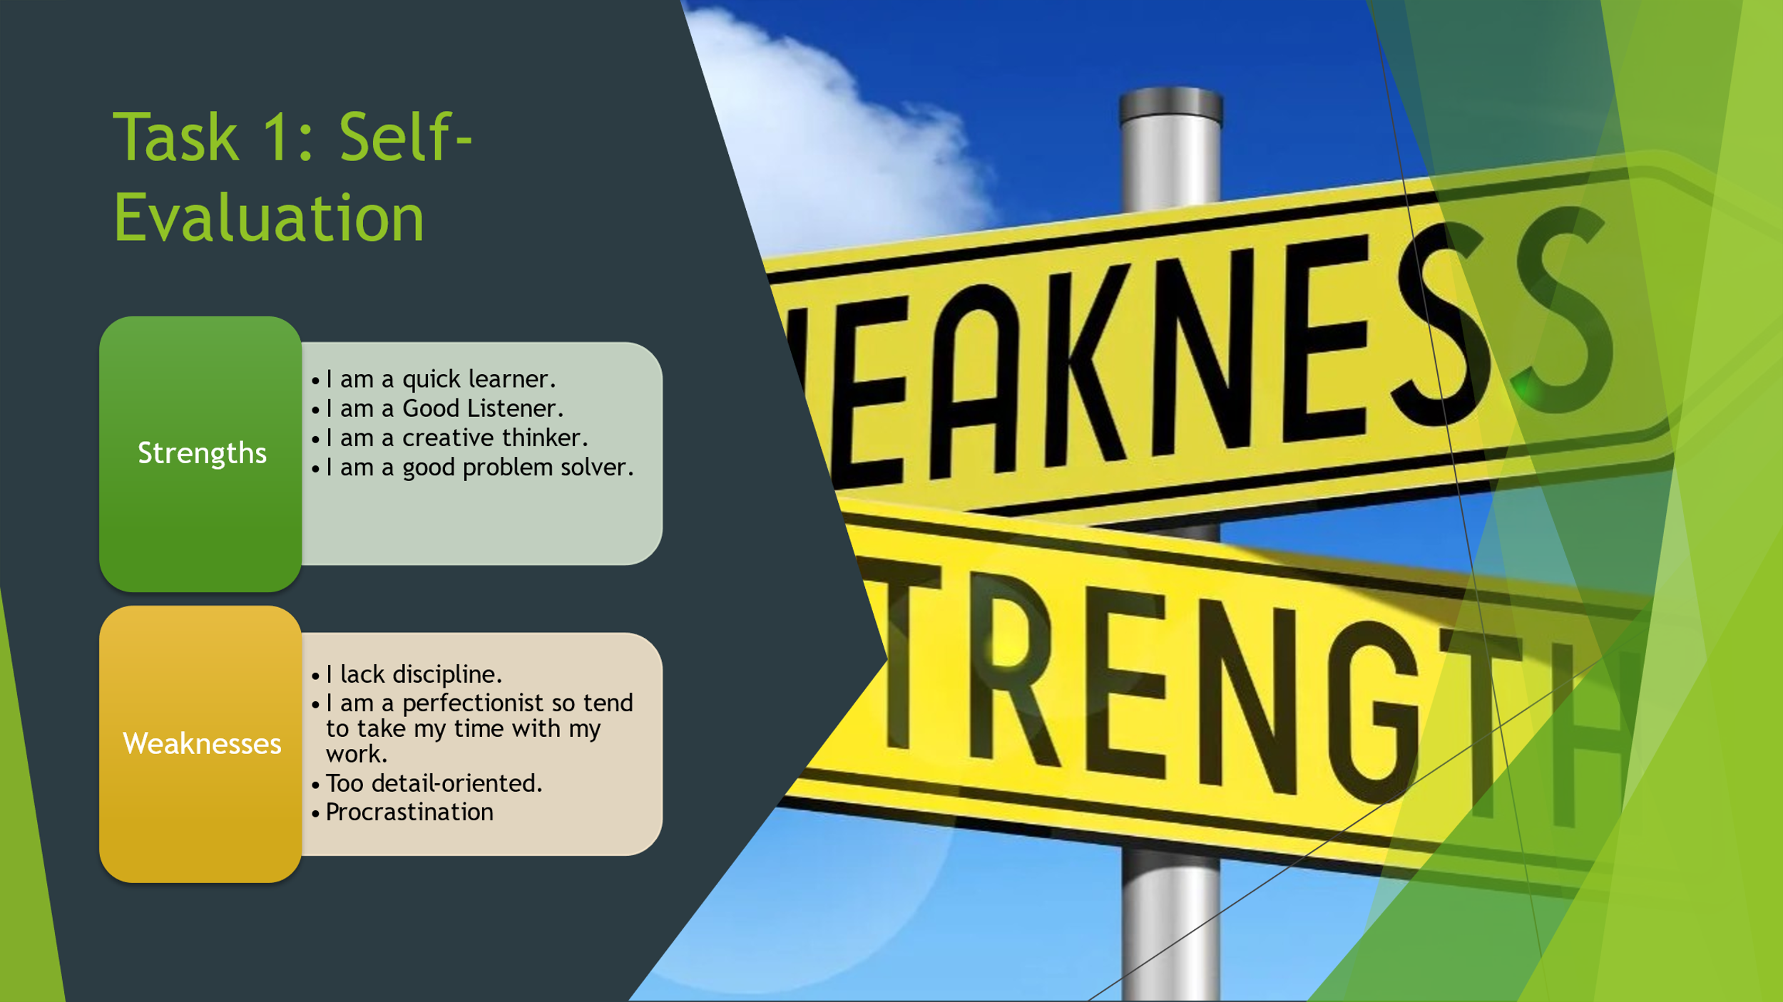
Strengths
One key strength identified through self-reflection is self-awareness. This enables an individual to recognize their actions, understand how their behaviour affects others, and identify areas where improvement is needed. Self-awareness supports learning from experience and responding positively to feedback.
Another strength is adaptability. The ability to adjust behaviour in response to change or challenges allows an individual to remain effective in different situations. Adaptability supports problem-solving, helps manage pressure, and encourages a positive response to new expectations or environments.
Commitment to improvement is also a significant strength. Reflecting on experiences demonstrates a willingness to learn, develop skills, and improve performance. This mindset supports long-term growth and contributes positively to both academic and professional settings.
Additionally, accountability is a strength developed through reflection. Taking responsibility for actions and outcomes helps build trust, reliability, and professionalism.
Weaknesses
A key weakness identified is time management, particularly in managing punctuality or balancing multiple responsibilities. This can affect performance and productivity if not addressed effectively.
Another weakness may be overreliance on routine, which can make it challenging to respond quickly to unexpected changes. While structure can be beneficial, too much dependence on routine may limit flexibility.
Confidence in decision-making can also be an area for improvement. Hesitation or overthinking decisions may reduce efficiency and impact performance under pressure.
However, identifying these weaknesses through reflection is a positive step, as it allows for targeted development strategies to be implemented.
Summary
Overall, self-reflection highlights a balance of strengths and weaknesses. Strengths such as self-awareness, adaptability, accountability, and a commitment to improvement support effective performance, while weaknesses such as time management and confidence provide clear areas for development. By acknowledging both, an individual can create realistic action plans to enhance performance and support continuous personal and professional growth.[2]

Slide 7 TRAITS GAINED FROM THE SELF EVALUATION
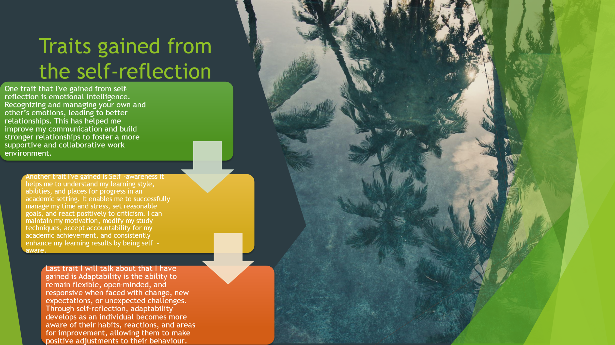

Brief explanation:
Self-reflection encourages people to assess their experiences, actions, and reactions, which aids in the development of a variety of beneficial attributes. One important quality acquired is self-awareness, which enables people to see their own advantages and disadvantages as well as how their actions affect other people. This encourages accountability and ongoing development.
Accountability is another crucial quality that arises from self-reflection, as people learn to accept responsibility for their deeds and results. Additionally, adaptability is enhanced, allowing people to modify their behavior in response to obstacles or change. Furthermore, self-reflection improves emotional intelligence, which enables people to identify and better control their emotions. All things considered, these characteristics support better decision-making, professional conduct, and personal development[3]

Slide 8 PROFESSIONAL DEVELOPMENT PLAN
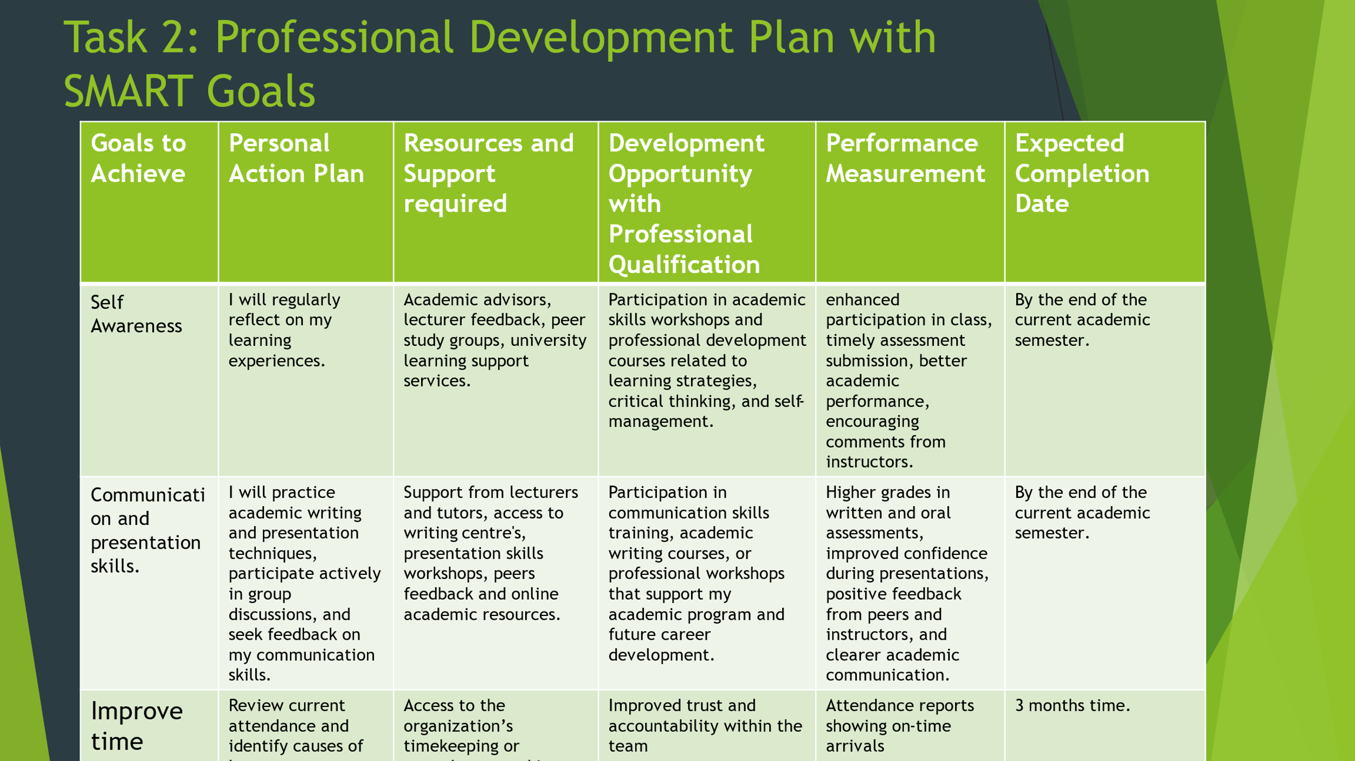
Brief explanation:
A Professional Development Plan (PDP) is an organized method that assists people in determining their professional goals, evaluating their present abilities, and organizing the actions required to attain advancement. It offers a precise road plan for education, skill enhancement, and professional advancement. People can create reasonable goals, track their progress, and take concrete action to enhance performance and accomplish their career goals in an organized and efficient manner by combining a PDP with SMART objectives.[4]

Slide 9 UNIT 4 TOPIC SUMMARY
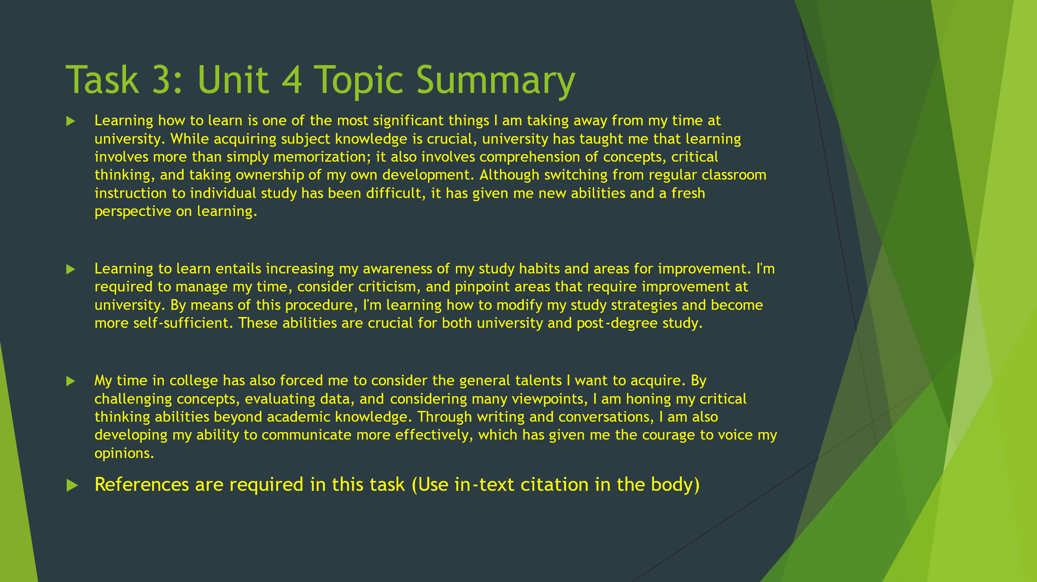
Brief explanation: The capacity to comprehend and successfully control your own learning process is known as learning to learn. It entails honing abilities like introspection, critical thinking, time management, and the capacity to apply information in various situations. People can recognize their strengths and shortcomings, adopt tactics that fit their unique learning style, and continuously advance their knowledge and abilities by learning how to learn. This ability promotes professional growth, flexibility, and lifelong learning.

Slide 10 CONCLUSION

Brief explanation: To sum up, thinking back on my advantages and disadvantages has taught me a lot. I've discovered that my strengths—adaptability, self-awareness, and accountability—help me function successfully and collaborate with others. Simultaneously, I've identified areas that need work, such as time management, decision-making confidence, and adaptability to unforeseen developments. I've developed valuable qualities like emotional intelligence, resilience, and a dedication to lifelong learning as a result of this self-reflection process. All things considered, this self-evaluation has not only improved my understanding of myself, but it has also given me specific ideas and tactics to enhance my performance and accomplish both my personal and professional objectives.

Slide 11

Conclusion
In conclusion, this document has provided a detailed reflection on my personal strengths, weaknesses, and the traits I have gained through self-reflection. By evaluating my performance and behaviours, I have developed a clearer understanding of myself, identified areas for improvement, and recognised key qualities that support my growth. This process has highlighted the importance of continuous learning, adaptability, and accountability in both personal and professional development. Overall, the insights gained will help guide my future actions, improve my performance, and support my ongoing personal and career growth.

References

[1] D. Gottlieb and C. Shu, "On the Gibbs phenomenon and its resolution," SIAM Rev. vol. 39, no. 4, pp.644–668, 1997,
[2] W. F. Stone, G. Lederer and R. Christie, "Introduction: Strength and weakness," in Strength and weakness: The authoritarian personality today, Springer, 1993, pp. 3–21.
[3] S. E. Taylor, E. Neter and H. A. Wayment, "Self-evaluation processes," Person.Soc.Psychol Bull. vol. 21, no. 12, pp.1278–1287, 1995,
[4] S. S. Yates, The SMART goal framework: Teacher perceptions of professional learning and teacher practice, Northcentral University, 2014.

