EXHIBTION TITLE: Visual Stimulation
Student: Todd Richards 0552082
Course: Ways of Perceiving ( ADDA4023/C )

Location: Yosemite National Park

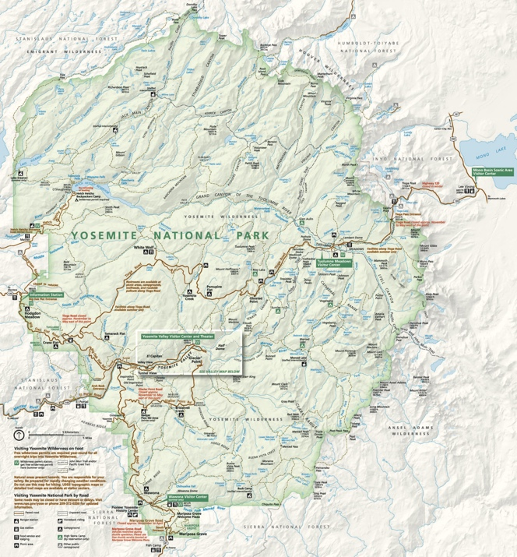
Figure 1 Map of Yosemite National Park (Yosemite Conservancy, 2022)

Good morning and welcome to Yosemite Park Visual Stimulation art exhibition. Today you will be visiting tourist destination throughout Yosemite Park that includes trails and vista points where you be able to enjoy some of mother nature's art works as well as chosen pieces of artwork by a variety of artists.

This exhibition includes work from Andy Goldsworthy, Jean Tonguely, Louise Bourgeois and Ansel Adams. The artwork chosen in this exhibition were picked for their connection with nature and the outdoors either due to their size, the materials they were made from, their content, or because they were made to be shown outside. Each artwork has been placed in the locations throughout the park for their connection with nature in relation to the area, to give them to best viewing surroundings to show off the art visually to the best extent and how the piece was originally meant to be viewed.

This exhibition drew inspiration from artists who challenged what exhibitions could and should be. Courbet set up a temporary exhibition near a salon after his work was rejected from being shown in the salon (Obrist and Raza, 2014). Manet changed the way that his paintings were viewed in a gallery. Instead of being displayed side by side he chose to display the paintings spaced out so that they could be viewed without the distraction of other paintings around it (Obrist and Raza, 2014). With Whistler’s The Peacock Room, instead of creating a room in which to view works of art he turned the room itself into a work of art (Obrist and Raza, 2014). These artists all changed the way art is viewed and perceived.

Outdoor art has become more popular and a there has been an increase around the world of art theme parks since the 1980s (Langen, 2015). With having the outdoors available, the artists can create gigantic pieces of work where there are no restraints and confinements in showing the work as they would find in a museum or gallery. Many artists will use the environment and the resources available at the site to create their work weather it is a temporary or permanent structures and many are allowed to decompose and give back to the environment making the work even more sustainable. Art exhibitions can be found outside within city centers, parks, deserts, privately own lands, forest, beaches, in the sea, national parks and more. Showing art in this way makes it more accessible to the public as well as giving the artist’s work more exposure. Patrion’s have the opportunity to view the work from different angles, perspectives and vistas. Even the position of the sun and moving shadows will give a change on how the work is perceived so as to encourage you to view it again and again in a different way, day or night, as if for the first time.

Location: Tuolumne Grove
Artist: Andy Goldsworthy
Work: Clay Tree Wall

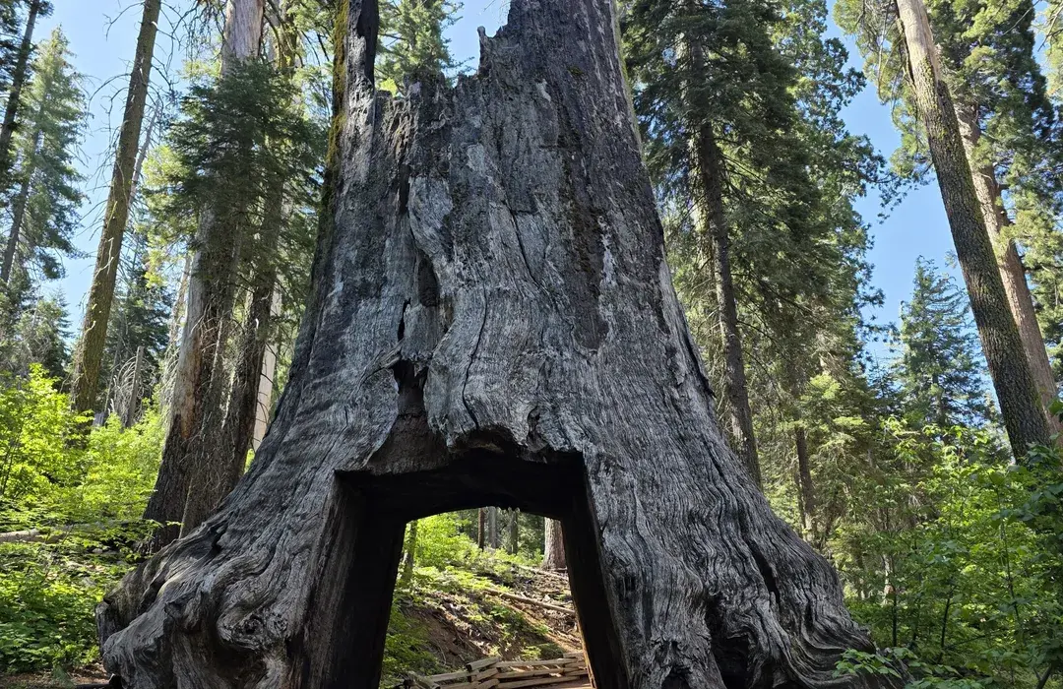
Figure 2 Tuolumne Grove (AllTrails, 2025)

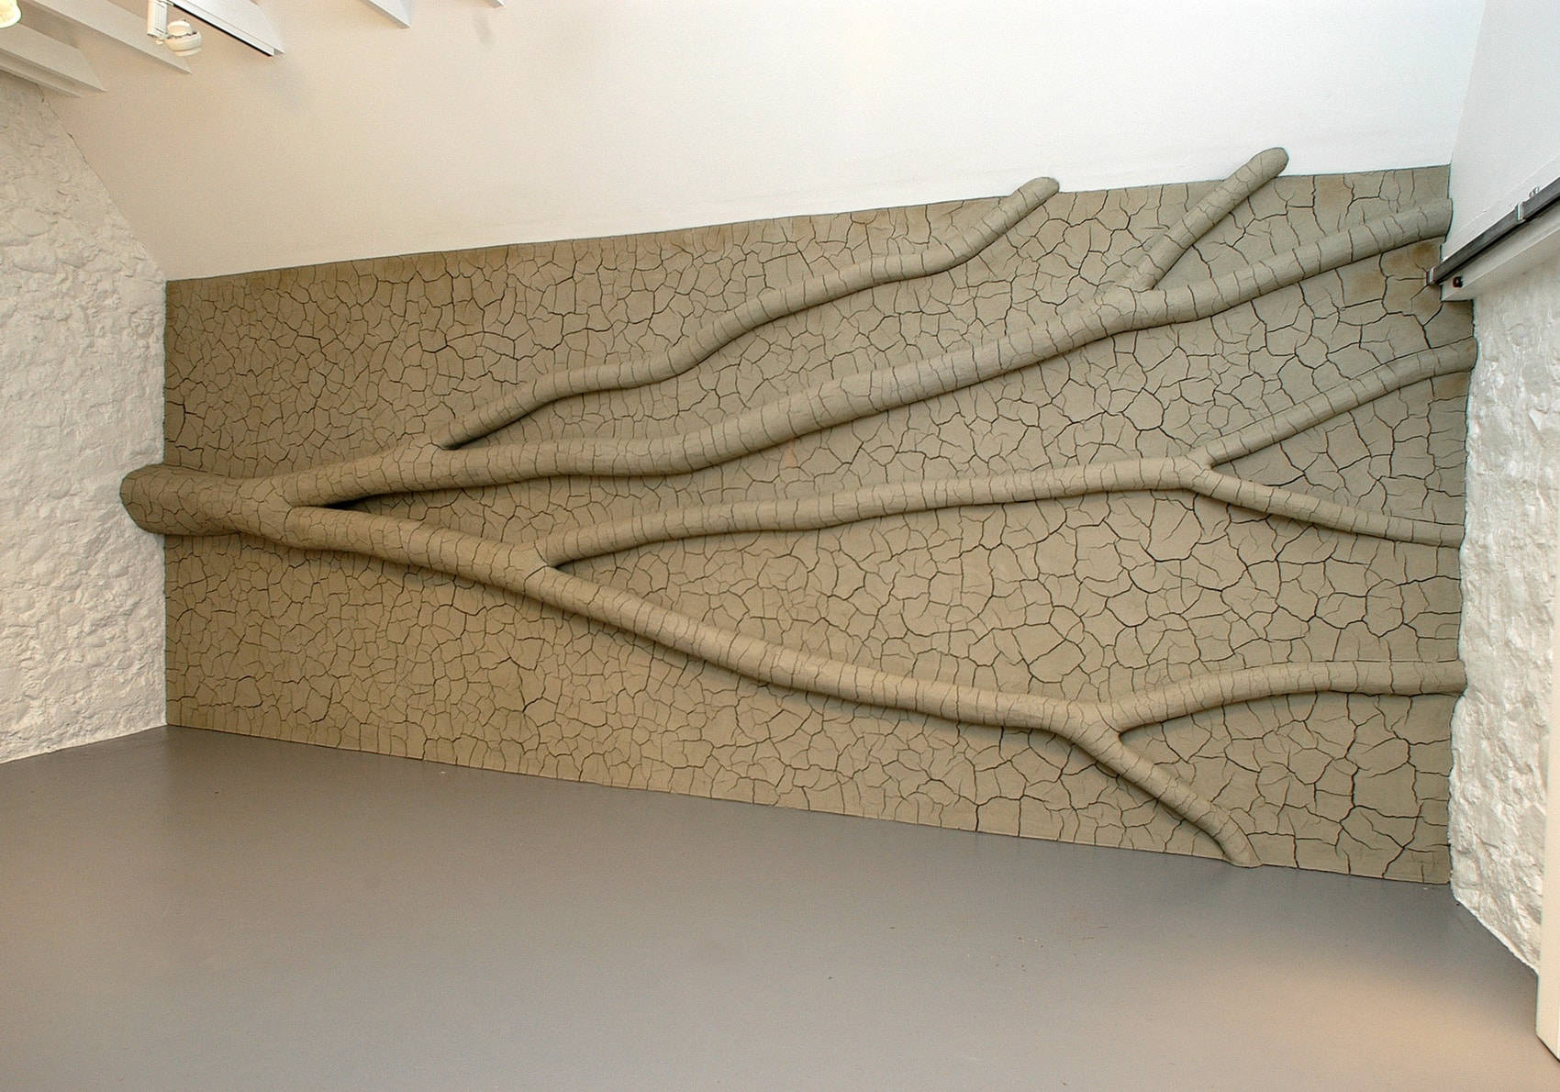
Figure 3 Clay Tree Wall, Andy Goldworthy, 2009 (Jupiter Artland, 2024)
Andy Goldsworthy is very well known for using natural materials in his artwork. Many of his pieces and not permanent structures and will decay or be destroyed due to the natural elements such as wind and rain. He works with leaves, wood, stone, and clay, many found in the surrounding areas where he creates the pieces.

Andy Goldworth’s Clay Tree Wall was created in 2009 (Jupiter Artland, 2024). It is a tree limb mounted laterally to the wall and then covering the whole surface with clay and then allowed to dry naturally. As the clay dried out over time, the form of the tree limb dictated the pattern of the fissures in the clay. This pattern can still change over time as the clay gets dyer and the tree limb starts to decay.

This work has been chosen because of the natural materials it was made from and the way it was allowed to naturally dictate the outcome of the piece.
This work will be situated in Tuolumne grove. Walking along the path in Tuolumne grove, you will come to a tunnel that has been cut through a stump of a giant sequoia tree. Going through the tunnel you will see on the other side Andy Goldworth’s Clay Tree Wall. Having Just walked through a tree stump, placing artwork made from a tree limb here brings a connection to them together as natural materials repurposed yet retaining their original form.

Location: El Capitan
Artist: Jean Tonguely
Work: Le Cyclop
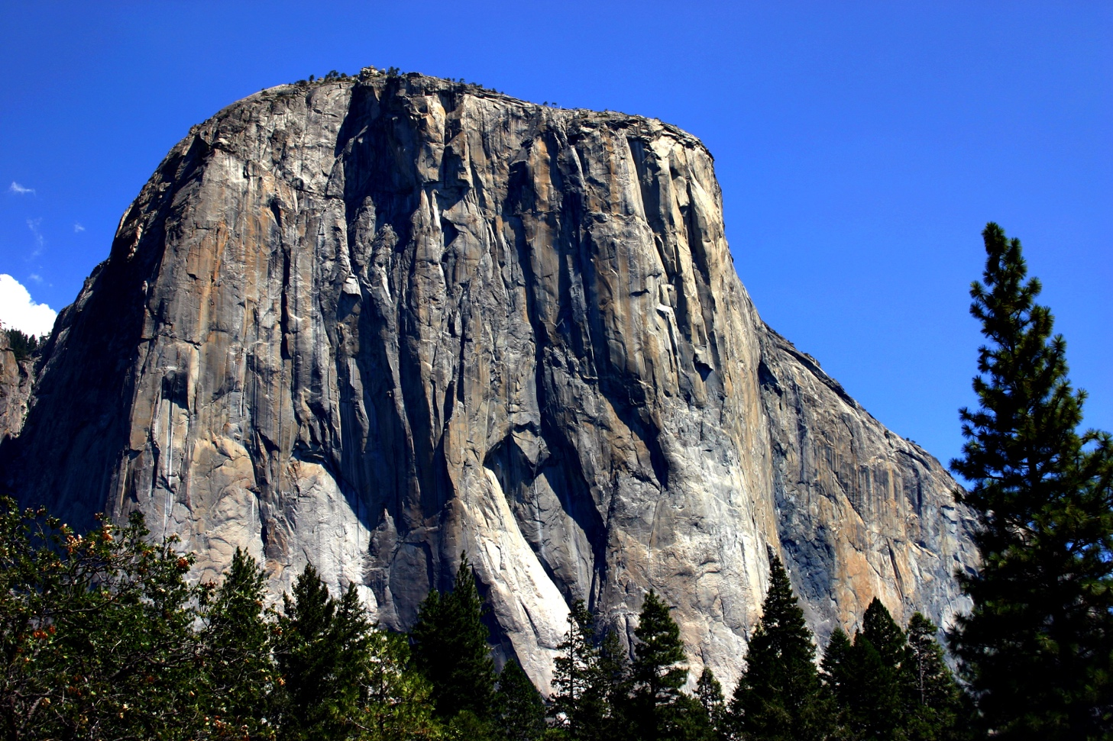
Figure 4 El Capitan, Yosemite National Park
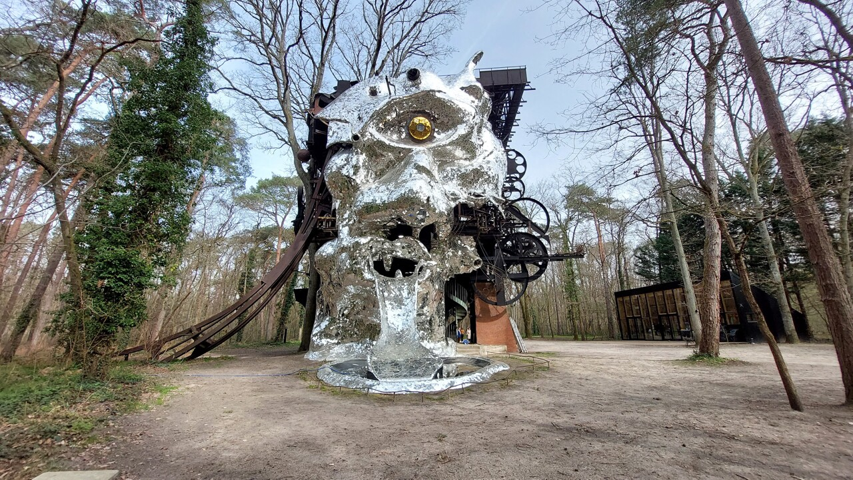
Figure 5 El Cyclop, Jean Tonguely (Thibaut Faussabry, 2023)
As in Homers’ The Odessey’ where Ulysses had to free his men from the cave in the mountain from the cyclops. Here we have Yosemite Mount El Capitan with Jean Tongueless El Cycop.

The next stop on our tour brings us to Mount EL Capitan. A favorite with both mountain climbers and cyclops. You cannot help but to be overwhelmed by to beauty of the mountain and the surrounding area. Displayed before El Capitan we have Jean Tonguely’s Le Cyclop (Dempsey, 2006, p. 76). Jean started to formulate his idea for a giant outdoor sculpture in the late 1960 and when a plot of land in the Fontainebleau Forest became available to Tonguely in 1969, El Cyclop was born. Jean worked on this intermittently over the next 20 years on this work. This piece is one of the few works of art that the viewer can climb into and view other pieces of work from collaborating artists. The forested area with El Capitan in the background is a logical location to view El Cyclop, giving its size and that it made to be viewed outside. A mountain with a resident cyclops gives birth to the imagination.

Location: Mirror Lake
Artist: Louise Bourgeois
Work: Crouching Spider

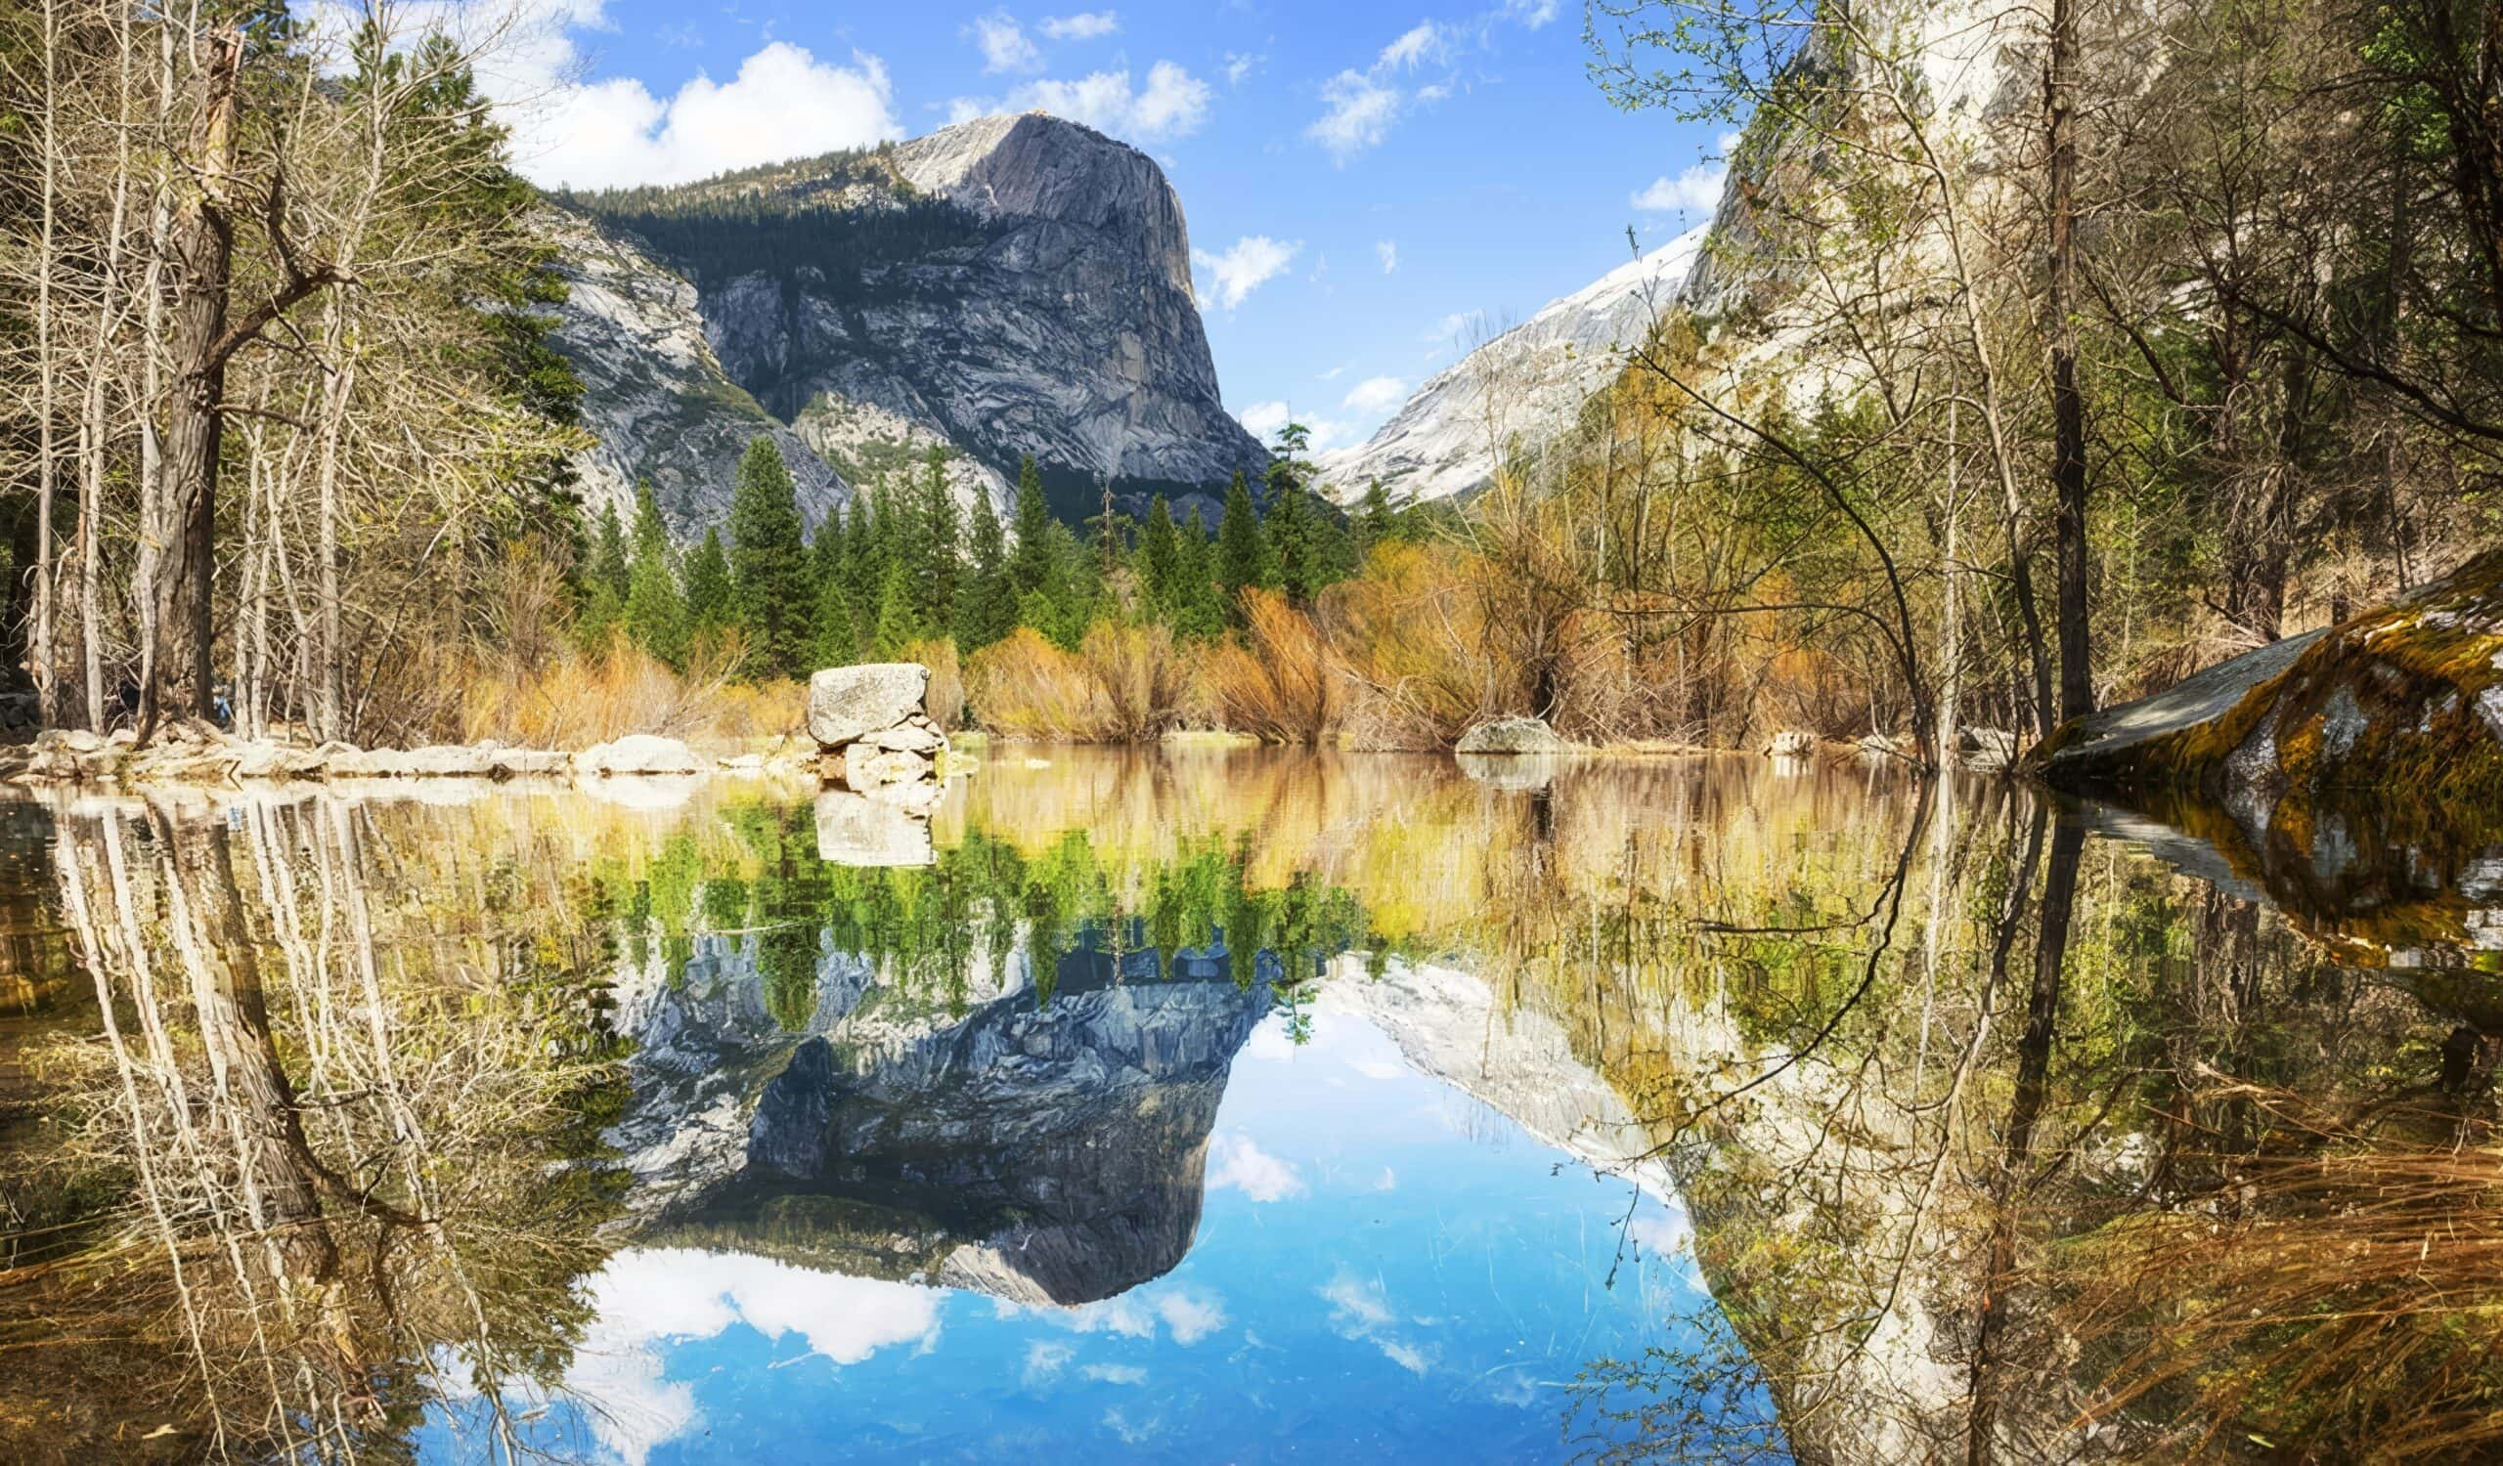
Figure 6 Yosemite Mirror Lake (Yosemite.com, 2022)

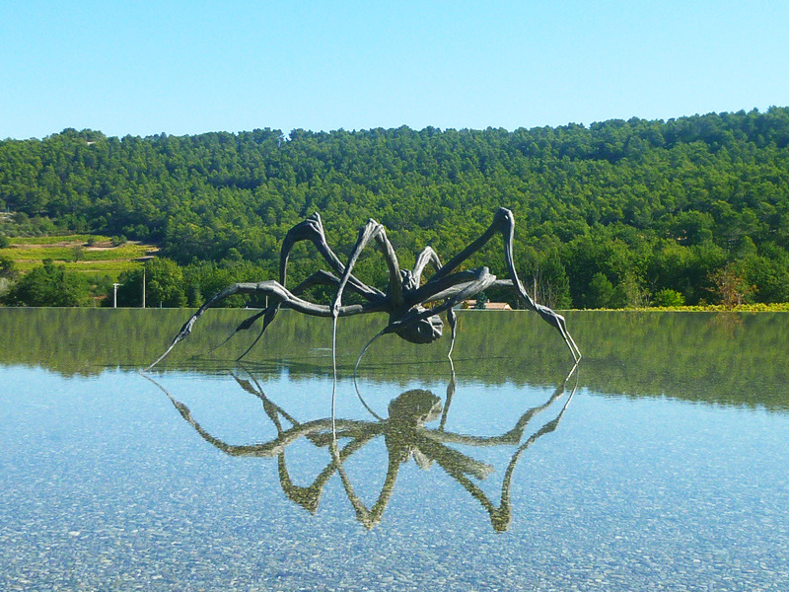
Figure 7 Crouching Spider, Louise Bourgeois, (Sutton, 2012)

Our next exhibit is at Mirror Lake with majestic views, clear still waters and a view of Half Dome in the distance. Placed within Mirror Lake is Louise Bourgeois Crouching Spider, the surface of the water giving an almost perfect reflection of the work. The crouching Spider is one of many spiders Bourgeois has created ranging for tinny to ginormous such as the Maman. When asked why the spider, Bourgeois explained. “Because my best friend was my mother and she was deliberate, clever, patient, soothing, reasonable, dainty, subtle, indispensable, neat and as useful as a spider.” She often described it as a representation of her mother, a resourceful and intelligent tapestry restorer (web, 2025). Some people find the spider frightening and disturbing and has been used to scare little brothers and sisters all over the world since time eternal, yet the spider is an integral part of nature and therefor has earned it place in the exhibition. Bourgeois’ Crouching Spider has been exhibited upon lakes on numerous occasions to stunning effect, so it only seems natural and right to exhibit here at Mirror Lake.

Location: Glacier point
Artist: Ansel Adams

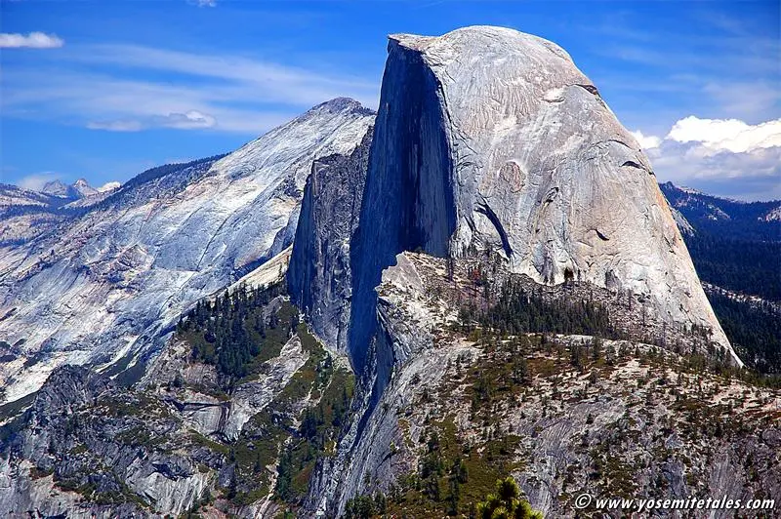
Figure 8 Yosemite Half Dome (Yosemite Tales, 2015)

You cannot have an exhibition in Yosemite Park without including one of the major art advocators to the park, Ansel Adams. For his service in expanding the awareness of the importance of preserving natural forests for further generations he was immortalized by having an area within the park named after him from Minarets Wilderness to Ansel Adams Wilderness (U.S. National Park Service, 2016).
To finalize the exhibition, we come to Glacier Point where there is a fantastic view of Yosemite’s famous Half Dome. Projected upon the Half Dome are three interchanging photos every five minutes from Ansel Adams collection and were chosen to avoid the redundancy of show Yosemite photos in Yosemite Park. Here we have two photos from the Leaves collection and one from The Mural Project Saguaro Monument.

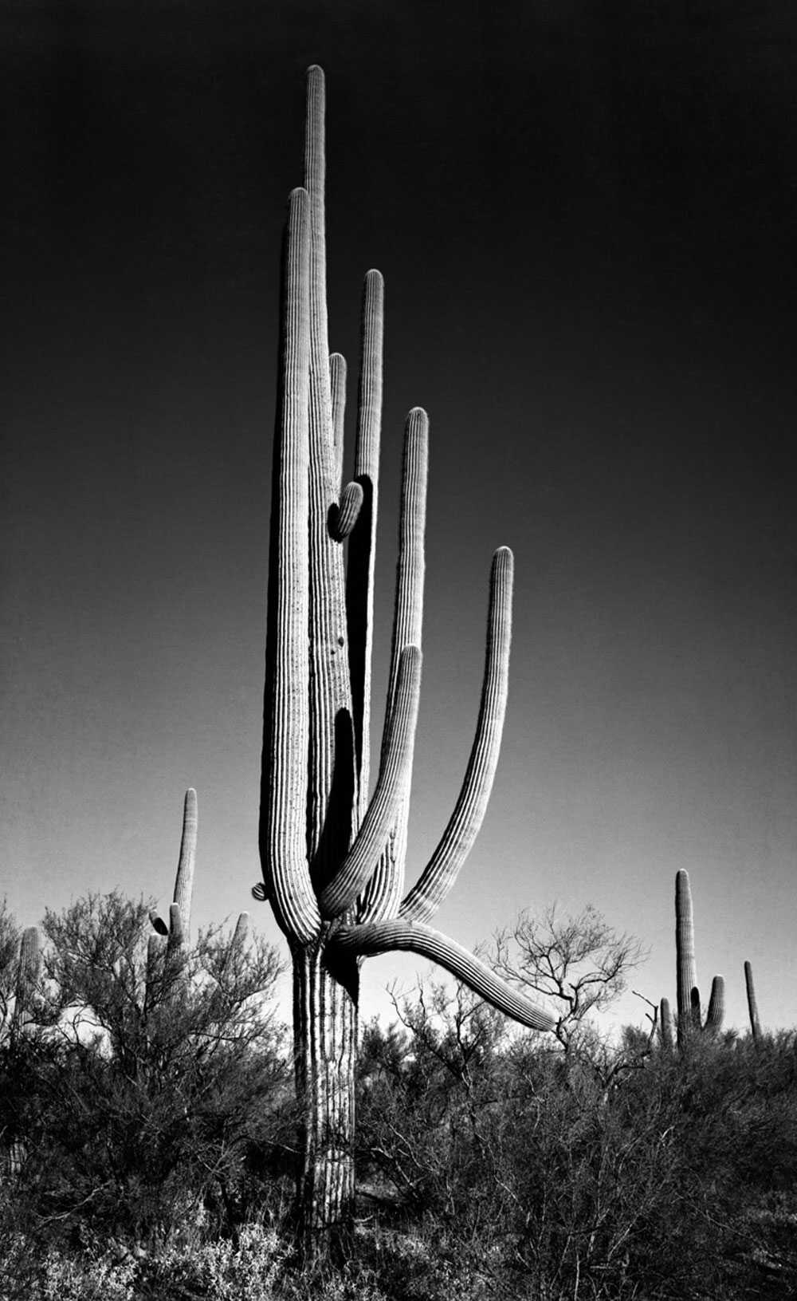
Figure 9 In Saguaro National Monument, Ariz, Ansel Adams (Naylor, 2010)

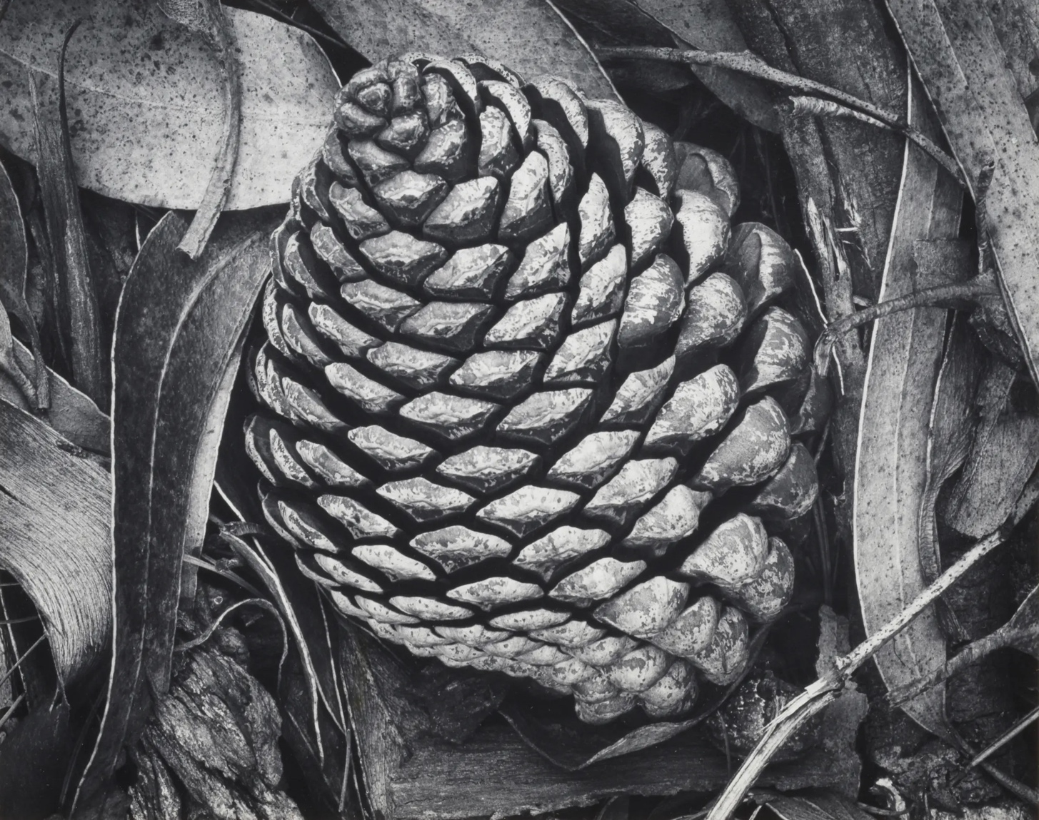
Figure 10 Pine Cone and Eucalyptus Leaves, Ansel Adams, 1932 (Bonhams, 2024).
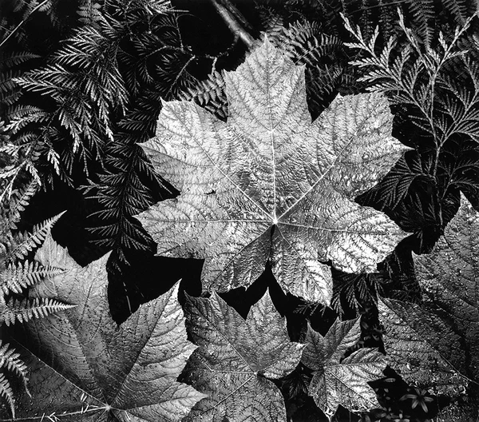
Figure 11 In Glacier National Park, Montana, Ansel Adams (20x200.com, 2018)
The selection of images (above) was chosen because they were not taken in Yosemite Park, simply to avoid the redundancy of showing photos of Yosemite Park in the park itself and to show some of the diversity in Adams photography. Using Half Dome as a projection Screen allows the
images to be viewed by many visitors in the park at once from a variety of locations and vantage points.

Conclusion
Thank you for visiting Yosemite Parks Visual Stimulation exhibition. This has been designed to give a new perspective in how the art is exhibited and to bring a connection to the natural world around us, the beauty it offers and the importance it is in preserving it.

Bibliography

20x200.com (2018). This Ansel Adams art stands apart: An unbe-leaf-able new edition. [online] 20x200. Available at: https://20x200.com/blogs/news/this-ansel-adams-art-stands-apart-an-unbe-leaf-able-new-edition [Accessed 25 Jun. 2025].
AllTrails (2025). Tuolumne Grove Trail. [online] AllTrails.com. Available at: https://www.alltrails.com/trail/us/california/tuolumne-grove [Accessed 25 Jun. 2025].
Bonhams (2024). Ansel Adams (1902-1984). [online] Bonhams.com. Available at: https://www.bonhams.com/auction/29511/lot/2/ansel-adams-1902-1984-pine-cone-and-eucalyptus-leaves/ [Accessed 24 Jun. 2025].
Dempsey, A. (2006) Destination art : [200 Monumente der modernen Kunst weltweit]. Stuttgart: Belser.
Jupiter Artland (2024). Andy Goldsworthy: Clay Tree Wall. [online] Jupiter Artland. Available at: https://www.jupiterartland.org/art/andy-goldsworthy-clay-tree-wall/ [Accessed 20 Jun. 2025].
Langen, S. (2015) Outdoor art : extraordinary sculpture parks and art in nature. Munich: Prestel.
Naylor, B. (2010). Forgotten Ansel Adams Murals Brought Back To Light. [online] NPR. Available at: https://www.npr.org/2010/03/27/125228486/forgotten-ansel-adams-murals-brought-back-to-light [Accessed 24 Jun. 2025].
Obrist, H. U. and Raza, A. (2014). Ways of Curating. New York: Farrar, Straus And Giroux.
Sutton, B. (2012). Benjamin Sutton. [online] Tumblr. Available at: https://bhsutton.tumblr.com/post/33144743080/louise-bourgeois-crouching-spider-6695-2003 [Accessed 25 Jun. 2025].
Thibaut Faussabry (2023). Essonne : Le Cyclop rouvre avec une nouvelle exposition et une série d’évènements. [online] actu.fr. Available at: https://actu.fr/ile-de-france/milly-la-foret_91405/essonne-le-cyclop-rouvre-avec-une-nouvelle-exposition-et-une-serie-d-evenements_58569515.html [Accessed 24 Jun. 2025].
U.S. National Park Service (2016). Ansel Adams - Yosemite National Park (U.S. National Park Service). [online] Nps.gov. Available at: https://www.nps.gov/yose/learn/historyculture/ansel-adams.htm [Accessed 6 Jun. 2025].
Yosemite Conservancy (2022). Yosemite Maps: How To Choose the Best Map for Your Trip — Yosemite Conservancy. [online] yosemite.org. Available at: https://yosemite.org/yosemite-maps-how-to-choose-the-best-map-for-your-trip/ [Accessed 25 Jun. 2025].
Yosemite Tales (2015). Half Dome and its Shape... [online] Yosemite Tales. Available at: https://yosemitetales.com/hiking-biking/half-dome-and-its-shape/.
Yosemite.com (2022). Mirror Lake: Yosemite’s Ephemeral Reflection. [online] Discover Yosemite National Park. Available at: https://www.yosemite.com/mirror-lake-yosemites-ephemeral-reflection/ [Accessed 25 Jun. 2025]. web, C. (2025). The Donum Estate. [online] Thedonumestate.com. Available at: https://www.thedonumestate.com/art/artists/21/louise-bourgeois [Accessed 27 Jun. 2025].

