Discuss how art and architecture were used as a medium of communication to convey political and ideological messages in the Roman Empire?
During his time as ruler of the roman people, Augustus used art and architecture to display his ideology. The four main points of ideology he communicated were: restoration, victory, peace and prosperity. In doing this he was also able to spread his own self-image about himself and the type of Rome he wished to create. The ancient source evidence available for ideological messages is seen within the remaining art and architecture from the years that Augustus was in control of Rome. All evidence is archaeological evidence meaning that a researcher is able to view the intended message themselves and doesn’t have to be concerned with objective views given by an author as they would with literary sources. Any interpretation of these sources is done by modern scholarship.
It can be assumed that at the time of Augustus many of the citizens of Rome would be illiterate. This would mean that trying to convey political and ideological messages through written word would be difficult as only the highest members of society would be able to understand it. In order to communicate a political message to the majority of society there are two possible options, through speech or through imagery. The easiest and most efficient way to convey a message would have been through imagery used in art and architecture. By doing this, political and ideological messages were always available for everyone to see. As well as this, they would have been on display for all hours of the day, making it more likely that every citizen would see them. Augustus was the ruler who used the power of imagery in the most direct way with art being used to present a peaceful empire with a powerful ruler. This use of imagery to show a political message can be seen during Augustus’ “restoration of the Republic”. The main purpose of this programme was to bring back the old ways and customs of the Republic. The imagery used was one of the most effective campaigns of its kind to ever happen. The wide use of imagery in this campaign, mostly through the form of architecture, would have been by not only the citizens of Rome but also the citizens of the empire and its allies.
The main way to spread ideological messages across the empire would be to use coins. Coins were useful when spreading a message as they would be in use throughout the empire and handled by all people. Any picture on a coin would have been seen by numerous people during its time in circulation. Any coin from the Augustan period can show an ideological message. Appendix A is an example of a coin. On the one side it shows the head of Augustus, stating him to be the Emperor of Rome and divine son of Caesar. This shows that it is Augustus who would have had this coin minted and distributed. The other side of the coin has a depiction of a woman with the word pax written next to her, implying that she is the goddess of peace. This would show that the main ideological message of the coin was one of peace, most likely implying the peace that was brought about by Augustus. Around the goddess is a laurel wreath. Laurel wreaths were typically used to crown victors and were often linked to victory. This would show that although peace was most likely the main message, there was also a message of victory, particularly the victories won by Augustus. It was also seen that the laurel tree was the tree of Apollo, cementing the link between Augustus and Apollo as presented by Augustus.
A part of Augustus’ self-ideology was to present himself in a way that made him seem like a young and powerful leader. He wanted himself to appear to be ever youthful, much like the god Apollo, who he associated himself with greatly. This self-imagery can be seen in the way he presents himself through the portraiture that was made of him. Augustus made all his statues show him as a young man. This contrasted greatly with the previous image held of the senate which was usually presented as older statemen. A prime example of this is the ‘Prima Porta’ statue of Augustus. This statue shows Augustus as an imperator in a Hellenistic style. In this representation two main ideological points can be seen. Firstly, it references victory for the Roman state. By being presented in a way that shows him to be addressing an unseen audience, he is displaying his victory to a crowd. In turn he is also displaying the victory of Rome. The second piece of ideology this statue represents is restoration. The idea of an imperator comes from the Republic. This would show Augustus’ view that he had restored the republic and brought Rome back to a ‘Golden Age’.
Augustus ‘Golden Age’ is also referenced in the reliefs of the Ara Pacis. The Ara Pacis was intended to give an image of what Rome would be under the rule of Augustus. It addressed the fears the Roman people had about unpredictable change and presented a reassuring view of Augustus’ ‘Golden Age’. The imagery on the Ara Pacis is a combination of both mythical and historical figures. It shows how the Romans would combine their mythical stories with their historical ones. The historical figures represented are placed into two categories: the imperial family and governmental officials. The imperial family are placed on the south wall of the structure. Within the imperial family stands Augustus, although he isn’t obvious to the eye. He is veiled with a wreath placed upon him, this being the only way for a person to know that Augustus is there. This could be a way for Augustus to display that he was primus inter pares, the first among equals. By showing himself as a veiled man he doesn’t emphasise his position as emperor. This presents a view of oneness with the people of Rome and reflects the peace that the Ara Pacis represents. The north wall of the structure depicts numerous officials such as magistrates, senators and members of religious organisations. The name “Ara Pacis” translates to “Alter of Peace”, showing that the ideological message Augustus was trying to represent was one of peace within the empire.
As has been show, Augustus used art and architecture to convey a series of ideological messages. The key messages of victory, peace and prosperity all linked into each other and further supported the message Augustus was delivering. These ideological messages would also have given political messages, especially around the issues of restoration of the republic and peace. The messages sent would have given Augustus the support he needed to gain and maintain the power he desired as well as giving the people of Rome reassurance on any issues that arose.

Bibliography
Holliday, P.J., 1990. Time, History, and Ritual on the Ara Pacis Augustae. Art Bull. 72, 542–557. https://doi.org/10.2307/3045761
Toynbee, J.M.C., 1965. The Art of the Romans, Ancient Peoples and Places. Thames and Hudson, London.
Wheeler, M., 1971. Roman Art and Architecture. Thames and Hudson, London.
Zanker, P., 1988. The Power of Images in the Age of Augustus. University of Michigan Press, Michigan.

Appendices

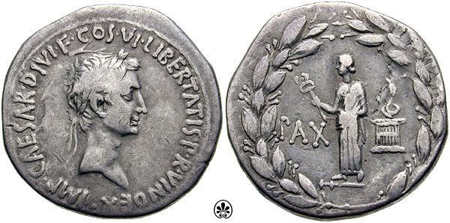(A)
http://www.romanemperors.com/augustus.htm

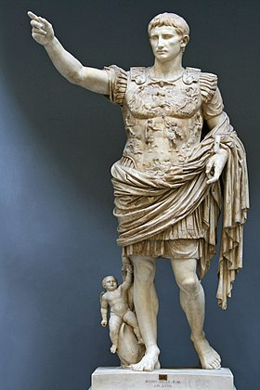(B)
https://en.wikipedia.org/wiki/Augustus_of_Prima_Porta

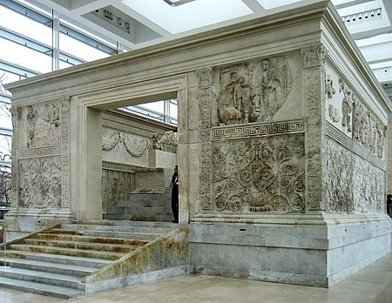(C)
https://en.wikipedia.org/wiki/Ara_Pacis

Zanker, 1988, p. v
Zanker, 1988, p. 101
Zanker, 1988, p. 101
Zanker, 1988, p. 92
Zanker, 1988, p. 93
Appendix B
Toynbee, 1965, p. 33
Toynbee, 1965, p. 33
Appendix C
Holliday, 1990, p. 542
Holliday, 1990, p. 542
Toynbee, 1965, p. 53
Wheeler, 1971, p. 164
Wheeler, 1971, p. 165
Wheeler, 1971, p. 165
Wheeler, 1971, p. 165
Wheeler, 1971, p. 164

