

EXAMINATION PAPER
MARKS AND COMMENTS SHEET

PROGRAMME | OME Degree Apprenticeship
LEVEL | 4
MODULE | ACDB4011 Chemistry
STUDENT I.D. | 2222202
EXAMINER | Ewa Kazimierska | INTERNAL VERIFIER
Once completed marks only should be transferred onto the front of the examination paper (no comments other than ticks or crosses on the examination paper)

Question  Number | Comments | Marks available | Marks awarded | 2nd marker (sample) | 3rd marker (where necessary)
1 | Only 2/10 True/False items correct. Major misconceptions across fundamental concepts including redox, molecular forces, and reaction energetics. | 15 | 3
2 | Bohr model structure present but missing subatomic details. Incorrect ionic charge and no Lewis structure. Bond length noted, but energy concept misunderstood. | 11 | 3
3 | No calculation shown for wavelength. Incorrect electron configuration and incomplete understanding of absorption/emission. | 10 | 2
4 | Correct combustion products identified, but equation not balanced. No calculations attempted for gas laws or stoichiometry. | 15 | 1
5 | Some general understanding of oxygen balance, but lacking depth or calculations. All other parts unanswered. | 16 | 2
6 | Energy profile shape incorrect and key values (enthalpy, activation energy) not calculated. Incorrect interpretation of energy changes. | 7 | 0
7 | Incorrect heating curve; limited correct data identified from the phase diagram. Bond-strength interpretation lacks supporting values. | 11 | 3
8 | Correct formula used for molarity, but unit conversion and significant figures were incorrect. No ionic equation provided. | 5 | 1
9 | General calorimetry idea recognised. ΔT calculated correctly, but final specific heat value incorrect due to multiple calculation errors. | 5 | 1
10 | Only oxidation of Al correctly noted. Other oxidation numbers missing and no response to identifying agents. | 5 | 1
 |  |  | 17

1st Marker Name | Ewa Kazimierska | 1st Marker Signature | 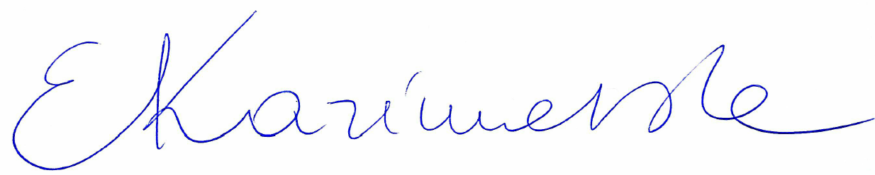
2nd Marker Name |  | 2nd Marker Signature
3rd Marker Name |  | 3rd Marker Signature
Reasons for awarding the final mark where there is more than one marker
Notes:
- The 3rd marker may be used where there is more than a 10 percentage point difference (in the TOTAL mark) between markers 1 and 2 OR when it is not possible to get agreement between markers 1 and 2. Reasons must be given where an agreed mark is given.
- This form is for internal use only and is NOT to be returned to the student. The final agreed marks must be transferred to the student feedback sheet in the assignment specification.
- The external examiner MUST be shown this form.

