Strategic Management Assignment 1 2019 – How does Lidl fulfil cost leadership?



November 2019

MODULE NAME: strategic management & sustainability （M3X9111）
Name: siping xue
Student Number: 1904774

Table of Contents

1. Executive Summary 1
2. Introduction 2
2.1 Report Remit 2
2.2 Background of the organisation 2
2.3 Definitions of major concepts 3
2.3.1 Strategy 3
2.3.2 Business level strategy 3
2.3.3 Competitive advantage 3
2.3.4 Porter’s Generic Strategies 4
3. Main Body 6
3.1 Application of the strategy 6
3.1.1 Produce own brand and limit assortments 6
3.1.2 Reduce operating costs 7
3.1.3 Emphasise sustianable development 8
3.2 Advantages & Disadvantages of the strategy 8
3.2.1 Advantages of cost leadership 9
3.2.2 Disadvantages of cost leadership 9
4. Conclusion 11
5. References 13

List of Figures
Figure 2-1 Lidl’s history lifetime (Corporate, 2019) 3
Figure 2-2 The structure of four main sources of competitive advantage (Porter, 1980) 5
Figure 2-3 The classification of generic strategies (Porter, 1980) 6

Executive Summary

This report is to identify and analyse the competitive strategy that Lidl has used to build its current competitive position. Lidl is one of the largest grocery retailers in Europe and its history began in Germany in the 1930s, then opens more stores in other countries, especially in the UK.

First and foremost, four major concepts of this report are depicted, they are strategy, business level strategy, competitive advantages and a model this report has applied, Porter’s Generic Strategies.

To prove that Lidl has implemented cost leadership strategy, three detailed examples of Lidl’s actions are given, including producing own brand and limiting assortments, reducing operating costs and emphasising sustainable development. These facts show how Lidl cuts the cost and achieves this strategy. Furthermore, the advantages and limitations of this strategy are analysed. For example, this strategy can resist the five forces with much lower costs than others, but there is also a possibility that might cause a price war or depend heavily on several suppliers.

In conclusion, Lidl has taken cost leadership as their strategy to operate. Although this pattern brings benefits to Lidl, the potential risks should not be ignored. To adopt its good points and avoid its shortcomings, there are five recommendations as follows.

- Spread their business abroad to lead the market share.
- Introduce much upper-class items to compete with other major retailers.
- Build own barrier to deter other firms from accessing the UK grocery market.
- Work closely with operators including suppliers.
- Make use of online resources.

If Lidl adopts suggestions above, it is possible that Lidl will outperform much more than its rivals and have larger share in the UK, or even in other countries.

Introduction

Report Remit

This report identifies Lidl’s competitive strategy, which is cost leadership. By giving examples of their actions, the benefits and limitations of this strategy are analysed. Then, appropriate recommendations for Lidl are made based on main findings.

Background of the organisation

Founded in Germany in 1973, Lidl has gradually become one of Europe's dominant grocery retailers (Corporate, 2019), their history timeline is showed below (see Figure 2-1).
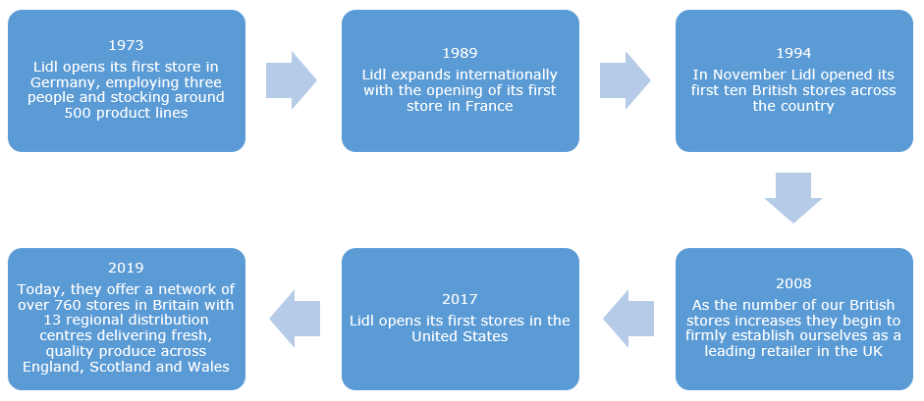
Figure 2-1 Lidl’s history lifetime (Corporate, 2019)

In 1994, Lidl started its first ten British stores. Now they have more than 769 stores, 13 regional distribution centres across England, Scotland and Wales, hiring more than 22,500 employees and owning 6% UK Market Share (Corporate, 2019). Lidl has four missions as follows:

- Increase customers’ satisfaction.
- Ensure the leading quality and value in the market by optimising work procedures.
- Build sustainable relationships with commercial partners and make contribution to local community.
- Achieve long-term success by recruiting, training and developing employees.

In general, Lidl provides the best quality at the possible lowest prices to customer and it reduces its cost by cooperating closely with local suppliers to accomplish a sustainable development. Recently, it is reported that Lidl commits to installing rapid electric vehicle charging points at all new stores (Corporate, 2019), to support customers to lead more sustainable lives.

Definitions of major concepts

Before applying model to analyse Lidl, the definitions of the main concepts and themes should be made first, and they are strategy, business level strategy, competitive advantage and the model which is applied, the Porter’s Generic Strategies.

    - Strategy

Strategy is the scope and direction of an organisation, achieving superiority by configuration of resources and competences in a constantly changing environment. The aim of strategy is to fulfil stakeholders’ expectations (Johnson et al, 2011).

    - Business level strategy

Business-Level Strategies attach importance to how an organization can compete in a single industry and an individual market, and it is also concerned with positioning and competing. This strategy can help an organization gain a competitive advantage in the market. They provide value to customers by leveraging the core competencies of the organisation (Porter, 1980).

    - Competitive advantage

Porter defined two competitive advantages which an organisation can be competent with their rivals in 1980, and they are lower cost and differentiation respectively. This competitive advantage can come from rivals’ attribute that allows them to outperform over other competitors, including skills, resources and market position (Porter, 1985).

    - Porter’s Generic Strategies

In this report, Generic Strategies is applied as criteria to analyse the strategy of Lidl, the food retailer. And there is a concise introduction of this model.

Porter proposed Generic Strategies in 1980, which is regarded as a leading model in the literature on strategic management and marketing (Salavou, 2010). Regarding the scope of activities that firms manage to fulfil, three generic strategies can result in better performance in the same industry: cost leadership, differentiation and focus (Porter, 1980). Note that the focus strategy is divided into cost focus and differentiation focus. The structure of four main sources of competitive advantage is shown below (see Figure 2-2).

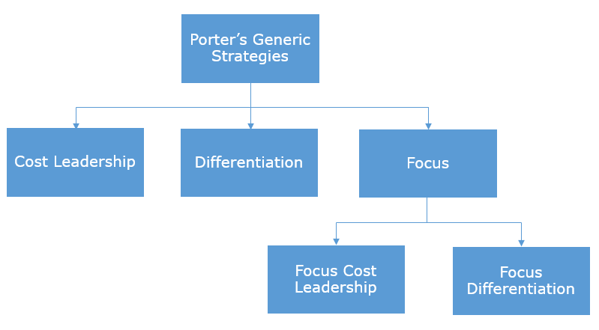
Figure 2-2 The structure of four main sources of competitive advantage (Porter, 1980)

According to different strategic advantages and strategic target, the attributes of generic strategies include wide industry or segmented industry, low-cost positioning or unique customer perception. Therefore, the four strategies can be defined as follows. (see Figure 2-3)
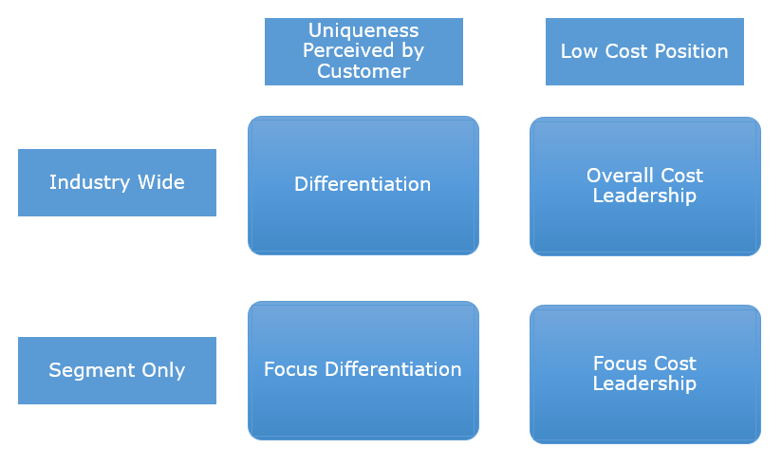
Figure 2-3 The classification of generic strategies (Porter, 1980)

Firms can get superior performance than the rivals if they succeed in one of the two competitive advantages (Xiao et al, 2012). Besides, companies have to make a choice between two advantages as they are incompatible. If two advantages work together, a situation ‘stuck in the middle’ will occur (Xiao et al, 2012). There is a certain amount of researchers proved that firms who use one competitive advantage act better than that who use both of them.

However, there are some arguments about this model. Others believed that if those two advantages are well balanced, it will still win over their competitors (Allen et al, 2006). As customers demand become more diversified, a single strategy does not meet their needs. This is a controversial part in this model.

For instance, according to Armstrong (1987), Toyota ranked high in customer satisfaction and product reliability but by using cross-functional conflict management techniques, the production cost per vehicle was still $1,500 lower than that of American competitors. In the same way, Mitchell (1987) argued that the Kellogg Company achieved an admirable leadership position in North American breakfast cereals industry by introducing new product, leading and developing new manufacturing techniques, and building brand loyalty (Manteghi, Zohrabi, 2011). Those two examples illustrate that cost leadership and differentiation can be simultaneously well balanced (Carlos, 2013).

Main Body

In this part, the strategic approach of Lidl is recognised, and three detailed examples are given to explain that strategy. Then, the limitations and opportunities are also analysed.

Application of the strategy

After investigating the actions Lidl has taken, the strategy of this firm is identified as cost leadership. To support how they implemented this strategy, three examples are well discussed below.

3.1.1 Produce own brand and limit assortments

Lidl is one of the pioneers of the hard-discount retailers in the world, and the prices are 15%-20% lower than those larger discounters, for example, Wal-Mart (Wall Street Journal, 2009). Make comparison with traditional retailers, hard discounters attach importance to minimising product categories (Food Marketing Institute, 2012), and they depend heavily on private brands.

Lidl operates 5,000 no-frills Lidl supermarkets and deep discount department stores and across Europe. These stores typically have around 800 different categories of items, about 90% of the products are Lidl's own brand (Business Insiders, 2017).

But hard discount chains have learned that price-based growth strategies also have limitations, as competitive prices make them more popular in discounters (Carlos, et al, 2013). Partly as a result of this recognition, a significant number of retailers are introducing more and more national brands into their products. As for Lidl, it is reported that 30% of goods are now made up of national brands, which contributes almost equally as their total sales (Steenkamp and Kumar, 2009).

There is a limitation of the categories of products. For example, Lidl might only sell two varieties of cereal, one is a national brand, another is its private brand. This limited assortments benefits Lidl from stronger purchasing power, because it can order more products in bulk with several suppliers in relatively lower prices. In addition, there are about 2,000 products in Lidl stores (Business Insiders, 2017). That is far less than the 20,000 unique products in a grocery store of the same size, or the 60,000 products in a super shopping centre.

To sum up, by producing own brands and setting categories of items, Lidl can reduce both costs to itself and prices to customers and this is the first example of the strategy they applied, cost leadership.

3.1.2 Reduce operating costs

Lidl has taken a number of steps to reduce operating costs. Firstly, items are moved fast in Lidl. Lidl prefers daily items that shoppers often buy. These categories are limited to the fastest moving goods, which contribute to gross profits. High turnover means less cost is associated with inventory. When visiting a new store, Lidl pays more attention to everyday items, such as cereal and juice, instead of specialty products like very expensive wine (Business Insider, 2017).

Secondly, it keeps labour costs low. The Lidl stores are understaffed to cut down labour costs. In Lidl, efficient technology and automation behind the scenes are used for releasing human labour, which has reduced the amount of human interaction dramatically (Business Insider, 2017). In stores, for external aspect, consumers are asked to weigh what they want to buy and put their individual grocery bags. For internal aspect, employees have received cross-training so that they are capable of working in different departments. As a consequence, human resources distribution tends to be more efficient and flexible.

Thirdly, Lidl has close cooperation with local supply chain operators. Building strong relationships with local suppliers and other operators makes them have more information about demand and supply. Because the pattern of underlying demand is more stable and predictable, the entire supply chain does not need expensive buffers of uncertainty. Lidl keeps its supply chain costs to a minimum so that they can offer consumers genuinely low prices.

3.1.3 Emphasise sustianable development

To in line with their mission, Lidl tends to adopt more sustainable ways to develop its strategy, and those sustainable strategies also indicate “cost leadership”.

The first action Lidl has taken is that they stack items in the boxes where they are shipped in. For instance, vegetables are displayed on paper boxes which are put by suppliers rather than restack in good shelves. Besides, Lidl also spends little on in-store promotions because it has fewer national brands. By doing so, Lidl can accelerate the restocking process which sets manpower free (Business Insiders, 2017). At the same time, Lidl can save much packaging costs which seems more sustainable by using the original carts.

In addition, Lidl also cuts costs in areas such as lighting. It avoids spending money shop decorations. They look at waste in a different way, it is not just in terms of things that end up in the bin, but the inefficiencies that cost consumers more in the process. One way to achieve lower cost is to make shops use as much natural light as possible. Furthermore, Lidl has claimed to install electric charging stops recently, to support an environmental friendly lifestyle for customers (Corporate, 2019).

Last but not least, Lidl spends little on advertisements, and insists on smaller-scale and local marketing. In supermarket promotions, Lidl prefers to use dump bins and baskets instead of elaborate cardboard or stacked pyramids to present products. As for marketing advertisements, it is active in local radio advertising and local social media, such as online leaflets in their websites, which are regarded more sustainable (Mitchell, 1987). People can also buy what they need in official website and app conveniently.

Advantages & Disadvantages of the strategy

By applying cost leadership strategy, Lidl cuts its cost and keeps relatively low prices. However, the disadvantages of this strategy cannot be ignored. In this section, the pros and cons of cost leadership are both analysed.

    - Advantages of cost leadership

- It resists the five forces. Lidl’s products are of standardization and it has strong cooperation with local suppliers, so that the costs and prices in Lidl are low. Therefore, this practice can resist the five forces (Coeurderoy, Durand, 2004). For example, Lidl has better exclusivity and security given by extensive private tags, which can both reduce cost and erect barriers for anther firms to entry.

- It outperforms competitors. Stable business pattern enables them to sell their items at relatively cheap prices but are in great quality. It shows that Lidl has capability to outdo rivals, such as Aldi. (Simon, et al., 2010; Kumar & Steenkamp, 2007).

- It satisfies customers’ sustainable lifestyles. Customers are more acceptable to the sustainable methods Lidl has used, such as saving lighting, setting electric vehicle charging stops and using delivery cart to avoid assortment waste.

    - Disadvantages of cost leadership

- It might cause possible prices wars. With the context of Lidl, it does not fully possess the market share of other large supermarkets in the UK, and its major competitor Aldi has surpassed Lidl’s market share and become the leading discount company (Poulter, 2014). If Lidl engages in a price war with other giant firms, it could force rivials to decrease prices (Felsted, 2014).

- It might be associated with lower quality. Since their items are not expensive, consumers usually hold a view that the quality is unsatisfying (FT, 2015; Siro, et al., 2008). Thus, building customer loyalty is also difficult but essential for Lidl to deal with.

- It is vulnerable to low cost operators. Because Lidl only rely on several main brands suppliers, if those relationships are not successful enough, Lidl will suffer from higher costs. In addition, it is also difficult to keep sustaining in long term unless they find more energy-saving ways to reduce costs.

Conclusion

To sum up, this report has given a brief introduction of Lidl and explained the meaning of strategy, business level strategy and competitive advantages. As this report applies Porter’s Generic Strategies to analyse Lidl in detail, concise concepts of this model are mentioned.

The strategy of Lidl is identified as cost leadership. To fulfil this strategy, three detailed actions are stated, they are producing own brand and limiting assortments, reducing operating costs and emphasising sustainable development. This practice has both pros and cons. For example, this strategy can resist the five forces with much lower costs than others, but there is also a possibility that might cause a price war or depend heavily on several suppliers.

Based on a detailed analysis of Lidl’s current market strategy, five recommendations are made to help Lidl gain a larger share of the UK grocery market. The five recommendations are as follows.

- Build firm entry barriers to prevent other firms from entering the UK food retailers market, which might reduce Lidl’s market share.

- Cooperate closely with firms operating in other countries to expand operations. By expanding business abroad successfully, it allows Lidl to provide more funds to prevail in the UK market. Additionally, it should also focus on the cultural values of each country and if any form of adaption is needed to satisfy customers, then not all have same tastes. For example, Lidl failed to open discount retailers in Norway as Norwegians have preferences for high quality interiors and branded items (Achievaint, 2017).

- Keep an eye on what competitors are doing, take actions and avoid price war.
To increase the share of Lidl in UK market, or even worldwide market, it is evitable that other international brands’ expansion will bring more competition. In this case, Lidl should pay attention not limited to the dynamic environment and the product itself.

- Develop and implement premium branded products that combine their t business structure with new demographic targets and compete on a more even environment with large supermarket retailers (Kumar, N. & Steenkamp, 2007).

- Improve their website to offer click, collect or delivery services with strong online services and employee training. Provide more details about the product on their website to ensure quality.

If Lidl acts well according to those recommendation, Lidl might achieve more market share in the UK.

References
1) Achievaint, (2017). Why study failure? The case of Lidl. [online] Available at: https://achievaint.com/study-failure-case-lidl [Accessed 19 Nov. 2019]

2) Allen, R.S., Helms, M.M., (2006). Linking strategic practices and organizational performance to porter's generic strategies. Business Process Management Journal, 12(4) pp.433-433.

3) Armstrong, L. (1987). Sony's Challenge. Business Week, 1 June, 64–69.

4) Business Insider, (2017). A German grocery chain that's coming to America is already dominating Walmart on prices — here's why it's so cheap. [online] Available at: https://www.businessinsider.com/how-lidl-keeps-its-prices-down-2017-6?r=US&IR=T&from=groupmessage [Accessed 19 Nov. 2019]

5) Carlos J.S, Gijsbrechts, L.E., (2013）. The impact of national brand introductions on hard-discounter image and share-of-wallet, International Journal of Research in Marketing, 30(4), pp.368-382.

6) Coeurderoy, R., Durand, R., (2004). Leveraging the advantage of early entry: proprietary technologies versus cost leadership, Journal of Business Research, 57(6), pp. 583-590,

7)Corporate, (2019). About Lidl GB. [online] Available at: https://corporate.lidl.co.uk/?_ga=2.241570306.123070606.1573556061-1008829033.1573556061 [Accessed 19 Nov. 2019]

8) Corporate, (2019). Lidl commits to installing rapid electric vehicle charging points at all new stores. [online] Available at: https://corporate.lidl.co.uk/media-centre/pressreleases/191028_lidl-installs-rapid-chargers [Accessed 19 Nov. 2019]

9）Felsted, A., (2014). Lidl expansion to crank up pressure on big stores. [Online] Available at: http://www.ft.com/cms/s/0/2465c426-fd53-11e3-bc93-00144feab7de.html#axzz3giD80B9c [Accessed 19 Nov. 2019]

10) Food Marketing Institute, (2012). FMI Speaks: The State of the Food Retail Industry. [Online] Available at: http://www.fmi.org/ [Accessed 19 Nov. 2019]

11) FT, (2015). Half of UK shoppers visited Lidl, Aldi over Xmas. [Online] Available at: http://www.ft.com/fastft/260632/half-of-uk-shoppers-visited-lidl-aldi-over-xmas [Accessed 19 Nov. 2019]

12) Johnson, G, Scholes, K and Whittington, R (2011). Exploring Corporate Strategy: Text and Cases, London: Prentice Hall.

13）Kumar, N. & Steenkamp, J. B. E. M., (2007). Private Label Strategy: How to Meet the Store Brand Challenge. Cambridge: Harvard Business Press.

14) Manteghi, N., Zohrabi, A., (2011). A proposed comprehensive framework for formulating strategy: a Hybrid of balanced scorecard, SWOT analysis, porter‘s generic strategies and Fuzzy quality function deployment, Procedia - Social and Behavioral Sciences, Volume 15, pp.2068-2073,

15) Mitchell, R., (1987). The health craze has Kellogg feeling, G-R-R-Reat. Business Week, pp.52–53.

16) Porter, M.E., (1985). Competitive Advantage. Free Press.

17) Porter, M.E., (1980). Competitive strategy. Free Press.

18）Poulter, S., (2014). Aldi and Lidl to force ‘big four’ supermarkets into price war to stop stampede of customers to discount chains. [Online] Available at: http://www.dailymail.co.uk/news/article-2539064/Aldi-Lidl-force-big-four-supermarkets-price-war-stop-stampede-customers-discount-chains.html [Accessed 19 Nov. 2019]

19) Salavou,H.(2010). Strategy types of service firms: evidence from Greece. Management Decision. 48(7), pp.1033-1047.

20) Shahid Yamin, A. Gunasekaran, Felix T. Mavondo, (1999). Relationship between generic strategies, competitive advantage and organizational performance: an empirical analysis, Technovation, 19(8), pp.507-518.

21）Simon, H., Gathen, A. V. D. & Daus, P. W., (2010). Retail Pricing – Higher Profits Through Improved Pricing Processes. In: Retailing in the 21st Century. Berlin: Springer Berlin Heidelberg, pp. 319-336.

22）Siro, I., Kapolna, E., Kapolna, B. & Lugasi, A., (2008). Functional food. Product development, marketing and consumer acceptance—A review. Appetite, 51(3), pp. 456-467.

23) Steenkamp, J.B.E.M., Kumar, N., (2009). Don't be undersold! Harvard Business Review, 87 (12), pp. 91-95.

24) StudyMoose. (2016). LIDL Case Study. [Online]. Available at:https://studymoose.com/lidl-case-study-essay [[Accessed 19 Nov. 2019]

25) Xiao, J., Li, Y., Niu, Y., (2012). "Do research organizations have generic strategies?: Cases from China," 2012 International Conference on Management Science & Engineering 19th Annual Conference Proceedings, Dallas, TX, 2012, pp. 1680-1685.

26) Wall street journal (2009). Aldi looks to US for growth. [online]. Available at :https://wsjassessment.com/ [[Accessed 19 Nov. 2019].

