Discuss the value of outdoor adventure (OA) programmes in a post-modern society.
In a postmodern society, the value of outdoor education is increasingly significant in postmodern culture. As individuals, the world has become compliant and reliant on technology and urbanization, and outdoor education provides a vital balance between nature and promoting development. This approach does not just help physically but also demonstrates other ways of intelligence and seeing how people thrive. This essay will discuss how the education system only helps some children and is still in the making of the conveyor belt. The outdoor education system has enhanced and broadened the scope of play and increased how the outdoors is perceived. Adventure is a perception of a risk. A critical thing that has moderated this from Tim Farran, sponsor on 2 November 2023 at 12:39 pm: "A Bill to require that every child be offered at least one outdoor education experience during primary school years and at least one such experience during secondary school years" the eef Outdoor adventure learning typically involves outdoor experiences, such as climbing or mountaineering; survival, ropes or assault courses; or outdoor sports, such as orienteering, sailing and canoeing. These can be organized as intensive residential courses or shorter courses run in schools or local outdoor centers." ("Outdoor adventure learning - E4L") this essay will cover some key areas of study and using sources to further push this issue.

The national curriculum is a set of subjects and standards that primary and secondary schools use to ensure that children learn the same information as each other, as an opinion of the curriculum has negative and positives. One positive of a curriculum is that a national curriculum establishes standards of learning and can compare schools. According to Lynn Cook School of Education, "The 1944 Education Act established a framework that, by consolidating previous legislation and encouraging Local Education Authorities (LEAs) to increase the use of the outdoors for educational purposes, extended outdoor education within the statutory education system" this established that outdoor education should be promoted throughout the education system the use of outdoor learning can demonstrate other ways the students can demonstrate skills that don't get demonstrated in the classroom. One issue with traditional classroom learning is that it only suits some. This is due to different mindsets, such as a fixed mindset where the classroom is suited, whereas a growth mindset is better for doing things and experiential learning. What is experiential learning? Experiential learning is a theory written by "Kolb. Experiential Learning Theory, developed by David A. Kolb, is a widely recognized and influential framework that describes how people learn through experience" (according to the Institute of Experiential Learning). (“What Is Experiential Learning?”) This style of learning is critical to outdoor education. The school system has been the same for over a century, all about testing children against each other in industrial Britain, but the postmodern is the same, setting children at ages and teaching all the same things. This is an unacceptable way to find students' true potential. Australia is a leading country in developing nature-based studies. He is shown in (ACARA 2012). "In the Australian Curriculum, sustainability is one of three cross-curriculum priority areas, which are intended to be integrated into all learning areas." (“Vertical schooling and learning transformations in curriculum research ...”) This is linked with the academia and curriculum, making sustainability be taught, which improves cognitive disarray with the natural world. Another argument about outdoor adventure vs curriculum is outdoor learning vs learning outdoors. This argument is if just taking the classroom learning into the outdoors vs experiential where it is not this or that it makes them think like why is that important what if exploring the grey area which classroom learning is teaching to the paper vs experiential learning which is learning from action then reflecting. Reflective is a key element of Kolb's cycle shown in figure 1. The reflective cycle starts with teaching. This could be an adventure then assess what we could do next time consider how then in practice learning and improving the mechanism. The use of classrooms is outdated they are made like production lines of education which is not suited to all learners this can cause issues within class of standardizing pupils this can consistently affect students as they are in to branches academic and nonacademic.
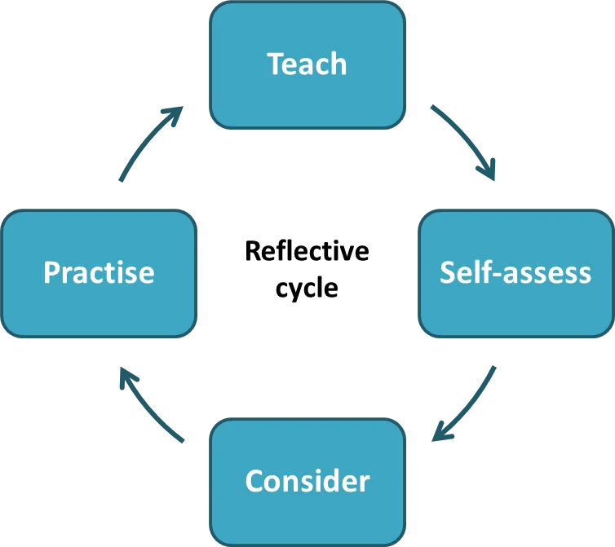
Figure 1
Health and wellbeing
Outdoor education is of major importance to health and well-being. Health can be further split into 2 physical health that is how physiologically their bodies cope and maintain themselves. The other section is mental health related to mental toughness and endurance from the brain. Well-being is Well-being is defined by the Oxford English Dictionary as “the state of being comfortable, healthy, or happy.” (“What is well-being, how can we measure it and how can we support people ...”) how outdoor learning centers develop health is by “a significant increase in physical activity promotes overall well-being and fine-motor skill advancement.” this promotes a motivation tom keep fit and healthy which is key to the centers is the residential visits they can provide this puts outdoor and endurance to the test when in stayed on an overnight residential we were put through our paces using navigational skills tom get us over a 5km walk to get to our campsite this is where we split into teams and built our tents for the night and then did numerous physical activities as well as having an early start on day two which was so we could fit in more activities. This was a keyway to get students to be in nature, you could be the best football or rugby player yet when tested within nature they could be weaker and vice versa it is all about skill and comfort. It is valuable for well-being and social development to play outdoors, not just sit in a classroom getting facts and learning to paper. The use of outdoor play is key to this such as It encourages pupils and children to develop in self-belief this is key to mental health and social skills. Some pupils have shown greater and more trust in themselves and others whilst they play and enjoy the outside. They play with self-belief withinside the ability that they might be noisier and boisterous and that they do now no longer experience as limited as they thought from being indoors. Confidence and vanity are vital for health and the capacity to learn. The ones given chances to manage success, whether through being able to be proper at hiking or being chief in an ingenious game, are the most likely to revel in pride and a sense of health. They will need greater this I feel would influence learning and their self-boundaries and personal limits. An argument against outdoor learning is the risk of injuries as it is not a controlled environment that the classroom has. Negative of this is the diss connection from nature risks help develop a rock-solid experience where people can learn from. The main benefit of soaking in the sun, according to Sehgal (2023), which was medically assessed by Dr. Neethu, is that it helps you meet your daily vitamin D requirements. To strengthen bones, vitamin D is necessary. The effectiveness of medications for vitamin D consumption decreases with everyday exposure to nature. When it comes to enhancing physical health, this is a key component in building immunity and long-term health. Kingswood's camps have discovered that a crucial component of wellbeing is the relationship between self-esteem and wellbeing. According to Kingswood, "Exploring nature through experiences in the outdoors enhances our vitality, well-being, and sense of personal development." Regardless of age, adventure experiences can teach us a great deal. Engaging in outdoor activities while in nature boosts our energy, wellbeing, and sense of personal development.

In conclusion the need for outdoor learning centers are essential to the postmodern world. The benefits outdoor adventure centers are essential in society as they tackle key elements of modern schooling and producing kids to keep pushing them and exploring ways of learning and development and helping the people getting involved in places where green spaces are not as accessible as they are home location is an urban jungle in major cities. A key reason to improve the quality is the reflective cycle. It works on how to improve, facilitate, educate the participants, and develop themselves. Outdoor centers I believe are a keyway to improve health and wellbeing as well as conclude that without outdoor education centers I believe the health crisis as well as the educational system need to be further pushed to improve life and career aspirations and love of your job and the need for outdoor education systems.
Word count 1,444

Reference list
https://www.gov.uk/national-curriculum#:~:text=The%20'basic'%20school%20curriculum%20includes,sex%20education%2C%20and%20religious%20education. Accessed 2/11/24 gov.uk
Presentation of Bills (PMBs) before Parliament. https://www.parallelparliament.co.uk/bills/session/2023-24/presentation
Outdoor adventure learning | E4L. https://evidenceforlearning.org.au/education-evidence/teaching-learning-toolkit/outdoor-adventure-learning
Cook, L. (2000). Outdoor education: Its origins and institutionalization in schools with What Is Experiential Learning? - Institute for Experiential Learning. https://experientiallearninginstitute.org/what-is-experiential-learning/
reference to the West Riding of Yorkshire since 1945. https://core.ac.uk/download/375530956.pdf
https://educationendowmentfoundation.org.uk/education-evidence/teaching-learning-toolkit/outdoor-adventure-learning#:~:text=What%20is%20it?,forest%20schools%20or%20field%20trips.
https://www.tandfonline.com/doi/pdf/10.1080/004676099284717#:~:text=The%201944%20Education%20Act%20established,within%20the%20statutory%20education%20system. Lynn cooks 1999.
https://experientiallearninginstitute.org/what-is-experiential-learning/ accessed 2/11/24 13:11
acara 2012 https://link.springer.com/article/10.1007/s41297-018-0053-y
https://www.cambridge-community.org.uk/professional-development/gswrp/index.html
https://www.mentalhealth.org.uk/explore-mental-health/blogs/what-well-being-how-can-we-measure-it-and-how-can-we-support-people-improve-it#:~:text=Well%2Dbeing%20is%20defined%20by,shy%20away%20from%20it%20either.
https://www.hkschool.org.uk/outdoor-environment-and-social-skills-expanding-learning-beyond-the-classroom/#:~:text=Holistic%20Development%20Outcomes,and%20fine%2Dmotor%20skill%20advancement.
Sue Durant 2019 https://www.communityplaythings.co.uk/learning-library/articles/the-value-of-outdoor-play?srsltid=AfmBOophMBzW6v9KK_SNztVZHoIJXQbFKsVkh5Yfo1Upi1kzHo8QSHSK
Sehgal (2023) https://www.nirvahealth.com/blog/how-nature-and-outdoor-activities-impact-well-being
http://www.oxforddictionaries.com/definition/english/well-being

