An Early Years Practitioner Guidance Handbook to Successful Transition.


(Source: Friendship circle, no date)

Content page

Introduction 3
Transitions 4
The needs of a child 5
Role of the adult 8
Partnerships 11
Interventions 14
Proposed outcomes 16
Reference list 17

Introduction

The purpose of this handbook is to guide and support early years practitioners to enable a smooth and effective transitional experience for young children who are beginning in a school setting. The guidance in this handbook will enable early years practitioners to explore the holistic approach towards a successful transition with desirable outcomes.
This handbook looks at the meaning of transitions, the needs of a child, the role of the adult, partnerships, interventions, proposed outcomes along with an emphasis on the importance of effective communication.

As emphasised by birthto5matters (2021) transitions which are managed sensitively within an early year’s setting may lay the foundations for positive transitions later on in life. In addition to this, birthto5matters (2021) state that transitions are not an event but a process and take time and careful planning.

Transitions
What is the meaning of transition?
“Transitions are changes that take place in our life; changes that move us from one stage to another. Transitions are an essential part of growing up and the most important ones happen when we are babies and young children” (Milton- Keynes, no date).
Further to this, Milton- Keynes (no date) highlights the variety of transitions in which individuals may face, these include:
- Milk to solids,
- Crawling to walking,
- Nappies to trained,
- Nursery to school,
- A new baby,
- A new home,
- Parents divorcing.

BirthTo5Matters (2007) states that most children starting school will have already experienced around seven transitions in family life and educational settings. In addition to this, BirthTo5Matters (2007) suggests that children find transitions just as stressful as adults and that this can impact on their academic outcomes and emotional well-being.
Moreover, O'Connor (2017) argues that children who are supported correctly during transitions are more emotionally intelligent and able to form good attachments while also being able to embrace changes and new experiences in later life. Therefore, it is imperative that children are treated with respect and supported by early years practitioners to ensure that these transitions are seamless.
Likewise, Milton-Keynes (no date) emphasises the importance of smooth transitions which have a positive effect on a child’s emotional development and enable individuals to cope with life's changes.

The needs of a child

O'Connor (2017) suggests that during a transition a child may feel a mixture of emotions such as anticipation, excitement, curiosity, anxiety, fear and uncertainty therefore it is crucial that every child is treated as an individual and that early year’s practitioners ensure they know the needs of the child.

Kline (no date) argues that Maslow’s Hierarchy of Needs is widely referred to within the educational sector, as for children to reach their full potential their needs must be met at their current level.
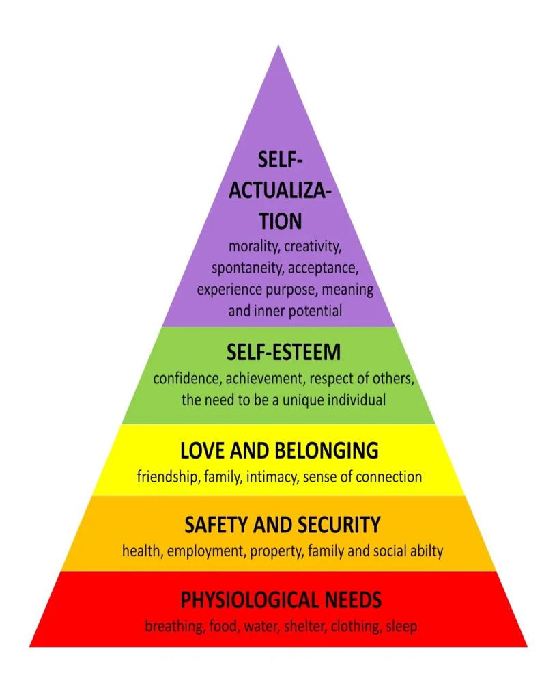
(Source: Simply Psychology, 2023)
Maslow’s Hierarchy of Needs (1943) is made up of five sections all of which can be applied to policies and procedures within an early year’s setting, for example:

- Basic needs - all children in an early year’s setting have access to water and free school meals,
- Safety needs - all schools provide a safe space for children with adults who are knowledgeable in safeguarding and have a DBS,
- Belongingness - children are encouraged to make relationships and friendships with peers,
- steam needs - all children are encouraged to contribute to their own learning.

PACEY (no date, A) state that a secure attachment between a child and an adult is imperative for a smooth, successful transition.
Conkbayir and Pascal (2014) highlight John Bowlby theory of attachment, stating children who have a positive, secure attachment with their main care giver usually the mother will be more likely to be happy and content due to their essential needs being met, and in contrast children who fail to make this attachment tend to have poor emotional well-being and form insecure attachments in later life.
In addition to this, Conkbavir and Pascal (2014) point out Mary Ainsworth theory that children can form multiple attachments with adults who provide care and meet their individual needs and in turn these attachments give the child a sense of security.
According to Norfolk County Council (no date) when the needs of the child are considered when organising a transition the outcomes are successful. Moreover, Norfolk County Council (no date) highlight some key points when considering the needs of the child, these include:
- Inclusive policies which meet the needs of every individual child,
- Policies for transitions for starting a new school, the beginning and end of day as well as a change of activities,
- Early years practitioners having regular meetings and reviews on children,
- Having a self-evaluation approach,
- Requesting parent’s feedback.

Environment and play
The environment in which the teacher creates for the children is also important, it needs to feel safe and inviting but also needs to encourage the children to be creative and feel the sense of freedom. Johnston and Nahmad-Williams (2018) back this argument and highlight Plowdens theory that children's curiosity tends to be stimulated by the environment the practitioner provides and leads to questions and how to find the answers - furthering their independence and knowledge. Further to this, Johnston and Nahmad-Williams (2018) state that Plowdens findings have influenced education nationally with early years settings adapting a child-centred approach within their curriculum.
Likewise, Frobel supported this idea of the importance of an inviting environment and independent play. Early Education (2021) maintain this stating Froebel believed that play is fundamental for a child's development as it is the way in which they construct their understanding of the world.
Furthermore, Conkbayir and Pascal (2014) argue that Frobel believed that an early year’s practitioners support along with a good environment and a range of resources suited to individuals age and ability would encourage children to be creative and imaginative. This would likely lead to the children taking control of their own learning through exploring and motivate the child to learn about the world and their surroundings independently.
In addition to this, the UNCRC article 13 the freedom of expression and article 31 play and cultural and artistic activities highlight the child's right to play independently (Save the Children, no date).

There are a variety of barriers an early year practitioner may come across when considering the needs of a child, these include:
Additional learning needs, mental health problems, behavioural problems, anxiety, adult to child ratio, resources
(Mentally Healthy Schools, no date).

Role of the adult
Lindon (2012) states that children who are well supported by knowledgeable and caring early years practitioners and parents tend to achieve more desirable outcomes.
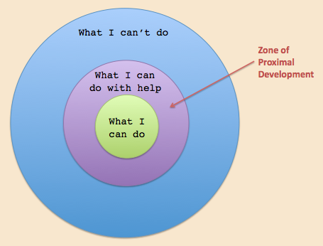
(Source: Instructionaldesign, no date)
Lev Vygotsky theory highlights the importance of interaction with peers and adults for a child's development.
Open Learn (no date) states that Vygotsky theory highlights the importance of a child being surrounded by individuals who have more life experience and are aware to their needs and abilities to further the child's cognitive development.
Likewise, Conkbayir and Pascal (2014) maintain Vygotsky theory that children learn from their interactions with others, this is because they imitate behaviours when completing tasks and in social situations.
Parent
According to The University of Chicago (DATE) Children learn everything from their parents and caregiver through talking and interactions, therefore it is imperative that the parent holds a positive view towards education as this will lead to the child holding the same view.
Plowden (1987) argues the importance of parent’s involvement within their child's education, stating that children who read at home with their parents tend to develop their literature skills at a faster pace in comparison to those who only read at school with their teachers and peers.
It is evidential that good parenting along with parental engagement with their child's education setting has a positive impact and consequently leads to successful outcomes for young people (Welsh Government 2017).
The UNCRC article 5 parental guidance highlights the parents right to guide their child to exercise their rights in line with the child's capacity.
Early Years Practitioner
It is the responsibility of the early years practitioner to ensure the child and their family are familiar with both the setting and the adults whom they will build relationships with prior to starting (BirthTo5Matters, no date).
Norfolk County Council (no date) argue that it is the responsibility of the settings manager to ensure:
- every child and family have been allocated a key worker at the first point of contact,
- Key workers have sufficient time to support both the child and their family,
- Key workers have allocated time to complete handover conversations with parents at the beginning and end of day,
- Opportunities for parents to visit are arranged which allow the early years practitioner to build on their continued relationship,
- manager supervisions are organised were advice and guidance can be given to the key worker to ensure the relationship is effective.
In addition to this, department for education (2014) states all children should be treated fairly, regardless of their race, gender, religion, beliefs, culture, home language, special education or ability.
Key worker
Pacey (no date, B) state it is the responsibility of a key worker to ensure the child's individual needs are always met. Moreover, Pacey (no date, B) argue that a key worker is crucial for a child's development as research and evidence proves children thrive when they have an adult they trust and respect.
According to birthto5matters (no date) a key worker tends to be the early years practitioner who makes those essential connections with a child. Therefore, it is imperative that the key worker is nurturing, approachable and aware of the needs of the child and able to ensure continuity.
In addition to this, Norfolk County Council (no date) state that a key worker is responsible for creating a reassuring, supportive relationship with not only the child but their family. This ensures communication is affective and allows the key worker to learn vital information about the individual child which they can then share with other early years practitioners. This then leads to the needs of the child being met and the correct support being put in place for the child both at the setting and at home.
Communication
Salamondra (2021) states effective communication within an early year’s setting is imperative as there are a variety of individuals in which an early year’s practitioner is expected to liaise with, these include children, parents, teachers, administrators and other agencies. Therefore, it is essential correct practise is utilised to enable the trust, and transparency needed for effective communication.
It is crucial that early year’s practitioners are flexible in the way they communicate with parents. Therefore, its important that early year’s settings use a range of communication methods, these include:
- newsletters,
- secure online forum,
- meetings,
- informal conversations,
- daily dairies (Norfolk County council. No date).

According to Mentally Healthy school (no date) there are many barriers in which an early year’s practitioner may encounter with the role of an adult, these include:
limited parental support, children being in care, lack of communication, resources, the amount of time available, language and adult to child ratios.

Partnerships

Butler and Ostrosky (2018) highlight that when families and early years practitioner work together with the child's needs at the forefront everyone involved benefits and outcomes are more desirable.

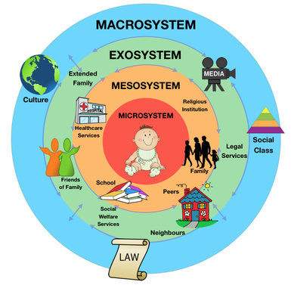
(Source: Study of the mind, 2015)
This illustration explains Bronfenbrenner’s ecological systems and highlights how a child's environment and relationships can affect not only their wellbeing but also their development.

According to Office for Multicultural Learning (no date) Bronfenbrenner’s theory suggests that the environment in which a child grows up in will affect every part of their life and the social factors will alter the way in which they think.
Conkbayir and Pascal (2014) argue that the microsystem tends to be most influential during a child's early life, this section includes family, nursery, school, teacher’s and health care professionals. Moreover, Conkbayir and Pascal (2014) highlight the importance of not only the relationship the child has with these individuals but the relationship the individuals within the mesosystem have with each other and how they interact as failing this it could potentially have a negative impact on the child's development.
Therefore, partnership working is crucial to ensure that a child's needs are met along with their development.

PACEY (no date, C) highlight four benefits of partnerships during transitions, these include:
- Children tend to appear more confident and settled,
- Families feel more reassured about their child transitioning,
- Parents participate more with the school curriculum and resources in their local community such as libraries and children centres,
- Schools and early years providers work together on how best to support the child during this time with both their confidence and wellbeing at the forefront.

Child
Carmarthenshire County Council (2023) argues children have their own views and have the right to be involved in any decisions which may affect them.
Therefore, it is important that a child willingly works in partnership with practitioners, their family along with other organisations to ensure the best outcome along with their needs being met.
A key worker or practitioner in some situations can be the voice of a child, and ensure the child feels heard and understood while conveying their opinion and choice (BirthTo5Matters, no date).
Additionally, the UNCRC article 12 respect for children's views highlights the child’s right to express their own thoughts and for these thoughts to be considered in any decision making (save the children, no date).

Families
BirthTo5matters (2007) state that research supports the idea that the only way we can really do the best for the children within our care is by involving their parents, this is because the parent is the child's first educator and holds a wealth of knowledge which an early year’s practitioner needs to be aware of to ensure the needs of the child are met.
Moreover, BirthTo5Matters (2021) suggest that the expectations of a child are highly influenced by what their families think, say and act, therefore its important that early year’s practitioners work in partnership with children, families and the community in a planned ad effective way to ensure the transition is as smooth as possible.
Likewise, attendance works (2023) suggests a few positive, supportive words during drop-off and pick-ups help build a good throughout with parents who may be more open to work in partnership with an early year’s practitioner if issues arise.

Other organisations
BirthTo5Matters (2021) highlights the importance of early years practitioners working in partnership with other organisations who are currently working with the child such as speech therapists, health visitors and previous settings to be able to support the child and meet their individual needs effectively.

Mentally Healthy School (no date) highlight a number of barriers an early year practitioner may face with partnerships, these include:
Parental support, language, lack of information, time and staffing ratios.

Interventions

Butler and Ostrosky (2018) argue that by understanding a young person's needs and abilities it enables early years practitioners and parents to plan accordingly and have more successful outcomes.

Welcome packs
Welcome packs contain important information about the early years setting.
Welcome packs are full of essential information and give parents and children a glimpse into the day- to – day life in the early years setting. Welcome packs prepare everyone for the upcoming academic year and can help anxious parents and children feel more confident about the transition (Sherborne School Qatar, no date).

Learning dairies
Learning dairies are an opportunity of early years practitioners to share information like what activities the child has participated in, what the child has eaten and drunk as well as any achievements they may of accomplished. This allows the parent an insight to their child's day and may reassure the parents who are anxious of leaving their child.
Colins (2010) states if both the early year practitioner and parent are encouraged to record information about the child's day along with their likes, dislikes, interests, activities and home events everyone will benefit as the child's needs and wants will be clear.

Settling in sessions
Settling in sessions give a child a chance to visit the setting and familiarise themselves with both the surroundings and the early years practitioners that will be working with them.
Colins (2010) suggests that settling in sessions are crucial for a smooth transition as it benefits both the child and their parents. Moreover, it is an opportunity for the child and parents to meet new faces and form attachments and gives a practitioner time to learn information about the child from the parents.
One Page profiles
One-page profiles hold all the key information about the child, they give you the knowledge to support a child and ensure their individual needs are met.
According to Carmarthenshire County Council (no date) a one-page profile holds value information about a child which enables everyone to get to know the individual as well as how best to offer support. Moreover, Carmarthenshire County Council (no date) state a one-page profile should contain the child’s full name, photo, what is important to them, the best way to support them as well as what people appreciate about them.

Proposed outcomes

A transition may look slightly different for every individual child therefore, it can be a little difficult to define a successful outcome. However, the behaviours and mannerisms in which the child displays can be an indicator on how the individual child has adjusted and settled into the setting. A settled child will make new friendships and relationships with peers and practitioners, they will also display happy, content emotions and be confident to play and learn independently.
The Welsh government (2023) states the four purposes ensure a broad, balanced education and give young people the knowledge and skills for employment, active citizenship and lifelong learning.
‘” The purpose of every school and setting’s curriculum is to support our children and young people to be:
- ambitious, capable learners, ready to learn throughout their lives
- enterprising, creative contributors, ready to play a full part in life and work
- ethical, informed citizens of Wales and the world
- healthy, confident individuals, ready to lead fulfilling lives as valued members of society” (Welsh Government, 2023).
UCL Psychology and Language science (no date) suggests a successful transition can be measured by how the child invests themselves academically and behaviourally in the school and if the child feels a sense of belonging to the school.

Reference list

Attendance works (2023) Creating a welcoming environment. Available: https://www.attendanceworks.org/resources/toolkits/early-education-toolkit/engaging-families/create-welcoming-environment/#:~:text=Greeting%20children%20and%20parents%20at,solving%20if%20attendance%20issues%20arise. (Accessed: 1.12.23)

Birthto5matters (2021) Transition. Available: https://birthto5matters.org.uk/transitions/#:~:text=When%20transitions%20in%20the%20early,vulnerable%20at%20times%20of%20transition. (Accessed: 20.10.23)

BirthTo5Matters (2007) All about… Transitions. Available: https://birthto5matters.org.uk/wp-content/uploads/2021/03/All-about...-transitions.pdf (Accessed: 26.11.23)

BirthTo5Matters (no date) Attachment and the role of key person. Available: https://birthto5matters.org.uk/attachment-and-the-role-of-the-key-person/ (Accessed: 27.11.23)

Butler, A. and Ostrosky, M. (2018) ‘ Reducing challenging behaviours during transitions: strategies for early childhood educators to share with parents’, Young Children, 74, (4), Pg. 1-9 Available: https://www.naeyc.org/resources/pubs/yc/sep2018/reducing-challenging-behaviors-during-transitions (Accessed: 20.11.23)

Carmarthenshire County Council (2023) Voice of the child/ young person. Available: https://www.carmarthenshire.gov.wales/home/council-services/education-schools/additional-learning-needs/voice-of-the-child-young-person/ (Accessed:2.12.23)

Carmarthenshire County Council (no date) Additional learning needs: Decision-making process. Available: https://www.carmarthenshire.gov.wales/home/council-services/education-schools/additional-learning-needs/additional-learning-needs-decision-making-process/3-what-is-a-one-page-profile/ (Accessed: 1.12.23)

Collins, S (2010) ‘Thinking through the uses of observation and documentation’ in Moyles, J. (ed) Thinking about play. Berkshire: Open University Press.

Conkbayir, M. and Pascal, C. (2014) Early Childhood Theories and Contemporary Issues. Bloomsburry: London.

Early Education (2021) Friedrich Froebel. Available: https://early-education.org.uk/friedrich-froebel/ (Accessed: 26.11.23)

Friendship Circle (no date) 7 Ways to Help Your Child with Special Needs Cope with Transitions. Available: https://www.friendshipcircle.org/blog/2017/05/10/coping-with-transitions (Accessed: 20.11.23).

Instructional Design (No date) Social Development Theory (Lev Vygotsky). Available: https://www.instructionaldesign.org/theories/social-development/ (Accessed: 26.11.23)
Johnston, J, and Nahmad-Williams, L. (2014) Early Childhood Studies. (1st ed.). Pearson Education: London.

Kline, T (no date) Applying Maslow’s Hierarchy of Needs in our Classrooms. Available: http://www.changekidslives.org/actions-4 (Accessed: 25.11.23)

Lindon, J. (2012). Understanding child development 0-8 years (3rd edn.). Hodder Education: Oxon.

Mentally Healthy Schools (no date) Transitions. Available: https://mentallyhealthyschools.org.uk/factors-that-impact-mental-health/school-based-risk-factors/transitions/ (Accessed: 27.11.23)

Milton- Keynes (no date) What are transitions. Available: https://www.milton-keynes.gov.uk/media/1893/download?inline (Accessed: 20.11.23)

Norfolk County Council (no date) Transitions between settings, rooms and key people. Available: https://www.wensumtrust.org.uk/_site/data/files/documents/wells/transition/nursery/F5594AE50E79DD96535D0E96BD4E5E69.pdf (Accessed:27.11.23)

O’Connor (2017) All about…transitions. Available: https://birthto5matters.org.uk/wp-content/uploads/2021/03/All-about...-transitions.pdf (Accessed: 26.11.23)

Office for Multicultural Learning (no date) Theoretical Framework. Available: https://www.scu.edu/oml/about-us/theoretical-framework/ (Accessed: 26.11.23)

PACEY (no date, A) transitions and settling in. Available: https://www.pacey.org.uk/Pacey/media/Website-files/PACEY%20member%20practice%20guides%20(PDFs)/PG10-transitions-and-settling-in.pdf (Accessed: 26.11.23)

PACEY, (no date, B) Your child’s key person. Available: https://www.pacey.org.uk/parents/resources-for-parents/tips,-factsheets-and-downloads/your-child-s-key-person/ (Accessed: 27.11.23)

PACEY (no date, C). Partnerships. Available: https://www.pacey.org.uk/Pacey/media/Website-files/PACEY%20general/pacey_sst_FINALforprint.pdf (Accessed: 26.11.23)
Plowden, B. (1987) ‘Plowden Twenty Years On’, Oxford Review of Education, 13, (1), 119-124. https://www.jstor.org/stable/1050516

Salamondra, T. (2021) ‘Effective Communication in Schools’, BU Jornal of Graduate Studies in Edication, 13, (1) Pg. 22-26 Available: https://files.eric.ed.gov/fulltext/EJ1303981.pdf

Save the children (no date) UN Convention of the rights of the child (UNCRC). Available: https://www.savethechildren.org.uk/what-we-do/childrens-rights/united-nations-convention-of-the-rights-of-the-child#:~:text=What%20is%20the%20UNCRC%3F,a%20summary%20of%20the%20UNCRC (Accessed: 26.11.23)

Sherborn School Qatar (no date). New parent information – welcome packs. Available: https://www.sherborneqatar.org/parent-information/new-parent-information-welcome-packs (Accessed: 1.12.23)

Simply Psychology (2023) Maslow’s Hierarchy Of Needs. Available: https://www.simplypsychology.org/maslow.html (Accessed: 25.11.23)

Study Of the Mind (2015) Urie Bronfenbrenner’s Ecological Systems Theory. Available: http://psychologydos.weebly.com/psych-journal/journal-8-urie-bronfenbrenners-ecological-systems-theory (Accessed: 26.11.23)

The University of Chicago (no date) The Power of Words. Available: https://tmwcenter.uchicago.edu/share/the-power-of-words/ (Accessed: 27.11.23)

UCL Psychology and Language Sciences (no date) School Transitions and Adjustment Research Study (STARS). Available: https://www.ucl.ac.uk/pals/research/clinical-educational-and-health-psychology/research-groups/school-transition-and-adjustment (Accessed: 2.12.23)

Welsh Government (2017) Flying start- Annex Parenting Support Guidance. Available: https://www.gov.wales/sites/default/files/publications/2019-07/flying-start-parenting-support-guidance.pdf (Accessed: 2.12.23)

Welsh Government (2023) Curriculum for Wales: overview. Available: https://www.gov.wales/curriculum-wales-overview#:~:text=The%20four%20purposes%20are%20the,encourage%20critical%20and%20civic%20engagement. (Accessed: 2.12.23)

