

Report Title: Integrated Human Capital Blueprint
Option 1 - Re-Engineering Performance & Job Design

Student Name: B M A RAHMAN
Student ID: 2526730

Programme: Master of Business Administration
Module Name: Human Capital Management
Module Code: LCMB7023

Lecturer’s Name: Dr Anupam Mazumdar

Work Count: 1646+1047=2693

Submission Date: 20 March, 2026

Table of Contents
Part 1: Re-Engineering Performance and Job Design at Aether Innovations 4
1. Introduction 4
2. Current Practices of Performance Appraisal and Job Design in Technology Companies 5
2.1 Traditional vs Modern Performance Appraisal & Job Design Systems in Technology Firms 6
3. Proposed Modern Performance Management System 6
3.1 OKR-Based Goal Alignment 6
3.2 360-Degree Feedback 7
3.3 Continuous Performance Conversations 8
4. Job Analysis and Job Design for Key Roles 8
5. Job Analysis of Key Leadership Roles 9
6. Job Design Principles 10
7. Integration of Performance Management and Job Design 11
8. Conclusion 11
Part 2: Reflective Learning and Professional Development 13
1. Reflective Learning Abstract 13
2. Description 13
3. Feelings 14
4. Evaluation 14
5. Analysis 15
6. Conclusion 15
7. Action Plan 15
8. Remaining Relevant in an AI-Driven Workplace 16
References 17

Table 1: Objective and Key Role Job Alignment 7
Table 2: Job Analysis and Proposed Specification 9

Figure 1: Job Problem-Solution Path 4
Figure 2: Traditional vs Modern Performance Appraisal & Job Design Systems in Technology Firms 6
Figure 3: OKR Performance Cycle for Continuous Performance Conversations 8
Figure 4: Job Characteristics Model and Its Impact on Employee Motivation and Performance 10
Figure 5: Integrated HR Architecture 11
Figure 6: Gibbs Reflective Cycle 13

Part 1: Re-Engineering Performance and Job Design at Aether Innovations

Introduction

Figure 1: Job Problem-Solution Path
Aether innovations is a fast-growing company involved in technology with a work force of about 300 employees but despite its expansion, the firm is experiencing myriad problems among them being a lack of organisational development, high employee turnover and customer dissatisfaction. This is common in the technological companies with instant scaling without creating effective people management systems. It is thus critical that strategic alignment should also be created between human capital practices and organisational objectives to revive innovation and performance. In the Strategic Human Resource Management profession, integrated HR practices are viewed as an effective source of organisational performance and competitive edge (Armstrong and Taylor, 2023).
Job design and performance management is specifically relevant as a way through which organisations can manipulate employee motivation, productivity and innovation. Modern studies point out that the orthodox systems of performance ratings and strict job designs often do not address the challenges of the dynamic nature of the changes in modern technology companies (Cappelli and Tavis, 2016). This report is a proposal of a comprehensive strategy that will reshape performance management systems as well as job designs in Aether Innovations, provided that the new strategy is implemented as the new Human Capital Consultant. Through implementing the modern performance framework and implementing the evidence-based principles of job design like the Job Characteristics Model, then the organisation will be in a position to develop a high-performance culture that will promote employee engagement, innovation and sustainable growth.

2. Current Practices of Performance Appraisal and Job Design in Technology Companies
Technology companies were used to using annual performance reviews, which were based on individual key performance indicators (KPIs). These reviews are normally top-down based evaluations that are performed at least once or twice a year by immediate supervisors. Although these systems offer an organized evaluation, critics claim that they do not represent the flexible and team-oriented aspects of the current digital workplace (Pulakos et al., 2019). The industries that require a rapid evaluation like the technology department, the assessment process will be obsolete within a few years and may not offer a feedback that is timely in the context of innovation and continuous improvement.
Consequently, a lot of technology companies have shifted to performance management systems that are more agile. Examples of frameworks implemented by such companies as Google and Intel include Objectives and Key Results (OKRs), which focus on transparency, quantifiable goals and periodic review of progress (Doerr and Page, 2018). In an equal measure, organisations are adopting 360-Degree Feedback as a means of obtaining ratings among various parties such as peers, subordinates and supervisors. This multi-dimensional feedback method enhances fairness, decreases the biases of the managers and gives a detailed picture of the employee performance (Bracken and Rose, 2011).
Technology companies are shifting to more flexible and skills-oriented job structures and away from fixed job descriptions in terms of job design. According to studies, knowledge workers have a higher intrinsic motivation and innovativeness when they work in a job that is characterised by autonomy, a skill variety and some meaningfulness (Parker, Morgeson and Johns, 2017). These traits are the key focus of the Job Characteristics Model that suggest that enriched jobs result in increased levels of motivation, job satisfaction as well as job performance (Hackman and Oldham, 1976).
But most organisations are unable to incorporate job design well with the performance management systems. Ambiguity of role or lack of engagement may be experienced among employees when performance expectations within organisations are not in relation to job structures and organisational strategy. As such, Aether Innovations needs an integrated strategy to synchronise the roles of the employees, performance goals and organisational objectives.

2.1 Traditional vs Modern Performance Appraisal & Job Design Systems in Technology Firms
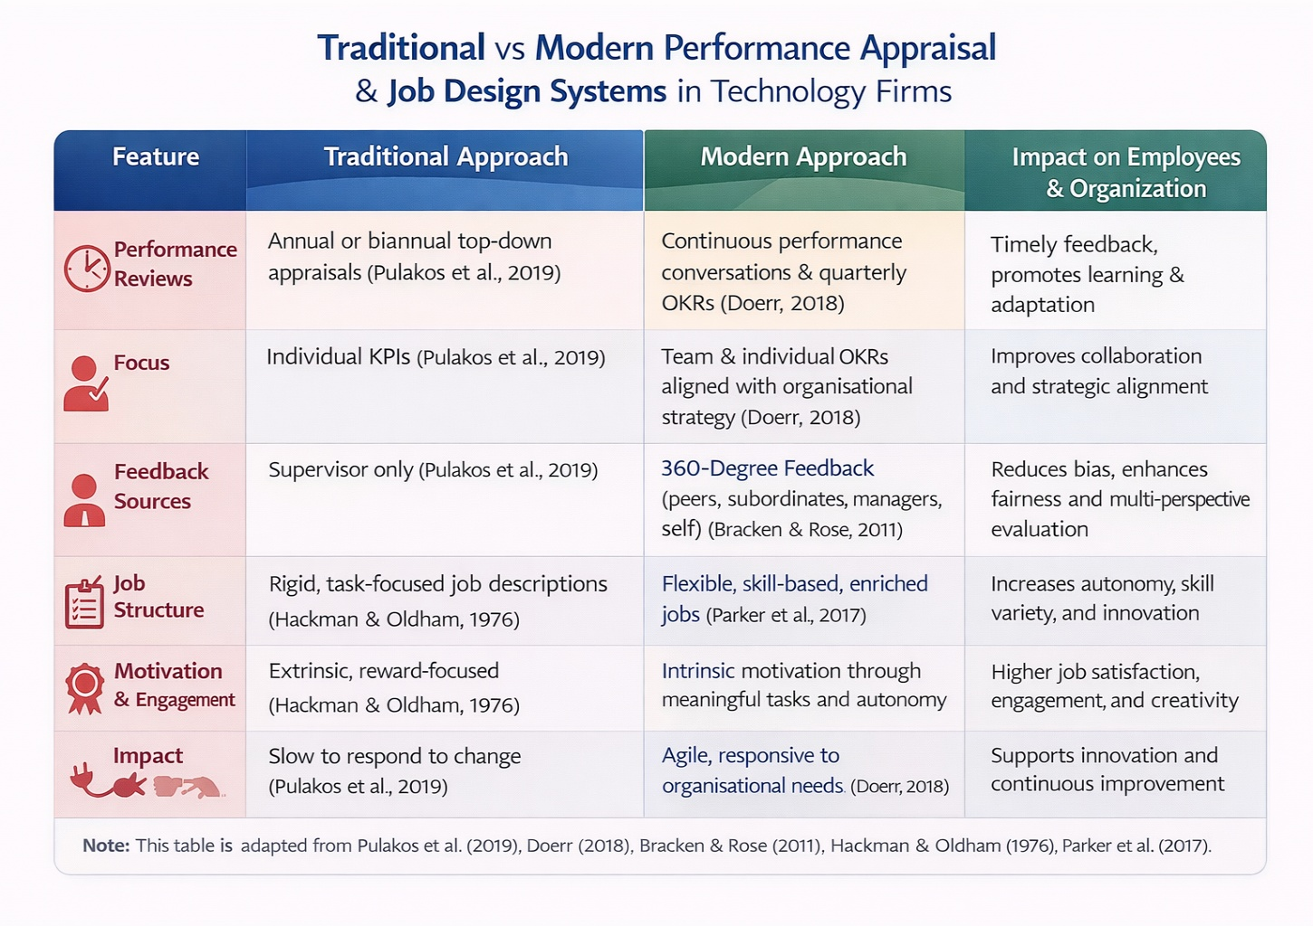
Figure 2: Traditional vs Modern Performance Appraisal & Job Design Systems in Technology Firms
(Hackman and Oldham, 1976; Bracken and Rose, 2011; Parker, Morgeson and Johns, 2017; Doerr and Page, 2018; Pulakos et al., 2019)

Proposed Modern Performance Management System
To solve the organisational problems experienced by Aether Innovations, a performance management system that is modern and growth oriented is suggested. The system is made up of a combination between OKRs, 360 degrees feedback and continuous performance conversations to achieve an agile and transparent performance culture.

OKR-Based Goal Alignment
The Objectives and Key Results model should be utilized as the center of the new performance framework. OKRs give organisations the opportunity to formulate bold strategic goals and quantifiable key outcomes that synchronize employee efforts with the goals of a company (Doerr and Page, 2018). The use of OKRs may be structured in an organisational, team and individual level of Aether Innovations to facilitate company strategic alignment.
For example:
Objective | Key Result | Measurement
Improve product innovation | Launch three new product features per quarter (Doerr and Page, 2018) | Product release metrics (Pulakos et al., 2019)
Increase customer satisfaction | Achieve customer satisfaction score above 90% (Doerr and Page, 2018) | Customer feedback surveys (Pulakos et al., 2019)
Table 1: Objective and Key Role Job Alignment
The OKR model promotes openness, teamwork and responsibility and provides employees with freedom in deciding how the goals would be accomplished.

360-Degree Feedback
Besides the use of OKRs, Aether Innovations must also implement the 360-Degree Feedback to promote the development of leadership and enhance the accuracy of the evaluation process. Feedback would also be gathered on the supervisors, colleagues, subordinates and self, and a holistic evaluation of performance is achieved (Bracken and Rose, 2011). This strategy works especially well in knowledge-based environments where cross functional teamwork and collaboration is paramount.

Continuous Performance Conversations
Instead of depending only on the annual reviews, performance conversations on a quarterly basis should be adopted. These are deliberations that are aimed at coaching and development and problem solving as opposed to judgement. Constant feedback allows employees to make improvements promptly and promotes the learning and improvement culture (Pulakos et al., 2019).

Figure 3: OKR Performance Cycle for Continuous Performance Conversations
(Doerr and Page, 2018; Pulakos et al., 2019)

Job Analysis and Job Design for Key Roles
Good job design is necessary to maximise employee motivation and innovative work. Job Characteristics Model firmly holds that motivation is affected by five fundamental job characteristics namely skill variety, task identity, task significance, autonomy and feedback (Hackman and Oldham, 1976). Aether Innovations may make employees more engaged and creative with the help of these dimensions offered in job design.

Job Analysis of Key Leadership Roles
The following table summarises job analysis and proposed specification for six critical leadership positions.

Role | Key Responsibilities | Required Skills | Innovation Contribution
CEO | Strategic leadership, organisational vision, stakeholder relations | Strategic thinking, leadership, decision-making | Drives innovation strategy
CFO | Financial strategy, budgeting, investment decisions | Financial expertise, analytical skills | Supports innovation funding
CTO | Technology development, system architecture | Technical leadership, engineering knowledge | Leads technological innovation
CIO | Innovation strategy, research initiatives | Creative thinking, strategic innovation | Develops new ideas and products
HR Director | Talent strategy, organisational development | HR expertise, leadership | Builds innovation culture
Head of R&D | Product research, experimentation | Scientific expertise, project management | Creates new technologies
Table 2: Job Analysis and Proposed Specification

Job Design Principles
All the functions must be made as autonomous and strategic as possible. As an illustration, the Chief Innovation Officer ought to be given the mandate of heading cross-functional innovation teams and exploring new technologies. Likewise, the R&D head unit must be involved in joint research through the incorporation of engineering, data science and product development.
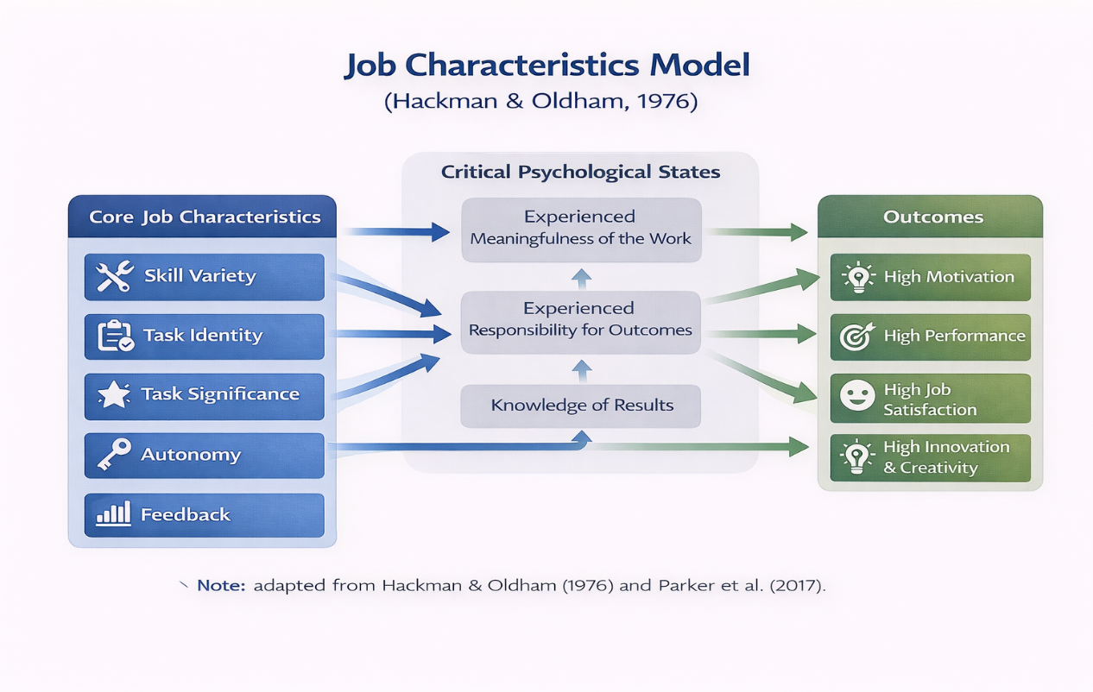
The job design that is based on skills can also contribute to the organisational flexibility. Focusing on competences instead of predetermined job activities, employees have an opportunity to work on a variety of projects and teams which enhances the exchange of knowledge and creativity (Parker, Morgeson and Johns, 2017).
Figure 4: Job Characteristics Model and Its Impact on Employee Motivation and Performance
(Hackman and Oldham, 1976; Parker, Morgeson and Johns, 2017).

Integration of Performance Management and Job Design
Figure 5: Integrated HR Architecture
Job design and performance management systems should act like part and parcel of the global HR strategy to have sustainable organisational improvement. OKRs and other performance frameworks offer explicit goals and fascinating results and enriched job designs offer the autonomy and resources needed by employees to realize these goals.
As an example, autonomy in job contributes to employees being able to explore new methods of doing things, and OKRs guarantee that the methods are in accordance with organisational strategy. Likewise, 360-degree evaluation will provide feedback that will assist employees to sharpen their skills as well as enhance interdepartmental cooperation.
These systems produce a performance-based culture with the elements of accountability, engagement and lifelong learning when properly incorporated. Studies state that organisations that align HR to strategic goals and objectives make them more productive, have their employees more loyal and dedicated to the company with better customer satisfaction (Armstrong and Taylor, 2023). In the case of Aether Innovations, the integrated approach would enable the organisation to recover innovation, employee turnover and enhance the strength of the organisation in a competitive edge with the technological industry.

Conclusion
Aether Innovations has serious organisational problems that need effective management of human capital through strategic approach. The current HR strategy that has been presented in this report is a combination of the contemporary efficiency management tools and innovative job design. The organisation can build a transparent and agile performance culture by adopting the use of the OKRs, 360-degree feedback and ongoing performance discussion. At the same time, the implementation of the Job Characteristics Model to the leadership positions boosts the sense of autonomy, ability to use skills and be innovative. Combined with the other systems, these systems bring the performance of employees and the organisational strategy in line to allow Aether Innovations to restock the innovation capability, to strengthen employee engagement and customer satisfaction.

Part 2: Reflective Learning and Professional Development

Figure 6: Gibbs Reflective Cycle

Reflective Learning Abstract
Reflection in professional learning allows people to deconstruct experiences by assessing the learning process and knowledge gains and devising ways in which they can be enhanced. The Gibbs Reflective Cycle is among the most popular reflective frameworks as it gives a systematized method with six steps: description, feelings, evaluation, analysis, conclusion and action planning (Gibbs, 1988). Based on this model, in the section, the learning journey during this module is being reflected on and how the acquired knowledge would contribute to creating effective learning and development (L&D) strategies and developing a personal culture of innovation and growth mentality.

Description
The key concepts regarding the role of the human resource management in the success of the organisation were learnt during this module. The main themes were the performance management systems, employee engagement strategy, organisational culture and innovation-oriented typology. One of the learning outcomes was the knowledge of how integrated HR practices match the performance of employees with organisational goals.
Such frameworks as the performance management systems and job design models revealed the contribution of the organisational practices to employee motivation and productivity. More specifically, job characteristics Model shedding light on the impact of job structures on employee level of motivation aspects of autonomy, skill variety and task meaningfulness (Hackman and Oldham, 1976). Also, the research of current performance management methods helped to understand the importance of constant feedback and aligning goals to enhance organisational effectiveness.

Feelings
Strategic HR models and organisational theories seemed to be complicated. Analytical efforts were needed to understand various ways that various HR systems relate to organisational culture and performance. As the module advanced however, these concepts were made more understandable and relevant to actual organisational situations.
The achieved understanding of how the HR strategies contribute to the engagement of employees and innovation enhanced the significance of human resource management in a strategic approach. The trust in the application of theoretical models to the actual organisational issues was enhanced through the necessity to favour analysis of case studies and practical examples as well.

Evaluation
The module offered great learning experiences especially in its discussion of the connection between the theory and a practical aspect. The learning process stimulated critical thinking on the way the HR models work in the complex organisational settings, rather than simply learning about the conceptual knowledge.
As an example, research on strategic HR systems showed that integrated systems like performance management, talent development and organisational culture can affect organisational innovation and productivity (Armstrong and Taylor, 2023). There exists one difficulty though: it was difficult to control the scope of theoretical concepts and also stay focused on the practical use of those ideas. This was to be dealt with through reading and contemplating to ensure that knowledge was being put into practice.

Analysis
An analytically, the module emphasized the significance of taking out appropriate knowledge and becoming flexible in the contemporary workplace. Digital transformation and rapid technological advancement necessitate organisations to have flexible and innovation-oriented HR policies. The examination of performance management structures and the system of employee development highlighted the necessity of organisational environments that promote the collaboration, innovation and life-long learning.
It is especially applicable to the concept of the growth mindset. In her view, Dweck states that in the growth mindset, people are sure that they can train their abilities with the help of effort and learning (Dweck, 2006). Using this lens in relation to professional development, it is important to note the need to remain to be ever-skilled in the aspect of adapting to a changing organisational environment.

Conclusion
A reflection on this module shows that HR management needs theoretical understanding and skills of application. The learning process reinforced the knowledge of the impact of integration of HR practices on such outcomes like employee engagement, innovation and performance. It also emphasised on the need to be flexible, think critically and continue learning throughout life as a professional in a vibrant organisational setting.

Action Plan
To advance in future, variety of measures can facilitate the next step of the professional growth. To begin with, frequent interaction with HR research and practices in the industry will ensure that there is a level of awareness of the new trends in management. Second, enhancing analytical and problem-solving skills will be useful in decision making in complicated organisational situations. Last but not least, it will be possible to seek opportunities to use HR concepts in real-life contexts, which will allow to unite theoretical knowledge with professional competence and facilitate building leadership skills.

Remaining Relevant in an AI-Driven Workplace
The fast progress in artificial intelligence (AI) is changing industries into automated routine work and improving performance in the organisations. Machine learning and advanced analytics have become the tools that enable people to do the previously human-performing tasks much faster and allow them to make decisions based on data (James Manyika and Kevin Sneader, 2018; World Economic Forum, 2020). Although these increases raise issues related to the displacement of jobs, it also offers the professionals an opportunity to work with AI systems which complements human abilities instead of substituting them.
Professionals who are to stay relevant should learn how to complement AI technologies. Certainly, creativity, critical thinking, emotional intelligence, and strategic judgement are unique human abilities that are hard to be replicated by AI (McAfee and Brynjolfsson, 2017; Davenport and Ronanki, 2018). Hence, people ought to enhance these skills during the process of using AI to enhance efficiency and evidence-based decision-making.
Artificial intelligence can help in human resource management by analysing human resource data, detecting the trends in talent, and enhancing evidence-based decisions. Nevertheless, HR professionals still need to draw conclusions, exercise moral judgement and organisational interpersonal relations (Jiang et al., 2017; Huang and Rust, 2021). This reaffirms the fact that technology literacy has to be coupled with effective leadership and people management capabilities.
The ability to learn and become flexible is also necessary to stay relevant. Through creating digital literacy without neglecting human-centred leadership, professionals will be able to implement AI in a sensible manner. Finally, AI is expected to be perceived as a symbiotic complement to the adaptable work environment in which it should not replace the human experience.

References
Armstrong, M. and Taylor, S. (2023) Armstrong’s Handbook of Human Resource Management Practice: A Guide to the Theory and Practice of People Management. Kogan Page. Available at: https://books.google.com.bd/books?id=_Jl5zwEACAAJ.
Bracken, D. and Rose, D. (2011) ‘When Does 360-Degree Feedback Create Behavior Change? And How Would We Know It When It Does?’, Journal of Business and Psychology, 26, pp. 183–192. Available at: https://doi.org/10.1007/s10869-011-9218-5.
Cappelli, P. and Tavis, A. (2016) ‘The performance management revolution’, Harvard Business Review, 94, pp. 58–67. Available at: https://api.semanticscholar.org/CorpusID:168392402.
Davenport, T.H. and Ronanki, R. (2018) ‘Artificial intelligence for the real world. Don’t start with moon shots’, Harvard Business Review, 96(1), pp. 108–117. Available at: https://openeclass.uom.gr/modules/document/file.php/BA222/ΕΡΓΑΣΙΑ%3A ΑΡΘΡΑ ΓΙΑ ΠΑΡΟΥΣΙΑΣΗ/Artificial_Intelligence_Real_World_HBR_Davenport_Ronanki_2018.pdf.
Doerr, J. and Page, L. (2018) Measure What Matters: How Google, Bono, and the Gates Foundation Rock the World with OKRs. Penguin Publishing Group. Available at: https://books.google.com.bd/books?id=u2NDDwAAQBAJ.
Dweck, C.S. (2006) Mindset: The New Psychology of Success. Ballantine Books (A Ballantine books trade paperback). Available at: https://books.google.com.bd/books?id=Pff9Xzpsj4oC.
Gibbs, G.R. (1988) ‘Learning by doing: A guide to teaching and learning methods’, in. Available at: https://api.semanticscholar.org/CorpusID:59957500.
Hackman, J.R. and Oldham, G.R. (1976) ‘Motivation through the design of work: Test of a theory.’, Organizational Behavior & Human Performance, 16(2), pp. 250–279. Available at: https://doi.org/10.1016/0030-5073(76)90016-7.
Huang, M.-H. and Rust, R.T. (2021) ‘A strategic framework for artificial intelligence in marketing’, Journal of the Academy of Marketing Science, 49(1), pp. 30–50. Available at: https://doi.org/10.1007/s11747-020-00749-9.
James Manyika and Kevin Sneader (2018) AI, automation, and the future of work: Ten things to solve for (Tech4Good) | McKinsey, McKinsey Global Institute. Available at: https://www.mckinsey.com/featured-insights/future-of-work/ai-automation-and-the-future-of-work-ten-things-to-solve-for (Accessed: 15 March 2026).
Jiang, F. et al. (2017) ‘Artificial intelligence in healthcare: past, present and future’, Stroke and Vascular Neurology, 2(4). Available at: https://doi.org/10.1136/svn-2017-000101.
McAfee, A. and Brynjolfsson, E. (2017) Machine, Platform, Crowd: Harnessing Our Digital Future. W. W. Norton. Available at: https://books.google.com.bd/books?id=zh1DDQAAQBAJ.
Parker, S.K., Morgeson, F.P. and Johns, G. (2017) ‘One hundred years of work design research: Looking back and looking forward.’, Journal of Applied Psychology. Parker, Sharon K.: UWA Business School, University of Western Australia, M252, Perth, WAU, Australia, 6009, haron.parker@uwa.edu.au: American Psychological Association, pp. 403–420. Available at: https://doi.org/10.1037/apl0000106.
Pulakos, E.D. et al. (2019) ‘Performance Management Can Be Fixed: An On-the-Job Experiential Learning Approach for Complex Behavior Change’, Industrial and Organizational Psychology, 8, pp. 51–76. Available at: https://api.semanticscholar.org/CorpusID:144005873.
World Economic Forum (2020) ‘The future of jobs report 2020 | world economic forum’, The Future of Jobs Report, (October), p. 1163. Available at: https://www.weforum.org/reports/the-future-of-jobs-report-2020/digest.

