CertHE in Business Skills

Student Name: Duaa Alhaj Ahmad
Student Number: 2439821
Course Name: Employability and Career Development (LCLM4005_LON)
Lecturer Name: Riaz Bhatti
Session: February 2026 Term
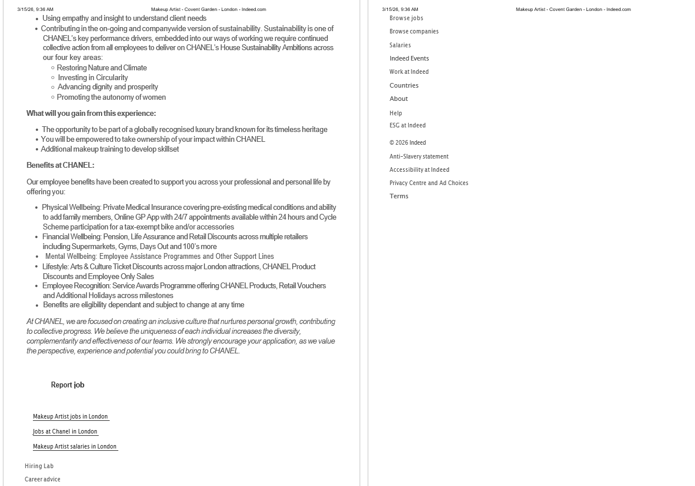
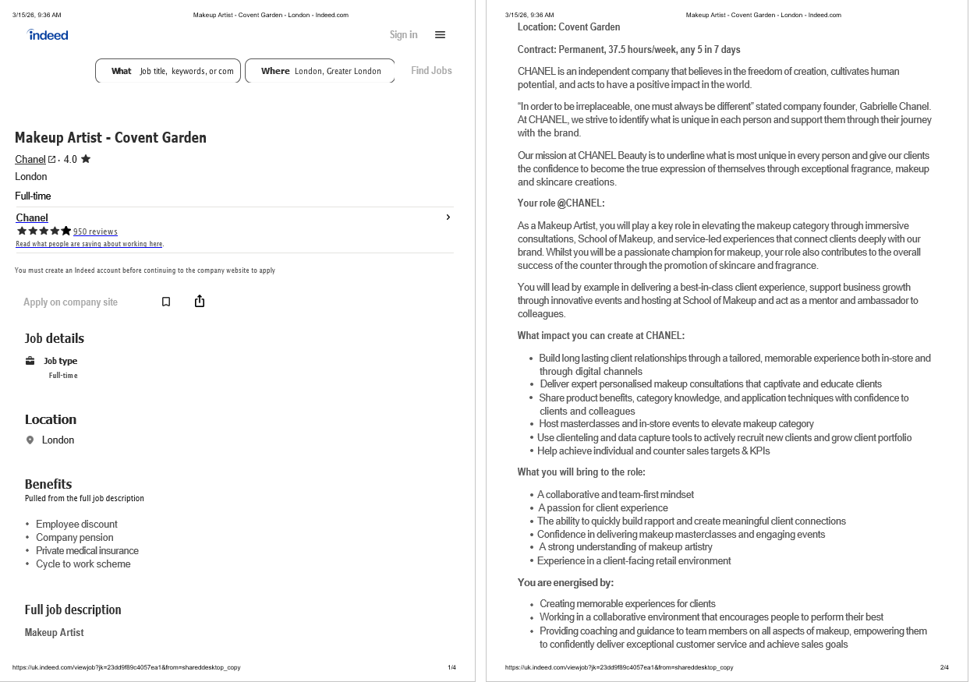
Duaa Alhaj Ahmad
7, Woodlands Street, London
Clarita Fernandes
Chanel Ltd,
Covent Garden, London
15.3.2026

Dear Mrs Clarita,
I would like to express my interest in the Makeup Artist position that I saw advertised on Indeed. I have attached my CV for your review.
Although I have not worked professionally yet, I have been interested in makeup for more than three years. Makeup is like a hobby for me, and I regularly do makeup for myself and my relatives. I enjoy creating different looks.
I have experience in choosing styles that suit different face shapes and occasions, and I am always seeking to improve my skills.
My interest in makeup, communication skills such as talking with my relatives to understand their preferred makeup styles, and creativity have helped me become more confident. I am eager to learn more and develop my skills, and I believe I can provide excellent beauty services and make customers happy.
Thank you for reviewing my application. I hope to hear from you soon.

Yours sincerely,
Duaa Alhaj Ahmad



