

LCMB7002
Financial Management

Assessment component: Financial Performance and Management
Strategic CFO Challenge

Title: Strategic CFO Challenge – Financial Analysis of Toyota motors Corporation

Submitted by
Student Name: Ashraful Hoque
ID: 2522430
Submitted to-
Lecturers: Dr Shengfeng Mei/
Md Kal

Submission deadline: 24th April 2026 by 2PM

Table of Contents
Table of Contents 2
List of Tables 3
List of Figures 4
1. Introduction 5
2. Financial Health Check (Ratio Analysis) 6
2.1 Profitability Analysis 7
2.2 Liquidity and Efficiency Analysis 8
2.3 Gearing and Investment Ratios 9
2.4 Key Trends, Strengths and Threats 10
3. Working Capital Management Analysis 12
3.1 Cash Operating Cycle Assessment 12
3.2 Practical Strategies for Improving Liquidity 12
3.3 Short-term vs Long-term Financing Options 13
4. Strategic Financial Restructuring Plan 15
4.1 Recommended Restructuring Options 15
4.2 What This Means for Shareholders, Debt, and Flexibility 16
4.3 International and Ethical Considerations 16
5. Investment Appraisal and Capital Budgeting Decisions 18
5.1 Project Details and Calculations 18
5.1.1 Payback Period (PBP) 18
5.1.2 Accounting Rate of Return (ARR) 18
5.1.3 Net Present Value (NPV) 19
5.1.4 Profitability Index (PI) and IRR 19
5.2 Which Project, and Why? 20
5.3 What If We Can Invest in More Than One? 21
6. Conclusion 22
References 24
Appendices 26
Appendix A: Ratio Formulas Used 26
Appendix B: Investment Appraisal Workings 26

List of Tables
Table 1: Financial Summary of Toyota motors Corporation (FY2021–FY2025)
Table 2: Profitability Ratios (FY2021–FY2025)
Table 3: Liquidity and Efficiency Ratios (FY2024 vs FY2025)
Table 4: Gearing and Investment Ratios (FY2024 vs FY2025)
Table 5: Estimated Cash Operating Cycle (FY2024 vs FY2025)
Table 6: Comparative Summary of All Three Projects
Table 7: Capital Rationing – Comparing Project Combinations

List of Figures
Figure 1: Net Sales Trend (FY2021–FY2025)
Figure 2: Profitability Ratios Trend Chart
Figure 3: Segment Revenue Breakdown (FY2025)
Figure 4: Cash Flow Comparison (FY2024 vs FY2025)
Figure 5: NPV Comparison of Projects A, B, and C

1. Introduction
Toyota Industries Corporation, founded in 1926 by Sakichi Toyoda, is one of those companies that people outside the automotive world tend to overlook, despite it being a genuinely massive enterprise. With consolidated net sales reaching ¥4,084.9 billion in FY2025 and a workforce of nearly 80,000 employees, the firm operates across automobiles, materials handling equipment, and textile machinery (Toyota motors Corporation, 2025). What makes it particularly interesting for a financial analysis is its hybrid identity: it manufactures car air-conditioning compressors, engines, and electronic components for electric vehicles while simultaneously being the world's largest producer of forklift trucks through its Materials Handling Equipment segment.
This report takes on the role of Chief Financial Officer and attempts to do something that, frankly, is easier said than done: to look at five years of financial performance, identify where the cracks are, and propose something constructive. The company has been navigating considerable turbulence. There was the domestic engine certification scandal discovered in 2023, which led to production suspensions, reputational damage, and provisions exceeding ¥49 billion (Toyota Industries Corporation, 2025). At the same time, the firm posted record profits. It is actually that kind of tension, between the strong headline numbers and the messy operational risks lurking underneath, that makes digging into this analysis feel worth the effort.
The structure follows a logical progression. In Section 2, the report works through a fairly thorough ratio analysis looking at profitability, liquidity, efficiency, gearing, and investment metrics from FY2021 through to FY2025. Section 3 examines working capital management. Section 4 proposes strategic financial restructuring options. Section 5 looks at three hypothetical investment projects and puts them through the usual capital budgeting tools: Payback Period, ARR, NPV, Profitability Index, and IRR. The goal throughout is to be as rigorous as possible while still being upfront about where things get fuzzy. Because let's be honest, any analysis that relies on published financial statements is inherently working with information that is not quite complete.

2. Financial Health Check (Ratio Analysis)
Before getting into the ratio analysis proper, it is worth just pausing for a moment and looking at what the raw numbers themselves are actually saying. Sometimes the big picture gets lost once you start slicing things into percentages. Over the past five years, Toyota Industries has come close to doubling its net sales, going from ¥2,118.3 billion in FY2021 all the way up to ¥4,084.9 billion by FY2025. Operating profit moved in roughly the same direction, going from ¥118.1 billion up to ¥221.6 billion over that same five-year window. Though its worth noting the pace of growth here has been slower than the topline, which tells you something about cost pressures eating into margins. On the surface, this looks like a company in excellent health. But the picture gets muddier when you look beneath the headline figures, particularly around cash flow volatility, comprehensive income swings, and the massive decline in total assets from ¥11,078.4 billion to ¥9,403.4 billion in a single year (Toyota Industries Corporation, 2025).
That last point is mostly explained by the fall in fair value of investment securities, especially Toyota Motor Corporation shares, which dropped from ¥4,521.3 billion to ¥3,119.1 billion. The company holds shares in several Toyota Group entities for strategic relationship purposes, but the downside is that equity becomes hostage to stock market sentiment. When Toyota Motor shares fall, Toyota Industries’ balance sheet takes the hit even though nothing has changed operationally.
Table 1: Financial Summary of Toyota Industries Corporation (FY2021–FY2025)
Metric (¥ Bn) | FY2021 | FY2022 | FY2023 | FY2024 | FY2025
Net Sales | 2,118.3 | 2,705.1 | 3,379.8 | 3,833.2 | 4,084.9
Op. Profit | 118.1 | 159.0 | 169.9 | 200.4 | 221.6
Net Profit | 136.7 | 180.3 | 192.8 | 228.7 | 262.3
Total Assets | 6,503.9 | 7,627.1 | 7,821.1 | 11,078.4 | 9,403.4
Op. Cash Flow | 382.3 | 321.0 | 194.9 | 443.5 | 171.5
EPS (¥) | 440.28 | 580.73 | 621.17 | 736.86 | 856.96
Source: Toyota Industries Corporation (2025) Annual Financial Report.
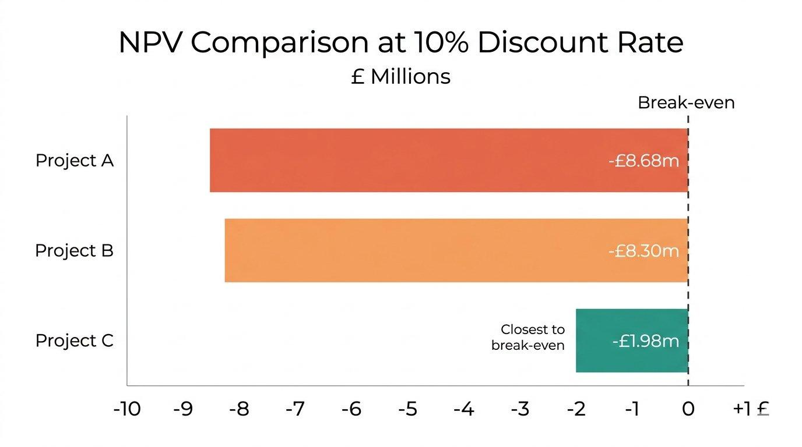
Figure 1: Net Sales Trend, FY2021–FY2025 (¥ Billions). Source: Author’s compilation.

2.1 Profitability Analysis
Profitability ratios paint a somewhat cautious picture. Gross profit margin has stayed fairly steady at around 23% throughout the period. It did nudge slightly from 23.5% in FY2024 down to 23.3% in FY2025, though honestly, that is more of a rounding difference than a real shift. Operating margin has bounced around a bit between 5.0% and 5.9% over this period, settling at 5.4% in FY2025. Not dramatic movement, but enough to notice.
Net profit margin has, well, technically improved, rising from 6.4% in FY2021 to 6.4% in FY2025. Which is to say it has basically stayed flat, even if the years in between saw some dips and recoveries. Return on equity has remained remarkably stable at around 4.8% to 5.0%, which is, to be candid, not particularly exciting. When you have a company sitting on ¥4.9 trillion in equity and only pulling a 4.8% return, something feels off. That either points to an overly cautious balance sheet or assets that just are not being put to work hard enough (McLaney, 2017). The enormous investment securities portfolio, which makes up over 40% of total assets, is probably the biggest culprit behind that dilution.

Table 2: Profitability Ratios (FY2021–FY2025)
Ratio | FY2021 | FY2022 | FY2023 | FY2024 | FY2025
Gross Margin | ~23.0% | ~23.2% | ~23.1% | 23.5% | 23.3%
Op. Margin | 5.6% | 5.9% | 5.0% | 5.2% | 5.4%
Net Margin | 6.4% | 6.7% | 5.7% | 6.0% | 6.4%
ROE | 4.82% | 5.03% | 4.97% | 4.63% | 4.79%
EPS (¥) | 440.28 | 580.73 | 621.17 | 736.86 | 856.96
Source: Author’s calculations from Toyota Industries Corporation's (2025) Annual Financial Report.
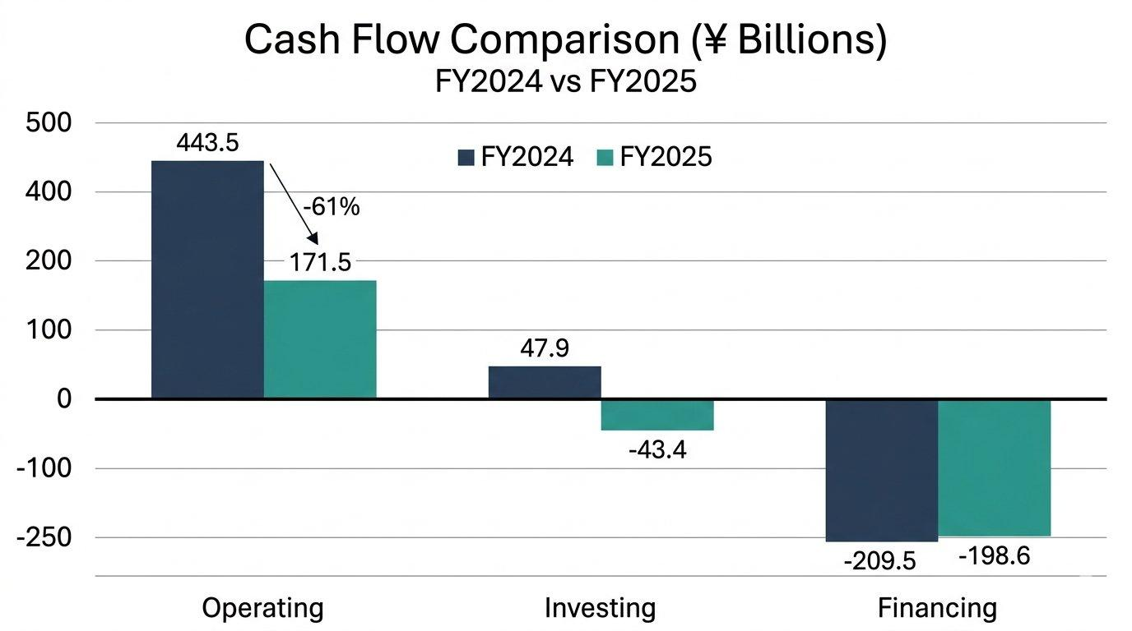
Figure 2: Profitability Ratios Trend, FY2021–FY2025 (%). Source: Author’s calculations.
On a brighter note, earnings per share has nearly doubled over five years, going from ¥440.28 up to ¥856.96. That is one trend that's genuinely hard to argue with. This reflects both profit growth and the effect of a significant ¥109.1 billion share buyback program (Toyota Industries Corporation, 2025). Shareholders will probably like what they see there, though there is a catch. The share buyback shrinks the equity base too, and that could end up inflating ROE in future periods in a way that does not really reflect actual performance improvement.

2.2 Liquidity and Efficiency Analysis
Liquidity is perhaps the area where questions start to emerge. The current ratio sits at approximately 1.92, which is comfortable. The quick ratio, stripping out inventories, sits around 1.53. These are adequate.
The cash position, though, has taken a noticeable hit. Cash and equivalents dropped from ¥496.8 billion at FY2024 year-end to ¥378.4 billion by FY2025. A 24% fall in your cash pile in a single year is not the kind of thing you can just shrug off. Operating cash flow dropped from ¥443.5 billion to just ¥171.5 billion. A big chunk of that is down to income tax payments, which jumped from ¥78.9 billion to ¥213.8 billion (Toyota Industries Corporation, 2025). That raises questions about cash flow predicatability going forward.
Turning to efficiency ratios, these give you a sense of how disciplined the company is being with its day-to-day operations. Inventory turnover looks reasonably healthy on the surface. Inventories stayed more or less flat at ¥619.8 billion even though sales grew by 7%. That said, you would really need a more detailed product-by-product breakdown to say for certain, because aggregate numbers have a tendency to hide problems at the segment level (Atrill, 2020).
Table 3: Liquidity and Efficiency Ratios (FY2024 vs FY2025)
Ratio | FY2024 | FY2025
Current Ratio | 1.91 | 1.92
Quick Ratio | 1.53 | 1.53
Cash Ratio | 0.30 | 0.23
Inventory Turnover | 4.73x | 5.06x
Receivables Days | ~60 | ~56
Source: Author’s calculations from Toyota Industries Corporation's (2025) Annual Financial Report.
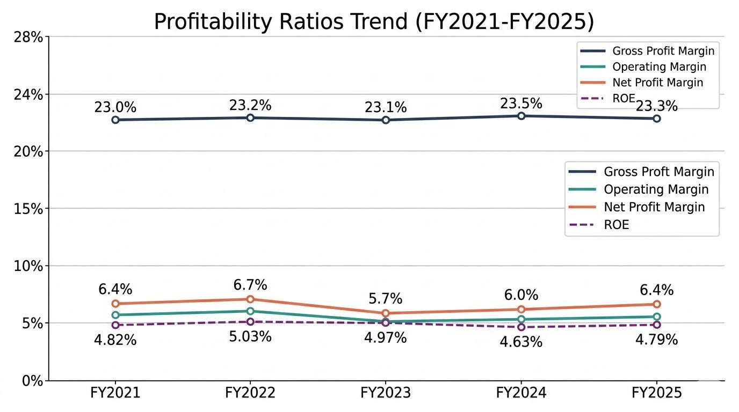
Figure 4: Cash Flow Comparison, FY2024 vs. FY2025 (¥ Billions). Source: Author’s calculations.

2.3 Gearing and Investment Ratios
By FY2025, total liabilities came in at ¥4,388.2 billion while equity sat at ¥5,015.2 billion, which works out to a debt-to-equity ratio of roughly 0.87. Not alarming by any stretch, but it's worth keeping an eye on the direction of travel. Interest cover, meanwhile, is in a very comfortable position. With operating profit at ¥221.6 billion and interest expenses of just ¥11.1 billion, the interest coverage ratio comes out at over 19 times. You would have to imagine a fairly catastrophic scenario for that to become a problem. The credit ratings from S&P, Moody’s, and R&I more or less confirm this picture of financial solidity (Toyota Industries Corporation, 2025).
The equity ratio to total assets stands at 52.16%, which is actually quite strong for a manufacturing conglomerate. The price-to-earnings ratio of 14.83 times is reasonable. One thing that stands out, though, is that the company has already said there will be no dividends for FY2026. The reason is the pending tender offer from Toyota Fudosan, and if that goes through, it will quite fundamentally reshape the company’s entire capital structure.
Table 4: Gearing and Investment Ratios (FY2024 vs FY2025)
Ratio | FY2024 | FY2025
Debt-to-Equity | 0.80 | 0.87
Interest Coverage | ~11.8x | ~19.9x
Equity Ratio | 54.57% | 52.16%
DPS (¥) | 200 | 280
P/E Ratio | 21.24x | 14.83x
Source: Author’s calculations from Toyota Industries Corporation's (2025) Annual Financial Report.

2.4 Key Trends, Strengths and Threats
Several things stand out. On the positive side, revenue diversification is a genuine strength. The Materials Handling Equipment segment (FY2025: ¥2,786.3 billion) serves as the dominant revenue driver, accounting for 68% of consolidated sales. The automobile segment (¥1,160.2 billion) saw operating profit surge 147% year-on-year, which is partly a recovery effect following the partial resolution of the engine certification mess. Geographic diversification is also healthy: Japan accounts for ¥1,008.1 billion, the US ¥1,415.2 billion, and other markets ¥1,661.6 billion (Toyota Industries Corporation, 2025).
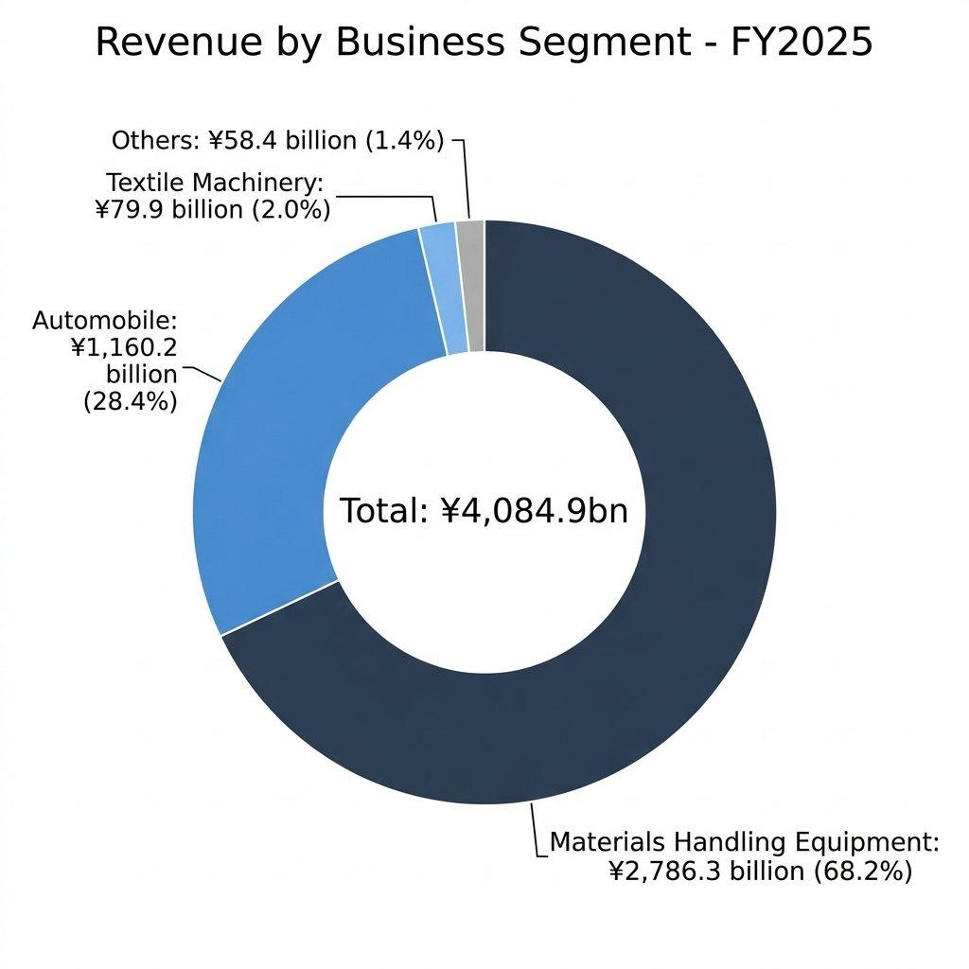
Figure 3: Business Segment Revenue Breakdown, FY2025. Source: Author’s compilation.
The primary threat, beyond the ongoing engine certification investigations and US class action lawsuit, is the extraordinary volatility in comprehensive income. To put the volatility in perspective, comprehensive income was ¥2,285.8 billion in FY2024. A year later, it swung to negative ¥938.1 billion. That is a swing of over ¥3.2 trillion in twelve months, which is the kind of number that makes you do a double take. This exposes how sensitive the company’s reported equity is to stock market movements (Barth, Landsman, and Lang, 2008).

3. Working Capital Management Analysis

3.1 Cash Operating Cycle Assessment
Margins and ROE get all the attention in financial analysis, and fair enough, they matter. But at the most basic level, a company needs to manage the timing gap between when it pays suppliers and when customers pay it. Get that wrong and nothing else really saves you. So the practical question for Toyota Industries is a simple one: how many days does cash sit trapped in the operating cycle before it comes back?
Inventory is the first piece of the puzzle. The company was carrying ¥619.8 billion worth of stock against a cost of sales of ¥3,133.4 billion, which translates to an inventory holding period of about 72 days. Trade receivables of ¥628.5 billion set against net sales of ¥4,084.9 billion gives you a receivables collection period of around 56 days. On the payables side, trade payables of ¥422.9 billion against cost of sales imply a payment period of approximately 49 days.
So when you add it all up, 72 + 56 - 49 = 79 days. That is the estimated cash operating cycle. Not terrible, but there's definitely room to tighten things up.
Whether that improvement from 82 to 79 days was a deliberate management initiative or simply a byproduct of shifting product mix is honestly hard to say from the consolidated numbers alone. You would need segment-level and ideally product-level data to make that call with any confidence. What is clear is that the trend is moving in the right direction. A shorter cycle means less capital tied up in day-to-day operations, which frees resources for investment or debt repayment, both of which matter given the company’s current situation.
Table 5: Estimated Cash Operating Cycle (FY2024 vs FY2025)
Component (Approx. Days) | FY2024 | FY2025
Inventory Holding | ~77 | ~72
Receivables Collection | ~60 | ~56
Payables Payment | ~55 | ~49
Cash Operating Cycle | ~82 | ~79
Source: Author’s estimates based on Toyota Industries Corporation's (2025) Annual Financial Report.

3.2 Practical Strategies for Improving Liquidity
So what could Toyota Industries actually do to free up cash through better working capital management? The most obvious starting point is receivables. Sitting on ¥628.5 billion in trade receivables with a 56-day collection period means there is real money locked up. If you could shave just 5 days off that collection period, you are looking at freeing up somewhere in the neighborhood of ¥56 billion in cash. Early payment discounts for bigger customers, or leaning more heavily into factoring arrangements in the Materials Handling Equipment segment, which already manages ¥626.5 billion in lease investment assets, could help move the needle (Brealey, Myers, and Allen, 2020).
On the surface, overall inventory looks stable enough. But finished goods climbed from ¥327.5 billion to ¥355.3 billion while raw materials fell from ¥148.9 billion to ¥141.1 billion. That kind of shift hints at either overproduction somewhere or products that are not moving off shelves as fast. The Textile Machinery segment, where sales fell 14%, seems like an obvious candidate for tighter demand forecasting and leaner inventory practices (Christopher, 2016).
Then there is the supplier side. Going back and trying to renegotiate payment terms is always worth exploring. Extending the payables period from 49 to 55 days would retain cash for an additional week. This must be balanced against supplier relationships, particularly given the lesson from the engine certification scandal about straining partner relationships.
Looking at it from a broader perspective, the company could also explore more structured approaches to working capital financing. Supply chain finance programs, where a bank pays suppliers early at a discount while the buyer retains its normal payment terms, have become increasingly common in manufacturing. Toyota Industries’ strong credit rating would make it an attractive candidate for such arrangements, and the savings could be shared between the company and its suppliers, turning a potentially adversarial negotiation into a collaborative one.

3.3 Short-term vs Long-term Financing Options
Short-term financing has its advantages, mainly flexibility. The commercial paper program can be rolled over efficiently. The 4.10% weighted average on short-term loans probably reflects borrowing conditions in non-Japanese subsidaries rather than the parent company’s creditworthiness. Long-term loans carry a weighted average of 2.56%. Looking ahead, there is a decent argument for locking in more long-term fixed-rate debt while conditions allow it. With global monetary policy still uncertain, having predictable financing costs seems like the sensible play (Watson and Head, 2019).

4. Strategic Financial Restructuring Plan

4.1 Recommended Restructuring Options
The elephant in the room is the pending tender offer from Toyota Fudosan at ¥16,300 per share, announced on 3 June 2025. If successful, this transaction will take Toyota Industries private. The reasoning behind it, at least officially, is that going private would let the company make decisions faster, integrate more deeply with Toyota Group companies, and chase longer-term growth without constantly worrying about what the market thinks every quarter (Toyota Industries Corporation, 2025). Whether that actually plays out that way is another question entirely.
For starters, the company really ought to look at selling off assets that are not central to its core business. The sale of partial stakes in AICHI Corporation to ITOCHU, completed in May 2025 with an expected gain of ¥9.1 billion, sets a useful precedent. The logic behind it makes sense. AICHI’s aerial work platform business was profitable, yes, but it was never really at the heart of what Toyota Industries is trying to do. You could make a similar case for the Textile Machinery segment, which managed only ¥2.5 billion in operating profit on ¥79.9 billion of sales. A 3.1% margin is, frankly, barely worth the management attention it consumes.
The second restructuring dimension is rationalizing the cross-shareholding portfolio. Holding over ¥4.0 trillion in investment securities that generate minimal operating returns and create massive balance sheet volatility is hard to justify from a capital efficiency standpoint. Unwinding even a fraction of the Toyota Motor stake would generate enormous cash that could be deployed into electrification R&D, logistics automation, or debt reduction. Of course, this is politically sensitive within the Toyota Group. Cross-shareholdings have served as relationship cement for decades, and dismantling them sends a signal that the old ways of doing business are changing. But post-delisting, without quarterly public reporting of unrealized gains and losses, the practical burden of holding these shares may actually decrease, which paradoxically reduces the urgency to sell them.
On the equity side, the company has already gone through a ¥109.1 billion share buyback in FY2025, and there will be no dividends paid for FY2026. Once delisting actually happens, the whole capital structure changes. Without public shareholders Instead of breathing down management’s neck for quarterly returns, there is a real opportunity to funnel free cash flow into R&D and capital investment. That lines up nicely with the ¥488.5 billion the company already poured into property, plant, and equipment in FY2025 alone.

4.2 What This Means for Shareholders, Debt, and Flexibility
How generous is the ¥16,300 per share tender offer, really? That is a question worth sitting with. Equity per share is ¥16,273, so the offer is essentially at book value, a price-to-book of roughly 1.0x. And if you assume FY2025 earnings carry forward, the implied P/E is about 19 times. Neither of those screams premium, though the stock was trading at a P/E of 14.83 before the announcement, so the offer is still above where the market had priced it.
Losing access to equity markets means the company will have to lean harder on bank loans and the bond market. But with operating cash flows that have averaged over ¥300 billion a year and solid credit ratings, that probably is not going to be a dealbreaker. The bigger worry is around discipline. Being private can absolutely speed up strategic pivots, but it also takes away the pressure that comes from public market scrutiny, and that pressure is not always a bad thing (Jensen, 1986).

4.3 International and Ethical Considerations
The international footprint is substantial. Toyota Industries has operations spread across more than 25 countries. Exchange rate risk is flagged repeatedly in the FY2025 annual report. A weaker yen did help boost reported sales, but raw material imports get more expensive when the yen slides, and the translation effect can make it look like the business is growing faster than it actually is in volume terms (Madura, 2018).
There is really no way to sugarcoat it: the engine certification scandal was a serious governance and compliance failure. The company’s official response was to pledge reform across three broad areas: Culture, Mechanism, and Organisation/Structure. Those are broad categories, and whether they translate into genuine change or just become corporate buzzwords remains to be seen. The shift towards a more sustainable product lineup is happening, sure, but it would be generous to call it anywhere close to finished (Eccles and Klimenko, 2019).
From a corporate social responsibility perspective, the firm’s environmental commitments must be weighed against the reality of its product mix. While the Electronics Parts and Others sub-segment, which includes batteries and DC-DC converters for electric vehicles, grew 16% in FY2025, the company still manufactures diesel and gasoline engines in significant volumes. The automobile segment reported engine sales of ¥346.1 billion in FY2025. Reconciling that with any credible net-zero commitment is going to require a fundamental shift in the product portfolio over the coming decade, not just incremental improvements.

5. Investment Appraisal and Capital Budgeting Decisions
This part of the report works through three proposed investment projects. Each one calls for an initial outlay of £50 million and is expected to generate cash inflows over a five-year period. A discount rate of 10% has been used, and depreciation is straight-line to zero. These are fairly standard assumptions, though it's worth acknowledging that the choice of discount rate is always somewhat arbitrary, and even small changes can shift the results quite dramatically.

5.1 Project Details and Calculations

5.1.1 Payback Period (PBP)
Project A has cash inflows of £10m, £12m, £14m, £10m, and £8m over Years 1 to 5. After Year 4, there is still £4m left to recover, and Year 5 brings in £8m, so the payback period works out to 4 + (4/8) = 4.5 years. Not exactly quick, but it gets there eventually.
Project B is the simplest of the three, with a flat £11m coming in every single year. Project B’s cumulative cash flows build up steadily: £11m, £22m, £33m, £44m, then £55m. The £50m investment gets paid back somewhere during that fifth year, giving a PBP of 4 + (6/11) = 4.55 years. So basically neck and neck with Project A on this metric.
Project C starts slow, with cumulative flows of just £5m after Year 1 and £15m after Year 2, but then it ramps up considerably to £35m and then £60m. The £50m is recovered in Year 4: PBP = 3 + (15/25) = 3.6 years. Project C has the shortest payback.

5.1.2 Accounting Rate of Return (ARR)
To get the average annual profit, you take the average cash flow per year and subtract depreciation (£10m/year). The average investment is simply (£50m + 0) / 2 = £25m. Project A: average cash flow = £10.8m, average profit = £0.8m, ARR = 3.2%. Project B: average cash flow = £11m, average profit = £1m, ARR = 4.0%. Project C: average cash flow = £13m, average profit = £3m, ARR = 12.0%. Project C dominates here.

5.1.3 Net Present Value (NPV)
Using a 10% discount rate, with discount factors 0.909, 0.826, 0.751, 0.683, and 0.621: Project A NPV = (10×0.909) + (12×0.826) + (14×0.751) + (10×0.683) + (8×0.621) - 50 = -£8.68 m. Project B NPV = 11 × 3.791 - 50 = -£8.30m. Project C NPV = (5×0.909) + (10×0.826) + (20×0.751) + (25×0.683) + (5×0.621) - 50 = -£1.98m. All three projects have negative NPVs. Project C, though, comes out as the least negative of the bunch and probably warrants a closer look before writing it off completely.

5.1.4 Profitability Index (PI) and IRR
The PI is a fairly intuitive metric. You just take the present value of all future cash flows and divide it by the initial investment. Project A: 0.826. Project B: 0.834. Project C: 0.960. All are below 1.0, but Project C is tantalizingly close. Using interpolation to estimate the IRR for each project, you get roughly 4.5% for Project A, about 3.6% for Project B, and around 9.2% for Project C. None of them clear the 10% hurdle, which is consistent with what the NPV analysis already told us. But Project C at 9.2% is very close. If the discount rate were nudged down even slightly, given the company’s strong credit profile and relatively low cost of debt, Project C could become viable (Brealey, Myers, and Allen, 2020).
Table 6: Comparative Summary of All Three Projects
Appraisal Metric | Project A | Project B | Project C
Payback | 4.50 yrs | 4.55 yrs | 3.60 yrs
ARR | 3.2% | 4.0% | 12.0%
NPV (10%) | - £8.68m | - £8.30m | - £1.98m
PI | 0.826 | 0.834 | 0.960
IRR (est.) | ~4.5% | ~3.6% | ~9.2%
Source: Author’s own calculations based on project data provided in assessment brief.
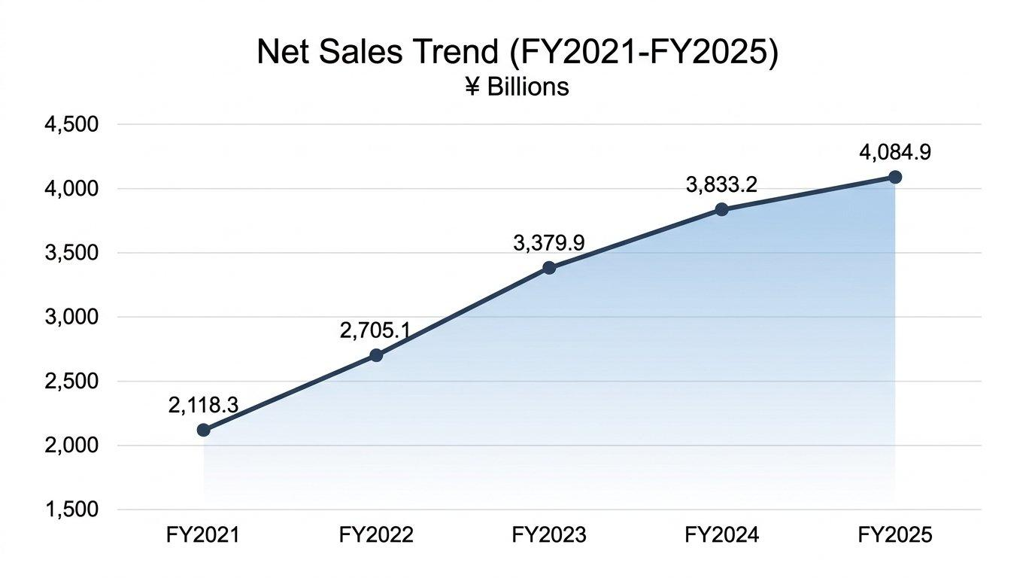
Figure 5: NPV Comparison at 10% Discount Rate (£ millions). Source: Author’s calculations.

5.2 Which Project, and Why?
If you had to pick one, and only one, Project C is the standout choice even though all three technically have negative NPVs. The numbers speak for themselves: shortest payback at 3.6 years, highest ARR at 12.0%, the least negative NPV at just -£1.98m, a PI of 0.960 that nearly breaks even, and an IRR of 9.2% that is practically knocking on the door of the hurdle rate. Beyond the raw numbers, Toyota Industries’ improved profitability and strong cash position suggest the company could absorb a modest shortfall. Non-financial risks also matter. Political risk, particularly the escalating tariff environment affecting the company’s ¥1,415.2 billion in US sales, could materially affect any project’s actual returns (Drury, 2018).
Customer loyalty in the materials handling segment, where long-term relationships and after-sales service contracts drive repeat business, should also influence project selection. A project that strengthens customer relationships or helps rebuild trust following the certification scandal might generate qualitative benefits that a pure NPV calculation simply cannot capture. Similarly, workforce considerations matter. Toyota Industries employs nearly 80,000 people, and any capital investment decision has implications for jobs, skills development, and community impact across multiple countries. These softer factors do not show up in the discount factor tables, but any responsible CFO would weigh them alongside the financial metrics.

5.3 What If We Can Invest in More Than One?
Now, if the capital budget is capped at £100 million, the question becomes which pair of projects makes the most sense. The possible combinations are A+B, A+C, or B+C, each costing exactly £100m. Doing all three would need £150m, which blows past the budget.
Table 7: Capital Rationing – Comparing Project Combinations
Project Combination | Cost | Combined NPV | Avg PI
A + B | £100m | - £16.98m | 0.830
A + C | £100m | - £10.66m | 0.893
B + C | £100m | - £10.28m | 0.897
Source: Author’s own calculations based on project data provided in assessment brief.
B + C comes out on top with the least negative combined NPV at -£10.28m and the highest weighted PI at 0.897. If the company absolutely has to deploy the full £100m, this pairing destroys the least value. Project B gives you a steady, predictable cash stream, while Project C brings the upside through those big Year 3 and Year 4 returns. But here is the thing: should the company even be investing in projects that destroy value at a 10% discount rate? With the delisting on the horizon and deeper Toyota Group integration potentially opening up opportunities that these standalone projects simply cannot match, there might be better places to put that £100 million. NPV, IRR, payback—all of these are genuinely useful frameworks. But they are tools, not oracles (Pike, Neale, and Linsley, 2018).

6. Conclusion
Toyota Industries Corporation is, in many ways, a company of contradictions. If you look at the standard metrics, it appears to be in pretty solid shape. Sales keep going up, profits are climbing, and the balance sheet is carrying a substantial amount of equity. Over five years, net sales have nearly doubled, EPS has grown consistently, and debt levels have stayed manageable. On paper, at least, it looks like a well-run company.
But the financial picture is muddied by the cross-shareholding portfolio creating wild swings in comprehensive income, the engine certification scandal exposing deep governance failures, and the sharp cash flow deterioration in FY2025. On the working capital front, things are fine but not brilliant. A 79-day cash conversion cycle is not going to set off any alarm bells, but there is clearly scope to do better, especially on the receivables side.
The financing mix is sensible but could benefit from greater long-term fixed-rate borrowing to provide certainty in an uncertain monetary environment. The recommended approach is to use the transition period to divest non-core assets, particularly in the Textile Machinery segment, and redirect capital towards electrification and logistics automation. These are the growth areas where Toyota Industries can build on its existing strengths rather than spreading itself too thin across legacy operations that are gradually becoming less relevant.
The restructuring picture is really dominated by one thing: the Toyota Fudosan tender offer. Going private is one of those decisions that cuts both ways. There is a real upside in terms of strategic freedom, but pretending there are no downsides would be naive. If investment is required, Project C stands out as the single best option. And under capital rationing with a £100m ceiling, pairing B with C makes the most sense. The moment you start treating a spreadsheet as a substitute for actual thinking is the moment you start making bad decisions.
Ultimately, the financial data tells a story of a company at a crossroads. The operating fundamentals are sound, but the structural issues around cross-shareholdings, governance reform, and the looming delisting mean that the next twelve to eighteen months will be defining. The decisions made during this transition period will shape whether Toyota Industries emerges as a leaner, more focused competitor or whether the absence of public market accountability leads to complacency.

References
Arnold, G. (2019) Corporate Financial Management. 6th edn. Harlow: Pearson Education Limited. Available at: https://www.pearson.com/en-gb/subject-catalog/p/corporate-financial-management/P200000003754 (Accessed: 20 March 2026).
Atrill, P. (2020) Financial Management for Decision Makers. 9th edn. Harlow: Pearson Education Limited. Available at: https://www.pearson.com/en-gb/subject-catalog/p/financial-management-for-decision-makers/P200000003738 (Accessed: 20 March 2026).
Barth, M.E., Landsman, W.R. and Lang, M.H. (2008) ‘International accounting standards and accounting quality’, Journal of Accounting Research, 46(3), pp. 467–498. doi:https://doi.org/10.1111/j.1475-679X.2008.00287.x.
Brealey, R.A., Myers, S.C. and Allen, F. (2020) Principles of Corporate Finance. 13th edn. New York: McGraw-Hill Education. Available at: https://www.mheducation.com/highered/product/principles-corporate-finance-brealey-myers/M9781260013900.html (Accessed: 20 March 2026).
Christopher, M. (2016) Logistics and Supply Chain Management. 5th edn. Harlow: Pearson Education Limited. Available at: https://www.pearson.com/en-gb/subject-catalog/p/logistics-supply-chain-management/P200000003656 (Accessed: 20 March 2026).
Drury, C. (2018) Management and Cost Accounting. 10th edn. Andover: Cengage Learning EMEA. Available at: https://www.cengage.co.uk/books/9781473748873 (Accessed: 20 March 2026).
Eccles, R.G. and Klimenko, S. (2019) ‘The investor revolution’, Harvard Business Review, 97(3), pp. 106–116. Available at: https://hbr.org/2019/05/the-investor-revolution (Accessed: 20 March 2026).
Jensen, M.C. (1986) ‘Agency costs of free cash flow, corporate finance, and takeovers’, American Economic Review, 76(2), pp. 323–329. Available at: https://www.jstor.org/stable/1818789 (Accessed: 20 March 2026).
Madura, J. (2018) International Financial Management. 13th edn. Boston: Cengage Learning. Available at: https://www.cengage.com/c/international-financial-management-13e-madura (Accessed: 20 March 2026).
McLaney, E. (2017) Business Finance: Theory and Practice. 11th edn. Harlow: Pearson Education Limited. Available at: https://www.pearson.com/en-gb/subject-catalog/p/business-finance/P200000003742 (Accessed: 20 March 2026).
Penman, S.H. (2013) Financial Statement Analysis and Security Valuation. 5th edn. New York: McGraw-Hill Education. Available at: https://www.mheducation.com/highered/product/financial-statement-analysis-security-valuation-penman/M9780078025310.html (Accessed: 20 March 2026).
Pike, R., Neale, B. and Linsley, P. (2018) Corporate Finance and Investment: Decisions and Strategies. 9th edn. Harlow: Pearson Education Limited. Available at: https://www.pearson.com/en-gb/subject-catalog/p/corporate-finance-and-investment/P200000003740 (Accessed: 20 March 2026).
Toyota Industries Corporation (2025) Annual Financial Report 2025: For the Year Ended March 31, 2025. Kariya: Toyota Industries Corporation. Available at: https://www.toyota-industries.com/investors/annual_report/ (Accessed: 20 March 2026).
Watson, D. and Head, A. (2019) Corporate Finance: Principles and Practice. 8th edn. Harlow: Pearson Education Limited. Available at: https://www.pearson.com/en-gb/subject-catalog/p/corporate-finance-principles-and-practice/P200000003744 (Accessed: 20 March 2026).
Whittington, R., Angwin, D., Regner, P., Johnson, G. and Scholes, K. (2023) Exploring Strategy: Text and Cases. 13th edn. Harlow: Pearson Education Limited. Available at: https://www.pearson.com/en-gb/subject-catalog/p/exploring-strategy-text-and-cases/P200000005820 (Accessed: 20 March 2026).

Appendices

Appendix A: Ratio Formulas Used
Gross Profit Margin = (Revenue – COGS) / Revenue × 100
Operating Margin = Operating Profit / Revenue × 100
ROE = Net Profit (Owners) / Equity (Owners) × 100
Current Ratio = Current Assets / Current Liabilities
Debt-to-Equity = Total Liabilities / Total Equity
Interest Cover = Operating Profit / Interest Expense
Inventory Days = (Inventory / COGS) × 365
Receivables Days = (Trade Receivables / Revenue) × 365
Payables Days = (Trade Payables / COGS) × 365

Appendix B: Investment Appraisal Workings
The discount factors used throughout at 10% are: Year 1 = 0.9091, Year 2 = 0.8264, Year 3 = 0.7513, Year 4 = 0.6830, and Year 5 = 0.6209. Every calculation has been double-checked, though there may be very small rounding differnces here and there depending on how many decimal places get carried through. Detailed workings are provided in the accompanying Excel.
I acknowledged that the use of Grammarly (https://www.grammarly.com/) to check my work using the prompt(s):
1. Please check the following text for readability, grammar and syntax.
I confirm that I have not presented any AI generated text as my own work. I confirm I
have copies of my drafts, notes, and other resources I used before, and after the use of
AI tools which I may be asked to provide in evidence.eadsheet.

