construction technology 2
Buildability and Sustainability Analysis

Mark Preston – ID 2223676
HND / BSc Construction Management

Table of Contents

Table of Contents 1
1. Introduction 2
2. Environmental Impact 2
2.1 Orientation, Daylight and Wind 2
2.2 Life Cycle and Material Durability 4
2.3 Aesthetics and Townscape Fit 6
3. Façade Greening and SuDS 6
3.1 Green Façades and Living Walls 6
3.2 SuDS Strategy 8
3.3 SuDS Sizing Calculation 10
4. Buildability Analysis 13
4.1 Construction Methods and Structural System 13
4.2 Site Logistics, Labour and Materials 14
4.3 Build Sequence and Storyboard 14
4.4 Buildability Risks and Mitigation 16
5. Conclusion 17
6. References 18
7. Appendices 21
7.1 Appendix 1 – Greenfield Run-off Estimation 21

1. Introduction

This report evaluates the buildability and sustainability of a proposed medium- to high-rise hotel in Sketty, Swansea, building on Assignment 1. The site lies south-west of Singleton Hospital and within ~1 km of Swansea Bay, so coastal exposure (salt-laden air, higher winds and heavy rainfall) is treated as a key constraint for durability, façade performance, logistics and maintenance.

The structural strategy from Assignment 1 underpins the analysis: a hot-rolled steel frame galvanised to BS EN ISO 1461 with A4/316 fixings, composite steel–concrete decking, and CFA piles with a secant/contiguous piled wall to enable basement works and limit vibration near the hospital.

The report first reviews environmental performance (orientation/daylight, wind exposure, durability and townscape fit), then compares façade greening options and sets out a SuDS approach under Schedule 3/SAB requirements. It concludes with a buildability appraisal covering construction methods, logistics, sequencing and key risks.

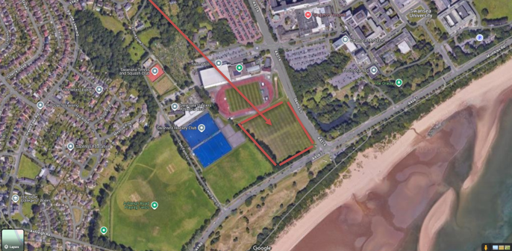

2. Environmental Impact

2.1 Orientation, Daylight and Wind

Building orientation is a primary determinant of operational environmental performance because it influences daylight availability, solar gains and wind loading. At Sketty, the proximity to Swansea Bay (under 1 km) increases exposure to coastal weather systems, including frequently strong south-westerly airflow across the Bristol Channel. Consequently, the orientation must balance passive daylighting benefits with measures to reduce wind-driven rain and façade pressure differentials, thereby supporting both energy efficiency and long-term envelope durability (Met Office, 2026).
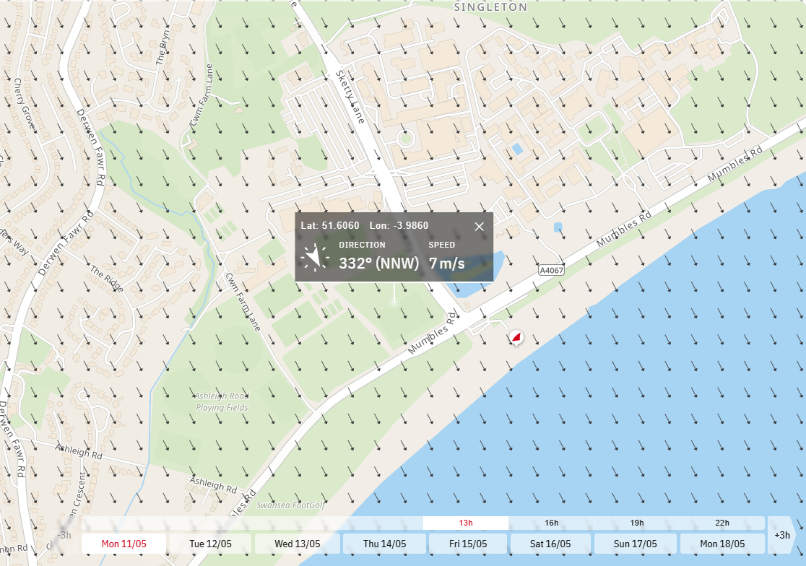
Wind direction and speed at site location (13:00, 11 May 2026)
(Windfinder.com GmbH & Co. KG, n.d.)

A south-east to south-west alignment offers a balanced daylighting strategy for guest rooms, public areas and circulation spaces by enabling useful morning and afternoon sun while limiting prolonged low-angle west sun that can drive summertime overheating. Overheating risk is commonly associated with high glazing ratios and inadequate shading or ventilation strategies; therefore, large west-facing glazed areas should be moderated and supplemented with external shading where appropriate (CIBSE, 2017). High-performance glazing with low-emissivity coatings can further reduce heat losses while moderating solar gains, improving thermal comfort and helping to limit operational energy demand.

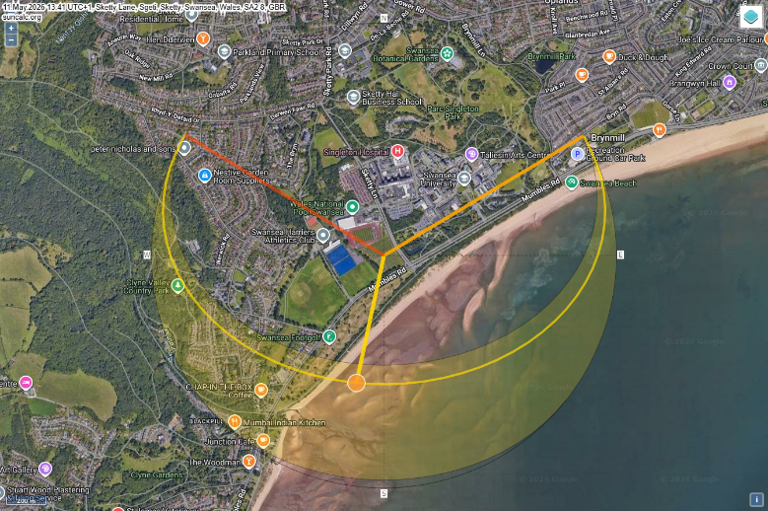
Sun path of site location (SunCalc, n.d.)

Wind exposure is a critical design driver for medium- to high-rise development. Increased height amplifies wind loads on the façade and primary frame, requiring design checks to EN 1991-1-4 (Eurocode: Wind Actions). In a coastal location, higher basic wind speeds and wind-driven rain increase the likelihood of moisture ingress and localised façade pressure cycling. A comparatively streamlined massing strategy (avoiding deep recesses and sharp re-entrant corners) can reduce turbulence, while a ventilated rainscreen façade helps manage moisture, equalise pressure and protect the primary structure, thereby supporting long-term durability.

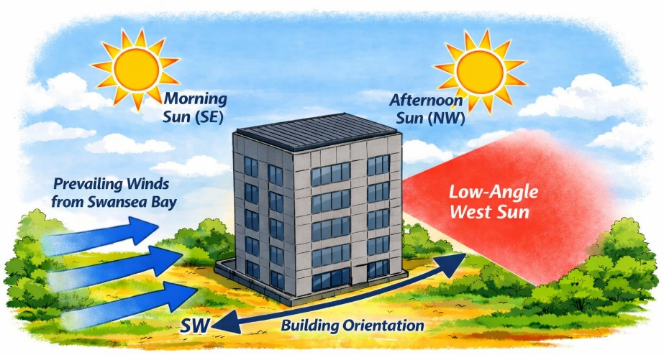
Diagram showing a medium to high rise hotel aligned SE–SW to maximise morning and afternoon daylight while reducing low-angle west sun. Also, prevailing SW winds from Swansea Bay indicated with arrows. (Microsoft Copilot, 2026)

2.2 Life Cycle and Material Durability

Swansea’s coastal environment presents distinct durability challenges. Salt spray, elevated humidity and wind-driven rain accelerate corrosion and material weathering, particularly for exposed metals and porous substrates (LABC Warranty, 2021). The structural solution developed in Assignment 1—a hot-rolled steel frame galvanised to BS EN ISO 1461—provides a robust barrier through a sacrificial zinc coating that slows corrosion. Critical fixings and connections are specified as marine-grade stainless steel (A4/316), which offers improved resistance to chloride-induced attack in maritime conditions.

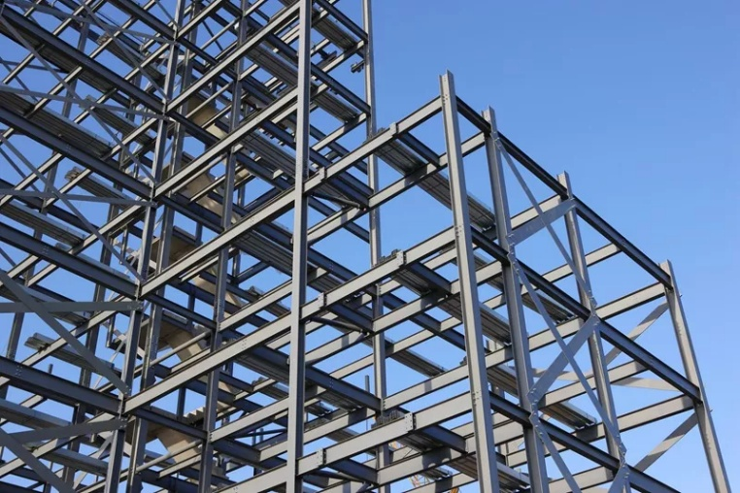
(iBeehive Steel Structures, n.d.)

The envelope specification is also guided by whole-life performance considerations. Fibre-cement or composite rainscreen cladding offers good resistance to moisture, ultraviolet exposure and saline conditions, while maintaining relatively low maintenance demands over its service life. Powder-coated aluminium window systems can provide robust weather-tightness and wind resistance when specified and installed in accordance with relevant standards (e.g., BS 6375-1). Roofing options such as natural slate or coated standing-seam metal systems similarly offer durable performance when detailed to manage coastal wind uplift and driving rain.

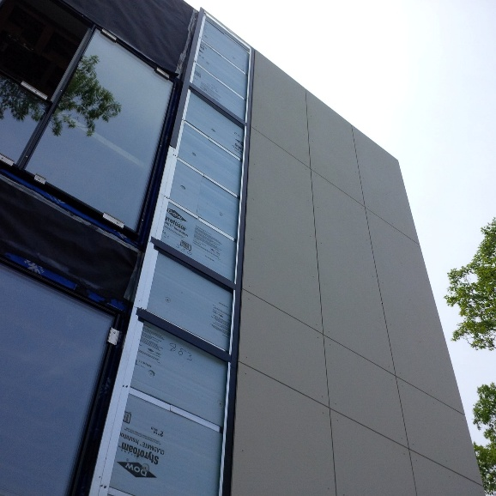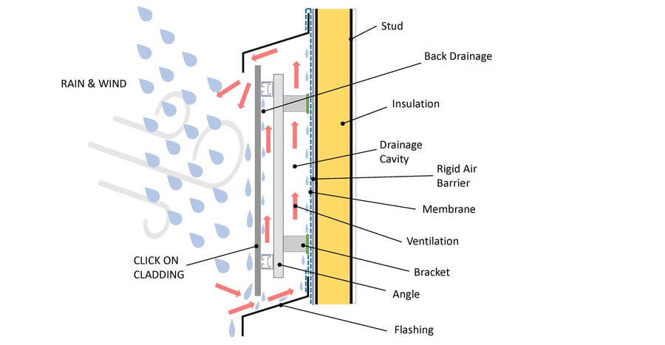
Fibre cement board & powder coated Typical Design of Rainscreen Cladding
aluminium windows (Clad-Tech, n.d.) (Sculptform, 2026)

In sustainability terms, the proposal prioritises lower-carbon material choices where feasible, including recycled-content steel, GGBS-blended concrete and bio-based insulation products. A whole-life carbon assessment (WLCA), following the RICS professional statement methodology, enables both embodied and operational carbon impacts to be evaluated and compared across design options (RICS, 2023). In addition, the adoption of modular construction for repeatable hotel rooms and bathroom pods can reduce on-site waste, improve quality assurance and shorten programme duration, which can contribute to reduced construction impacts and disruption.

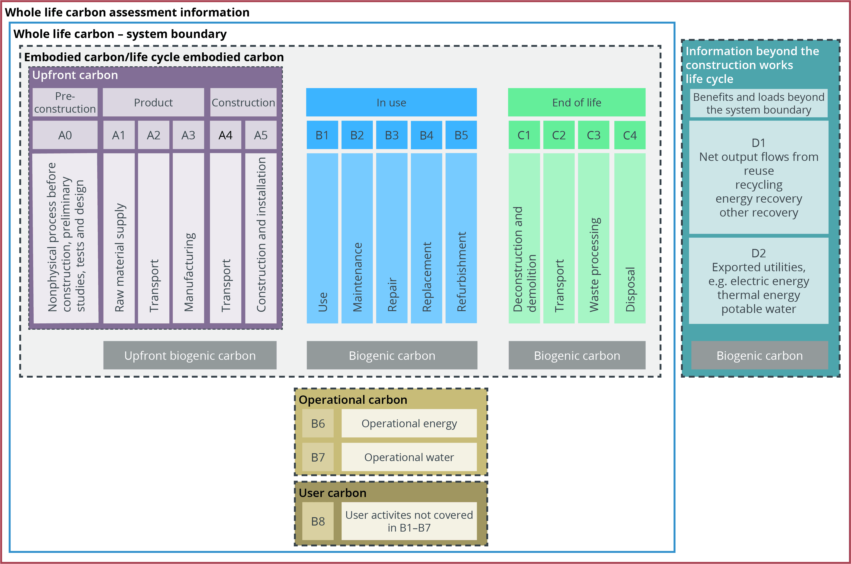
(RICS, 2023)

2.3 Aesthetics and Townscape Fit

The proposed hotel should respond sensitively to the established townscape of Sketty and the wider Swansea Bay setting. The immediate context comprises a mix of hospital buildings, residential neighbourhoods and university facilities, with typical heights of approximately two to six storeys. While the hotel exceeds this range, its medium- to high-rise form can be justified as a legible landmark within a major hospital–university district, provided that massing, façade articulation and public-realm design mitigate perceived bulk and address local character.

Material choice is central to achieving visual coherence. A restrained palette of fibre-cement or composite cladding, informed by locally prevalent coastal tones, can complement the surrounding built form and landscape. Natural slate or standing-seam metal roofing provides a contemporary expression while remaining consistent with regional material traditions. Vertical articulation, recessed bays and a clearly defined podium can reduce the apparent scale of the façade, improving the building’s relationship with adjacent streets and neighbouring buildings.

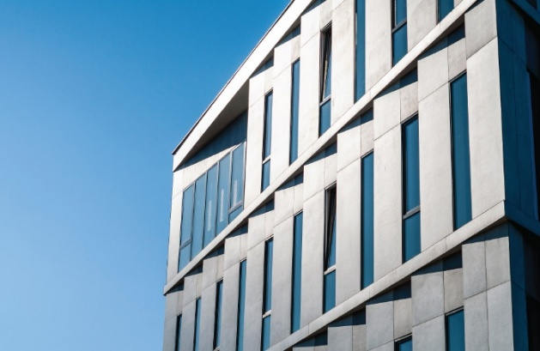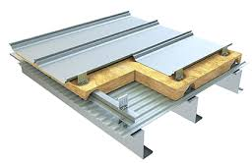
(Cladmate, n.d.) (Wiskind Steel Structure, n.d.)

Orientation and façade composition also contribute to contextual fit. Larger glazed areas may be concentrated on elevations that benefit from daylight and views, while more solid wall-to-void proportions can be used on colder or more exposed aspects to limit heat loss. Public-realm landscaping—including native planting and permeable surfaces—can strengthen place quality and deliver biodiversity benefits. This approach is consistent with the placemaking emphasis in Planning Policy Wales (Edition 11) and the strategic direction set by Future Wales: The National Plan 2040 (Welsh Government, 2021).

3. Façade Greening and SuDS

3.1 Green Façades and Living Walls

Façade greening can deliver measurable environmental and visual benefits for a medium- to high-rise hotel, particularly within an urban coastal setting. Potential benefits include improved microclimate, reduced surface temperatures, enhanced biodiversity and a softer visual transition between taller built form and lower surrounding development (CIRIA, 2023). For high-rise application, two systems are typically feasible: indirect greening (climbers supported on cables or trellises) and living wall systems (modular panels incorporating growing media).

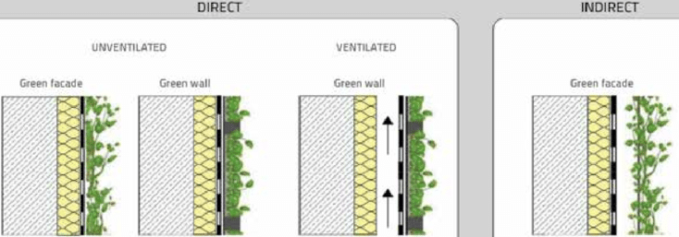

(Lesjak, Pajek and Košir, 2020)

Indirect greening is likely to be the most appropriate option for this scheme because it imposes lower structural loads and generally requires less intensive maintenance than modular living walls. Stainless-steel cable systems can be fixed back to the galvanised steel frame using marine-grade A4/316 anchors to provide resilience in a saline environment. Species selection should prioritise plants that tolerate wind exposure and salt spray and are suitable for local conditions; typical candidates include Hedera helix and selected Clematis and Lonicera varieties (RHS, 2025). Where non-native species are proposed, potential ecological impacts should be reviewed and planting should align with local biodiversity objectives.

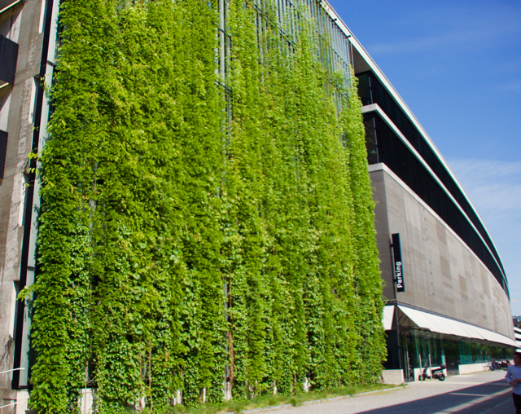
A cable-supported green wall façade in Switzerland (Livingroofs.org, n.d.)

Living wall systems offer greater visual impact and biodiversity value but require more intensive maintenance, irrigation and structural support. For a medium- to high-rise building, the additional weight of saturated substrate panels must be carefully considered in the façade design. Irrigation systems must also be protected from freezing and salt exposure. For these reasons, living walls are best limited to lower storeys, podium levels or sheltered elevations.

Green façades can also improve thermal performance by shading the building envelope, reducing heat gain in summer and providing an additional protective layer against ultraviolet exposure and driving rain. These benefits support good practice in climate-responsive design and align with Future Wales objectives for resilient development.

Green Façade and Living Wall Comparison Table

System Type | Advantages | Disadvantages | Suitability for Coastal High-Rise
Indirect green façade (cables/trellis) | Lightweight, low maintenance, low structural load | Slower plant establishment | Highly suitable – best option above podium
Living wall (modular panels) | High biodiversity, instant coverage | Heavy, expensive, high maintenance, irrigation needed | Limited suitability – only for podium levels
Ground-based climbers | Simple, low cost | Limited height, wind exposure issues | Not suitable for this building

3.2 SuDS Strategy

In Wales, Schedule 3 of the Flood and Water Management Act 2010 requires surface-water drainage for relevant developments to be designed in accordance with statutory SuDS standards and approved by the Sustainable Drainage Approval Body (SAB) prior to commencement. Given Swansea’s high rainfall and exposure to coastal storm events, the project requires a robust SuDS strategy that manages both runoff rate and water quality in a way that is durable and maintainable over the asset life (Welsh Government, 2026).

The aim of SuDS is “to return the post-development runoff, infiltration and evapotranspiration to as near natural conditions as possible” (Williams, 2026a, p.10). For the 2.75 ha coastal hotel site at Sketty Lane, this requires careful control of runoff quantity and quality due to the proximity of Swansea Bay and the presence of Combined Sewer Overflows (CSOs) discharging to the River Tawe and the bay (Williams, 2026a). The site’s coastal exposure, high rainfall and impermeable development footprint make attenuation and treatment essential.

The proposed SuDS system for the hotel includes:

- Permeable paving for car parks and pedestrian areas
- Swales along the site boundary to slow and filter runoff
- Underground attenuation tanks beneath the car park
- A flow-controlled discharge to the nearest surface water system
- Rainwater harvesting for irrigation and toilet flushing
- Green roof elements on lower podium levels (optional but beneficial)

Proposed SuDS System Types

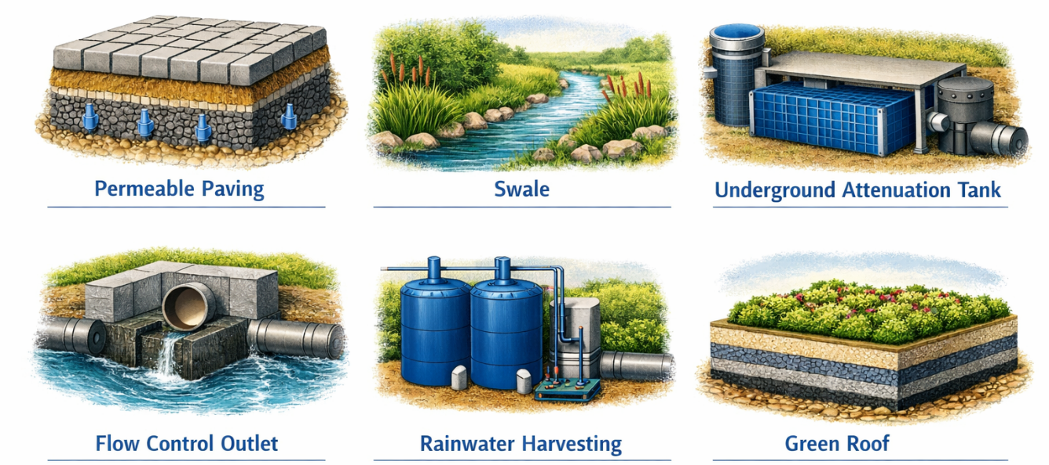
(Microsoft Copilot, 2026)

Site and proposed development sizes:

- Total site area: 2.75 ha (Google Earth, n.d.)

- Hotel building footprint: a medium–high rise block approx. $60\text{ m}×40\text{ m}=2,400 {\text{m}}^{2}$

- Other hardstanding (car parks, access roads, service yards, terraces): $14,100 {\text{m}}^{2}$

- Total impermeable area (roof + hardstanding): $2,400 {\text{m}}^{2}+14,100 {\text{m}}^{2}=16,500 {\text{m}}^{2}=1.65\text{ ha}$

- Remaining area (soft landscape / SuDS features): 1.1 ha

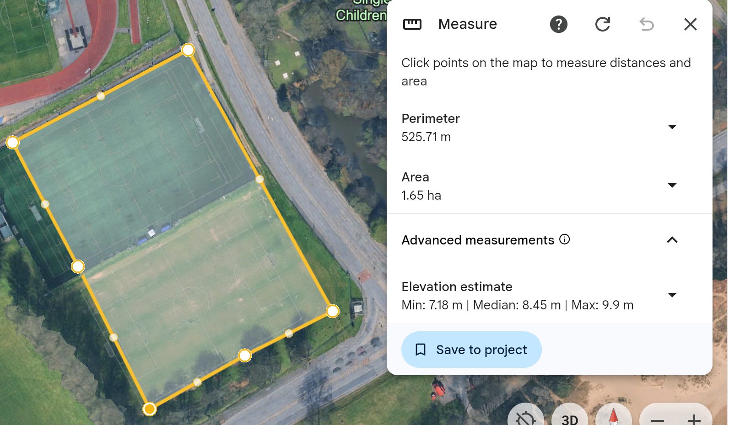Total impermeable area: 1.65 ha
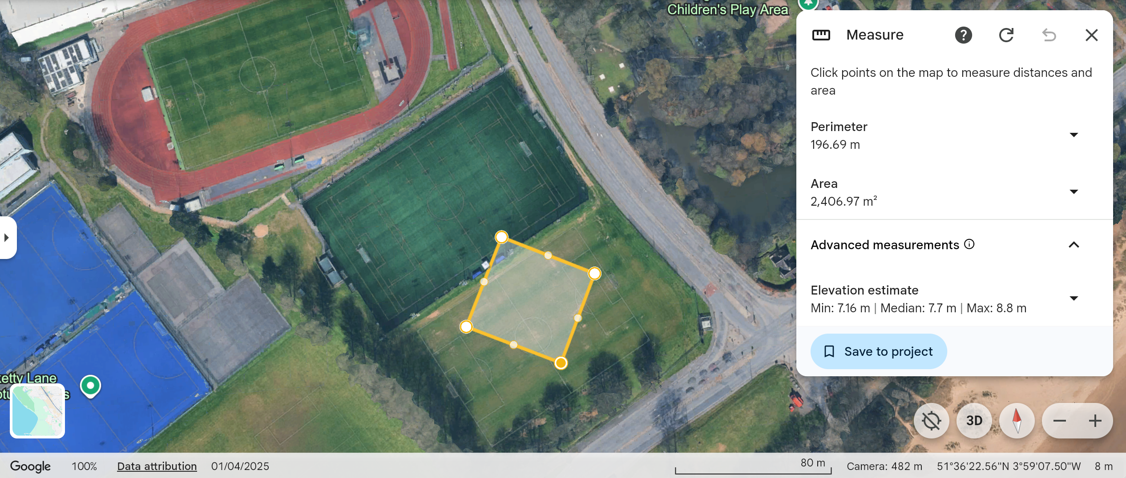Hotel building area: 2,400m2
(Google Earth, n.d.)

3.3 SuDS Sizing Calculation

Greenfield Runoff (IH124 Method)

Greenfield runoff was calculated using the IH124 method, consistent with Environment Agency guidance Rainfall Runoff Management for Developments (SC030219, 2013), the SuDS Manual C753 (CIRIA, 2015) and the non-statutory SuDS standards (Defra, 2015).

The IH124 formula is:

$$Q_{\text{BAR}}=0.00108⋅AREA^{0.89}⋅SAAR^{1.17}⋅SPR^{2.17}$$

Where:
- AREA = 2.75 ha
- SAAR = 1163 mm
- SPR = 0.37

In Appendix 1, the UKSuDS tool applies this automatically and returns:

$$Q_{\text{BAR}}=14.3\text{ l/s}$$

This is adopted as the Greenfield discharge limit for SAB approval. (UK SuDS, n.d.)
The class based example produced a per-hectare Greenfield runoff rate of 5.25 l/s/ha (Williams, 2026b). To scale this to the 2.75 ha hotel site:

$$Q_{\text{BAR,}}=5.25\text{ l/s/ha}×2.75\text{ ha}$$
$$Q_{\text{BAR}}≈14.4\text{ l/s}$$

This is <1% difference, confirming the robustness of the adopted 14.3 l/s Greenfield rate.

Peak Developed Runoff

To estimate post-development runoff, the Modified Rational Method was used:

$$Q=2.78⋅C⋅i⋅A$$

Where:
- C = 0.9 (impermeable surfaces)
- i = 17 mm/h (M5-60 rainfall intensity)
- A = 1.65 ha (hotel roof + car parks + access roads)

Substituting:

$$Q=2.78×0.9×17×1.65$$
$$Q≈70\text{ l/s}$$

Required Attenuation Volume

The difference between developed and Greenfield runoff is:

$$ΔQ=70-14.3=55.7\text{ l/s}$$

The storm duration is 60 minutes:

$$t=3600\text{ s}$$

Attenuation volume:

$$V=ΔQ⋅t$$
$$V=55.7×3600=200,520\text{ litres}$$
$$V≈200 {\text{m}}^{3}$$

Applying the Welsh Government 40% climate change uplift:

$$V_{\text{CC}}=200×1.4=280 {\text{m}}^{3}$$

Required attenuation volume: ≈ 280 m³

It should be noted that this is an outline calculation based on standard assumptions (e.g., uniform rainfall intensity and a simplified runoff coefficient). A detailed SAB submission would normally confirm storage and discharge using a full range of storm durations and (where required) hydraulic modelling.
This is for a 60-minute, 5-year storm with climate change uplift; SAB approval may require checking longer durations and higher return periods, but this gives a clear, conservative starting point.

SuDS hierarchy and component sizing for the hotel

The SuDS ‘management train’ (prevention, source control, site control and regional control) enables multiple components to be combined to achieve the estimated storage requirement of approximately 280 m³ while also improving water quality and amenity (CIRIA, 2015; Williams, 2026a). Worked examples from the module provide indicative storage volumes for typical elements, which can be used as preliminary design checks before detailed modelling and SAB review (Williams, 2026a).

- Rain garden (2 m × 1 m × (0.45 m soil + 0.1 m gravel) $≈0.285 {\text{m}}^{3}$

- Green roof (10 m × 5 m with 0.2 m substrate + 0.005 m geocomposite) $≈1.625 {\text{m}}^{3}$

- Swale (3 m × 1.5 m with 0.9 m sand + 0.3 m gravel plus surface volume) $≈4.255 {\text{m}}^{3}$

- Permeable pavement (5 m × 3 m with 0.035 m gravel + 0.475 m sub-base) $≈1.52 {\text{m}}^{3}$

Using these as building blocks, a feasible SuDS strategy for the hotel could be:

- Green / blue-green roofs on podium and lower roofs
- 800 m² of green roof across podium and lower levels.
- Using the worked example:
$${\text{Storage per m}}^{2}=\frac{1.625}{50}=0.0325 {\text{m}}^{3}/{\text{m}}^{2}$$
$$V_{\text{green roof}}=0.0325×800≈26 {\text{m}}^{3}$$

- Permeable paving in car park and access roads
- 4,000 m² of permeable parking and access.
- Using the worked example:

$${\text{Storage per m}}^{2}=\frac{1.52}{15}≈0.1013 {\text{m}}^{3}/{\text{m}}^{2}$$
$$V_{\text{perm paving}}=0.1013×4,000≈405 {\text{m}}^{3}$$

In practice, not all sub-base volume is “effective” attenuation (some is already accounted for in runoff coefficients), so we can conservatively assume about half of this contributes to usable storage:

$$V_{\text{perm paving,eff}}≈0.5×405≈200 {\text{m}}^{3}$$

- Swales and bioretention / rain gardens along site edges
- Assume three swales, each 30 m long, 2 m wide, with similar depth profile to the example: Using the worked example:

$$\frac{30×2}{3×1.5}=\frac{60}{4.5}≈13.33$$
$$V_{\text{one swale}}≈4.255×13.33≈56.7 {\text{m}}^{3}$$
$$V_{\text{three swales}}≈3×56.7≈170 {\text{m}}^{3}$$

Again, to stay conservative and allow for freeboard and partial filling, we might count ~100 m³ of effective storage from swales.

- Geocellular attenuation tank (if needed)

Even with conservative assumptions:
- Green roofs: ~26 m³
- Permeable paving (effective): ~200 m³
- Swales (effective): ~100 m³

Total indicative storage:

$$V_{\text{total,above}}≈26+200+100=326 {\text{m}}^{3}$$

This already exceeds the 280 m³ target, meaning a geocellular tank may be reduced or omitted, or used as a smaller “safety net” to fine-tune discharge rates. For example, a 10 m × 5 m × 1.0 m tank at 95% void ratio would provide:

$$10×5×1.0×0.95=47.5 {\text{m}}^{3}$$

This could be used if SAB modelling shows a need for additional storage or to manage longer duration storms.

Buildability Considerations

The lectures emphasise that “SuDS generally require the land they are constructed on to be isolated from the construction process to prevent damage” (Williams, 2026a, p.40). For the coastal hotel site:

- Protect swales and permeable paving from sediment during piling and steel erection.
- Install permeable paving late in the programme.
- Use salt-tolerant planting due to coastal exposure.
- Provide safe access for maintenance and sediment removal.

Summary of SuDS

- Greenfield runoff (IH124): 14.3 l/s
- Peak developed runoff: ~70 l/s
- Required attenuation (with climate change): ~280 m³
- Proposed SuDS storage: ~326 m³
- Outcome: SAB-compliant, buildable, and resilient to coastal conditions.

4. Buildability Analysis

4.1 Construction Methods and Structural System

The proposed medium- to high-rise hotel uses a structural system that was established in Assignment 1 and remains appropriate for the site’s coastal conditions, programme requirements, and long-term durability. The building is designed around a hot-rolled steel frame, fully hot-dip galvanised to BS EN ISO 1461, which provides excellent resistance to corrosion from salt-laden air. This is essential given the site’s proximity to Swansea Bay. All critical fixings use marine-grade stainless steel (A4/316) to prevent chloride-induced corrosion, which is a common issue in coastal Wales (LABC Warranty, 2021).

The floor system consists of composite steel–concrete decking, which offers several buildability advantages: rapid installation, reduced temporary works, and improved structural stiffness. Composite floors also integrate well with modular construction, allowing prefabricated hotel room modules and bathroom pods to be craned into position with minimal on-site adjustment.

The foundation system uses Continuous Flight Auger (CFA) piles, which are ideal for urban and sensitive environments because they generate minimal vibration — a critical factor given the hotel’s proximity to Singleton Hospital. The basement is formed using a secant or contiguous piled wall, providing both excavation support and groundwater control. This approach aligns with BS EN 1997-1 (Eurocode 7) and BS 8102:2022 for below-ground waterproofing.

The structural system supports a hybrid construction strategy, combining on-site works (foundations, podium, envelope) with off-site prefabrication (modules, pods, MEP risers). This reduces programme duration, improves quality, and minimises disruption to hospital operations.

4.2 Site Logistics, Labour and Materials

The site’s location near Singleton Hospital presents several logistical challenges that must be carefully managed to ensure safe and efficient construction. Access routes are limited, and construction traffic must avoid peak hospital hours to prevent disruption to emergency services. Deliveries should be scheduled during off-peak periods, with a designated holding area away from the hospital entrance.

A tower crane is recommended for the steel frame erection and modular installation due to the building’s height and the restricted site footprint. The crane should be positioned to avoid oversailing hospital property unless a formal oversailing licence is agreed with Swansea Bay University Health Board.

Material storage on site will be limited, so a just-in-time (JIT) delivery strategy is essential. Prefabricated modules and bathroom pods will require temporary laydown areas and lifting plans that comply with LOLER (1998) and BS 7121 for crane operations. Labour requirements will vary throughout the programme, with peak demand during steel erection, envelope installation, and MEP fit-out. Modular construction reduces on-site labour needs, improving safety and reducing congestion.

Environmental controls must be implemented to manage dust, noise, and vibration, particularly due to the hospital’s sensitivity. Measures include acoustic barriers, dust suppression systems, and continuous monitoring. These align with BS 5228-1:2009+A1:2014 for noise and vibration control on construction sites.

4.3 Build Sequence and Storyboard

A clear and logical build sequence is essential for ensuring programme efficiency and minimising disruption. The following sequence is recommended:

- Site Preparation and Enabling Works:

- Hoarding installation, site compound setup, temporary utilities, and traffic management.
- Archaeological and ecological checks as required by Swansea Council.

- Piling and Basement Construction:

- CFA piling for foundations.
- Secant/contiguous piled wall installation.
- Excavation and basement slab construction.

- Steel Frame Erection:

- Tower crane installation.
- Sequential erection of steel columns, beams, and bracing.
- Installation of composite metal decking and concrete pours floor by floor.

- Modular Installation (Hotel Rooms and Pods):

- Delivery of modules during controlled time windows.
- Lifting and placement onto prepared floor plates.
- Connection of MEP risers and services.

- Building Envelope Installation

- Rainscreen cladding system installation.
- Window and door installation (marine-grade aluminium).
- Roofing works (slate or metal standing seam).

- Internal Fit-Out and MEP Commissioning

- Corridor fit-out, fire stopping, and compartmentation.
- Final MEP connections, testing, and commissioning.

- External Works and Landscaping

- SuDS installation (permeable paving, swales, attenuation).
- Planting and soft landscaping using native Welsh species.

- Final Inspections and Handover

- Building Control sign-off.
- SAB approval for SuDS.
- Client handover and soft-landing process.

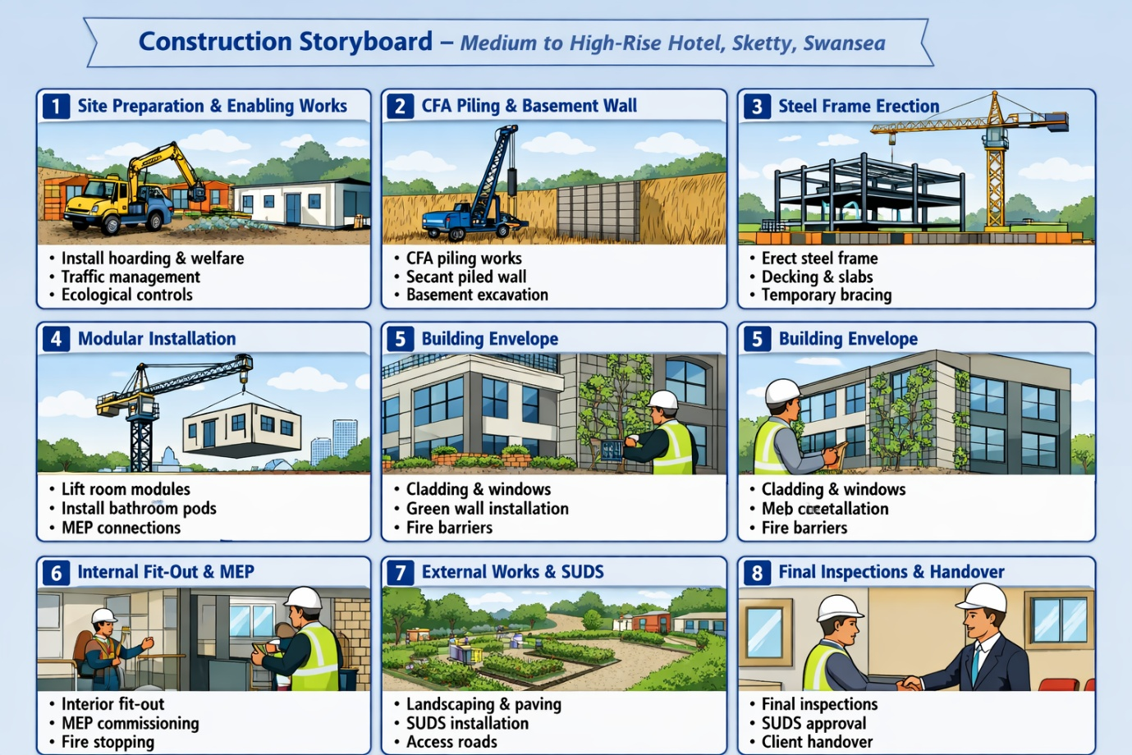
(Microsoft Copilot, 2026)

4.4 Buildability Risks and Mitigation

Several buildability risks are associated with the project, particularly due to its coastal location, proximity to a hospital, and use of modular construction. Key risks and mitigation strategies include:

- Coastal Weather Impacts

Risk: High winds and heavy rainfall may delay crane operations and cladding installation.

Mitigation:

- Use weather-resistant materials and temporary coverings.
- Schedule crane lifts during favourable weather windows.
- Use wind-rated lifting equipment.

- Hospital Proximity

Risk: Noise, vibration, and traffic disruption affecting hospital operations.

Mitigation:

- Implement BS 5228 noise controls.
- Use CFA piling to minimise vibration.
- Coordinate deliveries with hospital management.

- Modular Delivery Constraints

Risk: Large modules may be difficult to transport through Sketty’s road network.

Mitigation:

- Conduct swept-path analysis.
- Use police escorts for oversized loads.
- Deliver during off-peak hours.

- Fire Safety Compliance for High-Rise Buildings

Risk: Non-compliant façade materials or poor compartmentation.

Mitigation:

- Use A2-s1,d0 non-combustible cladding.
- Install fire-rated partitions and doors.
- Follow Building Safety Act (Wales) requirements.

- Programme Delays

Risk: Weather, supply chain issues, or labour shortages.

Mitigation:

- Use modular construction to reduce on-site duration.
- Maintain buffer stock of critical materials.
- Use digital project management tools (4D BIM).

5. Conclusion

The proposed hotel in Sketty, Swansea is technically feasible and environmentally responsive if key decisions are carried through detailed design. Orientation supports daylighting and helps limit overheating risk, while envelope measures address coastal wind-driven rain. Durable materials—galvanised steelwork, marine-grade fixings and rainscreen cladding—reduce corrosion risk and maintenance demand.

Façade greening and the SuDS strategy strengthen sustainability performance: indirect greening is practical at height, and SuDS manages runoff through source control and attenuation aligned with Welsh requirements and policy objectives (Welsh Government, 2021).

Buildability is supported by the chosen structural/substructure systems and modular components, with sequencing and controls aimed at limiting disruption to the adjacent hospital. Key risks can be managed through early planning, standards-based detailing and quality assurance.

Overall, the proposal appears robust for a coastal Welsh setting. Final façade detailing, SuDS modelling and fire-strategy coordination should be confirmed at detailed design stage before construction.

References

British Standards Institution (2023) Project 9023-08202: NA to BS EN 1990 – UK National Annex for Eurocode. Basis of Structural Design. Available at: https://standardsdevelopment.bsigroup.com/projects/9023-08202 (Accessed 12 January 2026).

British Standards Institution (2005) UK National Annex to Eurocode: Basis of Structural Design (NA to BS EN 1990:2002+A1:2005). Available at: https://ia802903.us.archive.org/35/items/bs.na.en.1990.2005/bs.na.en.1990.2005.pdf (Accessed 12 January 2026).

CIBSE (2017) TM59: Design methodology for the assessment of overheating risk in homes. London: Chartered Institution of Building Services Engineers. Available at: https://www.cibse.org/knowledge-research/knowledge-portal/technical-memorandum-59-design-methodology-for-the-assessment-of-overheating-risk-in-homes (Accessed: 11 May 2026).

CIRIA (2015) The SuDS Manual (C753). London: CIRIA. Available at: https://www.ciria.org/CIRIA/Books/Free_publications/C753F.aspx (Accessed: 11 May 2026).

CIRIA (2023) CIRIA guidance on green infrastructure. London: CIRIA. Available at: https://www.susdrain.org/resources/ciria-guidance.html (Accessed: 11 May 2026).

Clad-Tech (n.d.) 'Tee Graham', Clad-Tech. Available at: https://www.clad-tech.com/tee-graham (Accessed: 10 May 2026).
Cladco (n.d.) 'Fibre cement and composite cladding systems', Cladco. Available at: https://www.cladco.co.uk/cladding (Accessed: 8 May 2026).

Cladmate (n.d.) 'Fibre cement panel cladding', Cladmate. Available at: https://cladmate.co.uk/fibre-cement-panel-cladding/ (Accessed: 10 May 2026).

Defra (2015) Non-statutory technical standards for sustainable drainage systems. Available at: https://www.chelmsford.gov.uk/media/fh5p4zvs/eb-092-sustainable-drainage-systems-non-statutory-technical-standards-for-sustainable-drainage-systems.pdf (Accessed: 11 May 2026).

Environment Agency (2013) Rainfall runoff management for developments (Report SC030219). Available at: https://assets.publishing.service.gov.uk/media/602e7158d3bf7f7220fe109d/_Rainfall_Runoff_Management_for_Developments_-_Revision_E.pdf (Accessed: 11 May 2026).

ESPUG (n.d.) Sustainable Urban Drainage Systems (SuDS). Available at: https://espug.com/developers-and-landowners/sustainable-urban-drainage-systems/ (Accessed: 11 May 2026).

Google Earth (n.d.) Location view: 51.60672528, -3.9869503. Available at: https://earth.google.com/web/@51.60672528,-3.9869503,0a,820.63073379d,35y,0h,0t,0r/data=CgRCAggBMikKJwolCiExbmtvcVdnUTdEUlhRajdfV1lPSDNfQWs2NmtzT3B0V24gAToDCgEwQgIIAEoICPPDnPAEEAE?hl=en-GB (Accessed: 11 May 2026).

iBeehive Steel Structures (n.d.) 'Hot-rolled steel frame systems for multi-storey buildings', iBeehive Steel Structures. Available at: https://www.ibeehivesteel.com (Accessed: 8 May 2026).

LABC Warranty (2021) 'Coastal properties: corrosion risk and construction detailing', LABC Warranty. Available at: https://info.labcwarranty.co.uk/hubfs/LABC%20Developments%20within%20coastal%20locations.pdf (Accessed: 11 May 2026).

Lesjak, V., Pajek, L. and Košir, M. (2020) 'Indirect green façade as an overheating prevention measure', Građevinar, 72(7), pp. 569–583. Available at: https://doi.org/10.14256/JCE.2797.2019 (Accessed: 11 May 2026).

Livingroofs.org (n.d.) 'Green and living walls', Livingroofs.org. Available at: https://livingroofs.org/green-walls/ (Accessed: 11 May 2026).

Met Office (2026) 'UK wind map', Met Office. Available at: https://weather.metoffice.gov.uk/maps-and-charts/wind-map (Accessed: 11 May 2026).

Microsoft Copilot (2026) Construction storyboard – medium- to high-rise hotel, Sketty, Swansea [AI-generated image]. Created: 11 May 2026. Available at: Microsoft Copilot (Accessed: 11 May 2026).

Microsoft Copilot (2026) Integrated SuDS components for coastal hotel site (2.75 ha) [AI-generated image]. Created: 11 May 2026. Available at: Microsoft Copilot (Accessed: 11 May 2026).

Microsoft Copilot (2026) Hotel orientation diagram showing SE–SW alignment and environmental factors. Available at: Microsoft Copilot. Accessed: 11 May 2026.

RHS (2025) 'How to grow climbers and wall shrubs', RHS. Available at: https://www.rhs.org.uk/plants/types/climbers/growing-guide (Accessed: 11 May 2026).

RICS (2023) Whole life carbon assessment for the built environment (Professional standard, global, 2nd edn). Available at: https://www.rics.org/content/dam/ricsglobal/documents/standards/Whole_life_carbon_assessment_PS_Sept23.pdf (Accessed: 11 May 2026).

Sculptform (2026) What is a rainscreen façade system and what are its benefits? Available at: https://sculptform.com/en-gb/blogs/what-is-a-rainscreen-facade-system-and-what-are-its-benefits/ (Accessed: 11 January 2026).

SunCalc (n.d.) Sun position and sun path calculator. Available at: https://suncalc.org (Accessed: 11 May 2026).

UK SuDS (n.d.) Greenfield runoff rate estimation. Available at: https://www.uksuds.com/tools/greenfield-runoff-rate-estimation (Accessed: 11 May 2026).

Welsh Government (2021) Planning Policy Wales (Edition 11). Available at: https://www.bridgend.gov.uk/media/1nppbcsg/planning-policy-wales-edition-11.pdf (Accessed: 11 May 2026).

Welsh Government (2021) Future Wales: the national plan 2040. Available at: https://gov.wales/sites/default/files/publications/2021-02/future-wales-the-national-plan-2040.pdf (Accessed: 11 May 2026).

Welsh Government (2026) Sustainable Drainage (SuDS) statutory guidance. Available at: https://www.gov.wales/sites/default/files/publications/2026-03/sustainable-drainage-suds-statutory-guidance.pdf (Accessed: 11 May 2026).

Williams, A. (2026a) SuDS design and sizing lecture notes. Construction Technology 2 module materials, Swansea (unpublished).

Williams, A. (2026b) Greenfield runoff worked examples. Construction Technology 2 module materials, Swansea (unpublished).

Windfinder.com GmbH & Co. KG (n.d.) 'Wind map, wind forecast and weather reports (spot view)', Windfinder. Available at: https://www.windfinder.com/#16/51.6067/-3.9852/spot (Accessed: 11 May 2026).

Wiskind Steel Structure (n.d.) 'Metal roofing systems for high-wind coastal environments', Wiskind Steel Structure. Available at: https://www.wiskind.com (Accessed: 8 May 2026).

7. Appendices

7.1 Appendix 1 – Greenfield Run-off Estimation
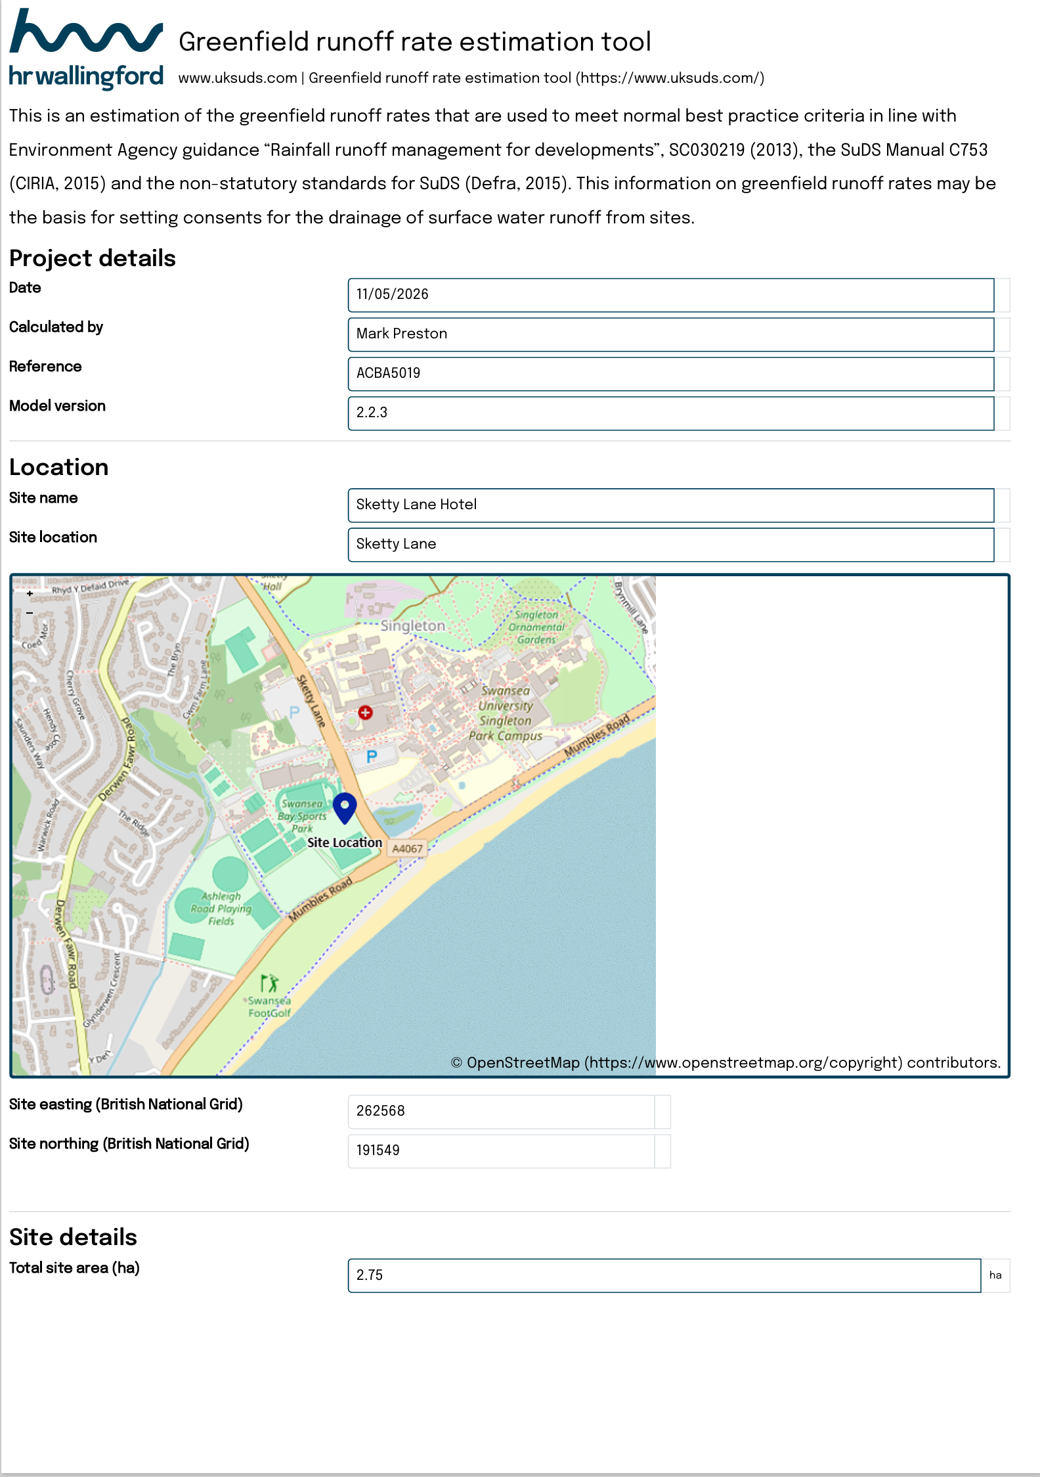

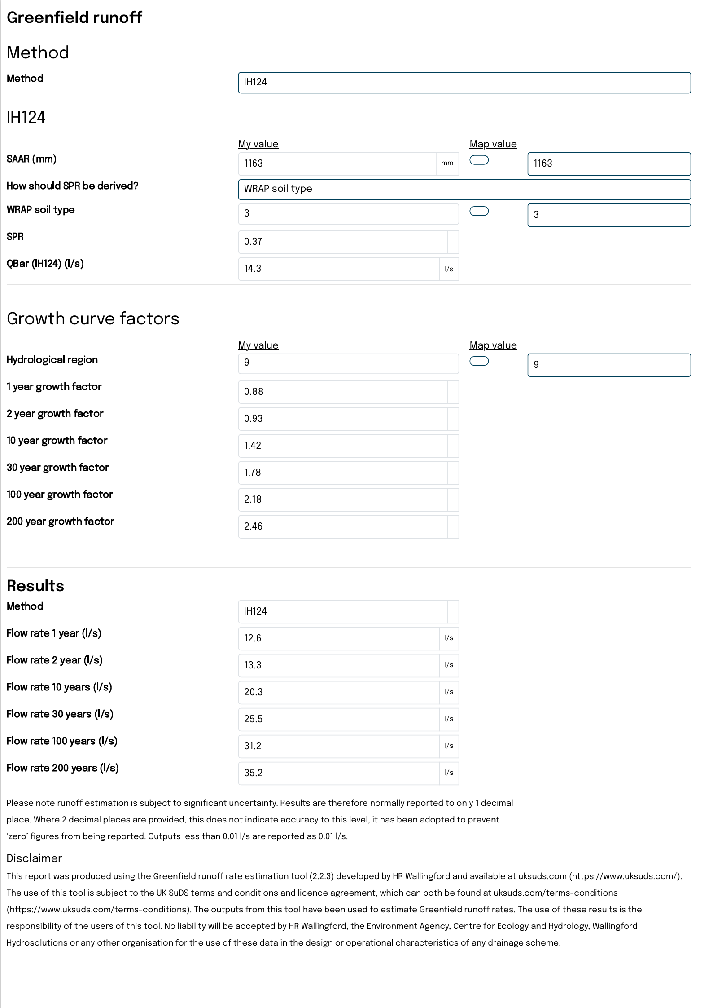
(UK SuDS, n.d.)

