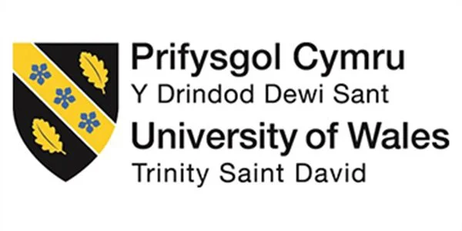

Master of Business Administration

Human Capital Management
LCMB7023

Assessment component 1:
Individual report – HR strategy

Integrated Human Capital Blueprint

Student ID: 2531265
Date: 20/03/2026

Table of Contents
Introduction 4
Part 1: Building a Culture of Innovation & Future Work Practices 4
1.1 Current Culture and Work Practices in Tech Companies 4
1.2 Recommendation of cultural and structural initiatives that embed innovation 6
1.3 Future of Work Model 6
1.4 Effectiveness of the new approach 8
Part 2: Reflection 8
2.1 Reflection of learning journey through Kolb 9
2.2 AI and Future Career Relevance 10
Conclusion 11
References 12

Report To: The Board of Directors, Aether Innovations
From: Human Capital Consultant
Date: 20/03/2026
Subject: Integrated Human Capital Blueprint: Aligning People and Performance

Executive Summary
One of the rapidly growing technology companies, Aether Innovations, which currently has approximately 300 employees, is already experiencing several organisational challenges, including a lack of growth and innovation, high staff turnover, and declining customer satisfaction. This raises concerns of the possible defects in the organisational culture and work practises that might be obstructing innovativeness and staff participation. However, the integrated human capital strategy proposed in this report aims at increasing performance within the organisation through the introduction of a culture of creativity, and the use of modern work practises. The report discusses the prevalent cultural and work practises applied in the industry by the leading companies such as Google and Microsoft, and the importance of psychological safety, adaptability, and teamwork. In order to enhance creativity and knowledge sharing, it proposes the establishment of innovation-oriented programmes, that is, innovation sprints, intrapreneurship programmes, and cross-functional teams. In addition, a hybrid future-of-work model is intended, which will enhance productivity, independence, and flexibility amongst the employees. All these activities aim to increase employee engagement, stimulate innovation, and increase customer satisfaction so that Aether Innovations can acquire a sustainable competitive advantage and receive long-term growth.

Introduction
Firms in the highly competitive IT industry have to depend on innovation, collaboration, and highly skilled employees to maintain consumer satisfaction and spur growth. Having approximately 300 employees, Aether Innovations is a fast-growing technology firm that now struggles with several organisational issues such as poor growth, high staff turnover, and customer dissatisfaction. All these problems demonstrate potential organisational culture and working practice deficiencies. This report will reflect an advancement of the tactics on how to promote a culture of innovation and exploit forthcoming work practises within Aether Innovations that enhance collaboration, teamwork, and high-quality work.

Part 1: Building a Culture of Innovation & Future Work Practices

1.1 Current Culture and Work Practices in Tech Companies
Success in the cutthroat and fast-paced industry of technology enterprises needs innovativeness and constant growth. Creativity, experimentation, sharing knowledge, and staff empowerment are usually at the forefront of the corporate culture of the leading technological businesses. In terms of the organisational culture theory, culture is that set of values, attitudes and actions that affect the way employees conduct themselves and perform their responsibilities in an organisation (Iskamto, 2023). However, creative technology companies encourage open communication, teamwork, and psychological safety to ensure that the employees feel safe to express ideas and question the existing practises. Organisations such as Google and Microsoft have established good cultures of innovation through encouragement of exploration and adaptation of errors (Steiber, 2024; Cheong et al. 2024). These firms encourage their workers to think of new concepts that, at some point, lead to innovation in new products and services. Even Netflix encourages an independent and accountable culture, according to which employees have a significant amount of freedom and are relied upon to make decisions (Jeffers et al. 2025). These strategies allow a working environment that permits employees to apply their creativity and strengths. Besides, agile, flexible work practises are also another important aspect of technology companies.
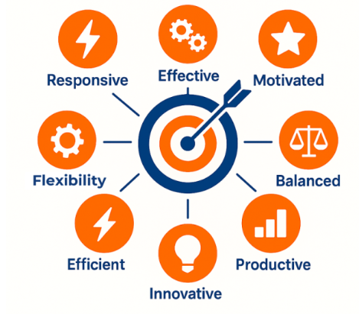
Figure 1: Principles of Agile Working
(Source: Chukwunweike and Aro, 2024)
As per Chukwunweike and Aro (2024), agile working assists the company in quickly adapting to the changing market through the encouragement of teamwork and quick problem-solving. The team also tends to be cross-functional, requiring people from various departments to work together in order to achieve shared objectives. This framework builds knowledge sharing and improves the level of creativity. Moreover, the sector of technology has noticed the growth of distant and hybrid workplaces, wherein, after the outbreak of COVID-19 and the ensuing alteration of office guidelines across the globe, such trends have grown in frequency (Kellerman, 2025). In this respect, flexible working hours enable employees to be productive and combine their home and work life. Studies indicate that flexible working arrangements enhance retention, engagement, and job satisfaction among employees. However, Haar et al. (2022) argued that firms which lack a supportive environment, though, can lack employee innovativeness and zeal. The high turnover and falling performance patterns are frequent signals indicating that the employees feel alienated or that they have not had enough chance to contribute. Hence, companies such as Aether Innovations that intend to grow in the long-term should build a powerful culture that is conducive to lifelong learning, collaboration, and innovation.

1.2 Recommendation of cultural and structural initiatives that embed innovation
At Aether Innovations, it is possible to implement several cultural and structural initiatives that would help create an environment where innovativeness and employee engagement thrive.
Activating innovation sprints is an important first step. Staff members work in intensive streams of creativity to produce and evaluate new ideas or solutions. This strategy fosters fast learning and innovation. Innovation sprints are very common in technology companies, notably Google teams, where properly organised design sprints allow employees to prototype and test innovations within a short period of time (Steiber, 2024). However, it would be better to encourage collaborative innovation by using similar strategies at Aether Innovations to speed up the process of creating new products.
The other initiative is the development of intrapreneurship programmes. Inspiring employees to become entrepreneurs in the firm by creating new products, services, or business opportunities can make intrapreneurship spur creativity. The companies that have managed to exploit intrapreneurship by enabling employees with time to concentrate on creative solutions are companies such as 3M (Mellit Quartucci et al. 2025). In the long term, this strategy promotes employee ownership, creativity, and commitment.
Another idea that should be created by Aether Innovations is to create cross-functional teams involving the employees of various departments, such as marketing, customer service, and engineering. In the opinion of Sanderson et al. (2022), teamwork provides better problem-solving through the sharing of various ideas/ knowledge. It is also used to ensure that ideas meet the demands of the customers, as well as being technological.
Last but not least, the sense of psychological safety should be established in such a way that the staff members can express an idea freely without the fear of being rejected and told off. When employees are allowed to explore new ideas and make mistakes, the chances of finding solutions of their own are higher (George and George, 2023). By featuring such cultural and institutional efforts, Aether Innovations will be able to assist in ensuring the development of an environment that will foster creativity, involvement, and constant development.

1.3 Future of Work Model
Independence of employees, digital collaboration, as well as flexibility will be more valuable in the future jobs of the technology sector. Aether Innovations should implement a hybrid work scheme that is a blend of remote and onsite work to enhance employee morale and create innovative solutions. As per Plester and Lloyd (2024), the hybrid workplace allows employees to work at home and still enjoy the fruits of face-to-face interactions when it is needed. For instance, employees could spend a few days at home a week, even when still coming to the office to plan the project, conduct meetings and brainstorm. However, this model enables employees to work to their best in their environment by seeking a balance between work and life. Besides, Naqshbandi (2025) stated that online teamwork technology is an unquestionable necessity that makes hybrid work environments possible. Nonetheless, the use of project management tools and platforms such as Slack and Zoom allows the staff members to communicate and cooperate productively wherever they are.
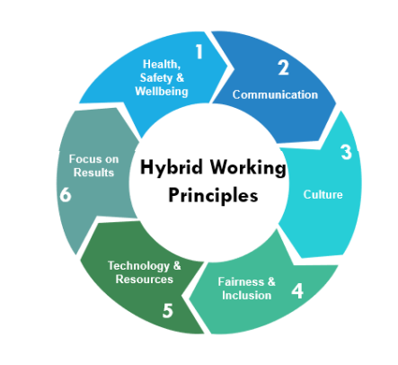
Figure 2: Hybrid Working Principles
(Source: Plester and Lloyd, 2024)
Such tools help teams to keep in touch and active as they can bring real-time communication, project organisation, and sharing files in a far easier way. Moreover, flexible work arrangements should be offered to encourage teamwork and creativity by companies where office designs are required to be redesigned. As compared to the former office designs that were developed around specific workstations, an innovation-based approach usually has open group areas, meeting rooms, and innovation centres where teams can devise and test new ideas (Plester and Lloyd, 2024). Furthermore, autonomy in employees is also enhanced through hybrid work schedules, which is a major element used in evaluating job pleasure and motivation. Nevertheless, workers who feel able to control their place of work and their working schedules have a higher chance of being felt as part of the team and being trusted. It would be possible to create a flexible and cooperative work environment, which, in turn, could enable Aether Innovations to increase the morale of its staff, decrease the rate of turnover, and create a more creative and efficient workforce.

1.4 Effectiveness of the new approach
In the case of Aether Innovations, the introduction of hybrid work and cultural programmes emphasising creativity may influence the effectiveness of the staff and the company's performance. The first step is to promote employee creativity by motivating employees to develop innovative ideas and solutions with innovation projects such as intrapreneurship programmes and innovation sprints. As per Azila-Gbettor et al. (2025), workers feel that they have more ownership and devotion to the success of the firm when they participate actively in the creative process. This relationship will enable a person to be more creative, create better products, and have a stronger competitive edge. Second, the collaboration of multiple abilities and perspectives through cross-functionality enhances the process of decision-making and problem-solving. Learning and finding ideas that do not emerge within autonomous groups is supported by the employees of numerous divisions (Šmite et al. 2023).
This collaborative world enhances the agility of corporations and allows them to react faster to the demands of shifting consumers. Thirdly, the hybrid style enhances the well-being and productivity of the employees. The flexibility in the working hours allows the workers to manage their time in a better way, and, hence, less stress and a better work-life balance are achieved (Barck-Holst et al. 2022). In the technology industry, where specialised skills and knowledge are required, employee retention could also increase due to increased job satisfaction. Lastly, an innovative culture enhances customer satisfaction. The more effectively the companies respond to the needs of the customers, the more employees are motivated to experiment and continuously upgrade their products or services (Lepistö et al. 2024). In turn, the proposed solutions not only make the employees more engaged but also enhance business growth and organisational success in the long term.

Part 2: Reflection
The reflection is essential to professional development as it is important to make individuals analyse their experiences and find out what they can do better. It is against this backdrop that I apply the experiential learning model as developed by Kolb in my reflection of my learning process in the course of doing the module, and consider the impact this will have on my future career growth (Vince, 2022).
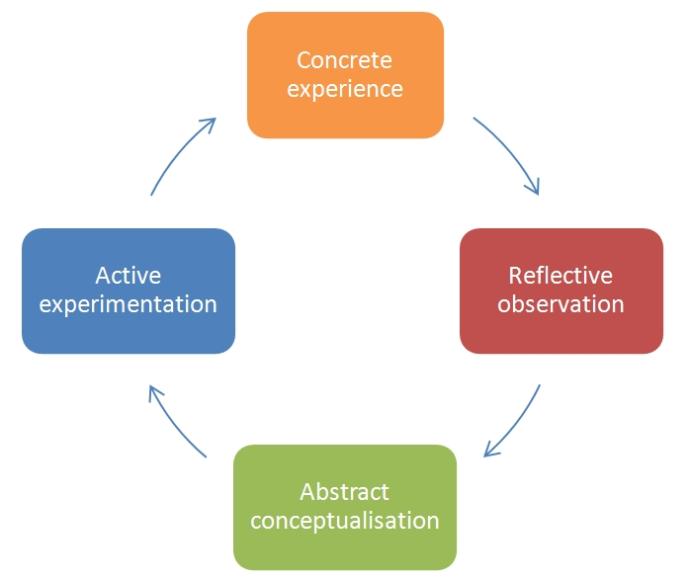
Figure 3: Kolb’s Reflective Cycle
(Source: Vince, 2022)

2.1 Reflection of learning journey through Kolb
According to the experiential model of learning, by Kolb, learning is a continuous process with four stages, including concrete experience, reflective observation, abstract conceptualisation, and active experimentation (Egan et al. 2023). This model provides a theoretical approach to understanding the role of experiences in knowledge building and development in a professional.
Concrete experience
Kolb's model starts with the step of concrete experience, which involves a practical involvement in a learning process. As a learner in this course, I was in a position to get familiar with such crucial areas of knowledge as organisational culture, leadership, human resource (HR) management, and innovation. Through readings, evaluations, and lectures, I got to learn about the influence of HR strategies on the performance of employees and how the organisation succeeds. The most useful aspect of the module was the development of the awareness of the impact of culture on employee behaviour and organisational outcomes.
Reflective observation
The second step is the reflective observation, where one looks at what they have experienced and finds out what they have learnt. Reflecting on all that I learned in the course of the module, I have concluded, based on the study of Al-Faouri et al. (2024), that the successful companies are reliant on the mastery of technology, as well as on the personnel management talents. I came to understand more about the impact of various leadership styles, communication styles, and employee developmental programmes on productivity at the workplace. The examples of real-life organisations helped me understand the importance of creating an atmosphere in which employees feel motivated and valued.
Abstract conceptualisation
The third stage of the paradigm of learning is the process that learners associate their experience with the theory, which is thus referred to as abstract conceptualisation. At this stage, I began to get acquainted with ways in which HR frameworks and theories can be applied to real organisational problems. Such concepts as the organisational culture, the motivation of its staff, and the management of innovations assisted the analysis of business issues (Mingaleva et al. 2022). These theories allowed me to understand why companies adopt some of the HR practises, and how the practises influence the behaviour of the employees. I developed more understanding of the role of HR practises in facilitating performance within organisations by relating abstract and concrete experiences.
Active experimentation
The final process in the learning cycle is active experimentation, which means putting new knowledge into action in the future. In order to become more innovative and attract employees, I will apply the knowledge acquired during this lesson as I continue my HR administration development. However, to illustrate this, I will endeavour to ensure that open communication, collaboration, and lifelong learning thrive within businesses. My desire is also to be creative in my thinking by supporting projects that would allow the employees to exchange ideas and develop innovative solutions.
Overall, the Kolb learning cycle has made me understand that continuous professional development is an unending process. This reflective strategy will enable me to enhance organisational performance and promote a healthy work environment by constantly employing it.

2.2 AI and Future Career Relevance
It is not just in the field of HR leadership that artificial intelligence (AI) is causing change in the workplace in the modern day. According to Paul and Richter (2025), increasingly technological solutions such as ChatGPT and Microsoft Copilot are being employed to automate various business processes such as data analysis, screening of candidates and administrative tasks. Even though the technologies can make industries become more productive and decrease the workload, job displacement in certain industries becomes an issue of concern. However, emotional intelligence as well as interpersonal communication have been required in HR management about activities such as leadership development, employee engagement, conflict management, and management of the organisational culture (Sharma et al. 2024). Apart from that, these capabilities are hard to mimic by AI systems because they should understand human emotions, values, and complex social relationships.
Besides, I think that it is easier to view AI as an aid rather than a threat by proving that this technology benefits human capabilities. For instance, AI could assist the HR staff to evaluate large volumes of data to identify employment trends, predict staff turnover, and improve the recruitment process. In addition, based on the study of Rodgers et al. (2023), I think that the administrative tasks can be reduced, and HR specialists can put more energy into employee development and strategic decision-making, taking advantage of AI tools. In the AI-driven working environment, continuous learning and digital literacy are required to remain up to date. Furthermore, technological skills should be supplemented with such skills as the ability to make ethical decisions, creativity, and critical thinking among professionals. As a result, human judgment enables individuals to be more productive with the same roles and positions; with technology, they gain the benefit of centralising around humans.

Conclusion
Overall, the success of technology companies is dependent greatly on their ability to adopt modern work patterns and innovative cultures. The problems Aether Innovations faces at the moment include the high turnover of staff, the declining customer satisfaction, and sluggish growth, all of which indicate that structural change is needed. Several recommendations include the enhancement of innovation, including cross-functional cooperation, intrapreneurship programmes, and innovation sprints. Moreover, the hybrid work model may enhance work-life balance, autonomy among employees, and output. Lastly, the reflection of the Kolb experiential learning model focused on the importance of continuous learning and the applicability of the theoretical knowledge to practice.

References
Al-Faouri, E.H., Abu Huson, Y., Aljawarneh, N.M. and Alqmool, T.J., (2024). The role of smart human resource management in the relationship between technology application and innovation performance. Sustainability, 16(11), p.4747. https://www.mdpi.com/2071-1050/16/11/4747
Azila-Gbettor, E.M., Nutsugah, F.F., Novixoxo, J.D., Glate, S.N. and Mensah, C., (2025). Empowering employee creativity in service organizations: unlocking the role of ownership, employee vitality and supportive leadership. The Service Industries Journal, 45(9-10), pp.899-934. https://www.tandfonline.com/doi/abs/10.1080/02642069.2024.2370037
Barck-Holst, P., Nilsonne, Å., Åkerstedt, T. and Hellgren, C., (2022). Reduced working hours and work-life balance. Nordic Social Work Research, 12(4), pp.450-463. https://www.tandfonline.com/doi/pdf/10.1080/2156857X.2020.1839784
Cheong, C.W., She, L., Ma, L., Karim, S., Chan, L.F., Chong, P.L., Choong, P.W., Gan, C.C., Gultom, N.D., Homer, S.T. and Hossain, S.M., (2024). Building a culture of innovation: Innovation 360. Global business and organizational excellence, 43(6), pp.5-23. https://www.researchgate.net/publication/379913863_Building_a_culture_of_innovation_Innovation_360
Chukwunweike, J. and Aro, O.E., (2024). Implementing agile management practices in the era of digital transformation. World Journal of Advanced Research and Reviews, 24(1), pp.2223-2242. https://www.researchgate.net/profile/Joseph-Chukwunweike/publication/385291725_Implementing_agile_management_practices_in_the_era_of_digital_transformation/links/671f05c6edbc012ea1427ff1/Implementing-agile-management-practices-in-the-era-of-digital-transformation.pdf
Egan, J.D., Tolman, S., McBrayer, J.S. and Ballesteros, E., (2023). Reconceptualizing Kolb's Learning Cycle as Episodic & Lifelong. Experiential Learning and Teaching in Higher Education, 6(1), pp.24-33. https://files.eric.ed.gov/fulltext/EJ1422266.pdf
George, A.S. and George, A.H., (2023). A review of ChatGPT AI's impact on several business sectors. Partners universal international innovation journal, 1(1), pp.9-23. https://puiij.com/index.php/research/article/download/11/5
Haar, J., O’Kane, C. and Daellenbach, U., (2022). High performance work systems and innovation in New Zealand SMEs: testing firm size and competitive environment effects. The International Journal of human resource management, 33(16), pp.3324-3352. https://www.tandfonline.com/doi/abs/10.1080/09585192.2021.1894213
Iskamto, D., (2023). Organizational culture and its impact on employee performance. International Journal of Management and Digital Business, 2(1), pp.47-55. https://journal.adpebi.com/index.php/ijmdb/article/download/584/542
Jeffers, C.N., Romulo, M.D., Duncan, S. and Mujtaba, B.G., (2025). Talent management and monetary benefits’ impact on Netflix and stock performance: A case study of innovative hr practices. Financial Markets, Institutions and Risks, 9(3), pp.1-16. https://armgpublishing.com/wp-content/uploads/2025/10/FMIR_3_2025_1.pdf
Kellerman, A., (2025). Global trends in work location, before, during, and after COVID-19: office, home, hybrid, and nomad. Urban, Planning and Transport Research, 13(1), p.2570279. https://www.tandfonline.com/doi/pdf/10.1080/21650020.2025.2570279
Lepistö, K., Saunila, M. and Ukko, J., (2024). Enhancing customer satisfaction, personnel satisfaction, and company reputation with total quality management: combining traditional and new views. Benchmarking: An International Journal, 31(1), pp.75-97. https://www.emerald.com/bij/article-pdf/31/1/75/9456153/bij-12-2021-0749.pdf
Mellit Quartucci, C., Sanz-Vicente, M., Fontdecaba, S. and Chianese, C., (2025). Intrapreneurs: A Hidden Potential Within Companies. In Business Entrepreneurship and Innovation: The Advocacy for a Tech-Corporate Ecosystem (pp. 27-43). Cham: Springer Nature Switzerland. https://link.springer.com/chapter/10.1007/978-3-032-05730-3_2
Mingaleva, Z., Shironina, E., Lobova, E., Olenev, V., Plyusnina, L. and Oborina, A., (2022). Organizational culture management as an element of innovative and sustainable development of enterprises. Sustainability, 14(10), p.6289. https://www.mdpi.com/2071-1050/14/10/6289
Naqshbandi, M.M., (2025). Beyond office walls: rethinking management practices in the hybrid workspace. FIIB Business Review, 14(4), pp.391-397. https://www.researchgate.net/profile/M-Muzamil-Naqshbandi/publication/393673106_Beyond_Office_Walls_Rethinking_Management_Practices_in_the_Hybrid_Workspace/links/6879e6b3f312d71d78c8256e/Beyond-Office-Walls-Rethinking-Management-Practices-in-the-Hybrid-Workspace.pdf
Paul, J. and Richter, T.T., (2025). EXPLORING THE IMPACT OF AI-BASED ASSISTANCE FUNCTIONS ON COLLABORATIVE BUSINESS PROCESSES. In INTED2025 Proceedings (pp. 6701-6709). IATED. https://library.iated.org/view/PAUL2025EXP
Plester, B. and Lloyd, R., (2024). New frontiers of fun: sharing and supporting workplace fun in hybrid work. Employee Relations: The International Journal, 46(4), pp.934-954. https://www.emerald.com/er/article-pdf/46/4/934/9575801/er-07-2023-0366.pdf
Rodgers, W., Murray, J.M., Stefanidis, A., Degbey, W.Y. and Tarba, S.Y., (2023). An artificial intelligence algorithmic approach to ethical decision-making in human resource management processes. Human resource management review, 33(1), p.100925. https://www.emerald.com/er/article-pdf/46/4/934/9575801/er-07-2023-0366.pdf
Sanderson, J., Esfahbodi, A. and Lonsdale, C., (2022). The effect of team-member knowledge, skills and abilities (KSAs) and a common learning experience on sourcing teamwork effectiveness. International Journal of Physical Distribution & Logistics Management, 52(5-6), pp.393-413. https://www.emerald.com/ijpdlm/article-pdf/52/5-6/393/1100450/ijpdlm-07-2021-0277.pdf

