
Skills for the Workplace
Module Assignment Submission
Student Name: | Lianne Davies
Student Number: | 1917783
Module No: | BMSK6007
Module Title: | Independent project

Statement of Confirmation of Authenticity
By the act of making this submission, the student declares that this is the work of the student named above. The work has not, in whole or in part, has been knowingly presented elsewhere for assessment, or where assessment has been built on a previous assessment, this has been identified. Where materials were used from other sources it has been properly acknowledged. If this statement is untrue, the student acknowledges that an assessment offence has been committed.
Attention is drawn to the plagiarism and unfair practice policies of both the University and of ILM.
Permission for ILM to use this script
ILM uses learners’ submissions – on an anonymous basis – for assessment standardisation. By submitting, both the centre and the learner agree that ILM may use this script on condition that identifying information is removed. However, if you are unwilling to allow ILM use this script, please refuse by ticking the box: □

Examining the influence of leadership styles upon sickness and absenteeism within Premier Inn Hotels
Lianne Davies 1917783
BMSK6007
November 2022

Acknowledgments

I would like to thank my family and amazing friends and study buddies Laura Williams and Lucy Mansbridge whose support has played a key role in my completing these last few years in university! I am also extremely thankful for my wonderful tutors, Michela (level 4) and Paul (Level 5 & 6) and all their support and guidance through the height of the pandemic. It has been an interesting journey, starting my academic career just as the pandemic hit and isolation were put in place, learning online was a new experience, but helped keep a focus while being at home unable to work. I am sad this journey is over, but I look forward to my next journey using the knowledge and skills I have gained during my time at University of Wales Trinity Saint David.

Abstract

Background
Premier Inn is a brand of hotel owned by a large company called Whitbread, Premier Inns and other hotel brands have taken a huge hit recently, due to COVID 19, which has caused disruption with the employees. Sickness and absenteeism has always been a topic of concern within any organisation. This report will take an in depth look at Leadership skills and Leadership styles that can have a positive influence on employee’s job satisfaction and commitment.
Aims and objectives.
This report aims to investigate the relationship between Leadership styles and its effect on job satisfaction and commitment with the aim to help reduce sickness and absenteeism within the hotel industry.
Research findings
From the literature review from various published articles, studies, journals, and books on the effect of leadership skills and leadership styles used and their effect on organisational performance, it were found that effective leadership positively influences the behaviour and attitudes of employees to ensure they feel appreciated and supported in their roles. Evidence concluded that leadership styles such as transformational and transactional Leadership used in combination with one another, can help improve employee job satisfaction and commitment.

Table of Contents
Acknowledgments 2
Abstract 3
1.0 Introduction 5
2.0 Literature Review 6
2.1 Reasons for Sickness and Absenteeism and Presenteeism in the workplace. 8
2.1.a Conflict Management 9
2.1.b Leadership and management 11
2.1c Emotional Intelligence 12
2.1.d Communication 14
2.1.e Resistance to Change within the hotel industry. 16
2.1.f How Leaders Motivate their Employees. 18
2.2 Effects of Covid within the hotel industry and Premier Inn Hotel 19
2.3 Leadership styles used in the hotel industry. 20
3.0 Methodology 22
3.1 Analysis 22
4.0 Conclusion 23
5.0 Future Recommendations 23
References 24
Appendix A 34
Appendix B 35
Appendix C 38
Appendix D 40
Appendix E 41
Appendix F 42
Appendix G 43
Appendix H 44
Appendix I 45
Appendix J 46

Introduction

This report will investigate the influence of leadership styles upon sickness and absenteeism within the hotel industry and Premier Inn Hotels using literature from journals, articles, and books. In recent years, the hotel industry has endured significant changes both within the industry and in its operating environment, this is in part due to the covid nineteen pandemic. This report will first look at the many reasons for sickness and absenteeism in the hotel industry, theses can vary from sickness/long term ill heath, conflict with colleagues or superiors, family issues/childcare and even presenteeism, all these reasons and many more, not only cause issues within the organisation it is also costly. In 2020 Wales had the highest rate of absence due to sickness at 2.2%, which is 0.4% higher than the UK rate (Leaker & Kumar, 2021). The report will then look at conflict management in the workplace, where conflict is unfortunately a widespread practice, such as bulling by colleagues and superiors and how this can affect an individual’s health causing stress and depression which can lead to them being absent. Managing conflict can be difficult for an organisation, however using conflict resolution models can help reduce conflict in the workplace improve moral, performance, and productivity. Davis et al., (2010) research found that women, were reported to possess conflict style skills that show a great interest for interpersonal relationships, and men were reported to possess conflict styles that shows interest for completion of tasks and success. Implying that women are more concerned with with building and maintaining relationships which can help resolve and reduce conflict, and men are more concerned with the organisation’s goals. The next section will look at Leaders and management and how they should have a basic understanding of leadership styles and what those entails. Leaders and managers have their own way of doing things which is their leadership style. Ispas & Băbăiță, (2012) managers and leaders must allow for the effects that their leadership style could have on the level of employee satisfaction and still be able to adapt it to any new situation that may arise in the hotel business. And they must be aware of the styles, that are accepted by their employees as that influences them in a positive way. However, each leader or manager have the same role to play in building trust, being a positive influence, and supporting their employees. The hotel industry may require leaders to change their style of leading from time to time to be able to help the organisation implement change and in completing organisational goals on time. Emotional intelligence is a highly regarded skill, understanding your own emotions will enable you to understand other emotions that are around you. Learning more about your own skills in emotional intelligence can be beneficial to manager and leaders. Using online questionnaires is a useful tool for gathering more knowledge about emotional intelligence, this can be used to self-develop or support others to develop into future leaders.
“No matter who we are, and where we work, play, or socialize, we are always trying to influence someone about something. Daily interactions with colleagues, peers, friends, and management require us to use our emotional intelligence whether or not we are cognizant of doing so.”
Sourced from (Chrusciel, 2006, pg 655)
Gender has been extensively researched in regard to emotional intelligence with much of the literature implying women have higher emotional intelligence than men. Miao et al., (2021, pg. 21) believed their study supported gender fairness in the workplace and revealed that men and women are both evenly qualified in using emotional intelligence. One of the key skills of emotional intelligence is communication, leaders must be able to communicate effectively to help in building a trusting culture, meaning interpersonal skills are needed to help maintain relationships. Communication models can be used to help improve or change how an organisation shares information with their teams. Whitbread PLC are invested in their teams, using surveys and forums to collect feedback and act on it. Change in the hotel industry is a common occurrence, even more so now due to the pandemic. For an organisation to implement a change successfully, the employees need to be on board. Resistance to change can cause many issues in the success. Knowing what motivates employees to be the best they can be, leaders need to be aware of their needs, be it professional needs such as engagement and development or personal needs such as wage and flexibility, using models such as Herzberg’s 2 factor theory, leaders will be able to appropriately attend the needs of their employees to keep motivation in place. The hotel industry n during the pandemic, at the height around 2.13 million jobs in the hospitality industry furloughed, hotels were closed, and staff were unable to work. Statistics show that women have a higher rate of sickness and absenteeism in the labour industry, and Whitbread PLC hourly workforce is made up of 66% of women. The last part of this section looks at leadership styles and what they do as leaders to keep their teams motivated and engaged.

2.0 Literature Review

Sickness and absenteeism in the workplace is an ongoing issue, it has the potential to cause many problems for the employees, the management, and an organisation as a whole. McHugh, (2001) said that there are several reasons employees are absent from the workplace, they could be experiencing poor health or certain aspects of the work environment may cause them to be absent. This suggests that not all reasons for absences in the workplace are caused by ill health but are due to the work environment and the issues that may arise in it. These issues may include poor working conditions, poor leadership, and large workload. Other factors may include bullying in the workplace (Moayed et al., 2006), and family commitments (Kocakulah et al., 2016 pg. 90). Managers, leaders, and supervisors have a responsibility to ensure the health, safety, and welfare of their employees. They are also responsible in having a helping hand in creating a healthy work environment and work relationships. According to Buzeti, (2021) Leaders have a significant role in creating (non)practical relationships in the workplace, the leader will display a distinctive personality in work, which shows in accordance with a particular type of behaviour. Employees emotionally detect the leader’s behaviour, and this behaviour should therefore be supportive and not harmful them. This suggests that leaders help build (non)functional relationships amongst their employees, while displaying an individual personality in the workplace. Employees will sense the behaviour being displayed, so it is important for leaders to display honest and positive behaviours. Values and beliefs vary from person to person, so it is important for managers and leaders to be aware of this. Momeni, (2009) study said that confidence and emotional behaviour of a manager has a predominate effect on the organisational climate. The research found that 70% of employees’ perceptions of the organisational climate comes straight from the managers behaviour, which encourages employee’s emotions and behaviours. And concluded that managers with higher emotional intelligence the healthier the organisations climate. Again, this suggest that the way a manager behaves can have a stimulating effect on their employees. And that having managers with higher emotional intelligence can create a better working environment and commitment from their employees. Which in turn improves satisfaction, commitment, productivity, and profit for the organisation.
“If we have to formulate the definition of leadership in just a few words, we could say that overall, leadership is building a bridge between individual and organizational goals.”
(Arany & Popovics, 2022. Pg 93)
Managers and leaders are human, they each have their own personality and ways of working, which we call Leadership styles. Some examples of leadership styles are.
- Transformational Leadership - Inspires change and transformation in their team members.
- Delegative Leadership – Trusts their team members and does not micromanage or get too involved.
- Authoritative Leadership - Gets to know each team member, to provide guidance and feedback on a more personalized level, helping individuals to succeed.
- Transactional Leadership – Follows structured routines and procedures, relies on a reward-based system.
- Participative Leadership – Listens to their team members and involves them in the decision-making process.
- Bureaucratic style - Relies on a clear chain of command, strict regulations, and conformation by the team members.
Minett et al., (2009) completed a study to assess the leadership styles of managers in the hospitality industry and understanding their ethical decision-making style, the study was completed using people from a range of organizations with various levels of experiences, responsibilities, and were a mix of age and genders. The study concluded that the leadership style, and ethical decision-making style of managers varied only according to age, suggesting this could be due to improved moral development. Which could mean, the older the manager the more they know the right from the wrong in decision making and the need for promotion is low, the younger the manager the need for promotion can be quite high and they may not care about who they stand on to get where they want to be. This could also be why there is varied leadership styles. However, a study completed by SÜRÜCÜ & SAĞBAŞ, (2020) on how leaderships styles impact job satisfaction, concluded that managers who embrace transformational leadership behaviours will help increase employee satisfaction, therefore increasing efficiency. They wrote that managers who want a healthy and sustainable competitive advantage in the hospitality industry should demonstrate transformational leadership practices. Meaning to ensure the workforce is happy and the organisation is successful the style of transformational leadership should be used. Kara et al., (2013) wrote that following the transformational leadership style can be an advantage and is highly advised. Transactional leadership serves to amplify hotel employees work life balance, which then improves commitment, reduces employee fatigue and in particular it increases employee’s overall life satisfaction. This can mean that transformational leadership can be good for not just an employee’s work life, but their personal life can become improved. This can then improve employee moral, sickness and absenteeism and increase overall productivity. Sickness and absenteeism can have a damaging effect on an organisation, with many reasons contributing to the why. Which brings us to the next section which will look deeper into some reasons which cause sickness absenteeism and presenteeism in an organisation.

2.1 Reasons for Sickness and Absenteeism and Presenteeism in the workplace.

There can be many reasons why sickness and absenteeism rates are high within a workplace. The most frequent reason for being absent from the workplace is seasonal illnesses such as a cold or flu, sickness, and diarrhoea and now we also have Covid 19 to add to the mix. According to Leaker & Kumar, (2021) the four main reasons for sickness and absenteeism in the workplace for 2020 was.
- Minor Conditions 26.1% - this includes the common cold or flu and sickness and diarrhoea.
- Other Conditions 17.1% - This includes coronavirus-related illnesses.
- Musculoskeletal problems 15.4% - This includes back neck and upper limb problems.
- Mental Health conditions 11.6% - tis includes stress, depression, and anxiety.
With Women having the highest sickness and absenteeism rate for 2020 with 2.3% compared to men with 1.5% and people at 1.8%. Other reasons could be due to workplace issues such as bullying, and toxic leadership. Personal reasons can also be a factor, for example family life, child sickness and no childcare can result in absenteeism. Kocakulah et al., (2016) said family problems play an important part in absenteeism. Balancing work and family life can be difficult. Childcare is often a problem. With the cost of childcare on the rise, there will be more individuals that are unable to pay the rising costs. This will not only impact the individual with loss of wage but also the workplace, the management will have to find cover or increase the current staff workload, and colleagues will lose time off to cover or become overworked by the increased workload. Other causes of sickness and absenteeism in the workplace could be.
- Productivity Pressures
- Difficult workload
- High workload
- Corporate Restructuring
- Workplace culture
Another Issue that has caused problems in an organisation is presenteeism, described by Johns, (2010) as people who are in work while experiencing ill heath, and not working to their best ability. Caverley et al., (2007) described presenteeism as employees who work while suffering with ill health and or medical issues, these can range from headaches and migraines to mental health and asthma or breathing difficulties. This shows that employees who have ill heath are still coming into work but are not completing their work to their full capacity, this can cause many problems within an organisation such as decreased service and productivity, profit and can cause conflict with other employees. There are many reasons why ‘presenteeism’ may happen within an organisation, according to Knani, (2022) there are elements that can lead to presenteeism, and these include work pressures, lack of job security, work-family conflict, and stress. Arslaner & Boylu, (2015) also found similar factors, such as to be afraid to lose their job, wage decrease, fear of conflict with colleagues, work-family conflicts and job loyalty can all lead to presenteeism. This shows that an organisation needs to have a strong culture that involves trust, open communication, and increased productivity. Introducing ways to solve or reduce conflict may help an organisation. During the research conducted in this report, ‘bullying’ in the workplace has been identified in the literature reviewed so the next section will investigate this further to identify if there are effective ways the leader could identify and deal with this problem sooner.

2.1.a Conflict Management

“A central feature of bullying is the imbalance of power between the parties, as the persons targeted find it difficult to protect and guard against ever more frequent and harsh treatment.”
Sourced from (Matthiesen & Einarsen, 2010)
Bullying in the 20th century can come in all shapes and sizes and with the improvement in technology bullying can also get creative. There is no barrier to who is the bully and who gets bullied, it can either be management, colleagues, or both, it can be one individual and a group of individuals. Below are some examples of bullying behaviour and ways that bullying can occur.
Examples of bullying behaviour | Ways bullying can happen
Spreading rumours that are malicious | Face-to-face
Treating others unfairly | By letter
Picking on an individual/s | By email
Denying someone's training or promotion opportunities | By phone
Undermining someone. | By text
Being physical/violent | By social media
Exclusion/isolation

Being a victim of bullying can have a detrimental effect on one’s physical and mental health, which can affect their everyday lives, it can also affect the organisation especially if nothing is done to correct and prevent bullying in the workplace. Bulutlar & Öz, (2008) study found a lot of research for identifying bullying as a severe form of stress. As well as helping to produce outcomes like absenteeism, decreases in turnover, commitment, job satisfaction, productivity, and efficiency. They wrote that bullying at work can lead to poor psychological and physical health, as well as anxiety and depression. The research also found that in long term cases of bullying, the harm to the victim could be serious enough that the individual quits employment all together. This implies that the impact of bullying can be extreme for all involved, with lasting damage to the victim’s personal health and personal and professional life. The reputation and bottom line of the organisation will also be affected. Not all employees leave employment while being bullied and harassed. Wall et al., (2018) study found that bullying can come from colleagues, supervisors and managers, 60-81% of complaints made, were about bullying behaviour by the management. Managers who harass and bully their staff members have a habit of taking credit for others work, to make themselves look better. Supervisors will give excessive workloads to an employee, ensuring the failure of the employee. Therefore, many employees forego quality of life to ensure they stay in their job. This in turn creates an unpleasant and unsustainable workplace culture. This implies that high number of complaints for bullying were perpetrated by the leaders and managers, using their employee’s quality work as their own and overloading employees with work to ensure they fail and look bad, although this is happening the employees choose to stay and work in that environment, this in turn creates a culture that’s filled with tension, lack of trust and generally unhappy people.
There are many conflict models available for example Thomas-Kilmann conflict management model (appendix A), this model can help minimise conflict within the workplace. The model has two sections, assertiveness and cooperativeness and there are five styles of conflict resolution approaches.
- Compete –Rejects compromise and does not give in to others wants. This style can resolve conflict quickly when there is no time to find a solution. High assertiveness, low cooperativeness.
- Avoid - Reduce conflict by ignoring it, removing the individuals involved, or evading the situation. This could be a suitable resolution if a separation would help the situation. Low Assertiveness, low cooperation.
- Accommodate - Putting other’s needs, before your own. This style is about keeping the peace. Low Assertiveness, high cooperativeness.
- Collaborate - Produces long-term results but can be time-consuming. This style is a win-win after some negotiation. High assertiveness, high cooperativeness.
- Compromise – Finds middle ground, by giving up something to find a solution. This style is a lose-lose situation. Centre.
The model is designed to help determine an individual’s behaviour in a conflict situation that involves another. Brahnam et al., (2005) study on conflict resolution strategies of 163 students of traditional age (18-22) males and females, in order to determine if gender-based differences exist. The results of the study showed evidence that women will more likely use the collaborative resolution style and men will more likely use the avoid resolution, showing that women may have more effective conflict resolution skills than males. This research shows women invest more time into their employees, creating relationships, building trust, and communicating, while the males tend to make it go away with a quick fix. Research has identified various leadership styles and it would be useful to examine the styles further to identify which style would be best suited in the hospitality industry in the aim to increase job satisfaction and reduced the sickness rates within the industry.

2.1.b Leadership and management

Management & Leadership
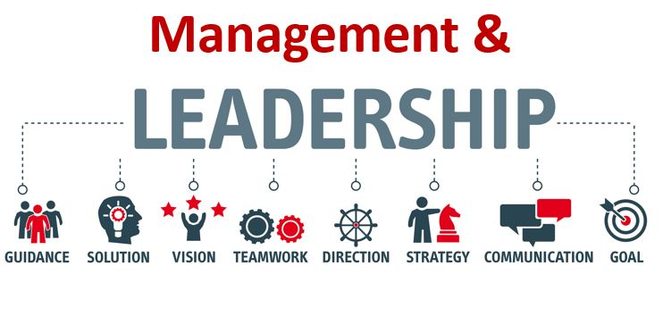
Sourced from (Dovetail Enterprises, 1993)
“By the term “Leadership” we mean social (i.e., interpersonal) influence exercised by a person in some position of superior authority over some subordinate.”
Sourced from (Leavitt et al., 1989, p. 224)
Leadership can and is, used by mangers, leaders, supervisors, and peers within an organisation, they are the people that are looked up to for guidance and stability, and they are trusted by their employees and colleagues. (Huey Yiing & Zaman Bin Ahmad, 2009) wrote that leadership is defined as a relationship of influence between leaders and followers. This shows how important the ability to inspire, change, and shape the behaviours of others to ensure the success of the organisation is. Clark et al., (2008) found that many believe a managers most significant role in leadership includes, guiding team members and groups towards achieving all goals. This shows that leadership is all about their teams, supporting them, guiding, and advising them to success, both personally, professionally, and more importantly for the organisation. However, Suh et al., (2012) research on hospitality managers found that oral communication skills were highly valued and leadership skills followed next. This shows that speaking with the team and communicating directly is found to be the most key role for a manager. So, a person in authority should have effective communication skills to enable them to do their jobs more effectively. Ispas, (2012) paper said that numerous authors conceded that a leaders’ style will vary according to their own personality, education, training, the environment, and their own personal ideology. Meaning all leaders are different, they each have their own set of values and beliefs and style of leading, some examples are.
- Autocratic leadership style - Where the leader makes all the decisions without taking input from anyone who works for them.
- Transformational leadership style – A leader will gain the trust and confidence of their employees, encourage them, and lead them toward meeting company goals.
- Transactional leadership style - Is where a leader uses rewards and punishments to get the job done and will tell employees they can expect rewards if a goal is met.
There are many articles, journals, books, and websites available to help a leader or potential leader identify their own leadership style, this is a great tool for self-development. Many websites are available that include quick questionnaires (Appendix B) that will help you identify which style you have, its also useful to be aware of several types of leadership styles to help others develop. Tracey & Hinkin, (1996) wrote that the hospitality industry is an actively changing environment that may require leaders to have a change-oriented, or transformational leadership style. This implies that due to other factors either from internal or external forces, leaders will need to quickly adapt to the current environment and behave differently to obtain the results needed. Feyerherm & Rice, (2002) Research found that effective leaders have more task related skills, are social, and are more motivated to lead than others. This shows that effective leaders have a wide range of skills, are more social and having good interpersonal skills can help improve job satisfaction in their employees, it can also help them to become more self- aware, this also has key points for high emotional intelligence. This is discussed in more detail in the next section.

2.1c Emotional Intelligence

Emotional Intelligence
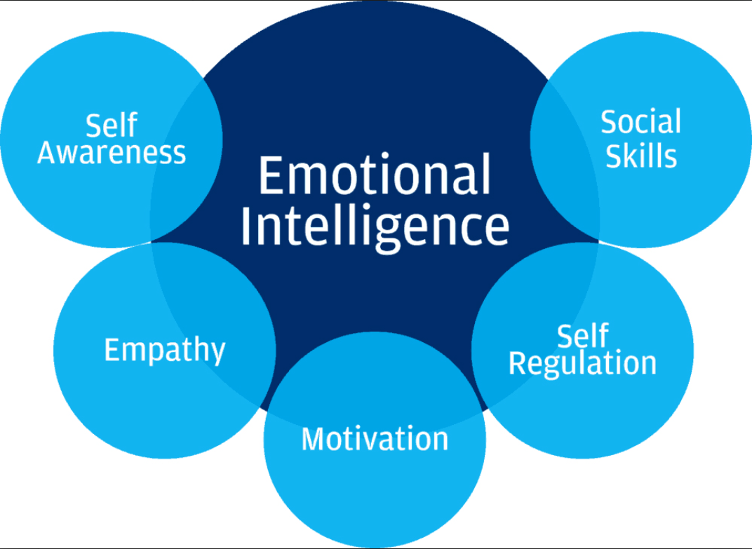
Sourced from (Cohen-Gadol, 2021)

“The ability to perceive emotions, to access and generate emotions so as to assist thought, to understand emotions and emotional meanings, and to reflectively regulate emotions in ways that promote emotional and intellectual growth.”
Sourced from (Scott-Halsell et al., 2008)
In simpler terms emotional intelligence is the skill to understanding your own emotions and how to manage them, this will help to understand and influence the emotions of others. Many journals, articles and literature can be found where emotional intelligence has been linked directly to transformational leadership style. Hur et al., (2011) study said the attributes of having empathy, motivation, self-awareness, trust, and emotional stability are also considered to be crucial factors of emotional intelligence, these are also qualities of a transformational leader. Scott-Halsell et al., (2007) research found that transformational leaders are able to create positive environments, furthermore transformational leaders increase employee performance by using EI to control disappointment and increase job satisfaction. By being in tune emotionally with employees, will aid them to complete their responsibilities more effectively. This shows that emotional intelligence skills are used in a positive way with transformational leadership, having the ability to understand employee emotions, helps give an advantage at being able to control or stop any upset that could affect an employee’s job. Suwandana, (2019) research found that transformational leadership arbitrates the connection between emotional intelligence and effectiveness in team performance. This shows that leadership styles such as transformational leadership can have a positive effect on the team’s performance by using the skills they have. A few examples of emotional intelligence skills are.
- Self-awareness
- Self-management
- Awareness of others
- Motivation
- Empathy
- Social skills
- Problem-solving

It is believed that females are associated with having a better understanding of emotions than their male counterparts. Fernández-Berrocal et al., (2012) research found that women scored higher in emotional intelligence than men. This reasoning was supported by literature on different genders and emotional characteristics, revealing that women are more competent at reading nonverbal emotions, they have a broader understanding of emotions, they are sensitive to others’ emotions, and they are more eloquent and display adept people skills. Implying that women are greater at showing, feeling, and reading emotions than men are. Kapur et al., (2012) study found that there is a difference between males and females in emotional intelligence, with males showing higher degrees of emotional intelligence than women. This research implies that males are greater at emotional intelligence than women. However, results from Doyle & Thompson, (2020) study showed that the gender difference in emotional intelligence skills can be moderately accredited to existing gender stereotypes. Implying that due to peoples exaggerated beliefs they assume one will always be better than the other. Emotional intelligence does not pick a side or a preference of gender, everyone possess traits of emotional intelligence that can be increased with knowledge and training.

To help a leader understand or improve their own emotional intelligence an example of a simple questionnaire can be used, such as Daniel Goleman’s model, Goleman (1996) which focuses on Emotional intelligence as various skills that enhance the performance of leadership styles and as suggested by Riopel (2023) these are broken down into five areas:
- Be aware of your own emotions.
- Manage your own emotions.
- Motivate yourself.
- Recognize and understand other people’s emotions.
- Manage relationships (others’ emotions)
These five realms are broken down into four quadrants:
- Self-Awareness.
- Social Awareness.
- Self-Management.
- Relationship Management
Other questionnaires are available online, such as Mind Tools (Appendix C). These questionnaires are a great tool in helping you develop both personally and professionally, they help you determine your strengths and weaknesses so you can work on areas of concern to improve your own emotional intelligence. It can also be used as a development tool for employees looking to progress within the organisation. The next section will look more into communication and how emotional intelligence skills have an impact on the forms of communication.

2.1.d Communication

Berlo’s S-M-C-R Model
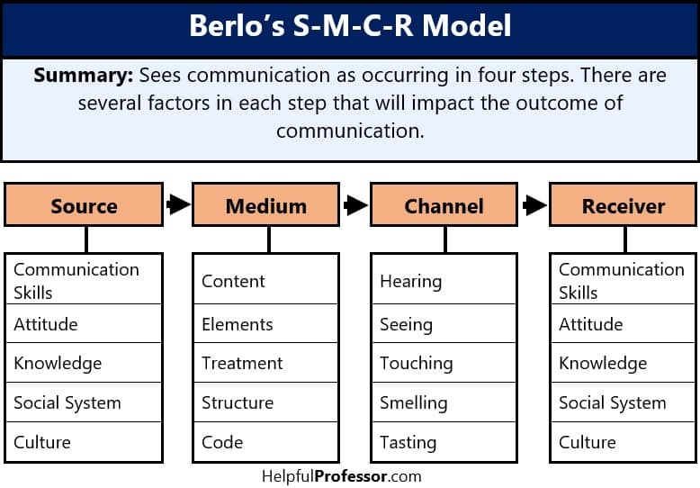
An example of Berlo’s Communication model. Sourced from (Drew, 2020)
Effective communication in the workplace is vital for an organisation’s success. Leaders must be able to effectively communicate to their team in all ways, this can help them to be heard and empower the team around them to succeed. Without effective communication skills a leader can struggle with being understood and even respected. Lolli, (2013) research found that hospitality leaders use up to as much as 80% of their day communicating orally with others. This shows interpersonal communication skills play an important part in the daily operations of a hospitality organisation. Bucăţa & Rizescu, (2017) concluded that communication is an important management tool, and its role is to assist and support relationships between people. Meaning that a manager, leader, and supervisors should have strong intercommunication skills, as this helps create and maintain effective working relationships, which should help decrease conflict and increase productivity. Mishra et al., (2014) found that internal communication between managers, leaders and employees should help build trust between them and increase employee engagement with the organisation. Showing communication between employees and management can lead to building a trusting environment which will help increase job satisfaction and productivity leading to less absenteeism. Meira et al., (2018) study revealed that communication, leadership, and planning influence the employees’ performance directly.
Many organisations use communication models to help change or improve their way of communicating internally and interpersonally. Communication models give an overview of the communication process and to be effective in communication its useful to know what is involved and why, below are three examples and a brief description of the way communication models work.
- Berlo’s SMCR Model of Communication (picture above) has four sections, sender, message, channel and receiver, each section has various elements to them. Berlo’s believes that the section and elements must be similar between the sender and receiver for effective communication.
- Shannon and Weaver Model of Communication (Appendix D) has five sections, sender, encoder, channel, decoder, and receiver, it also considers the noise that may occur during the processes which can disrupt the original message.
- Schramm’s Model of Communication (Appendix E) has five sections (similar to Shannon and Weaver), sender, receiver, message, feedback, and semantic noise. Schramm’s model is circular because he believed a message goes two ways. Communication with no feedback is not going to be complete.
Its important for organisations to implement ways that employees can communicate their concerns in a manner that makes them anonymous but still valued for their honesty. Whitbread have an employee forum which is called ‘Our Voice’ that is made up of representatives from all hotels, restaurants, and support centre, the representatives speak on behalf of their teams. The forum is a way to connect front lines teams with senior leaders for a two-way conversation to help understand the challenges from the team’s own viewpoint, and to ensure that the employee voices are heard and used to help to structure decisions that solve those challenges that they face. Whitbread also introduced the pulse survey during the pandemic to understand their team’s experience. The results from the autumn pulse survey showed that 87% of respondents felt COVID-19 safe at work, 86% of respondents reported fair treatment, 86% felt they could be themselves at work, and 85% reported being trained well to perform their role (AnnualReports.com, 2023). These results show that giving their employees ways to communicate are having a positive result with high percentages in all areas. It would seem logical to assume that emotional intelligence skills are required for a leader to communicate more effectively. If employees resist change, a leader with high emotional intelligence skills would be useful to identify the resistance and understand how to deal with each employee’s unique situation. Resistance to change in the hotel industry, will be discussed further in the next section.

The communication process in a
company is therefore an essential
management tool, a particular complexity
of the management system. The role of
communication as a management tool is to
facilitate relationships between people, to
establish an environment beneficial to the
internal development of the organization
The communication process in a
company is therefore an essential
management tool, a particular complexity
of the management system. The role of
communication as a management tool is to
facilitate relationships between people, to
establish an environment beneficial to the
internal development of the organization
The communication process in a
company is therefore an essential
management tool, a particular complexity
of the management system. The role of
communication as a management tool is to
facilitate relationships between people, to
establish an environment beneficial to the
internal development of the organization

2.1.e Resistance to Change within the hotel industry.

The 3 Stage Model of Change, created by Kurt Lewin
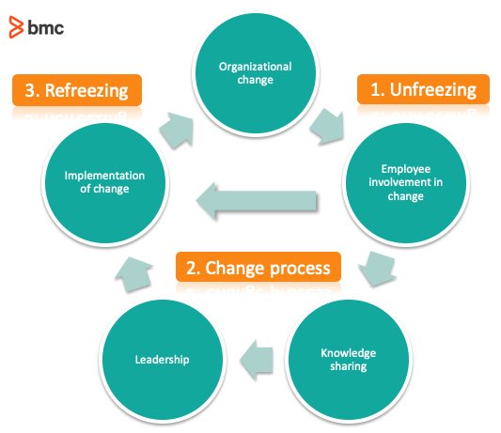
Sourced from (Raza, 2019)

The hospitality industry is ever changing due to many factors from either the micro or macro environment. Baquero, (2022) wrote that recently, numerous organizations have been downscaling, this can be considered a normal process, and yet it comes with unfavourable emotions from employees. Meaning due to unforeseen changes in the macro-environment, an organization will downsize their workforce to help save money, employees are aware of this but still react due to the uncertainties this brings.
Change can come from either inside or outside of an organisation and include many factors. A few examples are.
Micro-environment (Internal factors) | Macro-environment (External factors)
Suppliers | Political
Customers | Environmental
Competition | Economic
Employees | Community

Chiang, (2010) research found that employees assisted their managers to embrace change beneficially and reduce the aversion to change. The main reason for these actions involve the leader managing training, communication methods and engagement to avert any resistance to change. This implies that leaders who communicate and involve their employees in decision making shows trust which can lead to support when change occurs. Ramos-Maçães & Román-Portas, (2022) paper found Leaders are firstly responsible for the full conception and implementation of the organizational change process, and for encouraging the involvement of employees in the change process. This shows effective leadership is important to help the process of change, employees will need to feel like they are being supported and involved in the process from start to finish with effective communication.
The picture above is based on Lewin’s three-step model of change; the model involves three steps.
- Unfreezing - Create awareness for change, breaking down the current situation to make way for the new change.
- Change – Implement the change, allow for resistance and mistakes. People will start to believe and support the new change.
- Freezing – Change has been implemented and embraced the organisation can refreeze.
Islam, (2023) described each step as; Unfreezing is defined as adjusting the current situation and accepted stability, moving is defined as changing the existing circumstances based on present day knowledge and information and Refreezing, is defined as, settling the change. Hussain et al., (2018) study said employees must be spoken to about change, and the leaders should communicate, educate, engage, involve, Job support, emotional guidance and support, incentives, influence, co-operate and compel the employees about change. When implementing the three steps it is important for a leader to display all the behaviours at each point, employees will be looking for constant reassurance from their leaders during the change step. Ahmad Mukhtar & Yuen Fook, (2020) study to investigate the relationships of perceived leadership styles and emotional intelligence on attitude toward organizational change, using Lewin’s 3 step model. The results of this study showed the importance of leadership styles and emotional intelligence at the earlier stage change. The roles of these two individual variables in the change process at an earlier stage of change requires creating motivation which involves the modifying the attitude towards organizational change. Understanding the employee’s perspective is the first step in understanding human behaviours because when their outlook can be adjusted, then the behaviour can be influenced. This shows that leadership and emotional intelligence plays a key role in helping an organisation implement change successfully and motivate their employees to accept the change. Which brings us to the next part of the report, which will investigate motivation further.

2.1.f How Leaders Motivate their Employees.

“The need for motivation stems from the need for survival and motivated employees help organizations survive.”
Sourced from (Kontodimopoulos et al., 2009)
A well-motivated workforce shows loyalty to their organisation, and being committed to the organisation and its goals can help lead to success. Scott, (2016) research found that one of the foundational signs of quality leaders is the competence, talent, and skill to motivate their followers to achieve wonderful things. Naile & Selesho, (2014) wrote Leadership permits managers to influence employee behaviour in the organisation. Therefore, motivated employees are one of the prime results of effective leadership in the workplace. Venus et al., (2013) research found that exceptional leadership is expressed in effective communication of vision, goals and in motivating their followers through messages instilled with the core values. This shows that leadership skills such as capability, trust, and communication are important in being able to motivate the workforce to succeed.
Motivational theories are ways of explaining what goes into decision-making and how it impacts our behaviours and how we act the way we do. Some examples of motivational theories are.
- Herzberg's Two-Factor Theory (Appendix H) - This model puts forward two factors that motivate employees, Job satisfaction and Job dissatisfaction. While these look-like opposites, they work together in a cycle that keeps rotating.
- Maslow's Hierarchy of Needs (Appendix I) -This model of motivation states that there are five categories of human needs that dictate an individual's behaviour. The model is rectangular and starts from the bottom up each step are each category.
- Theory X, Theory Y (Appendix J) - Theory X assumptions employees do not like their work, they lack responsibility and prefer to be led rather than leading others. Theory Y are the direct opposite and believe employees are enthusiastic about their work and also employees readily accept responsibility.
Lundberg et al., (2009) said Herzberg’s two-factor Theory, suggests that individuals have two different sets of needs and that the different elements of the work situation can either satisfy or dissatisfy these needs. Concluding that work motivation is based on the satisfaction of higher needs or self-fulfilment needs and not the more common needs such as wage levels. This could mean that employees have the need to feel a part of something, rather than the worry about wage, or working conditions for example. Asni & Sulong, (2018) study on motivation-hygiene theory, was to evaluate the relationship between employee turnover intention, job satisfaction, compensation, engagement, motivation, and work environment. The study used 156 hospitality employees from three different areas to complete a survey online. The findings from this study encircle the idea that workplace compensation, engagement, motivation, environment, and job satisfaction are crucial factors to employees that could affect customers and the community in which they work. Meaning leaders should have effective skills of leadership to maintain these areas and keep the employees happy in their jobs, this will ensure customers service is effective and keeps the customers coming back. Akaligang et al., (2014) research found that employees in the hospitality industry are viewed to be more motivated by the presence of hygiene factors more than the motivational factors. Hotel employees rely more on the hygiene factors to help their motivation. This implies that employees are more concerned with strong leadership, safe working conditions, salary, and safety and security in their job. The recent pandemic has affected organisations worldwide. For the purpose of this study, the following section will examine the effects of the pandemic in the hotel industry and focus some on Premier Inn Hotels.

2.2 Effects of Covid within the hotel industry and Premier Inn Hotel

“Workplace absences cost the UK economy a £18 billion a year through lost productivity, with this figure expected to get up to £21 billion in 2022, causing notable losses for the hospitality industry as a whole. On top of the dip in productivity, employees who are renowned for calling in sick can put extra strain on other staff members who have to pick up their workload as a result.”
Sourced from (News, 2021)
The UK hotel Industry took a huge hit during the Covid 19 Pandemic, with many businesses having to close their doors for good due to the economic effects. Many others were successful and manged to stay afloat with the extra financial help given by the UK government. According to Hutton & Foley (2021) the hospitality industry’s contribution to the UK economy dropped from 3% in 2019 to 2% in 2020 and 2021. The hospitality industry was also one of the most users of the furlough scheme that helped keep jobs safe during the pandemic with around 2.13 million jobs in the hospitality industry furloughed. In early 2022 restrictions were slowly lifted, and the industry began the slow recovery. Whitbread PLC have a huge share in helping the UK economy and Europe’s economy, with over 841 Premier Inns in the UK (Statista, 2022), over 40 Premier Inns in Germany (Whitbread PLC, 2022) and seven brands of restaurants spread around the UK. Whitbread PLC employs over 35,000 people and ensures diversity.

Fig. 1
2022 | Women | Men
Hourly Paid Employees | 67% | 33%
Salaried Employees | 49% | 41%
Senior Leaders | 43% | 57%
Information sourced from (Whitbread PLC, 2022a)

Sickness and absenteeism rates within the labour sector has seen an increase in 2021 (Appendix I) compared to the year previous (Appendix J).
 | 2020 | 2021 | Increase
Male | 1.5 | 1.8 | 3%
Female | 2.3 | 2.6 | 3%
Other | 1.8 | n/a | n/a

These figures were produced by the’ Labour Force Survey’ relating to people from ages sixteen and over, and currently employed in the UK. The increase is due to Covid 19. The results show that women remain the highest of the genders when it comes to lost days due to sickness and absenteeism.
Whitbread PLC and the hotel industry has been affected by the pandemic with issues such as staff retention, staff shortages and recruitment. During the pandemic employees were supported financially, mentally, and physically by increasing communication with forums and surveys and manager capabilities. In regard to the pandemic risk management has been reviewed by many hotel organisations, Whitbread has put high importance on the risk management process and continue to develop and adapt, to ensure the ability to identify and analyse risks that could potentially affect the success of the business. The next section will examine the leadership styles used in the hospitality industry with the aim to identify recommendations of what works well and what do not, according to the research conducted in this report.

2.3 Leadership styles used in the hotel industry.

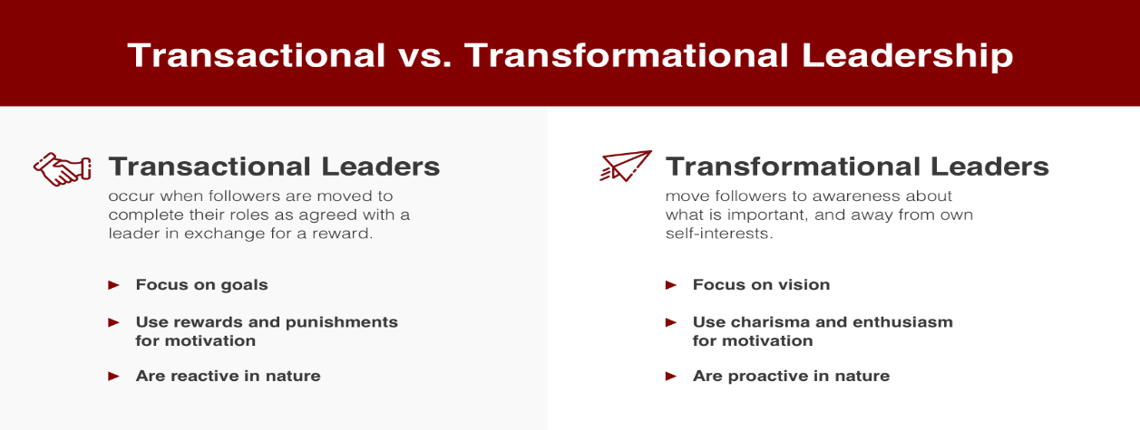
Sourced from (Florida Tech, 2019)
Leadership styles are a leader's behaviour and approach to influencing, motivating, and managing others. Toh et al., (2019) paper said transformational leadership style is where leaders motivate their employees by generating and inspiring vision by appealing to their ideals and moral values. Patiar & Wang, (2016) research said that transformational leadership style is influential with leaders motivating people to exceed their own interests to work for the common good of the organisation, oftentimes with remarkable results. Brown & Arendt, (2010) defined transformational leadership as the leader’s skill to motivate followers to perform beyond what he/she would normally expect. Rothfelder et al., (2012) research referred to transformational leadership as the procedure of influencing significant changes in the attitudes and assumptions of the employee’s and improve commitment for the organisation’s objectives or goals. Transformational leadership style has the ability to change people for the good of themselves and the organisation, it is about effective communication skills, strong interpersonal skills, and trust. This will also create job satisfaction which can help improve employee well-being.
Sanda & Arthur, (2017) said that transactional leadership style highlights the communication that takes place with the leader and their employees, the leader communicates with their employees on what needs to be done and what rewards the employees will receive if the tasks are completed. Sarros & Santora, (2001) suggested transactional leaders follow a cost-benefit, economic exchange with their employees. In this relationship, employees' physical needs and psychic needs are satisfied in return for required work performance. Dai et al., (2013) research describes leaders who have transactional leadership as being focused on refining roles and steering employees to achieve pre-arranged goals based on rewards and may only offer employees limited or no involvement in the decision-making process. Transactional leadership style uses the wants and needs of their employees to successfully complete tasks and goals set by the organisation, it can suggest that employees are not motivated and require structure, instruction, and supervision to complete tasks correctly and on schedule. Handayani et al., (2022) study found that transactional leadership has a positive and significant effect on employee performance.
Other styles of leadership have been identified in the hotel industry. Megeirhi et al., (2018) suggested that the effects of Authentic Leadership on employee well-being, job satisfaction, and organisational commitment, have been seen and confirmed. This implies that the style of authentic leadership which involves a strong morale code, has been observed to make a difference in employees mental health, fulfilment, and commitment to their organisation. Huertas-Valdivia et al., (2019) said leadership styles therefore play a direct role in attaining employee empowerment and engagement among customer facing employees. This implies that all leadership styles are important in maintaining employee’s job satisfaction within most organisations. From the literature review examined form this report, the next part of the report will now look to investigate the leadership styles and the effect they may have on sickness and absenteeism within hotel industry.

3.0 Methodology

This study is to investigate leadership styles and the effects they have on sickness and absenteeism within the hotel industry. Using qualitive secondary research collected from journals and articles, to see if leadership has an influence on the sickness and absence rates of their employees. Dlamini et al., (2017) suggests leadership behaviours that embraces and ingrains enthusiasm, encouraging unification of the vision, support ways of succeeding organisational vision, while focusing on leading and recognising employee achievements, simply portrays their emotional attachment, as well as their desire and need to remain working within an organisation. Liang et al., (2017) said employees recognize that a hotel’s leadership affects many important organizational outcomes, these include effective leadership, employee behaviours and performance. However, Marianne Tromp & Jan Blomme, (2014) research found that some academics argue that in their efforts to affect others, leaders often decide for their employees' the work rate, work duty and workplace flexibility. Fouad, (2019) research suggested micromanagers are autocrats with a compelling need to control every task within their control. The opposite to autocrat is the leader who delegates all their tasks, these types of leaders tend to display a hands-off approach to their management style and assigns power, task, and responsibility to others. This suggests that assorted styles of leadership are not suitable for the hotel industry. Fouad, (2019) study reveals that monetary and reward systems, personal development and advancement, empowerment and recognition, and appraisal procedures are the key factors for employee job satisfaction in relation to leadership style. This suggests a mix of transformational and transactional leadership styles are what employees look for in their leaders to ensure they feel fulfilled in their jobs and careers, this in turn should create a culture where employees feel comfortable to be open and honest about anything that concerns them.

3.1 Analysis

Structuring your research on and relating it to previous knowledge is the key ingredient of all academic research pursuits, regardless of discipline (Snyder, 2019). To complete this investigation, I have used numerous studies that include leadership in hotels that range from budget hotels to five-star hotels. Identifying what leadership styles seems more suited to the hotel industry, based on the literature. From the information gathered it would seem that a mixture of Transformational and Transactional leadership would improve employee trust, communication, and commitment to the organisation. Ohunakin et al., (2019) suggests transformational leadership style is primary in enhancing employees’ satisfaction with life and job, and vital in decreasing the high rate of employee turnover. This implies that transformational leadership can impact all aspects of a person’s life, in and out of the workplace. Lumbantoruan et al., (2020) concluded employees have elevated levels of job satisfaction when leaders display transactional leadership style, these include giving monetary rewards if an employee completes a set goal, ensuring they are motivated to work at their best. Wage or advancements will also make employees feel satisfied working in an organization. Leaders who appreciate their employee performance, who supervise their employees to prevent mistakes that can happen, will make employees feel more taken care of. This implies that transactional leadership enables an employee to feel appreciated and supported for the work that they do by receiving extras on top of their normal wage.

4.0 Conclusion

From the research conducted in this report, it was found that both Transformational and Transactional leadership is the best fit for leaders in the hotel industry. Chiang & Wang, (2012) study concluded transformational leadership must be used together with transactional leadership to successfully enhance trust and commitment towards management and the hotel. Sobaih et al., (2020) concluded employees are driven to stay with an organisation as long as the organisation returns with preferred means such as rewards and the gratification of training and development duty. This shows that both styles of leadership can help improve Job satisfaction and engagement with trust, communication, development, and productivity, using rewards and recognition to show appreciation and a job well done. This will help in decreasing sickness and absenteeism, by improving the environment and culture of a hotel.

5.0 Future Recommendations

It would be more useful to use qualitative data to enhance the results. Using questionnaires to gather information on individuals’ thoughts and feelings in regard to their managers or supervisors’ leadership styles within premier inn would be an advantage.

References

Ahmad Mukhtar, N., & Yuen Fook, C. (2020). The Effects of Perceived Leadership Styles and Emotional Intelligence on Attitude toward Organizational Change among Secondary School Teachers. Asian Journal of University Education, 16(2), 36. https://doi.org/10.24191/ajue.v16i2.10295
Akaligang, C., Valogo, M., & Akanpaadgi, E. (2014). An Assessment of the Effects of Leadership on the Motivation of Employees towards the Achievement of Organizational Goals: A Case Study of the Hospitality Industry in the Bolgatanga Municipality. European Journal of Business and Management, 6(24). https://core.ac.uk/download/pdf/234625749.pdf
AnnualReports.com. (2023). Whitbread plc - AnnualReports.com. Www.annualreports.com. https://www.annualreports.com/Company/whitbread-plc
Arany, L., & Popovics, P. (2022). THE MODERN LEADER: THE HISTORY OF LEADERSHIP STYLES AND THE MOST IMPORTANT QUALITIES OF A MODERN LEADER. Cross-Cultural Management Journal, 102(1), 91–95. https://doaj.org/article/3aa739afde7e41c8b4990837e4b2fc20
Asni, F. A. H. M., & Sulong, J. (2018). The Model of Istinbat by the Shariah Advisory Council of Central Bank of Malaysia. International Journal of Academic Research in Business and Social Sciences, 8(1), 218–248. https://doi.org/10.6007/ijarbss/v8-i1/3778
Baquero, A. (2022). Job Insecurity and Intention to Quit: The Role of Psychological Distress and Resistance to Change in the UAE Hotel Industry. International Journal of Environmental Research and Public Health, 19(20), 13629. https://doi.org/10.3390/ijerph192013629
Brown, E. A., & Arendt, S. W. (2010). Perceptions of Transformational Leadership Behaviors and Subordinates’ Performance in Hotels. Journal of Human Resources in Hospitality & Tourism, 10(1), 45–59. https://doi.org/10.1080/15332845.2010.500205
Bucăţa, G., & Rizescu, A. M. (2017). The Role of Communication in Enhancing Work Effectiveness of an Organization. Land Forces Academy Review, 22(1), 49–57. researchgate. https://doi.org/10.1515/raft-2017-0008
Bulutlar, F., & Öz, E. Ü. (2008). The Effects of Ethical Climates on Bullying Behaviour in the Workplace. Journal of Business Ethics, 86(3), 273–295. https://doi.org/10.1007/s10551-008-9847-4
Bulutlar, F., & Öz, E. Ü. (2008). The Effects of Ethical Climates on Bullying Behaviour in the Workplace. Journal of Business Ethics, 86(3), 273–295. https://doi.org/10.1007/s10551-008-9847-4
Buzeti, J. (2021). The connection between leader behaviour and employee sickness absence in public administration. International Journal of Organizational Analysis, ahead-of-print(ahead-of-print). https://doi.org/10.1108/ijoa-09-2020-2425
Caverley, N., Cunningham, J. B., & MacGregor, J. N. (2007). Sickness Presenteeism, Sickness Absenteeism, and Health Following Restructuring in a Public Service Organization. Journal of Management Studies, 44(2), 304–319. https://doi.org/10.1111/j.1467-6486.2007.00690.x
Chiang, C.-F. (2010). Perceived organizational change in the hotel industry: An implication of change schema. International Journal of Hospitality Management, 29(1), 157–167. https://doi.org/10.1016/j.ijhm.2009.08.002
Chiang, C.-F., & Wang, Y.-Y. (2012). The Effects of Transactional and Transformational Leadership on Organizational Commitment in Hotels: The Mediating Effect of Trust. Journal of Hotel & Business Management, 01(01), 1–11. https://doi.org/10.4172/2169-0286.1000103
Chrusciel, D. (2006). Considerations of emotional intelligence (EI) in dealing with change decision management. Management Decision, 44(5), 644–657. https://doi.org/10.1108/00251740610668897
Clark, R. A., Hartline, M. D., & Jones, K. C. (2008). The Effects of Leadership Style on Hotel Employees’ Commitment to Service Quality. Cornell Hospitality Quarterly, 50(2), 209–231. https://doi.org/10.1177/1938965508315371
Cohen-Gadol, A. (2021). Emotional Intelligence. Www.neurosurgicalatlas.com. https://www.neurosurgicalatlas.com/volumes/non-technical-skills-in-neurosurgery/emotional-intelligence
Communication Theory. (2014, July 10). Shannon and Weaver model of communication. Communication Theory. https://www.communicationtheory.org/shannon-and-weaver-model-of-communication/
Communication Theory. (2014a, July 10). OSGOOD- SCHRAMM MODEL OF COMMUNICATION. Communication Theory. https://www.communicationtheory.org/osgood-schramm-model-of-communication/
Davis, M. H., Capobianco, S., & Kraus, L. A. (2010). Gender Differences in Responding to Conflict in the Workplace: Evidence from a Large Sample of Working Adults. Sex Roles, 63(7-8), 500–514. https://doi.org/10.1007/s11199-010-9828-9
Dlamini, N., Garg, A., & Muchie, M. (2017). The impact of transformational leadership style on organisational commitment in the hospitality industry. African Journal of Hospitality, Tourism and Leisure, 6(3). http://www.ajhtl.com/uploads/7/1/6/3/7163688/article_32_vol_6__3__2017.pdf
Dovetail Enterprises. (1993). Management-Leadership-2. Dovetail Enterprises. https://www.dovetailenterprises.co.uk/management-leadership-2/
Doyle, R. A., & Thompson, A. E. (2020). The Influence of Stereotype Threat and Implicit Theories of Emotion on Gender Differences in Emotional Intelligence. The Journal of Men’s Studies, 29(2), 106082652092087. https://doi.org/10.1177/1060826520920878
Drew, C. (2020, February 23). All 8 Models of Communication, Explained! (2020). Helpful Professor. https://helpfulprofessor.com/communication-models/
Dudovskiy, J. (2013). Theory X and Theory Y - Research Methodology. Research-Methodology. https://research-methodology.net/theory-x-and-theory-y/
Florida Tech. (2019, September 23). The difference between transactional and transformational leadership. Florida Tech Online. https://www.floridatechonline.com/blog/psychology/the-difference-between-transactional-and-transformational-leadership/
Fouad, M. (2019). Impact of Leadership Style on Employee Job Satisfaction in the Hospitality Industry. International Journal of Heritage, Tourism and Hospitality, 13(1), 1–12. https://doi.org/10.21608/ijhth.2019.35101
Goleman, D. (1996). Emotional intelligence: Why it can matter more than IQ. Bloomsbury Publishing.
Hopper, E. (2020). Maslow’s hierarchy of needs explained. ThoughtCo. https://www.thoughtco.com/maslows-hierarchy-of-needs-4582571
https://www.facebook.com/verywell. (2016). What Type of Leadership Do You Have? Verywell Mind. https://www.verywellmind.com/whats-your-leadership-style-3866929
Huertas-Valdivia, I., Gallego-Burín, A. R., & Lloréns-Montes, F. J. (2019). Effects of different leadership styles on hospitality workers. Tourism Management, 71, 402–420. https://doi.org/10.1016/j.tourman.2018.10.027
Huey Yiing, L., & Zaman Bin Ahmad, K. (2009). The moderating effects of organizational culture on the relationships between leadership behaviour and organizational commitment and between organizational commitment and job satisfaction and performance. Leadership & Organization Development Journal, 30(1), 53–86. https://doi.org/10.1108/01437730910927106
Hussain, S. T., Lei, S., Akram, T., Haider, M. J., Hussain, S. H., & Ali, M. (2018). Kurt Lewin’s Change Model: A Critical Review of the Role of Leadership and Employee Involvement in Organizational Change. Journal of Innovation & Knowledge, 3(3), 123–127. Science Direct. https://doi.org/10.1016/j.jik.2016.07.002
Hussain, S. T., Lei, S., Akram, T., Haider, M. J., Hussain, S. H., & Ali, M. (2018). Kurt Lewin’s Change Model: A Critical Review of the Role of Leadership and Employee Involvement in Organizational Change. Journal of Innovation & Knowledge, 3(3), 123–127. Science Direct. https://doi.org/10.1016/j.jik.2016.07.002
Hutton, G., & Foley, N. (2021). Hospitality industry and Covid-19. Commonslibrary.parliament.uk, CBP 9111. https://commonslibrary.parliament.uk/research-briefings/cbp-9111/
Islam, M. N. (2023). Managing organizational change in responding to global crises. Global Business and Organizational Excellence, 42(3), 1–73. https://doi.org/10.1002/joe.22189
Ispas, A. (2012). The Perceived Leadership Style and Employee Performance in Hotel Industry – a Dual Approach. Review of International Comparative Management, 13(2), 294–304. https://rmci.ase.ro/no13vol2/10.pdf
Ispas, A., & Băbăiță, C. (2012). THE EFFECTS OF LEADERSHIP STYLE ON THE EMPLOYEES’ JOB SATISFACTION AND ORGANIZATIONAL COMMITMENT FROM THE HOTEL INDUSTRY (pp. 254–262). APPROACHES IN ORGANISATIONAL MANAGEMENT. http://conferinta.management.ase.ro/archives/2012/pdf/30.pdf
Johns, G. (2010). Presenteeism in the workplace: A review and research agenda. Journal of Organizational Behavior, 31(4), 519–542. https://doi.org/10.1002/job.630
Kapur, D., Khurshid, I., Kiani, M., Dasanayaka, S., Liu, J., Ying, Hassan, A., Khursheed, P., Diwaker, A., Bajpai, N., Wales, S., Khadija, A., Bari, M., Arain, F., Low, S., Pheng, Alam, B., Rashid, A., Hussain, M., & Nadir, K.-P. (2012). BUSINESS REVIEW IBA Chairman Board of Editors Editor Volume 7 Number 2. https://www.iba.edu.pk/Business_review/business_review_VOL-7_No_2_Jul-Dec_2012.pdf#page=110
Kara, D., Uysal, M., Sirgy, M. J., & Lee, G. (2013). The effects of leadership style on employee well-being in hospitality. International Journal of Hospitality Management, 34(1), 9–18. https://doi.org/10.1016/j.ijhm.2013.02.001
Knani, M. (2022). What motivates tourism and hospitality employees to practice presenteeism? Journal of Hospitality and Tourism Management, 52, 198–207. https://doi.org/10.1016/j.jhtm.2022.06.017
Kocakulah, M. C., Kelley, A. G., Mitchell, K. M., & Ruggieri, M. P. (2016). Absenteeism Problems and Costs: Causes, Effects and Cures. International Business & Economics Research Journal (IBER), 15(3), 89–96. https://doi.org/10.19030/iber.v15i3.9673
Kontodimopoulos, N., Paleologou, V., & Niakas, D. (2009). Identifying important motivational factors for professionals in Greek hospitals. BMC Health Services Research, 9(1). https://doi.org/10.1186/1472-6963-9-164
LEADERSHIP QUALITIES AND THEIR CONSEQUENCES IN AN ORGANIZATIONAL CONTEXT: LITERATURE REVIEW | American Journal of Leadership and Governance (ajpojournals.org)
Leaker, D., & Kumar, K. (2021, March 3). Sickness absence in the UK labour market - Office for National Statistics. Www.ons.gov.uk. https://www.ons.gov.uk/employmentandlabourmarket/peopleinwork/labourproductivity/articles/sicknessabsenceinthelabourmarket/2020
Leavitt, H. J., Pondy, L. R., & Boje, D. M. (1989). Readings in managerial psychology (p. 769). Chicago [U.A.] Univ. Of Chicago Pr. https://books.google.co.uk/books?hl=en&lr=&id=dwTvE44DOgQC&oi=fnd&pg=PA224&dq=What+is+meant+by+Leadership%3F&ots=sTtPq2_QDj&sig=4-wvvYsQlsSNQFrFendV_uTcOPM#v=onepage&q=What%20is%20meant%20by%20Leadership%3F&f=false
Lolli, J. (2013). Perceptions of the Importance and Preparedness of Interpersonal Communication Skills of the Entry-Level Hospitality Leader: Implications for Hospitality Educators. Journal of Teaching in Travel & Tourism, 13(4), 354–373. https://doi.org/10.1080/15313220.2013.839302
Lumbantoruan, S., Kurniawan, L., Christi, C., & Sihombing, J. B. (2020). Impact of Transactional Leadership Style on Employee Job Satisfaction. TAZKIYA: Journal of Psychology, 8(1), 56–63. https://doi.org/10.15408/tazkiya.v8i1.14664
Lumen. (2019). Herzberg’s Two-Factor Theory | Organizational Behavior / Human Relations. Lumenlearning.com. https://courses.lumenlearning.com/wm-organizationalbehavior/chapter/herzbergs-two-factor-theory/
Lundberg, C., Gudmundson, A., & Andersson, T. D. (2009). Herzberg’s Two-Factor Theory of Work Motivation Tested Empirically on Seasonal Workers in Hospitality and Tourism. Tourism Management, 30(6), 890–899. Sciencedirect. https://doi.org/10.1016/j.tourman.2008.12.003
Malik, P. (2022, February 24). The Kübler Ross Change Curve in the Workplace (2022) - Whatfix. The Whatfix Blog | Drive Digital Adoption. https://whatfix.com/blog/kubler-ross-change-curve/
Marianne Tromp, D., & Jan Blomme, R. (2014). Leadership style and negative work-home interference in the hospitality industry. International Journal of Contemporary Hospitality Management, 26(1), 85–106. https://doi.org/10.1108/ijchm-04-2012-0058
Matthiesen, S. B., & Einarsen, S. (2010). Bullying in the workplace: definition, prevalence, antecedents, and consequences. International Journal of Organization Theory & Behavior, 13(2), 202–248. https://doi.org/10.1108/ijotb-13-02-2010-b004
McHugh, M. (2001). Employee absence: an impediment to organisational health in local government. International Journal of Public Sector Management, 14(1), 43–58. https://doi.org/10.1108/09513550110387066
McPheat, S. (2022, October 4). What is the Thomas Kilmann Conflict Management Model? (With examples). MTD Training. https://www.mtdtraining.com/blog/thomas-kilmann-conflict-management-model.htm
Megeirhi, H. A., Kilic, H., Avci, T., Afsar, B., & Abubakar, A. M. (2018). Does team psychological capital moderate the relationship between authentic leadership and negative outcomes: an investigation in the hospitality industry. Economic Research-Ekonomska Istraživanja, 31(1), 927–945. https://doi.org/10.1080/1331677x.2018.1442234
Meira, J. V. de S., Dos Anjos, S. J. G., & Falaster, C. D. (2018). Innovation and performance in the hotel industry. Journal of Quality Assurance in Hospitality & Tourism, 20(2), 185–205. https://doi.org/10.1080/1528008x.2018.1512936
Miao, C., Humphrey, R. H., & Qian, S. (2021). Emotional intelligence and job performance in the hospitality industry: a meta-analytic review. International Journal of Contemporary Hospitality Management, 33(8), 2632–2652. https://doi.org/10.1108/ijchm-04-2020-0323
Mind Tools. (2022). MindTools | Home. Www.mindtools.com. https://www.mindtools.com/axbwm3m/how-emotionally-intelligent-are-you
Minett, D., Yaman, H. R., & Denizci, B. (2009). Leadership styles and ethical decision-making in hospitality management. International Journal of Hospitality Management, 28(4), 486–493. https://doi.org/10.1016/j.ijhm.2009.01.003
Mishra, K., Boynton, L., & Mishra, A. (2014). Driving Employee Engagement: The Expanded Role of Internal Communications. International Journal of Business Communication, 51(2), 183–202. https://doi.org/10.1177/2329488414525399
Moayed, F. A., Daraiseh, N., Shell, R., & Salem, S. (2006). Workplace bullying: a systematic review of risk factors and outcomes. Theoretical Issues in Ergonomics Science, 7(3), 311–327. https://doi.org/10.1080/14639220500090604
Momeni, N. (2009). The Relation between Managers’ Emotional Intelligence and the Organizational Climate They Create. Public Personnel Management, 38(2), 35–48. https://doi.org/10.1177/009102600903800203
Naile, I., & Selesho, J. M. (2014). The Role of Leadership in Employee Motivation. Mediterranean Journal of Social Sciences, 5(3), 175–182. Researchgate. https://doi.org/10.5901/mjss.2014.v5n3p175#
News. (2021, December 16). Research Shows UK Hospitality Workers are Amongst Most Likely to Show Up for Work. CLH News: Caterer, Licensee and Hotelier News. https://catererlicensee.com/research-shows-uk-hospitality-workers-are-amongst-most-likely-to-show-up-for-work/
Ohunakin, F., Adeniji, A. A., Oludayo, O. A., Osibanjo, A. O., & Oduyoye, O. O. (2019). Employees’ retention in Nigeria’s hospitality industry: The role of transformational leadership style and job satisfaction. Journal of Human Resources in Hospitality & Tourism, 18(4), 441–470. https://doi.org/10.1080/15332845.2019.1626795
Raza, M. (2019, November 5). Lewin’s 3 Stage Model of Change Explained. BMC Blogs. https://www.bmc.com/blogs/lewin-three-stage-model-change/
Riopel, L. (2023, February 17). Emotional Intelligence Frameworks, Charts, Diagrams & Graphs. PositivePsychology.com. https://positivepsychology.com/emotional-intelligence-frameworks/
Sanda, A., & Arthur, N. A. D. (2017). Relational impact of authentic and transactional leadership styles on employee creativity. African Journal of Economic and Management Studies, 8(3), 274–295. https://doi.org/10.1108/ajems-07-2016-0098
Sarros, J. C., & Santora, J. C. (2001). The transformational‐transactional leadership model in practice. Leadership & Organization Development Journal, 22(8), 383–394. https://doi.org/10.1108/01437730110410107
Scott-Halsell, S. A., Blum, S. C., & Huffman, L. (2008). A Study of Emotional Intelligence Levels in Hospitality Industry Professionals. Journal of Human Resources in Hospitality & Tourism, 7(2), 135–152. https://doi.org/10.1080/15332840802156873
Scott-Halsell, S., Shumate, S. R., & Blum, S. (2007). Using a Model of Emotional Intelligence Domains to Indicate Transformational Leaders in the Hospitality Industry. Journal of Human Resources in Hospitality & Tourism, 7(1), 99–113. https://doi.org/10.1300/j171v07n01_06
Snyder, H. (2019). Literature Review as a Research methodology: an Overview and Guidelines. Journal of Business Research, 104(1), 333–339. Science direct. https://doi.org/10.1016/j.jbusres.2019.07.039
Sobaih, A. E. E., Hasanein, A. M., Aliedan, M. M., & Abdallah, H. S. (2020). The impact of transactional and transformational leadership on employee intention to stay in deluxe hotels: Mediating role of organisational commitment. Tourism and Hospitality Research, 22(3), 146735842097215. https://doi.org/10.1177/1467358420972156
Statista. (2022). Premier Inn hotel numbers 2012-2020 Statistic. Statista. https://www.statista.com/statistics/739855/whitbread-premier-inn-hotels/
SÜRÜCÜ, L., & SAĞBAŞ, M. (2020). THE IMPACT OF LEADERSHIP STYLES ON JOB SATISFACTION: A STUDY OF THE HOSPITALITY INDUSTRY. Yönetim Bilimleri Dergisi, 19(40), 323–346. https://doi.org/10.35408/comuybd.787432
Suwandana, I. G. M. (2019). Role of transformational leadership mediation: effect of emotional and communication intelligence towards teamwork effectiveness. International Research Journal of Management, IT and Social Sciences, 6(2), 52–62. https://doi.org/10.21744/irjmis.v6n2.608
Toh, P. S., Liew, W. J., Abdul Rahim, I. H., & Sondoh, S. (2019). TRANSFORMATIONAL AND TRANSACTIONAL LEADERSHIP STYLES TOWARDS ORGANIZATIONAL COMMITMENT IN THE HOTEL INDUSTRY. Journal of Tourism, Hospitality and Environment Management, 4(17), 34–45. https://doi.org/10.35631/jthem.417004
Tracey, J. Bruce., & Hinkin, T. R. (1996). How transformational leaders lead in the hospitality industry. International Journal of Hospitality Management, 15(2), 165–176. https://doi.org/10.1016/0278-4319(95)00059-3
Venus, M., Stam, D., & van Knippenberg, D. (2013). Leader emotion as a catalyst of effective leader communication of visions, value-laden messages, and goals. Organizational Behavior and Human Decision Processes, 122(1), 53–68. https://doi.org/10.1016/j.obhdp.2013.03.009
Wall, A. E., Smith, R. A., & Nodoushani, O. (2018). BULLYING IN THE WORKPLACE: THE GREAT BALANCING - ProQuest. Www.proquest.com. https://www.proquest.com/scholarly-journals/bullying-workplace-great-balancing-act-victim/docview/2459652610/se-2?accountid=130472
Whitbread PLC. (2022). Property. Whitbread PLC. https://www.whitbread.co.uk/property/
Whitbread PLC. (2022a). Gender & Ethnicity Pay Gap Report 2022. Whitbread PLC. https://cdn.whitbread.co.uk/media/2022/09/Whitbread-Gender-Pay-Gap_2022_option-220929_v2.pdf

Appendix A
Thomas Kilmann Conflict management model
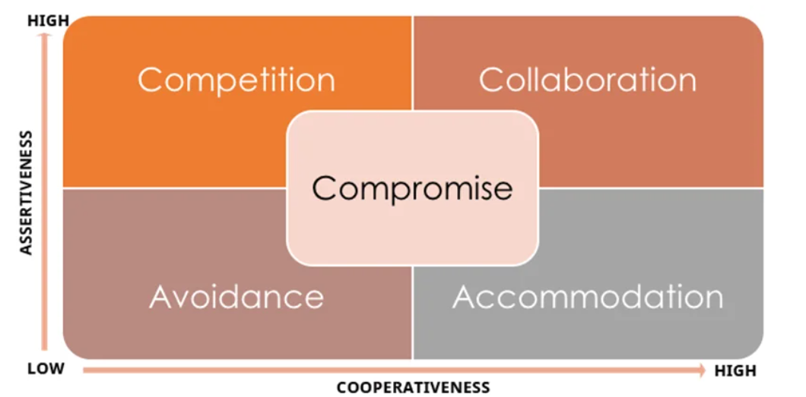
Sourced from (McPheat, 2022)

Appendix B

Leadership style questionnaire
What's Your Leadership Style?
Learn more about your strengths and weaknesses as a leader.
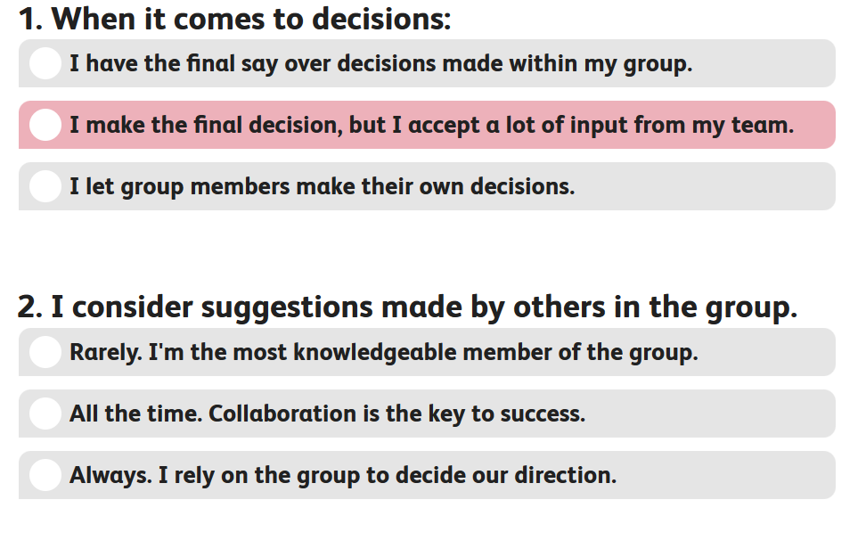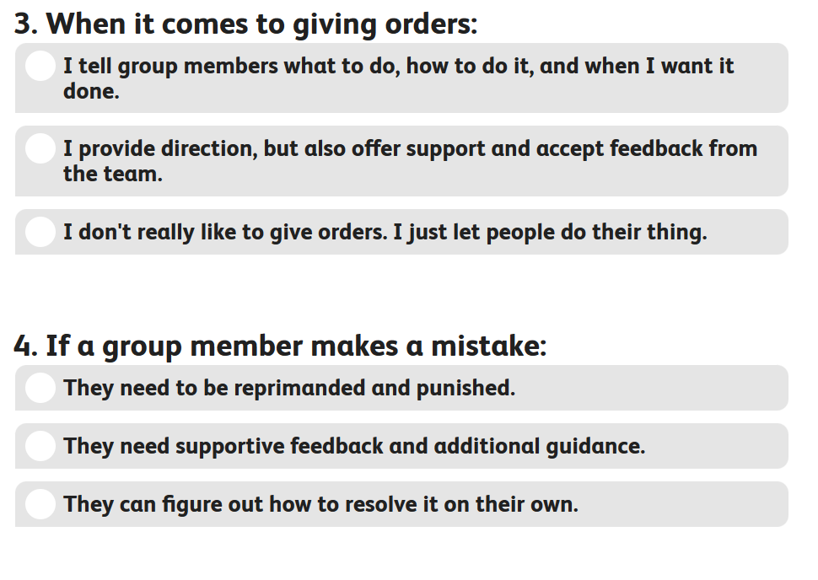
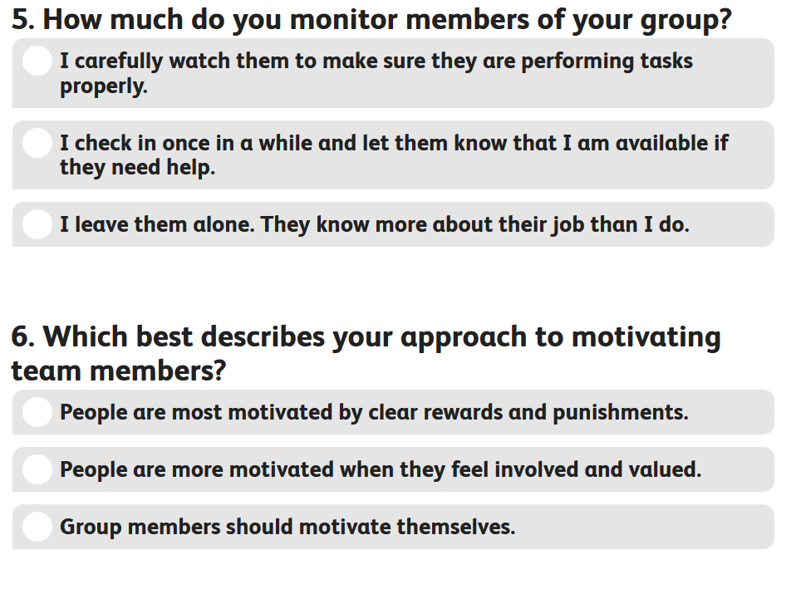
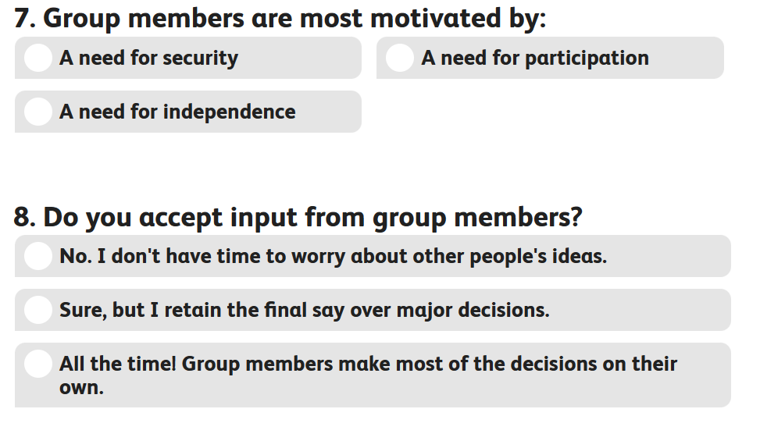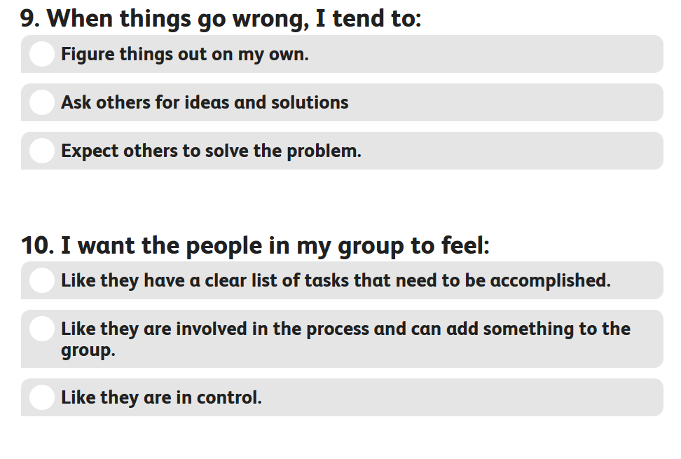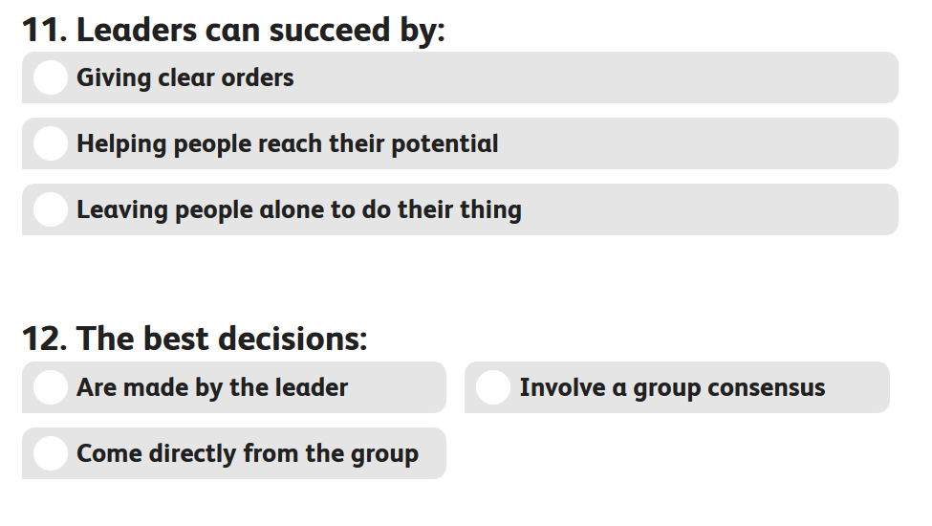
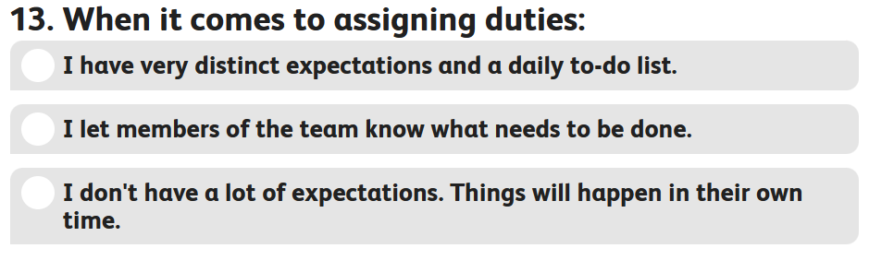
Sourced from (https://www.facebook.com/verywell, 2016)

Appendix C
Emotional Intelligence Questionnaire
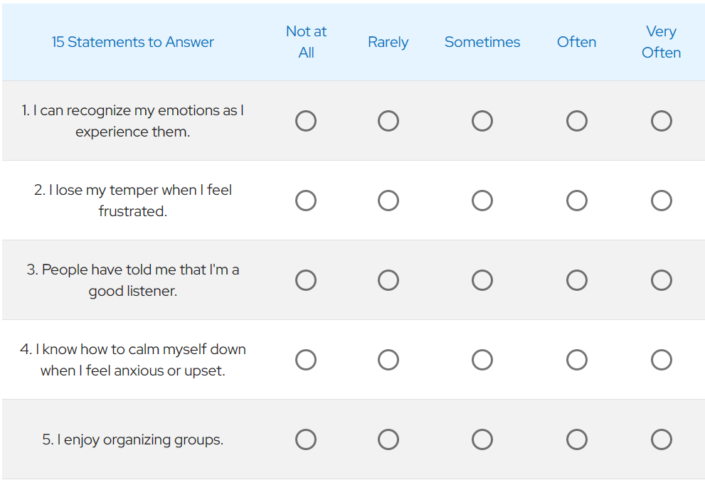
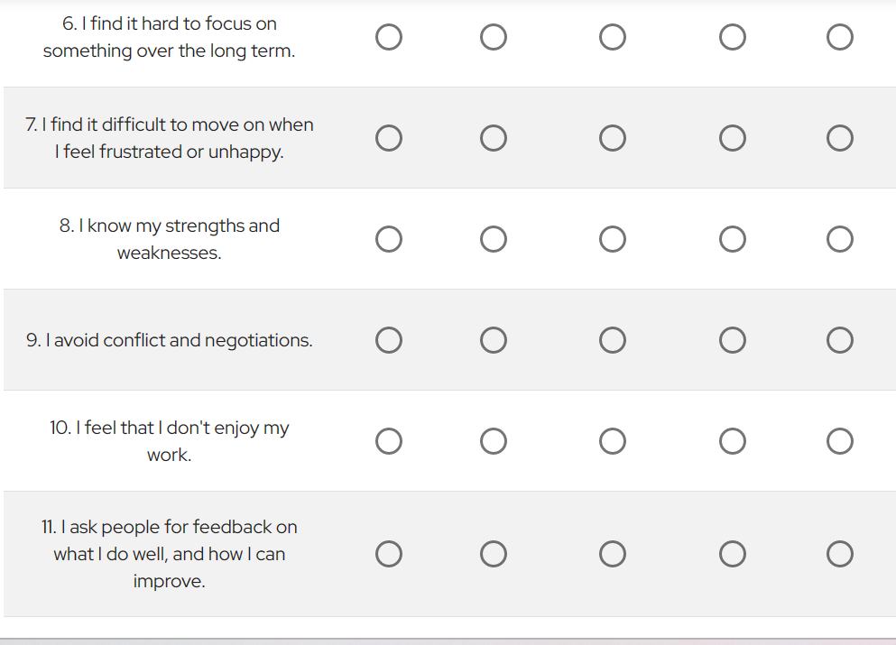
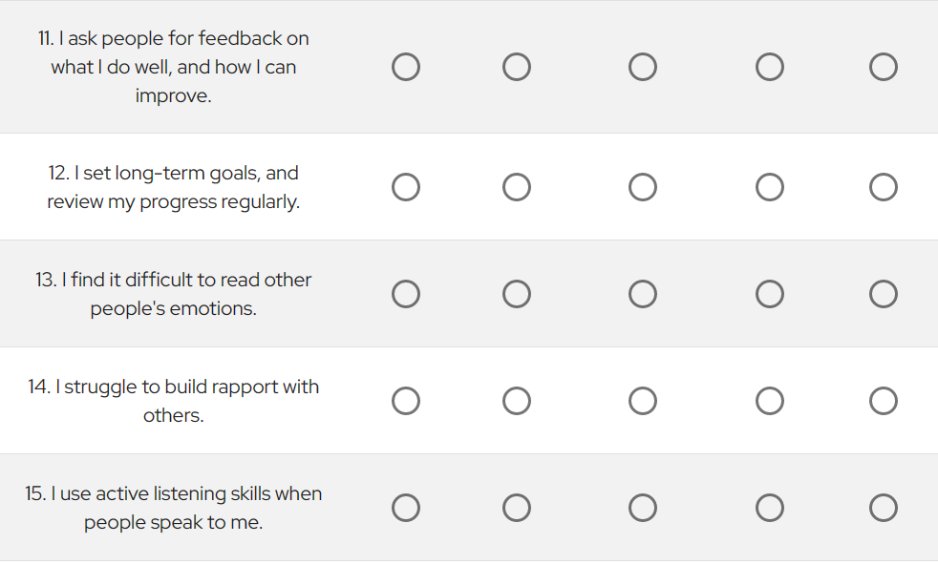
Sourced from (Mind Tools, 2022)

Appendix D
Shannon Weavers model of communication
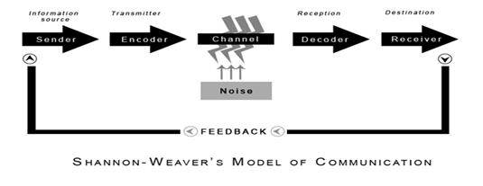
Sourced from (Communication Theory, 2014)

Appendix E

Schrams Model of communication
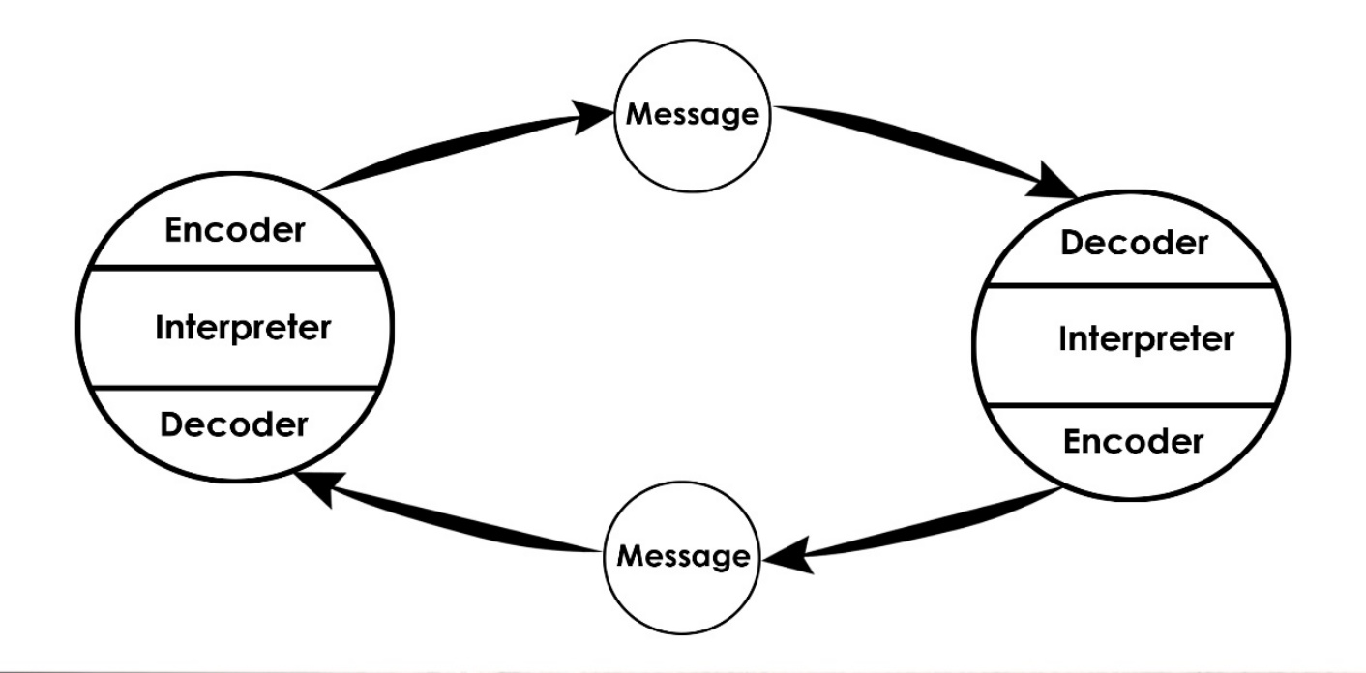
Sourced from (Communication Theory, 2014a)

Appendix F

Herzberg's Two-Factor Theory
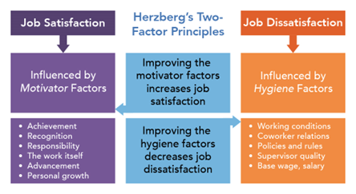
Sourced from (Lumen, 2019)

Appendix G

Maslows Hierarchy of Needs
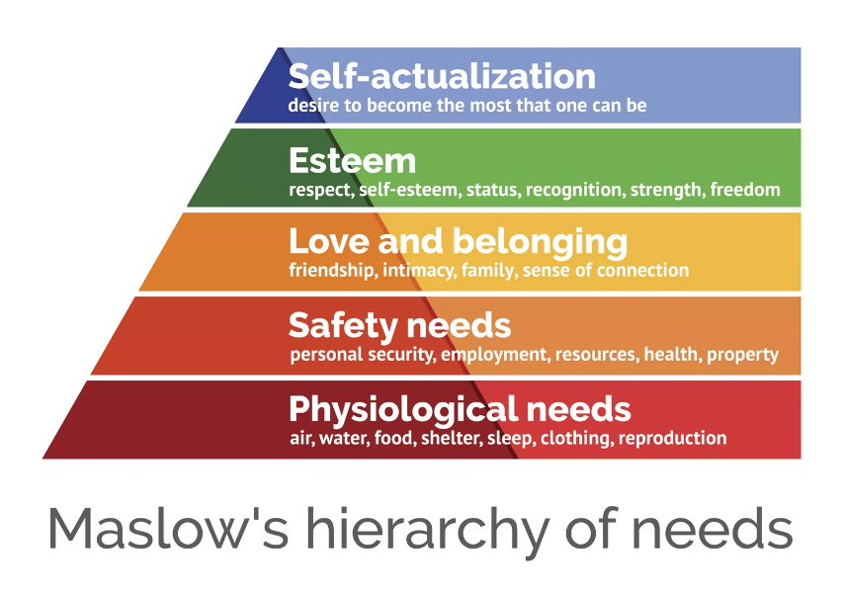
Sourced from (Hopper, 2020)

Appendix H

Theory X Theory Y model
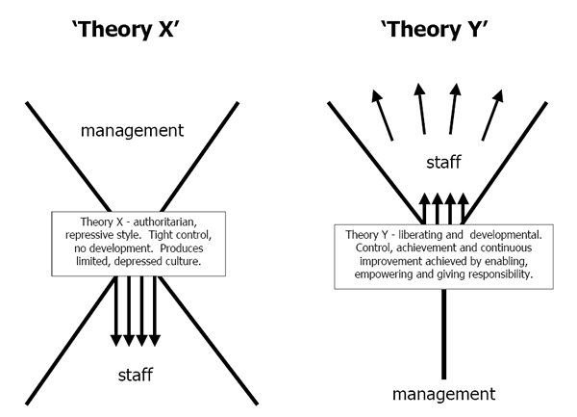
Sourced from (Dudovskiy, 2013)

Appendix I

Sickness rates by gender for 2021
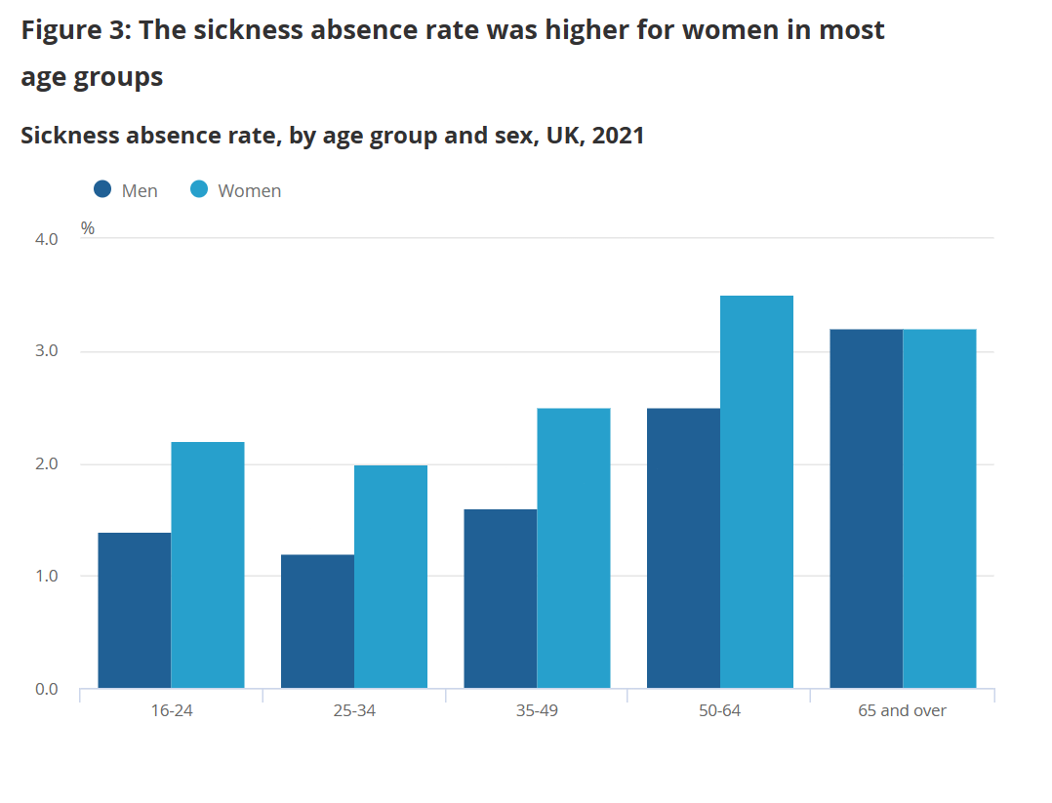
Sourced from (Wimot & Leaker, 2022)

Appendix J

Sickness rates by gender for 2020
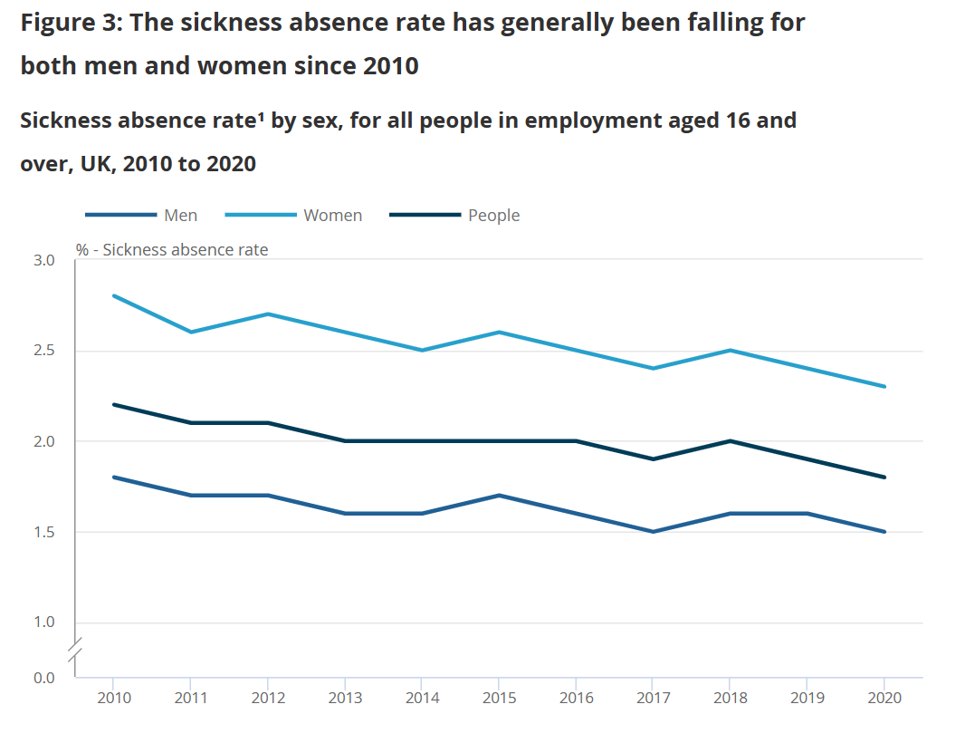
Sourced from (Leaker & Kumar, 2021)

