Student Name: Stanimira Yuliyanova Dimitrova
Student Number: 1909125
Lecture Name: Bianka Sanfilippo
Module Name: Mental Disorders and Psychopathology
Module Code: BMHP6006 (LON)
Assessment Component: 2
Submission date: 05. January. 2022

Page Content
Introduction……………………………………………………………………………………………3
General Anxiety Disorder (GAD)……………………………………………………………………3
Classification of GAD within ICD-10………………………………………………………………..3
People suffering from general anxiety disorder in the United Kingdom………………..……....3
Causes of GAD….……………………………………………………………………………………4
Signs and Symptoms of GAD……………………………………………………………………….4
Diagnosis and treatment of GAD …………………………………………………………..………4
Current treatment and measurements of rehabilitation of GAD…………………………………5
Recommendations for improvement of anxiety……………………………………………………5
Principles of care for people with generalized anxiety disorder (GAD)....................................6
Schizophrenia…............……………………………………………………………………………..6
Classification of schizophrenia within ICD-10..........................................................................6
People suffering from schizophrenia in the United Kingdom……………………………….……6
Causes of schizophrenia……………………………………………………………………….…….6
Signs and Symptoms of schizophrenia................................................................................ ....7
Diagnosis and treatment of schizophrenia……………………………………………………...…8
Current treatment and measurements of rehabilitation of schizophrenia………………………8
Recommendations for improvement of schizophrenia……………………………………………9
Principles of care for people with schizophrenia......................................................................9
Autism………………………………………………………………………………………………….9
Classification of autism within ICD-10……………………………………………………………..10
People suffering from autism in the United Kingdom…………………………………………....10
Causes of Autism……………………………………………………………………………………10
Signs and Symptoms of autism………………………………………………………………….…11
Diagnosis and treatment of autism…………………………………………………………….…..11
Measurements of rehabilitation……………………………………………………………….……12
Recommendations for improvement of autism……………………………………………..…….12
Principles of care for people with autism……………………………………………………..……12
National Autistic Society…………………………………………………………………………….12
Conclusion…………………………………………………………………………………………...13
References…………………………………………………………………………………………..13
Appendix……………………………………………………………………………….………….…17

Introduction
This assessment will be focusing on the critical examination of mental disorders such as general anxiety disorder, schizophrenia and autism. A critical look will consider their classification, how they live diagnosed, the appropriate treatment for the given mental disorders. Accompanied by treatment of diseases and their rehabilitation.

General Anxiety Disorder (GAD)
According to the NHS, (2018) individuals suffering from General Anxiety Disorder (GAD) suffer from a strong sense of anxiety and are mostly overwhelmed with fear, these individuals are overwhelmed with fear for most of their lives and find it challenging to live. remember the last time they were happy. GAD sufferers could develop both physical and mental symptoms. The condition of the patients can be mild or severe. Most people suffer from anxiety at some point in their lives, despite, in this case, the stress is constant, those who suffer from it cannot stop worrying. This brings severe damage to the life of the individual and what happens in his daily life.

Classification of GAD within ICD-10
According to Icd10data, (2019) General Anxiety Disorder "F40-F48 Neurotic Stress-Related and Somatoform Disorders". GAD is below F41.1, which is a specific code used to identify specific mental illnesses in ICD-10-CM. According to Icd10data, (2019) the state of anxiety and worry in patients lasts six months or more. GAD is expressed in vague anxiety, which is caused as an autonomous reaction of the individual to cope with the expectation of danger.

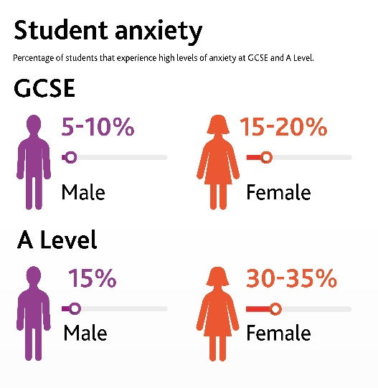
People suffering general anxiety disorder in the United Kingdom
According to Mental Health Foundation, (2017) people in one week diagnosed with GAD in the UK are 6.6 per cent of the population. Observations show that women are approximately twice as likely to develop symptoms. The age of the affected people could vary as the reasons for it. According to Cambridgeassessment, (2021) Student anxiety during GCSE is twice more with females, and during A level females suffer more than twice from anxiety.
(Cambridgeassessment, 2021).
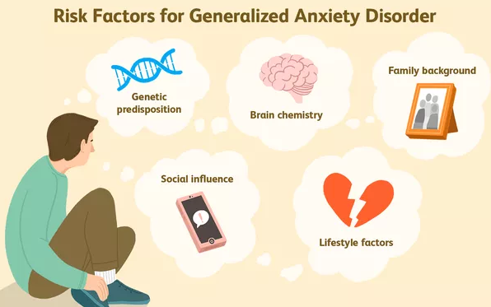Causes of GAD
There is no single reason for the development of GAD symptoms in an individual. According to Meek (2008), the reasons for the development of GAD can be the genetics of the individual, his brain structure, amygdala, grey matter, different types of life experiences, trauma experience, learned behaviour, social factors, different types of lifestyle factors, excessive caffeine use, relationships with other individuals, stress at work and others. Evidence has shown that combining several of these causes contributes to the development of GAD (Меек, 2008).
(Meek, 2008).

Signs and Symptoms of GAD
People with GAD have a huge problem with their social life, school or work, as well as their family and friends. The reasons for this are the constant feeling of restlessness and anxiety, they get tired very easily, they cannot concentrate, they are irritable, they have muscle tension, they suffer from lack of sleep (National Institute of Mental Health, 2019).
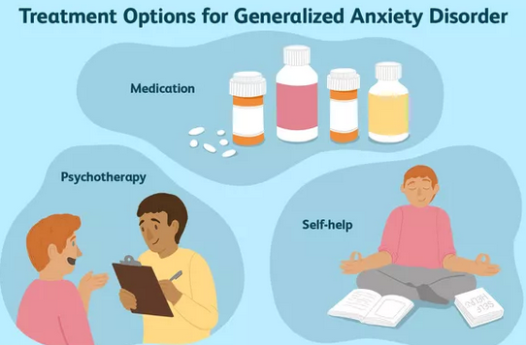
Diagnosis and treatment of GAD
An individual's GP can diagnose a GAD condition by examining mental health. The examination presents many different questions about the condition and when the individual feels this way, then the individual can be referred to a specialist such as a psychologist or a psychiatrist. The doctor may also perform medical tests such as blood, blood, and others to make sure that the sufferer is not abusing certain substances that are causing the symptoms of anxiety. After testing, proper treatment exists recommended. GAD is ministered, through cognitive behavioural therapy, various types of drugs, lifestyle changes to relieve the symptoms of GAD (Healthline, 2021).
verywell (2019).

Current treatment and measurements of rehabilitation of GAD
Treatment of GAD is mainly due to a combination of medication and cognitive-behavioural therapy. Cognitive-behavioural therapy helps the individual learn to recognize when to worry and when not. Through this type of therapy, the individual transforms the distorted thinking he has had and begins to see things on a realistic scale. The drugs used in the treatment help to relieve the symptoms, but are prescribed much less often than in the past due to their side effects. nowadays, home remedies for negotiating with GAD such as yoga, meditation, relaxation and others are preferred (WebMD, 2003).
The different types of treatments need to be evaluated for their effectiveness, thanks to the Anxiety Questionnaire (GAD-7). This check should be performed every two weeks and if the effect of the treatment is negative, the treatment should be changed. after completing the questionnaire, it is understood whether the individual has minimal anxiety, mild anxiety, moderate anxiety or severe anxiety (GAD-7 Anxiety, 2021)

Recommendations for improvement of anxiety
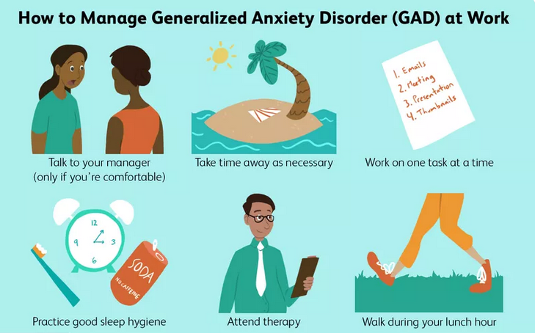To avoid more people suffering from GAD, knowledge about the disease is important. Another important thing that every individual needs to know is how to get rid of feelings of anxiety, especially when it is not necessary. Different types of relaxation lead to muscle relaxation and release of bad energy, here the individual comes to the aid of different types of complementary therapies such as aromatherapy, yoga, meditation, massage and others.
(Verywell Mind, 2021).

Principles of care for people with generalized anxiety disorder (GAD)
According to NICE, (2011) all working careers must respect the confidentiality of the information provided. The conversation between the patient and the therapist must be in an accessible and understandable language, even if it requires an interpreter. You also need to build a strong bond with the patient so that they can relax and share all their problems and worries. In this way, all worries and anxieties will be revealed and an adequate decision will be made. The decision on how the treatment will be carried out must be with the patient's participation and not be forced to carry out treatment to which he does not agree. Carriers should also be available to the patient in the event of a crisis.

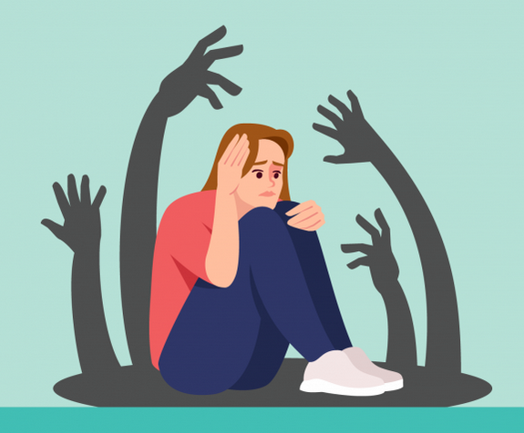Schizophrenia
According to the NHS, (2019) schizophrenia is a mental illness that is a type of psychosis. The disease is long-term and does not proceed easily. Under the influence of schizophrenia, the individual cannot distinguish between his own thoughts and reality, and the symptoms of the disease can be many and varied.
(Halza, 2021).

Classification of schizophrenia within ICD-10
According to Icd10data, (2019) Schizophrenia is classified as schizotypal and delusional disorder. The code by which schizophrenia and other mood disorders are detected is F20-F29, F20.9 is the code for schizophrenia.

Causes of schizophrenia
The exact cause of schizophrenia is not known, it is believed that a combination of different things in the daily life of the individual such as genetic predisposition, brain chemistry and the environment contribute to the development of the disease. There is a difference in the brain of an individual with schizophrenia and an individual who does not have this diagnosis. The difference is based on the naturally occurring chemicals dopamine and glutamate, which are found in the human brain and are one of the main causes of schizophrenia. These changes indicate that schizophrenia is a brain disease (Mayo Clinic, 2020).
People suffering from schizophrenia in the United Kingdom
According to Living with Schizophrenia, (2012) statistics show the large scale of schizophrenia in the UK. Every sixth individual needs at least once in their life to receive support or treatment for a mental problem. And every hundredth individuals would have an episode of schizophrenia at least once in their life. There is no specific gender that is more prone to the disease, it is common among both women and men regardless of age. Those diagnosed with schizophrenia are very likely to take their own lives, which is why the mortality rate of schizophrenics is very high.
Signs and symptoms of schizophrenia
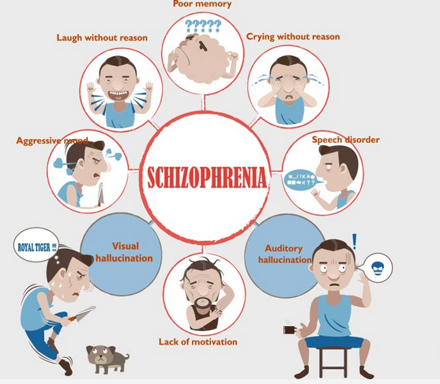Schizophrenia is directly related to psychotic, so everyone with the disease suffers from at least one type of psychosis in addition to the normal symptoms of schizophrenia. The forms of psychosis that can develop are hallucinations, delusions about the individual, as well as disorientation in the patient's thoughts and behavior (Halza, 2021). According to Netmeds, 2021 the typical symptoms that indicate the disease are hallucinations, the individual has uncoordinated movements and there is no connection between what he sees and what he does, talking to the patient is vague and meaningless. The individual loses interest in everyday life, in most cases, the person isolates himself because he does not understand what is happening and why people do not understand it. A schizophrenic's memory is impaired, resembling dementia, and unable to express the emotions he or she experiences in a particular situation.
(Netmeds, 2021).

Diagnosis and treatment of schizophrenia
There are no tests for the detection of a disease such as schizophrenia, so it happens through an examination by a psychologist and a psychiatrist, respectively. The individual's GP should be visited first to see if the cause of the symptoms is not the use of caffeine drugs or other substances, and then the patient is referred to a specialist. When an individual is diagnosed with schizophrenia, the specialist would ask for more detailed information about the patient so that a clearer assessment can be made of what caused the disease. The specialist used a diagnostic checklist to make the diagnosis (NHS, 2021).
According to NHS, (2021) the treatment of schizophrenia is carried out thanks to an individual combination of drugs and therapy. people with schizophrenia are mostly treated by community mental health teams (CMHTs). this team provides ongoing support to people with schizophrenia. Depending on how far the disease has developed and how often episodes of schizophrenia occur, an individual may need more serious treatment. The treatment is performed through antipsychotics, cognitive-behavioral therapy (CBT), various types of art therapies, talk therapies or others.

Current treatment and measurements of rehabilitation of schizophrenia
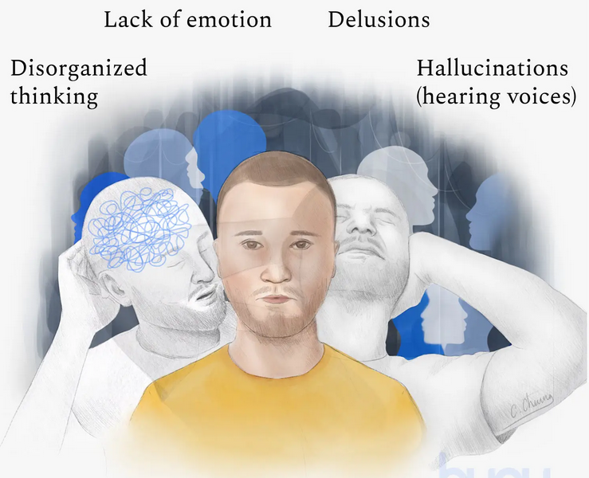Schizophrenia is a long-term disease and, unfortunately, it is not possible to measure the state of rehabilitation, but rather the quality of life of the sick individual despite his indicators. The measurement takes place of the quality of work, the care provided, the treatment provided as well as the avoidance of complications or self-harm and suicide. the other thing that can be appreciated is the way in which caregivers treat patients, with respect for human rights, respect for the patient and his or her right to publicity about treatment.
(Buoyhealth, 2018).

Recommendations for improvement of schizophrenia
Schizophrenia is a long-term serious disease, unfortunately, many people have no knowledge of it, which I consider a mistake. The more people are aware of the disease, the more understanding they would be of people with schizophrenia. In this way, patients would feel much better despite their psychoses, and they would decrease accordingly. It is believed that patients must take antipsychotic drugs, which have many side effects. The reason they are mandatory is that the lack of intake would lead to a high risk of the patient killing himself or causing great bodily harm. There is a case where patients refuse to take medication, therefore these people experience severe suffering for two to three months, after which the disease falls into remission. Therefore, more humane treatments must be devised that do not cause side effects on the patient and at the same time do not have this negative effect for two to three months.

Principles of care for people with schizophrenia
Those caring for people with schizophrenia should respect confidentiality, human rights and not make any changes in treatment without the consent of the individual. They must also have at their disposal the full range of recommended psychological, pharmacological, social and professional interventions. Physicians should be familiar with the drugs available on the market, innovations and side effects that they may have on the individual (NICE, 2014).

Autism
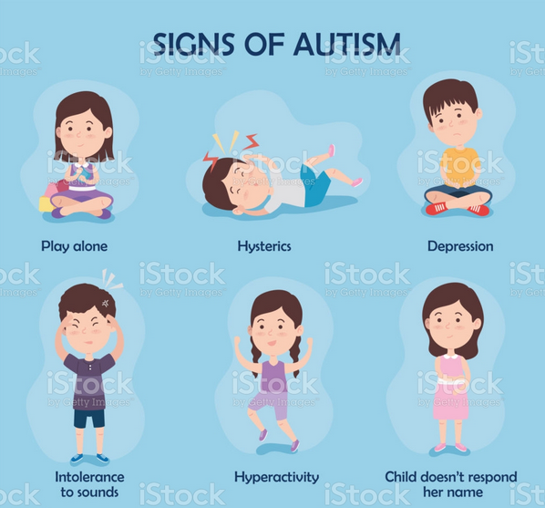Autism is a disorder that is affecting more and more people a wide range of behavioral changes it manifests itself in difficulties with verbal and nonverbal communication. Autism can be expressed through difficulties with an individual's social skills, repetitions in speech or movement. According to Autism Speaks, (2021) another way Autism is called is Autism Spectrum Disorder (ASD). The disease can be in different stages, all patients have different needs, so it cannot be concluded that autistic people need daily help. Some people with autism live on their own and cope with their daily needs, while others need help in their daily lives.
(iStock, 2021).

Classification of autism within ICD-10
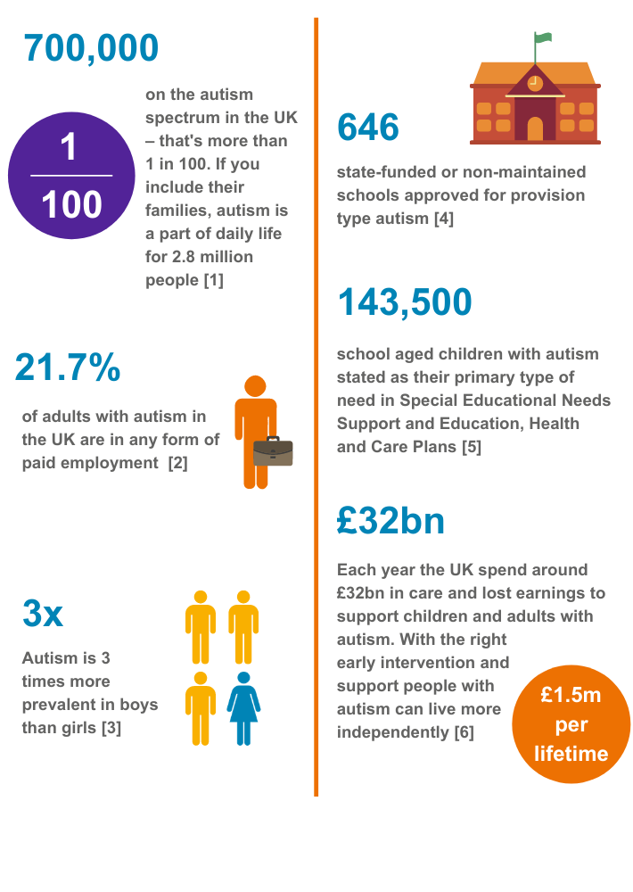
In ICD-10-CM, the code corresponding to Autism belongs to F80-F89, which corresponds to Disorders of psychological development. This type of disorder begins in the childhood of an individual characterized by a delay in the speech of children before 3 years of age. The disease is expressed through strange behavior in the child's communications and activity Icd10data (2019).

People suffering from autism in the United Kingdom
According to Mehlmann-Wicks, (2020) statistics show a very large number of people have symptoms of autism in the United Kingdom. Approximately 700,000 individuals suffer from the disease and every hundredth children is diagnosed with autism.

(BeyondAutism, 2021).

Causes of Autism
There is no cause for autism in an individual, the condition occurs with the help of many factors that affect a person. The disease is hereditary, so it is very logical that if there is a close individual with autism, then another member of the family will be autistic. Genetic motivations and diseases also play a role in the development of autism, as do various types of syndromes such as X syndrome. The age at which parents give birth to their children also matters, the older the individuals, the greater the chance of metabolic imbalances and genetic motivations, hence the greater the chance that the newborn will be autistic. Other reasons for the fetus to be autistic are medication, heavy metals, the environment during pregnancy and low birth weight (Cherney, 2018).
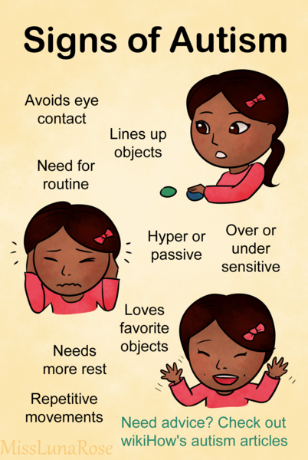
Signs and Symptoms of autism
Signs of autism can appear from the first months of the child, but also only at the age of two to three years. As some individuals show multiple symptoms, while others only have one or two, but it should be borne in mind that some of the symptoms are characteristic even of children who do not suffer from autism, so medical judgment is essential. The signs that betray autistic babies are as follows: no eye contact, no smiles or very faint, no facial expressions, reduced sounds that are made, do not live up to their name, gestures are missing or limited. Signs of autism in all other age groups are delay or loss of verbal communication, lack of eye contact, individuals isolating themselves, repeat gestures, lack of interest, strange reactions to noise, smell, light and others (Autism Speaks, 2019).
(MissLunaRose12, 2018).

Diagnosis and treatment of autism
According to Mayoclinic, (2018) for the detection of autism, there are no separate tests, and the symptoms vary from individual to individual. The diagnosis is made thanks to regular examinations, which are performed on an individual. Doctors look for the symptoms listed above, if there are signs of such symptoms, the child is referred to a specialist in the field. Specialists are child psychologists, psychiatrists, neurologists or paediatricians, in some cases two or more specialists may be needed. Unfortunately, there is no cure for autism spectrum disorders. The recommended treatments and medications serve to suppress the symptoms and stimulate the child to function normally. The needs of autistic people may change over time. The different types of autism can be therapies related to the child's communication or behavior, acquisition of new skills. Autistic children have learning difficulties; in some cases, they need educational therapies. There are also family therapies where adults can gain better knowledge about how to communicate with the child. There are other therapies: speech therapy, occupational therapy, physical therapy, and medications that are used to control symptoms (Mayoclinic, 2018).

Measurements of rehabilitation
Ways to measure the rehabilitation of an individual diagnosed with autism is thanks to the Childhood Autism Assessment Scale (CARS). The other way is through monitoring called ADOS.

Recommendations for improvement of autism
First of all, we must note that this is a state of life. Caring for a child with ASD can be difficult and tiring. It is very important to consider the individual with autism and his needs. The child's interests need to be upgraded on a daily basis and complex tasks need to be broken down. Last but not least, parents should be involved in dealing with children. Another way to improve care for autistic people would be to create more places where autistic people can gather to share experiences and, last but not least, to give parents a break so that they can be refreshed during the rest of the day. take care of autistic people.

Principles of care for people with autism
All human beings with autism must have full rights and access to health and social services. Each municipality should have a specialized team that responds to the needs of autistic people, regardless of their age. Professionals caring for autistic children need to take the environment into account and take into account anything that could negatively affect the autistic person. By negative environment is meant the level of noise, light, bright colours, and others according to the senses of the individual. The very process of examination and treatment that an autistic person goes through needs to be adapted. Examples of adaptation are the individual's waiting time to be minimal or non-existent, as well as the adaptation of a room. Providing accessible information to the family about autism is essential (NICE, 2021).

National Autistic Society
National Autistic Society is a charity in the United Kingdom that helps people with autism. If you need support, guidance, advice, services and opportunities regarding autism and societies that work for autistic people, then contact the charity (National Autistic Society, 2018).
(National Autistic Society, 2018).

Conclusion
All people on Planet Earth should be treated with dignity and respect, regardless of their abilities, skills or illness. For any individual, something in life can happen that will change his world. This can help you develop an illness or a mental problem. People are born the same, and they leave the planet earth in the same way, so everyone must be treated well while living their path and destiny. A life without discrimination that respects human rights would be so good, and people who respect it will feel good that they did something good on the other person's day.

References
Autism Speaks (2019) Learn the Signs of Autism | Autism Speaks [Online] Available at: https://www.autismspeaks.org/signs-autism.
(Accessed: 27 December 2021).

Autism Speaks (2021) What Is Autism? | Autism Speaks [Online] Autism Speaks. Available at: https://www.autismspeaks.org/what-autism.
(Accessed: 27 December 2021).

BeyondAutism (2021) Statistics. [Online] Available at: https://www.beyondautism.org.uk/about-autism/understanding-autism/statistics/.
(Accessed: 27 December 2021).

Buoyhealth (2018) Schizophrenia | Understanding Schizophrenia & How to Treat It [Online] Available at: https://www.buoyhealth.com/learn/schizophrenia#definition (Accessed: 24 December 2021).

Cambridgeassessment (2021) Helping students manage anxiety in 2021 and beyond [Online] Available at: https://www.cambridgeassessment.org.uk/blogs/helping-students-manage-anxiety-2021-and-beyond/.
(Accessed: 19 December 2021).

Cherney, K. (2018) Everything You Need to Know About Autism [Оnline] Healthline. Available at: https://www.healthline.com/health/autism#causes.
(Accessed: 27 December 2021).

GAD-7 Anxiety (2021) [Online] Available at: https://adaa.org/sites/default/files/GAD-7_Anxiety-updated_0.pdf.
(Accessed: 21 December 2021).

Halza (2021) What Is Schizophrenia? [Online] Available at: https://www.halza.com/mental-health/schizophrenia/.
(Accessed: 24 December 2021).

Healthline (2021) Generalized Anxiety Disorder (GAD): Symptoms and More [Online] Available at: https://www.healthline.com/health/anxiety/generalized-anxiety-disorder#lifestyle-changes.
(Accessed: 20 December 2021).

Icd10data (2019) 2019 ICD-10-CM Diagnosis Code F20.9: Schizophrenia, unspecified. [Online] Available at: https://www.icd10data.com/ICD10CM/Codes/F01-F99/F20-F29/F20-/F20.9.
(Accessed: 27 December 2021).

Icd10data (2019) 2019 ICD-10-CM Diagnosis Code F41.1: Generalized anxiety disorder. [Online] Available at: https://www.icd10data.com/ICD10CM/Codes/F01-F99/F40-F48/F41-/F41.1.
(Accessed: 18 December 2021).

Icd10data (2019) 2019 ICD-10-CM Diagnosis Code F84.0: Autistic disorder [Online] Available at: https://www.icd10data.com/ICD10CM/Codes/F01-F99/F80-F89/F84-/F84.0.
(Accessed: 27 December 2021).

iStock (2021) six kids with signs of autism [Online] Available at: https://www.istockphoto.com/vector/six-signs-of-autism-gm1314809470-402945708 (Accessed: 24 December 2021).

Living with Schizophrenia (2012) Facts and Figures - Living with Schizophrenia [Online] Living With Schizophrenia. Available at: https://livingwithschizophreniauk.org/facts-and-figures/.
(Accessed: 24 December 2021).

Mayo Clinic (2020) Schizophrenia - symptoms and causes [Online] Available at: https://www.mayoclinic.org/diseases-conditions/schizophrenia/symptoms-causes/syc-20354443.
(Accessed: 24 December 2021).

Mayoclinic (2018) Autism spectrum disorder - Diagnosis and treatment - Mayo Clinic [Online] Available at: https://www.mayoclinic.org/diseases-conditions/autism-spectrum-disorder/diagnosis-treatment/drc-20352934.
(Accessed: 27 December 2021).

Meek, W. (2008) Generalized Anxiety Disorder: Causes and Risk Factors [Online] Available at: https://www.verywellmind.com/gad-causes-risk-factors-1392982. (Accessed: 19 December 2021).

Mehlmann-Wicks, J. (2020) Autism spectrum disorder [Online] The British Medical Association is the trade union and professional body for doctors in the UK. Available at: https://www.bma.org.uk/what-we-do/population-health/improving-the-health-of-specific-groups/autism-spectrum-disorder.
(Accessed: 27 December 2021).

Mental Health Foundation (2017) Mental health statistics: anxiety [Оnline] Mental Health Foundation Available at: https://www.mentalhealth.org.uk/statistics/mental-health-statistics-anxiety.
(Accessed: 19 December 2021).

MissLunaRose12 (2018) English: This poster was drawn by an autistic artist, and describes autism in simple language without value judgments [Online] Available at: https://commons.wikimedia.org/wiki/File:Signs_of_Autism.png
(Accessed: 27 December 2021).

National Autistic Society (2018) Autism support - leading UK charity - National Autistic Society [Online] Available at: https://www.autism.org.uk/.
(Accessed: 28 December 2021).

National Institute of Mental Health (2019) Anxiety disorders [Online] Available at: https://www.nimh.nih.gov/health/topics/anxiety-disorders.
(Accessed: 20 December 2021).

Netmeds (2021) Schizophrenia: Causes, Symptoms And Treatment [Online] Available at: https://www.netmeds.com/health-library/post/schizophrenia-causes-symptoms-and-treatment.
(Accessed: 24 December 2021).

NHS (2018) Overview - Generalised Anxiety Disorder in Adults [Online] Available at: https://www.nhs.uk/mental-health/conditions/generalised-anxiety-disorder/overview/. (Accessed: 18 December 2021).

NHS (2019) Overview - Schizophrenia [Online] nhs.uk. Available at: https://www.nhs.uk/mental-health/conditions/schizophrenia/overview/.
(Accessed: 23 December 2021).

NHS (2021) Diagnosis – Schizophrenia [Online] Available at: https://www.nhs.uk/mental-health/conditions/schizophrenia/diagnosis/.
(Accessed: 24 December 2021).

NHS (2021) Treatment - Schizophrenia [Online] Available at: https://www.nhs.uk/mental-health/conditions/schizophrenia/treatment/.
(Accessed: 24 December 2021).

Nice (2011) Generalised anxiety disorder and panic disorder in adults: management | Guidance [Online] Available at: https://www.nice.org.uk/guidance/cg113/chapter/1-Guidance#principles-of-care-for-people-with-generalised-anxiety-disorder-gad.
(Accessed: 23 December 2021).

NICE (2014) 1 Recommendations | Psychosis and schizophrenia in adults: prevention and management | Guidance [Online] Available at: https://www.nice.org.uk/guidance/cg178/chapter/1-Recommendations#promoting-recovery-and-possible-future-care-2.
(Accessed: 24 December 2021).

NICE (2021) Recommendations | Autism spectrum disorder in under 19s: support and management | Guidance [Online] Available at: https://www.nice.org.uk/guidance/cg170/chapter/Recommendations#general-principles-of-care
(Accessed: 28 December 2021).

verywell (2019) How Is Generalized Anxiety Disorder Treated? [Online] Available at: https://www.verywellmind.com/generalized-anxiety-disorder-treatment-4171993. (Accessed: 20 December 2021).

Verywell Mind (2021) Understanding How to Cope With Generalized Anxiety Disorder at Work [Online] Available at: https://www.verywellmind.com/cope-with-generalized-anxiety-disorder-at-work-4125397.
(Accessed: 23 December 2021).

WebMD (2003) Generalized Anxiety Disorder [Online] Available at: https://www.webmd.com/anxiety-panic/guide/generalized-anxiety-disorder. (Accessed: 20 December 2021).

Appendix



