

Programme: | BSc Health and Social Care
Module: | Changemakers: Building your Personal Brand for Sustainable Employment
Module code: | BMHP5015
Lecturer: | Olufemi Oluranti | Internal Verifier: | Dr Eleni Koutsogeorgou-Andreou
Assignment Title: | Component 1: Online Portfolio of Set Exercises

Task 1 – Personal Brand
Personal branding describes the way I would share my professional identity, values, and strengths with others in such a way that I develop a perspective that is clear and continuous. Personal branding is important in health and social care, which is necessary to improve employability and professional credibility (Montoya and Vandehey, 2009; Musch et al., 2023).
At this point I would define my personal brand as kind, trustworthy, and dedicated to person-centred care. I speak in a polite tone, collaborate in a team, and have the ability to show compassion to needy people. Such attributes are compliant with professional standards in health and social care environments. Nonetheless, I understand that I need to enhance my leadership confidence and digital communication skills, especially in business networking sites like LinkedIn. Training, reflection practice and mentorship development of these areas will help me to become more visible and achieve confidence in my career. Shepherd (2005) supports the belief that strategic self-presentation enhances career opportunities.
Generally, through my purposely cultivated personal brand, I will become more employable and present myself as a competent and reflective practitioner within the health and social care sector.

Task 2 - Network Map and Rationale
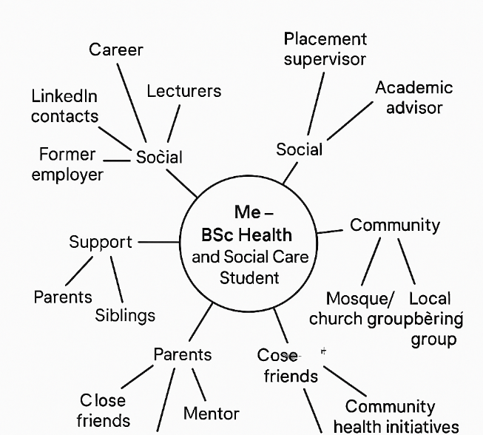
My network map provided in Figure 1 shows the career, social, support and community dimensions that help me develop professionally and live a healthy life.

Figure 1: Source- Author’s Work

My network can be defined as hybrid as it entails not only close relatives and friends but also academic contacts and work-related contacts. Granovetter (1973) establishes that the weak ties are significant in relationship to the accessibility of new opportunities. I have good bonding capital in the form of family and close friends, but my bridging capital is weak since majority of my contacts are fellow students like me. My networks capital is also not well established because I do not have many contacts with senior managers or decision-makers in health and social care organisations. According to Tang and Chan (2024) access to information and opportunity is enhanced with social capital. To become better, I should widen my professional network by using LinkedIn, placements, conferences and volunteering. Enhancing bridging and connecting links will solidify my employability and career development within the health and social care sector.

Task 3- Blog
Why Are Mental Health Waiting Times Failing Young Adults in the UK? A Blog for University Students
Understanding the Growing Crisis
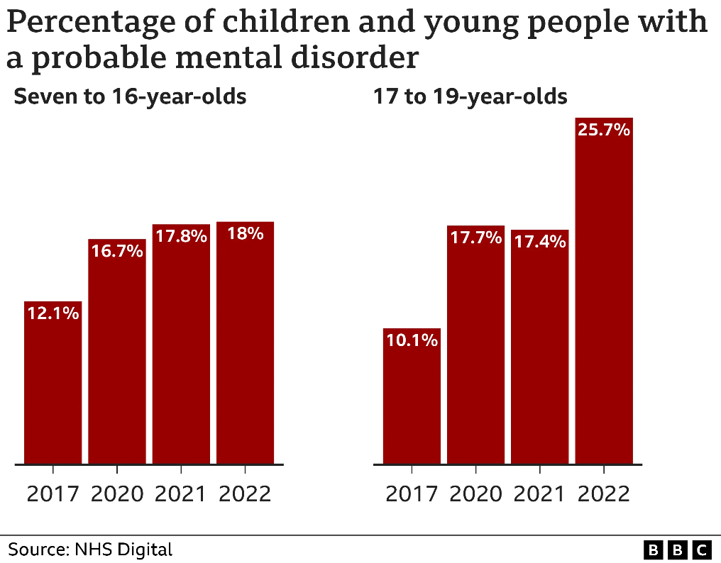

The issue of mental health issues among young adults (UK) is on the increase, and the access to the timely assistance is a severe issue (O’Dowd, 2025). Academic pressures, financial challenges and social shifts pose a frightening influence on university students. As indicated by NHS England (2024), more than 1.8 million individuals were referred to NHS-funded mental services within one month, which illustrates the extent of the demand. The time spent in long queues implies that many young adults may start to struggle alone without professional assistance, which will only aggravate anxiety, depression and academic performance (Punton, Dodd and McNeill, 2022).
Figure 2: Source- (BBC, 2022)


Why Waiting Times Matter for Students
Several issues may occur as a result of crisis due to delays in accessing counselling or other services that are specialised such as higher dropout rates and long-term health effects (Miras-Aguilar et al., 2026). Although universities have wellbeing services, they are usually overstretched. The failure to secure an appointment may leave the students depressed, discouraged, and unsupported when it takes weeks or months to get one.
What Can Be Done?
University wellbeing teams, GP referrals and trusted charities should be used as early sources of support by the students (Dutton, Humphrey and Qualter, 2023). Meanwhile, policymakers need to focus on financial investments and labour supply. Stigmatisation can be minimised by creating awareness and discussing mental health to promote prompt help seeking.

Task 4- NHS Equality, Diversity and Inclusion Quiz
- What is the primary goal of the NHS Equality, Diversity, and Inclusion Improvement Plan?
The main aim of the NHS Equality, Diversity and Inclusion Improvement Plan is to establish a work environment that is fair and inclusive so that everyone employees feel appreciated and is given equal chances to advance to enhance the wellbeing of the workforce and the care provided to the patient (McIntosh, 2023).

- How does the NHS EDI Improvement Plan propose to tackle the gender pay gap?
The Plan suggests addressing the gender pay gap by reporting on pay, promoting and hiring employees in a transparent manner, and supporting underrepresented leaders in their development (Stokes and Woodhams, 2022).

- What is meant by the term ‘intersectionality’ as used in the NHS EDI Improvement Plan?

Intersectionality is a term used to describe the interaction of various components of an individual’s identity, which could be race, gender and disability, and the experiences of disadvantage or discrimination that an individual undergoes (‌Martin et al., 2024).

- Why is it important for the NHS to create a psychologically safe work environment?
When the workplace is psychologically safe, staff members feel comfortable to report on issues, errors or discrimination without intimidation, enhancing learning, safety and human resource retention.
- How does the NHS EDI Improvement Plan suggest improving the experience of internationally recruited staff?
The Plan encourages internationally recruited employees by providing improved induction, pastoral care, career development opportunities and no discrimination (Adegoke et al., 2024).

- What role does leadership play in advancing EDI objectives according to the NHS Improvement Plan?
Leadership has a significant role as it models inclusive behaviours, establishes clear accountability and incorporates EDI objectives into the organisational strategy.

- Identify one way the NHS EDI Improvement Plan aims to reduce health inequalities within the workforce.
One of them is enhancing equitable access to training, advancement and growth within all staff communities.

- Why does the NHS EDI Improvement Plan emphasise the importance of collecting and analysing data on protected characteristics?
Gathering information on the features of protection assists in determining disparities and assessing progress appropriately.

- Explain how flexible working policies can contribute to equality and inclusion in the NHS workforce.
Flexible working helps employees with parenting jobs or medical requirements, which fosters inclusion and retention (Kelly, Stoye and Warner, 2023).

- What is one strategy mentioned in the NHS EDI Improvement Plan to combat bullying and harassment in the workplace?
The main strategy is the strengthening of reporting systems and the creation of clear anti-bullying policies.

Task 5- A Letter to Yourself
Dear Younger Me,

I recall how helpless you were when in your first year in university. You were balancing stress, family pressure and unbelief, but you continued to say to yourself, just be strong. Your wellbeing was poor at that time, and you were not entirely aware of the way you felt or how to cope with it. The new knowledge of emotional intelligence that I now have is that it is not weakness to be able to name and identify feelings but strength. You might have stopped to acknowledge your anxiety and fear, you would have responded more calmly rather than be self-critical.
Resilience is not about avoiding stress and not showing everything is okay. It is concerned with adjusting, finding comfort, and understanding that bad times do not last long. You would have decreased the burden you were imposing on yourself had you invented more effective coping mechanisms including the ability to open up with friends, set achievable goals and engage yourself with self-compassion. You did not have to do all by yourself.
I would like you to learn that failures are normal in development. All these obstacles you had to deal with had developed the self-esteem you now possess. Earlier emotional awareness and resilience would have given you time to take care of your wellbeing but even learning it after the fact has made you a more resilient and thoughtful person.

With understanding,
Your Future Self.

Task 6- GANTT Chart
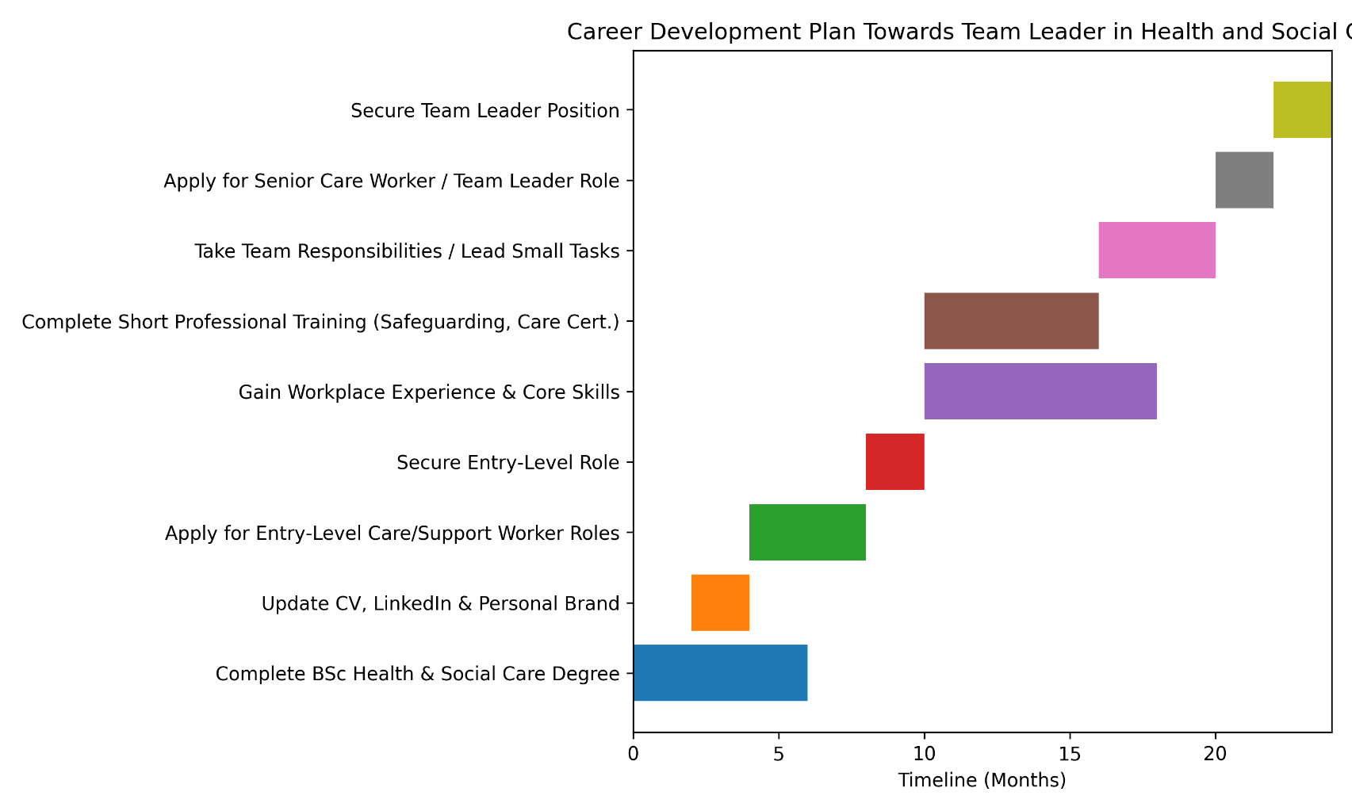
Career Goal: Senior Leadership Role in Health and Social Care

Task 7- Making Changes- Report
Being the manager of a residential care home, I intend to implement a digital care planning system as a replacement of paper-based records. The purpose of this change is to enhance the accuracy of documentation, communication and person-centred care delivery.
Planning the Change: With the Change Theory of Lewin (unfreeze-change-refreeze), I will introduce the employees to the purpose of forming a digital documentation to enhance safety and efficiency (unfreeze) first. This will be followed by training sessions and a gradual implementation (change). Then policies are to be revised and the progress tracked so that the system can become established practice (refreeze). Until-feedback of the staff will be promoted to facilitate interaction and ownership (Lewin, 1951).
Skills Required: I will require high communication skills, transformational leadership, digital literacy, time management, and staff motivation, and support through transition to lead this change (Kotter, 2012).
Barriers and Solutions: The possible obstacles are the resistance to technology among the staff, the lack of digital skills and time constraints. It is possible to decrease resistance through early involvement of staff and emphasising the benefits in terms of workload and patient safety. Peer mentoring and training workshops will resolve skill differences (Carvalhais and Formosinho, 2024). The time factor can be addressed by implementing in stages and changing rota. Effective management and frequent review sessions will be used to provide support and problem-solving.
Digital care planning will bring about modernisation and quality of care practices, enhance accountability and support staff development and organisational sustainability (Bail et al., 2023).

Task 8- Self-Reflection (Gibbs’ Reflective Cycle)
Through Gibbs Reflective Cycle (1988) I have been able to reflect on what I have learned in this module.
Description: In the process of making my own personal brand and accomplish the task of managing the change, during the module, I conducted the structured self-assessment and professional planning.
Feelings: One of the strengths involved identifying my strengths in compassion and communication when involved in health and social care. I also developed skills in reflective writing. Nevertheless, I have discovered weaknesses in leadership confidence and networking skills.
Evaluation: This event led me to the conclusion of the significance of planning my career and making a good impression on myself. The personal branding theory and change management theory were applied, and this aspect allowed me to relate theoretical information with practice. It showed that the development of a professional needs is the one that should be reflected and flexible.
Analysis: One of the strengths involved identifying my strengths in compassion and communication when involved in health and social care. I also developed skills in reflective writing. Nevertheless, I have discovered weaknesses in leadership confidence and networking skills.
Conclusion: I learnt that becoming employable is a continuous process. I might have made more opportunities in networking during the earlier stage of the module.
Action Plan: Reflective journaling, enhanced LinkedIn presence, and the pursuit of leadership on placements will also be part of my future practice. This will help me to achieve my objectives of advancing to senior leadership in the field of health and social care.

Reference List
Adegoke, V., Seuwou, P., Farini, F., Parkes, J. and Pilkington, A. (2024). Fostering Ethnic Diversity in NHS Employment: The Role of Education, Training, and Professional Development in Creating Inclusive Healthcare Workforces. In ICERI2024 Proceedings (pp. 3853-3862). IATED.
Bail, K., Gibson, D., Hind, A., Strickland, K., Paterson, C., Merrick, E., Gibson, J., Kozlovskaia, M., O’Dea, A., Smith, B. and Redley, B. (2023). ‘It enables the carers to see the person first’: Qualitative evaluation of point‐of‐care digital management system in residential aged care. Journal of Clinical Nursing, 32(1-2), pp.174-190.
BBC (2022). Quarter of 17-19-year-olds have probable mental disorder - study. BBC News. [online] 29 Nov. Available at: https://www.bbc.com/news/health-63784751 [Accessed 28 Feb. 2026].
Carvalhais, L. and Formosinho, M. (2024). Training, recruitment, and supervision of personnel in residential care centres: An exploratory study. Residential Treatment for Children & Youth, 41(4), pp.482-507.
Dutton, B., Humphrey, N. and Qualter, P. (2023). Getting the pieces to fit: NHS and third sector collaboration to enhance crisis mental health service provision for young people. BMC Health Services Research, 23(1), p.307.
Gibbs, G. (1988) Learning by Doing: A Guide to Teaching and Learning Methods. Oxford: Oxford Polytechnic.
Granovetter, M. S. (1973). The strength of weak ties. American journal of sociology, 78(6), pp.1360-1380.
Kelly, E., Stoye, G. and Warner, M. (2023). Patterns of less-than-full-time working by NHS consultants (No. R258). IFS Report.
Kotter, J. P. (2012). Leading change. Harvard business press.
Lewin, K. (1951). Field theory in social science: selected theoretical papers (Edited by Dorwin Cartwright.).
‌Martin, S., Cox, S., Alejandre, J.C., Phoenix, A., Coupe, N., McGowan, L., Escobar, O., Moore, G., Uttley, L. and Zhang, L. (2024). BR-UK: Equality, Diversity, Inclusion and Intersectionality Guidance and Policies.
McIntosh, N. (2023). How should nurses promote equality, diversity and inclusion?. Nursing Older People, 35(4).
Miras-Aguilar, M., Ruiz-Gutiérrez, J., Martínez-Gómez, S., Pérez-García-Abad, S., Ramos-Barrón, C., Pariente-Rodrigo, E., Piñán-Setién, L., Otero-Cabanillas, N., Priede, M.I. and González-Blanch, C. (2026). Waiting Times in Clinical Psychology in Public Mental Health Units: Predictors of Attendance at the First Appointment and Early Dropout. Psicothema, 38(1), pp.13-22.
Montoya, P. and Vandehey, T. (2009). The brand called you. New York, NY: McGraw-Hill.
Musch, K.L., Tyler, L.S., Vest, T.A. and Ivey, M.F., 2023. A personal brand strategy to elevate the new practitioner’s career. American Journal of Health-System Pharmacy, 80(21), pp.1531-1534.
NHS (2024). NHS England» England’s NHS mental health services treat record 3.8 million people last year. [online] England.nhs.uk. Available at: https://www.england.nhs.uk/2024/10/englands-nhs-mental-health-services-treat-record-3-8-million-people-last-year/ [Accessed 28 Feb. 2026].
O’Dowd, A. (2025). Quarter of young adults in England have a mental health condition, data suggest. BMJ, [online] 389. https://doi.org/10.1136/bmj.r1351.
Punton, G., Dodd, A.L. and McNeill, A. (2022). ‘You’re on the waiting list’: An interpretive phenomenological analysis of young adults’ experiences of waiting lists within mental health services in the UK. Plos one, 17(3), p.e0265542.
Shepherd, I. D. (2005). From cattle and coke to Charlie: Meeting the challenge of self marketing and personal branding. Journal of marketing management, 21(5-6), pp.589-606.
Stokes, M.I.C.H.E.L.L.E. and Woodhams, C.A.R.O.L. (2022). Equality, diversity and inclusion. Human Resource Management: People and Organisations, 199.
Tang, Y.Y. and Chan, R.S.K. (2024). Unveiling the Importance of the Roles of Social Capital from Clan Association Memberships:: A Comprehensive Review. Journal of Ethnic and Diversity Studies (JOEDS), 2(1).

