Case Study Report: Management and Education of Patients with Type 2 Diabetes
Assignment Title: Case Study 1: Diabetes Management in Primary Care
Mariam Karim
2407469

1. Introduction
Diabetes Mellitus is a highly serious health concern of the twenty first century globally, which is manifested in chronic metabolic dysfunction and unremitting hyperglycemia. According to the World Health Organisation (2022), the number of individuals diagnosed with this condition is increasing very fast, especially in the middle-income nations. Type 2 Diabetes Mellitus (T2DM) can be the major preoccupation in the clinical setting of a local GP surgery. T2DM is also marked by progressive resistance to insulin action complemented by a subsequent reduction of the pancreatic secretin pool as opposed to Type 1 diabetes, which is normally characterised by an absolute lack of insulin through the effect of the autoimmune destruction of pancreatic beta cells (Magliano et al., 2021). This condition of metabolism causes an increase in blood glucose that with uncontrolled conditions causes grievous microvascular and macrovascular emergencies.
T2DM is a complex multifactorial condition that requires the complex interaction between genetic predisposition and environmental risks. Public Health England (2017) notes that obesity is the only factor as a modifiable risk factor that is highly significant because the excess adipose tissue produces pro-inflammatory cytokines that disrupt the insulin-signalling pathways. Moreover, lack of exercise and the excessive intake of ultra-processed and energy-rich diets have increased the rates of diagnosis in populations of younger age. The ethnicity is also significant you usually find people of South Asian and African-Caribbean origin being diagnosed with the condition at a lower Body Mass Index (BMI) than their Caucasian counterparts (Diabetes UK, 2023). Another factor associated with the risk profile is ageing, since physiological variation in glucose tolerance is a natural occurrence over time, but the recent trend of T2DM in younger people is pointing towards the fact that lifestyle factors are gaining traction at the expense of biological ageing (Minari et al., 2023).
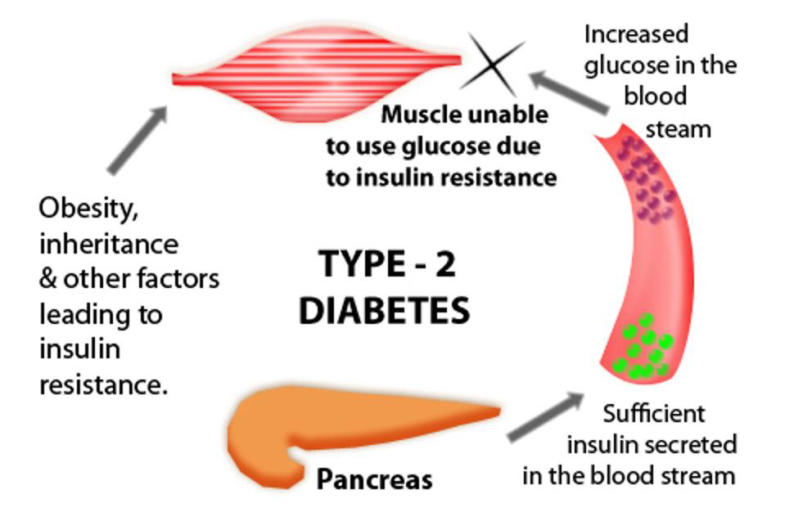
Figure 1: Type 2 Diabetes Mellitus (T2DM) Overview
Source: https://danii.org.au/type-2-diabetes/

2. Maintenance of Blood Sugar Levels

2.1 The Endocrine Role of the Pancreas
Blood glucose homeostasis is a core process of the human body that needs to maintain the constant availability of energy to the brain and peripheral tissues. In a healthy patient the normal range of fasting blood glucose is carefully closed to a range of 4.0and 7.0 mmol/L. The pancreatic endocrine functions regulating this are mainly those of the Islets of Langerhans that is a glucose sensor of the body. Tortora and Derrickson (2018) state that the mechanism of a negative feedback helps the body to avoid the too large changes in the glucose levels that otherwise result in acute crisis, e.g., diabetic ketoacidosis or hyperglycaemic hyperosmolar state.

2.2 Hormonal Regulation and Insulin Action
The beta cell of the pancreas release insulin into the blood when the level of glucose in the blood increases after the breakdown of carbohydrates. Insulin is known to promote glucose uptake to insulin sensitive tissue including skeletal muscle and adipose tissue by inducing the translocation of GLUT4 transporters to the cell membrane. Also, insulin stimulates glycogen production in the liver whereby the surplus glucose is stored as glycogen. On the other hand, the glucagon secretion is produced by the alpha cells of the pancreas during the fasting or strenuous physical activity. Holt and Flyvbjerg, (2024) explain that glucagon activates the liver into glycogenolysis and gluconeogenesis to maintain the flow of blood glucose within a healthy level. This delicate balance is not maintained in patients with T2DM. To put it in other words, insulin resistance implies that when insulin is present, the reaction of cells to it is weakened, resulting in the state of blood saturation with glucose that cannot be effectively used by the cells.

2.3 Pathophysiology of Insulin Resistance
When it comes to T2DM, simple glucose is not the only pathophysiological process. Over-nutrition and obesity which occur chronically cause the deposition of lipid in the non-adipose tissues, including the liver and the skeletal muscles. That ectopic fat build up induces cellular stress responses disrupting the signal transduction of insulin receptors. The first clinical phase, as Powers et al., (2022) recognizes, is usually the compensatory hyperinsulinemia in which the pancreas overworks to create more insulin in order to neutralise resistance. The beta cells eventually become so exhausted that they are unable to produce as required and the clinical stage of T2DM ensues. This development highlights the importance of primary care intervention at an early age to maintain left-over beta-cell activity.

3. Cell Metabolism: The Use of Oxygen and Glucose

3.1 The Foundations of Cellular Respiration
The major goal of the cellular metabolism is the synthesis of the universal currency of biological labor Adenosine Triphosphate (ATP). This is a process, referred to as aerobic cellular respiration, which needs a steady periodical supply of glucose as well as oxygen. The chemical foundation of this process is summarised by the equation:
$${\text{C}}_{6}{\text{H}}_{12}{\text{O}}_{6}+6{\text{O}}_{2}→6{\text{CO}}_{2}+6{\text{H}}_{2}\text{O}+\text{Chemical Energy (ATP)}$$

This metabolic pathway, according to Skull, (2022), consists of a large number of separate steps with the initial one developing in the cytosole with the glucose conversion into pyruvate, which produces a low concentration of ATP.
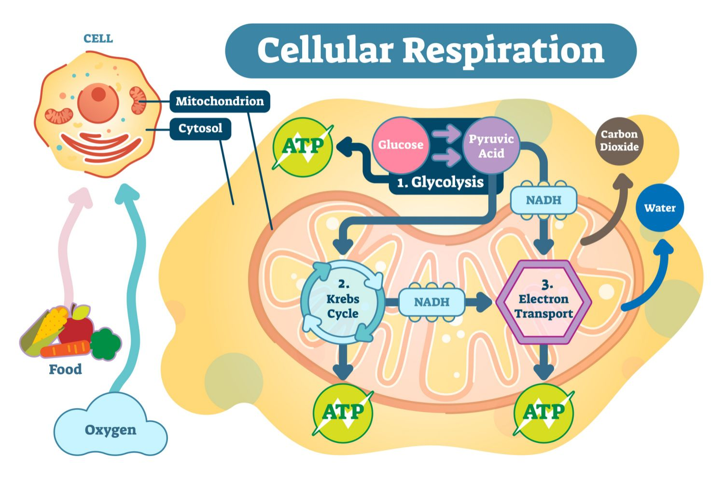
Figure 2: Cellular Respiration
Source: https://www.biologyonline.com/dictionary/cellular-respiration

3.2 Mitochondria and Oxidative Phosphorylation
After glycolysis, the pyruvate gets into the mitochondria to be subjected to the Krebs Cycle and the Electron Transport Chain. It is at these stages that most of the ATP is produced by oxidative phosphorylation. Oxygen is the last electron donor in the electron transport chain, its absence would stop this process, and anaerobic fermentation would be left to support the cell, much less efficient and resulting in the build up of lactic acid. According to Scanlon and Sanders (2018), the effectiveness of such a process largely regions on the presence of glucose in the mitochondrial matrix. With diabetes, the energy production cannot be maximised in the cell due to the inefficiency of the glucose transport into the mitochondria (Baynes and Dominiczak, 2018).

3.3 Metabolic Failure and Clinical Symptoms
This is a biochemical breakdown that describes the persistent feeling of lethargy and even fatigue reported by the patients at the clinic. Since the glucose does not get into the cells (the location of the mitochondria) where the energy production takes place; instead of the glucose getting into the cells, it stays in the extracellular fluid (the blood) where the glucose is located in large amounts; the patient develops a paradox of high fuel content and low energy output. Moreover, in the event of glucose being unable to serve the purpose it can result in the body trying to break down fats faster, resulting in the generation of ketone bodies and causing the acidity of the blood to shift (Whittlesea and Hodson, 2018). The nurse needs to know about this metabolic traffic jam, which would explain to patients why they feel tired despite having regular meals.

4. Recording and Tracking Blood Sugar Levels

4.1 Strategies for Glucose Monitoring
The regular documentation and monitoring of the blood glucose data are the important elements of self-management in cases of individuals living with T2DM. There is preventive value in monitoring which eliminates acute complications and long-term complications. National Institute for Health and Care Excellence (NICE, 2022) also mentions that the early detection of hypoglycemia may be ensured through regular monitoring and includes the factors that may potentially lead to instant cognitive impairment and physical harm, i.e., a drop in the blood glucose levels to less than 4.0mmol/L. Moreover, tracking can be used to inhibit long-term proliferation of hyperglycemia that is the leading cause of diabetic retinopathy, nephropathy, and peripheral neuropathy.

4.2 HbA1c vs. Self-Monitoring
HbA1c testing offers a wider clinical picture since it addresses the glycation of the hemoglobin in the past two to three months. HbA1c reflects average blood glucose over 3 months: ≤5.7% normal, 5.7–6.3% pre-diabetes, ≥6.3% diabetes. Nevertheless, real-time feedback on the impact of particular lifestyle decisions on glycemic stability can be obtained by daily self-monitoring (either by the conventional capillary blood glucose or Continuous Glucose Monitoring (CGM)). According to the evidence presented by Wilding et al., (2022), the patients who keep a detailed record of their readings and note down the dietary and activity patterns start having a more prominent sense of health literacy. This will enable the patient to engage in the shared decision-making with medical professionals, shifting toward the former paternalistic care model to the collaborative one that enhances clinical results in the long term (Fischer et al., 2024).
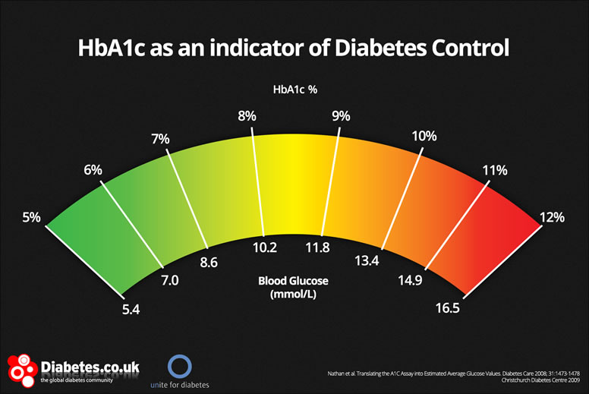
Figure 3: HbA1c
Source: https://www.caring2u.com/health-center/health-info/hba1c-or-self-monitor-my-blood-sugar/

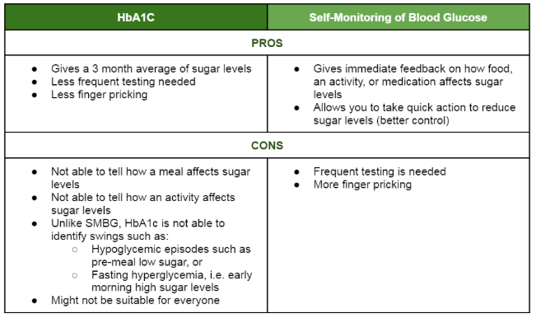
Figure 4: HbA1c vs. Self-Monitoring
Source: https://www.caring2u.com/health-center/health-info/hba1c-or-self-monitor-my-blood-sugar/

4.3 Patient Education and Psychological Impact
The issue of psychological burden of tracking should also be discussed by the practice nurse. Patients are mainly judged by numbers. Education should therefore shift the focus to letting people know that blood sugar readings are not an indicator of their failure but this is a figure that creates an opportunity to adjust the treatment plan. According to Chiauzzi et al. (2015), the applicability of a patient-centered approach to monitoring consists of the establishment of personalised goals based on the age, comorbidity, and risk of hypoglycemia of the patient. The nurse will be able to demystify the numbers and make the patient feel that she is in control rather than controlled by the disease.

5. Evidence-Based Lifestyle Recommendations

5.1 Nutritional Management and the Glyce

mic Index
The primary source of T2DM treatment has always been lifestyle intervention, and in many cases, it can be as effective as pharmacological therapy during the initial phases of the disease. The changes in the diet must be associated with the quality of carbohydrates and not just a quantity. The Mediterranean has had its fully healthy grains, legumes, fruits, and vegetables diet that, in addition, incorporates healthy monounsaturated fats found in olive oil, and the diet has undergone extensive validation in the clinical literature on its capacity to reduce HbA1c and improve cardiovascular health (Martín-Peláez et al., 2020). Patients have been advised to ensure that the foods they consume have low-glycemic index, and this leads to a slow and prolonged release of the glucose into the blood, and this goes a long way in lowering the strain on the already crippled pancreatic beta cells.

5.2 Physical Activity and Insulin Sensitivity
Exercise is also essential, as it is a non-drug approach to the promotion of insulin sensitivity. The skeletal muscles use glucose through an insulin-independent pathway during exercise that is, the body is capable of reducing the level of glucose in the blood even in cases of high insulin resistance. According to the guidelines of the current UK Chief Medical Officers, no less than 150 minutes of moderate-intensity aerobic exercises is recommended every week, whether they are combined with muscle-strengthening exercises on not fewer than two days (Department of Health and Social Care, 2019). Rodríguez-Gutiérrez et al. (2021) have famously shown that intensive lifestyle modifications have the potential to mitigate the progression of pre-diabetes into T2DM by up to 58%, a clear manifestation of the power of movement as a medicine.

5.3 Smoking, Vaping, and Vascular Protection
Moreover, the diabetic patient cannot compromise on the issue of quitting smokers and vapers. Macrovascular complications such as myocardial infarction and stroke are strongly predisposed by smoking, which has been found to deteriorate insulin resistance directly (Maddatu et al., 2017). Nicotine is a vasoconstrictor and elevates stress hormone (such as cortisol) levels that further elevate the amount of blood glucose. To a patient with an already risky circulation state in threat of nerve damage, smoking is a major jump-start toward amputations of limbs and heart failure.

6. Conclusion
It is important to conclude that Type 2 Diabetes Mellitus is a multifactorial and complicated condition that needs to be managed in a holistic and informed manner. Having the knowledge of the basic physiology of glucose regulation, and biochemical needs of the cell metabolism, patients can be more appreciative of the need of clinical interventions. The practice nurse should be able to mediate this realisation, which is accomplished by offering the necessary education that ensures the affected patients are able to monitor their health information efficiently and make long-term lifestyle modifications. This education should also be based on empathy and joint decision making to make sure that it is long-term. By means of the combination of evidence-based eating, routine physical activities, and avoiding dangerous habits, such as smoking, the patients will keep the energy level high, avoid debilitating complications and provide a high standard of life even with the diagnosis.

7. Reference List
Baynes, J.W. and Dominiczak, M.H., 2018. Anaerobic metabolism of carbohydrates in the red blood cell. Medical Biochemistry,, pp.111-124.
Chiauzzi, E., Rodarte, C. and DasMahapatra, P., 2015. Patient-centered activity monitoring in the self-management of chronic health conditions. BMC medicine, 13(1), p.77.
Department of Health and Social Care (2019) UK Chief Medical Officers' Physical Activity Guidelines. London: HM Government. Available at: https://www.gov.uk/government/publications/physical-activity-guidelines-uk-chief-medical-officers-report
Diabetes UK (2023) How many people in the UK have diabetes? Available at: https://www.diabetes.org.uk/about-us/about-the-charity/our-strategy/statistics
Fischer, L., Scheibler, F., Schaefer, C., Karge, T., Langer, T., Schewe, L.V., Florez, I.D., Hutchinson, A., Li, S., Maes-Carballo, M. and Munn, Z., 2024. Fostering shared decision-making between patients and health care professionals in clinical practice guidelines: protocol for a project to develop and test a tool for guideline developers. JMIR Research Protocols, 13(1), p.e57611.
Holt, R.I. and Flyvbjerg, A. eds., 2024. Textbook of diabetes. John Wiley & Sons.
Maddatu, J., Anderson-Baucum, E. and Evans-Molina, C., 2017. Smoking and the risk of type 2 diabetes. Translational Research, 184, pp.101-107.
Magliano, D. J., Boyko, E. J., and IDF Diabetes Atlas 10th edition scientific committee . (2021). IDF DIABETES ATLAS. (10th ed.). International Diabetes Federation.
Martín-Peláez, S., Fito, M. and Castaner, O., 2020. Mediterranean diet effects on type 2 diabetes prevention, disease progression, and related mechanisms. A review. Nutrients, 12(8), p.2236.
Minari, T.P., Tácito, L.H.B., Yugar, L.B.T., Ferreira-Melo, S.E., Manzano, C.F., Pires, A.C., Moreno, H., Vilela-Martin, J.F., Cosenso-Martin, L.N. and Yugar-Toledo, J.C., 2023. Nutritional strategies for the management of type 2 diabetes mellitus: a narrative review. Nutrients, 15(24), p.5096.
National Institute for Health and Care Excellence (NICE) (2022) Type 2 diabetes in adults: management. Available at: https://www.nice.org.uk/guidance/ng28
Powers, A.C., Niswender, K.D. and Evans-Molina, C., 2022. Diabetes mellitus: diagnosis, classification, and pathophysiology. Diabetes, 1000, p.415.
Public Health England (2017) Health matters: obesity and the food environment. London: PHE. Available at: https://www.gov.uk/government/publications/health-matters-obesity-and-the-food-environment/health-matters-obesity-and-the-food-environment--2
Rodríguez-Gutiérrez, R., Millan-Alanis, J.M., Barrera, F.J. and McCoy, R.G., 2021. Value of patient-centered glycemic control in patients with type 2 diabetes. Current diabetes reports, 21(12), p.63.
Scanlon, V.C. and Sanders, T., 2018. Essentials of anatomy and physiology. FA Davis.
Skull, A.L.I.C.E., 2022. Circulation-anatomy, physiology and pathophysiology. McGloin S, Skull A. Principles of acute care nursing. SAGE Publications, p.86.
Tortora, G.J. and Derrickson, B.H., 2018. Principles of anatomy and physiology. John wiley & sons.
Whittlesea, C. and Hodson, K. eds., 2018. Clinical pharmacy and therapeutics e-book: Clinical pharmacy and therapeutics e-book. Elsevier Health Sciences.
Wilding, J.P., Evans, M., Fernando, K., Gorriz, J.L., Cebrian, A., Diggle, J., Hicks, D., James, J., Newland-Jones, P., Ali, A. and Bain, S., 2022. The place and value of sodium-glucose cotransporter 2 inhibitors in the evolving treatment paradigm for type 2 diabetes mellitus: a narrative review. Diabetes Therapy, 13(5), pp.847-872.
World Health Organization (2022) Diabetes: Key Facts. Available at: https://www.who.int/news-room/fact-sheets/detail/diabetes

