Title: Portfolio of 6 elements
Module: Foreign languages and Cultural Awareness
Module code: BMIH5009
Lecturer: Natalie Brailsford
Name: Marius Daniel Cirpaci
Student Number: 2317399

Acknowledgement: I have used AI to proofread my work using (Trinka.ai, 2020)

Element One: Reflective essay
I am from Romania, which is in Eastern Europe. The that I have grown up had a massive influence on my culture and my view of the world. From a young age in school I was thought about the Romanian rich history and how many great Leaders have come together to form our country. Togetherness and teamwork is one main aspect that was highlighted the most in our teaching. One of the main social element that that influenced my culture is religion. I went to church every Sunday from a young age and have been listening to the stories and the ways of the Bible. Romania is a very religious country with teaching of religion been educated in school regularly. The cuisine of Romania is diverse because of many foreign influences. In Romania you can see a mix of foods, first , the Turks and their ciorba de perisoare ( meatball soup)and lastly the Bulgarians who transformed many Romanian dishes in vegetable based styles like zacusca (eggplant and vegetable spred) In Romania, the dish that is known as mamaliga made of maize flour, salt and water is readily available, and often eaten with pork, cheese, sausages and other meats. Soups such as vegetable, chicken, bean, and tripe are a staple in Romania. Given their low-calorie count, these also make for good breakfast or light meals. Food plays a significant role in shaping and representing cultural identity, it influences how individuals construct and maintain their cultural heritage. In different societies, food serves as a bridge for cultural exchange and integration. Also, this is influenced by factors such as health and convenience. Food traditions at social gatherings help preserve cultural heritage. Cultural food practices reflect deeper meanings, connecting to traditional beliefs and wisdom. Although food can differ from one group to another, the underlying importance remains consistent because it acts as a medium of connection and understanding. (Reddy and van Dam, 2020) I have lived in a small town in a near the countryside. The community was very important in my culture which means that we had a great relationship with everyone. One of the things that I had grown up with in my hometown is to greet everyone. It did not matter if you knew them or not, a greeting went a long way and shown a sign of respect within the community. Furthermore, this has caused a friendly and heartwarming environment that is embedded in the culture that I has influenced the way I am . Looking after the elderly and respect people who are older is another aspect that has influenced my culture. This has also influenced my culture because It is something that was practise and known all around the community and it is something that has stayed with my culture and the way I look at the world and people. As a community it was very typical to share food and have dinner together, a great time for socialising and appreciation for you family .According to (Arias and Punyanunt-Carter, 2017) Family serves as a fundamental component that significantly influences our cultural identity and values from the moment of birth. It functions as a crucial foundation, guiding us through life and teaching us how to navigate the complexities of our environment. Culture plays a pivotal role in determining family dynamics; however, it also affects behaviours, power dynamics and communication styles. Multicultural families often prioritize activities that preserve cultural heritage—such as language and tradition sharing. In Hispanic and Latino families, for instance, living with extended relatives is common, which fosters a strong support system that reinforces cultural. Families are influential in the formation of culture through many ways. Traditions may positively or negatively affect us depending on our personal relationship to them. Cultural Attitudes and Families are also able to develop cultural perception and reactions that continue to influence our thinking and actions. Language tends to influence the culture through time, a process that can establish the cultural identity in many different ways. Furthermore, Behavioural Patterns Variations on the family's cultural backgrounds with different trends within society result in creating our values and beliefs. My culture has evolved quite significantly over time. One massive change was when I have moved to Wales in 2008.I had to adapt and follow a different way of life and thinking by learning the language and the practices that are followed. Also trends and events that around the world has impacted the culture because sometimes we have to change the way that we normally and regularly behave. By adapting your culture, this will help you in having better relationships and understanding within you community (Walker and Soule, 2017). My culture impact my interaction with people in the way I feel. I am empathetic towards people trying to experience someone else’s point of view and understating what they may be going though .this means that, the action that I have is very honest. Another way is been hospitable by having guests and showing gratitude towards them by offering a coffee or tea and making sure that I am making their experience welcoming and enjoyable in the best way possible. When I speak with people from different background I try to familiarise myself with their way of life and attitude that they have .Also, I try not to say anything that might offend them by actively listening. Furthermore, using the phrases “please” and “thank you” is very common within my culture and I try to show that when I have interaction with people from different backgrounds. This is another aspect that has influenced my culture and the consideration of other people.

Element Two: Written Report
Different types of cultures has different values ingrained. Chinese individuals prioritize social benefits and community engagement, whereas Americans focus on economic gains and personal rewards. To satisfy and meet the guests expectation you can initiate loyalty programs and promotional. These examples of service modifications can enhance both social and economic results of your organisation. Understanding these cultural objectives is critical for success in various markets, however businesses must find a balance between global consistency and local cultural practices. Service customization, influenced by cultural context, can substantially improve the client experience. This is essential because it cultivates a more profound connection between service providers and their guest, although it may necessitate extra effort and resources. (Suh et al., 2022) Furthermore, according to (Han, 2012) traditions and culture have a significant impact on service quality and overall business performance. Moreover, a hefty and inclusive culture can serve as a predictor of performance outcomes. Family-oriented cultures tend to enhance financial success whereas, traditional cultures may return opposed results. In order to elevate service outcomes, companies should cultivate flexible corporate cultures that can adapt to evolving environments while maintaining a steady and fast service principle. Balancing cultural norms with effective strategies to meet shifting client expectations is essential. Although there are challenges, fostering adaptability is essential for success. Furthermore, businesses must navigate the delicate balance between their longstanding practices that they had in place and the necessity to swiftly adjust to changing client demands accordingly. Cultural awareness is (undeniably) critical in hotels, particularly within multinational hotel chains. It represents an essential component of international hospitality management. This awareness enables workers to learn about and be cognizant of, other cultural backgrounds—an essential skill because hotels engage with a vast range of visitors and personnel on an international scale. Successfully navigating cultural diversity offers hotels a competitive advantage in the global market; however, employees must contend with communication difficulties and be adaptable in addressing misunderstandings. They must also be comfortable working alongside individuals from different cultures. Cross-cultural competency, which includes cultural awareness, is especially vital in the global hospitality industry. Although hotel employees must be sensitive to various cultures, this sensitivity is essential for thriving in today's diverse society. (Sucher and Cheung, 2015) Cultural communication within hotels is important and also creates brand recognition. Another aspect is to have international standards with local cultural, to align with guest preferences. Modern hotels, however, are increasingly adopting to provide unique experiences while still maintaining to a global standard service. National culture, because of its significant influence, affects customer perceptions and staff performance. Hotels gain advantages from possessing cultural traits that resonate with their clientele. Also, Hotel names serve as powerful marketing instruments because they embody cultural values and help establish unique hotel identities. Although current trends indicate a rise within the hospitality sector, this approach not only attracts guests but also celebrates local culture. Furthermore, this technique enhances the individuality of the hotel brand while simultaneously elevating the overall client experience. Cultural branding is vital and incorporating cultural elements enables hotels to differentiate themselves in a competitive marketplace, all while safeguarding local traditions (Fărcasiu, M.A. 2024). The majority of meaning in American society is expressed through words, but many other cultures employ indirect signals and delicate hints. Latin American and Caribbean cultures use strong verbal and facial expressions, whereas American Indian, Alaskan native, and East Asian cultures use gentler voices and less expressive language. Silence and pauses are perceived differently in American Indian societies, which prioritise processing of information. Personal interaction patterns differ, with white Americans preferring direct eye contact while other Asian cultures consider it disrespectful. also, Emotional expression varies in Europe as well, Western Europeans are comfortable expressing grief, whilst East Asian societies reject strong emotional displays. Cultural identity influences both transparency and trusting (Galanti, 2008) . The hospitality industry is both complex and diverse, presenting numerous challenges for effective service delivery. there is a growing demand for employees capable of delivering appropriate service experiences while simultaneously navigating cultural distinctions. this means that key training and development strategy procedures can include practical training techniques and cultural integration. Practical training methods often incorporate “buddy schemes" that pair less experienced workers with seasoned staff, alongside internal coaching and mentoring initiatives, as well as regular meetings and briefings. Cultural integration involves nurturing a family-oriented atmosphere, fostering a customer-centric mindset and valuing workforce diversity. (Marinakou and Giousmpasoglou, 2019) As international travel continues to expand, the hospitality industry confronts the challenge of integrating standard service with cultural sensitivity. Communication trends, preferences for personal space and emotional expressions are all significant cultural aspects that must be taken into account. To thrive in today's hospitality sector, it is essential to cultivate cultural intelligence, which allows employees to recognize and appreciate cultural differences. The objective is to offer personalized experiences that honour cultural diversity while maintaining efficient service standards. Balancing these attributes is crucial, however neglecting them may lead to client dissatisfaction. Despite the challenges that are faced, the dedication to personalisation and efficiency remains a critical aspect. (Varga, 2023) According to a case study by (Lyon and Sulcova, 2009) Cultural integration and communication strategies in hotels are crucial for managing a diverse workforce. Essential training, such as cultural awareness programs, should be provided during employee onboarding, and bilingual staff can assist with translation of important documents. Language barriers can lead to negative customer experiences, with some guests expressing frustration over communication difficulties. To improve integration, team-building exercises are recommended to enhance relationships between local and migrant workers. Effective communication is vital for customer service success, and local employees play a key role in bridging cultural gaps and addressing language issues. Overall, fostering a supportive environment is essential for enhancing both employee collaboration and customer satisfaction. According to a study by (Li and Zhang, 2022) they have applied Hoftstead’s framework of cultural dimensions. Their study indicates how variations in culture that influence the behaviour of hotel visitors and their preferences for reviews. Chinese visitors, originating from a collectivist society characterized by significant power distance, tend to seek out reviewer profiles and place their trust in authorities that highlight expertise and reputation. However, American visitors emerge from a more independent society with a fewer power distance meaning that they assign greater importance to the content of reviews and individual evaluations. These cultural distinctions enable hotel managers to tailor service strategies effectively. For instance, they might promote experienced reviews to Chinese visitors, while prioritising subjective judgments for American customers. This approach ultimately results in enhanced service for guests hailing from diverse cultural backgrounds. This study agrees with Hofstede's theory. They offers valuable perspectives into cross-cultural consumer behaviour within hospitality settings. The practical significance of this framework is demonstrated by its ability to influence business decision; for example, hotels can customize their review presentation strategies based on varied cultural contexts. Research findings consistently show that different cultural groups evaluate the helpfulness of reviews differently. However Although cultural differences are a crucial aspect of consumer behaviour, this framework should be employed alongside other analytical approaches, because relying solely on it may not provide a comprehensive understanding.

Element Three: Staff guide
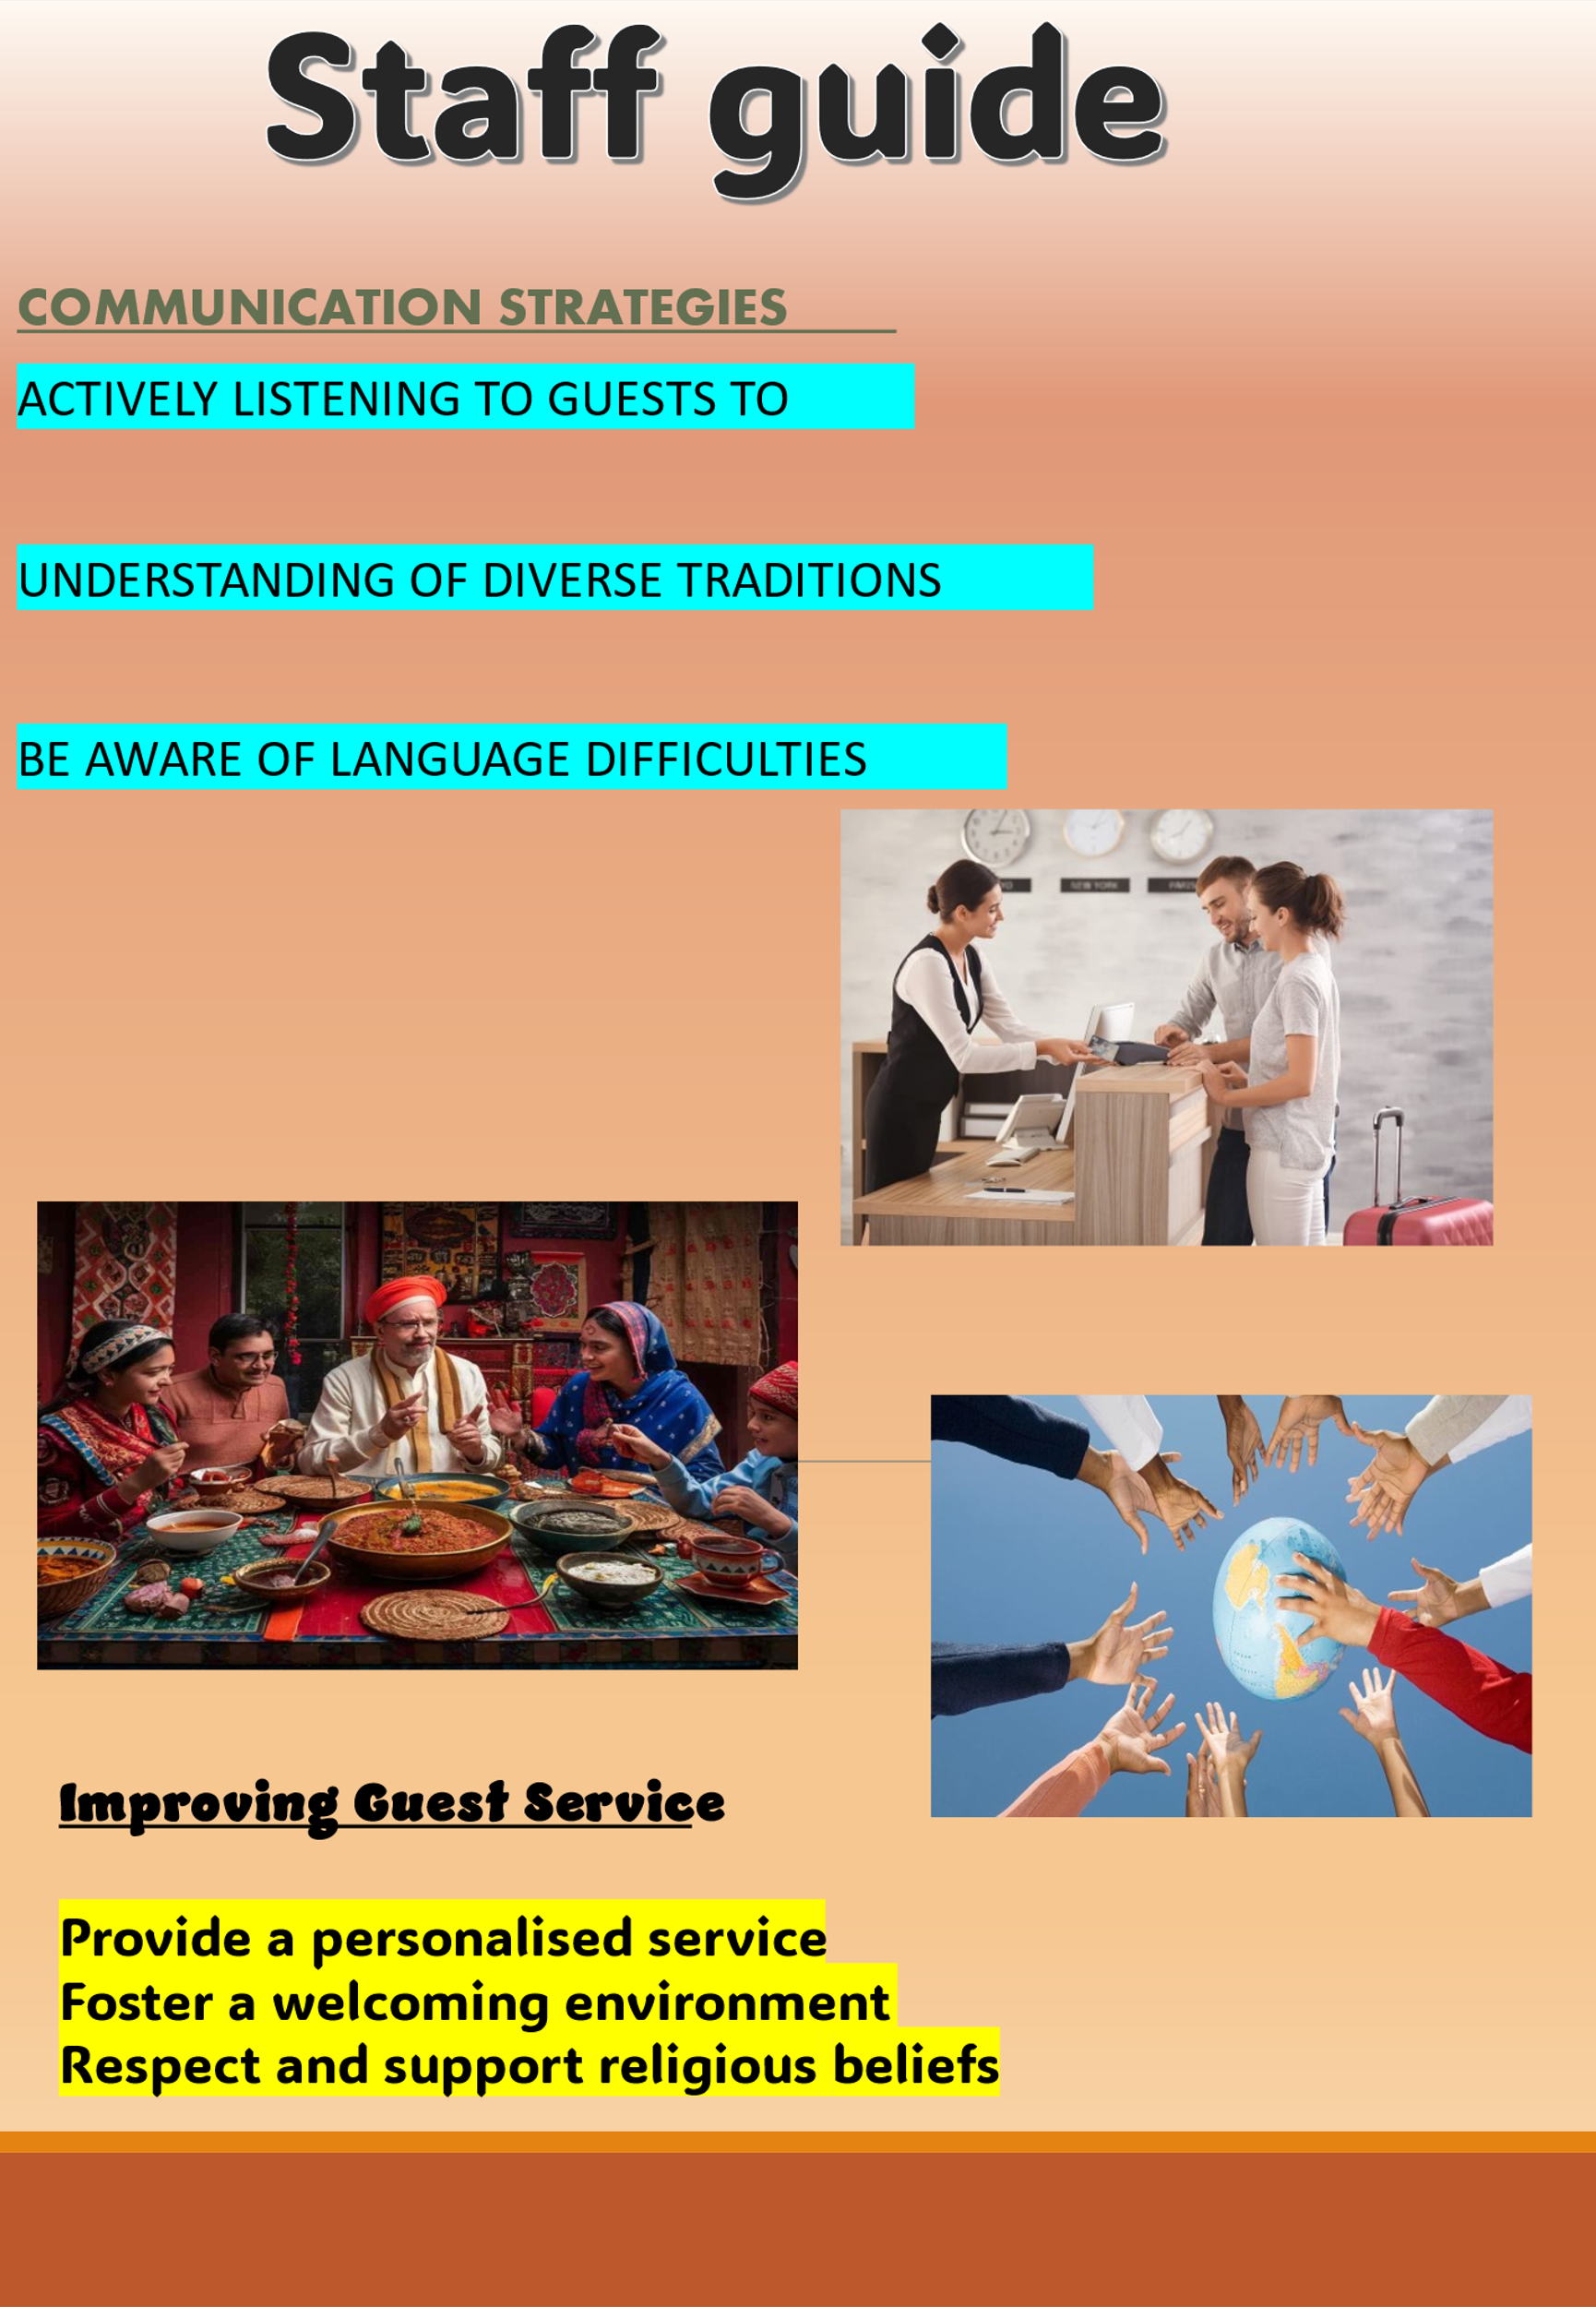
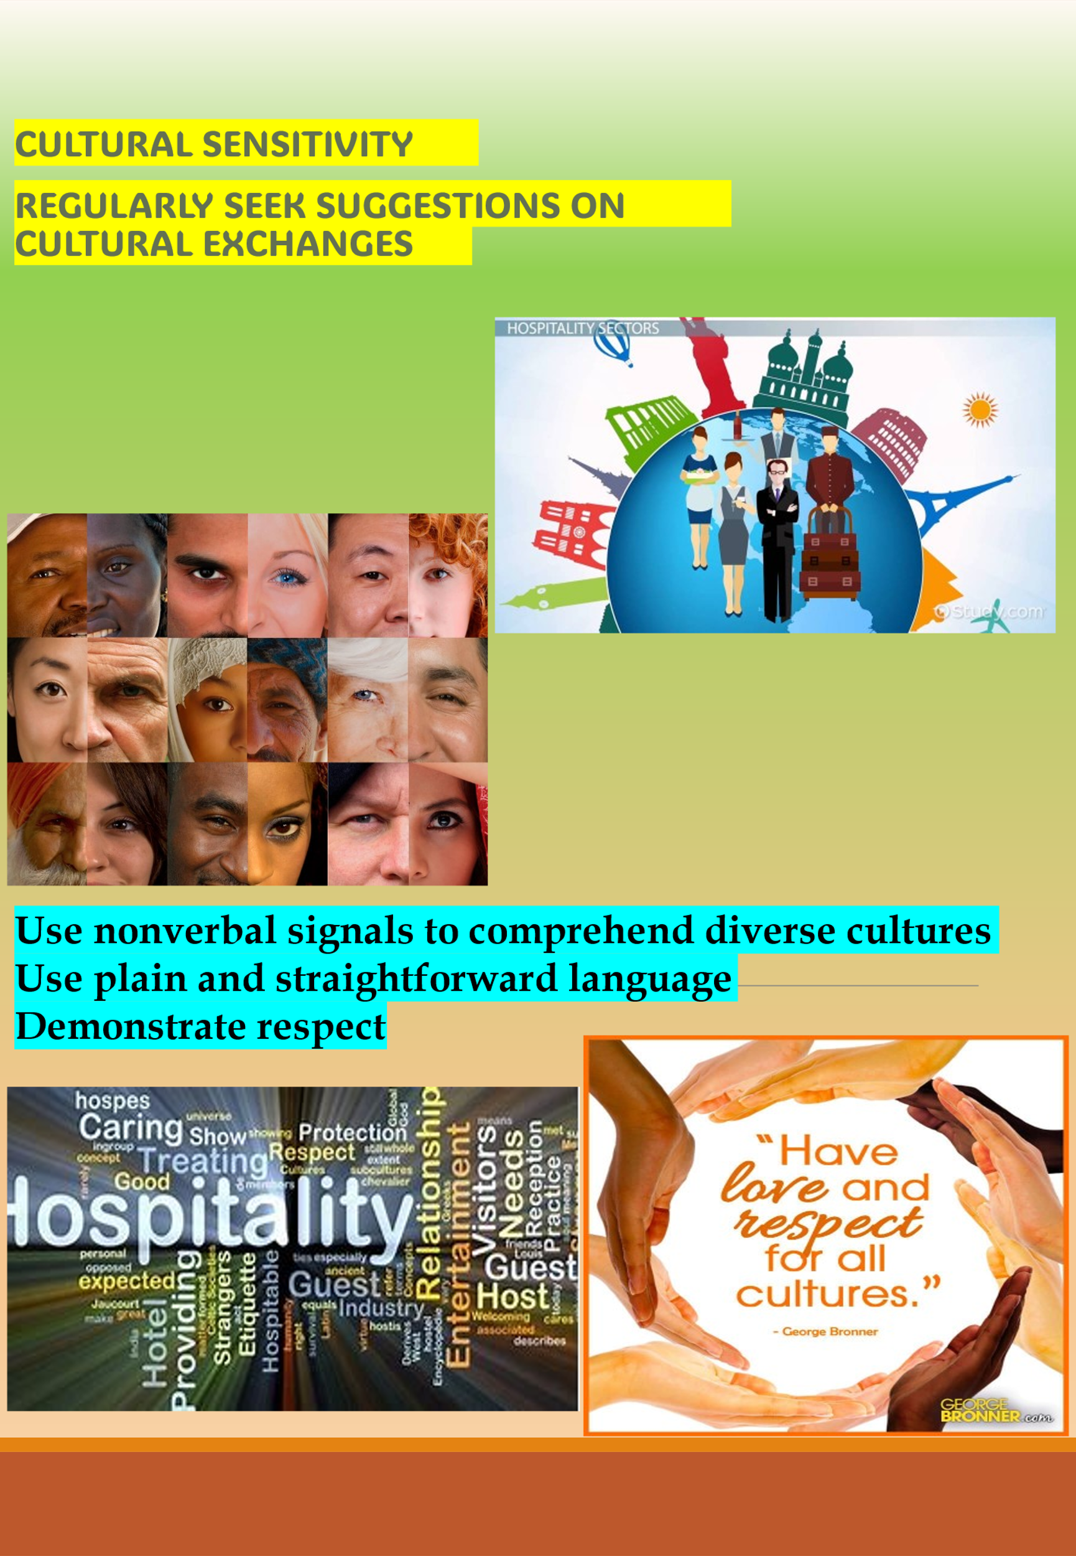

Element Four
I was in a metro in Paris, France on holiday with my wife and as we were on our way there was other passengers who were staring at me. This made me feel uncomfortable because It is something that is not often the case to deal with in the Uk. Also, I felt guilty as I thought that I have done something wrong or something was out of place, perhaps my shoelaces or tie. I was also confused as to what to what is happening. I think that others did not make much of this situation and their emotions were quite normal. Cultural misunderstanding can occur when people watch movies and how they are portrait in the media. There are things that might be quite normal to you and it might be part of your daily routine. Other cultures might find that offensive. This means that it is important to be vary your actions because this can lead go culture misinterpretation. According to (Reguieg, 2020) Cultural misunderstandings within the hotel industry are common, sometimes they arise from limitations in language and the comparison of cultural norms. Understanding client behaviour and managing cultural differences are essential skills, however, utilizing appropriate body language is crucial. Communication challenges often arise from a lack of awareness regarding consumer cultures, poor usage of body language and inappropriate word choices. Solutions can involve exposing employees to diverse cultural contexts through realistic materials and integrating cultural awareness into training programs. It can be very easy to make certain assumptions about the actions of other around you. One of the stereotypes is that the French are arrogant and elegant, that is the reasons that I had these assumption about the French people and their behaviour. Furthermore, Fashion, gastronomy and delicacies are all crucial aspects of French culture. (Segueg, 2023) In order to increase my cultural awareness, I need to understand my own cultural background and how others view it furthermore. I can try to interact with multiple cultures through a variety of techniques, including, viewing films. I plan to seek out opportunities to engage with individuals from various cultures, whether through job, or participation in community events. Learning another language may be very advantageous since it allows me to understand different ways of thinking. Most importantly, I would prioritise the development of true connections with people from many cultures, seeing our differences with inquiry rather than judgement. (Pascual, 2022)

Element Five-Presentation
Slide one

Slide 2
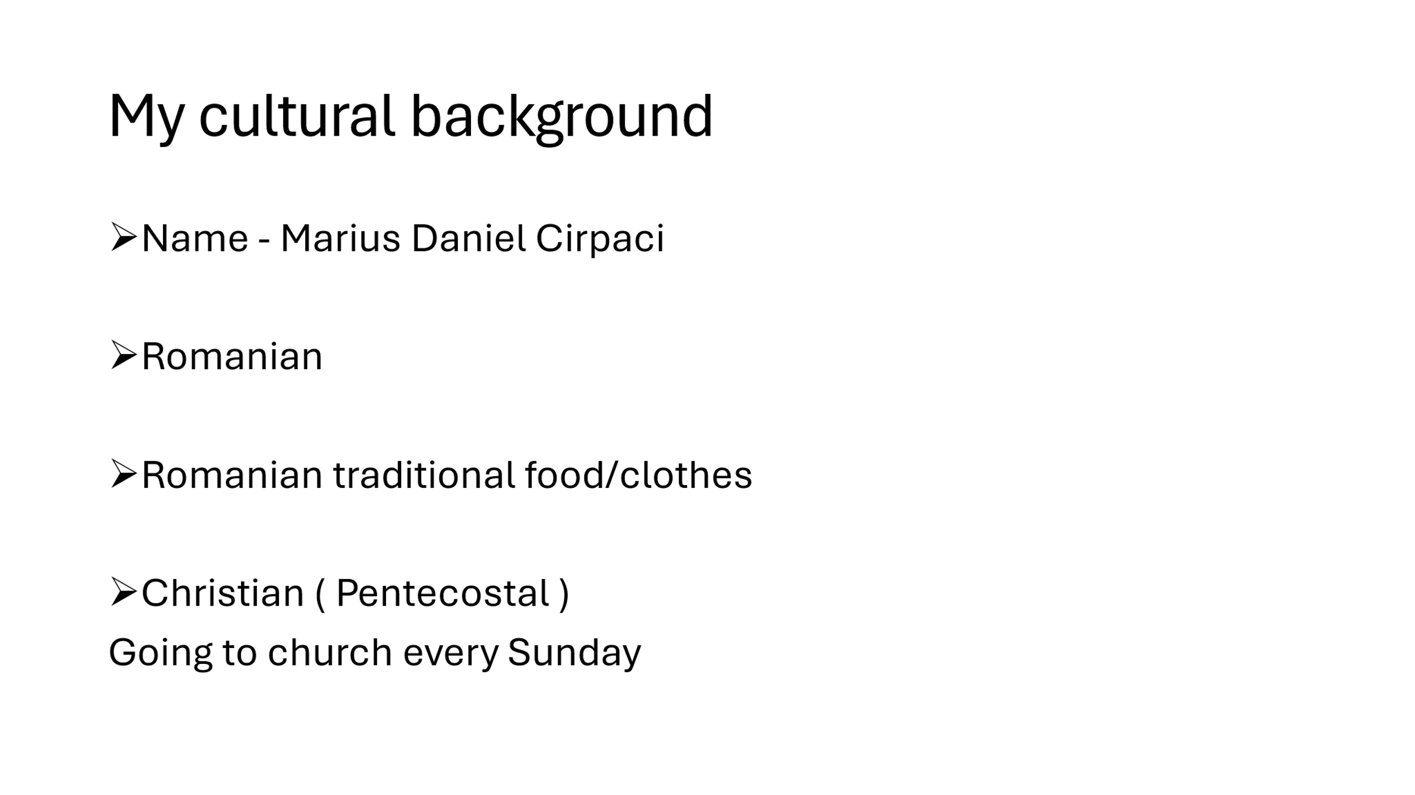
Slide 3
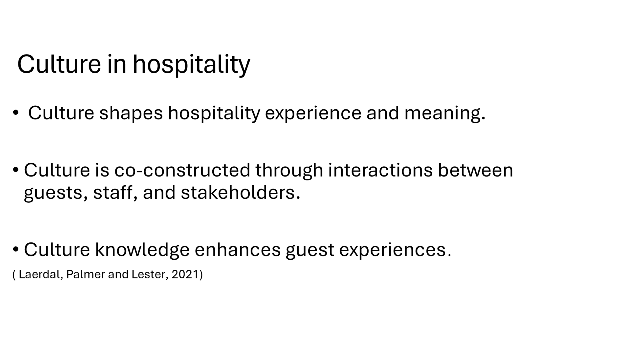
Slide 4
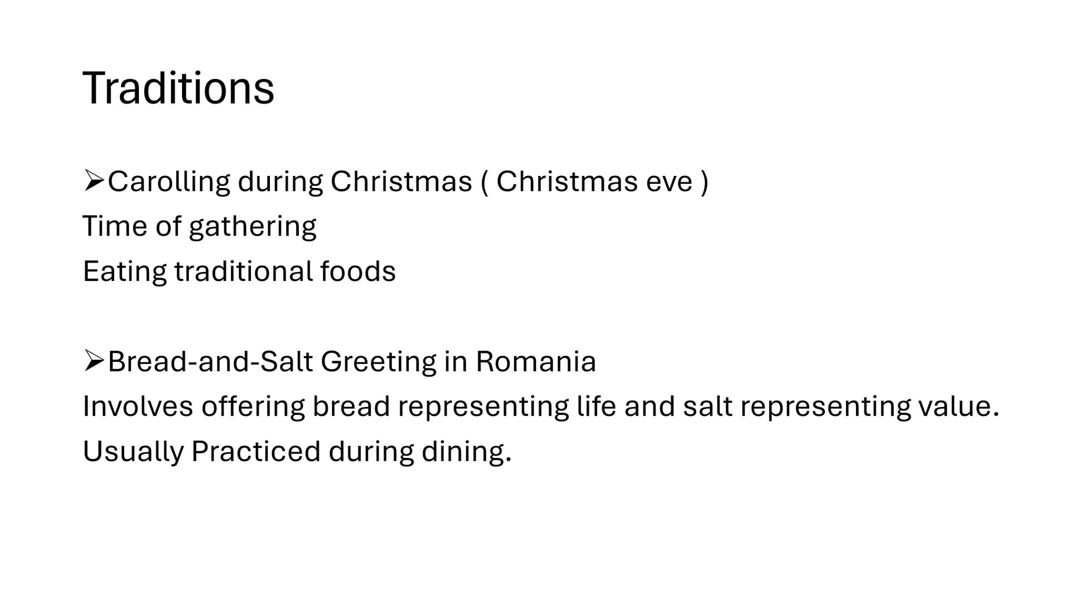
Slide 5
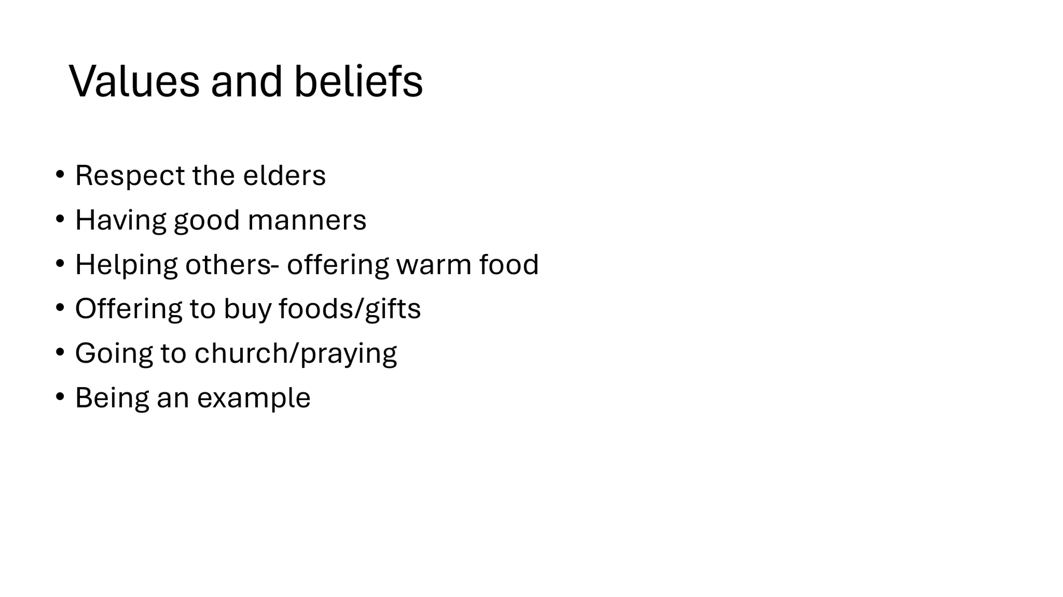
Slide 6
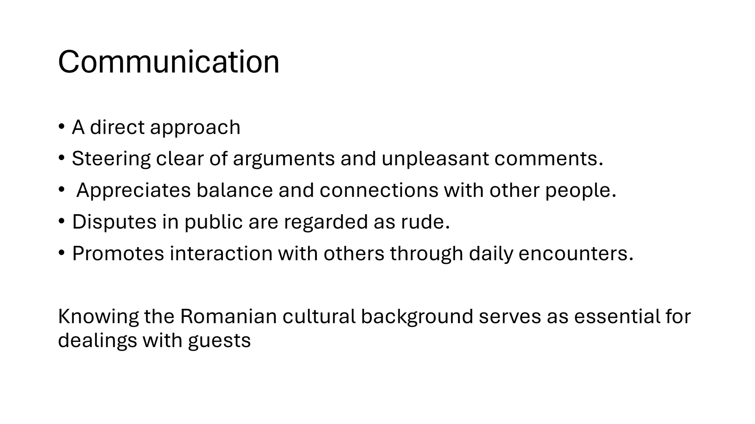
Slide 7
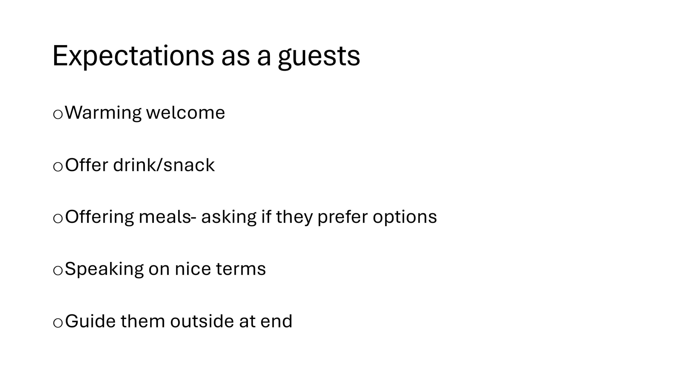
Slide 8
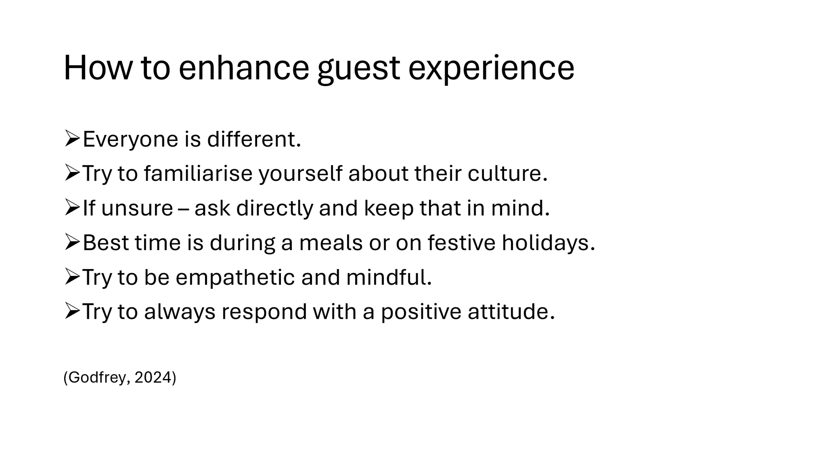
Slide 9
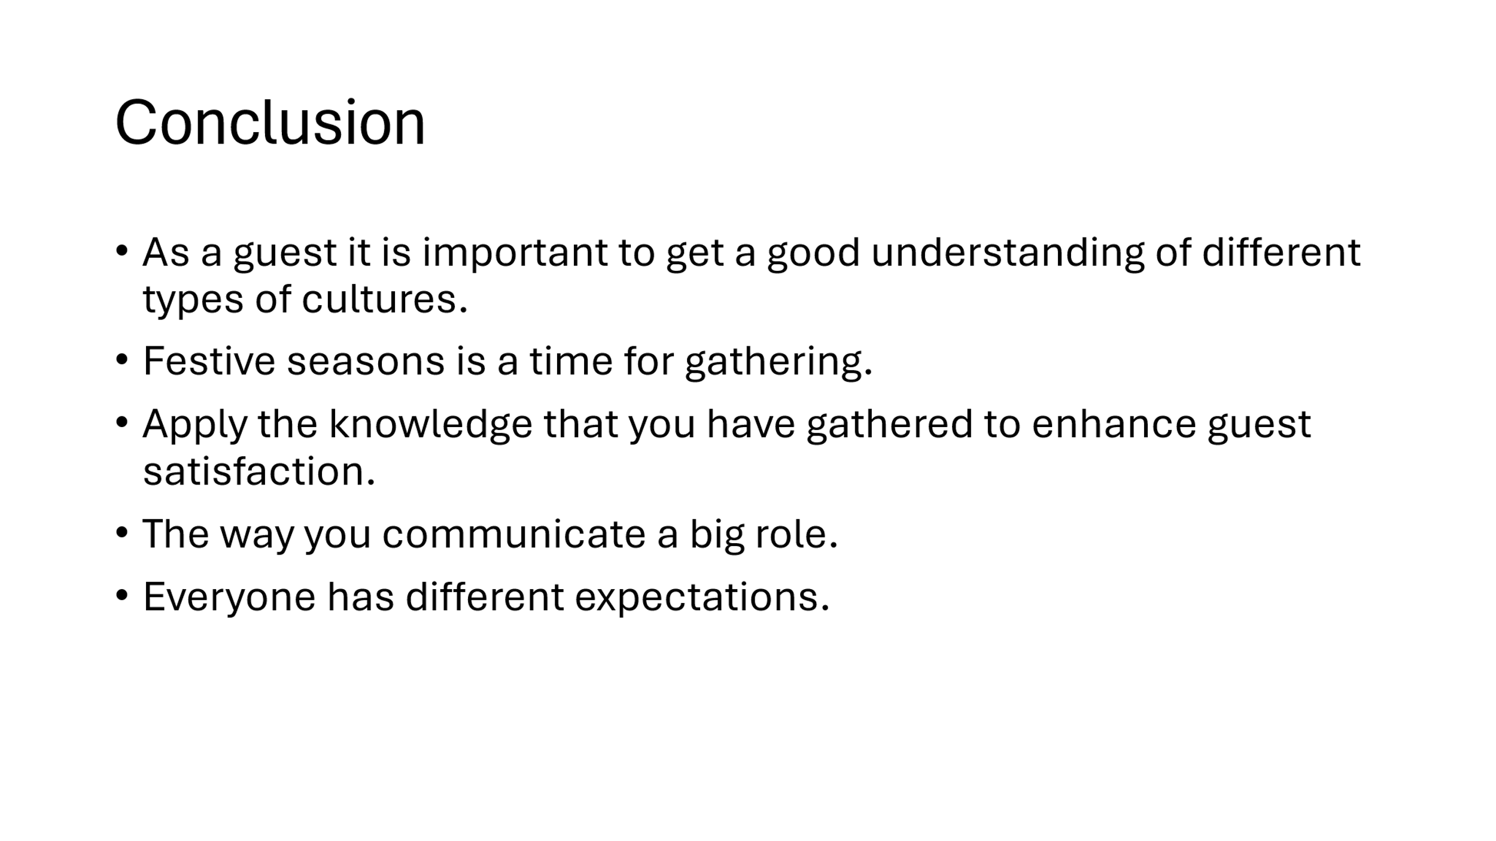
Slide 10
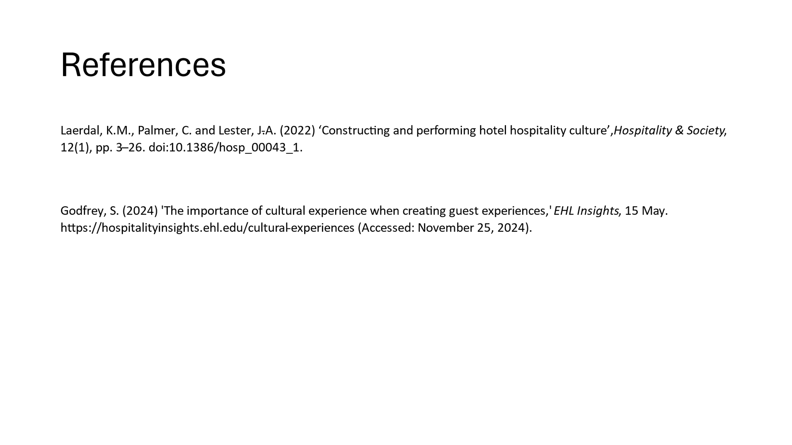
Element Six- reflective essay
Cultural diversity within organisations enhances workplace performance. Also, it introduces unique perspectives and innovative solutions. This allows organisations to comprehend diverse client bases and exchange traditions; however, it also promotes professional development. Although cultural variety can elevate a business's reputation, it also presents competitive advantages because it merges various knowledge resources, skills and viewpoints, which ultimately enhances productivity. (Alaa-Eldeen et al., 2022) My cultural backgrounds is Eastern European from Romania. I have lived there since 12 years old , after moving to the UK. As a Romanian we value family and our culture very much also, we try to keep our traditions going. But living in the UK for about 12 years, I would like to say that I have developed a Welsh culture as well by going to primary school and been around the Welsh culture. I have developed a understanding of the Welsh culture which is very beneficial in terms of interacting and communicating effectively with people on a regular basis. By having the knowledge of two different cultures, I can understand and offer the right response and also support to guests from Romanian and also from Wales which has great benefits for guest satisfaction and overall business performance in the hospitality industry. During this Module I have learnt and developed very interesting knowledge. The one specific experience that made me understand culture in more depth was in Swansea at the Dylan Thomas centre at a lecture when we had German week with Jemma. The information that she had shared with us as a German has really made me question my beliefs about other cultures and why I should always be actively listening and learning the truth behind different cultures. Most of the ways that Germans are portrayed can be very different to the actual facts. Learning about the rich history and the passion that they have for their culture and heritage is very mesmerizing. Furthermore, their passion for food and different types of dishes was also very interesting. One of the stereotypes of German culture is that they are very serios and not enjoying their time as much. This was not the case as I have come to the realisation that German are very passionate and most of them have hobbies that they do in their spare time. This moment have made me to look at people’s culture and stereotypes and are not true about a culture. In fact in 2021 Germany was ranked 7th in the world for the happiest people (Wedia, 2021). During this experience I have felt surprised and eager to learn more about different cultures. I feel that my ability has increased in term of interacting the guests from many different backgrounds and upbringings. This can have a massive effect on the guests and can create better costumer retention and also performance of your industry. I had some moments of discomfort when I have learned that a simple gesture or a simple misunderstanding can offend guests so much. One of the moment that stood out for me during this experience was the similarities between the English language to the German, which was not the expectation that I had beforehand. Progressing through the module these feelings has transformed in excitement to learn many different languages and how to communicate with guests effectively from different culture but also having to respect their cultural norms and beliefs. Also I have developed a lot of new skill over this module which will be very beneficial for my placements when working at a Hotel. I have also felt that a was judgemental and jumping to conclusion but, as we have progressed through the module those feelings transformed into understanding, respectful and fair. I think that the different types of interactions during this module were very interesting and insightful. One aspect that has worked well during interactions is that I am very empathetic towards different types of guests from many different culture and I try to experience their feelings before making any assumptions. According to (Jami, Walker and Mansouri, 2023) Empathy is essential in social relationships; it encompasses both mental and emotional understanding. This quality fosters significant connections and encourages generous behaviour. However, effective empathy entails a genuine concern for others while remaining aware of the distinctions between one's own sentiments and those of others. Although this may seem straightforward, the distinction can be complex because individuals often have varying emotional responses. I have also learnt that Power Distance score is 65/100 which means that Power is centralized in Belgium the attitude is more Formal and on a Family based Basis. Individualism had Belgium 81 which is in favour of individual and private opinions of themselves and their take of immediate family, rather than Belonging to a group. Motivation towards achievement and success is 54/100 In the middle win or lose negotiation Style. Will not be as effective in and decision process may be slower. Belgians Strive towards a winning discussion. on uncertainty and accordance it scored 94/100 which is one of the highest. this means that rules and regulations and planning are preferred. but also it is very difficult to negotiate a new set of skills . Effectively managing workplace culture requires a multifaceted approach: supervisors must become bridge builders, taking proactive measures to navigate cultural diversity. Understanding that variations in culture influence communication styles, decision-making processes and team dynamics is essential. Key strategies can involve implementing regular team discussions and workshops centred around cultural differences, as well as providing cross-cultural communication training for both employees and supervisors.

Being mindful of non-verbal cues and recognising different communication styles is critical, this awareness can enhance interactions. It’s also beneficial to avoid yes/no questions, offering options to employees instead. Furthermore, it is crucial to understand that some cultures may communicate dissent indirectly, complicating talks. The main objective is to create an environment in which cultural variety is not just tolerated, but appreciated and used for innovation and creativity. Recognising these variations and developing an effective group capable of operating peacefully, despite the multiplicity of cultural norms and expectations present in the workplace, is thus the key to success. (Masteringculturaldifferences.com, 2023) For my action plan there is a cultural sensitivity course (trainingcred.com, 2024) I think that this will help me to understand more about other cultures that perhaps I did not discuss in the lecture during this module. As I am sure that I will find many surprises in stock on this training course to help me to achieve the best potential of guest service that I can offer to enhance the satisfaction and to deal with difficult cultural experiences that and help me to offer the right support and direction to the guest.
References
Alaa-Eldeen, M., Tawfik, A., Eldaly, S. and Tag-Eldeen, A. (2022). Exploring the Growing Importance of Cultural Diversity: Case Studies of the Hospitality Industry. Athens Journal of Tourism, 9(4), pp.243–264. doi:https://doi.org/10.30958/ajt.9-4-4.

Arias, V.S. and Punyanunt-Carter, N.M. (2017). Family, Culture, and Communication. Oxford Research Encyclopedia of Communication. doi:https://doi.org/10.1093/acrefore/9780190228613.013.504.

Fărcasiu, M.A. (2024) ‘Communicating culture through hotel names: The case of the Maramureș region in Romania’, Agathos : an international review of the humanities and social sciences, 15(1), pp. 277–290. Available at: https://doi.org/10.5281/zenodo.10968245.

Galanti, G. (2008). Caring for patients from different cultures (4th ed.). Philadelphia, PA: University of Pennsylvania Press.

Han, H. (2012). The Relationship among Corporate Culture, Strategic Orientation, and Financial Performance. Cornell Hospitality Quarterly, 53(3), pp.207–219. doi:https://doi.org/10.1177/1938965512443505.

Hofstede, G. (2001). Culture’s Consequences : Comparing values, behaviors, institutions, and Organizations across Nations. Thousand Oaks, Calif. ; London: Sage.

Jami, P.Y., Walker, D.I. and Mansouri, B. (2023). Interaction of empathy and culture: a review. Current Psychology, 43(4), pp.2965–2980. doi:https://doi.org/10.1007/s12144-023-04422-6.

Li, X. and Zhang, Y. (2022). A prediction framework on the helpfulness of reviews for processing Chinese and English hotel reviews. International Journal of Contemporary Hospitality Management, 34(12), pp.4415–4437. doi:https://doi.org/10.1108/ijchm-11-2021-1384.

Lyon, A. and Sulcova, D. (2009). Hotel Employer’s Perceptions of Employing Eastern European Workers: A Case Study of Cheshire, UK. Tourism Culture & Communication, 9(1), pp.17–28. doi:https://doi.org/10.3727/109830409787556648.

Marinakou, E. and Giousmpasoglou, C. (2019). Talent management and retention strategies in luxury hotels: evidence from four countries. International Journal of Contemporary Hospitality Management, [online] 31(10), pp.3855–3878. doi:https://doi.org/10.1108/ijchm-10-2018-0862.

Masteringculturaldifferences.com. (2023). Embracing Cultural Differences in the Hospitality Industry. [online] Available at: https://www.masteringculturaldifferences.com/blog/global-diversity-series-embracing-cultural-differences-key-success-strategies-for-hospitality-professionals.

Pascual, P. (2022). 10 Effective Ways to Increase Your Cultural Intelligence (CQ). [online] Talaera. Available at: https://www.talaera.com/blog/10-effective-ways-to-increase-your-cultural-intelligence-cq.

Pearson, E. (2020). 8 reasons a French person might be staring at you. [online] The Local France. Available at: https://www.thelocal.fr/20200925/9-reasons-why-a-french-person-might-be-staring-at-you [Accessed 16 Dec. 2024].

Reddy, G. and van Dam, R.M. (2020). Food, culture, and identity in multicultural societies: Insights from Singapore. Appetite, 149, p.104633. doi:https://doi.org/10.1016/j.appet.2020.104633.

Reguieg, N.B. (2020). Cultural Conflicts At The Hotel Front Desk:, A Case Of English For Tourism. مجلة جسور المعرفة, p.663. doi:https://doi.org/10.35645/1711-006-002-045.

Segueg, C. (2023). French stereotypes: What’s true and what’s not. [online] LingoCulture. Available at: https://lingoculture.com/blog/culture/french-stereotypes/.

Sucher, W. and Cheung, C. (2015). The relationship between hotel employees’ cross-cultural competency and team performance in multi-national hotel companies. International Journal of Hospitality Management, 49(1), pp.93–104. doi:https://doi.org/10.1016/j.ijhm.2015.05.007.

Suh, J., Tosun, C., Eck, T. and An, S. (2022). A Cross-Cultural Study of Value Priorities between U.S. and Chinese Airbnb Guests: An Analysis of Social and Economic Benefits. Sustainability, 15(1), p.223. doi:https://doi.org/10.3390/su15010223.

trainingcred.com. (2024). Cultural Sensitivity for Hospitality Professionals Training Course. [online] Available at: https://trainingcred.com/training-course/cultural-sensitivity-for-hospitality-professionals-training [Accessed 16 Dec. 2024].

Trinka.ai. (2020). Trinka. [online] Available at: https://www.trinka.ai/free-proofreading-tools [Accessed 16 Dec. 2024].

Varga, P. (2023). Valuing cultural differences: Why it matters and how to do it right. [online] hospitalityinsights.ehl.edu. Available at: https://hospitalityinsights.ehl.edu/cultural-differences-why-it-matters.

Walker, B. and Soule, S.A. (2017). Changing Company Culture Requires a Movement, Not a Mandate. [online] Harvard Business Review. Available at: https://hbr.org/2017/06/changing-company-culture-requires-a-movement-not-a-mandate.

Wedia (2021). Germany ranked the seventh-happiest country in the world. [online] IamExpat. Available at: https://www.iamexpat.de/lifestyle/lifestyle-news/germany-ranked-seventh-happiest-country-world.

