BA International Hotel Management
Financial Management for the Hotel Industry
Student Name:Alexandra Elena Vlad
Student Id:2118684
Lecturer:Chris Wilkin
Executive Summary
The report has reflected the various financial aspects of two selected hospitality sectors. A detailed background of both hotels has been analysed in the first chapter of this report. This report has also focused on the financial management of two selected organisations from the hotel industry. Different areas of financial management include total revenue, market position, assets, growth potential, and financial commitment to CSR. The report has also highlighted the comparison of the cash flow statements between IHG and Hyatt Hotels. After discussing the different areas of financial management, a list of recommendations has been provided in this assignment. The conclusion of the report has summarised all key findings from the selected companies.

Table of Contents
1. Introduction 4
2. Background of both organisations 4
2.1 Background overview of Intercontinental Hotels Group (IHG) 4
2.2 Background details of Hyatt Hotels 5
3. Financial comparison 5
4. Recommendations 11
5. Conclusion 12
References 13

1. Introduction
International hotel management is a study that deals with operational activities and delivery of services in international hospitality sectors globally. International hotel management study provides vast knowledge about the financial management of hospitality sectors. The purpose of the report is to understand the informational requirements for the financial management of hotels. Intercontinental Hotels Group and Hyatt Hotels have been selected for this report as the comparison between their financial aspects will be evaluated. The report will also highlight some recommendations for both hotels to improve their business growth. Additionally, one recommendation will be rationalised in this paper in an effective way.

2. Background of both organisations

2.1 Background overview of Intercontinental Hotels Group (IHG)
IHG is a UK-based hotel chain founded in 1946 by Juan Trippe in Denham, England. It is one of the biggest and leading hotel companies in the world. The number of employees working in IHG is around 345,000 (IHG, 2023). The hospitality chain consists of 17 brands including Holiday Inn, Regent, Voco, Crowne Plaza, Six Senses, and Hotel Indigo. IHG operates and franchises more than 6,179 hotels and resorts including 914,928 rooms in more than 100 countries across the world (IHG, 2023). As per the report of Pitchbook (2022), the USA accounts for around 57% of the total rooms of IHG while China represents around 18% of room occupancy. Around 25% of the total rooms of IHG have been occupied by Europe, the Middle East, Asia, and Africa. IHG delivers true hospitality services to more than millions of customers across the world. The current market cap of IHG is around £9.4 billion in 2023 (Macrotrends, 2023).

2.2 Background details of Hyatt Hotels
Hyatt is a U.S.-based global hospitality brand headquartered in Chicago, North America. The hotel chain was founded in 1954 by Jack Dyer Crouch. However, in 1957, Jay Pritzker bought the original Hyatt House motel. As of 2021, the number of hotels in Hyatt was more than 1,150 in 70 countries across the world. According to Hyatt (2021), the number of employees working for Hyatt was more than around 130,000. The current market cap of Hyatt Hotels is around £9.96 billion as of 2023 (Macrotrends, 2023). Hyatt operates in the US, France, Germany, Finland, Indonesia, Hong Kong, Ireland, Italy, the UK, Japan, and China (Hyatt, 2021). Hyatt Hotels has various brands including Grand Hyatt, Park Hyatt, UrCove, Hyatt House, Hyatt Regency, Hyatt Place, and Hyatt Residence Club (Hyatt, 2021).

3. Financial comparison
Basis | Intercontinental Hotels Group (IHG) | Hyatt Hotels
Total revenue | According to Statista (2022), IHG Groups generated £1.46 billion in revenue in 2022. The maximum revenue generated by this hotel group was £1.65 billion in 2019. After 2016, their revenue is increasing gradually up to 2019 but the emergence of the pandemic has reduced the revenue to £0.8 billion in 2020 only. A little fluctuation could be observed from Figure 1 indicating IHG could achieve more stability in their total revenue. | According to Statista (2022), Hyatt generated £4.68 billion in revenue in 2022 which is a 95% increase from the previous year’s revenue. According to ‌ Macrotrends (2022), the organisation generated £4.67 billion in revenue in 2021. The percentage of increase in revenue was lowest in 2020 due to the emergence of COVID-19. Figure 2 is showing stability in their income from 2010 to 2023 without the specific period of the pandemic. Compared with the IHG hotel group, the revenue of Hyatt is greater.
Market position | According to ‌ Macrotrends (2022), IHG Hotels Group has a market capitalization of £9.48 billion in May 2023. This hotel group has acquired the 1286th position worldwide in terms of valuable company. The percentage of change in their market capitalisation in 2023 compared to 2022 is 16.76%. Their market capitalisation was £8.12 billion in 2021. According to ‌Companiesmarketcap (2023), the difference between IHG Groups and Hyatt Hotels in terms of market capitalisation is 4.01% in 2023. IHG Group is one of the leading brands with over 3,00,000 employees all over the world. They operate in over 100 countries and focus on trying true hospitality (‌Kim et al., 2019). | According to ‌CSI Market (2023), Hyatt has an 8.24% market share in the fourth quarter of 2022 compared to its big competitors such as IHG, Hilton, Marriott International and others. Hyatt has a 10.45% market share in the same time within the hotels and tourism industry. This indicates a great market positioning of the hotel organisation. Even in the service sector, the share of Hyatt is highest with 10.33% in 2022. According to ‌CSI Market (2023), it has a market capitalisation of £9.87 billion in 2022. This hotel group has acquired the 1250th position worldwide in terms of valuable company. According to ‌Companiesmarketcap (2023), the change in the market capitalisation was 28.42% in 2023 compared to 2023.
Assets | Intercontinental Hotels Group has a total asset of £3.35 billion in 2022. Their assets were £3.74 in 2021 which was greater than 2022 (Statista, 2022). A small decrease in goodwill and other tangible resources could be seen from their balance sheet. They have £1195 million in goodwill and other tangible resources in 2021 which reduced to £1144 million in 2022 (‌Kim et al., 2019). | The assets of Hyatt include cash and equivalent, restricted cash, short-term investment, receivables, inventories, prepaid and other assets along with prepaid income taxes. Additionally, equity method investments, property equipment, financial receivables, tangible resources, and goodwill are also included in the assets of Hyatt. Their total current assets were £1635.48 million in 2021 whereas they became £1784.6 million in 2022 (Statista, 2022).
Growth potential | According to Simplywall (2023), the earning growth rate of IHG is 16% along with an EPS growth rate of 23%. The forecasted annual revenue rate of IHG will be £1.85 billion per year by 2025. There is also a growth potential for IHG with an annual earning rate of £586.96 million per year by 2025 as shown in Figure 3. However, the revenue of IHG is expected to decline by -3.1% per year for the next 3 years. That means the growth potential of annual revenue in IHG is estimated as lower than Hyatt Hotels. | As per the report of Simplywall (2023), the current earnings growth rate of Hyatt Hotels is 6.8%. The EPS growth rate of Hyatt Hotels is around 13.9% in 2023. The annual revenue growth of Hyatt Hotels has been forecasted to be increased with a £5.96 billion per year revenue growth rate by 2025. The annual earnings growth rate of Hyatt Hotels has been estimated at £348.28 million per year by 2025. The revenue of Hyatt Hotels has forecasted to increase by 9.8% per year. This means the growth potential of Hyatt is higher than IHG in terms of annual revenue growth.
Financial commitment to CSR | IHG donated around £1.51 million capital amount to community-based projects. The hotel chain has also committed to improving the lifestyles of around 30 million people across the world by providing financial and social support. In 2022, the OzHarvest partnership team of IHG donated around 228,794 meals to local communities. IHG has saved around £5.56 amount for every £0.79 which was invested in preventing food waste (IHG, 2022). IHG also delivered around 57,000 hours of volunteering dedicated to community-based projects in ‘Giving for Good’ month in 2022 (IHG, 2022). | In 2018, the total amount of donations of Hyatt was estimated at £7.79 million (Hyatt, 2019). Among this, corporate hotels donated around £3.97 million, Hyatt Hotels Foundation donated around £0.45 million, and Hyatt Community donated £0.29 million in grants in 2018. Around 11,000 employees of Hyatt volunteered over 150,000 hours in 46 countries in 2018. Hyatt also responded during disasters by donating around £0.1 million to the global disaster relief fund for supporting affected communities across the world (Hyatt, 2019).
Cash flow statement | According to the annual report of IHG (2022), the hotel chain generated around £763.87 million in cash in 2022, compared to £89.82 million higher than in 2021. The adjusted free cash flow of IHG was an inflow of £449.08 million which was consistent with the prior year of 2021 with £453.85 million. The net cash flow of IHG before the movements of other net debt was £146.15 million in 2022. During COVID-19, the Committee of IHG decided to use the maximum amount of £870 million which reflects the exceptional performance of IHG regarding the management of cash flow (IHG, 2022). | The cash flow of Hyatt Hotels from operating activities has resulted in a growth of £285.42 million in 2022, compared to 2021. Hyatt Hotels also received around £201.95 million refund in cash due to the loss carryback claim. The claim was received under the provision of the ‘CARES’ (Coronavirus Aid, Relief, and Economic Security) Act in 2021. As per the financial report of Hyatt (2022), the hotel chain received around £85.85 million of net cash from short-term investments and marketable security sales.
Table 1: Financial comparison for Intercontinental Hotels Group (IHG) and Hyatt Hotels
(Source: Author)
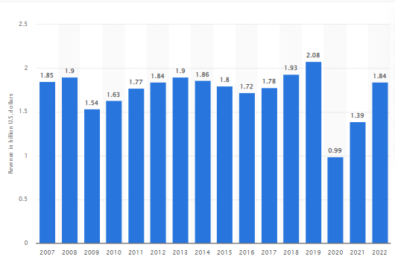
Figure 1: Total revenue of InterContinental Hotels Group (IHG) (2007-2022)
(Source: Statista, 2023)
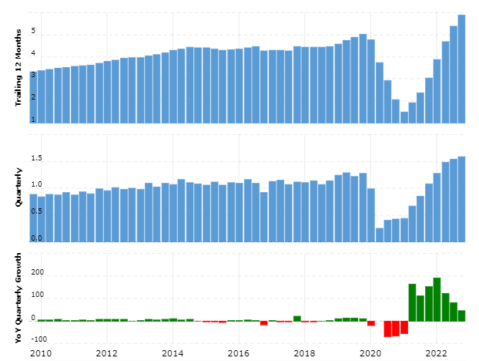
Figure 2: Total revenue of Hyatt (2010-2022)
(Source: Macrotrends, 2023)
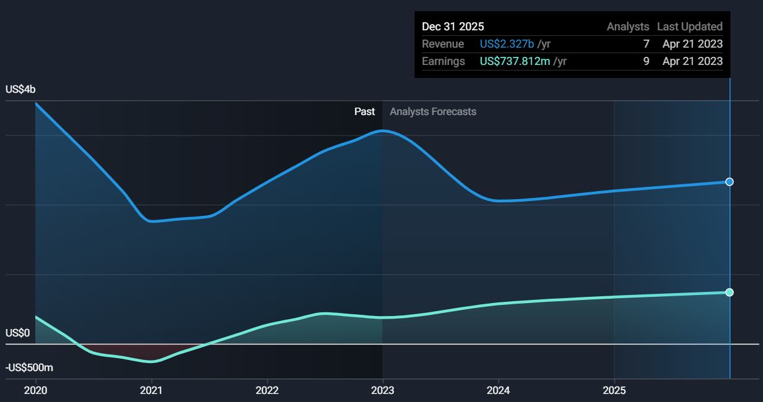
Figure 3: Growth potential of IHG
(Source: Simplywall, 2023)
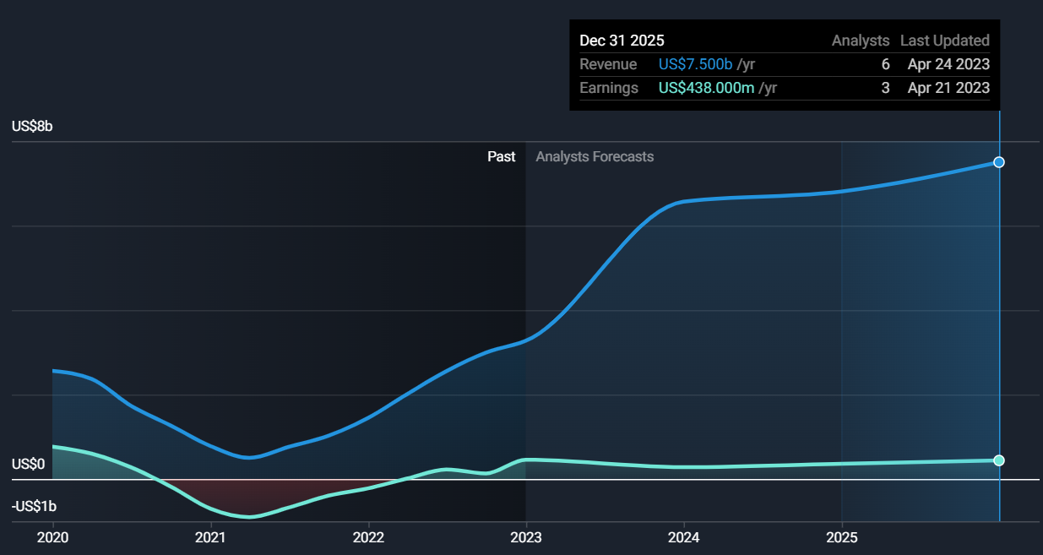
Figure 4: Growth potential of Hyatt Hotels
(Source: Simplywall, 2023)

4. Recommendations
Recommendation 1: Growth opportunities
IHG requires focusing more on those areas where a high-growth market prevails. The fluctuating total revenue could be adjusted by investing in opportunistic destinations in different countries. Thus, loss in a region could be adjusted by the revenue of other regions. Similarly, they could also invest in luxury sectors, mixed-use of properties and long-stay options which are now trending as staycation. Hyatt could reduce the price as they follow a premium pricing strategy which will help them to gather more customers for themselves.
Recommendation 2: Potential for outsourcing
Outsourcing has become a great option which could be useful for both IHG and Hyatt hotels. This means subcontracting with a third-party company to provide service. This service could be both temporary or permanent. Both IHG and Hyatt hotels could provide food options to their customers from big brands or famous local restaurants as well. As an example, they could provide coffee from Starbucks, pizza from Domino, and in the hotels of the UK, they also could offer different snacks from Costa Coffee, Pret A Manger and others.
Recommendation 3: Enhancing human resources
Hyatt has only 1,89,000 employees whereas IHG Hotels has 3,25,00 employees. Hyatt is one of the most renowned hotel brands in the world henceforth they could enhance human resources to provide more improved customer service. They need to ensure the staff know to use the newest technology and have good communication skills. Similarly, IHG Hotels could use different technology in their hotels to reduce their dependence on human power. Self-checkout systems, robotics technology and many more are there which could reduce their operational cost by reducing the number of employees.
Recommendation 4: Enhancing the acceptance in the market
Both hotels could enhance digital marketing strategies such as Search Engine Optimisation, using tools like Google Analytics, and provide rewards for booking their hotels. This will make more customers aware of the service and they will book at their hotels as well.

5. Conclusion
This report has focussed on IHG Hotel Groups and Hyatt for comparing their financial elements. The first part of this report has described the background of both of the organisations whereas the next part described various elements of financial management. This includes total revenue, market position, assets, growth potential, and financial commitment to CSR. The above discussion has demonstrated that both hotel organisations are quite strong and well-known brands all over the world. Comparatively, the financial position and assets of Hyatt are more than the IHG Groups Hotel.

References
‌Companiesmarketcap, (2023). Hyatt Hotels (H) - Market capitalization. Available at: https://companiesmarketcap.com/hyatt/marketcap/ [Accessed 5 May 2023]
‌CSI Market, (2023). Hyatt Hotels Market share relative to its competitors, as of Q4 2022. Available at: https://csimarket.com/stocks/competitionSEG2.php?code=H [Accessed 5 May 2023]
Hyatt, (2019). Corporate Responsibility Highlights 2018/2019. Available at: https://about.hyatt.com/content/dam/HyattStories/thrive/2018-2019-CR-Highlights-Hyatt.pdf [Accessed 05 May 2023]
Hyatt, (2021). About Hyatt. Available at: https://about.hyatt.com/ [Accessed 05 May 2023]
Hyatt, (2022). 2022 Annual Report on Form 10-K. Available at: https://d18rn0p25nwr6d.cloudfront.net/CIK-0001468174/5e44d5ec-2de4-4041-8087-3c9f4bcc6f65.pdf [Accessed 05 May 2023]
IHG, (2022). Annual Report and Form 20-F 2022. Available at: https://www.ihgplc.com/en/-/media/ihg/annualreports/2022/annual-report-2022.pdf [Accessed 05 May 2023]
IHG, (2022). Responsible Business Report 2022. Available at: https://www.ihgplc.com/en/-/media/ihg/files/responsible-business/2022-rbr/ihg-responsible-business-report-2022.pdf?la=en&hash=115A33AF9BD435895B864E3DE019AE1C [Accessed 05 May 2023]
IHG, (2023). About Us. Available at: https://www.ihgplc.com/en/about-us [Accessed 05 May 2023]
‌Kim, Y.H., Barber, N. and Kim, D.K., (2019). Sustainability research in the hotel industry: Past, present, and future. Journal of Hospitality Marketing & Management, 28(5), pp.576-620.
‌Macrotrends, (2022). Hyatt Hotels Revenue 2010-2022. Available at: https://www.macrotrends.net/stocks/charts/H/hyatt-hotels/revenue [Accessed 5 May 2023]
Macrotrends, (2023). Hyatt Hotels Market Cap 2010-2022. Available at: https://www.macrotrends.net/stocks/charts/H/hyatt-hotels/market-cap [Accessed 05 May 2023]
Macrotrends, (2023). Intercontinental Hotels Group Market Cap 2010-2022. Available at: https://www.macrotrends.net/stocks/charts/IHG/intercontinental-hotels-group/market-cap [Accessed 05 May 2023]
PitchBook, (2022). InterContinental Hotels Group. Available at: https://pitchbook.com/profiles/company/10981-18#overview [Accessed 05 May 2023]
Simplywall, (2023). Future Growth. Available at: https://simplywall.st/stocks/us/consumer-services/nyse-ihg/intercontinental-hotels-group/past [Accessed 05 May 2023]
Simplywall, (2023). Hyatt Hotels Future Growth. Available at: https://simplywall.st/stocks/us/consumer-services/nyse-h/hyatt-hotels/future [Accessed 05 May 2023]
Statista, (2022). IHG revenue worldwide 2022. Available at: https://www.statista.com/statistics/273254/revenue-of-the-intercontinental-hotels-group/#:~:text=UK%2Dbased%20multinational%20hotel%20company,of%201.39%20billion%20U.S.%20dollars. [Accessed 5 May 2023]
Statista, (2022). IHG total assets worldwide 2022. Available at: https://www.statista.com/statistics/223404/total-assets-of-the-intercontinental-hotels-group/ [Accessed 5 May 2023]

