

Cover Page

Component 1 – Online Portfolio of Set Exercises

Name and Student Number: Andreea-Catalina Paun 1919504

Module Code and Assignment Title: Component 1 – Online Portfolio of Set Exercises

Task 1 – Personal Brand
Write about your own person brand and how you could develop this to enable you to reach your employment goals (250 words- Minimum of 2 referenced sources)

Personal branding is the process by which people convey to others their professional identity, values, and skills. A good personal brand in the health and social care sectors involves more than just self-promotion; it also involves exhibiting professionalism, integrity, and a dedication to person-centred practice. Employers are looking for graduates who can demonstrate both technical expertise and transferable abilities including teamwork, communication, and resilience (Tomlinson, 2017).
Compassion, responsibility, and ongoing development are at the core of my personal brand. Effective health and social care providers, in my opinion, should combine empathy with evidence-based practice to deliver high-quality care that respects people's autonomy, dignity, and cultural variety. Over the course of my degree, I have gained more self-assurance in my ability to interact with people, collaborate with others, and comprehend the moral obligations involved in helping those in need.
Despite the fact that these strengths offer a strong base, I understand that employability necessitates ongoing improvement. By participating in Continuing Professional Development (CPD), attending training pertinent to mental health and safeguarding, creating a professional LinkedIn profile, and actively looking for opportunities to obtain real-world experience in health and social care settings, I hope to strengthen my professional identity. Making connections with academics, medical professionals, and professional associations will also assist me in expanding my understanding of the business and locating potential career paths.
Another crucial component of my personal brand is the development of emotional intelligence. Professionals with emotional intelligence are able to control their own feelings while sympathetically attending to the requirements of coworkers and service users. According to research, emotional intelligence enhances leadership, teamwork, and communication in healthcare environments (Mayer, Caruso, and Salovey, 2016). I want to become a thoughtful practitioner that upholds the highest professional standards while providing safe, compassionate, and person-centred care by further developing these qualities in addition to my academic knowledge.
Task 2 - Network Map and Rationale
Create a map of your own network considering career, support, social and community dimensions. Additionally you should provide a supporting rationale explaining and critically assessing this (250 words-Minimum of 2 referenced sources).

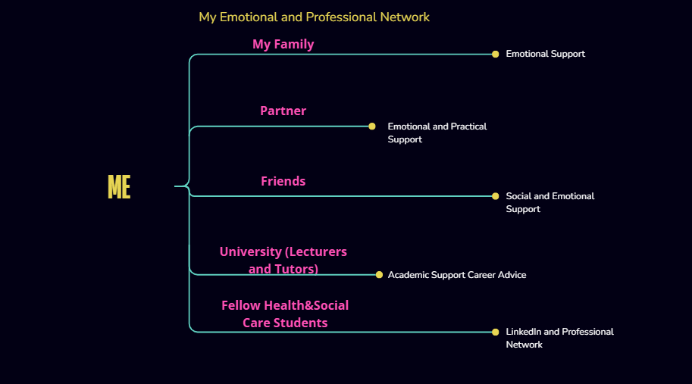

Because it offers chances for learning and employment, emotional support, and information access, a professional network is crucial for career growth. Since I am a student of health and social care and currently work full-time outside of the field, my network is still growing at this point in my career. Nonetheless, I am aware that my future employability is influenced by both personal and professional relationships.
I am able to manage a full-time job and academic pursuits because to the practical and emotional support of my family, partner, and close friends. Their assistance keeps me inspired during stressful times and strengthens my resilience, which is acknowledged as a crucial employability quality in the health and social care sectors (Jackson and Tomlinson, 2020).
From an academic standpoint, my instructors and tutors are a vital component of my network since they offer helpful criticism, direction, and career counsel. By exchanging educational experiences, debating scholarly subjects, and promoting group problem-solving, fellow students also contribute significantly. Collaborating with others fosters the development of collaboration and communication skills, which are highly sought after in the health and social care sector.
I intend to grow my network by setting up a professional LinkedIn profile, going to university career events, and interacting with organisations like Skills for Care and NHS Careers, even though I presently have few professional contacts in the industry. These resources offer useful information regarding job prospects, professional growth, and career trajectories.
According to Granovetter (1973), "weak ties"—like professional acquaintances—often offer access to new information and job chances that are not possible through strong personal relationships. Therefore, expanding my professional network will be crucial to assisting me in making a smooth transition into a career in health and social care, even though my current network is primarily focused on personal support.

Task 3- Blog
Write a blog exploring a current topic or issue of your choice within the health and social care sector in the UK. The purpose of this is to inform a specific target audience of your choosing (400 words) Referencing of your sources of information is not a compulsory requirement but could be beneficial.

Why the NHS Workforce Crisis Matters to Every Future Health and Social Care Professional
Target audience: Health and Social Care students and newly qualified professionals
People frequently envision improving people's lives when they choose a career in health and social care. Although this is still the case, today's workforce is dealing with serious issues that have an impact on both employee well-being and the standard of patient treatment. The lack of healthcare experts is one of the biggest problems the NHS is now dealing with.
NHS England (2024) claims that a lack of workers has put more strain on current employees, resulting in greater workloads, stress, and lengthier patient wait times. In the UK, community services, care facilities, and mental health services are all impacted by these issues in addition to hospitals. Understanding these challenges is crucial for us as future professionals since we will be part of the team that is in charge of providing safe and efficient care.
The rising demand for social and health care services is one of the primary reasons for personnel shortages. As the population of the UK ages, more people have chronic illnesses and need continuous care. Due to workload pressures, fatigue, and limited career advancement, many seasoned workers have left the industry, making recruiting and retention more challenging.
There are reasons to be hopeful in spite of these difficulties. In addition to increasing educational options and enhancing career development routes, the NHS Long Term Workforce Plan lays out ambitious initiatives to attract, educate, and retain more healthcare professionals (NHS England, 2024). Over the future years, investments in professional development, digital technologies, and apprenticeships are intended to build a more sustainable workforce.
It is also our duty as students of health and social care to get ready for these changes. We may thrive in challenging healthcare settings by cultivating strong communication skills, emotional intelligence, resilience, and a dedication to lifelong learning. Since successful teamwork is essential to providing high-quality treatment, fostering great connections with coworkers and accepting multidisciplinary working are equally crucial.
Every aspiring healthcare worker has the chance to make a good contribution, even when staffing shortages cannot be resolved quickly. We can contribute to the development of a more robust and caring health and social care workforce in the future by upholding professionalism, encouraging colleagues, and continuing to advance our knowledge and abilities.

Task 4- NHS Equality, Diversity and Inclusion Quiz (250 words equivalent)
- What is the primary goal of the NHS Equality, Diversity, and Inclusion Improvement Plan?
(Answer in one or two sentences.)

Regardless of background or protected characteristics, the main goal is to establish a fair, inclusive, and courteous workplace where all NHS employees have equal opportunity (NHS England, 2023).
- How does the NHS EDI Improvement Plan propose to tackle the gender pay gap?
(Answer in one to two sentences.)
In order to detect and lessen wage disparities, the plan supports equitable hiring, open promotion procedures, leadership development, and routine workforce data monitoring.
- What is meant by the term ‘intersectionality’ as used in the NHS EDI Improvement Plan?
(Answer in one to two sentences.)
Intersectionality recognises that people may encounter various and overlapping types of discrimination based on traits such as ethnicity, disability, age, gender or sexual orientation.
- Why is it important for the NHS to create a psychologically safe work environment?
(Answer in one to two sentences.)
Psychological safety improves learning, staff wellbeing, and patient safety by allowing employees to freely discuss issues, errors, and ideas without fear of prejudice or blame

- How does the NHS EDI Improvement Plan suggest improving the experience of internationally recruited staff?
(Answer in one to two sentences.
To make globally hired employees feel included and appreciated, the proposal suggests more pastoral assistance, professional development possibilities, mentoring, and organised induction programs.
- What role does leadership play in advancing EDI objectives according to the NHS Improvement Plan?
(Answer in one to two sentences.)
It is expected of leaders to set an example of inclusive behaviour, confront discrimination, advance justice, and guarantee accountability for equality goals across their businesses.
- Identify one way the NHS EDI Improvement Plan aims to reduce health inequalities within the workforce.
(Answer in one to two sentences.)
The NHS wants to give employees from under-represented groups better equal access to hiring, training, advancement, and leadership opportunities.
- Why does the NHS EDI Improvement Plan emphasise the importance of collecting and analysing data on protected characteristics?
(Answer in one to two sentences.)
Organisations can monitor progress, uncover disparities, and create evidence-based initiatives to increase inclusion by gathering workforce data.
- Explain how flexible working policies can contribute to equality and inclusion in the NHS workforce.
(Answer in one to two sentences.)
Flexible work arrangements improve employee well-being, retention, and equality by enabling workers to manage work with caregiving obligations, needs linked to disabilities, or personal situations.
- What is one strategy mentioned in the NHS EDI Improvement Plan to combat bullying and harassment in the workplace?
(Answer in one to two sentences.)
To foster respectful workplaces, the NHS encourages transparent reporting protocols, caring leadership, staff assistance, and swift action against inappropriate behaviour.

Task 5- A Letter to Yourself
Think of a time in the past when you may have been experiencing issues or difficulties, and after considering what you have learned in this module about emotional intelligence and resilience write a letter to your younger self explaining how these attributes were important at that time and perhaps how developing these areas could have been useful (300 words)

Dear Younger Me,

If I could travel back in time and talk to you during one of the most trying times in your life, I would tell you that adversity does not define who you are; rather, it shapes the person you will become. Instead of acknowledging the qualities you were growing in, including resilience, tenacity, and empathy, you frequently concentrated on what was going wrong at the time.

Studying health and social care has taught me the value of emotional intelligence, among other things. In retrospect, you might have been better able to handle stress if you had understood your own feelings rather than dismissing them. Avoiding unpleasant emotions is not the goal of emotional intelligence; rather, it involves identifying them, comprehending their causes, and reacting to them in a productive and healthy manner. You would have been able to make judgments with more assurance and express your opinions to those around you more honestly if you had become more self-aware.

Another trait that I now value much more than I did in the past is resilience. There were moments when you thought that setbacks equated to failure. I now realise that resilience is adjusting to difficulties, taking lessons from past mistakes, and carrying on in spite of setbacks. Every challenging event has helped me become more self-assured and mature.

As I get ready to pursue a profession in health and social care, I see how important these attributes are for both my personal well-being and helping others. Healthcare providers frequently assist people who are dealing with illness, bereavement, and uncertainty. Understanding ourselves and developing excellent pressure management skills are prerequisites for providing compassionate care.
My advice is straightforward: practise self-compassion. Never undervalue your capacity to improve, ask for assistance when you need it, and learn from your mistakes rather than being afraid of them. The difficulties you encounter now will become the experiences that enable you to assist others in the future.

Keep becoming the person you once needed,

Your future Self

Task 6- GANTT Chart (200 words equivalent)
Compile a Gantt chart which illustrates the tasks you have to complete to achieve your future employment goals

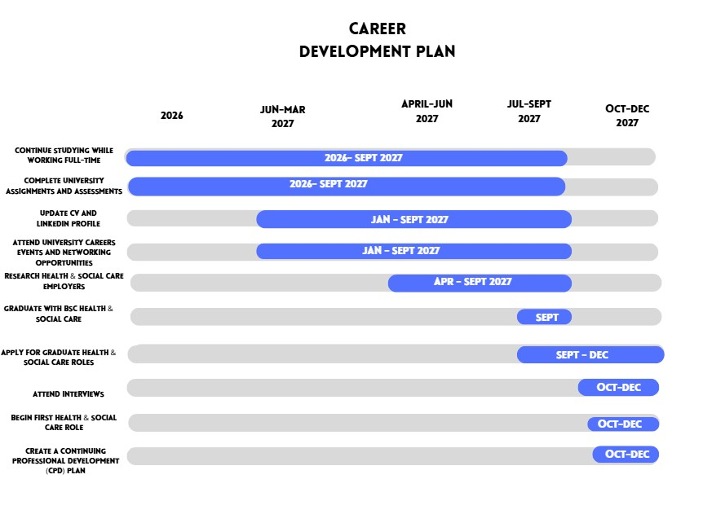

This Gantt chart shows my current situation as well as practical initiatives I may take to reach my long-term career goal in the health and social care industry. My top objective right now is finishing my degree in September 2027 because I am a full-time student working outside of the healthcare industry. Effective time management, organization, and resilience are necessary for juggling work and school, and employers respect these transferable qualities.
By updating my resume, creating a LinkedIn profile, and going to university career events to learn more about job options in the industry, I hope to increase my employability prior to graduation. In order to find positions that align with my hobbies and professional goals, I also intend to investigate several organisations.
I'll start applying for graduate jobs in health and social care after I graduate. I will study person-centred care concepts, professional values, and current NHS priorities throughout this time to get ready for interviews. After I start working, I want to finish all required training and create a plan for Continuing Professional Development (CPD) so that I may keep improving my knowledge and professional skills throughout my career.
This schedule is realistic since it takes into account my current educational level and acknowledges that building a successful career necessitates incremental preparation, lifetime learning, and continuous professional development.

Task 7- Making Changes- Report
You are the manager of a care home and want to make changes your workplace. Identify one specific change that you want to implement and write a brief report on how this is going to be achieved considering the necessary skills needed and addressing possible barriers to success. Relevant change models can be highlighted (350 words Minimum of - 3 referenced sources).

Implementing a Digital Handover System in a Residential Care Home
Introduction
In order to provide safe, person-centred care, staff members must effectively communicate with one another. Inadequate communication during shift handovers can lead to inconsistent care, prescription errors, and lost information. I would implement a digital handover system as the recently hired manager of a residential care facility in order to boost continuity of care, decrease documentation errors, and increase communication.
Implementing the Change
I would use Kotter's Eight-Step modification Model (Kotter, 1996) to successfully implement this modification. The first step would be to demonstrate how a digital system may enhance resident safety and provide proof of communication problems in order to create a sense of urgency. In order to promote shared ownership of the project, I would then assemble a directing team of senior carers, nurses, and administrative personnel
Before the new system was put into place, staff members would have hands-on training to make sure they felt comfortable using it. Regular meetings would enable staff members to voice concerns, offer suggestions, and pinpoint any real-world challenges. Maintaining motivation and promoting long-term adoption would be facilitated by acknowledging early achievements, such as increased documentation accuracy and favourable employee feedback.

Skills Required
Successful implementation of this shift would require a number of leadership abilities. Staff members would comprehend the change's goal and the advantages for the residents if there was effective communication. Leadership and teamwork would stimulate collaboration throughout the diverse team, while problem-solving abilities would help resolve unexpected obstacles during implementation. Because employees may experience uncertainty and worry as a result of change, emotional intelligence would also be crucial. Maintaining trust during the process would be facilitated by exhibiting empathy and paying attention to concerns.
Potential Barriers
Resistance to change is one of the biggest obstacles, especially for employees who are not accustomed with digital technologies. Some workers could be concerned that technology would replace long-standing habits or increase workload. Implementation may also be delayed by a lack of funding and time. Phased implementation, continuous training, and clear leadership support could all help lower these obstacles.
Conclusion
Implementing a digital handover system could enhance staff productivity, patient safety, and communication at the assisted living facility. In addition to implementing new technology, successful organisational transformation also requires staff engagement, suitable support, and strong leadership throughout the implementation process. Organisations can enhance the quality of care provided to residents and the experiences of their employees by implementing structured change management techniques.

Reference List

Granovetter, M.S. (1973) ‘The Strength of Weak Ties’, American Journal of Sociology, 78(6), pp. 1360–1380.
Jackson, D. and Tomlinson, M. (2020) ‘Investigating the relationship between career planning, proactivity and employability perceptions among higher education students’, Journal of Education and Work, 33(5–6), pp. 365–381.
Kotter, J.P. (1996) Leading Change. Boston: Harvard Business School Press.
Mayer, J.D., Caruso, D.R. and Salovey, P. (2016) ‘The Ability Model of Emotional Intelligence: Principles and Updates’, Emotion Review, 8(4), pp. 290–300.
NHS England (2023) NHS Equality, Diversity and Inclusion Improvement Plan. Available at: https://www.england.nhs.uk/long-read/nhs-equality-diversity-and-inclusion-improvement-plan/ (Accessed: 4 July 2026).
NHS England (2024) NHS Long Term Workforce Plan. Available at: https://www.england.nhs.uk/publication/nhs-long-term-workforce-plan/ (Accessed: 4 July 2026).
Skills for Care (2024) Workforce Strategy for Adult Social Care. Available at: https://www.skillsforcare.org.uk (Accessed: 4 July 2026).
Tomlinson, M. (2017) ‘Forms of graduate capital and their relationship to graduate employability’, Education + Training, 59(4), pp. 338–352.

