

LEVEL 5

SEMESTER 1

MODULE CODE: SHSS5081
PEDEGOGY OF PLACE: SUSTAINABLE OUTDOOR EDUCATION
aSSESSMENT TYPE: aSSIGNMENT
Assessment/Component: 1

COMPONENT WEIGHTING: 30 %

WORD COUNT: 1000 WORDS

MODULE TUTOR: Denise Leonard/Graham Harvey
Portfolio
Undertake two days (approximately equivalent to16 hours) of volunteer work in a project directly connected to conservation. Link this with field experiences and write a reflective journal on your experience and how this has contributed to your knowledge and understanding of sustainability in an Outdoor Education context. You must also provide a full account of your placement including photographs completed timesheets and other placement related paperwork.

SUBMISSION DETAILS:
Date: 3pm 10/01/2020
Portal: Turnitin

School of Sport, Health & Outdoor Education

Assessment Feedback Sheet

Student No./Name: Georgina Ireland 1805551
Module: Pedagogy of Place; Sustainable Outdoor Education
Module Code: SHSS5081

Personal Evaluation – to support your academic progress please complete the section below BEFORE submitting your work.
What do you consider to be the best aspects of this work? |  |  | Volunteering
Which aspects do you consider could have been improved in this piece of work? |  |  | Organisation
What have you found most satisfying whilst undertaking this submission? |  |  | Beach clean
ASSESSMENT CRITERIA | Learning  Outcomes |  | GRADE
ASSESSMENT CRITERIA |  |  | Poor  < 20% | Weak  20-29% | Unsatisfactory  30-39% |  | Satisfactory  40 – 49% | Good  50 – 59% | Very Good  60 – 69% | Excellent  70 – 84% |  | Exceptional  85– 100% | %
Evaluate how conservation volunteering within a chosen organisation might contribute towards sustainability. | 2  4 |  |  |  |  |  |  |  |  |  |  |  | 30%
Reflect on the link between conservation, sustainability and wider outdoor education principles. | 3  4 |  |  |  |  |  |  |  |  |  |  |  | 30%
Organise and undertake voluntary work in conservation with evidence from log book/ diary, photographs and relevant paperwork. | 1 |  |  |  |  |  |  |  |  |  |  |  | 30%
Range and quality of sources of information. Referencing accuracy. | All |  |  |  |  |  |  |  |  |  |  |  | 10%
It is expected that students will present work that is proof read and follows the School Reference Guide and Assessment Checklist. Therefore a range of 0 – 10 marks will be deducted for non-completion of any of the points on the checklist below.
TUTOR COMMENTS:

Submission date:  via Turnitin |  | Return date:  (at least within 4 weeks) |  |  |  | Tutor: |  |  |  |  | Mark:

Assignment Checklist

- Please complete the Personal Evaluation section of the Assessment Feedback sheet and paste it into the front of your assignment

- Submission is a single word file, clearly labelled with your name and module code
- Font style - Times New Roman, size -12 for text and 14 for headings
- Ink colour – black only
- Line spacing – 1.5 line spacing and 2cm- 2.5cm page margins
- Quotations more than three lines to be indented 1 line spacing
- One line space between paragraphs, paragraphs must be left aligned
- Pagination (your essay should have page numbers)
- All tables and figures are internally referenced and have a title
- Word count checked and written at end of text (before references and any appendix)
- Essay is within 10% of the word limit (excluding references and any appendices)
- All references in the text are included in the reference list
- Correct reference list using SHOE Reference Guide
- Direct quotations - state page numbers in the text citation
- Correct spelling using UK English
- Correct use of punctuation
- Grammar and syntax correct- double check anything that has a green line under it
- I have read my essay out loud to myself and it makes sense and is easy to read
- Somebody else has read my work and it makes sense to him or her!
- I have checked and I have not plagiarised
Failure to follow these guidelines will cost you marks!

Conservation can be defined as ‘the act of conserving; prevention of injury, decay, waste, or loss; preservation: conservation of wildlife; conservation of human rights.’ (www.dictionary.com, 2020). A volunteer can be defined as ‘a person who performs a service willingly and without pay.’ (www.dictionary.com, 2020). Conservation volunteering therefore simply offers people a chance to give something back, to use their skills to help and benefit other species. Conservation volunteering is important because it helps to protect habitats and the species that live in them from threats such as litter, pollution and destruction from humans.

Keep Wales Tidy is a charity organisation that aims to protect the environment for now and future generations. ‘We know a good quality environment matters to people and the benefits can have a big impact on our communities, health and well-being and economy.’ (Keep Wales Tidy, 2020). Keep Wales Tidy has a project called Yellow Fish which raises awareness about the pollution and quality of water and what the sources for this are in local streams, rivers and ponds. ‘Volunteers mark drains using the yellow fish stencil and awareness is raised by distributing leaflets and putting up posters.’ (Keep Wales Tidy, 2020). Sustainability in terms of the environment is ‘the quality of causing little or no damage to the environment and therefore able to continue for a long time’ (Dictionary.cambridge.org, 2020).

Conservation volunteering aims to help with the intention of helping the environment and wildlife in those areas without there being a benefit to humans for example helping to clean up a beach with the aim of making it safer for the wildlife that lives on that beach and in the surrounding area instead of for the use of the public. Conservation volunteering contributes to sustainability because it helps to restore and protect areas for wildlife and the environment and so encourages people to look after those areas and keep them clean instead of allowing them to get bad again. Keep Wales Tidy focuses on litter throughout wales but not just on the beaches it looks at in all areas and comes up with different ways to tackle it. Conservation volunteering through Keep Wales Tidy would contribute to the sustainability of the welsh landscape because they have projects all around wales to keep the environment free of litter and help conserve the wildlife and their habitats in those environments, preserving them not just for now but for future generations as well. However, having people walking around those environments may cause disruption to the wildlife and accidental damage to habitats which may be more damaging to the animals, although it is likely that they take into consideration the time of year and what that means to the animals before planning an event.

Outdoor education links to both sustainability and conservation. Outdoor education teaches people about the environment, why it is important and what they can do to look after it, it teaches people sustainable ways to use the environment using principles such as leave no trace, which means leaving no litter in places you’ve been. Outdoor education also teaches people to pick up at least five pieces of litter whenever they are out in the outdoors, this helps conservation because not only does it teach people to look after the environment they are in by not doing anything themselves to harm that environment it also teaches them to help it by picking up other bits that may be there. Using outdoor education to teach people about the environment helps to spread understanding of the importance of the environment and why we need to protect it, these leads to more people doing a little bit to conserve an environment near them which all adds up and helps to preserve the areas for future generations and make it more enjoyable for those using the area now. Using sustainable practices such as changing venues means that there is less damage to areas and gives them time to heal from what damage may have been caused by general use. It can also help the wildlife, for example, seals have their pups on beaches and normally return to the same beach each year, by not using those beaches during those times and conserving the area allows the seals a safe environment to return to such as in Abreiddi.

For my conservation volunteering placement I was unable to get a placement with an organisation so instead myself and a couple of others organised a beach clean at Freshwater East beach, at first the beach looked pretty clean and so we thought we would not find much litter to pick up however once we started looking we found that there were lots of little bits of plastic scattered in the sand and amongst the debris that had been washed up, there was also more distinguishable bits in the grass running along the beach. We spent the day gathering as much rubbish as we could between us and by the end of the day I felt that we had done our bit to help keep the beach clean however I was a little disappointed by the lack of evidence as even though we had collected a lot it was all little pieces and so overall did not look like much. Between us we collected a bin bag full of a mixture of rubbish, I am happy with this because it is the small pieces of plastic we collected that are the most damaging to wildlife because they can easily be swallowed by animals and then get stuck in their stomachs. Whilst we were out on the beach, we were stopped by a few people that asked us what we were doing and why we were doing it, once we explained why we were there most left us to carry on, there were a few other people there collecting rubbish as well when we arrived.

Word count: 978
References:
Dictionary.cambridge.org. (2020). SUSTAINABILITY | meaning in the Cambridge English Dictionary. [online] Available at: https://dictionary.cambridge.org/dictionary/english/sustainability [Accessed 6 Jan. 2020].
Keep Wales Tidy. (2020). Who we are. [online] Available at: https://www.keepwalestidy.cymru/who-we-are [Accessed 6 Jan. 2020].
Keep Wales Tidy. (2020). Yellow Fish. [online] Available at: https://www.keepwalestidy.cymru/yellowfish [Accessed 6 Jan. 2020].
www.dictionary.com. (2020). Definition of conservation | Dictionary.com. [online] Available at: https://www.dictionary.com/browse/conservation?s=t [Accessed 6 Jan. 2020].
www.dictionary.com. (2020). Definition of volunteer | Dictionary.com. [online] Available at: https://www.dictionary.com/browse/volunteer?s=t [Accessed 6 Jan. 2020].

Appendix:
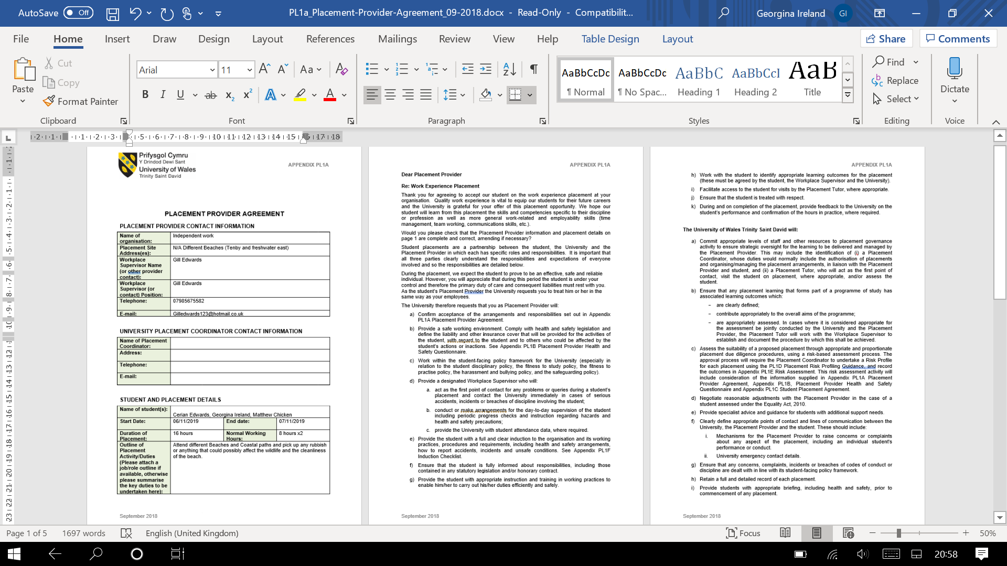
Appendix 1a: form 1

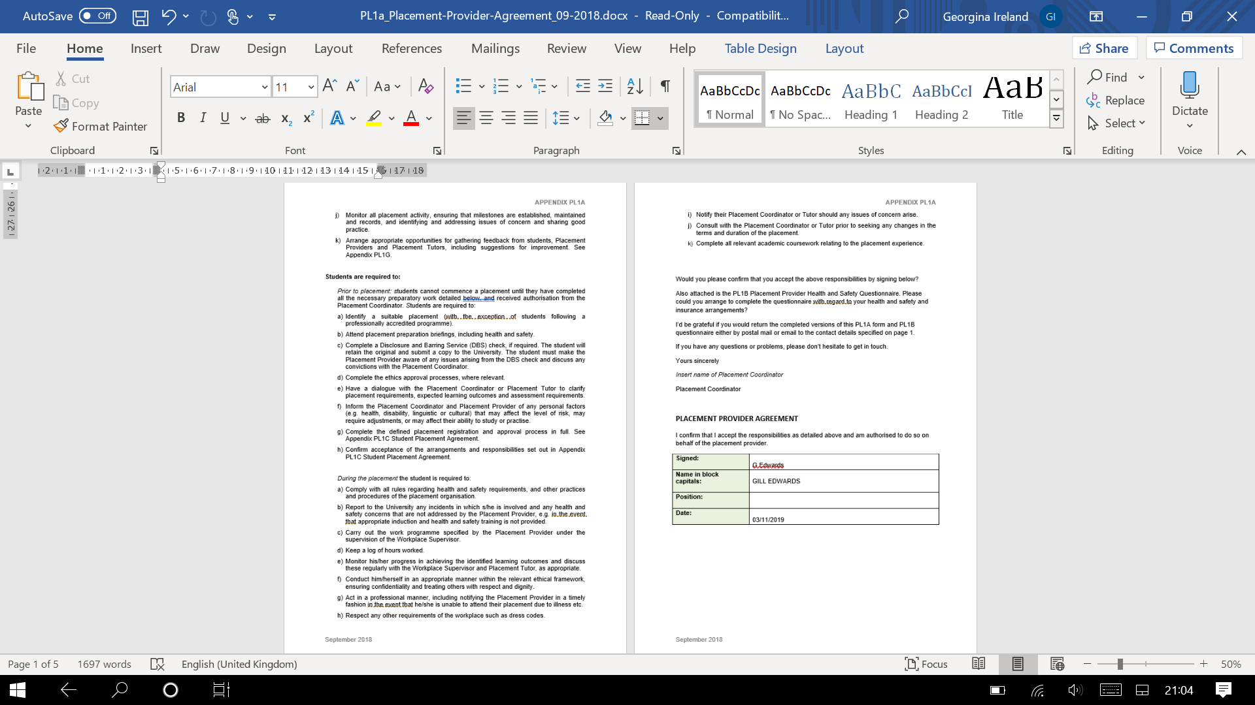

Appendix 1b: Form 2
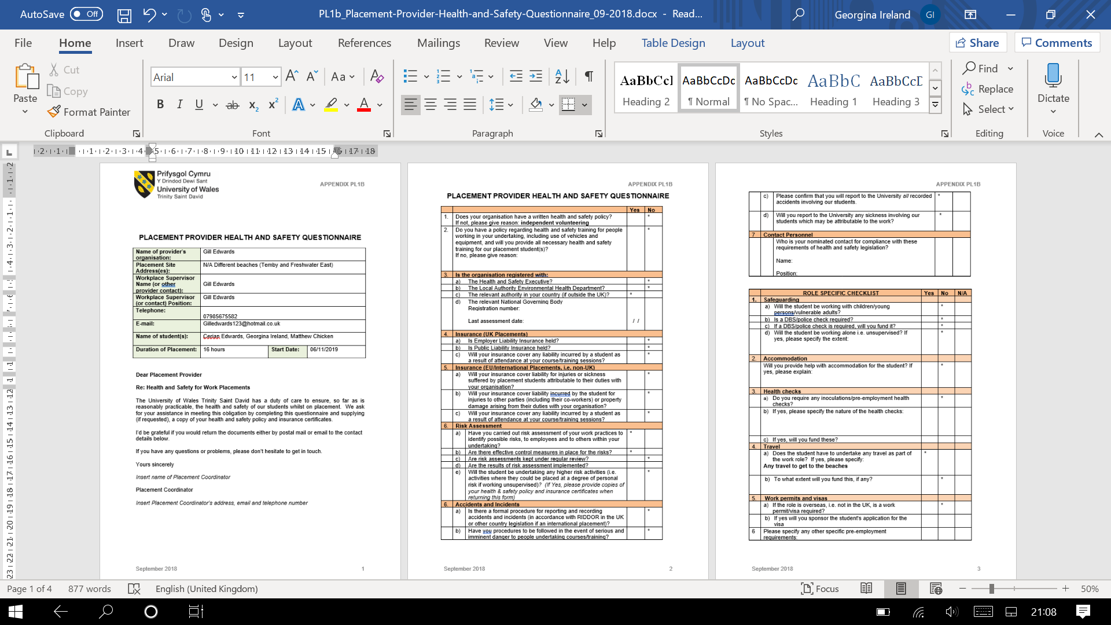

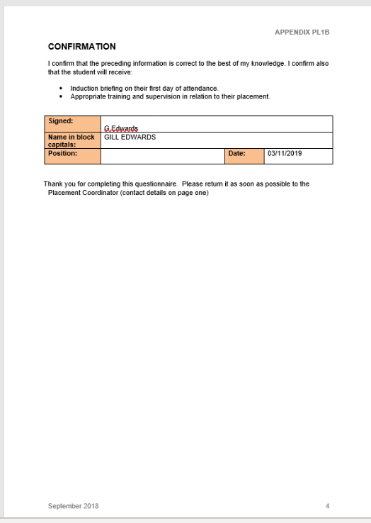

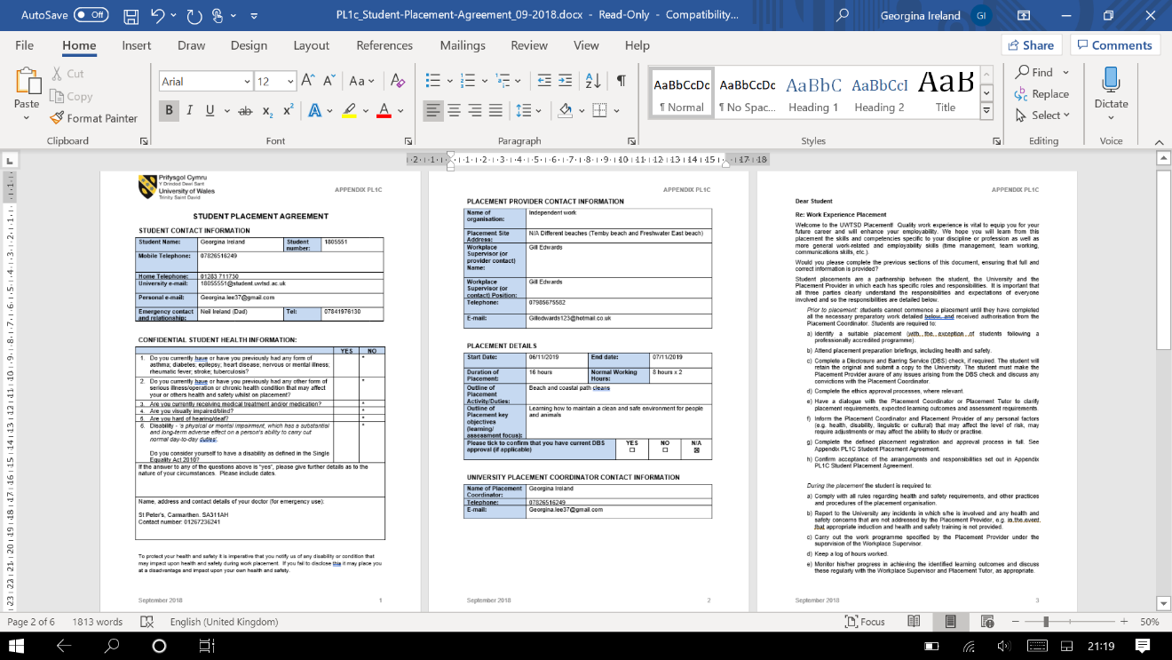
Appendix 1c: Form 3

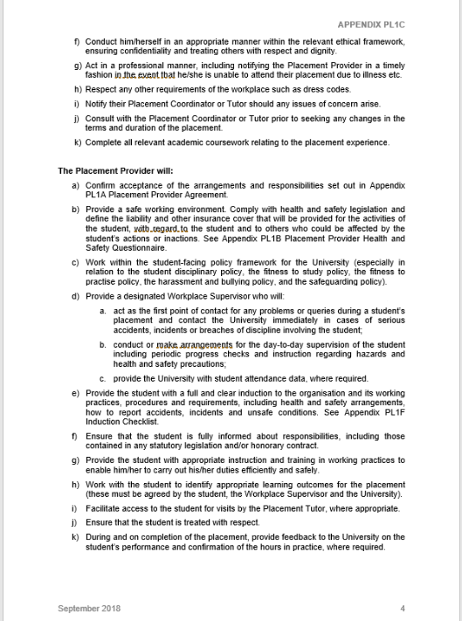

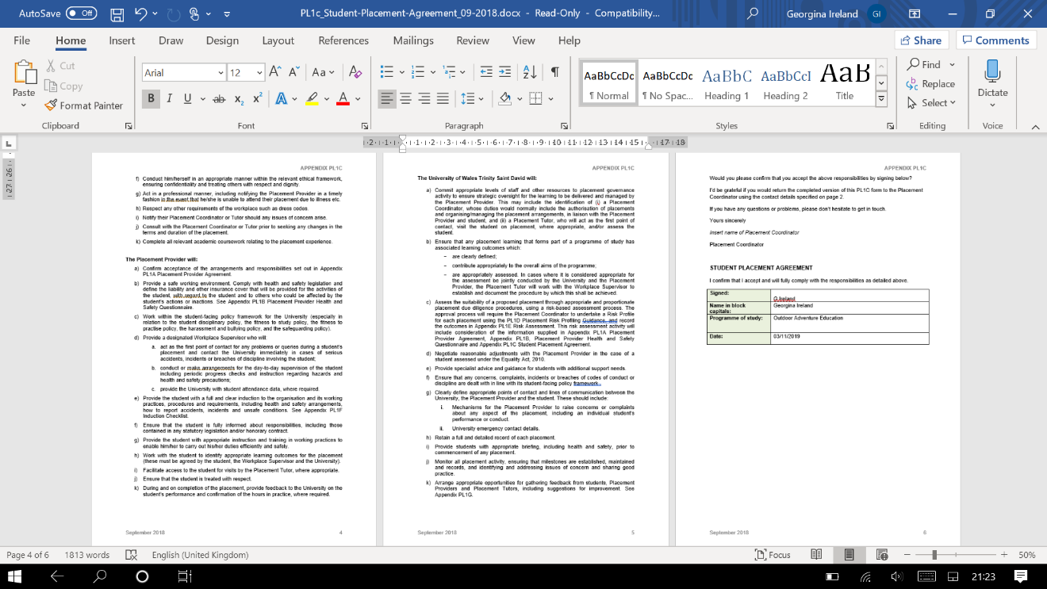

Appendix 1d: Form 4
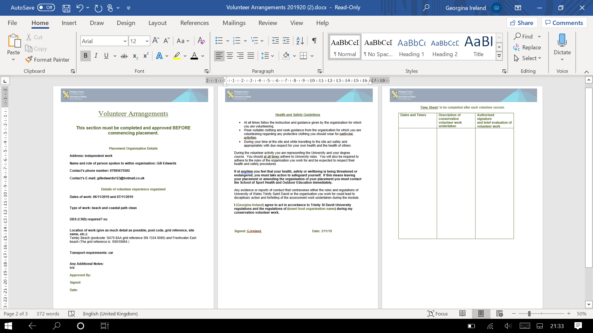

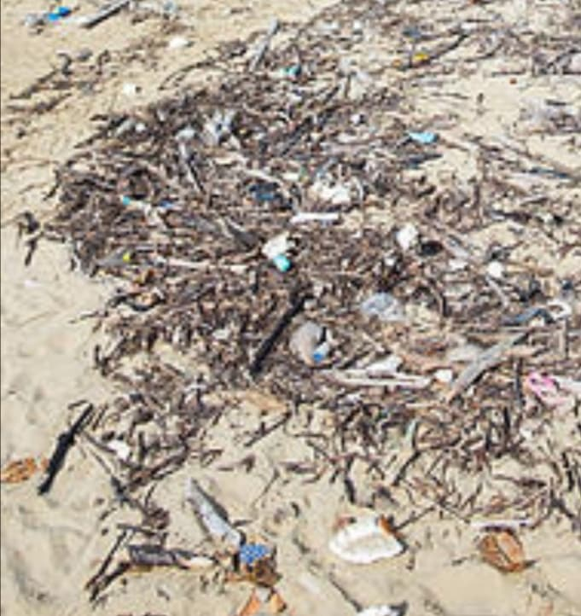
Appendix 5: photos

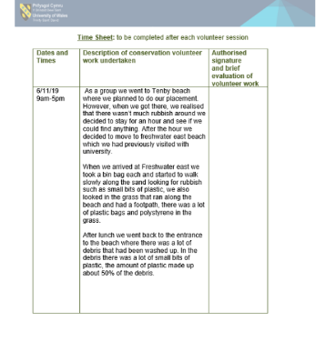
Appendix 6: time sheets



