5/19/2023
Jack, Dixon
Tata STeel
Less Gas, More Production, Maximized Profit
Dissertation By Jack Dixon

Abstract
The purpose of this paper was to investigate a potential solution to the current global energy crisis and improve the energy expenditure of Tata Steel, Hot Mill. The solution devised was to look at the reimplementation of the Hot Box Lids on the hot connect process. These would be used to increase the ambient temperature of the area and therefore decrease the cooling rate of the slabs in the area, as per Newtons Law of Cooling. Upon investigation it was discovered that we are currently losing 62.4847% of the heat generated by these slabs and the average ambient temperature of the area is 114°C. This could be improved through the use of the Hot Box Lids creating an environment that will store as much heat as possible and raise the ambient temperature.
The average charge temperature for a slab is around 250°C to 300°C currently saving around £2521.13 on furnace fuels per 2000t, if these slabs were charged at 500°C to 600°C the business could instead save £4643.15 to £5865.84 per 2000t.
Also at a 500°C average charge temperature the business could increase its Hot Connect speed of work by 44.26%. This means that by implanting this project and reinstalling the hot connect lids the business is able to roll more product, roll product faster as well as use their wasted energy to save money on current costs of charging the furnace.

Table of Contents
1. The Hot Mill Process 3
1.1. Slab Yard 3
1.2. Reheat Furnaces / HSB 4
1.3. Reversing Rougher 4
1.4. Coil Box 4
1.5. Crop Sheers / FSB 5
1.6. Finishing Mill 5
1.7. Run Out Table 5
1.8. Down Coilers / HCF 6
2. Current situation 7
3. The Proposal / Hypothesis 8
4. Research and Background Information 9
4.1. The Energy Crisis 9
4.2. Hot Connect – Background 12
4.3. Hot Connect Future / Potential Benefits 14
4.4. Limitations 16
4.5. Testing Effectiveness 17
5. Implementation 22
5.1. Crane system 22
5.2. Materials 22
6. Experiments 25
7. Results 26
8. Conclusion 28
9. References 29
9.1. Figure List 30
10. Appendices 32

The Hot Mill Process

The Hot Mill in Port Talbot is often referred to as the bottle neck for UK steel making. Without the hot mill rolling and producing product the Tata Steel Downstream operations for the UK are unable to create any further product as all slabs are first processed at the hot mill and rolled into coils. This means that there is a lot of pressure on the business to keep this department operational and functioning at full capacity. Without the hot mill rolling the whole of Tata Steels UK operations will come to a halt.
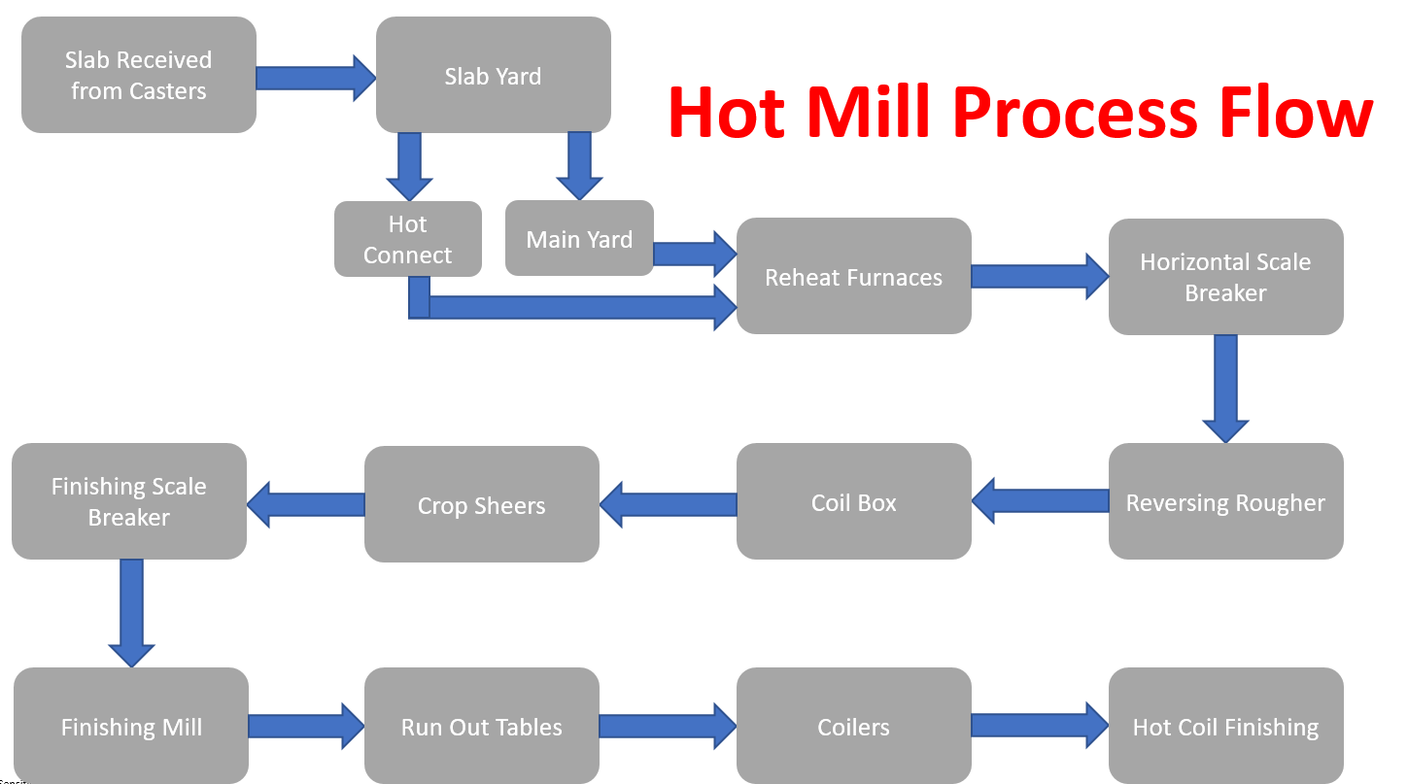
Figure 1. A Process Flow Diagram of the Hot Mill. Jack Dixon.
(Dixon, Hot Mill Process, 2023)

Slab Yard

Figure 1 demonstrates a basic process flow diagram of the hot mill operation. The first point is when the slabs are received from the casters by the Kress Carriers are carried to their respective area of the slab yard. Although this is a vast area with many different processes and aspects they can be narrowed down to Hot Connect and Main Yard storage. Main Yard storage is where the slabs are stored in the yards in order to be rolled through the process at a later date. These slabs may require further processing due to damages and defects being present such as tapers, laminations, beading and bows. Some of these defects can be rectified prior to entering the Reheat Furnaces however ones that cannot can be scrapped and recycled back into the process. The Hot Connect is where the hot slabs from the casters are taken to the hot boxes, they are placed in here in order to preserve as much heat as possible before they get placed into the furnace.

Reheat Furnaces / HSB

Once the slab has exited the furnaces at around 1650°C it is moved down the process using rollers and guides to keep the bar central. It then approaches the Horizontal Scale Breaker (HSB), this is where the scale of the bar that was created in the furnace is removed using high pressure water. This is done so when the slab is compressed there is no excess scale being rolling into the final product.

Reversing Rougher

The next stage of this process is the Reversing Rougher, the Rougher is the first time in the process where the slab is compressed in depth and as a result is lengthened. This piece of machinery uses 2 rollers and 2 backups in order to compress the material. The slab will pass through once, the rollers will then reverse and send the slab back through the Rougher and will repeat this 5 times, each time the rollers will slightly move in order to compress the slab further. After the last pass through the Rougher (specification dependant) the strip can be now be anywhere from 5mm to 7mm thick.

Coil Box

Once the strip has exited the Rougher it may then enter the Coil Box, this is again dependant on the customer specification and slab length. The Coil Box takes the intermediately completed product from the Rougher and temporarily coils it, then uncoils it and feeds it along the process. This is done for several reasons, one reason is to prevent cooling of the coil, it is important that it is kept as hot as possible throughout the process so by coiling the strip the heat from the centre of the coil can be maintained for as long as possible before it is sent further down the line. This was also introduced to solve an issue back when the company started to create larger products. Before the Coil Box was introduced the process went straight from the Reversing Rougher to the Finishing Mill, the distance between these two pieces of equipment was too short and the longer material would be in two different processes at once. With both machines operating at different speeds it would cause a great deal of disruption and delays. To counter this the Coil Box was added, this allowed the strip to be coiled and refed into the finishing mill, and is now a critical part of the process. (MARNIXR, 2016)

Crop Sheers / FSB

The Crop Sheers and FSB are the two crucial pieces of machinery that are operated before the strip enters the Finishing Mill. Once exiting the Coil Box the Crop Sheers will detect the head end and the tail end of the strip and then cut through the strip removing the head and tail. These will then drop down into the crop pit there they are extracted and recycled back into the process. The FSB is the Finishing Scale Breaker. This is very similar to the Horizontal Scale Breaker that is used earlier in the process, it again uses highly pressurised water in order to remove the excess scale that may have built up in the process.

Finishing Mill

The Finishing Mill is the last but one rolling practise that is used within the Hot Mill. The Finishing Mill has seven different stanchions that are used to roll the product further until it is around 1mm to 3mm thick. This part of the process also uses rollers and backups in order to apply pressure to the strip and compress it further. However due to the many stanchions ranging from F5 to F11 they also use what is called a looper, the looper is located underneath the area where the strip is traveling and is propped up in order to keep tension on the strip. This will help to prevent the strip from crashing in on itself and causing a “Cobble”.

Run Out Table

In between the Finishing Mill and the Coilers the area has the Run Out Tables (ROT). This is a key element of the process that can determine what grade of steel that they are producing. The Run transports to the strip from the Finishing Mill to the Coilers where it is Coiled and Banded. During its travel along the Run Out Tables water is sprayed on to the top of the strip in order to cool the product. The amount of water that is sprayed will be directly related to the grade of steel that they are making on that strip. This is because the strip is cooled to trap specific amounts of carbon in the strip and there for creating a certain grade of steel. From the Run Out Table the strip is transported to the Coilers.

Down Coilers / HCF

In the Down Coiler area the strip is sent down the ROT until it reaches C4 or C5, the strip would enter C4 and be coiled up until it is completed, it is then banded and sent further down the line into HCF. HCF is where the coil is stored or worked on further using machinery such as the Coil Temper Mill. It can be sampled using the Light Gauge Sample Unit or the Heavy Gauge Sample Unit. Or sent to customers or further downstream operations using the road and rail services. It could also go to into the Cold Mill to be cold rolled.
This report will be heavily focused on the Slab Yard and Reheat Furnaces Process, more specifically the Hot Connect process.

Current situation

Tata Steels current situation in the steel industry is very different to 10 years ago. The current cost of steel is down, the price of raw materials is up, and the energy prices have near doubled in the past few years. At present the industry is doing everything it can to keep money in the business and generate profit wherever it can. The Hot Rolling Mill is consistently outperforming the heavy end operations which is resulting in a lot of down time and maintenance periods. This means that the Hot Mill is not producing steel and therefore not making as much money as it has in previous years. There is a drive to save in the business at this point in time also meaning that only safety critical money can be spent in an effort to keep as much money in the business as possible. As can be seen in Figure 2.
Key points of the below are:
- Driving cash performance within the business, and cutting back on expenditures, cancelling, delaying or reducing spend.
- This business’ new focus is to only spend money on essential items. These items include equipment that ensures a safe working environment, equipment that prevents a stop of production, or equipment that will deliver short term cash.
- All orders must be authorised by a senior leader or above.
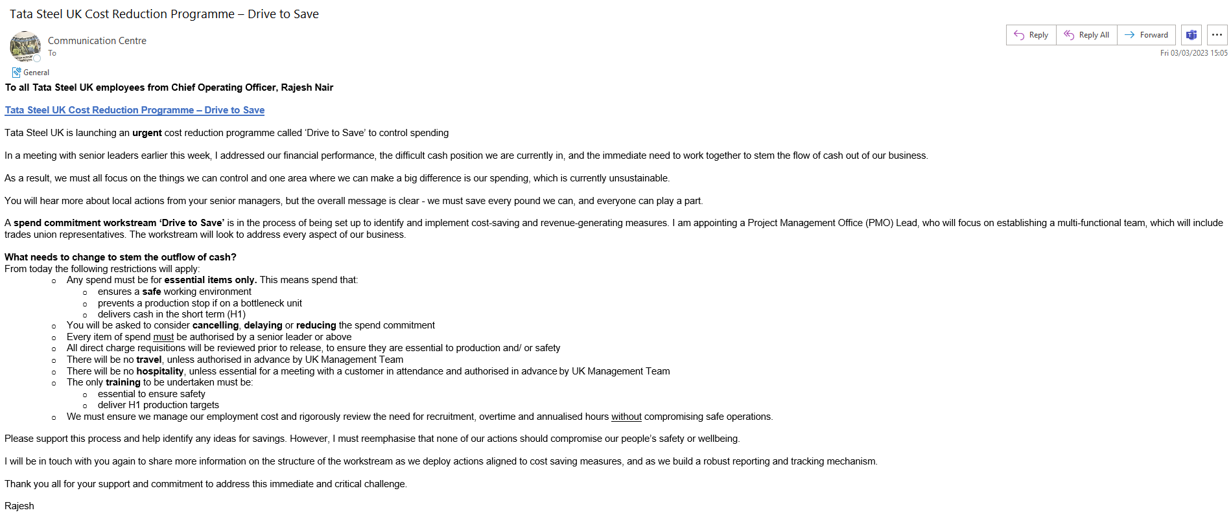
Figure 2. Drive to Save Email from COO. Rajesh Nair.
See Appendices 10.4 for details.
(Nair, 2023)

The Proposal / Hypothesis

Due to Tata Steel’s current situation a potential solution to this is to re-add hot box lids to the hot connect process. The hot connect, as stated in “The Hot Mill Process” chapter, is where hot slabs from the casters are stored so that they can retain as much heat as possible before they enter the furnace.
The Reheat Furnaces run on the principle that the hotter the slab goes in the quick it gets to temperature and the quicker it comes out the other side. The hot connect process places the hot slabs into an area with other hot slabs, the heat that is expelled by one stack of slabs is used to generate heat in the area and in turn slow the cooling process. A Potential Solution is that the organisation add lids to the hot boxes again in order to store as much heat as possible.
By doing this the slabs would retain more heat before being placed into the furnaces and therefore they would be heated to temperature quicker and can be sent down the production. This would increase production significantly. In this report the potential of implementing this feature again is investigated. The potential savings are outlined in chapter 4.3. Due to the nature of the business, the safety aspects has been taken into account looking at if it would impose any danger for those working in the area as well as those who would have direct contact with the area, those walking through the area and those who are interacting with it such as the crane drivers.

Research and Background Information

The Energy Crisis

The First step in this process was to look at the current energy prices at the Hot Mill in order to see if this project would be effective. In 2014/2015 the energy price at the Hot Mill was roughly £42,170,640 per year. (Purchase, 2023) This was a price that was average when the energy prices were considered to be “normal”. However nowadays this is very far from the truth. As of 2022’s quarter 4 the average percentage increase across non-domestic markets for electricity was 41% to 24.06 p/kWh, and the price of gas rose on an average of 46% to 5.81 p/kWh. As shown in Figure 3.
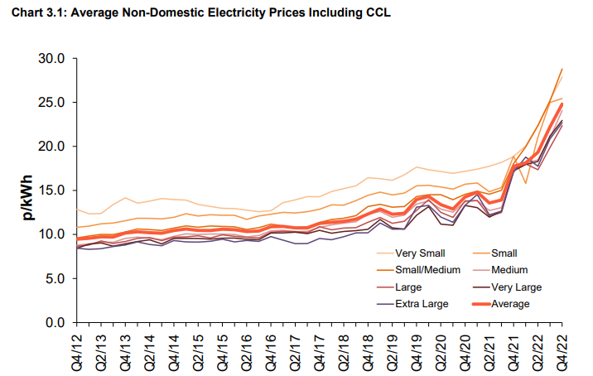
Figure 3. Graph Showing Non-Domestic Electricity Prices. The department for Energy Security.
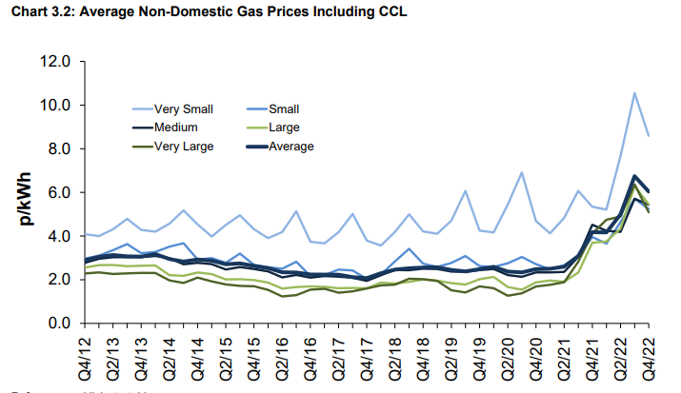
Figure 4. Graph Showing Non-Domestic Gas Prices. The Department for Energy Security.
(The Department for Energy Security and Net Zero, 2023)
As can be seen from figures 4 and 5, the average price for both electricity and gas has spiked significantly from Q2 2021 to where it is now at Q4 2022. From Q1 to Q4 of 2022 there was an increase of 37.9% for electricity and 47.8% for gas.
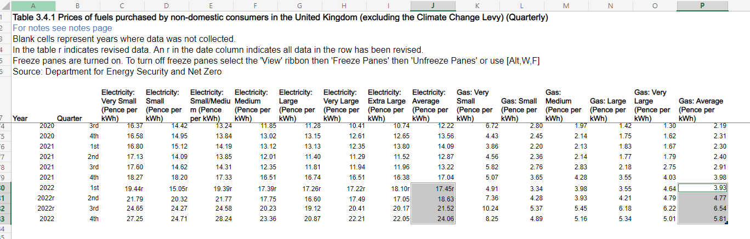
Figure 5. Table Showing Recent Increase in Gas and Electricity Prices. The Department for Energy Security.
(Department for Energy Security and Net Zero and Department for Business, Energy & Inductrial Security, 2023)
These increases for industry have caused significant damage and loss of production. As can be seen below from the map below several steel industries have been forced to either halt, slow or delay production due to these costs. As seen in figure 6, several plants have been required to shut down their blast furnaces or delay their start. As well as, Arcelor Mittal in Poland, Arvedi and Ferriere Nord in Italy have been had to stop production. Due to these prices Acerinox in Cádiz has been forced to Furlough over 85% of their work force due to their lack of production and being forced to close their steel mill.
These are just a few examples of the effect that the energy crisis has had across Europe. (Aris, 2022)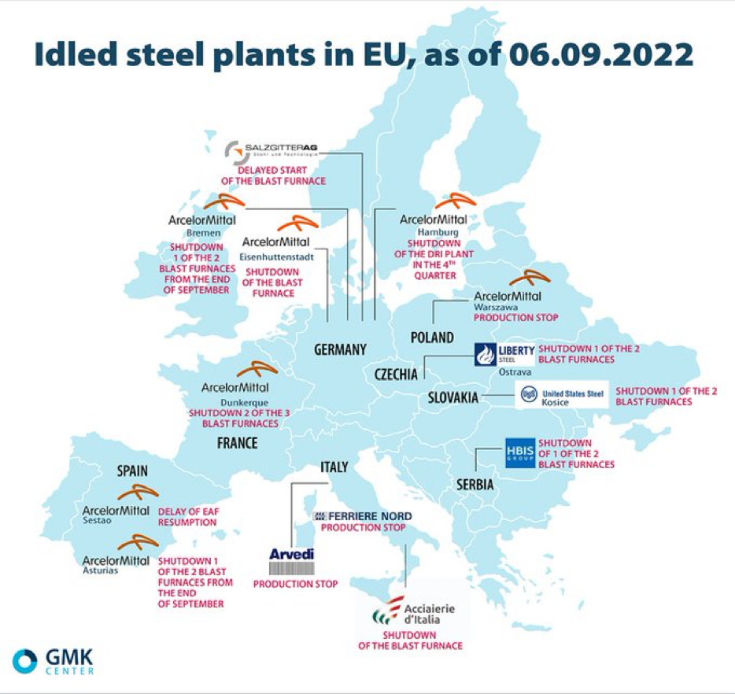
Figure 6. EU Map Showing Energy Crisis Effect on Steel Plants Across Europe. Ben Aris.
This source was written in the second quarter of the energy crisis. It demonstrates how industries were affected in the early stages of the energy crisis, from then the prices have since increased which will undoubtably have a profound impact on businesses across Europe.

Hot Connect – Background

After establishing the current climate of the steel industry across Europe and looking at the increase in the energy prices there was then a base and drive for the improvement. Throughout the Hot Mill there was a potential for more savings from the departments energy expenditures. As an operational plant it is difficult to find where the department can cut on their energy usage as the plant runs 24/7 with stoppages used for maintenance activities. Instead it was more beneficial to look at where the company have the potential to utilise their already generated energy more efficiently. Several options were considered such as using the steam generated from the cooling processes to be fed back into the system and be recycled, and insulating all their heating pipework throughout the Mill and all the Office Blocks in order to maximise their heating efficiency. However, these options did not seem effective enough or have the potential to save the company more money and help with their production. The hot connect system was then considered for energy savings. Through interviews with the area team it was apparent that the Hot box previously had an enclosure which created a greenhouse effect. It was decided to investigate reopening this project and examine if this could be a solution that would help the business through this energy crisis.
Regarding research it was important to understand why this implementation was decommissioned to begin with. See figures 7 and 8 below, emails to and from the area specialist Mark White, who has worked throughout his career on the Hot Connect process and allowed it to become what it is today. Key to the Hot Mill’s production.
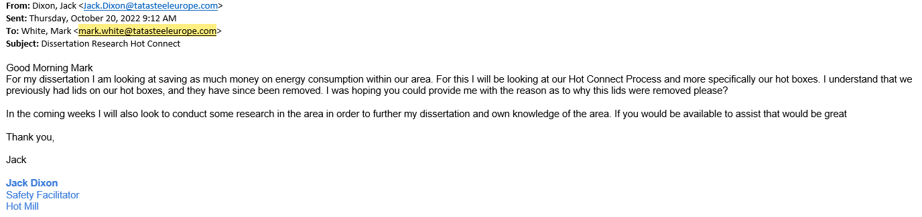
Figure 7. Email from Jack Dixon enquiring around Hot Connect. Jack Dixon
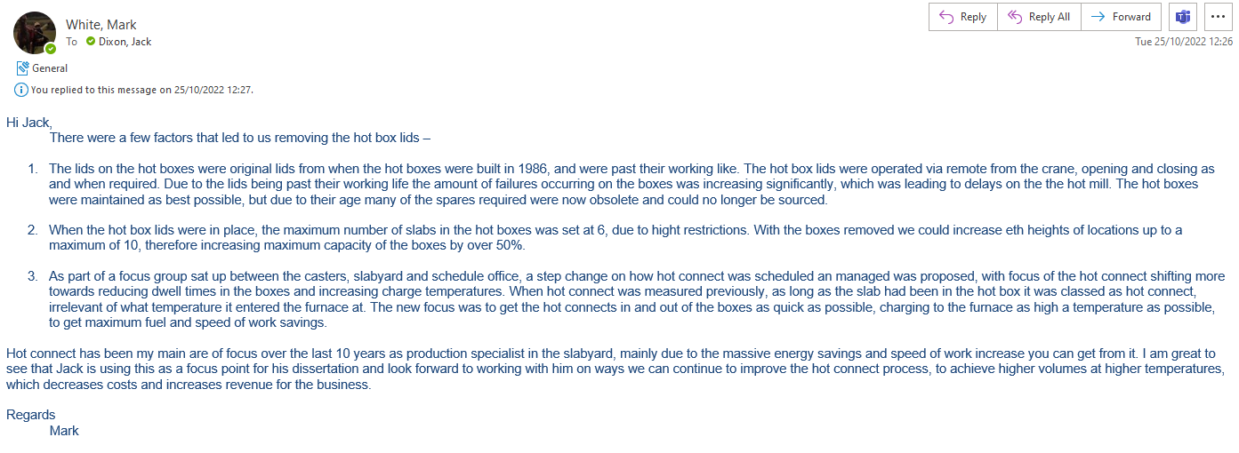
Figure 8. Email reply from Mark White around Hot Connect. Mark White
(White, 2022)
For further details on figures 7 and 8 see appendices 10.1. and 10.2.
To summarise these replies there are three main justifications as to why these original hot box lids needed to be removed.
- The lids were passed their working life, with breakdowns and malfunctions becoming more frequent and spare parts being increasingly difficult to source. The lids were becoming more obsolete and irreparable.
- With Hot box lids the area could hold a total of 6 slabs, with the lids removed this increased to 10 meaning a 66.667% increase in storage.
- The focus of the Hot Connect shifted towards reducing dwell times in the hot boxes and focusing on charge temperature and speed of work. Previously any slab that entered the hot boxes was classed as hot connect regardless of charge temperatures and time in the boxes.
This means that if the business were reinstating these conditions, it would also need to prove that this would be a benefit to the plant and show that it would improve the current situation. Consequentially, there will be Benefits and Limitations to these potential changes however in the current climate it could be beneficial to revert on aspects such as dwell time in the boxes in order to increase charge temperature.

Hot Connect Future / Potential Benefits

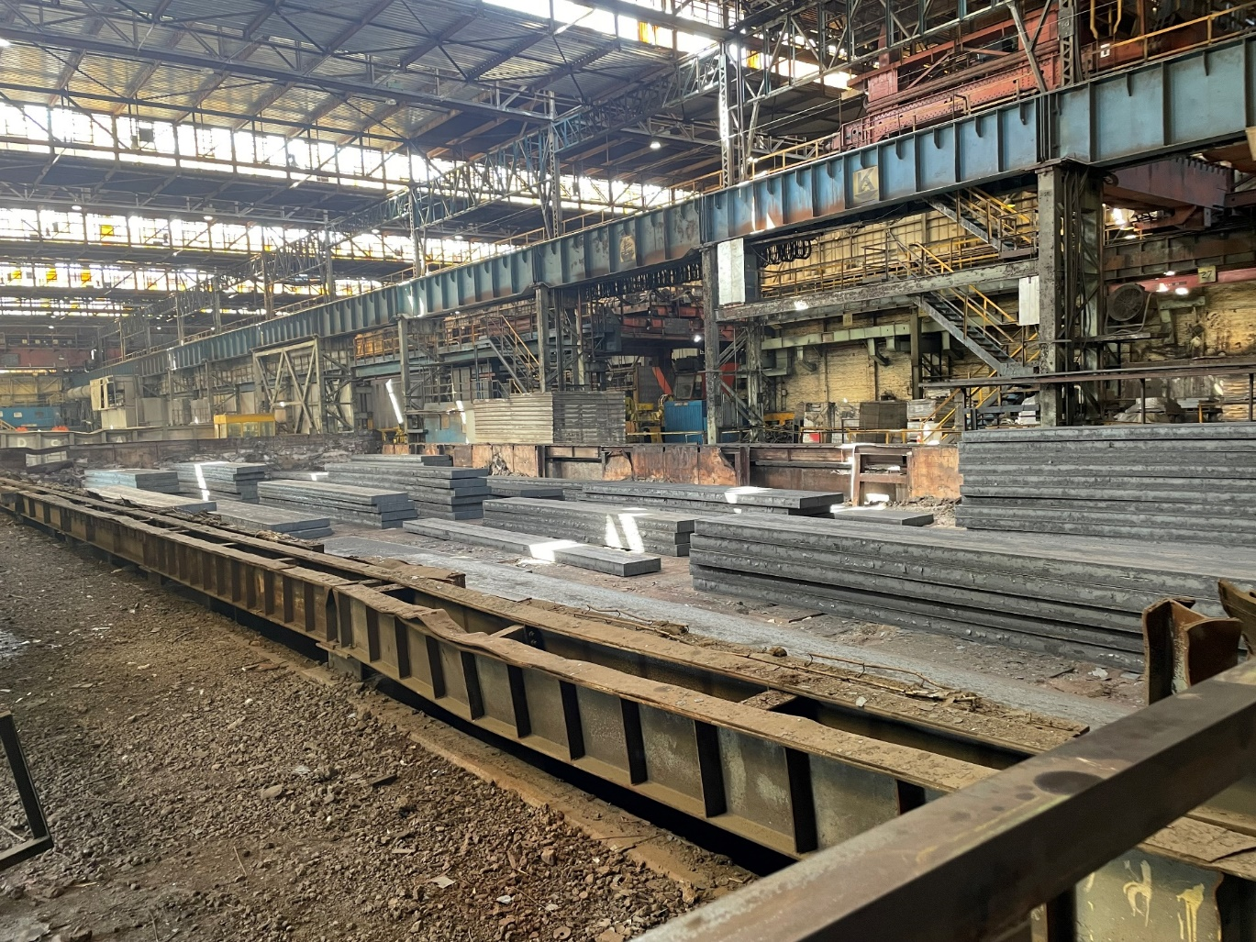
Figure 9. Photo of current Hot Connect. Jack Dixon
(Dixon, Photo Graph of Hot Boxes, 2023)
Figure 9 shows a current photograph of the Hot Boxes. Shown above can be seen hot slabs that are waiting in the hot boxes to be placed into the furnaces. These slabs are categorized into rounds. A round of slabs are slabs that will be rolled through the mill at the same time. They will be similar in width and properties so that they can minimise adjustments in the furnace, and other processes down the mill such as the Finishing Mill and Coilers. As can be seen the slabs are stacked in their own sections with a significant space in between each in order to allow the cranes to extract the slab with ease. This would need to be accounted for redeveloping these boxes. The Hot Boxes in their current condition are open and exposed to the rest of the Mill, meaning as hot air rises, it is lost to the most environment of its surroundings. Due to this the area are not maximising the temperature of their slabs heading into the furnace, although it is currently a higher temperature than the Cold Connect rounds that are rolled. From the spreadsheet shown (Figure 10) below can be seen the current savings on the hot connect process. The average charge temperature is currently 250°C to 300°C.
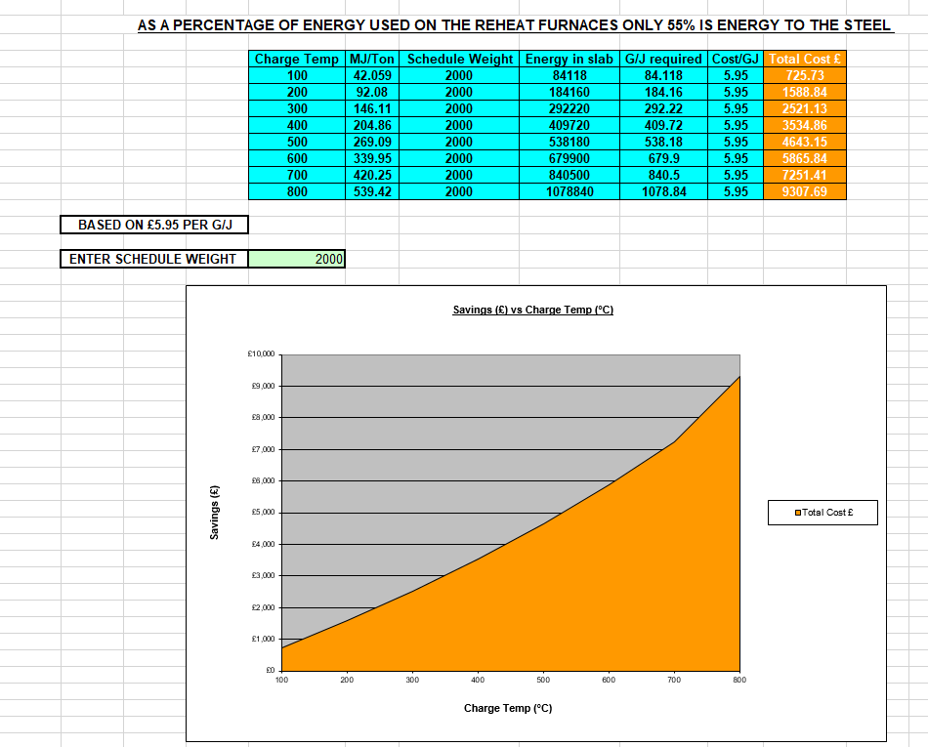
Figure 10. Spreadsheet Showing Charge Temperature savings from Hot Connect. D, Bamsey.
(Bamsey, 2010)
On a 2000tn round we would look to save £2521.13 on the energy prices if the slabs are charged at 300°C.
As a current estimate the reintroduction of the Hot Box lids could aim for the slabs to be charged at around 500°C to 600°C. This would been an energy saving of anywhere from £4643.15 to £5865.84 per 2000tn on furnace fuels alone.
In terms of SOW (Speed of Work) at present with the hot connect as it is allows the mill to roll an additional 30.5tn per hour. This is with a standard charge temperature of 250°C. In total it allows the mill to roll an extra 3660.9tn per week and saves the business £183,047 per week. As shown in figure 11.
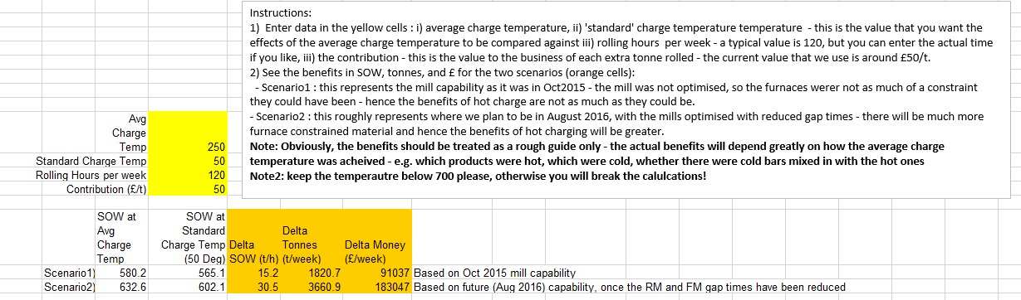
Figure 11. Table Displaying Charge Temp Speed of Work at 250°C. Ben Martin
(Martin, 2016)
With the theory of Hot Box lids being able to trap as much heat as possible and keeping the slabs to temperature, if the area charged the furnace at around 500°C they could roll an additional 44tn per hour as apposed to 30tn per hour. Meaning they could roll an extra 5280.4tn per week and save £264,022 per week. Shown below in figure 12
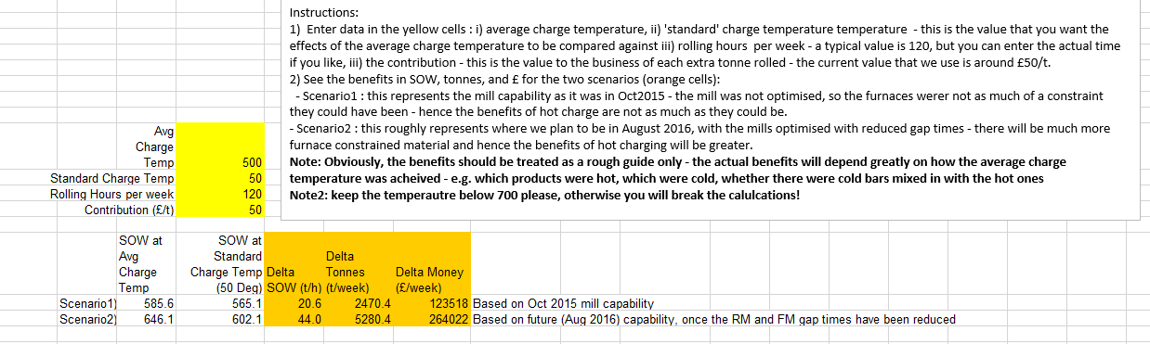
Figure 12. Table Displaying Charge Temp Speed of Work at 500°C. Ben Martin
(Martin, 2016)
As can be seen above in figure 12, this is potentially a 44.23% increase in business savings from this adjustment and a 44.26% increase in tons per hour. This is a drastic increase which could save the business a great deal of much needed money. There will undoubtedly be savings in this project although the extent is what will be outlined.

Limitations

Chapter 4.3. outlines the potential benefits for this project and justifies the need for this to be implemented into the area. However, as with all projects there are going to be some limitations to this. One of the biggest concerns is the safety factors. The correct and suitable materials needed to be selected for this project. This is essential as the materials need to be structurally sound, durable and be able to withstand high temperatures that they will be forced to hold. This means a lot of research and time will need to go into creating a safe and suitable design for this implementation. These are outlined in chapter 5.2..
Another limitation would be demonstrated in appendices 10.2. As stated be Mark White, one of the reasons that the hot box lids were removed in the first instance was due to the increase in slab storage. Previously they would store 6 slabs per location which was then increased to 10 on removal, increasing the storage by 66.667% per location. Reimplementing these lids would therefore revert back to the old storage capabilities of 6 slabs per location. However, the increased speed of work as well as the decrease in fuel expenditures would undoubtably justify the means for these to be reimplemented.
This is a large scale project and will not be able to be implemented over a short space of time. Furthermore, the mill would not be able to charge any Hot Connect during the implementation which is one of its biggest savers currently. Also, certain materials such as slabs with a high silicon content would not be able to be processed during this time. Which are again very valuable to the mill. This means that selecting the appropriate time frame to complete this is essential. Twice annually the Hot Mill has its shutdown maintenance period. during this time the Hot Mill is on planned maintenance for around 7 – 14 days depending on the workload and approval from the company directors. This would be the most efficient time to implement this project as the area would not be losing any project as a result. Hot Connect is critical to the mills performance so undertaking this at a time when there is no production would be the best course of action.

Testing Effectiveness

In order to strengthen the argument for reintroducing the Hot Box there will be an experiment in which cooling rate of a slab that is in the Hot Boxes before it is placed into the furnaces will be measured. To do this it is crucial to take into account Newtons Law of Cooling. “Newton's law of cooling predicts that the instantaneous rate of temperature change of any warm body for time is proportional to the body's temperature difference with the ambient, measured in integer units of time.” (El-Amin, 2022). Using this information a graph can be plot to demonstrate the cooling rates of slabs in the hot boxes so that it can be seen on average how fast slabs cool currently and how much heat the area are losing to the atmosphere. Before undertaking this experiment, figures 13 to 16 show a prediction that was made to the current cooling. This can then be compared to the final results for comparison and analysis.
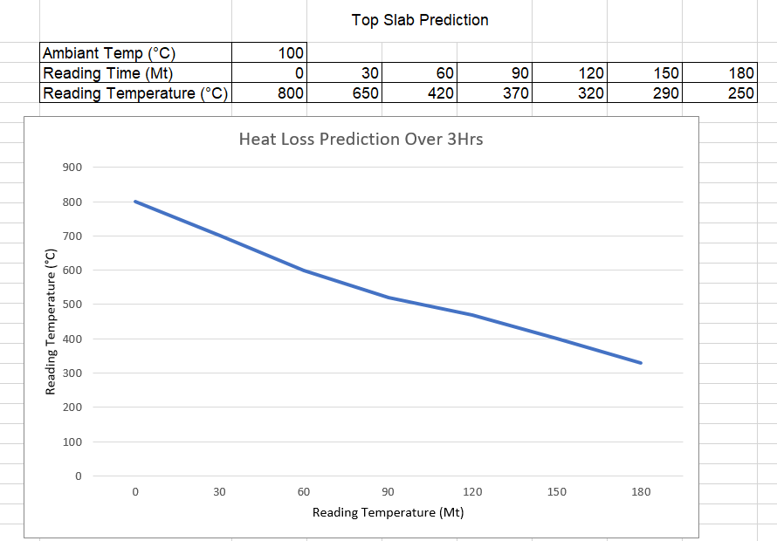
Figure 13. Top Slab Cooling Prediction. Jack Dixon
Figure 13 shows estimate of the cooling rate of a top slab in the Hot Boxes over a 3hr period. It is shown that as there is a far lower ambient temperature it will cool significantly quicker at the start and it levels to the ambient temperature which is estimated to be 100°C the cooling will become a lot slower and more controlled. As this is a prediction for the top slab in a stack it must be taken into account that it is more exposed to the atmosphere than a middle or bottom slab. Therefore, it is predicted that it would cool much quicker. In the experiment, much like the above prediction, temperatures are taken every 30 minutes over a 3hr period as this is the average time a slab will be in the hot boxes before it is placed on the walking beam and is placed into the mill, however this time may vary.

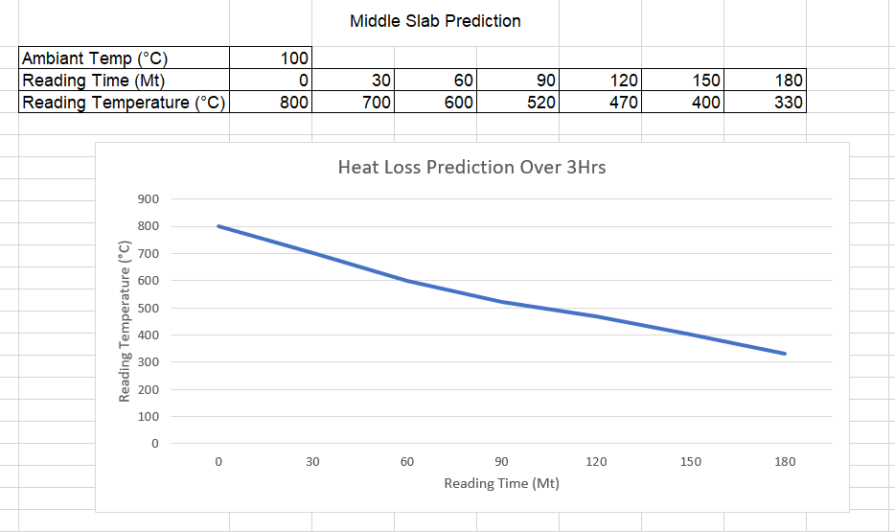
Figure 14. Middle Slab Cooling Prediction. Jack Dixon.
Again considering Newtons Law of Cooling, figure 14 again demonstrates a rapid decline in temperature when the slabs are placed into the Hot Boxes. However this time it is shown that it will be more gradual and end in a higher temperature after the 3hr period. This is due to the middle slab being between 2 two bodies of immense heat and the heat transfer that is taking place between these bodies. This mean the slab will cool and a slower pace and have an increased temperature in comparison to the top slab due to the slab not being able to project its heat energy vertically, only horizontally through a smaller surface area. “An object with a wider area has more surface particles working to conduct heat. As such, the rate of heat transfer is directly proportional to the surface area through which the heat is being conducted.” (The Physics Classroom, n.d.)
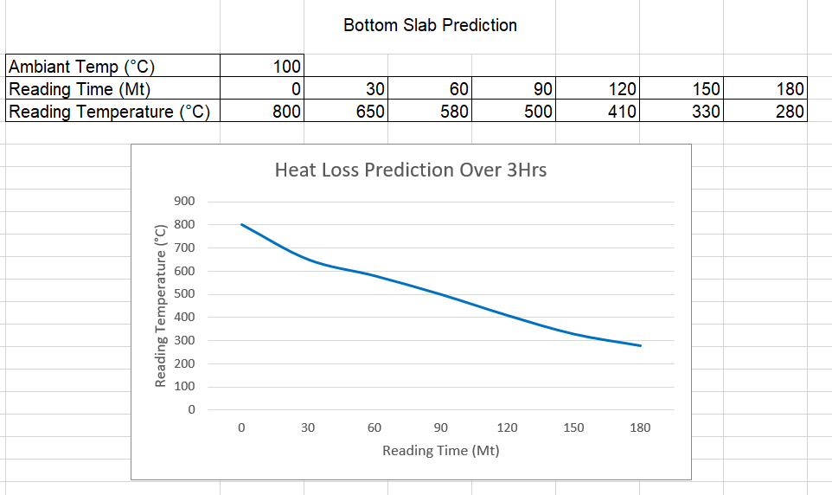
Figure 15. Bottom Slab Cooling Prediction. Jack Dixon.
Figure 15 predicts the bottom slab cooling rate, it is important to understand its conditions which are different to the top and middle slabs. These bottoms slabs are not stacked on the concreate floor they are stacked on “Bearer Slabs”. These are redundant slabs that have been placed lying the opposite direction to the product slabs, to ensure they are lying on an even surface. This will affect the rate of heat transfer throughout the bottom slab. Otherwise these slabs would be placed onto concrete which would slow the rate of cooling as concrete is a poor conductor of heat.
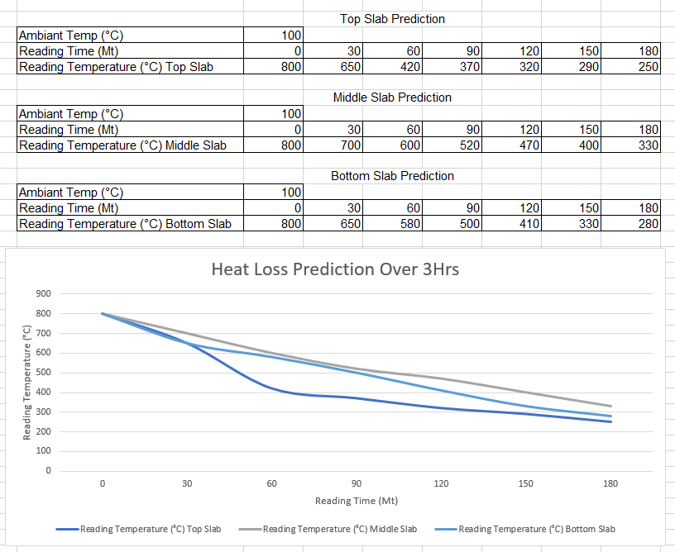
Figure 16. Combined Predictions. Jack Dixon.
Figure 16 above shows the combined graphs and the cooling predictions as can be seen the middle slab reading would have the greatest charge temperature and the top slab would have the coldest charge temperature.

Implementation

Crane system

There are several costings that need to be considered when looking into this. One of the reasons that the hot box lids were removed was due to the safety implications with the crane movement in previous years. Often the overhead cranes would make contact with the lids of the hot box and cause damage. Which lead to reason number 1 outlined by mark in figure 8 and appendices 10.2. Cranes in the area use the Oasis and Belgravium Technology system in order to locate slabs. These systems show the slabs location in the Slab Yard so that the crane can pick up the correct slab. In order to counter the issue where the crane tongs were hitting the lids and causing damage a system in which the crane hook does not lower until the lid is fully open can be added to the Belgravium system. This could be used so that the operator can open the lid remotely via the crane cab. The crane hoist will then not be able to be lowered until the lid hits a limit. Once the limit is activated then the crane hoist can be lowered into the boxes. Therefore preventing any contact with the lid.
However, in theory this system would work very well however the reality is that at this time the business would rather save as much money as possible. This system would need to be installed to all cranes in the outer gantry area. As a temporary measure a beacon would be installed to the top of the box, this beacon again set to a proxy limit, would activate once the lids are retracted to a suitable position for the crane driver to lower their tongs and pick up the slabs.
(Matthews, 2009)
Appendices 10.3. shows a potential SWP that has been devised for this task. The amendments are included in the risk assessment as well as in the procedure section 9 point 3. This SWP would be cascaded to all crane drivers and operators in the area to make them aware of the new process.

Materials

The materials that are selected for this implementation are extremely important. It is essential that they are durable and fit for purpose. The ideal material for the outer frame of the structure is 304 grade stainless steel. This material provides excellent corrosion and oxidization resistance due to its high nickel content of 8% - 10.5%. This makes it the ideal choice for the frame of the hot box lids due to the adverse weather conditions that this structure can be exposed to. (Thyssenkrupp AG, n.d.)
The hot boxes must also be transparent so that the crane drivers are still able to see the material they are collecting as well as personnel in the area are able to inspect and book the slabs. It is important that this material was heat proof, transparent and has a high durability. Quartz glass is a high density material that preforms like normal glass, however as it is made from quartz crystals it has an extremely high melting point of 1683°C and a tensile strength of 7,000psi. It also has a low thermal conductivity which is essential to the safety aspect of the structure. (Industrial Quick Search, n.d.) These properties make it an optimal choice for the hot box lids.
The ideal choice for the lid of the hot boxes would be a horizontal roller door. These could then be controlled remotely via a remote in the crane cab or possibly an addition to the oasis system. These would be installed on the top of hot boxes with the proxy mentioned in chapter 5.1. so that the beacon would trigger and signal the driver that is it safe to enter. The horizontal roller doors can be sourced from UK Roller Shutters and built to be fit for purpose specifically for this task. Example displayed in Figure 17. (UK Roller Shutters, 2023)
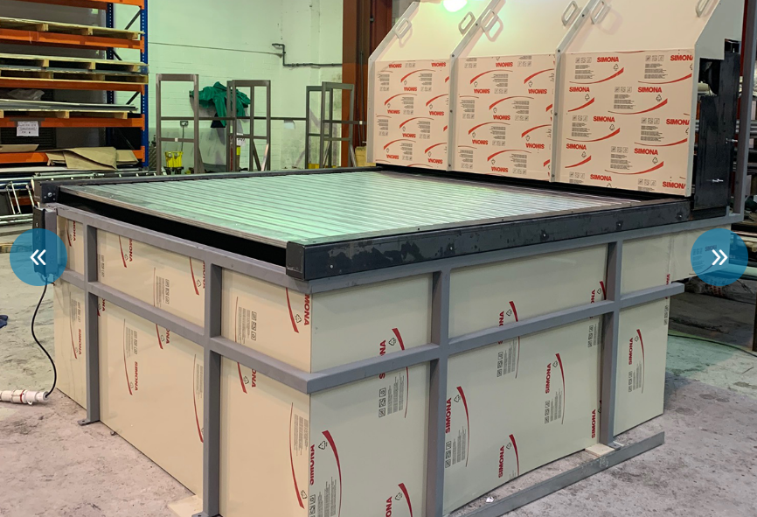
Figure 17. Horizontal Roller Shutters Example. UK Roller Shutters.
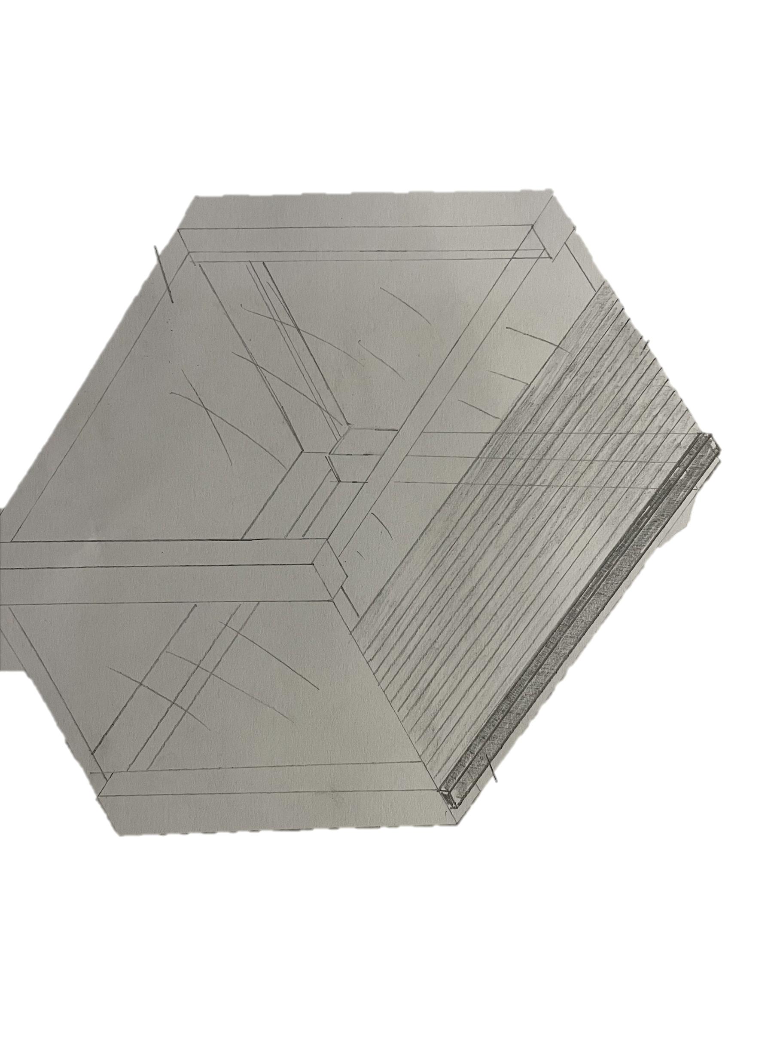
Figure 18. Potential Hand Drawn Design created for a Hot Connect Hot Box using materials referenced above. Jack Dixon

Experiments

To confirm the predictions that were made in chapter 4.5 “Testing effectiveness” an experiment was undertaken in order to have an accurate reading of the temperature drops with a 3hr time period. These were taken in accordance again with Newtons Law of Cooling where the rate of cooling is directly proportionate to the ambient temperature.

Figure 19 (Left) and Figure 20 (Right). Temperature readings on the Hot Connect and Photograph of equipment used. Jake Johnson & Jack Dixon.
Figures 19 and 20 show the beginning of the experiment as can be seen temperatures were taken via the thermal imaging camera shown in figure 20 this experiment was conducted over a number of rounds in order to plot a graph showing the average cooling temperatures. Whilst this experiment was undertaken it was paramount that all safety precautions and SWP’s were adhered to. This included the use of a high visibility vest for the area due to the large volumes of crane movement in the area. In order for this experiment to be fair and display accurate results the readings were taken from different locations in the hot boxes. This will give an overall average temperature for each slab in a location as well as an overview of the hot boxes in general. Each temperature was take roughly the same distance away from the slabs however due to the high temperatures personnel are not allowed into the hot boxes so temperature were taken at the most appropriate and safest distance possible.

Results

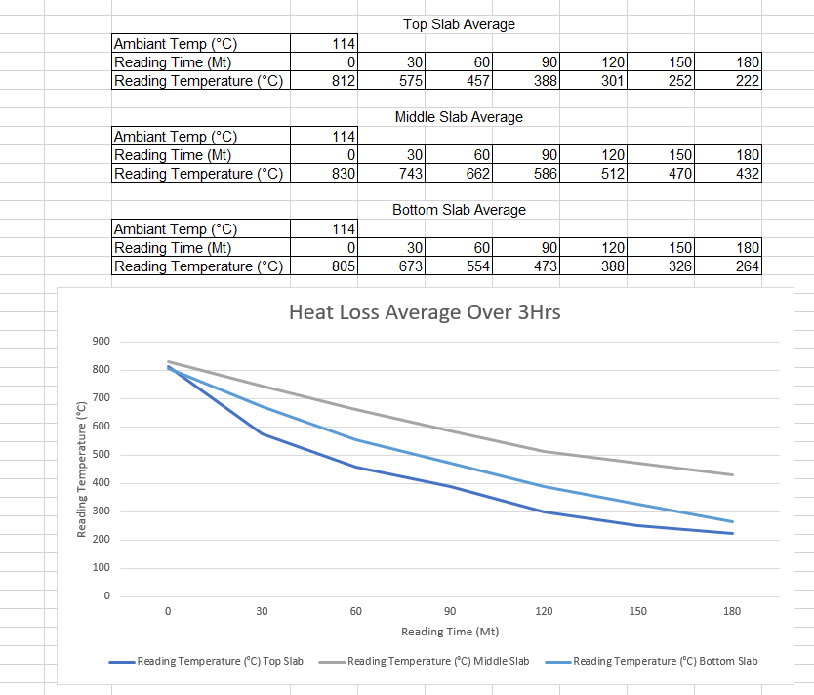
Figure 21. Results of Chapter 6’s Experiment on average cooling temperatures. Jack Dixon
Figure 21 shows the results on the cooling temperature experiment in chapter 6. As can be seen above the predictions that were made in chapter 4.5. were fairly accurate. Above can be seen fairly similar model to a Newtons Law of Cooling curve. As predicted the top slab had the lowest temperature after the 3hr period and had the most rapid decline in temperature after the first 60 minutes. This is directly proportional to Newtons Law of Cooling because as the temperature of the slab approached the ambient temperature the cooling process slowed. This was common across all 3 positions. The highest temperature at the end of the experiment was the middle slab with an average temperature of 432°C. This was expected to have the highest temperature after the period as the material is positioned in between several other hot slabs, which slows the rate of heat loss as the heat cannot escape through the larger surface areas.
This experiment confirmed that the area is roughly losing 62.4847% of the potential heat energy within the hot connect process. By the area implementing the suggestion of hot box lids in order to keep the ambient temperature significantly hotter than the current ambient temperature of 114°C.

Conclusion

In conclusion, based on the findings of the experiment 62.4847% of heat is being lost to the surrounding atmosphere over a 3hr period on the hot connect process. Due to the current energy crisis plants all over Europe were shutting down operations in order to find a way through the current climate and keep their business running. In order to navigate this Tata Steel needs a way to save as much money as possible which has been investigated as to how the hot box lids could reduce energy expenditures on the furnace operations as well as increase speed of work.
These hot box lids would be made from 304 grade stainless steel, due to its high nickel content it is durable and resistant to oxidization / rust. Quartz glass, as it has a low thermal conductivity as well as a high melting point of 1683°C, and a horizontal roller door, so that it can be opened and access by the crane driver in order to avoid contact and collision. This project has the potential to save the business £264,022 per week, if charging the furnace at 500°C which can be more than possible as shown by the results of chapter 8’s figure 20. Proposed design shown in figure 18.
As the previous boxes were manufactured in 1986, technology and industry has developed hugely, the boxes could be rebuilt with the upgraded design in order overcome the engineering failures that once occurred. (Appendices 12.2.)
This project has huge potential to be a great benefit to Tata Steels future rolling practices. If implemented this has the potential to steer Tata Steel through the current energy crisis and set the business in a strong position going forward in the future.

References

Aris, B. (2022, September 20). Intellinews. Retrieved from Energy crisis: Europe’s industry shutting down: https://www.intellinews.com/energy-crisis-europe-s-industry-shutting-down-255913/
Bamsey, D. (2010, October 20). Fuel Savings . Port Talbot.
Department for Energy Security and Net Zero and Department for Business, Energy & Inductrial Security. (2023, March 30). Gov.uk. Retrieved from Statistical data set - Gas and electricity prices in the non-domestic sector: https://www.gov.uk/government/statistical-data-sets/gas-and-electricity-prices-in-the-non-domestic-sector
Dixon, J. (2023, January). Hot Mill Process. Port Talbot: Jack Dixon.
Dixon, J. (2023, Jan). Photo Graph of Hot Boxes. Port Talbot.
El-Amin, M. F. (2022). Fractional-Order Modeling of Dynamic Systems with Applications in Optimization, Signal Processing and Control. Science Direct.
Industrial Quick Search. (n.d.). Quartz Glass. Retrieved from Iqsdirectory: https://www.iqsdirectory.com/articles/glass-cutting/quartz-glass.html#:~:text=Quartz%20glass%20is%20valued%20for,precursor%20such%20as%20silicon%20tetrachloride.
MARNIXR. (2016, November 24). COILBOX PROCESS. Retrieved from Drifting In and Out Of Steel: https://driftinginandoutofsteel.wordpress.com/2016/11/24/coilbox-process/
Martin, B. (2016, April 06). CHG Temp Sensitivity. Port Talbot.
Matthews, N. (2009). Hot Connecting Slabs in the outer yard. Port Talbot: Tata Steel.
Nair, R. (2023, March 03). Tata Steel UK Cost Reduction Programme – Drive to Save. Port Talbot.
Purchase, A. (2023, January 16). Historic Energy Prices. (J. Dixon, Interviewer)
The Department for Energy Security and Net Zero. (2023, March 30). Gov.uk. Retrieved from Quarterly Energy Prices: https://assets.publishing.service.gov.uk/government/uploads/system/uploads/attachment_data/file/1146323/quarterly-energy-prices-march-2023.pdf
The Physics Classroom. (n.d.). Rates of Heat Transfer. Retrieved from The Physics Classroom: https://www.physicsclassroom.com/Class/thermalP/u18l1f.cfm#:~:text=An%20object%20with%20a%20wider,the%20heat%20is%20being%20conducted.
Thyssenkrupp AG. (n.d.). Stainless Steel 304 1.4301. Retrieved from Thyssenkrupp: https://www.thyssenkrupp-materials.co.uk/stainless-steel-304-14301.html
UK Roller Shutters. (2023). Horizontal Shutters. Wombourne.
White, M. (2022, October 25). Dissertation Research Hot Connect. Port Talbot.

Figure List

Figure 1. A Process Flow Diagram of the Hot Mill. Jack Dixon.
Figure 2. Drive to Save Email from COO. Rajesh Nair.
Figure 3. Graph Showing Non-Domestic Electricity Prices. The department for Energy Security.
Figure 4. Graph Showing Non-Domestic Gas Prices. The Department for Energy Security.
Figure 5. Table Showing Recent Increase in Gas and Electricity Prices. The Department for Energy Security.
Figure 6. EU Map Showing Energy Crisis Effect on Steel Plants Across Europe. Ben Aris.
Figure 7. Email from Jack Dixon enquiring around Hot Connect. Jack Dixon
Figure 8. Email reply from Mark White around Hot Connect. Mark White
Figure 9. Photo of current Hot Connect. Jack Dixon
Figure 10. Spreadsheet Showing Charge Temperature savings from Hot Connect. D, Bamsey.
Figure 11. Table Displaying Charge Temp Speed of Work at 250°C. Ben Martin
Figure 12. Table Displaying Charge Temp Speed of Work at 500°C. Ben Martin
Figure 13. Top Slab Cooling Prediction. Jack Dixon
Figure 14. Middle Slab Cooling Prediction. Jack Dixon.
Figure 15. Bottom Slab Cooling Prediction. Jack Dixon.
Figure 16. Combined Predictions. Jack Dixon.
Figure 17. Horizontal Roller Shutters Example. UK Roller Shutters.
Figure 18. Potential Hand Drawn Design created for a Hot Connect Hot Box using materials referenced above. Jack Dixon
Figure 19 (Left) and Figure 20 (Right). Temperature readings on the Hot Connect and Photograph of equipment used. Jake Johnson & Jack Dixon.
Figure 21. Results of Chapter 7’s Experiment on average cooling temperatures. Jack Dixon

Appendices

  - “Good Morning Mark
For my dissertation I am looking at saving as much money on energy consumption within our area. For this I will be looking at our Hot Connect Process and more specifically our hot boxes. I understand that we previously had lids on our hot boxes, and they have since been removed. I was hoping you could provide me with the reason as to why this lids were removed please?
In the coming weeks I will also look to conduct some research in the area in order to further my dissertation and own knowledge of the area. If you would be available to assist that would be great
Thank you,
Jack”
  - “Hi Jack,
There were a few factors that led to us removing the hot box lids –
- The lids on the hot boxes were original lids from when the hot boxes were built in 1986, and were past their working like. The hot box lids were operated via remote from the crane, opening and closing as and when required. Due to the lids being past their working life the amount of failures occurring on the boxes was increasing significantly, which was leading to delays on the the hot mill. The hot boxes were maintained as best possible, but due to their age many of the spares required were now obsolete and could no longer be sourced.

- When the hot box lids were in place, the maximum number of slabs in the hot boxes was set at 6, due to hight restrictions. With the boxes removed we could increase eth heights of locations up to a maximum of 10, therefore increasing maximum capacity of the boxes by over 50%.

- As part of a focus group sat up between the casters, slabyard and schedule office, a step change on how hot connect was scheduled an managed was proposed, with focus of the hot connect shifting more towards reducing dwell times in the boxes and increasing charge temperatures. When hot connect was measured previously, as long as the slab had been in the hot box it was classed as hot connect, irrelevant of what temperature it entered the furnace at. The new focus was to get the hot connects in and out of the boxes as quick as possible, charging to the furnace as high a temperature as possible, to get maximum fuel and speed of work savings.

Hot connect has been my main are of focus over the last 10 years as production specialist in the slabyard, mainly due to the massive energy savings and speed of work increase you can get from it. I am great to see that Jack is using this as a focus point for his dissertation and look forward to working with him on ways we can continue to improve the hot connect process, to achieve higher volumes at higher temperatures, which decreases costs and increases revenue for the business.
Regards
Mark”

When printed this is an UNCONTROLLED COPY

Document Information
Document Type: | Safe Working Procedure |  | Status: | Current – 03/05/2023
Restricted To: | Field Not Used |  | Authors: | Neil Matthews/UK/Corus  Jack Dixon/UK/Tata Steel
Document Sort No:  (within Category) | 1.000
Effective Date: |  |  | Review Date: | 03/05/2025

Safe Working Procedure | Document No.: | NMAS-6W7M22
 | Revision: | 1
Status: Current - 03/05/2023 | Owner: | Lee Adams/UK/Corus

Title: | Hot Connecting Slabs in the Outer Yard

Cell: | Slab Yard |  | Section: | Moving Slabs
Subsection: | Cranes |  | Detail: | Outer Yard

Document

COMAH: | Is this activity related to COMAH? | No
If you are unsure please contact your COMAH support engineer, shift support engineer or process co-ordinator.

Task: | Receiving hot slabs from Concast into hot boxes and charging them onto beam
Task Summary: | Positioning of slabs in hot boxes from concast after checking by south stocker and then when committed to schedule charging them from the hot boxes into the furnace
Location: | outer yard
SAP info for task:
Functional Location / Equipment no.

1.Emergency Issues
Emergency Assembly Point Location: | Main Canteen Car Park

Link to Local Emergency Plan:
Link to Local Environmental Emergency Issues:
Applicable Contact Numbers: | Port Talbot
Environmental: | 4378/2627
Transport: | 2509
Energy: | 4272
Emergency Telephone Number : | 2222/3333/4444
External Emergency Telephone Number | 01639 872222
2.Evaluation of Risk:
This job has been rated:
 | BEFORE Controls | AFTER Controls
Hazard Rating | 12  Moderate Risk | 8  Moderate Risk
...
Hazard Category |  | Who might be harmed | Before  Hazard Rating |  |  |  |  | After  Hazard Rating
 |  | Who might be harmed | Prob. |  | Sev. | Before |  | Prob. |  | Sev. |  | After
Category: Electricity |  | Team member crane driver | 3 |  | 4 | 12 |  | 1 |  | 4 |  | 4
Detail of hazard: Electrocution |  |  | Controls: PAT testing and regular electrical maintenance
Category: Extreme Temperature |  | Team member crane driver and south stocker | 4 |  | 1 | 4 |  | 2 |  | 1 |  | 2
Detail of hazard: Heat from hot slabs |  |  | Controls:Air con on south outer crane
Category: Fall of Person from height |  | Team member crane driver | 3 |  | 4 | 12 |  | 2 |  | 4 |  | 8
Detail of hazard: Falls |  |  | Controls: Access via landing stage
Category: Fall of Person same level |  | Team member crane driver and south stocker | 3 |  | 3 | 9 |  | 2 |  | 3 |  | 6
Detail of hazard: slips and trips |  |  | Controls: Access via landing stage
Category: Hot/Molten Substances |  | Team member crane driver and south stocker | 4 |  | 1 | 4 |  | 2 |  | 1 |  | 2
Detail of hazard: hot slabs |  |  | Controls: Air con on south outer crane
Category: Housekeeping |  | Team member crane driver and south stocker | 3 |  | 2 | 6 |  | 2 |  | 2 |  | 4
Detail of hazard: poor housekeeping |  |  | Controls: Access via landing stage and regular housekeeping
Category: Lifting Equipment |  | Team member crane driver and south stocker + passers by | 3 |  | 3 | 9 |  | 2 |  | 3 |  | 6
Detail of hazard: tongs |  |  | Controls: Regular maintenance on cranes and tongs
Category: Lighting |  | Team member crane driver and south stocker + passers by | 3 |  | 2 | 6 |  | 2 |  | 2 |  | 4
Detail of hazard: poor visibility |  |  | Controls: Lighting audits and regular repairs
Category: Moving Machinery |  | Team member crane driver and south stocker + passers by | 3 |  | 4 | 12 |  | 2 |  | 4 |  | 8
Detail of hazard: kress entering bay, hot box lids moving |  |  | Controls: Kress entry system via slab controller and traffic lights
Category:Noise |  | Team member crane driver and south stocker + passers by | 4 |  | 1 | 4 |  | 3 |  | 1 |  | 3
Detail of hazard:very noisey area |  |  | Controls:ear defenders mandatory
Category:Oil-Grease |  | Team member crane driver and south stocker + passers by | 3 |  | 2 | 6 |  | 3 |  | 2 |  | 6
Detail of hazard:leaks off cranes, housekeeping |  |  | Controls:Drip trays and regular housekeeping
Category:Overhead Cranes |  | Team member crane driver and south stocker + passers by | 3 |  | 3 | 9 |  | 2 |  | 3 |  | 6
Detail of hazard:risk of collision |  |  | Controls:Crane working alone whilst charging boxes and when unloading boxes south crane parks well south of where slabs are to be removed when middle crane carrying out operation
Category:Hot Box Lid Contact | Team member crane driver and south stocker + passers by |  | 3 | 4 |  |  | 12 |  | 1 |  | 4 |  | 4
Detail of hazard: Damage to plant, objects falling from height |  |  | Controls: Beacon added to each lid of hot box, once lid is open beacon will flash and then crane may lower into box. Beacon controlled remotely via crane cab.
3. People
Minimum Number of Personnel: | 1
Minimum Training, Knowledge or Experience: | Competent in this task
4. Safety Equipment
PPE Requirements:  Photo(Optional): | PSA007 HELMET FIBREGLASS  PSB059 SPECTACLES SAFETY  PSE023 WAISTCOAT HI VIS E  As Supplied PORBAN TROUSERS  As Supplied PROBAN JACKET  PSC002 EAR-DEFENDER HELME  BSF 001 SAFETY BOOTS
ALL YOUR PPE MUST FIT and YOU MUST ENSURE THAT IT IS MAINTAINED CORRECTLY
DO NOT WEAR DAMAGED PPE

Additional Safety Equipment:
5. Tools to Complete the Task
Tools and equipment:
6. Specific Permit Isolations
7.Access and Egress into Task Area
Safe Access is via: | Via crane access platform at A34 or A 55
Safe Egress is via: | Via crane access platform at A34 or A 55
8. Plant Status
9.Procedure
1. Access onto the hot connect pads is only when traffic lights in the yard for the kress are green and vis prior consent by the slab controller to ensure no collisions occur between the kress and the crane.
2.i) Directions for loading the boxes are given via the belgravium system on the crane, after the south stocker has accepted the slabs onto the pad.
ii) Directions for unloading the boxes are also given via the belgravium system on the crane,after the slab controller has set up the crane, but a paper copy can be printed out, to aid slab removal
3. Control of the hot box lids are via controls on the crane, manual overide controls can also be used if necessary.
4. When 2 cranes are being used to load/unload the boxes control of the lids is via the south most crane who will dictate via radio what is required.
5. The south most crane has the responsibility to remove himself from the area where the lifts are requiring movement, prior to requesting the other crane to carry out the lift.
6. Loads must not be carried over the heads of people on the floor. If people on the floor appear unaware of the cranes approach the t/m must slow and sound his siren. If this fails to alert people the t/m must stop and contact the t/l via radio
7. When work has to be carried out on or near cranes or gantries the t/ms on the cranes must observe the following regulations:
(i) He must take care when approaching positions marked with the yellow/black bunting and stop block. At not time can he proceed past these points
(ii) T/ms must inform adjacent cranes that his crane is out of action and maintenance work is being carried out. The person carrying out the maintenance/repairs must have the correct permits including a CSO., he should also place a CSO sign in the crane cab.
(iii) Craftsman working on cranes will drop flags/banners from the crane as indicators to other cranes that men are at work on the crane.
Other useful SWP's associated with the outer yard
Charging slab onto the BWG
Driving outer yard cranes
Using Hot Box Manual Controls
South Charging at the rear of the furnace
Slab controller
Kress carrier operations
10.4.
To all Tata Steel UK employees from Chief Operating Officer, Rajesh Nair

Tata Steel UK Cost Reduction Programme – Drive to Save

Tata Steel UK is launching an urgent cost reduction programme called ‘Drive to Save’ to control spending.

In a meeting with senior leaders earlier this week, I addressed our financial performance, the difficult cash position we are currently in, and the immediate need to work together to stem the flow of cash out of our business.

As a result, we must all focus on the things we can control and one area where we can make a big difference is our spending, which is currently unsustainable.

You will hear more about local actions from your senior managers, but the overall message is clear - we must save every pound we can, and everyone can play a part.

A spend commitment workstream ‘Drive to Save’ is in the process of being set up to identify and implement cost-saving and revenue-generating measures. I am appointing a Project Management Office (PMO) Lead, who will focus on establishing a multi-functional team, which will include trades union representatives. The workstream will look to address every aspect of our business.

What needs to change to stem the outflow of cash?
From today the following restrictions will apply:
- Any spend must be for essential items only. This means spend that:
- ensures a safe working environment
- prevents a production stop if on a bottleneck unit
- delivers cash in the short term (H1)
- You will be asked to consider cancelling, delaying or reducing the spend commitment
- Every item of spend must be authorised by a senior leader or above
- All direct charge requisitions will be reviewed prior to release, to ensure they are essential to production and/ or safety
- There will be no travel, unless authorised in advance by UK Management Team
- There will be no hospitality, unless essential for a meeting with a customer in attendance and authorised in advance by UK Management Team
- The only training to be undertaken must be:
- essential to ensure safety
- deliver H1 production targets
- We must ensure we manage our employment cost and rigorously review the need for recruitment, overtime and annualised hours without compromising safe operations.

Please support this process and help identify any ideas for savings. However, I must reemphasise that none of our actions should compromise our people’s safety or wellbeing.

I will be in touch with you again to share more information on the structure of the workstream as we deploy actions aligned to cost saving measures, and as we build a robust reporting and tracking mechanism.

Thank you all for your support and commitment to address this immediate and critical challenge.

Rajesh

