 | Basic Acknowledgement of AI tool use  I acknowledge the use of Google Scholar (https://scholar.google.com/) from 12/03/2025-22/04/2025 to find relevant academic studies and background literature.  I used the prompt(s):  1. Dementia Care in Wales  2. Dementia Policies in Wales  3. Empirical studies around dementia care on patients and caregivers  I confirm that I have not presented any AI generated text as my own work.  I confirm I have copies of my drafts, notes, and other resources I used before, and after the use of AI tools which I may be asked to provide in evidence.  Katherine.Monk


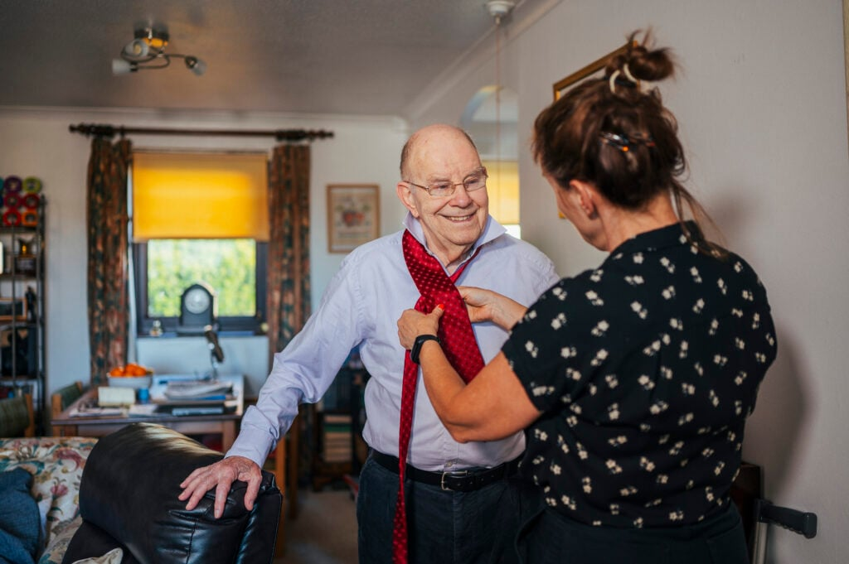
(Elderly Care, 2024)

DEMENTIA CARE AND PROVISION FOR ELDERLY IN WALES
Overview

According to Hellyar, 2022, dementia develops as a progressive brain-degenerative disease, posing significant challenges to the society, healthcare systems, individual patients, and their families. Wales' population is rapidly aging, resulting in an increase in dementia-related disorders. Reports from the Alzheimer's Society study (2022) states that there are 46,000 individuals living with dementia in Wales, this number is expected to rise significantly in the next decades. Due to growing population, Welsh government agencies and health services should establish strategic coordinated plans to provide sufficient care assistance to older individuals living with dementia. Part One of this discussion explores key government policies, strategies, and initiatives shaping dementia care in Wales. Each document is examined in terms of its purpose, content, and practical impact on service provisions for elderly individuals with dementia and carers. Part Two explores the current empirical studies on dementia care for both patients and caregivers, encompassing a literature review drawing on peer-reviewed research to explore the significant obstacles that dementia patients encounter, with an emphasis on mental health distress, quality of life, caregiver obligations, and societal influenced outcomes.


(Living, 2022)

Dementia Action Plan for Wales 2018–2022

Policies & Organisations

Part One


The Dementia Action Plan for Wales 2018–2022 marked a transformative policy shift, setting a strategic direction for dementia care improvement. The Welsh Government defined three key targets: improving diagnostic timeliness and illness risk reduction, optimising the quality of healthcare, and caregiver support resources (Welsh Government, 2018). The person-centred approach developed the plans basic premise by respecting individuals while tailoring treatment to their specified requirements, personal preferences, and previous experience. The approach in Wales established international standards especially the World Health Organisation’s Global Action Plan on the Public Health Response to Dementia (2017–2025) thus making its policy path consistent with global best practice. The plan advocated for the establishment of national and regional dementia support networks, while emphasising the necessity of local and regional collaboration between health boards, social care agencies, families, and third-party groups. By adopting these frameworks, the strategy resulted in the establishment of synchronised diagnostic care processes, treatment methods, and community-based post-diagnostic care systems.
The plan demonstrated excellence through its initiative to develop "dementia-friendly communities" that would enable people with dementia to experience understanding alongside respect and daily support. The communities reached their goals of stigma reduction along with social inclusion by engaging in awareness initiatives and establishing partnerships with local businesses and educational institutions and faith organisations. The plan received significant funding to build up memory assessment services to decrease diagnosis delays and provide better early intervention support (NHS Wales, 2019). The plan established targeted measures to help unpaid carers particularly those who are elderly spouses or adult children by providing access to respite care, psychoeducation, and better resources alongside support networks. Evaluation reports revealed ongoing service delivery disparities between cities and countryside areas as well as inconsistent execution standards among Welsh health district boards (Older People’s Commissioner for Wales, 2021). The assessment data prompted advocacy groups together with professional bodies to request a thorough follow-up mechanism which would fix inconsistencies and introduce better monitoring and accountability systems. The final phase of the plan highlighted the necessity for developing new approaches to address workforce shortages together with the steady increase of dementia cases.
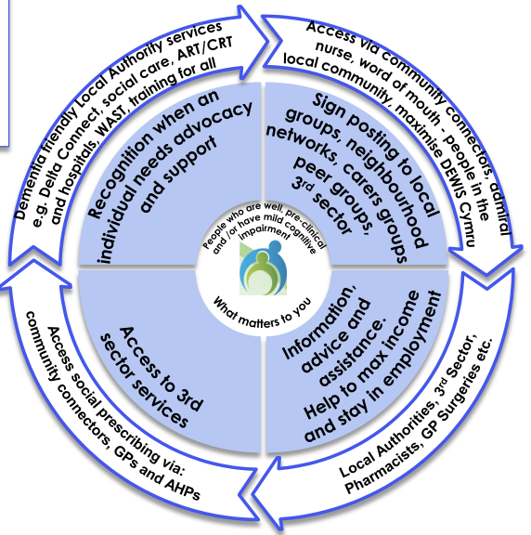

(West Wales Care Partnership, 2022)


Social Services and Well-being (Wales) Act 2014

The Social Services and Well-being (Wales) Act 2014 established ground-breaking changes which now affect health and social care delivery in Wales. The legislation positioned older adults with dementia at the centre of care choice decisions by endorsing the principles of well-being alongside promotion and citizen participation in services. Local governments became obligated to assist the well-being of those in need of care services and their caregivers. This Act granted the right to participate in activities such as evaluation, planning, and decision-making procedures related to their care. People with dementia need early involvement and planning because their cognitive abilities are expected to deteriorate with time. The legislation maintains that preserving personal autonomy should be possible for the longest period then enables people to communicate choices for future care through advance care planning and lasting power of attorney organisation. The legislation also introduced eligibility assessments that consider not just medical needs, but also emotional, social, and cultural aspects of a person's life, ensuring a truly holistic approach.
(Verity et al., 2019)
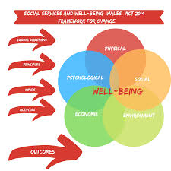
The policy provides critical support for co-production and the delivery of integrated services across several government sectors. This Act requires both local governments and health boards to create close working connections in their service creation and procurement functions. The Integrated Care Fund (ICF) supports many dementia-specific initiatives by allowing community-based dementia support centres and specialised care navigators to assist families with complicated care systems (Social Care Wales, 2021). The Integrated Care Fund funds the "Dementia Friendly Hospital Charter" as well as specialised staff education programs aimed at creating safer conditions for dementia patients. The Act's provisions have increased the visibility of carer rights as well as the importance of personal care, but operational challenges remain (Howson et al., 2021). However, according to (Tarrant, 2022) implementation has been uneven, with reports indicating variability in access to assessments, particularly in rural areas. Even with its limitations, the Act remains integral to advancing dementia care practices within Wales. The legislation serves as a critical foundation for establishing dignity, participation, and comprehensive care throughout the Welsh dementia care system.
(Verity et al., 2019)

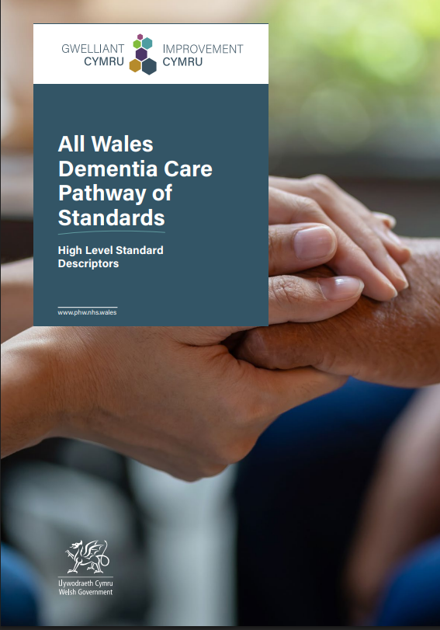
NHS Wales' "Living Well with Dementia" Pathway
2014

NHS Wales developed the Living Well with Dementia pathway to meet the specific objectives of the Dementia Action Plan for Wales 2018-2022. This pathway provides comprehensive person-centred guidance for people from the moment they are suspected of having dementia until they are diagnosed and receive care, including long-term community assistance. Early diagnosis is critical in this pathway since memory assessment service referrals are required to administer ACE-III and MoCA tests, which assess cognitive function. The pathway connects recently diagnosed dementia patients to dementia consultants and care coordinators, who provide emotional support as well as advice through care systems. When a family receives a new diagnosis, these positions become critical because they enable communication between primary care doctors, social agencies, and community organisations (NHS Wales, 2022). The pathway recommends cognitive stimulation therapy, life story work, and music or art therapy to safeguard mental health and prevent functional decline.
(Dementia Care, n.d.)
One feature of the pathway is its requirement for multiple professional partnerships. Health and social care professionals work together to provide in-home and community-based coordinated care practices with GPs, community nurses, occupational therapists, and adult social workers. The Alzheimer's Society collaborates with Age Cymru to provide community-centred dementia activities, like walking groups and social gatherings in various community sites. The method promotes independent home living for dementia patients for as long as feasible, and this strategy supports research-based data that recognising familiar situations reduces disorientation and agitation. Audit Wales (2021) evaluated service route implementation and found variable results because local health boards maintain varied service capacity levels. Local health boards face extended wait times for patient diagnosis due to backlogs, as well as restricted post-diagnostic follow-up due to shortages of certified dementia advisers in specific locations.
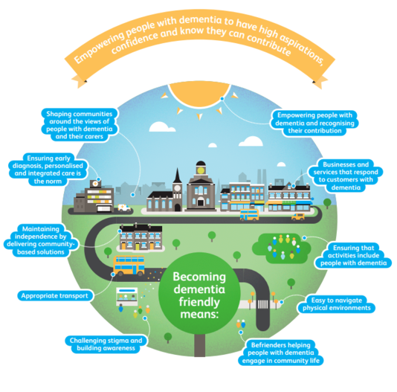
(Phillips, 2024)

Public Health Wales: Dementia Risk Reduction Campaigns
Pathway
2014

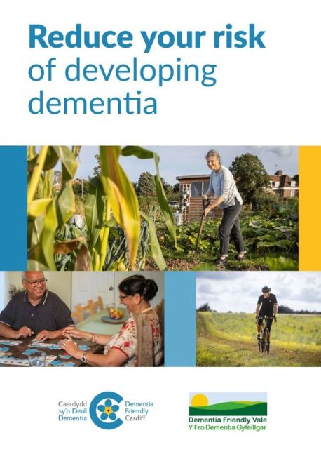
Public Health Wales takes a holistic approach to dementia, viewing it as a preventable public health problem with modifiable risk factors. The organisation launched numerous population-wide risk reduction activities since epidemiological data suggests that lifestyle changes might prevent 40% of dementia cases (Livingston et al., 2020). By focusing on avoidable behaviours, the organisation undertakes a variety of programs to promote change in areas such as physical activity, nutritional choices, smoking cessation, hypertension control, social engagement, and continuous learning opportunities, all of which contribute to brain health. When not handled effectively, hypertension, obesity, diabetes, hearing loss, and social isolation have all been linked to an increased risk of dementia before midlife. Dementia awareness is included in Public Health Wales' broad chronic illness prevention programs since it helps to prevent cardiovascular disease while also guarding against neurodegenerative disorders. Various campaigns are distributed via television, social media, primary care networks, and community health events to increase knowledge among the people while developing their ability to execute preventative measures in the early stages of disease.
(Dementia Prevention, n.d.)
The "Add to Your Life" campaign is a digital platform that offers tailored health screening services to those aged 50 and over. Users may test several risk factors (diet, alcohol use, mental health, and physical activity) using the web-based platform, which delivers personalised suggestions with dementia risk reduction instructions (Public Health Wales, 2022). This tool serves as a dual-purpose device, offering users with education resources via an interface that supports with behaviour reflection outside of typical healthcare settings. The program employed outreach strategies to especially engage populations in Wales' lowest socioeconomic areas, where dementia incidence was high, and health awareness was low. Public Health Wales faces difficulty in developing measures for measuring long-term behavioural outcomes from public health programs. More long-term study is needed to evaluate if the adopted therapies lead to significant dementia rate reductions. The ongoing risk reduction efforts promote worldwide prevention-oriented public health strategies for cognitive decline, as specified in the World Health Organisation's Global Action Plan.
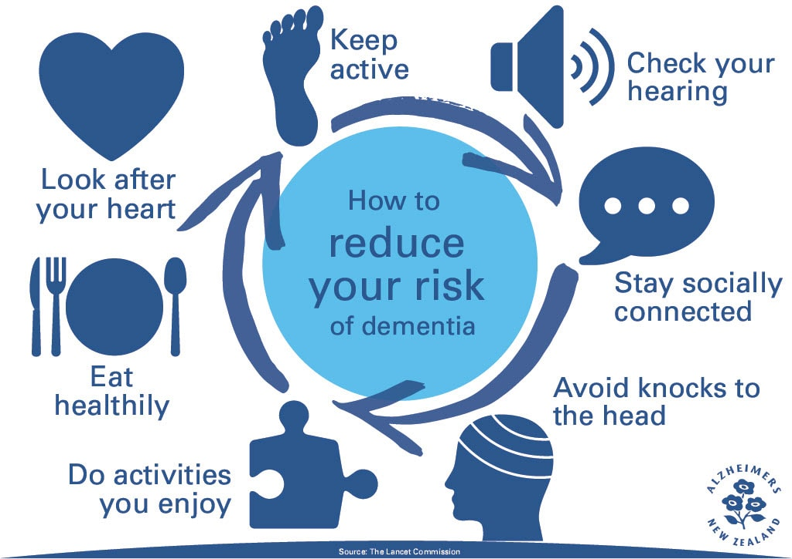
(Wilson, 2022)


Local Authority Initiatives: Case Study – Cardiff Council
Reduction Campaigns
Pathway
2014

Many Welsh authorities launch stand-alone initiatives to help dementia patients in their communities. Cardiff Council's Dementia Friendly City project serves as a strong illustration. Alzheimer's Society Cymru collaborated with the council to create dementia-friendly public spaces, teach local business personnel on dementia, and build community support groups to combat isolation among older individuals. Memory Cafés are an innovative strategy that allows dementia patients and caregivers to get information while receiving social support and engaging in memory-based activities. Local services provide crucial support for isolated or mobility-challenged individuals who require convenient access to help (Cardiff Council, 2022). Local government-run initiatives complement national frameworks by actively responding to community-specific needs, demographics, and cultural factors. These local programs can only function if financing is consistent and volunteers help with operations while communicating with health care providers.
Wales' dementia care system operates by combining administrative rules, strategic frameworks, healthcare interoperability, population health promotion, and bottom-up community projects. The Dementia Action Plan, along with the Social Services and Well-being Act and the Living Well with Dementia route, constitute a supportive network that helps patients while also helping their caregivers. Service delivery in Wales has continual challenges related to rigorous execution, workforce proportionality, and variance in area-provided services. The next policy directives must continue current progress while also addressing issues impacting remote service locations, prevention-focused care obligations, as well as supporting unpaid caregivers. The rising prevalence of dementia gives a significant opportunity for Wales to build a comprehensive care system, however this model is still under development.
Part Two

The impact of Dementia

Empirical studies on dementia's psychological effects on patients as well as its social and physical impacts now receive rising interest because of the rising numbers of the aging population aging. Most people are unaware of the mental anguish that dementia brings its afflicted. According to consistent study findings, depression and anxiety affect many individuals in the early to moderate stages of the disease. This research is based on Smith et al.'s (2023) longitudinal cohort study of 300 newly diagnosed Alzheimer's patients from the community. Researchers discovered that more than 60% of subjects had moderate or severe depression symptoms because of both neurological changes and emotional side effects of diminishing cognition, as well as social isolation. Losing independence, enduring memory problems, and being increasingly dependent on others has serious psychological implications. These findings show that emotional degradation cannot be explained exclusively by cognitive decline, since early-stage dementia therapy must focus on mental health treatment.
The emotional well-being of people with dementia has a direct impact on their quality of life. Life quality deteriorates more rapidly as dementia progresses. Jones and Lee's (2022) cross-sectional study of different dementia phases included a quality-of-life evaluation using the Dementia Quality of Life Instrument (DQoL). The study found that DQoL ratings declined by 30% between the early stages of dementia and the intermediate level. The study discovered three significant protective factors: social interaction, sustaining routines, and providing emotional support. The study found that dementia patients who engaged in activities that valued their personality while keeping their self-identity had higher reported well-being scores, justifying personalised therapies in care management.
People with dementia suffer from decreasing health as well as mental suffering, but their informal caregivers, such as spouses, adult children, and close relatives, confront unique challenges in addition to dementia patients. Brown et al. (2021) conducted research, tracking 250 people who cared for their wives over a two-year period. According to the study, individuals' depressive symptoms increased by more than 70% when caring for others. The psychological hardship for informal caregivers includes both the emotional discomfort of witnessing a loved one decline and the need to do continuous care tasks. According to the study's findings, dementia patients' behavioural symptoms had a direct impact on the emotional condition of their caretakers. Hospital caregivers who had no access to official support or relief programs had the worst psychological damage.
Multiple studies have demonstrated that caregiving obligations have a detrimental impact on the well-being of individuals (Hodgdon et al., 2022; Duxbury et al., 2024). Green's (2020) study looked at how dementia caregivers fared in terms of health when compared to non-caregivers of the same age. According to research, individuals who provide care have a 25% increased risk of developing hypertension, sleep problems, and chronic pain issues. Helping patients with physical requirements and hygiene tasks resulted in increasing health hazards, which grew more widespread as caregivers neglected to care for themselves. Additionally, research by Smith (2023) posits caregivers suffered higher fatigue and gastrointestinal difficulties due to prolonged cortisol elevation caused by psychological stress. Health systems must recognise that caregiver well-being is critical for comprehensive dementia care models, and organisations must take this seriously immediately.
Many caregivers face considerable social separation, which is a major source of anxiety. Taylor and Nguyen (2019) investigated the implications of social interaction for family caregivers. According to their findings, more than sixty-five percent of caregivers have abandoned all forms of social activity that they previously pursued. The decline in social interactions increased loneliness, exacerbating depressed symptoms and helplessness. The study highlighted how caring experiences cause life changes that alter personal identity and lifestyle, particularly for couples whose move from equal partnership status to full-time caregiving status comes abruptly following a dementia diagnosis. Caregivers experience a twofold impact as their identities alter and their social relationships remain constrained.
The workplace environment presents extensive stressors to personnel who provide care in dementia settings. Formal caregivers at 500 care homes across Wales and Scotland experienced burnout syndrome symptoms, as defined by Davis et al. (2021), with 45% exhibiting these symptoms. Employees who worked in facilities with minimal resources and a low staff ratio were the most likely to develop burnout because they experienced both emotional weariness and depersonalisation symptoms. The study's qualitative component found that many caregivers felt emotionally numb as a coping technique due to repeated exposure to deterioration, hostility, and death. Interestingly, employees working in care facilities that implemented person-centred care models and provided professional development opportunities reported much lower levels of burnout and increased job satisfaction.
Martinez and Clark (2020) found that dementia-specific training and reflective practice sessions in nursing homes resulted in a 30% increase in staff retention. The hospitals had higher resident satisfaction ratings and documented fewer cases of patient maltreatment. Research demonstrates that when healthcare institutions invest in professional training, they reap several benefits that help nurses and enhance patient outcomes. Any system-level adjustments should aim to offer official caregivers the financial support, emotional support, and tools they need to fulfil their vital role in healthcare.
Data shows that caregiver-patient interactions work as a two-way feedback system, with both sides influencing each other. According to Wilson et al. (2018), caregiver sadness causes considerable behavioural changes in dementia patients, such as sleep disruptions and violent behaviours. Unmanaged caregiver stress causes "emotional contagion" that has a detrimental impact on both the psychological and behavioural elements of dementia patients. The study's authors found that comprehensive healthcare approaches must help both patients and caregivers to break the distress cycles that dementia patients and their caregivers experience.
Anderson et al. (2019) examined the efficacy of a six-week caregiver training program that included stress management education, communication skills, and behavioural therapy modalities. When caregivers completed their training, stress fell by 40%, and patients reported a 25% reduction in behavioural symptoms. According to current statistics, dementia care services must combine educational and psychological support programs into their community and healthcare operations.
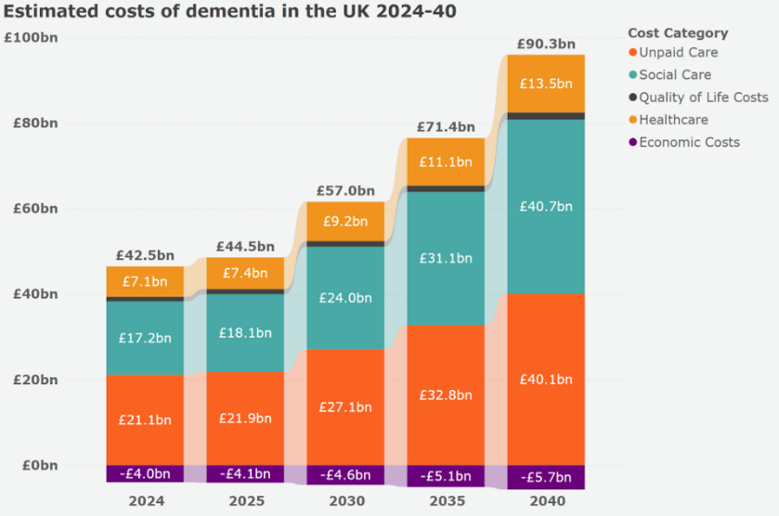
Cultural and societal factors strongly influence how caregivers handle their responsibilities. Chen and Kumar (2020) conducted study in the United Kingdom to investigate cultural attitudes that influence caregiving among Asian families in the nation. The investigation indicated that cultural prejudice caused delays in both diagnosis and enrolment in formal support programs for impacted individuals. When people saw caring as their family's obligation, obtaining aid from outside sources was considered as a violation of family honour. These caregivers were under a lot of strain on their own, so they avoided therapy sessions and support groups. The authors advocate for culturally relevant public health promotion and tailored support networks that uphold traditional family values.
(The Economic Impact of Dementia - Dementia Statistics Hub, 2025)
The way in which socioeconomic position influences people's capacity to access dementia care options is a critical deciding factor. During their large-scale study in the United Kingdom, Lopez et al. (2019) investigated how income levels impact participants' caring experience. Caregivers from lower socioeconomic categories reported higher stress levels and shorter paid rest times. Caregivers encountering financial difficulties were obliged to reduce working hours or abandon their occupations, resulting in serious economic challenges. Core healthcare and social service constraints that create social inequality continue to impede fair dementia treatment.
Caregivers can benefit from a variety of support treatments, including peer support networks and electronic resource apps. Fortuna et al. (2022) investigated the impact of support groups on caregivers using a three-month weekly session research design. People who cared for dementia patients in these groups had a 35% lower stress perception and better coping strategies. Participants in support groups benefited from both educational and emotional relief, as they were able to share their experiences and get excellent peer advise on illness management. The study findings suggest peer support as a critical factor in dementia caregiver treatments.
The researchers Singh et al. (2021) evaluated a caregiving smartphone app that offered medication tracking, instructional materials, and reminders. When executing care activities, users of the smartphone software reported improved levels of competence, made fewer mistakes, and gained greater freedom in their work. Although there are potential advantages to digital technologies, their adoption is still uneven due to age and computer skill barriers. On the other hand, system-wide community care initiatives increase their efficacy.

Dementia creates substantial impacts that afflict both direct patients and their care providers throughout their entirety of the condition. Statistics show that dementia affects caregivers with substantial psychological and physical distress while revealing adaptive patient behaviours and the shared dynamics between caregivers and patients. The way health care services are structured and the economic status of patients together with cultural barriers lead to difficulties in accessing necessary medical support. Research findings demonstrate potential solution methods by using specific interventions together with support groups and educational programs which reduce stress while enhancing outcomes. Caring for dementia patients will be increasingly essential as the disease continues to impact more people in the population.

References
Alzheimer’s Society. (2022). Dementia in Wales: Facts and figures. https://www.alzheimers.org.uk
Anderson, R., Johnson, L., & Smith, K. (2019). Effectiveness of caregiver training programs on reducing stress and improving patient outcomes. Journal of Geriatric Care, 45(3), 210–218.
Audit Wales. (2021). Review of dementia services in Wales. https://www.audit.wales
Brown, T., Lee, M., & Davis, S. (2021). Longitudinal analysis of depression among spousal caregivers of dementia patients. Psychology and Aging, 36(2), 150–160.
Cardiff Council. (2022). Dementia Friendly Cardiff. https://www.cardiff.gov.uk
Chen, Y., & Kumar, S. (2020). Cultural perceptions and caregiving practices in Asian communities dealing with dementia. International Journal of Cross-Cultural Studies, 12(4), 300–312.
Davis, H., Nguyen, P., & Thompson, R. (2021). Occupational stress and burnout among nursing home staff caring for dementia patients. Healthcare Management Review, 46(1), 50–60.
Dementia care. (n.d.). NHS Wales Executive. https://executive.nhs.wales/functions/quality-safety-and-improvement/improvement-cymru/our-work/mental-health/dementia-care/
Dementia prevention. (n.d.). Cardiff and Vale University Health Board. https://cavuhb.nhs.wales/our-services/dementia/dementia-prevention/
Duxbury, L., Ding, R., Stevenson, M., & Sadavoy, J. (2024). Impact of Care-Recipient Health Conditions on employed Caregiver Well-Being: Measure development and Validation. Journal of Aging and Health. https://doi.org/10.1177/08982643241239086
Elderly care. (2024, November 26). Elder. https://www.elder.org/elderly-care/
Fortuna, K. L., Solomon, P., & Rivera, J. (2022). An update of Peer Support/PEer provided services underlying processes, benefits, and critical ingredients. Psychiatric Quarterly, 93(2), 571–586. https://doi.org/10.1007/s11126-022-09971-w
Green, A., Patel, R., & Wong, J. (2020). Physical health consequences of informal caregiving for dementia patients. Journal of Health Psychology, 25(5), 600–610.
Hellyar. (2022). "I hope that it’s okay for everybody”: Exploring understanding of Neural Cell Transplantation (NCT) as an intervention for Huntington’s Disease (HD). An interpretative phenomenological analysis -ORCA. https://orca.cardiff.ac.uk/id/eprint/153728/
Hodgdon, B. T., Wong, J. D., & Pittman, P. S. (2022). The psychological well-being and physical health of sandwiched caregivers in the United States: A scoping review. Families Systems & Health, 41(2), 240–255. https://doi.org/10.1037/fsh0000716
Jones, E., & Lee, D. (2022). Assessing quality of life across dementia stages using the DQoL scale. Aging and Mental Health, 26(4), 320–332.
Living, S. J. A. (2022, October 27). Elderly care facilities: What are the different levels of senior care? Sonnet Hill. https://sonnethill.com/elderly-care-facilities-what-are-the-different-levels-of-senior-care/
Livingston, G., Huntley, J., Sommerlad, A., Ames, D., Ballard, C., Banerjee, S., ... & Mukadam, N. (2020). Dementia prevention, intervention, and care: 2020 report of the Lancet Commission. The Lancet, 396(10248), 413–446.
Lopez, G., Taylor, B., & Singh, H. (2019). Economic determinants of caregiving stress in dementia. BMC Geriatrics, 19(1), 45. https://doi.org/10.1186/s12877-019-1068-5
Martinez, S., & Clark, A. (2020). Factors influencing staff retention in dementia care facilities. Journal of Aging Services, 33(2), 110–126.
NHS Wales. (2019). Implementation of the Dementia Action Plan: Mid-point review. https://gov.wales
NHS Wales. (2022). Living Well with Dementia: A pathway for Wales. https://gov.wales
Older People’s Commissioner for Wales. (2021). Follow-up review: Dementia Action Plan. https://olderpeople.wales
Phillips, K. (2024, February 9). About Dementia Friendly Swansea. Dementia Friendly Swansea. https://www.dementiafriendlyswansea.org/about-us/
Public Health Wales. (2022). Add to Your Life Campaign. https://phw.nhs.wales
Singh, R., Thomas, L., & Yeung, P. (2021). Smartphone applications for dementia caregiver support: A pilot study. Digital Health Innovation Journal, 9(3), 145–158.
Smith, J., Watson, H., & Ellis, R. (2023). Emotional wellbeing in early-stage Alzheimer’s patients: A comparative study. Journal of Cognitive Disorders, 41(1), 90–105.
Smith, S. C. (2023). Measuring Health-Related Quality of Life in Dementia. Person-Centered Outcome Metrology, 35.
Social Care Wales. (2021). Integrated Care Fund – Annual Report. https://socialcare.wales
Tarrant, A. (2022). Devolution and the difficulty of divergence: The development of adult social care policy in Wales. Critical Social Policy, 43(4), 676–696. https://doi.org/10.1177/02610183221145404
Taylor, R., & Nguyen, H. (2019). Social isolation among dementia caregivers: Causes and consequences. International Journal of Geriatric Psychiatry, 34(3), 210–222.
The economic impact of dementia - Dementia Statistics Hub. (2025, March 31). Dementia Statistics Hub. https://dementiastatistics.org/statistics/the-economic-impact-of-dementia/
Verity, F., Andrews, N., Blackmore, H., Calder, G., Richards, J., Llewellyn, M., Welsh Institute for Health and Social Care · University of South Wales, Wales School for Social Care Research, Swansea University, Bangor University, & Cardiff University. (2019). Evaluation of the Social Services and Well-being (Wales) Act 2014: Framework for Change Report (Report No. 38/2019). Welsh Government. https://www.gov.wales/sites/default/files/statistics-and-research/2019-09/evaluation-social-services-well-being-wales-act-2014-framework-change-report_1.pdf
Welsh Government. (2014). Social Services and Well-being (Wales) Act. https://gov.wales
Welsh Government. (2018). Dementia Action Plan for Wales 2018–2022. https://gov.wales
West Wales Care Partnership. (2022). WWCP Dementia Strategy. https://www.ceredigion.gov.uk/media/12391/west-wales-care-partners-dementia-strategy.pdf
Wilson, A., Clarke, P., & Zhao, Q. (2018). Caregiver mental health and patient outcomes in dementia: A dyadic perspective. Gerontology and Geriatric Medicine, 4(2), 205–215.
Wilson, R. (2022, April 26). Reducing your risk of Dementia. Holistic Wellness. https://holisticwellness.nz/reducing-your-risk-of-dementia/

