Object Analysis:
Shaft-hole axe head with bird-headed demon, boar, and dragon
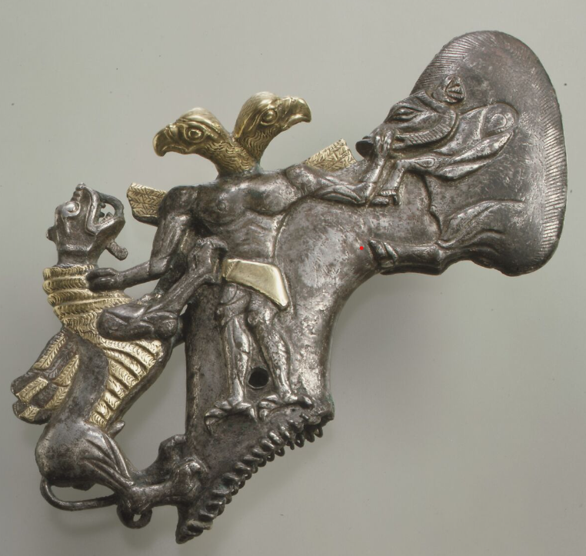
Across the ancient near east there are countless recorded instances of avian humans being spiritual creatures. This object analysis will focus on what is thought to be a Bactrian axe head dating to the 2nd millennium BCE that was purchased by the Met Museum. The axe head is of a unique and of intricate design. The history of this artifact is of a questionable nature as there is no traceable archaeological details behind its discovery meaning that the civilisation this artifact belongs to is unclear. Despite this the imagery depicted has a deep history that ranges across the near east civilisations, alongside likely being connected to rituals and spiritual ceremonies due to the ornate imageries and lack of practicality presented on the artifact. By impractical nature this is meant as an observation based on the style of the axe as practically this axe head would have been a hinderance to work generically attributed to axes, primarily due to the possibility of the ornate iconography being damaged while being used for example to chop wood. This Analysis will focus on the materiality and background of the axe head along with comparisons to similar artifacts found. The axe head features imagery of a being with both human and avian features. This imagery depicted on the axe head is dated to the end of the 2nd millennium BCE Iran.
Image 1
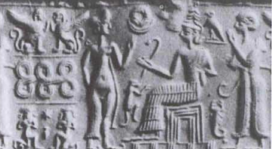
The axe head itself is small in relative terms to other axes. The artifact measures 15cm in length and 10.8cm in height. The axe head has the shaft hole exposed measuring 5.1cm in length and 1.5cm in width. The accession number: 1982.5. This artifact is also created in three dimensions as the iconography depicted is mirrored on the opposing side of the artifact. The materials used in the creation of this axe head are silver and gold foil. The axe head has an extremely ornate design depicting three creatures: a boar (right side), a winged dragon/demon (Left side), and a human mixed avian figure. The human avian seems to be adorned with two eagle heads. However, this is not a duel headed being as the mirrored nature of this artifact simply creates the illusion of a duel headed being on the two-dimensional image. Notably the human mixed avian figure is gripping the boar by the tusk (which seems to have broken) and grasping the dragon by the neck as if the human mixed avian figure were positioned in a heroic pose after defeating two beasts. Notably the feet and hands of this figure are not those of a human but are instead the feet of an avian. The lower portion of the axe head the area surrounding the shaft has been serrated adding to the ornate features. Interestingly the blade of the axe is the back of the boar. Additional details have been added to the eagle heads, along with the cloth covering the figures crotch, on the small wing like points adorning the eagle man’s shoulder, and along the belly and wings of the dragon. These highlighted areas have been covered in gold foil. Visually this axe head is reminiscent of the head of a walking cane or a staff, possibly indicating that rather than an axe head this may have been the ornament at the apex of a staff. This is supported by artwork found depicting curved staffs in bronze age Mesopotamian carvings. In many of these carvings’ staffs can be seen held above the persons head or held at chest height indicating that axe head when connected to the haft could have been held towards the sky for ritual use, this can be supported by the bird iconography depicted on the axe head as birds where seen as connected to the heavens and sky and by extension what we would call the “divine”. These carvings are exceedingly similar in shape to the axe head being analysed in the paper. However, it is notable that the ornate imagery is not present in the carvings due to a lack of ability to portray such ornate and intricate detail in a stone carving. Shown below is an example of these carvings:
Image 2
The ornate nature of this axe head makes the possibility that this was used as a practical tool unlikely, but instead was likely a spiritual idol/implement. This is supported by the imagery portrayed on the axe as visually the scene depicted is seemingly mythical in nature. Symbolically a heroic avian mixed human has been observed in artwork across the near east with the first recorded instance of this hailing from 2nd millennium BCE Iran. This indicates that this axe head is for ceremonial and ritual purposes. Scholars such as Feldman (2014) have indicated that items with the symbology of mythical creatures were used in rituals as they are imbued with a power given to the item from a higher power/being. Alongside theorising that the object itself having less importance as opposed to the iconography displayed and the actions committed while engaging with this and similar artifacts. This practice was common among ancient near east civilisations alongside more Mediterranean based civilisations such as the ancient Egyptians who had a rich tradition of spiritual magic, implying that artifacts such as this were deeply religious in nature and used for spiritual purposes. The anthropomorphic elements of this artifact are intriguingly similar to symbology found in ancient Egypt that portray the God Ra. Specifically the depiction of this figure as topless with nothing but a cloth covering the crotch area alongside the more obvious fact that both are portrayed with avian heads. As previously mentioned, the visual style of this artifact is reminiscent of a staff head rather than that of an axe, if this where the case this could strengthen any potential links between ancient Egyptian Gods as they are commonly depicted holding long staffs. The depiction of an eagle battling a serpent has been linked to the Indo-Iranian people. The first appearance of this myth in Indo-Iranian civilisation was recorded in the Rgveda IV. 26 and 27. Theoretically this may be the origin of the mythological aspect of this artifact and in some way have relation to this artifacts purpose. This outlines the possible shamanistic elements attributed to this artifact. Where this the case then this artifact would have been used for primarily ritual purposes however this draws another question, this being the question of the practical use for this axe head.
The axe head itself has many grooves and ridges strewn across the main body of the artifact. This means that by holding this artifact one would experience a kind of sensory overload. To modern humans this has little consequence for us spiritually or physically as practices that would be significant to the lives of ancient people have been phased out over the past five millennia. However, people in the ancient world had vastly differing beliefs to modern humans with a drastically different perception of the world around them. An example of this is the belief in magic and enchantments, which would be an intense aspect of life for ancient people as magic was used for purposes that have now been taken over by modern science, such as medicine which in the ancient near east has related to serpents and magic surrounding serpents. Ultimately this leads scholars to the unfortunate conclusion that we may never truly comprehend the significance artifacts (such as the axe head being examined) held to the people of the ancient world. Notably the skilled craftsmanship that is embodied by this artifact as proposed by Gell (1992) may be a spiritual practice as well as practical. This being due to Gell (1992) theories surrounding enchanted technology of the ancient world. As previously stated, magic played a significant role in the ancient world and the minds of ancient people in a similar sense to how modern science is revered. Sebbane (2016) writes of other artifacts that have been unearthed from ancient Sumerian temples that suggest the ritual use of other weapons such as maces which dates back to the 4th century BCE. Maces have been found in temple sites spanning the ancient near east implying their use as a spiritual tool. This supports the ideas of Gell and Feldman as these artifacts are also ornately designed and contain mythological iconography. This adds credence to the idea that the axe head being examined was used as a spiritual tool and would have had a more significant meaning to ancient people as opposed to practical tool or weapon. The enchantment of technology and tools has been observed across the world in countless civilisations. Often the most visual conformation of this is in two ways these being glyphs and iconography. However, it is still possible that verbal enchantments where cast upon an item. Commonly iconography for the purpose of enchantment will portray a mythical event or story such as that seen on the axe head that is the focus of this analysis.
Little is known of the origin of this piece as it was purchased by the Met Museum in 1982 from a private collector where it remains. However, it has been linked to the Bactrian civilisations that spanned areas of Iran through to Afghanistan. The depictions on this artifact have also been linked to other areas across the near east leading into the Indus Valley. This could indicate that the artifact in question had travelled along the trade routes that spanned the near east in the late bronze age. Evidence of this can be found across the near east one of the most notable examples of artifacts relating to far away civilisations is the Indus Valley seals that have been found in Mesopotamia. The distance between these civilisations is immense spanning from the modern-day Pakistan Indian border across to what is now turkey. Unfortunately due to the artifact being purchased from a private collection nothing archaeological is known about this specific artifact.
This artifact is indeed a fascinating piece of late bronze age near east art. The axe head was likely used as a spiritual tool as outlined by the theories previously mentioned by Gell and Feldman, due to the ornate design and iconography presented. Although the origins of this artifact are a mystery it is comparable to other artifacts found in the near east that were used as spiritual implements such as the maces of the ancient near east as mentioned in the work of Sebbane (2016). It is also likely that as outlined by Gell’s theories on technological enchantments play a heavy role in the true use and nature for this axe head due to the iconography present that is reminiscent of magical practices observed among civilisations across the near east and the magical practices of the ancient Egyptians. The material that this artifact is made from also indicates its use in ritual. Primarily due to the use of both silver and gold plating which are extremely rare earth metals and indicates that this would have been used by people of high social standing such as priests and shamans. Despite referring to this as an axe head throughout this paper it is the conclusion of this analysis is that instead of an axe head this artifact is the head of an ornate staff. Likely used as a spiritual implement due to the examinations of artwork briefly covered in this paper linking the iconography and visual shape of this artifact to pre-existing artwork depicting the ritual use of curved staves. However, this is simply a theory and due to the mysterious nature surrounding this artifacts’ archaeological history it cannot be confirmed that it is either a staff head or an axe head as both would be similar in construction.
Bibliography
Images:
Image 1:
Shaft-hole axe head with bird-headed demon, boar, and dragon, Image Source –
https://www.metmuseum.org/art/collection/search/329076 accessed 09.03.2023
Image 2:
Sitting deity lifting a curved staff. Before the sitting god stands a woman (presumably a goddess), behind him stands a worshipper with a crook, Image Source–
Ambos, C. and Krauskopf, I., 2008, May. The curved staff in the Ancient Near East as a predecessor of the Etruscan lituus. In Material Aspects of Etruscan Religion: Proceedings of the International Colloquium Leiden, May 29 and 30 (pp. 127-53).
Sources:
Ambos, C. and Krauskopf, I., 2008, May. The curved staff in the Ancient Near East as a predecessor of the Etruscan lituus. In Material Aspects of Etruscan Religion: Proceedings of the International Colloquium Leiden, May 29 and 30 (pp. 127-53).
Argyros, A., 2018. Reviving Ophidia: Godly Serpents in Ancient Egyptian Magic and Mythology.
Duggan, A., 2019. Images at Work: The Material Culture of Enchantment.
Feldman, M., 2014. Beyond iconography: meaning-making in Late Bronze Age eastern Mediterranean visual and material culture. The Cambridge Prehistory of the Bronze and Iron Age Mediterranean, pp.337-51.
Frenez, D., Esposti, M.D., Méry, S. and Kenoyer, J.M., 2016, January. Bronze Age Salūt (ST1) and the Indus Civilization: Recent discoveries and new insights on regional interaction. In Proceedings of the Seminar for Arabian Studies (pp. 107-124). Archaeopress.
Gell, A., 1992. The technology of enchantment and the enchantment of technology. Anthropology, art and aesthetics, 1992, pp.40-63.
Golding, W.R.J., 2013. Perceptions of the serpent in the ancient Near East: Its Bronze Age role in apotropaic magic, healing and protection (Doctoral dissertation, University of South Africa).
Harris, E., 2016. Ancient Egyptian Magic. Weiser Books.
Knipe, D.M., 1967. The Heroic Theft: Myths from Ṛgveda IV and the Ancient near East. History of Religions, 6(4), pp.328-360.
Sebbane, M., 2016. Ceremonial and ritual maces in the temples of the ancient Near East, and the nature of the hoard from Nahal Mishmar. Alphabets, texts and artifacts in the ancient Near East: studies presented to Benjamin Sass, pp.421-73

Ambos, C. and Krauskopf, I., 2008,
Knipe, D.M., 1967.
Knipe, D.M., 1967.
Argyros, A., 2018.
Harris, E., 2016.
Knipe, D.M., 1967.
Feldman, M., 2014.
Golding, W.R.J., 2013.
Sebbane, M., 2016.
Duggan, A., 2019.
Frenez, D., Esposti, M.D., Méry, S. and Kenoyer, J.M., 2016.

