University Of Wales Trinity Saint David
London campus

KNOWLEDGE AND INFORMATION MANAGEMENT SKILLS
FOR THE WORKPLACE

BMSK5006
Luzidia Tangal 1605821
Lecturer Anupam Mazumdar

Contents
Introduction 3
1.1 Explain the relationship between data, information and knowledge 4
1.2 Explain the relationship between individual knowledge and organisational knowledge. 5
1.3 Apply analysis and modelling techniques to identify knowledge assets. 7
1.4 Evaluate actual and potential knowledge assets. 9
2.1 Explain what is required to create, store, apply and integrate knowledge. 10
2.2 Consider the importance of Intellectual Property rights 11
3.1 Explain the contribution knowledge assets have on an organisation. 12
3.2 Evaluate the knowledge requirements for the organisation. 13
3.3 Evaluate the organisation’s framework for enabling knowledge sharing. 14
3.4 Recommend improvements to the current framework 16
Conclusion 17
Reference 18

Introduction

Knowledge is progressively being known as the novel strategic imperative of businesses. The most recognised example is that knowledge is strength. Consequently, one has to hoard it, retain it to oneself toward maintaining a benefit (Rundle-Thiele & Wymer, 2010). Nowadays, knowledge is still measured strength - a vast strength in detail - nonetheless the considerate has altered significantly, mainly from the viewpoint of business. The novel example is that inside the business knowledge essential be shared in demand for it to develop. It is clear that the business that shares information between its administration and workforce develops stronger and develops more modest.
Knowledge assets are one of the company’s greatest valued assets. It is also valuable assets for Tesco PLC. The marketing department of Tesco PLC perform in an effective way to manage knowledge and information. They collect data from different sources for knowledge management. Information is well-defined as info that is modified to a specific or a shared assembly to care choice making. Information assets comprise both explicit knowledge and tacit knowledge.

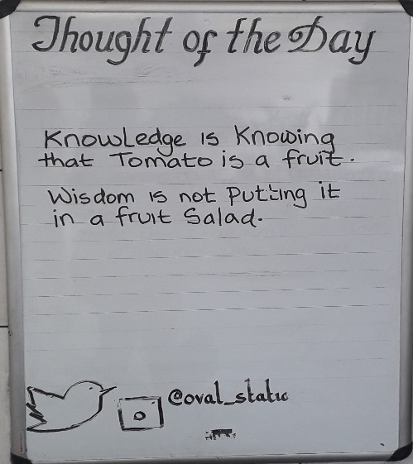

1.1 Explain the relationship between data, information and knowledge
With the purpose of understand knowledge management, it is essential to first comprehend the idea of knowledge. What is knowledge? In what way is it diverse from information, And in what way is information unlike from simple data.
When a word or a number or a letter having no context then this is termed as data. For instance, numbers like 3 or 30, deprived of any context, are simple data. Deprived of reference to either time, these statistics or number are worthless points in time. The important expression for the data is without context. Then as it is out of framework then it has no expressive relative to anything other (Vitell, 2015).
A simple gathering of statistics is not information. This indicates that if there is no connection between the quantities of numbers, at that point it isn’t information. What creates an assembly of records data is the consideration of the relations among the quantities of statistics or among the assembly of statistics as well as other info. On the other hand what is vital in creating data info is the framework, that is, the connection among the quantities of data.
For instance, if there is a set of a number like 2, 5, 8, and so on but this number will serve as no context. From this number, it is easier to relate this number from upper to lower number or lower to upper serial. It is not possible to gather much knowledge from this number. Hence it is clear that this number serve as mere data without any context. Only this data can be informed if there is a relation like 3 days for 1 month or 7 days in 1 week. Now, this data become informative as there is context. Hence context helps the data to become information.

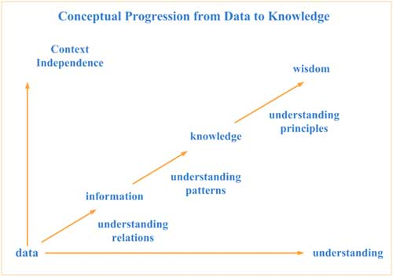
Source: (Vitell, 2015)
From the above example, it is clear that understanding relations involves an indulgent of the connection between data. In overall, info remains comparatively stationary in period and line in nature.
Meanwhile, info only delivers the association between data, it consequently doesn’t deliver a basis for why the statistics are what it is as well as doesn’t show as in what way the data is possible to alteration over time. Info is an association between data that is hooked on context for its importance as well as with little insinuation for the upcoming (Rundle-Thiele & Wymer, 2010).

1.2 Explain the relationship between individual knowledge and organisational knowledge.

Individual knowledge and organization knowledge are related to each other as without individual knowledge there is no organization knowledge. Organization knowledge of Tesco PLC is a combination of the individual or the group of people knowledge. Individual knowledge is the talents, skill, knowledge, ability, intellectual thoughts, decision-making strategy, efficiently performing capabilities, and so on all are considered as individual knowledge. Everyone in the business needs to acquire this type of knowledge for the growth of the business. All of their activities and knowledge can be termed as organization knowledge. Organization knowledge can identify the information which is obligatory for the application of procedures besides obtaining conformism of goods and facilities. Keep information and create it available to the level required. Be considerate of the current administrative information and measure it in contradiction of current necessities and styles. The required knowledge of the individual can be obtained by analysing the organization knowledge. For the case of Tesco PLC, all individual knowledge can be obtained and evaluate by the management of the department so that this individual knowledge can be the assets of the organization. For difficult task sometimes Tesco PLC takes several strategies such as do not offer any individual knowledge rather focus on group knowledge as by this way organization can solve the problem in an effective way. It is necessary for every business to have a talented or knowledgeable workforce for the growth of the business in an effective way. Nowadays when a company like Tesco PLC needs to expand the auctions of goods at its facility positions, it employs executives from other renowned organization with know-how in transaction. When an air company needs to get enhanced at managing customer relations, it employees managers from Marriott with knowledge in client service. Everyone in the business needs to acquire this type of knowledge for the growth of the business. All of their activities and knowledge can be termed as organization knowledge. Organization knowledge can identify the information which is obligatory for the application of procedures besides obtaining conformism of goods and facilities. Keep information and create it available to the level required. Be considerate of the current administrative information and measure it in contradiction of current necessities and styles.
A person's knowledge is shaped when info goes over an internal procedure linking clarification, reﬂection, and assembly between new info as well as his current information so as to be functional in a novel condition or framework. So as to inspire persons to procedure info to generate information, such knowledge procedure necessity be expressive. A perfect vision of the information to be established is essential to inspire promise to its formation as well as operationalization.
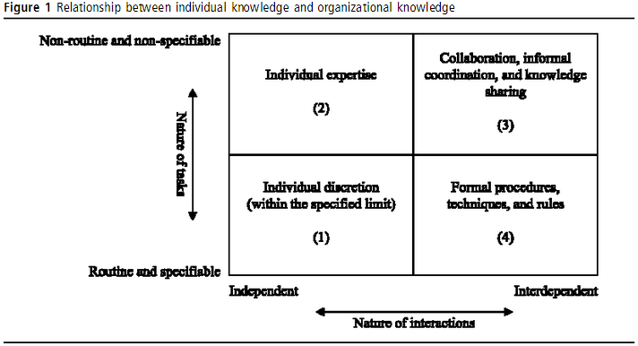
Source: (Vitell, 2015)
The relation between organization knowledge and individual knowledge can be described in the following framework. In this picture, the nature of interaction can express in a horizontal axis and the nature of tasks can be express in the vertical axis (Rundle-Thiele & Wymer, 2010).

1.3 Apply analysis and modelling techniques to identify knowledge assets.

So as to make use of information assets besides to accomplish information formation and misuse efficiently managements must be able to classify and measure these assets. Hence, a business like Tesco PLC has to chart its frameworks of information resources while keeping in attention that they are active, besides new knowledge resources be able to be shaped from current ones.
The position of information assets is contingent on the objectives, aims and the policy of the precise association. A very significant information strength of one business might be unusable for an additional one. Consequently, the knowledge resources must be examined at the foundation of the business’s objectives and ideas. For this determination, Carlucci & Schiuma (2006) have planned information resources worth twisting that purposes to response to the inquiry of classifying and enlightening information resources. In their outline, information possessions are well-defined on the foundation of their influence on the administrative presentation (Smith, et. al., 2010).
The Knowledge Asset Value Spiral of marketing department of Tesco PLC has four key stages: meaning of main business’s presentation aims, examination of information asset worth drivers, the meaning of information asset organization procedure, and valuation of enactment developments.
Meaning of main business’s enactment aims- First of all, the important matters for businesses worth formation and the main people whose attainment is connected to organisation of administrative information assets must be exposed. The purpose is to bring into line information administration creativities with the business’s policy.
Examination of information asset value drivers- A graphic outline that depicts and evaluates the relations among administrative presentation and information resources has been proposed. To map information assets, first, information assets that effect accomplishment of the purposes are determined. Carlucci projected structure a “matrix of straight needs”, in which the business’s information assets are registered and the presentation purposes are registered in rows and support correspondingly.
Subsequently, executives have to choose whether the information asset is significant or not for the attainment of each objective. The planned map not only displays the relatives among information assets besides purposes but also displays information the collaboration between the resources for worth formation (Vitell, 2015). Upon illustration this chart, bosses be able to obviously see the influence of knowledge resources to business’s enactment. Therefore, they are able to concentrate on the most significant information assets that can be measured the important information asset, worth drivers.
Definition of knowledge asset organisation procedure- After examining worth asset drivers the administrators must work out the suitable knowledge procedures that would enable enlightening and preserving main information asset worth drivers. A very significant information strength of one business might be unusable for an additional one. Consequently, the knowledge resources must be examined at the foundation of the business's objectives and ideas. For this determination, (Carlucci & Schiuma, 2006) have planned information resources worth twisting that purposes to response to the inquiry of classifying and enlightening information resources. In their outline, information possessions are well-defined on the foundation of their influence on the administrative presentation.
Valuation of enactment developments- In this stage the achievement of information organization performs is assessed. The bosses regulate the consequence of information assets on the presentation of the business. Through this method both the efficiency of current policies are examined and investments into definite main information asset worth drivers are acceptable. In case rules were dotted to be incorrect, new information strength drivers must be recognised.

1.4 Evaluate actual and potential knowledge assets.

There are several types of knowledge assets that are presented in Tesco PLC. It is the duty of the marketing management team to find out what is the actual and potential knowledge assets. A Knowledge Asset is a tried besides verified method toward arranging and recording captured working information, plus the background required to create a sense of it. Information Assets comprise of strategies, established inside commercial situation, brightened through stories besides appraisals from knowledge, and related to persons and papers for further study. The determination of Knowledge Assets is to allocation learning from one group to additional in recognised form - crossways period and natural features. It is a method to organise the information necessary through the commercial, in an arrangement that makes the best use of its recycling through other groups and persons facing similar contests in upcoming. Knowledge assets are a method toward creating information stimulating, available, relaxed to read as well as easy to adapt; somewhat healthier than additional dull report. The information essentials are obtainable in bite-sized pieces in an instinctive method, exemplified with sections, figures, and movies, and effortlessly cross-referenced.
Actual knowledge such as the knowledge of the individual of the organizations where potential knowledge refers to the knowledge of the organization that needs to perform potentially within the business. Hence potential knowledge not only comprises of all knowledge.

2.1 Explain what is required to create, store, apply and integrate knowledge.

Creating, storing and distributing knowledge is serious to any knowledge management system. This begins with classifying where the business’s information is situated. This process is occasionally mentioned to as a knowledge map.
For marketing department of Tesco PLC, Making a knowledge chart characteristically includes recording the workflows and policymaking procedures to classify main knowledge workforces in the business. Just put, knowledgeable workforces are persons who generate, usage and distribute knowledge. This classically comprises experts, engineers, authors, teachers, creators, and other specialists.
Knowledge workforces are frequently a portion of a specialised association. Though, knowledge is able to also be present elsewhere in the business. For instance, knowledgeable bosses frequently have a prosperity of information even if they do not fall in the distinctive classes of a knowledgeable employee.
Once the place of the knowledge has been recognised in the procedure of precise persons or assemblies, it requirements to be taken. Capturing information comprises gathering all the pertinent papers and establishing them in an expressive way. Though, numerous features of information are not logged in official documents. Capturing information might, therefore, likewise need more active approaches, for example directing meetings with selected persons or groups.
Knowledge is characteristically kept in the procedure of an information repository, which comprises papers, reports, and records. Particular software tools are accessible to establish this measurable in a real and practical way.

2.2 Consider the importance of Intellectual Property rights

Intellectual property be able to comprise of numerous diverse zones, from symbols and business individuality over to goods, facilities, and procedures that distinguish the commercial offering.
It’s at what time these thoughts are used deprived of approval that a business can suffer. Nearly all companies have certainly advanced from the internet, where goods, facilities, and advertising infrastructures are able to reach massive viewers at comparatively low costs - but then again this has likewise amplified the probabilities of knowledgeable possessions theft. Businesses of all dimensions are at danger of consuming their exclusive thoughts, goods or facilities infringed upon, even if they are on the opponent of the globe, creating intellectual property defense more significant than ever (Greve, et. al., 2016).
Keep the ideas
Intellectual Property rights help Tesco plc to keep the ideas. When an individual has an excessive knowledge of merchandise or facility, there will continuously be persons who will want to identical the business achievement and vend a person’s ideas as their personal. Contingent on personal situations, an individual is able to use patents, attributes or copyrights – all of which shelter dissimilar zones of intellectual property. These can serve to check contestants or anybody else from consuming a person's thoughts for their individual revenue without person’s agreement.
Protect business growth
For the case of small business, it is very significant to keep any single goods or facilities that a business owner as contestants be able to use the business achievement to take away marketplace share, resultant in deliberate development or damage of profits. Dropping marketplace share initial on in a company’s growth can be overwhelming besides time overriding if trying toward chase up the shamefaced gathering deprived of any lawful defense (Vitell, 2015). It is significant to recall that no one else would check toward seeing if the individual intellectual property has trespassed; it is the business or the individual accountability toward ensuring that no one else is using the business resources.

It’s easier
It might seem firstly intimidating or time-consuming, nonetheless protecting the business Intellectual Property is fit value the period and energy in addition to is not as problematic as the business or person might think. Whilst the business cannot defend a knowledge itself, be able to defend the resources through which the business put the knowledge into a process and this is what the business will defend by means of Intellectual Property (IP) (Greve, et. al., 2016).

3.1 Explain the contribution knowledge assets have on an organisation.
Knowledge management stops workforce from continually reinventing the wheel, delivers a starting point for development dimension, decreases the load on skilful attrition, creates graphic discerning palpable, and achieves efficiently great capacities of info to aid staffs to help their customers better as well as faster.
Being an important commercial enabler, information organization will aid businesses:
- Defend their intellectual property
- Emphasis on their greatest significant resources: their human resources
- Re-orient their philosophy through choosing for a best information distribution policy
- Link persons to persons through arrangement co-operative approaches
Organization Knowledge opens the doors to a new epoch of teamwork and sharing
Today, with business unions, worker turnover plus worldwide growth, person’s necessity effort differently: they essential to co-operate with peers that are foreign, discussion thoughts, retain present on world-wide stuff and have rapid responses to their problems. The control of Communal Media shows a significant part in information organization as it allows staffs to co-operate, attach and quickly entrance to specialists and info.
Social systems likewise permit persons to cooperate, to be social and to direct themselves in the electric situation. They have a hard substance of faith and acceptance amongst staffs and they are part of the information distribution philosophy.
Increasing corporation welfares with an actual information organisation strategy
Information management aids resolve greatest of the mutual commercial difficulties and aids businesses rise their welfares by:
- Enlightening commercial choices thanks to helped access to know-how and to important observes
- Increasing efficacy, output and perform cleverer through decreasing cases of “reinventing the wheel”
- Improving novelty over broader and borderless teamwork
- Dropping damage of knowledge through pick up obvious and unspoken information
- Fast-moving output with onboard exercises and suitable admittance to information
- Growing customer approval through transporting worth insights
- Enhancing value and capability to co-operate through regulating conducts of functioning and allowing conferences with leading specialists (Greve, et. al., 2016).

3.2 Evaluate the knowledge requirements for the organisation.

To define the information necessities in the business. This procedure includes the next steps: 1) Documentation of requirements over the examination of the administrative procedures to identify flaws or chances connected to information.
2) Determination of supplies for incisive or acquiring information through essential the kind of information desired its precise supplies, and the budget for not recycling information that is previously obtainable.
Knowledge pull
Which mentions the search, achievement, and acceptance of knowledge necessary by associates of the business. It includes the next sub-processes:
1) Formation of exploration standards founded on the necessities definite for information in the business.
2) Exploration for applicant information foundations subsequent the clear exploration standards.
Knowledge push
Mentioning to the spreading, the formation of information distribution spaces besides information allocation. It includes the subsequent sub-processes:
1) Statement of the modified information or novel information so as to the business becomes conscious of it.
2) Elevation of instances for information distribution amongst persons in the business.

3.3 Evaluate the organisation’s framework for enabling knowledge sharing.

Several related writings have decoratively offered information sharing and its aids to business in several dimensions. Though, there happens little linked effort on the involvement of information sharing toward administrative enactment in relation to judgment creation. Therefore, the investigation gap as recognised is to measure the influence of information sharing with precise KPIs ‘main enactment displays’. In the literature, the communal setting in which information adaptation proceeds place was lengthily deliberated and in what way knowledge contributors play a serious role. KSP an information sharing classification, where the situation for communication is measured to be face-to-face.
Henceforth, the essential to make an administrative culture founded on faith, affection, and shared intellectual model which imitates the dream of management. As shown in Figure 1, there are three phases of communication;
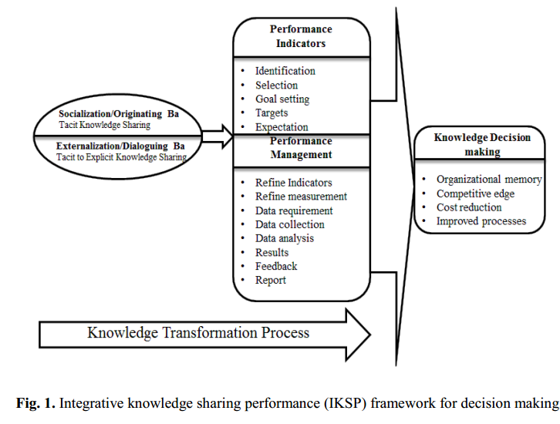
Source: (Olan, Liu and Neaga, 2015)
- The first period for knowledge sharing is to classify staffs with involvements which imitates the practical and commercial ‘know-how’, likewise the situation for information communication.
- The performance phase is the assessing of the influence/influence of information with enactment displays, these displays are business precise i.e. a business chooses on the procedures which displays are measured with.
- Finally, the judgment phase usages some logical tools to draw assumptions on the efficacy of the information alteration procedure.
Though, there happens little linked effort on the involvement of information sharing toward administrative enactment in relation to judgment creation. Therefore, the investigation gap as recognized is to measure the influence of information sharing with precise KPIs ‘main enactment displays'. In the literature, the communal setting in which information adaptation proceeds place was lengthily deliberated and in what way knowledge contributors play a serious role. KSP an information idea knowledge sharing classification, where the situation for communication is measured to be face-to-face.

3.4 Recommend improvements to the current framework

There are limits which are recognised in this report:
(1) There are administrative issues which be able to conceal the effective application of IKSP outline, these issues can though be accomplished established on the attention of the management arrangement.
(2)The accessibility of little or no statistics for experimental data assembly and examination is a compressing issue.
Future investigation will examine the influence of administrative issues on information sharing and presentation, particularly those issues that directly affect judgment making in the business. Rich data gathering and examination will be carried out toward legalising the employment of IKSP outline. In-depth meetings would be used for statistics assembly method. This method would deliver thorough answers and rich calculable imaginative data for examination.
Though, this report is significant for organizations in the following methods.
(1) The transition from administrative procedures to administrative information procedures will decrease process reversal cost as well as time.
(2) The dimension of the production of organizational information procedures delivers the business with cutting edge modest benefit over race.
(3) IKSP outline delivers knowledge support for judgment making in the business, consequently, information sharing will meaningfully affect administrative enactment through providing an atmosphere for information improvement and support for staffs through details.

Conclusion

Knowledge organisation is a sequence of stages that comprise classifying, gathering, storage, and sharing clear, implicit, and unspoken info to persons through a business. An instance of an instrument used in information management is a company's intranet website. Nowadays, knowledge is still measured strength - a vast strength in detail - nonetheless the considerate has altered significantly, mainly from the viewpoint of business. The novel example is that inside the business knowledge essential be shared in demand for it to develop. This study established the following results: It displays the status of information assets on realizing a modest benefit. It displays the trouble of the dimension of these resources even though of the average dimension. It displays the final level of the human capital assets and information resources in the UK countries. It clarifies the modest benefit idea and the role of information management in upholding, smearing, and allocating knowledge. It describes the role of an information based economy in Globalization.

Reference

Barker, P. and Yazdani, M. (2000). Iconic communication. 1st ed. Bristol, UK: Intellect.
Barron, P. and Whitford, M. (2004). An Evaluation of Event Management Education. Journal of Teaching in Travel & Tourism, 4(2), pp.19-43.
Brei, V. & Böhm, S. (2011), "Corporate social responsibility as cultural meaning management: a critique of the marketing of ‘ethical’ bottled water", Business Ethics: A European Review,vol. 20, no. 3, pp. 233-252.
Brooks, N. & Simkin, L. (2012), "Judging marketing mix effectiveness", Marketing Intelligence & Planning, vol. 30, no. 5, pp. 494-514.
Buning, R.J. & Walker, M. (2016), "Differentiating mass participant sport event consumers: traditional versus non-traditional events", Sport Marketing Quarterly, vol. 25, no. 1, pp. 47.
Campbell, D. (2007). The challenge of assessing leadership characteristics. Leadership in Action, 11(2), pp.1-8.
Chikweche, T. & Fletcher, R. (2012), "Revisiting the marketing mix at the bottom of pyramid (BOP): from theoretical considerations to practical realities", Journal of Consumer Marketing, vol. 29, no. 7, pp. 507-520.
D. Raggio, R., M. Walz, A., Bose Godbole, M. & Anne Garretson Folse, J. (2014), "Gratitude in relationship marketing", European Journal of Marketing, vol. 48, no. 1/2, pp. 2-24.
Echchakoui, S. (2014), "Salesperson profitability in relationship marketing", Journal of Modelling in Management, vol. 9, no. 3, pp. 306-323.
Engels-Schwarzpaul, A.-. & Peters, M.A. (2013), Of Other Thoughts: Non-Traditional Ways to the Doctorate : A Guidebook for Candidates and Supervisors, Sense Publishers, Rotterdam.
Eur, J. (2009). Organisational Culture as Organisational Identity — Between the Public and the Private Organisation, 42(3).
Hurt, K. and Dye, D. (2016). Plan Meetings that Are Productive and Targeted for Results. Employment Relations Today, 43(2), pp.35-41.
Jurek, S. and Scime, A. (2013). Achieving Democratic Leadership: A Data-Mined Prescription. Social Science Quarterly, 95(1), pp.97-110.
Law, R. (2009). INTERNET AND TOURISM—PART XXVII: TRAVEL BLOG. Journal of Travel & Tourism Marketing, 26(3), pp.344-346.
Mascia, A. (2014). Project manager: leader, influencer e conflict manager. PROJECT MANAGER (IL), (20), pp.19-23.
Olan, Liu and Neaga, (2015) “The Contribution of Knowledge Sharing to Organizational Performance: An Integrative Knowledge Sharing Performance Framework for Organizational Decision Making, Employment Relations Today”, 43(2), pp.35-41.

