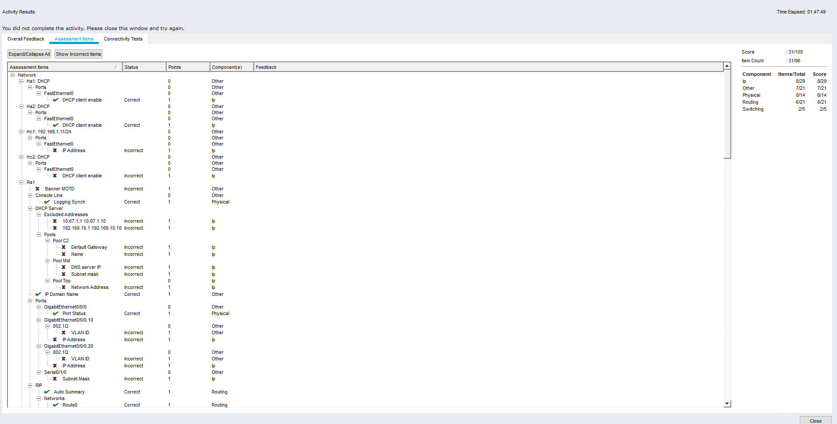

- Is DHCP successful in Ha1 and Ha2?
no
Should be successful. If not Troubleshoot!
- From Ha1, ping Ha2. Is it successful?
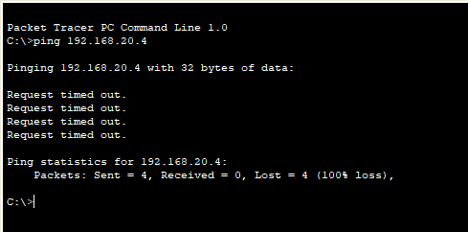
Should be successful. If not Troubleshoot!

- From Ha2, ping Ra1. Is it successful?
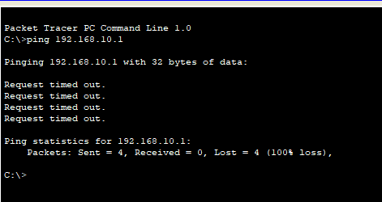
- Connect 209.165.201.1 from Hc1 using SSH. Is it reachable?
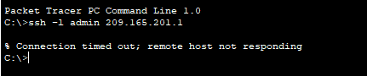
Should be reachable. If not Troubleshoot!
- Connect 209.165.201.1 from Hc2 using SSH. Is it reachable?
- 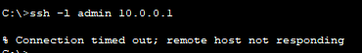
Should be reachable. If not Troubleshoot!
- Connect 209.165.201.1 from Ha1 using SSH. Is it reachable?
- Should be reachable. If not Troubleshoot!
- Connect 209.165.201.1 from Ha2 using SSH. Is it reachable?
Should be reachable. If not Troubleshoot!
- Connect 209.165.201.1 from Hc1 using SSH. Is it reachable?
Should be reachable. If not Troubleshoot!
- Connect 209.165.201.1 from Hc2 using SSH. Is it reachable?
Should not reach. If not Troubleshoot!
- Connect 209.165.201.1 from Ha1 using SSH. Is it reachable?
Should not reach. If not Troubleshoot!
- Connect 209.165.201.1 from Ha2 using SSH. Is it reachable?

