Managing Enterprise- Business Plan
Luciana Florea
2126969
Sizzlers Food


Table of Contents
Introduction 2
Services 2
Marketing Activities 3
Marketing Mix 3
Questionnaire 3
Promotional Material 4
Physical Resources 4
Financial Resources 5
Justification 5
Human Resources 5
Job Description 6
SWOT 7
Cash Flow 8
References 9

Name of Business
The name of my restaurant business is Sizzlers Food. The legal structure of my business will be sole proprietorship. A sole proprietorship is one of the quickest ways to start a business. A sole trader is a person who runs a business on their own.
Advantages of operating as a sole trader
  - Any gain in the value of the property will increase your capital
  - Control of the finances through your account
  - The tax process is simpler
Disadvantages of operating as a sole trader
  - Unlimited liability
  - Any fall in the value of the property will decrease your capital
  - Funding can be difficult.
Sizzlers Food’s mission is to serve my customers with delicious and hygienic food in safe and pleasant environment. The aim of my business is to work better for our community, environment, and employees. The objective of Sizzlers Food is to make sure that each customer feels special and that they can trust that the food I provide is of the highest quality.

Introduction and rationale
A product or service's unique selling proposition (USP) is a feature that can be used in advertising to show how it is different from and better than equivalent products or services. USP stands for "Unique Selling Point," which is what it means. The unique selling point of Sizzlers Food is the use of local, fresh ingredients and the focus on health and wellness. By utilizing local ingredients and creating health-conscious dishes, my restaurant will provide a modern twist on traditional cuisine which will increase the demand of my services. Additionally, my restaurant will offer a wide range of vegan and vegetarian options, making it an excellent choice for health-conscious diners which is effective to give hard to the competitors of hotel sector. The current trend of healthy eating and the popularity of food drives the demand for my restaurant. Furthermore, the lack of fast-casual restaurants will give my restaurant an edge.
I have chosen to pursue a career in the restaurant business because I have a passion for food, customer service, and hospitality. I have always been interested in the culinary arts and the restaurant industry, and I am excited to have the opportunity to pursue this passion finally. I have chosen the restaurant sector because restaurant industry is a suitable place to learn and grow. The industry is constantly changing and evolving, and I am eager to learn and stay current on all the trends. I am also excited to be able to work with several types of people and cultures and provide customers with a unique and enjoyable experience every time they visit.

Services
People all over the world now prefer to shop on e-commerce platforms. This is because e-commerce is so convenient and has so many options that it has grown beyond its original definition (Jiang et al., 2013; Rezaei et al., 2016). My restaurant services will provide a high-quality experience for my customers. It will provide various food options, attentive service, a pleasant atmosphere, and a well-organized take-away service. I plan to take a personal approach to customer service, providing a customized experience for each customer both dining in and take away. This includes listening to their needs and preferences and creating a meal tailored to them (Rayna and Striukova, 2016). I will also strive to create a pleasant and welcoming atmosphere in my restaurant to make my customers comfortable. The adventurous chef who can increase interest in fascinating and unique ingredients will be able to justify a higher price for menu options, which will increase profits, reputation, and most important, client satisfaction. I will also emphasize providing fresh and high-quality ingredients. I understand that my food reflects my restaurant, so I will only use the newest and best ingredients. I will also strive to source local ingredients to support my local farmers and ensure that my customers get the best possible food. Moreover, I want to provide an enjoyable experience for my customers. It includes providing attentive and friendly service and ensuring that my restaurant is a clean and inviting space. I want to ensure that my customers leave my restaurant feeling satisfied and happy.

Marketing Activities
The fast growth of online systems gives customers a wide range of products and services to choose from through real-time communication, and fast shipping. Organizations are always adding modern technology to their business practises to help new business models grow quickly. This is because of several things, such as the availability of smartphones and the ease of using them (Bezerra et al., 2013).
I will undertake numerous marketing activities to sell my restaurant service, but a few are the most important.

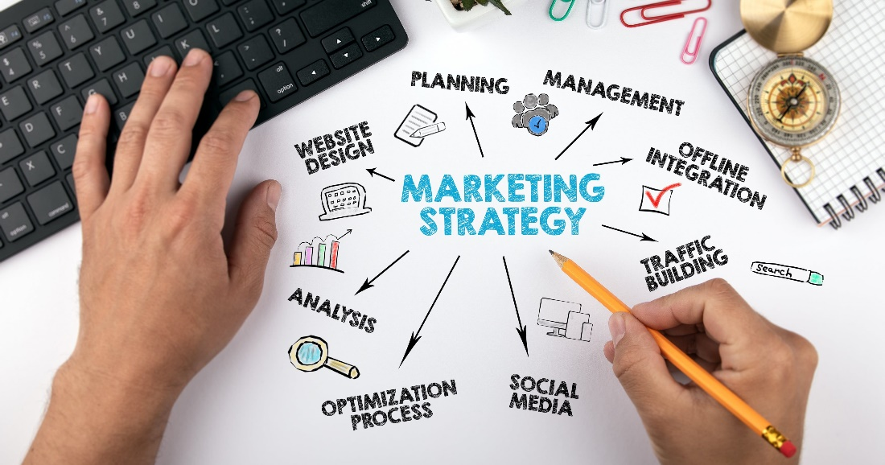
First, I plan to use social media to reach potential customers. This includes creating a website, engaging content for my social media accounts, and utilizing social media ads to reach my target audience. I plan to use visuals like photos and videos to promote my restaurant and its services. Second, I plan to use traditional marketing methods such as print, radio, television, and billboard ads. I target the audience most likely to visit my restaurant through these mediums. Finally, I plan to utilize email marketing to reach my existing and potential customers. This will enable me to build relationships with customers, keep them engaged, and inform them about my restaurant's offerings. These marketing activities will help me reach my target audience and promote my restaurant. These activities will allow to drive more business and generate more revenue. It is important to create a successful business (Massa et al., 2017).
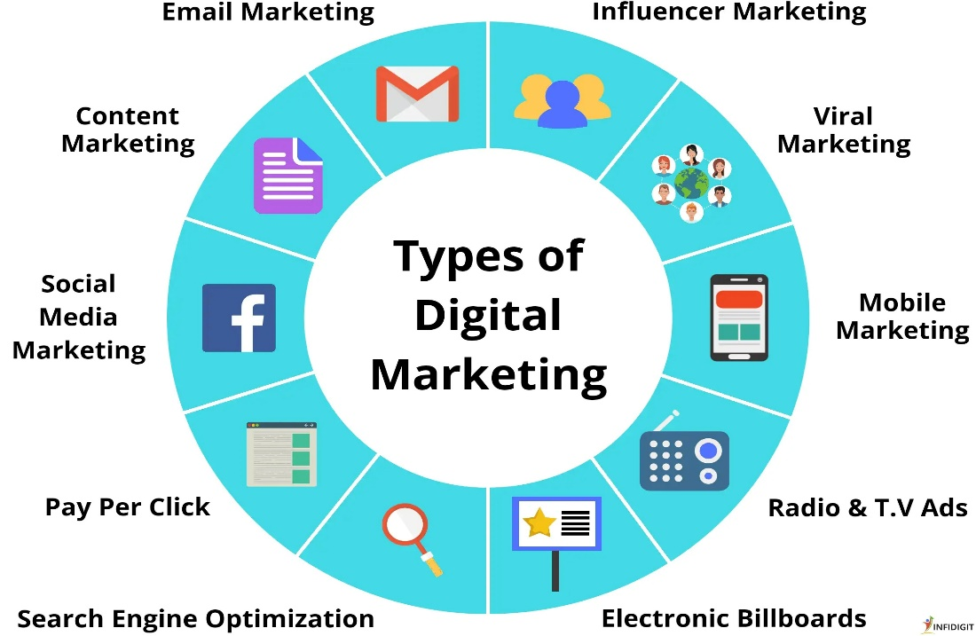

Marketing Mix
The marketing mix combines product, price, place, and promotion. These elements are used to create a marketing strategy to help a business reach its goals (Lee et al., 2019).

Questionnaire
- Do you live within a 5-mile radius of our restaurant?
- How often do you dine out at restaurants?
- What type of cuisine do you prefer when dining out?
- Are there other restaurants in the area that serve similar cuisine?
- Are there any features or services that make you more likely to visit our restaurant?
- Are there other restaurants you would prefer to visit in the area?
- How would you rate the overall quality of food and service at other local restaurants?
- Are there any other factors that would influence your decision to visit our restaurant?
- Are there any times of day or days of the week when you would be more likely to visit our restaurant?
- What is your approximate monthly budget for dining out?

Promotional Material
I plan to use them to advertise my restaurant business services, including flyers, online adverts, newspaper ads, and posters. The plan to promote restaurant business services in local newspapers, social media platforms such as Facebook and Instagram, and local radio stations (Geissdoerfer et al., 2018). There are multi-restaurant mobile apps, like food panda, Pathao, and Zomato, that work as catering intermediaries for several independent restaurants and provide a blended network effect (Kung & Zhong, Citation2017; Sjahroeddin, 2018). I also plan to distribute flyers in local neighbourhoods and post posters around my restaurant. The cost of advertising restaurant business services will depend on how many ads place and where remember those (Budur et al., 2019). I anticipate spending a few hundred pounds on newspaper ads, a few hundred pounds on radio ads, and a few hundred pounds more on online ads. Additionally, I expect to spend a few hundred pounds on flyers and posters.

Physical Resources
My restaurant will be based in a physical location, making it a brick-and-mortar business.
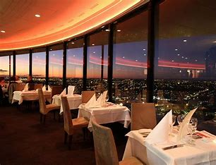
I plan to locate the restaurant in a high-traffic, easily accessible area close to public transportation. I will also create an online presence for the company, including a website and social media accounts, to reach potential customers and promote the restaurant. It will allow customers to order online or pick up their food in person.
A cook in a barren kitchen cannot cook; or he is helpless (Fine, G. A., 1996). Reputations for cooking depend on things like stoves, refrigerators, and tables. Even though people do the work, we could not do what we do without tools.
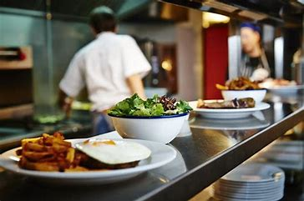
In addition, my restaurant business will require an array of equipment. It includes fixtures and fittings such as tables, chairs, other seating, and items like kitchen equipment, refrigerators, and dishwashers. Additionally, the establishment will require IT systems to manage bookings, stock, and payments. Costings for these items will vary depending on the equipment quality needed, and sourcing these items can be done through local suppliers or online retailers. I recognize the importance of having the necessary resources to run a successful business. Although it may require an initial investment, having the right help makes the company more efficient and more profitable (Rayna and Striukova, 2016). With the proper research and negotiations, I can acquire the necessary resources at a reasonable cost.

Financial Resources
One of the major disadvantages of a sole proprietorship is the difficulty in raising capital.
Even though there are fewer formalities to fulfil as a single proprietor, it is more difficult to raise capital and expand as an independent business than it would be to incorporate. However, sole proprietorship is the most usual form of organization for startups because it facilitates rapid decision making and requires little in the way of investment oversight (Baik et al., 2015).
I have chosen to obtain my restaurant business finance through bank loans. It is a reliable and established option, and I am confident I can secure the necessary financing. I must provide evidence of a strong business plan, adequate collateral, and a good credit score to ensure a loan. I will also need to research the best loan options for my business to ensure I get the best terms and conditions.

Justification
I chose a bank loan because it offers the most flexibility, allowing me to access funds when needed and make payments as I can. It also has lower interest rates than other forms of financing, making it a more affordable option. Additionally, bank loans have longer repayment terms, giving me more time to repay the loan and build up my business.

Human Resources
Sole proprietorship businesses, according to previous studies, benefit from fast decision making and a simpler, less expensive startup process. Without a board of directors and stockholders to answer to, owners are free to shift the company's focus quickly and easily when they spot a promising new opportunity. Additionally, sole proprietorship businesses have lower tax rates than their corporation peers (Demirguc-Kunt et al. 2006).
Restaurant business owners must possess various qualifications and skills to manage their businesses successfully. These include a good understanding of the hospitality industry, business acumen, economic management, marketing, and interpersonal skills (Massa et al., 2017). Restaurant business owners have a comprehensive account of the hospitality industry, including food safety regulations, customer service standards, and the latest trends in the industry (Lee et al., 2019). This knowledge is essential for running a successful restaurant. Business acumen is also necessary for restaurant business owners. This includes identifying profitable opportunities, making strategic decisions, and managing risk. Economic management is also critical for restaurant owners (Geissdoerfer et al., 2018). This involves creating and managing budgets, analyzing financial data, and making informed decisions about pricing, costs, and investments. Marketing skills are also crucial for restaurant owners. This includes creating engaging campaigns, understanding consumer trends, and using digital platforms to reach new customers (Budur et al., 2019).
I will decide on the owner's roles by analyzing their skills and abilities to help them perform their tasks or projects effectively. The first owner will undertake the human resource role because the owner has a wide range of human resources skills and experiences, which will help to operate their tasks effectively. At the same time, the second owner will undertake the role of finance operations manager because of his efficient experience in financial activities. Lastly, the third owner will essay on the part of marketing. The third owner will perform their marketing roles and responsibilities more effectively because of high qualifications in marketing degrees.
Yes, I will need to employ other people in the business such as waiters, chef, managers, and many others. I will obtain these people from various sources, including job boards, recruitment agencies, and direct referrals. The qualifications, experience, and skills needed will vary depending on the position. Employees should have a good understanding of the industry, be knowledgeable of current trends, and be able to think strategically. Employees also possess strong problem-solving and communication skills and a willingness to learn and grow with the company (Rayna and Striukova, 2016).

Job Description
Restaurant Manager
Job Summary
We are looking for an experienced Restaurant Manager to join our team. The Restaurant Manager will oversee operations, manage staff, and create a positive atmosphere for customers. The ideal candidate should be highly organized, have excellent customer service skills, and be able to handle multiple tasks at once.

Responsibilities:
- Oversee day-to-day operations of the restaurant, including scheduling, training, and supervising staff.
- Ensure that all health, safety, and sanitation standards are met
- Monitor food inventory and order supplies as needed
- Develop and implement marketing strategies to increase sales and profits
- Maintain accurate financial records and prepare reports as required
- Monitor customer feedback and respond to complaints promptly
- Create a positive atmosphere for customers and staff

Qualifications:
- Proven experience as a Restaurant Manager or similar position
- Excellent customer service and problem-solving skills
- Ability to work in a fast-paced environment.
- Strong organizational and leadership skills
- Knowledge of restaurant management best practices
- Ability to multitask and work under pressure.
- BSc/BA in hospitality management or a related field is preferred.

Swot
Strengths | Weaknesses | Opportunities | Threats
High demand for restaurant services | High overhead costs | Growth of delivery services | Increased competition
Ability to offer a unique and memorable customer experience | High employee turnover rate | Growth of internet marketing | Changes in consumer preferences
Flexibility in menu options | High competition | Development of food delivery apps | Increased labor costs
Ability to provide delivery and take out services | Limited control over customer experience | Increase in customer demand for convenience (Lee et al., 2019) | Regulatory changes (Geissdoerfer et al., 2018)

Cash Flow

References
BAIK, Y., LEE, S. and LEE, C., 2015. Entrepreneurial firms' choice of ownership forms. International Entrepreneurship and Management Journal, 11(3), pp. 453-471.
Bezerra, I.N. et al. (2013) “Consumo de Alimentos Fora Do domicílio no Brasil,” Revista de Saúde Pública
Budur, T., Faraj, K.M. and Karim, L.A., 2019. The benchmarking operations strategies via hybrid model: a case study of Café-Restaurant Sector. Amazonia Investiga, 8(23), pp.842-854.
DEMIRGUC-KUNT, A., LOVE, I. and MAKSIMOVIC, V., 2006. Business environment and the incorporation decision*. Journal of Banking & Finance, 30(11), pp. 2967.
Fine, G. A. (1996). The kitchen as place and space (2nd ed., pp. 80-111). University of California Press.
Geissdoerfer, M., Vladimirova, D. and Evans, S., 2018. Sustainable business model innovation: A review. Journal of cleaner production, 198, pp.401-416.
Jiang, L. (A., Yang, Z. and Jun, M. (2013) “Measuring consumer perceptions of online shopping convenience,” Journal of Service Management, 24(2), pp. 191–214.
Kung, L.-C. and Zhong, G.-Y. (2017) “The optimal pricing strategy for two-sided platform delivery in the sharing economy,” Transportation Research Part E: Logistics and Transportation Review, 101, pp. 1–12.
Lee, C., Hallak, R. and Sardeshmukh, S.R., 2019. Creativity and innovation in the restaurant sector: Supply-side processes and barriers to implementation. Tourism Management Perspectives, 31, pp.54-62.
Massa, L., Tucci, C.L. and Afuah, A., 2017. A critical assessment of business model research. Academy of Management annals, 11(1), pp.73-104.
Rayna, T. and Striukova, L., 2016. 360° Business Model Innovation: Toward an Integrated View of Business Model Innovation: An integrated, value-based view of a business model can provide insight into potential areas for business model innovation. Research-Technology Management, 59(3), pp.21-28.
Rezaei, S. et al. (2016) “Determinants of app stores continuance behavior: A PLS path modelling approach,” Journal of Internet Commerce, 15(4), pp. 408–440.
Restaurant manager job description [updated for 2023] - indeed (no date). Available at: https://www.indeed.com/hire/job-description/restaurant-manager
Welsh, C. (2007) ‘Ingredients can be a unique selling point’, Caterer & hotelkeeper, 197(4492), p. 18.
Twin, A. (2023) Sole proprietorship: What it is, Pros &amp; Cons, examples, differences from an LLC (Limited Liability Company), Investopedia. Investopedia. Available at: https://www.investopedia.com/terms/s/soleproprietorship.asp

