Research project

Student Name: Nantale Mariam
Student ID: 1905626
Assignment Title: Effective Team Working And Communication
Lecture’s Name: Joy Botu
Assignment 2

Table of Contents
Tittle of the project: 2
Introduction: 2
Literature review: 2
Research Aim: 4
Research objectives: 4
Research plan: 4
Research method: 6
Research strategies: 6
Data collection methods: 6
Sampling methods: 6
Research ethical considerations: 7
Research limitations: 7
Analysis and discussion: 7
Conclusion and recommendations: 12
Reference: 13
Appendix: 15

Figure 1Study mode of students (Source: Author) 8
Figure 2 Familiarity of students (Source: Author) 8
Figure 3Impact of VLE process (Source: Author) 9
Figure 4 impact in the learning process (Source: Author) 10
Figure 5 Misses class lecture (Source: Author) 11

Tittle of the project: The tittle of the project is “The impact of Virtual Learning Environment (VLE) – Moodle on students’ learning experience at the University of Wales Trinity Saint David London Campus”.

Introduction:
The combination of education and modern technologies make the learning process more efficient and productive. Nowadays universities are following online-based learning and try to maximize the benefits of learning. In this research project, the researcher has talked about the virtual learning environment (VLE) and its impacts on the University of Wales students. Through using an online survey, the researcher has determined different aspects of VLE. In the final segment, the researcher has given some recommendations to increase the efficiency of Wales University.

Literature review:
A set of learning tools that help students to develop his or her capability via computer and internet is called a virtual learning environment (Chen et. al., 2017). It is a term used to describe a digital-based platform, where several web-based applications are used to enhance the learning system. A virtual learning environment adds additional value to the existing traditional learning through the usage of various resources and tools. These resources and tools are accessible to teachers and students mostly through the use of the internet. VLE is mainly a comprehensive system that is formed by the combination of many media (audio, graphics, animation, sound effects) together (Chen et. al., 2017). The term VLE covers a lot of territories and according to its comprehensive sense; it means graphics, music, sound effects, voice, video, and animation. So, the main element of a virtual learning environment is a collection of media through which it operates (Junmin, et. al., 2020). The main purpose of the virtual learning environment is to use all the media like text, sound, voice, animation, graphics, image, etc. This process effectively provides the end-user with the best possible experience of learning which is not possible through the use of one media alone. In this world of the modern era, no technology comes into existence without any shortcomings. The virtual learning environment has also its pros and cons. To establish VLE as a fundamental technology in teaching methods, its advantages and disadvantages also need to be recognized appropriately (Junmin, et. al., 2020). If compared with the existing traditional teaching methods VLE has numerous merits. For example, teachers can track the activities of their students. For instance, whether the students are engaging with online learning or not, giving his or her feedback or not, these all activities of a particular student can be tracked by the teacher easily (Chen et. al., 2017). Tracking the activities of the students, a teacher can know what the actual condition of a particular student is, and the teacher can customize his or her lectures or give instructions to the students in that way (Gibson et. al., 2016). Another important merit of VLE, it enhances the communication or interaction between the participants. The participants can communicate and share information easily, through which learning on a particular matter gets intensified (Junmin, et. al., 2020). If all the participants both the students and teacher) participate interactively in the discussion, all participants will get to share their knowledge or experience, which increases their knowledge or teach furthermore (Johnston, 2017). All the needed information and materials can be stored safely and kept in an organized manner very easily. All the important materials needed for effective learning, for example, course-related information, pdf of the needed books, instructions from the instructors, all can be accessible by students from one particular authoritative source through VLE (Levitt et. al., 2017). To enhance the learning of the students, the teachers can also provide them with various external links of sources related to a particular topic (Gibson et. al., 2016). This will help the students to get an overall deep knowledge on any topic or subject. Virtual environment learning appears to be a great time saver for both the teacher and students. The most important advantage of VLE is that it enables a learning experience for the students, which is connected with all the media (Palinkas, 2015). The information in VLE gets presented at various scales through the use of various media i.e. text, image, audio, graphics, etc. The students can gain knowledge about the presented information from many perspectives at a time (Gibson et. al., 2016). A common shortcoming of VLE is that students need to be skilled at using the technologies very effectively. Students cannot get the experience of learning through the use of actual or real materials. It is said and believed by everyone that the learning or knowledge that can be gained from the real world is not comparable with anything let alone VLE.

Research Aim:
The research aims to determine the impacts level VLE process has on the students. Besides that though this project researcher can determine the positive and negative sides of VLE and give some recommendations regarding the process.

Research objectives:
Like every research project, this research project also has some objectives. Such as,
- To find the impacts VLE process on students.
- To find out the success rate of VLE in the university of wales.

Research plan:
Scope: After completing this project, there is the scope of learning process research, online-based learning research.
Cost:
Particulars | Pounds
Variable cost:  Salary of the assistance | 5,000
Total variable cost | 5,000
Fixed cost:  Computer  Laptops | 2,000  3,000
Other | 1,000
Total cost | 11,000
Work break down:
Items | Date | Day
Introduction | 2 Mar
Research method | 4 Mar | 2 days
Interview (Through online) | 5 Mar | 1 day
Analysis | 7 Mar | 2 days
Conclusion | 8 Mar | 1 day
Recheck | 10 Mar | 2 days

Gantt chart:

Research method:
The researcher had used a mixed research method which is the combination of quantitative and qualitative research methods.
Quantitative method: Method, where data are collected in theoretical form, is called a quantitative method (Booker et. al., 2018). Most of the data of this research project in numeric form and there need some sorts of assumptions for the research projects. That’s the core reason behind using quantitative methods. The research had collected data regarding the recommendation of students for improving the VLE process in a quantitative format.
Qualitative method: Method, where data are collected in numeric form, is called a qualitative method (Buckland, 2015). Numeric value gives more clear values regarding the topic. Most of the primary data had been collected by using a qualitative method.
Mixed method: As there were need some assumptions regarding qualitative data and quantitative data represent the facts (Eldar, 2015). That’s why the researcher had used a combination of both of the methods.

Research strategies:
The researcher had used survey strategies as there was some budget limitation. Through the survey, the researcher had collected data regarding VLE impacts.

Data collection methods:
The researcher had collected data from primary and secondary sources.
Primary sources: The researcher had sent a questionnaire to at least 12 students through survey monkey as he or she couldn't take face to face interview.
Secondary sources: The researcher also took the help of the textbook, library, internet sources, and articles for the research purpose, and every source was mentioned.

Sampling methods:
The researcher had used random sampling techniques as it is most appropriate for research and there were some opportunities for all the students to be selected. The sample size was 12 for the research projects.

Research ethical considerations:
There were some ethical considerations in the research projects and the researcher maintained those considerations.
- No pieces of information had been used without provider considerations.
- The researcher had ensured that there was a lower level of misrepresented data.

Research limitations:
Every activity has some limitations. That this research project had some limitations. Such as,
- The researcher could not ensure proper time management.
- The researcher could not ensure proper cost management.
- There might be some errors in the collected data.
Analysis and discussion:

The researcher has surveyed on 12 students about the Virtual Learning Process to know the efficiency and adaptability of this system at Wales University.

Study mode of students:

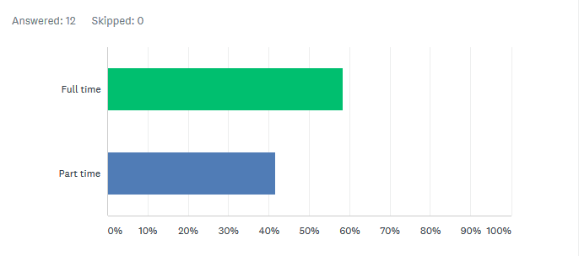
Figure 1Study mode of students (Source: Author)
All of the 12 students answered this question. Among the 10 students, 58% of them are full-time students, 42% are part-time students who are mostly service-holders. In the UK most of the students earn their livelihood that why the rate of part-time students is so high. VLE process can be a better option for them to study in their busy schedule.
Familiarity with students:

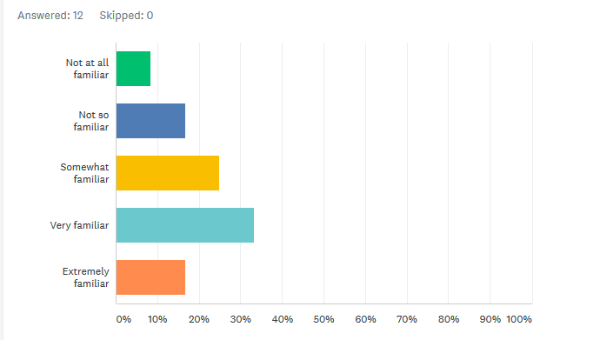
Figure 2 Familiarity of students (Source: Author)
Among the 10 students, Almost 33% of students are very familiar to this system, more than 16% are extremely familiar, 25% are somewhat familiar, 17% are not so familiar, and a very few students less than 9% are not familiar at all, which indicates a mixed result about the familiarity of VLE process and requires more and more initiatives and promotions to reach more students. All 12 students answered this question.
Impact of VLE Process:

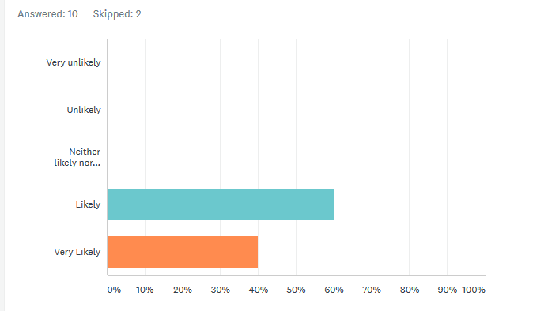
Figure 3Impact of VLE process (Source: Author)
When the question arises about the impact of this system and an increase in learning experience almost everyone has given positive feedback. 10 students answered this questioned and 2 of them skipped this question and among the 10 students, 60% of the students said it has likely any impact and the rest of 40% of students assumed it very likely. As the world moves faster, people take globalization and digitalization positively that is why they express a positive feeling about the VLE Process (Wu et. al., 2017).

Impact in Learning Process:

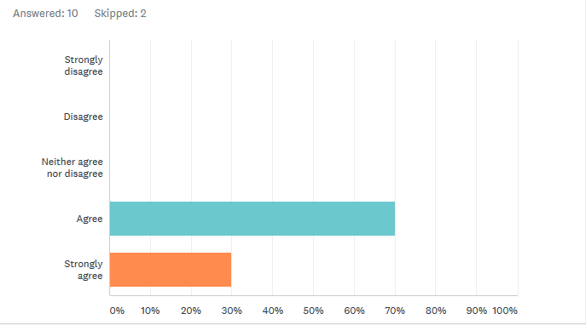
Figure 4 impact in the learning process (Source: Author)
From 12 students, 10 students have answered this questioned and 2 of them skipped this question. Among the 10 students, almost 70% of students agree that VLE increases learning experience and 30% of the students also agree with the statement but quite strongly. Students have their positive view of learning through online and also believe that it helps increasing experience can be plus point of VLE system. Reducing the use of traditional learning systems and introducing more sophisticated, more appropriate, and more convenient learning can add a great change in the education system (Zayed, 2018). It can result in save of time and money. In this part of the questionnaire, two students skipped these questions, which might be because of their confusion or irrelevance.

Misses class lecture:

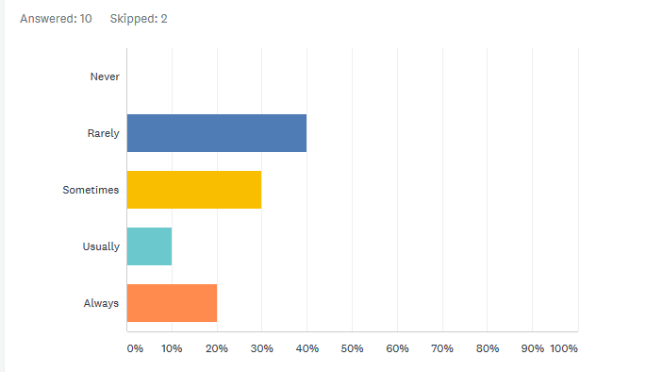
Figure 5 Misses class lecture (Source: Author)
In the next part, students are asked how often they think student misses the class lecture because of VLE. The scenario is the same here, only two of the students skipped this question. The researcher found mixed results in this part. 40% of students think it rarely happens, 30% think it happens sometimes, 10% think it happens usually and 20% of them think it happens always. Overall, most of the students don’t think it is a big problem, and it is not. Proper time management and study plan can help them in avoiding this situation (Woodgate et. al., 2016). Moreover, the VLE process can be developed in such a way that should not hamper routine class, job, or day to day life. 2 of them skipped this question also as they could not decide or did not want to say anything.
Ways of ensuring efficiency of VLE:
In the last part of the questionnaire, an open-ended question is asked to them how the university can ensure the efficiency of the VLE process to enhance the learning experience. 6 of the students skipped this perhaps due to lack of time or willingness and 6 students give their opinion. The rest of them answered with their own opinion, some of them mentioned about proper research and maintaining strategy, some of them put their idea how the university can resolve problems in VLE process facing at this moment. However, the university can launch an effective VLE process according to the needs and opinions of the students (Wang et. al, 2017).

Conclusion and recommendations:

By analysing the VLE process of the University of Wales, the researcher has found that the process is increasing the learning process of students at least 20% (Wales, 2020). Besides that, it is reducing the cost of studies for students. But sometimes this process influences the students to miss classes. So the University of Wales takes some initiatives. Such as,
- At the time of designing the process, the University should take opinions from students.
- University should appoint a monitor who will observe the positive and negative impacts of the VLE process.

Reference:
Booker, D.D., and Steadman, J., Quidel Corp, 2018. Method for reducing analyzer variability using a normalization target. U.S. Patent 9,989,466.
Buckland, S.T., Rexstad, E.A., Marques, T.A., and Oedekoven, C.S., 2015. Distance sampling: methods and applications (p. 277). New York, NY, USA: Springer.
Chen, L., Yi, X., Lu, P., Ma, T., and Hou, P., 2017, July. Quantitative reliability analysis method for power systems with multi-level standby structure based on GO method. In 2017 Second International Conference on Reliability Systems Engineering (ICRSE) (pp. 1-5). IEEE.
Eldar, Y.C., 2015. Sampling theory: Beyond bandlimited systems. Cambridge University Press.
Gibson, F., Hibbins, S., Grew, T., Morgan, S., Pearce, S., Stark, D. and Fern, L.A., 2016. How young people describe the impact of living with and beyond a cancer diagnosis: feasibility of using social media as a research method. Psycho‐oncology, 25(11), pp.1317-1323.
Johnston, M.P., 2017. Secondary data analysis: A method of which the time has come. Qualitative and quantitative methods in libraries, 3(3), pp.619-626.
Junmin, L.I.U. and Drangova, M., 2020. Method for dixon MRI, multi-contrast imaging, and multi-parametric mapping with a single multi-echo gradient-recalled echo acquisition. U.S. Patent 10,534,057.
Levitt, E.E., and Chapman, R.H., 2017. Hypnosis as a research method. In Hypnosis (pp. 85-114). Routledge.
Palinkas, L.A., Horwitz, S.M., Green, C.A., Wisdom, J.P., Duan, N. and Hoagwood, K., 2015. Purposeful sampling for qualitative data collection and analysis in mixed method implementation research. Administration and policy in mental health and mental health services research, 42(5), pp.533-544.
Wales.ac.uk. 2020. Home - University Of Wales. [online] Available at: <https://www.wales.ac.uk/en/Home.aspx> [Accessed 23 April 2020].
Wang, H., He, Y., Li, Y.H., Su, Z.E., Li, B., Huang, H.L., Ding, X., Chen, M.C., Liu, C., Qin, J. and Li, J.P., 2017. High-efficiency multiphoton boson sampling. Nature Photonics, 11(6), pp.361-365.
Woodgate, R.L., Zurba, M., and Tennent, P., 2016, November. Worth a thousand words? Advantages, challenges, and opportunities in working with photovoice as a qualitative research method with youth and their families. In Forum Qualitative Sozialforschung/Forum: Qualitative Social Research (Vol. 18, No. 1).
Wu, C.Y., Manmatha, R., Smola, A.J., and Krahenbuhl, P., 2017. Sampling matters in deep embedding learning. In Proceedings of the IEEE International Conference on Computer Vision (pp. 2840-2848).
Zayed, A., 2018. Advances in Shannon's sampling theory. Routledge.

Appendix:
The impact of the Virtual Learning Environment (VLE)
1. What is your study mode?
Full time
Part time
2. Are you familiar with the Virtual Learning Environment (VLE)?
Extremely familiar
Very familiar
Somewhat familiar
Not so familiar
Not at all familiar
3. Do you think there is any impact of the Virtual Learning Environment (VLE) on learning experience?
Very likely
Likely
Neither likely nor unlikely
Unlikely
Very unlikely
4. Do you agree that VLE increases the learning experience?
Strongly agree
Agree
Neither agree nor disagree
Disagree
Strongly disagree
5. How often do you think student miss the class lectures because of VLE?
Always
Usually
Sometimes
Rarely
Never
6. According to you, how can the university insure for efficient VLE process to enhance the learning experience?
Answer:
Bottom of Form

