Student Name: Ola Abusaid
Student Number: 2408409
Module Code: BMHP5015
Module Title: Changemakers: Building your Personal Brand for Sustainable Employment
Assignment Title: Component 2 – Report

Introduction
This report evaluates my employability skills in relation to the role of an Early Years Teaching Assistant in the UK. I selected this career because I enjoy supporting young children's learning, wellbeing and development. My interest in early years education has developed through completing a Level 2 Childcare qualification, a one-year nursery placement, my current BSc Health and Social Care studies and my part-time role as an Arabic language teacher in Birmingham. Together, these experiences have strengthened my commitment to pursuing a long-term career as an Early Years Teacher.
The report is based on a current Early Years Teaching Assistant vacancy advertised by Zest Education in Birmingham. The job advertisement is used to identify the qualifications, skills and personal qualities required for the role. A skills audit and SWOT analysis are used to evaluate my current employability, identify areas for development and support a realistic professional development plan. Finally, the report explains how I will strengthen my personal brand, professional identity and career prospects.

1. Job Description and Person Specification
Figure 1. Early Years Teaching Assistant Vacancy (Zest Education, Birmingham, 2026) 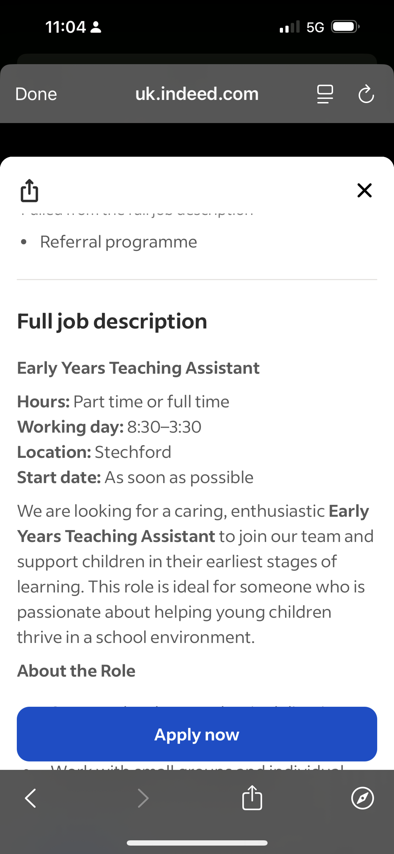
Figure 1 shows the selected Early Years Teaching Assistant vacancy used for this report (Indeed, 2026).

The selected vacancy is an Early Years Teaching Assistant position advertised by Zest Education in Stechford, Birmingham (Indeed, 2026). The role requires an enthusiastic and caring individual who can support children's learning, promote positive behaviour and contribute to a safe and inclusive environment.
The advertisement highlights responsibilities including supporting classroom activities, monitoring children's progress, communicating with parents and colleagues, and following safeguarding procedures. These expectations closely reflect the principles of the Early Years Foundation Stage (Department for Education, 2024), which emphasises children's learning, development and wellbeing.
Several employability skills are essential for this role. Effective communication enables practitioners to work successfully with children, families and colleagues while supporting children's language and social development. Teamwork is equally important because Teaching Assistants work alongside teachers and other professionals to provide consistent support. Patience and empathy are also required, particularly when working with children who have different learning needs, including those with SEND or English as an Additional Language. Finally, organisation and safeguarding are fundamental responsibilities because practitioners must prepare learning activities, maintain accurate records and ensure children's safety.
Overall, the vacancy demonstrates that employers seek candidates who combine appropriate qualifications with strong interpersonal skills, professionalism and a genuine commitment to children's development.

2. Analysis of Employability Skills
Table 1. Skills Audit
Employability Skill | Job Requirement | My Current Level | Evidence | Development Action
Communication | Excellent communication | Good | Nursery placement and Arabic teaching | Improve professional English through CPD
Teamwork | Work with teachers and parents | Very Good | Nursery placement and teaching | Gain school-based experience
Patience and Empathy | Support children's wellbeing | Excellent | Teaching and parenting experience | Learn additional SEND strategies
Organisation | Prepare activities and routines | Very Good | Balancing study, work and family | Improve professional documentation
Safeguarding | Follow safeguarding procedures | Good | Safeguarding and First Aid certificates | Complete refresher training annually

The skills audit indicates that I already possess many of the competencies required for the role. My strongest skills are patience, teamwork and communication, which have developed through both my nursery placement and my teaching experience. These experiences have improved my confidence in supporting children's learning while working effectively with colleagues and families.
Communication is particularly important because it supports positive relationships with children, parents and professionals. During my nursery placement, I learned to adapt my communication to children's individual needs and learning styles. My current role as an Arabic teacher has further strengthened my ability to explain ideas clearly, encourage participation and work with families from different cultural backgrounds.
Reflecting on my placement has helped me recognise my professional development. At the beginning, I relied on guidance from experienced practitioners, but over time I became more confident in supporting activities and communicating independently. This experience demonstrated the value of reflective practice and continuous learning.
Although I meet many of the requirements identified in the job advertisement, I recognise that improving my professional English remains an important development goal. Strengthening my written and spoken professional communication will improve my confidence when writing reports, communicating with parents and participating in professional meetings.

3. My Qualifications, Experience, Personal Brand and Unique Selling Point
Table 2. Personal SWOT Analysis
Strengths | Weaknesses
One-year nursery placement | English is my second language
Level 2 Childcare qualification | Limited experience in UK mainstream schools
Part-time Arabic language teacher | Limited experience writing formal school reports
Safeguarding and First Aid certificates

Opportunities | Threats
Growing demand for Early Years Teaching Assistants | Competition for permanent posts
Completion of BSc Health and Social Care | Changing recruitment requirements
CPD and teacher training | Keeping professional knowledge up to date
Professional networking

Analysis of My Qualifications and Experience
My qualifications have provided both theoretical knowledge and practical experience relevant to early years education. My Level 2 Childcare qualification introduced me to child development and safeguarding, while my BSc Health and Social Care studies have strengthened my understanding of communication, equality, diversity and person-centred practice.
My one-year nursery placement allowed me to apply this knowledge by supporting children's learning, encouraging positive behaviour and working collaboratively with experienced practitioners. It also developed my confidence and understanding of how children learn through play and positive relationships.
My current role as a part-time Arabic language teacher has strengthened my classroom management, lesson planning and communication skills. In addition, my experience as a parent has developed my patience, empathy and understanding of children's emotional needs. Together, these experiences have prepared me for the responsibilities of an Early Years Teaching Assistant.
Critical Reflection
Reflecting on my experience has shown how my confidence has increased through practice, feedback and continuous learning. While I recognise the need to improve my professional English and gain further experience within UK schools, I view these as realistic development goals that will strengthen my future career progression.
My Personal Brand
My personal brand is based on patience, responsibility, professionalism and a genuine commitment to supporting children's learning. These qualities are demonstrated through my university studies, nursery placement and teaching experience. Following Rampersad (2008), I believe that a strong personal brand should be authentic, consistent and supported by continuous professional development.
My Unique Selling Point
My greatest strength is the combination of academic study, practical nursery experience and teaching experience. In addition, being bilingual in Arabic and English allows me to communicate with families from diverse backgrounds and contribute to inclusive practice. Although I continue to develop my professional English, I believe my qualifications, experience and commitment to lifelong learning provide a strong foundation for achieving my long-term goal of becoming an Early Years Teacher.

4. Professional Networking and Five-Year Action Plan
Professional Networking
Professional networking is important because it provides opportunities to learn from experienced practitioners, access professional development opportunities and become aware of employment vacancies. Building professional relationships also supports the exchange of knowledge and good practice within the education sector.
My current network includes university lecturers, tutors, classmates and colleagues from my role as an Arabic language teacher. During my nursery placement, I also worked alongside experienced Early Years practitioners who helped develop my confidence through guidance and feedback. Although this network has supported my development, I recognise the importance of expanding it further.
To improve my future employment opportunities, I intend to attend Continuing Professional Development (CPD) courses, educational workshops and local networking events. I will also continue developing my LinkedIn profile and build relationships with professionals working in schools and early years settings. Expanding my network will increase my knowledge, improve my confidence and provide access to future career opportunities.

Table 3. Five-Year Professional Development Action Plan
Career Goal | Planned Action | Timescale | Resources Required | Expected Outcome
Complete BSc Health and Social Care | Successfully complete all modules | 2026–2027 | University support and study resources | Graduate successfully
Improve professional English | Attend English courses and practise academic writing | Ongoing | Online learning and university workshops | Increased confidence in communication
Secure employment as an Early Years Teaching Assistant | Apply for suitable vacancies and prepare for interviews | Within one year | Updated CV and references | Obtain full-time employment
Continue professional development | Attend CPD training and renew certificates | Annually | CPD providers | Maintain professional competence
Become an Early Years Teacher | Complete teacher training | Within five years | Teacher training programmes | Achieve long-term career goal

Critical Evaluation of the Action Plan
This action plan provides a realistic pathway towards my long-term career goal. Completing my degree and improving my professional English are immediate priorities because they will strengthen both my knowledge and confidence. Gaining employment as an Early Years Teaching Assistant will allow me to apply my academic learning while developing practical experience in a school environment.
Continuous professional development will remain essential throughout my career because educational policies and teaching practices continue to evolve. Therefore, I intend to participate regularly in CPD activities and continue reflecting on my practice to improve my professional skills.

5. Promoting My Professional Identity
Developing a strong professional identity is essential for securing employment and progressing within the education sector. Professional identity is influenced by qualifications, practical experience, communication skills and professional behaviour.
To present myself professionally, I will maintain an up-to-date Curriculum Vitae (CV) that highlights my Level 2 Childcare qualification, BSc Health and Social Care studies, nursery placement, Safeguarding and First Aid certificates, and my experience as a part-time Arabic language teacher. I will also continue developing my LinkedIn profile to demonstrate my professional interests and connect with schools, recruitment agencies and education professionals.
When applying for jobs, I will prepare tailored cover letters that demonstrate how my experience and personal qualities meet the requirements of each vacancy. My personal brand reflects the values of patience, responsibility, organisation and professionalism, while my bilingual communication skills allow me to support children and families from diverse cultural backgrounds. I believe these qualities will contribute positively to inclusive practice and strengthen my future career opportunities.
Professional identity continues to develop through experience, reflection and lifelong learning. By seeking feedback, participating in CPD and maintaining high professional standards, I will continue strengthening my confidence and competence as I progress towards becoming an Early Years Teacher.

6. Conclusion
This report has evaluated the employability skills required for the role of an Early Years Teaching Assistant and compared them with my own qualifications, experience and personal qualities. The analysis of the selected job advertisement demonstrated that employers value communication, teamwork, organisation, safeguarding knowledge and a commitment to supporting children's learning and wellbeing.
The report identified several strengths, including my Level 2 Childcare qualification, one-year nursery placement, current role as an Arabic language teacher, Health and Social Care studies, and Safeguarding and First Aid training. My experience as a parent has also strengthened qualities such as patience, empathy and resilience.
At the same time, I identified areas for further development, particularly improving my professional English and gaining additional experience within UK schools. My skills audit, SWOT analysis and five-year action plan provide a realistic framework for achieving these goals.
Overall, I believe that my qualifications, practical experience and commitment to continuous professional development provide a strong foundation for achieving my long-term ambition of becoming an Early Years Teacher.

Reference List
Department for Education (2024) Statutory framework for the Early Years Foundation Stage. Available at: https://www.gov.uk/government/publications/early-years-foundation-stage-framework--2 (Accessed: 12 July 2026).
Early Education (2024) Supporting Children's Learning and Development. Available at: https://www.early-education.org.uk (Accessed: 12 July 2026).
Early Years Alliance (2024) Supporting High Quality Early Years Practice. Available at: https://www.eyalliance.org.uk (Accessed: 12 July 2026).
Education Endowment Foundation (2024) Teaching and Learning Toolkit. Available at: https://educationendowmentfoundation.org.uk (Accessed: 12 July 2026).
Gibbs, G. (1988) Learning by Doing: A Guide to Teaching and Learning Methods. Oxford: Oxford Polytechnic.
Indeed (2026) Early Years Teaching Assistant – Zest Education, Stechford, Birmingham. Available at: https://uk.indeed.com (Accessed: 12 July 2026).
LinkedIn (2024) What is Personal Branding? Available at: https://www.linkedin.com (Accessed: 12 July 2026).
National Careers Service (2024) Teaching Assistant. Available at: https://nationalcareers.service.gov.uk/job-profiles/teaching-assistant (Accessed: 12 July 2026).
Ofsted (2024) Education Inspection Framework. Available at: https://www.gov.uk/government/organisations/ofsted (Accessed: 12 July 2026).
Rampersad, H.K. (2008) Authentic Personal Branding: A New Blueprint for Building and Aligning a Powerful Leadership Brand. Charlotte, NC: Information Age Publishing.
Skills for Care (2024) Continuing Professional Development. Available at: https://www.skillsforcare.org.uk (Accessed: 12 July 2026).
UNICEF (2024) Early Childhood Development. Available at: https://www.unicef.org (Accessed: 12 July 2026).

