ACBA 5001: NPTCBC Bridge
  - By Ben Kneeshaw – 1902457

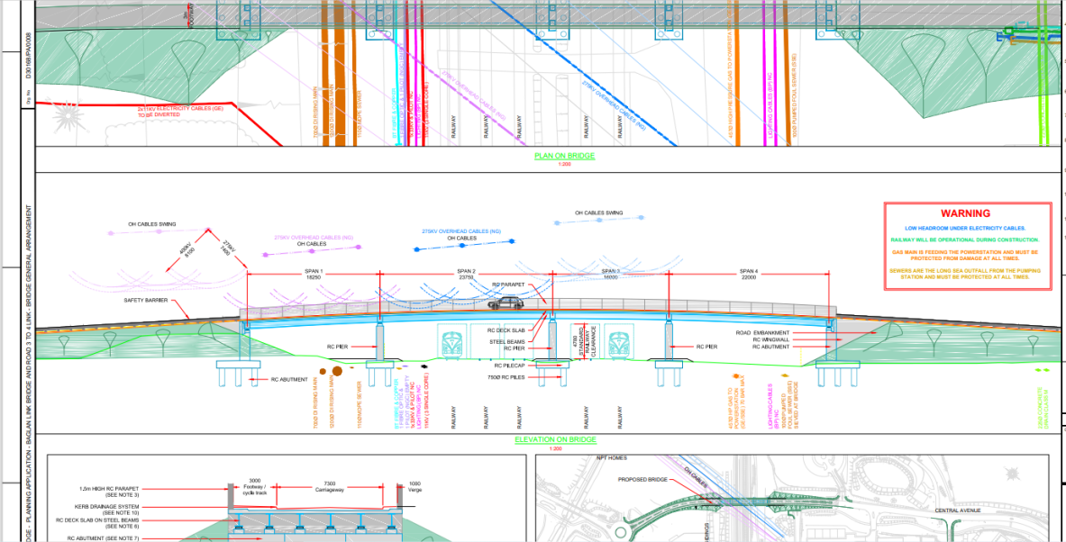

Table of contents

1. Introduction………………………………………………………….Page 3
2. Time, cost and resource analysis………………………………...Pages 3-6
2.1 Time………………………………………………………………...Pages 3-4
2.2 Cost………………………………………………………………...Pages 4-5
2.3 Resource…………………………………………………………..Page 6
3. Reference list……………………………………………………….Page 7
4-7. Appendices………………………………………………………Pages 8-10

Introduction

This report details time, cost and resources for the proposed bridge linking two industrial estates in the NPTCBC area. A detailed work breakdown structure is included in Appendix A. Method statements for three of the major activities taking place as part of the works are included in Appendices B, C and D.

Time, cost and resource analysis

Time


The project is projected to run for 140 days, starting on the 5th of May 2021 and running until the 20th of September 2021, shown in figure 1 below. This cumulates as 2,816 work hours overall, graphs in figure 2 and 3 show how these are split between the various stages of the build and how they are split between the various professions on site. Labourers will account for 1,280 of the work hours whilst skilled workers will account for 1,536 of the hours. The most time intensive stages of the build will be the road construction and pier/abutment construction, with each taking over 600 work hours.
Figure 2:
Graph showing a breakdown of work hours by project stage.
Figure 1:
Graph showing timeline for project and cumulative work.
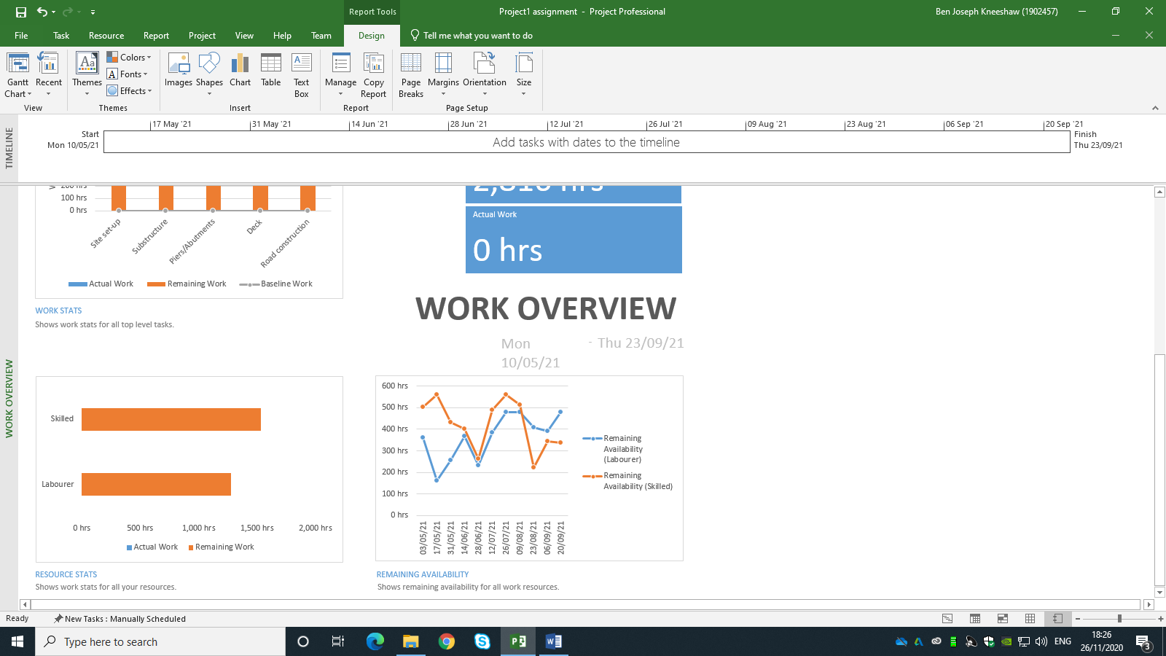
Figure 3:
Graph showing a breakdown of work hours by profession.

Cost


The project is projected to cost £43,750.00 overall, a graph detailing how this will accrue is shown in figure 4. Additional graphs showing the breakdown of cost in comparison to work stages are shown in figures 5 and 6. This is a figure derived from the cost of labour coupled with the concrete costs; actual figures may be slightly higher as steel rebar has not been taken into account in this analysis. The concrete used will be of grade C20, suitable for a structure of this type; this is projected to cost £90.00 per cubic metre (homeguides, 2020). This cumulates to £2,790.00. Labourers will be payed £8.00 per hour whilst skilled workers will be payed £20.00 per hour. This cumulates to just over £10,000 for labourers and just over £30,000 for skilled workers, a graph showing this is included in figure 7. An additional graph is included in figure 8 showing the cost distribution between resources.
Figure 4:
Graph showing cumulative cost over time

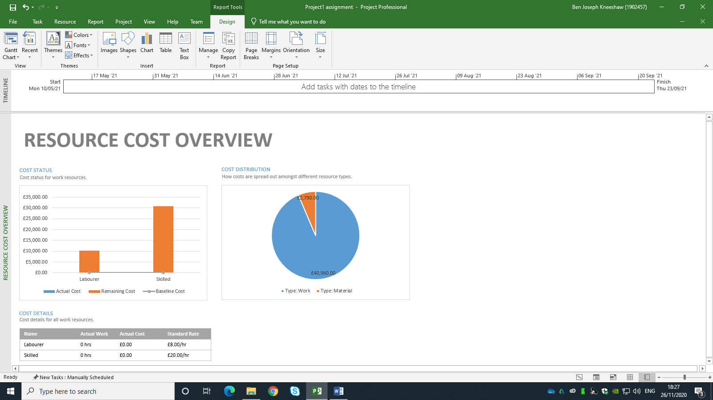
Figure 8:
Pie chart showing cost allocation by resource type.
Figure 7:
Graph showing breakdown of cost by profession.
Figure 6:
Table showing the costs associated with each of the main tasks for the project
Figure 5:
Graph showing the costs associated with each of the main tasks for the project.



Resources

The two resources covered in this report are labour and concrete. A comparison for the costs of these is shown above in figure 8. The concrete is estimated to cost £2,790 with a total of 31 cubic metres being used, this is a figure derived from the attached gant chart. The labour is estimated to cost £40,960; a breakdown of this is available above in figure 7. The cost for resources may rise as steel rebar has not been taken into account in this analysis.

List of references

- Homeguides (2020). Your guide to concrete prices. [Online] Available at: https://homeguides.co.uk/concrete/ (Accessed: 01.12.20)

Appendix A: Work breakdown structure
Bridge construction

2. Piers/abutments
4. Road construction
3. Deck placement
- Substructure
4.1 Drainage system placed
3.1 Deck delivery
2.1.1 Rebar and formwork for abutments
1.1.1 Drilling for piles

4.2 Sub-base lain
3.2 Deck staging mechanism put in place
2.1.2 Concrete pours for abutments
1.1.2 Rebar and formwork for piles
#
4.8.2 Road lights installed
4.8.1 Sideguards placed
4.7 Surface course for road and pavement lain
4.6 Binder course lain
4.5 Electrical cables placed
4.4 Base course lain
4.3 Kerbs placed
3.3 Deck placement
2.4 Embankment building
2.3.3 Formwork removal for wing walls
2.3.2 Concrete pours for wing walls
2.3.1 Rebar and formwork for wing walls
2.2.3 Formwork removal for piers
2.2.2 Concrete pours for piers
2.2.1 Rebar and formwork for piers
2.1.3 Formwork removal for abutments
1.2.3 Formwork removal for pile caps
1.2.2 Concrete pours for pile caps
1.2.1 Rebar and formwork for pile caps
1.1.4 Formwork removal for piles
1.1.3 Concrete pours for piles

Appendix B: Method statement: Substructure

The first part of the substructure to be completed will be the piles. There are many underground utilities to be aware of, including a sewage outlet and a gas main feeding the nearby power station. It is critical to avoid these and as such the locations for the piles will be lain out by qualified professionals prior to works beginning. Due to the overhead cables present on site, eliminating the possibility of driving the piles, a drill auger will then be used to excavate for the piles. Formwork and rebar will then be put in place. The next step will be to pour the concrete for each of the piles. As with all concrete pours for this site it will be done via pump from a mixer along the side of the rails. This is because the rails are live and must be kept clear as much as possible. After the concrete has been allowed to set for 48 hours the formwork will be removed, formwork and rebar can then be put in place for the pile caps. The concrete can then be poured for the pile caps; this will again be allowed to set for 48 hours before the formwork can be removed and work on the piers and abutments can begin. All workers on this stage of the project must have the relevant qualifications (PTS) as the rails are live.

Appendix C: Method statement: Piers/Abutments

The next stage of this project will be the piers and abutments. Once the formwork has been removed from the pile caps, work can begin on erecting the rebar and formwork for the abutments. Concrete can then be poured, again via pump due to the live rails. This will be left for 48 hours to set. During this time rebar and formwork will be erected for the piers, subsequently followed by another concrete pour. By this time the concrete for the abutments will have had 48 hours to set and as such the formwork can be removed. Rebar and formwork can then be put in place for the wing walls alongside each abutment. This will be followed by a concrete pour for the wing walls. Once both the piers and wing walls have had 48 hours to set the formwork can be removed. As the concrete will need 28 days to reach full strength for the deck to be placed, this is an ideal time to build the embankments and fill in any remaining excavated areas. Once again all workers on this stage will need PTS qualification due to the live rails.

Appendix D: Method statement: Deck placement

The next stage of this project is the placement of the deck. 28 days after the concrete pour for the wing walls, all of the concrete will have reached maximum strength. As such work can begin on the deck. First the staging mechanism will be put in place for the deck. During this time a bridge crane will be erected along the length of the bridge so as to lift the deck into place when it arrives, a tower crane is unsuitable for this project due to the overhead cables. Once these elements are in place the pre-manufactured deck can be delivered. This will then be lifted into place and locked in. Once again all workers on this stage will need PTS qualification due to the live rails.

