  Event Strategic Planning and Delivery Considerations for Eid Event  (BMIH6007) | Abstract  An Eid event is planning held on 16th June 2024 at Town Garden, Swindon. The aim of this report is to create strategic planning and delivery considerations for Eid event. Event cycle of distinct phases will confer in this report. Also, the concept, aims and objectives will elaborately explain in this report. Event operation process and how can the budgeting, latest trends, issues, and impacts that linked with MICE industry by referring with 4p’s, SWOT & PESTLE Analysis will discuss. The wider cultural/ situational consideration linked with the event and its importance will demonstrate with practical skills, deploy few examples, and case studies.  Tahmina Islam (2124414)  International Meetings Management for the Hotel Industry
Prepared for
Kathryn Flynn

Contents
Introduction: 1
Event Cycle: 1
❖ Domains 3
❖ Processes 3
❖ Phases 3
Event concept: 3
Aims and objectives: 4
Event operations: 4
Event budget: 5
Industry trends: 6
SWOT Analysis: 7
➢ Strength 7
➢ Weakness 7
➢ Opportunity 7
➢ Threats 7
PESTLE Analysis: 8
Cultural and situational considerations: 8
References: 9

Executive Summary: The aim of this report is to evaluate the delivery and the strategic planning of the Eid event that were previously proposed as part of the feasible stage. This report strongly built and more strategic in focus, concentrating on the specifics of important planning linked to the potential future delivery focusing on theoretical and practical issues of the event that develop on the information of the presentation.
Event is important for celebrate and share the joys with everybody. Eid event is going to celebrate on 16th June 2024 at Town Garden, Swindon. It is organising for Muslim community member in Swindon as here people celebrate Eid Ul Adha privately. A successful event is going through 5 stages. These stages have 3 phases. The phases are planning, delivery and evaluation. They are plan, organise, measure, Analyse, and share. For first phase, planning according to the aims and objectives, arrange a budget, meet with fundraisers and so on towards organising process. In this process, how the event will work out, number of people attended, what types of food, decorations, safety etc. will be there in delivery phase. Next the evaluation phase, feedback will be getting through the online platform and measure them. Analyse the feedback and share it with others for future events. This report will disseminate the Eid event through the EMBOK model that have 3 dimensions. They are domains, Processes, and phases. In the domain part, the event has theme, 4p’s, catering, human resources, security. Next, process all the domains and make tools and techniques via documentation and monitoring the domains. After the processing period, there are 3 parts of phases. At first, the initial period contains with feasibility study. Secondly the planning period, specifying the requirements of feasibility studies. Thirdly, implementation by contrasting and evaluate the event and share it for future references. As it is an Eid event themed with technology and innovation, contactless check-in process and latest trends will be using in the event. Entertainment will be there for kids and grownups. Food will serve in buffet system with sitting facilities and strictly no alcohol will serve. Event will record via live streaming and selfie booth will be available or this day. The main aim is to bring friends and family together and enjoy the special day. The SMART objectives were setting ups in the event. So, kids will learn Islamic culture, foods, and festivals. Also, another objective is to be increasing the satisfaction level of guest for future event. In this report, 4p’s will going to discuss challenging the characteristics. Maslow’s Hierarchy needs shows 5 stages are describing according with the Eid event. In the very first and second stage, the physiological needs described in this event as a ground, safety and security arrangements will need to organise it. In the third and fourth stage, approaches of organise the event, success rates with families and friends are describes. At last stage, self-actualization will hold by doing activities towards a successful event. Planning a budget is particularly important to successful an event. This event approximates revenue is £33000 and expenditures is £30820. That helps to generate profit £2180. With the help of sponsors, I have got £29000 to organise the event. I need £4000 for the expenses including the miscellaneous cost as I am searching for new sponsors. Moreover, MICE industry growing as it attracts the sponsors and guests significantly via social media. Using situational analysis to understand the SWOT & PESTLE analysis of the successful event. However, sponsors and technology will help to organize and promote the event for enjoyable experiences for all participants.

Introduction:

An event is a public gathering for purposes of celebrating something such as- occasion, marketing, education etc. to make it memorable (Event Education,2024). Someone gets experienced or takes places called Event (Collins,2024). So, the events are huge part of hospitality industry that are continuous to grow making millions of incomes and change the route of strategy in hospitality industry (Glion,2020). In this report, I am outlining the strategic planning and developing the consideration of delivery regarding the presentation of Eid event. Eid ul Adha is also known as ‘Feast of sacrifice’ is celebrate by Muslims (Muslim Aid,2021). 1.6 billion of Muslims in worldwide for three to four days (Harvard, 2020). Wherever 6310 people are Muslims in Swindon (City population,2021). Eid ul Adha Event is planning to celebrate in Town Garden at the very heart of the local community of Old Town, Swindon as people usually celebrating this festival privately around 100-150 people maximum. This place is available for event as they host range of events such as- Holi, Easter Egg Trail etc. were organised recently. There are parking available on the Westley and two entrances of Quary (Town Garden,2024a).
Event Cycle:
For every successful event, there were a goal to working out systematically towards continuously improve the value in the direction of reach the event goals (Quick,2020). Event design model have 5 stages. They are describing along with the event give below:

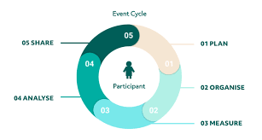
(Source: Lyyti, 2021)

In the first stage, I need to set an aim and few objectives that relevant on guests with realistic budget. Also, mark up few event facilities for guests. Next, I need to Organise the Eid event with online marketing and follow up start to end of this event. After that taking several feedback as its important after the completion of an event. Guests will be sending a follow up email to send their opinions about the event. After getting the response from guest, need to analyse it and improve product and service that attracts new customer and helps to initiate conversations with dissatisfied customers. Sharing the action plans at last from the findings with colleagues to plan better in future (Kaunisto, 2021).
The event cycle consists of sequences of phases that arises in result to an event (Khan, 2016). There are 3 phases of the Event Cycle. They have given below:

The planning phases (feasibility stage) | The delivery phases | The evaluation phases
Establishing a conventional strategic plan to relate the vision and detail the actions that will fulfil and attain the vision (Lynch 2009). In the feasibility stage need to define the objectives, customary the budget, venue selection, invitation the audience, design the programme content, choice catering, entertaining and audio-visual facility, workforce planning, consult with suppliers, determine the time and the process to evaluate (Project Manager,2018). | The execution of goals and objective will accommodate & map out the crucial and potential emergencies in this stage. Keeping track of paperwork, hiring enough staff, provide a smooth, memorable experiences by using technology, easy check in services to help direct attendees that can optimize and enhance the lifecycle of the event (Busila, 2024). Also look out of the last minutes changes to pay off the hard- work (UVA, 2022). | After the wrapped-up event, this time is to evaluate and reflect the success. According to Bowdin (2009), event’s evaluation phase consists of few steps, are comparing task descriptions and planned timelines with actual performance, assessing the flexibility of the system, evaluating the timeliness of reports, assessing the effectiveness of management decisions, and comparing planned milestones with the reality.

Moreover, EMBOK (2004) model have 3 dimensions. They are stating below with application of Eid event:
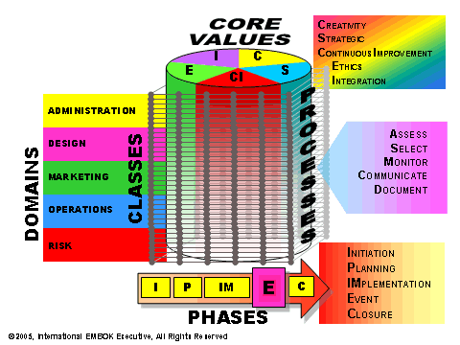
- Domains: It consists of 5 parts. They are Administration, Design, Marketing, Operation and Risk. Eid event is planning and organise by adjusting with event’s theme, environment, human resources, production, catering, promotions, financial factors, sponsors, timing, participants, communication, security, Health, and Safety.
- Processes: In this stage, process all the domains to build tools and techniques by using documentation, monitoring, and communication.
- Phases: There are 3 steps before the event. At first the initiation period, wherever researching the concept and validate the feasibility study. If the event is feasible then the planning period will help to specify the requirements and tactics developments. Then the Implementation period will help to contrast and coordinate the event move towards the reality. After successfully organizing the event, the closer phase will help to get feedback from guests to evaluate it and share it for improvement in future events.

Event concept:

Precisely in Arabic Eid means a "festival" or "feast" (Chitwood,2024). This event is themed on technology and innovation that will open for all Swindon Muslim community members to attend this festival for just £40 per family, guest will be registering them via online and ticketing as it is much easier and saves time (GLION, 2023). Contactless check-in through QR code and payment process via Apple pay, Goggle pay etc (Chefswear, 2024) will help guest’s life easier rather than carry a hard copy of ticket. People are loving to pay online rather than caring cash after COVID. According to Office for National Statistics (2022), retail sales were 26.6% that was more than February 2020 as it is latest trends. In this event entertainments will be held on for kids and family. Face painting will be available for kids under 10 years starting at 3:30 PM. Robotic henna artists will also be available starting at 3:00 PM & food and drinks stall will be available for guest’s own cost. Food stalls will operate on buffet system near the Ball ground wherever sitting facilities are available. No alcohol allows in this event. Also, few Shopping stalls will be available such as-Fashion, Decorations/ Toys etc. Kids activity will be available including trampolines, inflatables, drop slide, and bubble soccer on 3pm to 5.55pm. The last Rides will close 5 minutes earlier this event close time. For safety reasons, grip socks required for all children participating in activities. People can either bring your own or purchase them for £3 each at the gate from the centre. Live streaming will record to allow attendees engagement and connecting with people in other places (Les Roches, 2024). Parents/Guardians will ask ed to sign a consent form to give permission for use of images where children can easily identify. Few Cartoons character such as- Omar and Hana, Micky mouse will come to entertain the kids. Selfie points are available to make a memory as selfie is more popular to young generations and others. Through the feedback summery, guest can attend the Prize Draw will be held with 1st prize £200, 2nd place £100 and the 3rd place being £50 will be awarded as an Amazon Vouchers after the event that will improve product and service that attracts new customer and helps to initiate conversations with dissatisfied customers by using follow up emails (Needle, 2023).

Aims and objectives:
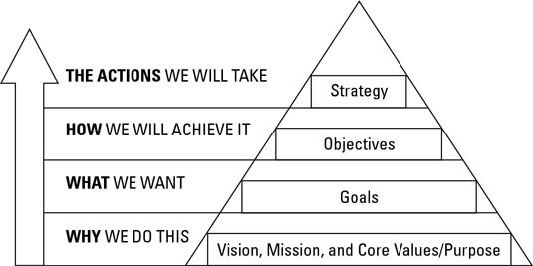
Goals form the foundation of your event strategy and guide the planning and Objectives are significant as they deliver standards and targets to aim for and performance gauges that facilitate supervising and measures for feedback and evaluation (Bladen, 2012). A goal should be specific and measurable to producing leads is too ambiguous to measure goal and add a time limit (VanCuren,2023). This event’s aim is to bringing communities, friends, and families together and enjoy the event. Setting SMART objectives taking the project proceeding onwards, improves with accountability and timing, and the way of accomplishing the aim. The SMART Objectives are stands for specific, measurable, achievable, relevant, and time bound (Personio, 2024). This event objectives are giving a fun evening with family and friends that leads to more specific and measurable While the kids have a blast with our activities and learn about Islamic festival as well as they can Taste traditional Eid festival food and drinks that is achievable and relevant. Also Increasing customer satisfactions in time bound to make the event successful and moved the business forward.
Source: Stigall (2019)

Event operations: It is important to consider the ‘Services Marketing Mix or 4 p’s’ that help to address the Service Sector challenging characteristics (Coursera, 2023) given below:
Product: | Eid Event.
Promotion: | Social media marketing, email marketing, Apps, and websites.
Place: | Town Garden, Old town. Swindon.
Price: | £40 per family.
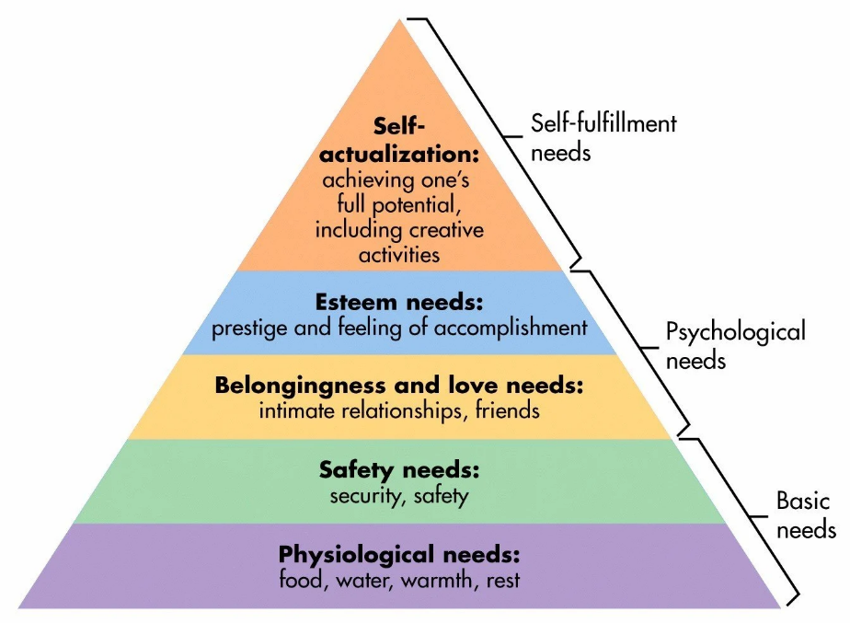
According to Maslow’s Hierarchy of needs, there are 5 stages. This theory applies on this event. As it is describing as follows- At first, I need to book a ground wherever 500 families can attend the event. Traditional cakes, rice puddings, Doner-kebab, authentic Asian cuisine, sweets, Veg. cutlets etc will be available on the day. In safety needs stages for security, I am booking 40 security guard by making a contact with Titan Serv company (2024) to protect the people with the help of the highly qualified guards to prevent any issues or conflicts and use drones to secure the ground of the event. Also, the guest’s health and safety with Rhino Safety (2024) to managing the health and safety such as fire safety and train the staff as well. For the psychological needs of the event, 5 skilled staff will need for the event who will get trained and lead the team. In the event, 50 volunteers will help us by doing virtuous deeds serving the people on the day of Eid to organise the grand event. For the self-actualization needs, I am planning to open 15 stalls for foods and drinks, fashion, toys etc... This event will decorate by lighting, colourful festoons, and traditional decor. Funfair will be booking for kids’ entertainment while the Funfirm company will provide their qualified staff as the company has their own risk assessment tests and £10 million public liability insurance (Funfair, 2024). I am booking the robots from Cyberstain as a henna artist to make traffic in the event because first time using a robot into an event as a henna artist.
Source: Simple Physiology (2024)
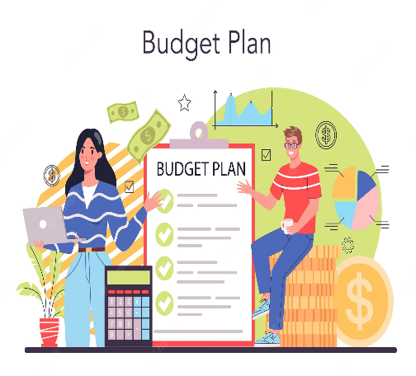
Event budget: For constructing budget of the event need to establish economic environment as well as making a draft copy of budget and sub budget according with objectives by identify the source of revenue and cost for approval from committee to evaluate the final budgets and control ratio (Bowdin, 2006). I am accepting £33000 revenue including £3000 donations as I am accepting 500 family including parents and kids, even couple can attend this event. The shopping stalls revenue is counting £5000 and food stalls is £2000 that is 10% of total sales. However, total food sales are counting £20,000 wherever 50% will go for charity to help the Muslims in Palestine, 20% local community help and leftover money will go for event’s temporary toilet hire, cleaning process and other maintenance cost. Kid’s activity including trampolines, inflatables, drop slide, and bubble soccer are free for kids use to 3pm until 5.55pm. Robotic henna artist and other’s revenue will be £3000. So, approximately £33000 will be getting as a revenue.
Source: Ayub (2024)
5 team leaders will help us to organise the event and lead the 50 volunteers will get free food, uniform, free passes for next event. They will work 16 hours with £14 per hour that cost £1120 and free training facilities (If I need more hours, they will help as overtime that cost £15 per hour). Food and other equipment cost will be £7000. Event’s ground booking cost will be £4000 for 2 days. 15 Shopping and food stalls will cost £3000 (EPH Creative, 2024). However, shopping stalls items will cost £3000. Kids rider booking cost will be £700 from Funfirm company. 40 security guard will appoint for 5 hours (2pm to 7pm) from Titan SERV company that cost me £3000. Decoration and other items cost £5000, Health and safety cost will be £2000 and robot booking cost £2000. Total cost in this event will be £30820 that helps me to generate profit around £2180.
To organising the event, few sponsors will be sponsoring the Eid Event. The detail of sponsoring amounts along with names given below:

Name | Amounts | Sponsoring sites
- Madina Halal Meats | £2000 | Health and Safety
- UTC Swindon | £4000 | Event place booking cost
- Biplob restaurant, Swindon | £3000 | Food stall cost
- Swindon Theatres | £5000 | Decoration & others
- Swindon local food bank | £2000 | Rider booking + 5 Team leader
- Jewel in the crown, Swindon | £7000 | Food and other equipment
- CMD recruitment | £3000 | Security
- Grow Insurance | £3000 | Shopping stalls
Total sponsoring amount= | £ 29000

£1820 required to complete the approx. cost amount. Miscellaneous cost can be come up any time in the event. So, I need £4000 as I am searching for other sponsors to organise the event.
Industry trends:

Industry growth and developments in the MICE industry majorly drives the economic growth and complex. However, Global MICE industry size was $0.94 trillion in 2022 and projected to reach $1.85 trillion in 2031 (SyQuest, 2024). The event segment is a substantial sponsor to the UK economy as it makes £84billion yearly (Evans, 2022). In 2019, over 1.3 million business events held in the UK annually that generated £31 billion of explicit expend with leisure events contributing further to the sum (mfullard,2020). Moreover, the global event industry market share expected to grow to US$1965.99 billion by 2028 and even US$2.1 trillion by 2032 (Deshmukh and Srivastava, 2023). TCEB (Thailand Convention and Exhibition Bureau) is a government agency to organise the event smoothly using innovation and information technology to support the events with worldwide trends for making opportunities and expand products and services to become renowned internationally (Business Events Thailand, 2020). Expo 2020 represent the cultures of 192 countries all together to connect the people with hopes and opportunities of ideas, innovations, live streamed event, and new source of inspiration (Expo2020 Dubai, 2024). Moreover, MICE industries growth driven by social media that attracts the sponsors as well as the guests (Fortune Business Insights, 2024). Eid ul Fitr observed in Trafalgar square in April 2024 was in remarkable success as they were using technology as same as this event (Mayor of London, 2024).
Source: Nallalingham (2023)

SWOT Analysis:
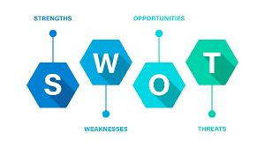
Situation analysis is the process of collecting, evaluating, and organising information regarding an organisation's internal and external environments (Grant. R, 2005). The SWOT analysis for this event given below:
- Strength: A motivated and experienced team will work in the event. It has online registration & payment processing systems, effective tools like social media marketing to book tickets, make donations and any updates of event will notify via websites, apps.
- Weakness: Lack of sufficient financing for the event.
- Opportunity: Charity will help the marketing of any companies.
Source: Score (2024)
- Threats: As the event is hold in outside, it may rain on the day. The event has sufficient gazebos and umbrellas for all if any rains.

PESTLE Analysis:
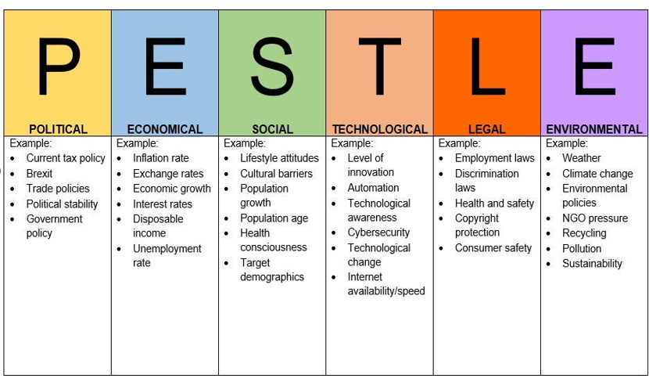
Political factors often have an impact on organisations. Government policy might change as well as price of goods may change that can affect the event. Governments use interest rate control, taxation policy and government expenditure as their main mechanisms they use for this. Also, Technological factors affect marketing and the management, guest lifestyle can influence the event. Health and Safety are more important as it seen by Rhino Safety. Factors include an awareness of climate change or seasonal or terrain variations which may affect charities’ service delivery methods. Environmental factors are important due to the increasing scarcity of raw materials, pollution targets, doing business as an ethical and sustainable company, carbon footprint targets set by governments.
Cultural and situational considerations: Sponsors and technology will help to make this event more successful. Bowdin et al. (2011) stated that “Each year, events occur throughout the United Kingdom. They lead the media, fill transport systems, hotels, and venues, meet business goals, motivate communities, and create positive and negative impacts.” Events often represent ‘high-end’ visitor spend, community empowerment that can attract global expertise, getting people together and awareness by creating and spreading knowledge world-wide to promote global understanding (Ontario, 2016). Good events involve careful planning and coordination to ensure a seamless and enjoyable experience for participants (Morlot,2024). Events play a significant role in supporting other businesses replaced other depleted industry types, such as manufacturing by promote investment, trade, communications, and technology.

References:
- Agsa Ayub (2024). ‘Event Budget Guide – Planning and Cost Breakdown.’ [Picture]. Available at: https://images.app.goo.gl/dEv5RJhV5pp9Wa4S8 (accessed on: 20th May 2024).
- Aleksi Kaunisto (2021). ‘Introducing the Event Cycle – The core of Event Success Management.’ Lyyti. [Blog]. Available at: https://www.lyyti.com/en/blog/introducing-the-event-cycle-the-core-of-event-success-management( accessed on: 10th May 2024).
- Anca Busila (2024). ‘Navigating the event life cycle: before, during and after your event.’ Fancee. Available at: https://wearefancee.com/2024/04/navigating-the-event-life-cycle-before-during-and-after-your-event (accessed on: 11th May 2024).
- Antwone Stigall (2019). ‘Meeting & Event Management: Goals & Objectives.’ [Picture]. Available at: https://images.app.goo.gl/LGYaTmnSgvgYpc8m9 (accessed on: 20th May 2024).
- Bladen, C. et al (2012). ‘Events Management: An Introduction.’ Abingdon: Routledge Seven. (Accessed on: 13th May 2024).
- Bowdin, J. (2009). ‘THE PROCESS OF CUSTOMER ENGAGEMENT: A CONCEPTUAL FRAMEWORK.’ Journal of Marketing Theory and Practice. Vol. 17. pp. 63–74. Available at: https://doi.org/10.2753/MTP1069-6679170105 (accessed on: 12th May 2024).
- Bowdin, G., Allen, J., O’Toole, W., Harris, R. and McDonnell, I. (2011). ‘Events Management.’ Oxford: Elsevier. (Chapter Eleven) (Accessed on: 6th May 2024).
- Bowdin, G., Allen, J., O’Toole, W., Harris, R. and McDonnell, I. (2006) Events Management. Oxford: Elsevier. (accessed on: 13th May 2024).
- Business Events Thailand (2020). ‘Knowing TCEB & MICE in Thailand.’ [Video]. Available at: https://youtu.be/i2o542R6MDA?si=nWKYCxQb07q7cBf2 (accessed on: 12th May 2024).
- City population (2021). ‘SWINDON Unitary District in Southwest England.’ Available at: https://www.citypopulation.de/en/uk/southwestengland/admin/E06000030__swindon/ (accessed on: 24th April 2024).
- Clélia Morlot (2024). ‘Why are Events Important? Understanding why events matter.’ Piratex. [Blog]. Available at: https://piratex.com/blog/events-are-important/#:~:text=They%20play%20a%20crucial%20role,and%20enjoyable%20experience%20for%20participants (accessed on: 25th April 2024).
- Collins (2024). ‘Definition of Event.’ Available at: https://www.collinsdictionary.com/dictionary/english/event#:~:text=noun-,1.,the%20event%2C%20after%20the%20event) (accessed on:7th May 2024).
- Coursera (2023). ‘The 4 Ps of Marketing: What They Are and How to Use Them.’ Available at: https://www.coursera.org/gb/articles/4-ps-of-marketing (accessed on: 13th May 2024).
- Cyberstein Robotics (2024). ‘Enquiry.’ Available at: https://cyberstein.com/booking-enquiries/ (accessed on: 6th May 2024).
- Dylan Jones- Evans (2022). ‘The huge economic impact of the UK’s event industry.’ Business Live. Available at: https://www.business-live.co.uk/opinion-analysis/huge-economic-impact-uks-event-23563660 (accessed on: 7th May 2024).
- Event Education (2024). ‘What is an event?’ Available at: https://www.eventeducation.com/what-is-event.php (accessed on: 7th May 2024).
- EMBOK (2004). ‘EMBOK model.’ Available at: https://www.embok.org/index.php/embok-model (accessed on: 13th May 2024).
- EPH Creative (2024). ‘Food Stall and Countertop.’ Available at: https://www.eventprophire.com/product/food-stall-counter-top/ (accessed on: 27 April 2024).
- Expo 2020 Dubai (2024). ‘Expo 2020 Dubai story’. Available at: https://www.expo2020dubai.com/understanding-expo/world-expos-history/expo-2020-dubai-story (accessed on: 13th May 2024).
- Fortune Business Insights (2024). ‘MICE Market size, share & Industry Analysis by Event Type (Meetings, Incentives, Convention and Exhibitions), and regional forecast, 2024-2032’. Available at: https://www.fortunebusinessinsights.com/mice-market-108653 (accessed on: 13th May 2024).
- Funfirm (2024). ‘About Us.’ Available at: https://www.thefunfirm.co.uk/pages/about-bouncy-castle-hire#BodyContent (accessed on: 27 April 2024).
- Flori Needle (2023). ‘The Benefits of Customer Feedback, According to Expert.’ HubSpot. [Blog]. Available at: https://blog.hubspot.com/service/benefits-of-customer-feedback (1st May 2024).
- Glion (2020). ‘Why Events Are So Important to The Hospitality Industry.’ Available at: https://www.glion.edu/magazine/events-important-hospitality-industry/#:~:text=Events%20and%20conferences%20are%20a,hospitality%20organizations%20and%20resorts%20operate. (Accessed on: 7th May 2024).
- Grant, R. (2005). ‘Contemporary Strategy Analysis.’ Melbourne, Blackwell. (Accessed on 7th May 2024).
- Ken Chitwood (2024). ‘What is Eid al-Fitr? 6 questions about the holiday and how Muslims celebrate it, answered’. CBC News. Available at: https://www.cbsnews.com/news/what-is-eid-al-fitr-6-questions-about-the-holiday-and-how-muslims-celebrate-it-answered/#:~:text=Eid%20literally%20means%20a%20%22festival,and%20Eid%20al%2DAdha%20later. (Accessed on: 11th May 2024)
- Lee Nallalingham (2023). ‘Why Keeping Up with Industry Trends is Key to Career Success.’ [Picture]. Available at: https://images.app.goo.gl/habXHLMhyWdhbJZA9 (accessed on: 20th May 2024)
- Les Roches (2024).’The future of Event Planning: How Technology Change the Game’. [Blog]. Available at: https://lesroches.edu/blog/future-event-planning-technology-changing-game/ (accessed on: 27th April 2024).
- Lynch, R. (2009) Strategic Management, 5th ed. Prentice Hall: Harlow. (Accessed on: 6th May 2024).
- Lyyti (2021). ‘Introducing the Event Cycle – The core of Event Success Management.’ [Picture]. Available at: https://images.app.goo.gl/yUusp5jygVRjHzod8 (accessed on: 20th May 2024).
- Mayor of London (2024). ‘Eid in the square 2024’. London Assembly. Available at: https://www.london.gov.uk/events/eid-square-2024 (accessed on: 25 April 2024).
- Mfullard (2020). ‘The UK Events Report reveals depth of £70bn events industry’. Conference News. Available at: https://www.conference-news.co.uk/news/uk-events-report-reveals-depth-ps70bn-events-industry/ (accessed on: 8th May 2024).
- Muslim aid (2024). ‘The Two Types of Eid in Islam.’ Available at: https://www.muslimaid.org/media-centre/blog/the-two-types-of-eid-in-islam/ (accessed on: 24th April 2024).
- Ontario (2016). ‘The importance of culture.’ Available at: https://www.ontario.ca/document/environmental-scan-culture-sector-ontario-culture-strategy-background-document/importance-culture#:~:text=In%20addition%20to%20its%20intrinsic,for%20both%20individuals%20and%20communities. (Accessed on: 13th May 2024).
- Office of National Statistics (2022). ‘How our spending has changed since the end of coronavirus (COVID-19) restrictions’. Available at: https://www.ons.gov.uk/businessindustryandtrade/retailindustry/articles/howourspendinghaschangedsincetheendofcoronaviruscovid19restrictions/2022-07-11 (accessed on: 11th May 2024).
- Olivia VanCuren (2023). ‘Event management process: 5 steps and stages to launching an event’. Webex Events. [Blog]. Available at: https: //socio.events/blog/event-management-process( accessed on: 10th May 2024).
- Personio (2024). ‘SMART Objectives: Meaning, Writing Tips & Examples.’ Available at: https://www.personio.com/hr-lexicon/smart-objectives/ (accessed on: 11th May 2024).
- Project manager (2018). ‘How to Conduct a Feasibility Study- Project Management Training.’ [YouTube]. Available at: https://youtu.be/WI6_snOjlm0?si=Bp6iRMhjLWy-jRy1 (1st May 2024).
- Rhino Safety (2024). ‘How important is health and safety for events. [Blog]. Available at: https://www.rhinosafety.co.uk/blog/how-important-is-health-and-safety-for-events/#:~:text=Health%20and%20safety%20at%20an%20event%20is%20being%20clear%20about,for%20both%20staff%20and%20attendees. (Accessed on: 4th May 2024)
- Sarah Harvard (2020). ‘Eid al-Adha: 8 Things You Should Know About Islam’s Biggest Holiday of the Year’. Teenvouge. Available at: https://www.teenvogue.com/story/eid-al-adha-islamic-holiday-facts#:~:text=Nearly%201.6%20billion%20Muslims%20around,and%20Christianity%3A%20the%20prophet%20Abraham (accessed on: 25th April 2024).
- Score (2024). ‘Important Questions to Ask in Your SWOT Analysis.’ [Picture]. Available at: https://images.app.goo.gl/rbsuMvx8RwCFSCsN6 (accessed on: 20th May 2024).
- Simple Physiology (2024). ‘Maslow’s Hierarchy of Needs.’ [Photo]. Available at: https://images.app.goo.gl/yjtCXorUjYRQ6pKR6 (accessed on: 27th May 2024).
- Sugandha Srivastava | Roshan Deshmukh (2023). ‘Events Industry Market Size, Share, Competitive Landscape and Trend Analysis Report by Type, by Revenue Source, by Organizer, by Age Group: Global Opportunity Analysis and Industry Forecast, 2023-2032’. Allied Market Research. Available at: https://www.alliedmarketresearch.com/events-industry-market (accessed on: 8th May 2024).
- SkyQuest (2024). ‘Global Mice Market Size, Share, Growth Analysis, By Type of Event (Meetings, incentives), By Application (Corporate, healthcare) - Industry Forecast 2024-2031’. Available at: https://www.skyquestt.com/report/mice-market#:~:text=Global%20Mice%20Market%20size%20was,period%20(2024%2D2031). (Accessed on: 13th May 2024).
- Titan Serv (2024). ‘About us.’ Available at: https://www.titanserv.co.uk/about/ (accessed on: 29th May 2024).
- Town Gardens (2024a). ‘About us. Available at: https://towngardens-swindon.co.uk/about/ (accessed on: 25th April 2024).
- Usman Tahir Khan (2016). ‘What is event cycle?’ Quora. Available at: https://www.quora.com/What-is-the-event-cycle#:~:text=The%20event%20cycle%20refers%20to,user%20interaction%20or%20system%20activity. (Accessed on: 10th May 2024).
- UVA (2022). ‘The Stages of Event Production: A Complete Guide.’ OPAV. [Blog]. Available at: https://op-av.com/blog/stages-event-production-guide (accessed on: 11th May 2024).
- Quick, L (2020). ‘Managing Events, Real Challenges Real Outcomes.’ SAGE Publications Ltd. (Accessed on: 7th May 2024).

