Seren Levi Cassell

E-Portfolio
Learning in the Digital Era

Contents
Summary of ‘A focus on fathers in child mental health interventions’ 2
Video Presentation 2
Academic Poster 3
Reflection of Contribution 4
Team Communication 4
Reference Page 5

Summary of ‘A focus on fathers in child mental health interventions’
In the mental health services, many professionals have complained that many fathers do not get involved in the treatment of their children. it is more the mothers that get involved in the sessions for treatment to help their children get better. It has been found that having the fathers there will give a greater outcome of the treatment. The state of a child’s mental health is not always down to the mother and both parents have influence towards it. Half of mental health problems have been found to originate in early childhood. There needs to be a united force to tackle mental health problems from both parents. Research shows that there needs to be a strong relationship between parent and child for treatment to be successful. The mental health advice was being delivered to women by mostly women and this has shown problems when treating male children. The benefits of fathers being involved are clear, but it improves the outcomes of the treatment in relation to topics like conduct problems. When both parents take part there is more understanding and reliable delivering of the advice that is given. When both mum and dad are present their can be a wider perspective to why their child is facing these challenges due to one parent possibly not knowing the history of the others family or each of them having different perspectives on the events that have happened. There are many barriers to why fathers cannot attend the sessions and one of them is work commitments, it has been identified that there needs to be a more flexible way to deliver the support so that fathers can attend. It has to be said that the mother also has to encourage the father’s participation especially when there is a co-parenting relationship and how strong that relationship is. When the family contact the practitioner, they should identify who the main care givers are to the children so that they can have the most comprehensive care. The invite to attend the sessions should be to both parents. This is to encourage the fathers to participate (Tully et al, 2022).

Video Presentation

E-PORTFOLIO - TOP SKILLS OF A PSYCHOLOGIST.pptx

Academic Poster
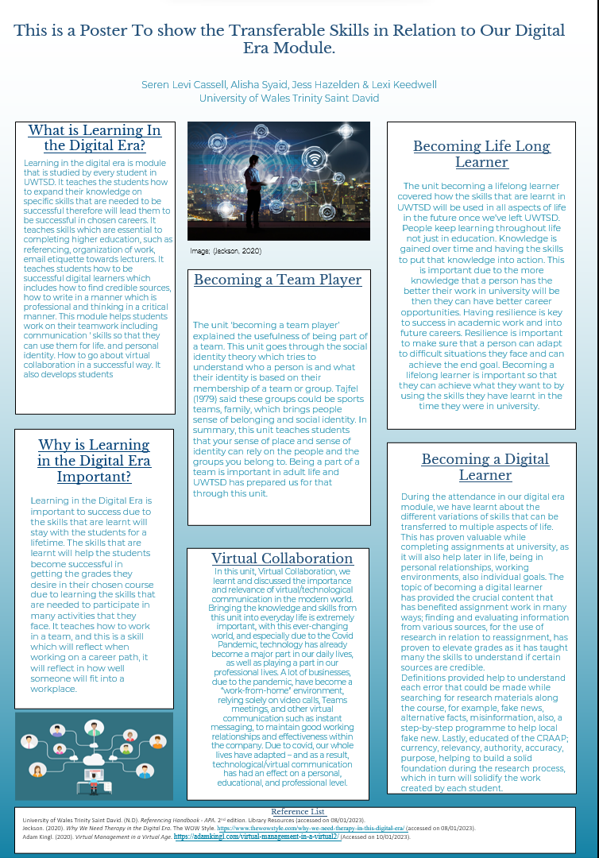
Link to Poster

Reflection of Contribution
I think we worked well together, we got together and shared our ideas of how to complete it. We then went away and wrote our own little paragraphs to add into the poster. I did the layout, introduction, and unit 4 which is becoming a lifelong learner. I think we all did this well and used our skills that we’d learnt to complete this task. I am happy with my work and I am proud we worked effectively as a team to complete this task. We had a few bumps in doing it due to us finding it hard to meet up to start the work as we do not live near each other. We overcame these issues and managed to complete the task. I enjoyed completing this task as I was using the skills we had learnt. Overall I think the team worked well and we all worked well to achieve the end goal.

Team Communication
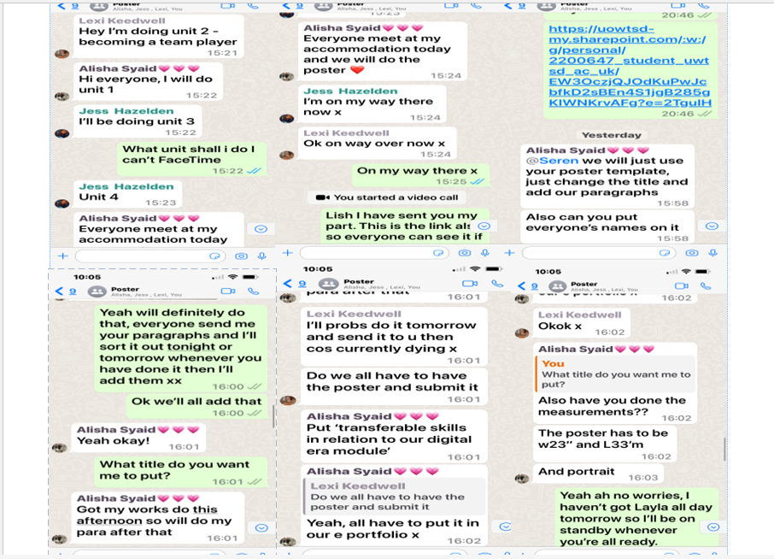

Reference Page

Tully, L., Hawes, D., & Dadds, M. (2022, June 14). A focus on fathers in child mental health interventions. The Psychologist. Retrieved January 6, 2023, from https://www.bps.org.uk/psychologist/focus-fathers-child-mental-health-interventions
Kendra Cherry, 2022. What is Empathy?. https://www.verywellmind.com/what-is-empathy-2795562 (Accessed on 05/01/2023).
Gran Canyon University, 2021. What Skills Do You Need To Become a Psychologist. https://www.gcu.edu/blog/psychology-counseling/skills-needed-to-become-a-psychologist#:~:text=Psychologists%20need%20excellent%20problem-solving%20skills%20because%20it%20is,also%20referred%20to%20as%20an%20emotional%20quotient%20%28EQ%29. (Accessed on 06/01/2023).
Cambridge Dictionary, 2023. Diligence. https://dictionary.cambridge.org/dictionary/english/diligence (Accessed on 06/01/2023).
Good Therapy, 2015. Patience. https://www.goodtherapy.org/blog/psychpedia/patience#:~:text=Evolutionary%20psychologists%20are%20increasingly%20interested%20in%20patience%2C%20and,reward-gratification%20seems%20to%20involve%20some%20degree%20of%20calculation. (Accessed on 06/01/2023).
University of Wales Trinity Saint David. (N.D). Referencing Handbook - APA. 2nd edition. Library Resources (accessed on 08/01/2023).
Jeckson. (2020). Why We Need Therapy in the Digital Era. The WOW Style. https://www.thewowstyle.com/why-we-need-therapy-in-this-digital-era/ (accessed on 08/01/2023).
Adam Kingl. (2020). Virtual Management in a Virtual Age. https://adamkingl.com/virtual-management-in-a-virtual2/ (Accessed on 10/01/2023).

