Data Handling and Business Intelligence
LCBB5000

Student: Andrada Maria Oncescu
ID: 2030829

Table of Contents
PART 1 3
1.1 Determination of the decline in the sale or profit over the years 3
1.2 Evaluation on the use of Excel for pre-processing the data, analyzing and visualizing the data 4
1.3 Determination of the decline in the sale or profit by Pivot tables and IF 4
PART 2 7
2.1 Number of the students likes vanilla flavored ice-cream 7
2.2 Determination of Male and Female students 9
2.3 Evaluation of Mean and Median of participants likes either chocolate and strawberry flavored ice-cream 10
2.4 Clustering -K Means 11
2.5 Explanation of the most common data mining and text mining methods can be used in business 12
2.6 Discussion related to advantages and disadvantages of using SPSS and Excel 12
Reference List 14

PART 1

1.1 Determination of the decline in the sale or profit over the years
Here, within the data set it has been reviewed that the rate of profit, discount, and sales throughout the years have been successfully emphasized in the Superstore sales dataset, and it can be shown that, while profit has risen , there has also occurred a side by side fall in profit over certain years. In addition to this, the same data set also shows that profit and sales decreased from 2009 to 2012. In July of 2009, the rate for sales is 261.54 and the income is -213.25; this shows that the profit loss is substantially more than the rate of sales. According to the report of Gruner et al. (2019), it has been stated that the profit and sales have an inverse relationship among them. Although, by any chance if the company’s cost of sales is higher or equal as sales value then the profit of that particular organization would be marginal or zero.
In addition to this, during the same year it has seen that firm has benefited by another profit and that has valued 642.8. On the other hand, the volume of sales has dropped significantly in the same time by -253.11. It has been stated that, in usual profit increases and sales decreases if the company has another income of resources and the value is relatively high compared to the other resources of income (Klein et al. 2020). Thereby, considering the same year , the sale rate was estimated at 942.42 and the decrease in sales was -634.87. In contrast, the volume of sales during the month of September, the sale rate has been 549.92, along with a -210.97 decrease in sales. This reflects that, for this company named as Superstore the sales have continued to rise, meanwhile the profit margins have decreased throughout the year. Furthermore, the rate of sales in December in the year of 2009, estimated at 5572.92, and the profit range has decreased up to -639.47 during the same time.
During the month of June in 2010, the rate of sales was valued at 436.17 meanwhile the profit or profit volume has dropped by a number of -141.27. This output indicates that in this year and more specifically in this month there is no significant profit or marginal amount of profit has been seen. As per the report of Johnson and Lichter (2019), it has been stated that during the month Feb in 2010, the rate of sales was only 669.02, and the profit dropped by -1274.02, indicating that the profit decline was considerably more than the previous year. Furthermore, in March of 2010. Thoroughly, the rate of sales has been estimated at 1168.15 and on the other side the rate of profit has been reduced and valued at -743.96. Following the previous months results and conditions the rate of profit has similarly decreased in the month of March.
During the month of December in the year 2010, the sales rate has been estimated at 1280.34, while the profit dropped by -1048.25/ Therefore, from the results or outcome it can be significantly stated that indicating that profitability level of this company was significantly below in comparison with the sales rate. While in the year of 2011, the fall in sales has been clearly visible in the Superstore Selling statistics. As stated by Devi et al. (2020), a significant fall or decrease in a company's sales or profit shows the company’s operations are not as efficient as they need to be. In July 2011, the sales rate was 663.784 and the profit fell by a number of -481.04. Hence, it further refers that the profit rate was not significantly greater in this year as well similar to other previous years. The rate of sales for April, 2011 was valued at 1837.44, and it had climbed higher in last month, despite the reduction in sales was -1414.41, it was considerably lower against the rate of sales.
In the month of October during the year 2011, the sales rate was estimated at 1326.04, it is assumed that compared to other years or months the rate of sales was substantially higher. However, the profit has further dropped by a number of -1129.96. Apart from this year, the reason that reduction in earnings happened in 2012, as well as the prior three years due to the cost of product might be higher (Clausing, 2020). Henceforth, at the month of February 2012, the rate of sales was 538.22, and the decline in sales was -154.66, indicating the capability of earning huge sales is not good for this company. In April 2012, the rate of sales was 2728.65, and the drop in sales was -5572.39, and in this situation, the decrease in profit was more than the reduction in sales. In September of 2012, there were 281.546 sales and profit decreased by the number of -434.56 that is estimated as more than the amount of sales.

1.2 Evaluation on the use of Excel for pre-processing the data, analyzing and visualizing the data
Excel or Microsoft Excel is known as one type of computerized statistical tool that includes multiple features computation or calculation, graphing tools, pivot tables and macro programming language that is known as “Visual Basic Application”. According to the report of Elsi et al. (2021), excel is helpful for the users includes “recommending”, “automatically creation of Pivot Tables”, “summarizing”, “analyzing”, “exploring” and “representing the data”. Pivot table and graphing is a part of an interactive data summarization tool that condensed the large datasets into separate sections such as consisting tables. Hereby, the three main processes that Excel follows pre-processing data, analyzing and visualizing the data includes evaluating, cleaning and summarizing.

1.3 Determination of the decline in the sale or profit by Pivot tables and IF
In general, Pivot Table is a tool within the MS-Excel Spreadsheet which is also known as a statistical tool that helps in summarizing. As per the report of Cloutier and Ravasi (2021), most of the researchers have confirmed that the pivot table can reorganize or summarize the data from any selected rows and column. The main purpose of evaluating a pivot table in data is to quickly summarize a large amount of data within a short period. On the other hand, the function “IF” in excel is considered as one of the popular functions that offers users to make logical comparisons within a value and the expected value (Zhou et al. 2019). Hence, it means , while the IF statement consists of two values it means either the user's prediction is right or wrong. Although, the main purpose of IF function is determination of the values that need to be displayed in the worksheet or spreadsheet.
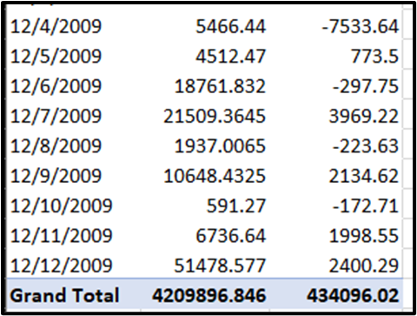
Figure 1 : Pivot Table 1
(Source: SPSS)

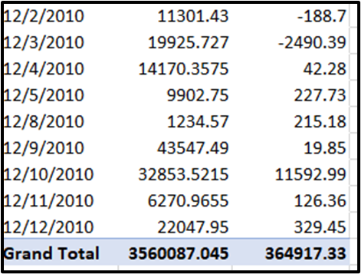
Figure 2: Pivot Table 2
(Source: SPSS)

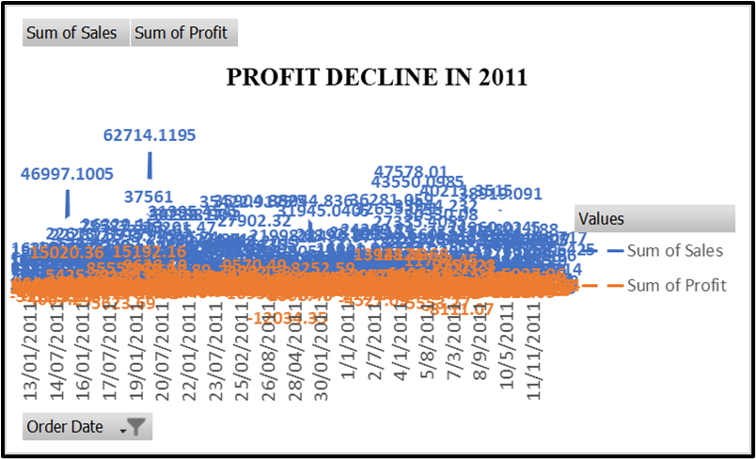
Figure 3: Profit decline in 2011
(Source: SPSS)
From the above graph, it can be assumed that the total sale value in 2011 was 4209896 and the profit was 434096.02 in the same year. Henceforth, the sum of sales or the sum of profit based on different months has fluctuated over the years.

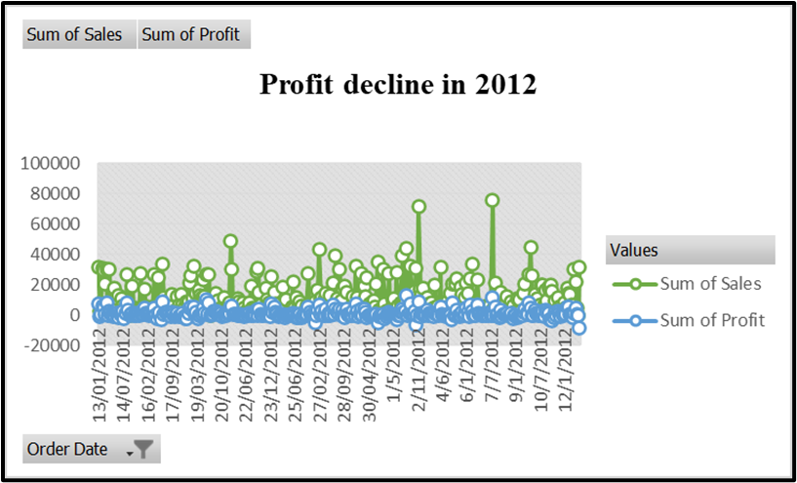

Figure 4: Profit decline in 2012
(Source: SPSS)
From the above graph, it can be assumed that the total sale value in 2012 was 3560087.045 and the profit was 364917.33 in the same year. In this year similarly s, the sum of sales or the sum of profit based on different months has been fluctuate till the end of the year.

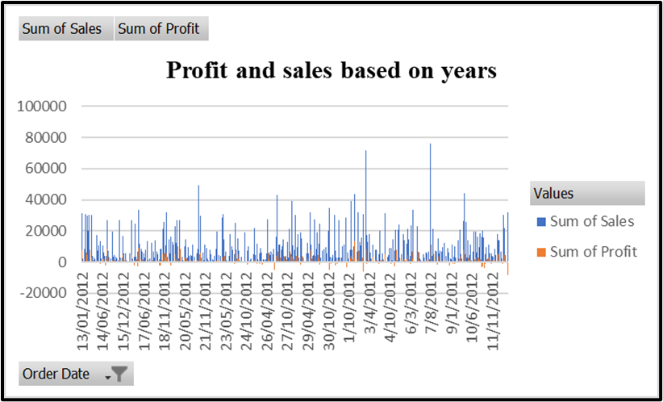
Figure 5: Profit and Sales based on each year using IF function
(Source: SPSS)
Using the IF function, it has been seen that identification of both increase and decrease of profit and sales over the years of this company can be effectively visualized. Both increase and decrease of sales and profit for four years including 2009 up to 2012 has been shown. Thereby, the profit range within the data has fluctuated and the range of profit in sale has been 30.94 and the rate of sale is estimated at 394.27.

PART 2

2.1 Number of the students likes vanilla flavored ice-cream
In order to identify the number of students, are fond of vanilla flavor in ice-cream, a survey of over 200 students in high school has been organized. According to the report of Ma et al. (2021), a survey often uses various types of methods and approaches to conclude a particular answer against one or multiple questions. Hereby, the data or the response of students has been gathered through several types of tests that include puzzles and video games. Whereas, the findings of the results from data output have been visualized by using different types of charts such as bar, pie and histograms. The data has been already gathered in the form of excel -spreadsheet that is included with two different data sets such as Ice cream.xls and Ice cream. CVS. Apart from this, in order to make a statistical or numerical interpretation of the data gathered, a SPSS software has been used to accumulate the right answer. Statistical Package for Social Science, formerly known as SPSS is a software program that is mainly used by the researchers in order to conduct various disciplines for quantitative analysis allotted with complex data (Abbasnasab Sardareh et al. 2021). Therefore, the SPSS software has been similarly used to illustrate the numbers of students who like vanilla flavored ice-cream.

ice-cream
 |  | Frequency | Percent | Valid Percent | Cumulative Percent
Valid | 1 | 95 | 47.5 | 47.5 | 47.5
Valid | 2 | 47 | 23.5 | 23.5 | 71.0
Valid | 3 | 58 | 29.0 | 29.0 | 100.0
Valid | Total | 200 | 100.0 | 100.0

Table 1: Number of Students like Vanilla flavored Ice-Cream
(Source: SPSS)
From the above image or figure given, three different numbers represent three different flavors. Here, number 1 represents the flavor of vanilla, number 2 denotes the flavor of chocolate and number 3 refers to the ice-cream flavor that is strawberry. In such instances, it has been seen that for vanilla flavor ice-cream the frequency number and the valid percentage is higher compared to other flavors. In general, under the context of SPSS analysis, frequency refers to the value in numbers that shows the times that particular item has appeared in the data set (Pappas and Woodside, 2021). Thus, the frequency number of vanillas is 95, while for chocolate the value of frequency is 47 and for the strawberry is 58. On the other hand, the cumulative percentage of each flavor is also valued differently. For example, the valid percentage of vanilla flavored ice-cream is 47.5%. The chocolate flavored and strawberry flavored ice-cream is 23.5% and 29.0%. It shows that 47.5% of 200 students like vanilla flavored ice-cream . 95 students in the high schools like this flavor in ice-cream. Moreover, to visually understand the difference between three flavors liked by the students , a histogram has been represented in the below part.
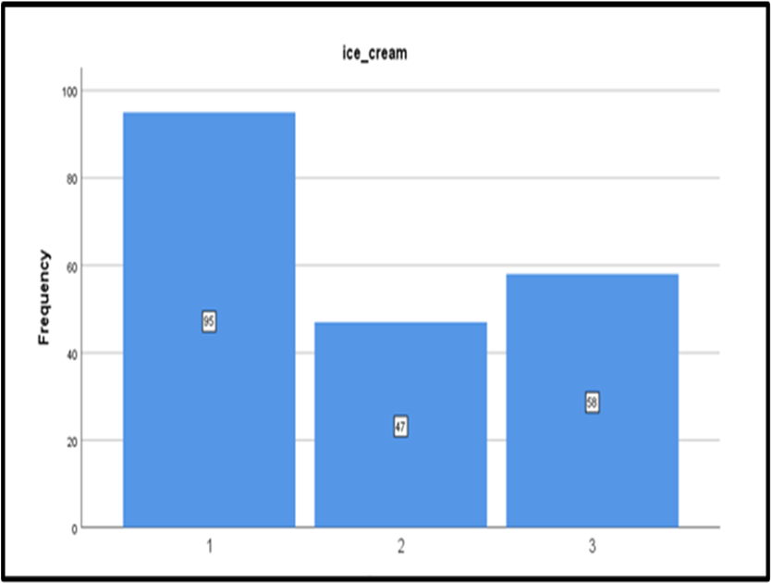
Figure 6: Histogram on the number of students like Vanilla flavored Ice-Cream
(Source: SPSS)

2.2 Determination of Male and Female students
Similar to the previous section, to distinguish between the male and female students among 200 students, the use of SPSS software has been significantly done. As per the report of Şahin and Aybek, (2019), it is stated that SPSS software is highly used by the scientific researchers as it can provide data analysis for descriptive and bivariate statistics. It further gives numeral outcome predictions and also predictions for identifying different groups within a large data set. In order to identify the female candidates and female candidates two different numerical variables have been stated for two different groups such as 0 for male students and 1 for female students. It has been often stated that the SPSS software often uses numerical values to characterize different variables for making statistical interpretation (Mohajan, 2020). The result from the given data shows that the percentage of female students which is denoted by 1 is identified by 54.5%.

Female and Male Students
 |  | Frequency | Percent | Valid Percent | Cumulative Percent
Valid | 0 | 91 | 45.5 | 45.5 | 45.5
Valid | 1 | 109 | 54.5 | 54.5 | 100.0
Valid | Total | 200 | 100.0 | 100.0
Table 2: Percentage of female and male
(Source: SPSS)
Apart from this, the percentage of male candidates is accumulated at 45.5% which is relatively lower than the other group. Therefore, it can be said that among all 200 students in the high school 109 students are females and 91 students are male. From the result and difference of percentage based on genders, it can be stated that rather than males, females are more interested about ice-cream and its flavors. Furthermore, for understanding females and male, a visual representation has been done through a pie-chart.
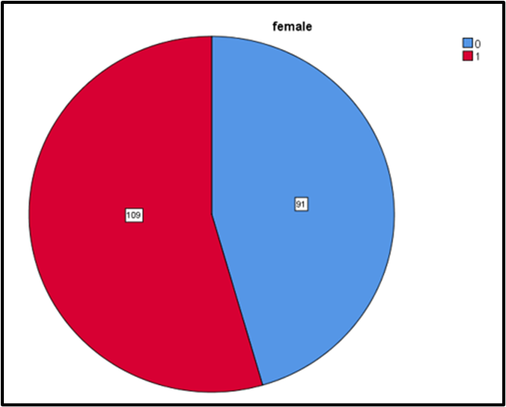
Figure 7: Distinguish between male and female students
(Source: SPSS)
From the above pie-chart, the red color signifies the number of female students and that is estimated at 109. On the other hand, the blue color signifies the number of male students and is estimated at 91. Apart from this, it has been reviewed that the valid percentage of both groups has resulted differently. As per the statement of Abulela and Harwell (2020), valid percentage in SPSS software represents the missing data that is excluded from the calculations. In this section, percentage and valid percentage are the same that shows no data has been missed. Although, the number of total students or N is valued at 200 and the total percentage is 100%. It further shows that the data that has been gathered here has no missing value and also the data has been found without any hazards or errors in data. At the end it can be stated that the high school has more female students than the male students and also can be said that female students take more interest in research on ice-cream flavor than male students.

2.3 Evaluation of Mean and Median of participants likes either chocolate and strawberry flavored ice-cream
The SPSS software has been used to evaluate the mean and median of participants, like either chocolate and strawberry flavored ice-cream. As per the report of Jopling (2019), under the context of SPSS, mean defines mathematical average and the median refers to ordinal, internal and ratio variables. In order to represent that mean and median statistics a descriptive statistical analysis has been conducted to retain the output in a single table form. Hence, the table of descriptive statistics has been drawn in the below section.
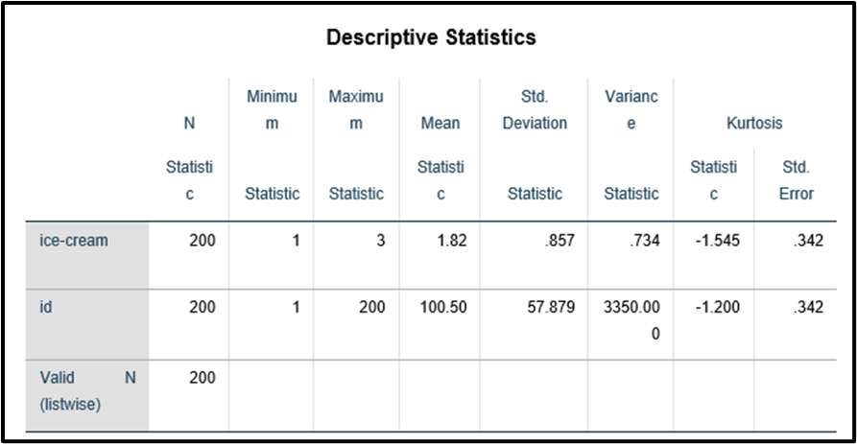
Figure 8: Descriptive Statistics including Mean and Median
(Source: SPSS)
From the above figure, it has been reviewed that the mean statistic is valued at 1.82. Thereby, the man value is higher than 1 that shows a positive response in terms of liking the ice-creams of chocolate flavored and strawberry flavored. While, the maximum statistics of ice-cream is estimated at 3 and the minimum statistics is valued at 1. Henceforth, it shows that around 45% of the students either like the chocolate flavor or strawberry flavor as ice-cream. Apart from this, the standard deviation statistics and variance deviation statistics are valued at .857 and .734 that shows the relationship between students' affection toward liking chocolate flavored or strawberry flavored ice-cream is strong.

2.4 Clustering -K Means
In general clustering-K means the task of dividing the population or data points that consist of a number of groups such as data points that consist of the same group. In the views of Yuan. and Yang (2019), “K-means clustering” refers to a basic process of unsupervised learning related algorithm that is used for resolving the clustering problems within a data. In addition to this, it has been stated that the overall process relies on the classification of the given data to resolve cluster-based issues that can be defined by using the letter K that is fixed as in the beforehand situation.
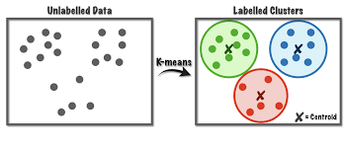
Figure 9: Clustering -K Means
(Source: Yuan. and Yang, 2019)

2.5 Explanation of the most common data mining and text mining methods can be used in business
In a business, data mining is the process that helps in sorting large or big-sized data that helps in term of identifying patterns and relationships that can further help business to solve business issues through resolving the data. It has been stated that data mining processes can be vast and varied from each other that are used by various other businesses (Francis and Babu, 2019). Whereas, there are large options available within text mining methods. Therefore, the common type of data mining methods that can be seen used by various organizations such as “decision tree analysis”, “Bayes theorem analysis” and “frequent item-set mining”. On the other hand, the process of common data mining is different from the methods that includes “clustering”, “data cleaning”, “association”, “data warehousing”, “machine learning”, “data visualization”, “classification”, “neural networks” and “prediction” (Abu Saa et al. 2019). The text mining and the process included within it is different from the other common type of data mining process. In short, text mining is the process that helps to form an unstructured text into a structured format to identify meaningful patterns and also find new insights. Therefore, the common type of text mining methods that is used by business includes “information extraction”, “information retrieval”, “categorization”, “clustering” and “summarization”.

2.6 Discussion related to advantages and disadvantages of using SPSS and Excel
SPSS

Advantages | Disadvantages
SPSS is able to offer reliable and fast answers | The software is not capable of analyzing very large data sets.
Effective Data Management | SAS is more useful and beneficial rather than SPSS while analyzing a large data set.
The software is involved with vast and various dynamics that provides useful table and graphs | There are certain fields where the data cannot be changed or irreplicable
In order to start the software no requirement of putting extreme efforts | IBM has the only best SPSS tool in the market
Table 3: “Advantages and disadvantages of using SPSS”
(Source: Self-Developed)
Excel

Advantages | Disadvantages
The users of Excel or MS-Excel are capable of identifying the trend. | The process consists of lack of control and security.
The capability of sorting data in meaningful categories is also high. | The process is hard to consolidate in excel without having proper knowledge.
It provides the option of conditional formatting to every data. | Excel is unsuitable for a type of business that consists of Agile Business Practices.

Table 3: “Advantages and disadvantages of using Excel”
(Source: Self-Developed)

Reference List
Abbasnasab Sardareh, S., Brown, G.T. and Denny, P., 2021. Comparing four contemporary statistical software tools for introductory data science and statistics in the social sciences. Teaching Statistics, 43, pp.S157-S172. https://researchspace.auckland.ac.nz/bitstream/handle/2292/55280/2021%20Abbasnasab%20Sardereh%20et%20al%20Tching%20Stats%20accepted%20author%20.pdf?sequence=2
Abu Saa, A., Al-Emran, M. and Shaalan, K., 2019. Factors affecting students’ performance in higher education: a systematic review of predictive data mining techniques. Technology, Knowledge and Learning, 24(4), pp.567-598. https://www.academia.edu/download/87738909/s10758-019-09408-720220619-1-1j6j1xs.pdf
Abulela, M.A. and Harwell, M., 2020. Data analysis: Strengthening inferences in quantitative education studies conducted by novice researchers. Educational Sciences: Theory & Practice, 20(1), pp.59-78. https://jestp.com/index.php/estp/article/download/792/721
Clausing, K.A., 2020. Profit shifting before and after the Tax Cuts and Jobs Act. National Tax Journal, 73(4), pp.1233-1266. https://www.taxpolicycenter.org/sites/default/files/clausing_tcja_profit.pdf
Cloutier, C. and Ravasi, D., 2021. Using tables to enhance trustworthiness in qualitative research. Strategic Organization, 19(1), pp.113-133. https://journals.sagepub.com/doi/pdf/10.1177/1476127020979329
Devi, S., Warasniasih, N.M.S., Masdiantini, P.R. and Musmini, L.S., 2020. The impact of COVID-19 pandemic on the financial performance of firms on the Indonesia stock exchange. Journal of Economics, Business, & Accountancy Ventura, 23(2), pp.226-242. https://www.researchgate.net/profile/Sindy-Warasniasih/publication/347435502_The_Impact_of_COVID-19_Pandemic_on_the_Financial_Performance_of_Firms_on_the_Indonesia_Stock_Exchange/links/60fd21d40c2bfa282afc7069/The-Impact-of-COVID-19-Pandemic-on-the-Financial-Performance-of-Firms-on-the-Indonesia-Stock-Exchange.pdf
Elsi, Z.R.S., Rohana, G. and Nuranjani, V., 2021. New Student Admissions Information System With Client Server Based Sms Gateway. JITK (Jurnal Ilmu Pengetahuan dan Teknologi Komputer), 6(2), pp.159-166. http://ejournal.nusamandiri.ac.id/index.php/jitk/article/download/1377/792
Francis, B.K. and Babu, S.S., 2019. Predicting academic performance of students using a hybrid data mining approach. Journal of medical systems, 43(6), pp.1-15. http://starc.stthomas.ac.in:8080/xmlui/bitstream/handle/123456789/119/10.1007%40s10916-019-1295-4%20%281%29.pdf?sequence=1&isAllowed=y
Gruner, R.L., Vomberg, A., Homburg, C. and Lukas, B.A., 2019. Supporting new product launches with social media communication and online advertising: sales volume and profit implications. Journal of Product Innovation Management, 36(2), pp.172-195. https://minerva-access.unimelb.edu.au/bitstream/handle/11343/284643/https%20onlinelibrary.wiley.com%20doi%20am-pdf%2010.1111%20jpim.12475.pdf?sequence=1&isAllowed=y
Johnson, K.M. and Lichter, D.T., 2019. Rural depopulation: Growth and decline processes over the past century. Rural Sociology, 84(1), pp.3-27. https://www.researchgate.net/profile/Daniel-Lichter/publication/330519740_Rural_Depopulation_Growth_and_Decline_Processes_over_the_Past_Century_Rural_Depopulation/links/5e958b28299bf1307997ac3f/Rural-Depopulation-Growth-and-Decline-Processes-over-the-Past-Century-Rural-Depopulation.pdf
Jopling, M., 2019. Using quantitative data. In Practical Research Methods in Education (pp. 55-66). Routledge. https://wlv.openrepository.com/bitstream/handle/2436/622333/Jopling_Using_quantitative_data_2019.pdf?sequence=2&isAllowed=y
Klein, R., Koch, S., Steinhardt, C. and Strauss, A.K., 2020. A review of revenue management: Recent generalizations and advances in industry applications. European journal of operational research, 284(2), pp.397-412. https://translateyar.ir/wp-content/uploads/2021/04/A-review-of-revenue-management-Recent-generalizations-and.pdf
Ma, J., Jiang, X., Fan, A., Jiang, J. and Yan, J., 2021. Image matching from handcrafted to deep features: A survey. International Journal of Computer Vision, 129(1), pp.23-79. https://link.springer.com/article/10.1007/s11263-020-01359-2
Mohajan, H.K., 2020. Quantitative research: A successful investigation in natural and social sciences. Journal of Economic Development, Environment and People, 9(4), pp.50-79. https://mpra.ub.uni-muenchen.de/105149/1/MPRA_paper_105149.pdf
Pappas, I.O. and Woodside, A.G., 2021. Fuzzy-set Qualitative Comparative Analysis (fsQCA): Guidelines for research practice in Information Systems and marketing. International Journal of Information Management, 58, p.102310. https://www.sciencedirect.com/science/article/pii/S0268401221000037
Şahin, M. and Aybek, E., 2019. Jamovi: an easy to use statistical software for the social scientists. International Journal of Assessment Tools in Education, 6(4), pp.670-692. https://dergipark.org.tr/en/download/article-file/892792
Yuan, C. and Yang, H., 2019. Research on K-value selection method of K-means clustering algorithm. J, 2(2), pp.226-235. https://www.mdpi.com/2571-8800/2/2/16/htm
Zhou, Y., Zhou, B., Pache, L., Chang, M., Khodabakhshi, A.H., Tanaseichuk, O., Benner, C. and Chanda, S.K., 2019. Metascape provides a biologist-oriented resource for the analysis of systems-level datasets. Nature communications, 10(1), pp.1-10. https://www.nature.com/articles/s41467-019-09234-6

