
Skills for the Workplace
Module Assignment Submission
Student Name: | Yoana Georgieva
Student Number: | 1714886
Module No: | EMPL4003
Module Title: | Digital Skills and Research Methods
Lecturer: | Anupam Mazumdar

Statement of Confirmation of Authenticity
By the act of making this submission, the student declares that this is the work of the student named above. The work has not, in whole or in part, been knowingly presented elsewhere for assessment, or where assessment has been built on a previous assessment, this has been identified. Where materials have been used from other sources it has been properly acknowledged. If this statement is untrue, the student acknowledges that an assessment offence has been committed. Attention is drawn to the plagiarism and unfair practice policies of both the University and of ILM.

Table of content

Introduction 2
Literature review 2
Motivation at work 2
Importance and benefits of motivation 4
How to increase workplace motivation? 4
Research methodology 4
Findings, analysis and discussion 5
Conclusion 10
References 11

List of figures

Figure 1 6
Figure 2 7
Figure 3 8
Figure 4 9
Figure 5 10

Introduction
This report aims to analyze the importance of motivation in the workplace. The report will give a proper description of the motivation, its benefits and different methods to improve and increase it. A survey will be carried out, and final results and analysis will be provided. Employee motivation is a vital aspect in the workplace which leads to the overall performance of the company. Motivated employees work better and perform more effectively which increases the company’s success and achievements.

Literature review

Motivation at work
There are different theories of workplace motivation, however, two of the most popular models are Maslow's Hierarchy of Needs and Herzberg’s Two-Factor Model.
Maslow's hierarchy theory is based on levels of prioriti
es is focused on the psychological needs of employees. According to Maslow, there is five level of human needs that employees need to have fulfilled at work. The first level of his hierarchy pyramid is the basic needs, which is food, water, and shelter. The next step in the pyramid is the security, which is a safe environment in the workplace and a secure job. On third place, Maslow puts the social aspect. This is the need to feel wanted, the feeling of belonging and being part of a team. The next step is the esteem, which is the self-respect, level of status and how we are seen in other people's eyes. The top of the pyramid is the self-achievement, completing targets, intellectual needs, and fulfilling potential. In his theory, Maslow describes that employees can be motivated at work only once a lower level of demand has been fully met (Maslow, 2013).
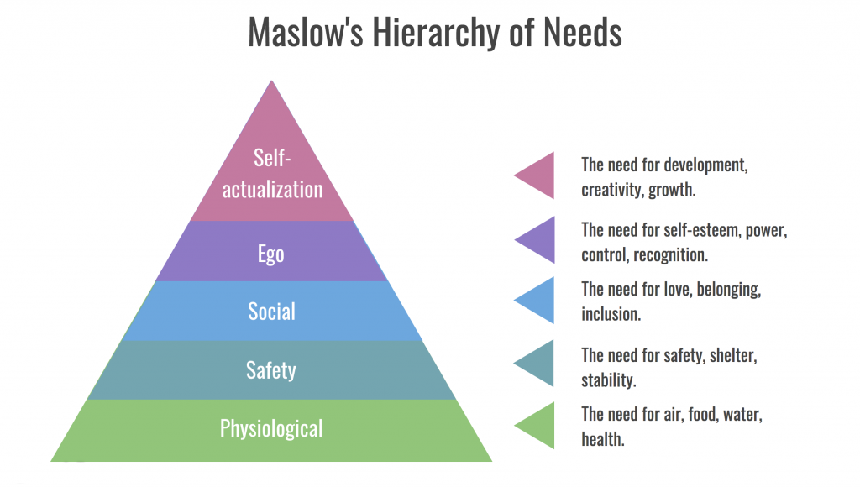 https://www.google.co.uk/search?q=maslow+theory&rlz=1C1EJFA_enBG793BG793&source=lnms&tbm=isch&sa=X&ved=0ahUKEwjb6s7GzIjfAhUsJ8AKHXfUDFsQ_AUIDigB&biw=1350&bih=649#imgrc=lmt-MUeOqaoHfM
This is the reason why motivation in the workplace is essential, and managers should offer different incentives to keep employees motivated to fulfill their needs and work and progress in the hierarchy pyramid.
Herzberg's motivational theory presents job factors as contributing to either satisfaction or dissatisfaction and is based on two factors, motivators and hygiene factors. According to Herzberg, motivators are more concerned about the job itself, like the level of responsibilities it would provide, how exciting it is and the opportunities and recognition it would give. On the other hand, hygiene factors, are the one the job depends on, for example, the level of pay, the safe working environment, and the working conditions. Those factors, however, are not motivational as they would not make employees work harder and increase productivity. Herzberg believed that the usage of some methods could enhance motivation in the workplace. The first method is job enlargement, which means providing a wider variety of task to perform which would make the job more interesting. The second method is job enrichment or giving a more extensive range or more complex tasks, which would provide a greater sense of achievement to employees. The last process is empowerment, which means giving the power to employees to make their own decision over their working life areas.

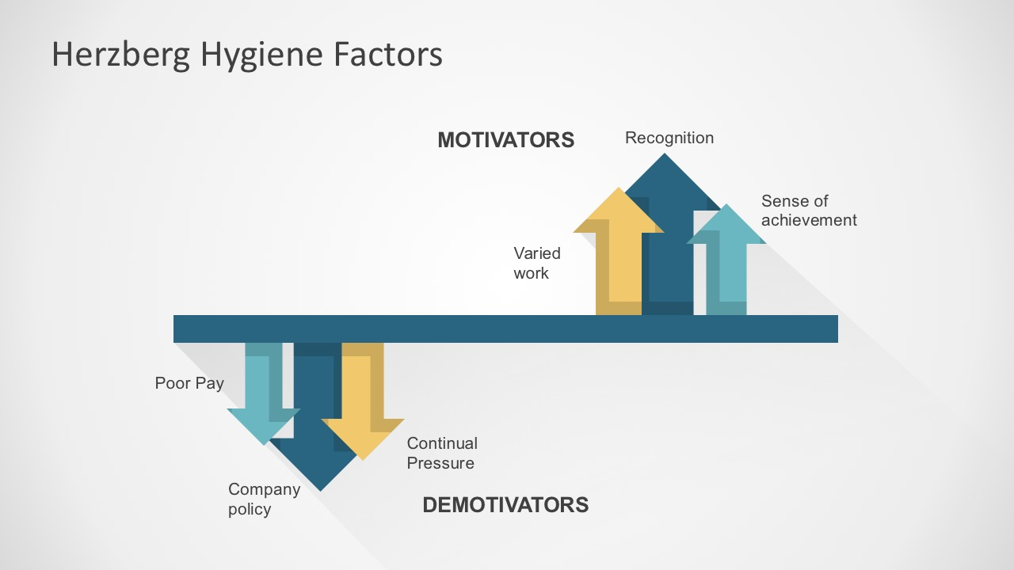https://www.google.co.uk/search?q=herzberg+theory+of+motivation&rlz=1C1EJFA_enBG793BG793&source=lnms&tbm=isch&sa=X&ved=0ahUKEwiFxsDizYjfAhVBGsAKHVUwDNMQ_AUIDigB&biw=1366&bih=577#imgdii=4I_gqWIOtQPWKM:&imgrc=IhUosawJQjHlnM

In summary, Herzberg's theory gives a bright and soundproof that employees work better and increase their productivity at the workplace when they are motivated by factors like responsibilities, exciting tasks and more praise for a good job. Employees, however, could be de-motivated by factors like the pay rate, the security over the workplace and communication at work.

Importance and benefits of motivation
Motivation at the workplace is a significant factor for many reasons. Its primary concern is that it allows management to meet the company's goal and aims. Without a motivated workplace, companies could be placed in a hazardous situation.
Another factor for the importance of motivation in the workplace is that motivated employees can lead to increased productivity and allow on organizations and companies to achieve higher levels of outputs.
Motivation in the workplace is significant and very beneficial. The main reason is that it increases employee's commitment. The more employees are motivated, the more effort they would put in the task they are working on — another benefit of motivation, which is the employee's satisfaction. When workers feel satisfied with the work they have made, they would be inspired and motivated to reach even higher goals, work harder and dedicate more time and effort.
Last but not least, motivation can improve employees' efficiency and increase in productivity. Workers' level of competence is not only based on their ability or qualifications but the balance between being able to perform the task given and the actual willingness to do so.

How to increase workplace motivation?
Workplace motivation can be increased by using different methods and tactics. Employers can use six main methods. The first method is making clear expectations and setting up achievable goals. Employees should know what their tasks are and how they are expected to do them. Another way is providing continues feedback. The feedback plays a vital role in the motivation of the employees as it lets them know what progress they are doing for the company and the impact they have. Being corrective over employees is another tactic of increasing the motivation. This, however, should always be made privately to avoid embarrassment. Another two crucial factors for the motivation at the workplace are the belief in employees and the ability to compliment and praise them. Managers should always show how happy and satisfied they are with their workers and be able to show appreciation. The sixth method for achieving higher motivation at work is making possible rewards. Employees are highly motivated and more dedicated when they know they would be rewarded for their hard work.

Research methodology
In this report, I am using a quantitative research method. Quantitative research is a fundamental way of data collection and analyzation gathered by different sources. This research method involves the use of a variety of tools, such as statistics, mathematics, and calculations to determine results. The data collection tools for quantitative research are surveys and experiments. However, the most common approach of doing quantitative market research is a survey or questionnaire. Reviews can include interviews, which can be done utilizing a few several different strategies, including the face-to-face questionnaire, telephone interviews, online or computer-assisted interviews. Another step in the completion of quantitative market research after the data collection is the data process. In order to organize the analysis of statistical data, systematic tools and methods are required. There are many analytical tools, such as variance calculations, independent sample t-tests and regression analysis that can be used to get results from the information.
The sample size is a selection of respondents chosen in such a way that they represent the total population as good as possible. Using a correct survey sample size is crucial for the research. On the one hand, a sample that is too big will lead to the waste of resources, such as time and money. On the other hand, a sample size which is too small will not allow gaining reliable insights.
A population is the broader group to whom the results of the survey are intended to be generalized. The sample size is always a subset of the population. The specific population depends on the scope of the study. In my situation, for example, the population is the number of employees in the company which is 400. The sample size, however, is 15 or the number of people I have interviewed.

Findings, analysis, and discussion
I carried out a survey among fifteen of my work colleagues by asking them five different questions about the motivation at work, its importance, and the impact managers have on it. I received a lot of mixed reactions and comments on some of the questions. However, there is a clear indicator of the opinion of my colleagues. I will also provide definition and analysis of each question at the end of the survey and will mention colleagues and personal recommendations on the level of motivation at work, how to improve it and what impact it has on the organizations and companies.

Question 1: Do you agree that motivation is essential at the workplace?
Strongly agree | Agree | N/A | Disagree | Strongly disagree
7 | 5 | 1 | 2 | 0

Figure 1
The majority (almost 50%) of my sample size strongly agreed that the motivation at the workplace is fundamental. Another 35% agreed with that statement. Only 15% of the interviewed people disagreed and said that motivation does not have any impact at their workplace.

Question 2: Do you agree that the motivation at the workplace can increase the success of the company?
Strongly agree | Agree | N/A | Disagree | Strongly disagree
4 | 6 | 3 | 2 | 0

Figure 2
27% of the interviewed strongly agreed that the motivation at work increases the success of the company. 40% agreed with the statement and the rest 33% were divided between ‘disagree' and ‘no opinion.'

Question 3: Do you agree that the managers should actively and continuously monitor the level of motivation in the workplace?
Strongly agree | Agree | N/A | Disagree | Strongly disagree
2 | 2 | 7 | 3 | 1

Figure 3
The question rather the managers should pay attention to the level of motivation at work, was the one that brought confusion to my colleagues. The high percentage of 47 said that they do not have an opinion on the question. Only 14% strongly agreed, and another 14% agreed with the statement and said that managers are responsible for the motivation at the workplace and should monitor it at all times. There were 20% of interviewed who disagreed and only 7% with an opinion that the motivation at work is not something that should be monitored by the managers.

Question 4: Do you agree that you would feel more motivated and determined at your workplace if your manager was more encouraging?
Strongly agree | Agree | N/A | Disagree | Strongly disagree
3 | 7 | 1 | 2 | 2

Figure 4
The majority of the sample size agreed that they would feel more motivated and would work harder at work if their manager was more encouraging and was showing more appreciation. A small percentage of people who said that their manager's opinion and action would neither motivate nor de-motivate them and change their work production.

Question 5: Research shows that only 13% of employees are engaged at work. Do you agree that this percentage is so low because managers fail to encourage and motivate their employees?
Strongly agree | Agree | N/A | Disagree | Strongly disagree
6 | 1 | 4 | 3 | 1

Figure 5
A whole 40% of the sample size strongly agreed with the statement that managers fail to encourage their employees which leads to less motivation and decrease the final production. 27% of the interview did not have an opinion on the question, and 20% disagreed with the statistics and the statement.

Conclusion
In summary, the level of motivation at the workplace is an essential method to increase the productivity and determination of the employees. Different ways can increase motivation and bring more significant satisfaction to both employees and employers.
I agree that I work better and I am more productive when I have high motivation. Furthermore, this leads to top results and an increase in the production and effectiveness of the work. In my opinion, employers should pay more attention to the level of motivation they create at work. They should show more appreciation to their workers, give them more positive feedback and rewards.

References

Maslow, A. (2013) A theory of human motivation. Wilder Publications: London.

Crabtree, S. (2013) ‘Worldwide, 13% of Employees Are Engaged at Work’. Gallup. (Accessed: 5 December 2018). https://news.gallup.com/poll/165269/worldwide-employees-engaged-work.aspx

Herzberg, F. (1959) The motivation to work. 2nd Ed. John Wiley and Sons Inc.: London

Burkus, D. (2012) Six ways to drive employee performance and motivation. [Online] Available from: https://davidburkus.com/2012/07/six-ways-to-drive-employee-performance-and-motivation/ (Assessed: 5 December 2018).

Research, I. (2018) What is quantitative research. [Online] Available from: https://www.sisinternational.com/what-is-quantitative-research/ (Assessed: 5 December 2018).

Dessel, G. (2013)’How to determine population and survey sample size.' Check market (Assessed: 5 December 2018). https://www.checkmarket.com/blog/how-to-estimate-your-population-and-survey-sample-size/

