

Understanding and Engaging the Customer Experience
(BMSW 5103_LON)

Student Name | Almpiona Ntemai
Student Number | 1920427
Lecturer Name | Ze Zook

Executive summary
CRM is an important part of any company. This department has gained more value after the outbreak of the covid-19. Businesses shattered, jobs are gone, people became unemployed etc. This report has talked about the role of CRM in bringing back the customers to the company in an effective manner after the outbreak of Covid-19 in the UK. It has become vital for companies to reach out to customers on their own because covid-19 has shaken everyone's financial condition. People are waiting for their favourite brands huge discount offers. This is one of a kind the correct time to approach their regular and loyal customers. A prestigious firm has been selected for the report. Some important models, their benefits and drawbacks, and some great ideas on the development and handling of CRM in this tough situation are the main focus of this study.

Table of Contents
Executive summary 2
Introduction 4
Briefly introduce the key marketing theory or theories 5
Critically analyse the factors that influence your organisations quality systems and controls for customers in times of crisis like COVID-19 9
Critically evaluates the benefits and challenges of developing and maintaining good customer relationships 20
Conclusion 24
References 25

Introduction
A company's competitive advantage lies in its customer experience. The recent impact of worldwide Covid-19 has forced many businesses to rethink their customer relationship management. The current report will discuss the key marketing theories which could help a firm to regain its customer base. The main aim of this report is to help the selected company to back on its track with the help of some effective CRM models. The selected firm for this report is Sainsbury. Sainsbury's was chosen for this research because it is the UK 's nd largest grocery brand with a sales dominance of 16.0%. John James Sainsbury established the firm in 1869 with a store on Drury Lane in London, and by 1922, it had expanded to became the world 's leading food merchant. However, the company registered some losses due to the covid-19 outbreak. The customer relationship management of Sainsbury needs some improvised structure by which they can again approach their most regular and loyal customers. The report will discuss some of the effective CRM models and some important benefits and challenges of CRM in current times.

Briefly introduce the key marketing theory or theories
Covid-19 has done major changes in the world. The present worldwide epidemic created by COVID-19, as well as shifts in consumer behaviour. It has also compelled businesses to utilise CRM as a strategic role to increase performance and user experience. Some of the key marketing theories have been discussed below to understand the process used by Sainsbury.
Ansoff Matrix strategy
The Ansoff Matrix theory was developed by Igor Ansoff, a Russian-American mathematician and industrialist. It's a methodology that's designed to help firms figure out how to expand their marketplace and supply offerings. This technique is undoubtedly beneficial not only to huge organisations, but also to modest businesses and startups (Wright, 2020). The matrix has four quadrants, and Sainsbury's can select from any of them to find the best plan for them.
- Permeation of the market in Ansoff Matrix: The Ansoff Matrix approach with the lowest risk is this one. It is concerned with enhancing the potential of an existing brand in an existing marketplace. As a result, Sainsbury's aims to sell more of its items in its current market by utilising any of these methods. This can be done by increasing advertising and distribution support, price reduction, and takeover a competitor. As a result, Sainsbury can employ this technique to gain a stronger grip on the market.
- Development of product in Ansoff Matrix: In this approach, they expand their present market by developing new items to meet customer demands. They already have a consumer base for a product, but the market is saturated. As a result, they can offer consumers a similar solution to solve the issue and improve their experience (Loredana, 2017). Obtaining a license to produce another's thing, labeling a product/ service as your own, or engaging in further brand r & d can all be used to develop a unique commodity.
- Developing the market: With established goods that have successfully gained profit margins in other market group, Sainsbury can utilise the Ansoff matrix approach to extend out to an another segment of the marketplace. For instance, after a company has achieved nationwide brand awareness in one nation, it can increase its outreach to customers in different countries where it has not yet formed a presence.
- Diversification: Sainsbury may bring new items to a new market by applying diversification. The Ansoff matrix is moved into two quadrants because the company is engaging in a growing marketplace as well as in a up to dated commodity. As a result, this is the riskiest option. Diversification strategies may or may not be linked (Finola et al., 2020). There is a link and hence possible synergy between the businesses in relevant sectors. There is no link between the companies in un-related.
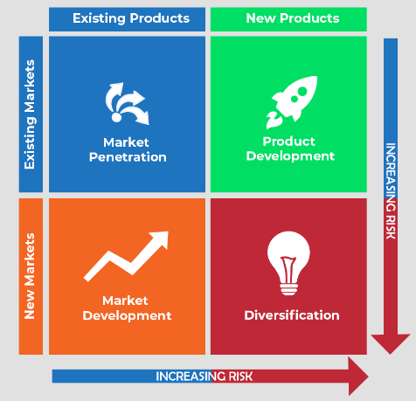
Figure 1. Ansoff matrix strategy
Source: (Loredana, 2017)
Boston consulting group matrix
The Boston Consulting Group's (BCG) growth-share matrix is a management technique that uses a visual representation of a company 's products and activities to help the company decide what to keep, sale, or invest in more (Wright, 2020). The structure is a multiple framework containing a y-axis that represents market growth and the x-axis that shows market share in a firm's offering. It was founded by the Boston Consulting Group in 1970. The Boston Consulting Group growth-share matrix divides goods into four quadrants, which are referred to as "dogs," "cash cows," "stars," and "question marks," respectively.
- Dogs (or Pets): If a firm 's item has a small industry position and a slow growth rate, it is referred to as a "dog" and must be traded, dissolved, or reorganised. Because of their small industry position and slowness of development dogs, which are placed in the bottom right corner of the matrix, do not generate much income for the company (Gallardo et al., 2018). As a consequence, dogs might become bunches of revenue, binding company expenses for long durations. As a result, they make ideal divestiture candidates.
- Cash Cows: Cash cows are low-growth products with a high market share that the company should utilize for as long as manageable. In the bottom left hand corner, cash cows are generally the main items on existing markets. These products generate greater profits on average than the industry expansion ratio and are self-sustaining working capital. Sainsbury should utilise these facilities as long as practicable. Due to the extremely regular pattern of working capital in cash cows, their value may be estimated simply. Indeed, low-crowded, high-share cash cows are supposed to get money to reinvest in large, fast-growing "stars" with great potential in the future (Loredana, 2017).
- Stars: "Star" products are those that are in greater regions and represent for a substantial portion of the market, and Sainsbury should invest extra budget on them. Stars in the upper left corner generate big revenue but they also spend a lot of it. So when market's overall development rate slows, a star may continue to be the top seller and eventually become a cash cow.
- Question marks: High-growth areas in which the firm does not have a substantial market share are considered questionable possibilities. In the upper right corner of the matrix, there are question marks (Finola et al., 2020). They often grow fast while consuming a large portion of the organization's assets. Sainsbury should regularly examine the products of this section in order to see whether they are value maintaining or not.
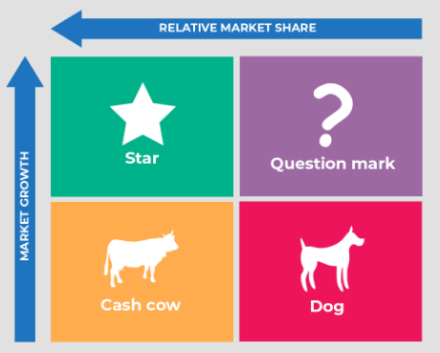
Figure 2. Boston consulting group matrix
Source: (Birafane et al., 2020)

Critically analyse the factors that influence your organisations quality systems and controls for customers in times of crisis like COVID-19
Sainsbury's is focused on developing and keeping strong customer connections. It's tough, though, to keep track of who the clients are and their connection with the company. The easiest approach to deal with the problem is to use the proper instrument, which in this situation is a solid CRM (Wright, 2020). The most crucial aspect of any CRM is right there in the name—all it's about is the customers. A customer relationship management system (CRM) should help Sainsbury to better understand customers and utilise that knowledge to provide the best possible service, i.e., Customer experience (CX). There are usually three significant models of CRM which could Sainsbury use to enhance its customer loyalty in these hard times.
The IDIC model of customer relationship management
Customer Relationship Management (CRM) is a systematic process that focuses on establishing and sustaining positive relationships with customers throughout time. It strives to give excellent technical assistance while also providing a platform to coordinate and synchronise client care (Loredana, 2017). As a result, CRM becomes increasingly crucial for a company's long-term success. A good CRM solution can help Sainsbury to get important feedback on their goods and respond to customer questions and complaints. Certain models are followed in order to ensure that customer service runs well. Various academics have created these customer connection models during the last few decades. The IDIC Model, QCI Model, and CRM Value Chain Model are the most prevalent CRM models. Peppers & Rogers created the IDIC (identify, distinguish, interact, customise) paradigm in 1995. The model helps define the demands of the client and its value for the firm. This model helps to:
- Determine the requirements of customers: Customers' requirements, goals, and preferences must be identified before a company can engage in customer relationship management. This assists in the curation of new customer-centric goods and initiatives. For example, Sainsbury's performed a market assessment to determine the consumer base for their coffee in Covid situations by analysing the countries with the highest caffeine use (Finola et al., 2020). It was discovered that European nations had a more favourable attitude toward coffee beverages, whilst Eastern countries chose tea as their caffeinated beverage in covid times.
- Customers' expectations should be distinguished: It is important to split the customer base into quality and requirement sectors to meet consumer requirements. This difference helps to design tactics that meet both corporate objectives and consumer preferences which produce strong connections with clients. Customers who are loyal and should be targeted can be identified via value differentiation. Their input can be useful for expanding product lines, improving efficacy and performance, and generating money (Kaul, 2017). Differentiating current consumers based on their demands assists in marketing planning. For example, in addition to assessing consumers who contribute value to Sainsbury's brand equity, some researchers made it a point to recognise that other consumers need a good customer care to satisfy their unique demands.
- Regular interaction with customers: Customers' demands and how they connect to products and services are better understood via customer interactions. The engagement, which is focused on consumer value and requirements, allows for the collection of comments, views, and desires (Gallardo et al., 2018). Sainsbury's sales professionals and customer service representatives are always available to talk about product enhancements or receive input for improvement. This has aided in the development of customer-focused goods.
- Customer-specific modifications to match their needs: A reasonable concept for new tactics and product adaptations may be created after recognising, distinguishing, and connecting with clients. Customers' input, for example, led market research organisations like McKinsey to recognise the need for adaptations. Customers anticipated more personalization in their demands. This will assist them in making key choices based on McKinsey studies (Kaul, 2017). In its reports, McKinsey included a provision allowing for a percentage of customisation flexibility.
The IDIC model gives a solid foundation for organisations to navigate when it comes to consumer interaction and meeting their objectives.
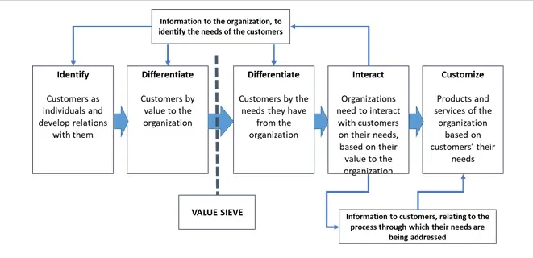
Figure 3. IDIC Model of customer relationship management
Source: (Jaya et al., 2020)
Advantages of the IDIC model of CRM:
- This model can be scaled up and down: If Sainsbury is to thrive, it must have an expanding client base that appreciates the value proposition it provides. Because each encounter requires a unique time commitment, it becomes increasingly difficult to satisfy individual demands on a personal level as the number of consumers rises (Brooks et al., 2021). This model is a scalable solution that can be tailored to nearly any budget and will only expand as the firm expands, ensuring that all requirements are satisfied.
- It collects all requirements in one location: This model help to gather all the required data in a single location. Instead of scouring the internet for specific data points, Sainsbury may simply be on the same page because they all have access to the same information. Workers are more productive as a result of being able to focus more on addressing the demands of prospects and customers.
Disadvantages of the IDIC models of CRM:
- Data might be lost if not managed properly: Important data of the customers might get lost if not handled properly in this model (Kaul, 2017). This data are identifying customers and differentiating them.
- Interchange in customers data: Another drawback of this model is customers data can get mixed, which could become a huge problem for Sainsbury to approach them accordingly.
The QCI model of customer relationship management
Another customer management model is the Quality Competitive Index (QCI) model. According to this model, a company must undertake specific activities that aid in the acquisition of new consumers and the retention of existing ones. The approach is distinct from others in that it emphasises customer ‘management' rather than relationship building. Customer management entails prioritising impulsive shoppers (Brooks et al., 2021). The QCI model aids in the assessment of current processes and the development of a quantitative research method to better customer management.
The model consists of eight components:
- Planning and analysis
- Telecommunications
- Proposition
- Individuals and organisations
- Management of processes
- Actions related to customer management
- Customer service Effect measurement.
Customer management activities like acquisition, penetration, and retention are at the centre of this approach. People and organisations are sustaining factors that are influenced by customer experience and external factors.
- Planning and analysis: Customer management begins with an examination of consumer habits and a strategy for increasing the company's value. Sainsbury may then plan how to engage customers through customer management initiatives. The analysis and planning are based on the REAP (Retention, Efficiency, Acquisition, and Penetration) model of customer management operations (Gallardo et al., 2018).
- Proposition: Customers and their requirements are the foundation of ‘analysis and planning,' which leads to good planning. The next step in the QCI paradigm is to develop the 'proposition.' The proposal contains methods that can lure new consumers, which are dependent on the previous step's appraisal of the customers' demands. Customer segmentation must serve as the foundation for various offers. This also contributes to improved customer experience and engagement initiatives.
- Information and technology: Information and technology facilitate the management of customers and customer-related data. Customers' vital information is delivered to Sainsbury through technology, and vice versa (Chinnappa et al., 2021). As a result, information and technology systems must be updated on a regular basis in order to successfully manage consumers and people as their demands change. Important sub-processes within this aspect include:
- customer information sources
- information planning and analysis
- Quality control and evaluation of information technologies for substitution and regeneration
- Individuals and organizations: Without a strong staff of customer relationship executives, Sainsbury cannot manage its customers. According to the QCI model, the company must establish and maintain a responsible team to:
- Customer requests management
- Feedback
- Concerns and questions
Sainsbury must also develop a framework for identifying roles, job segregation, and conducting training gap analyses.
- Managing processes: According to the QCI model, customer management requires the coordination of marketing, sales, and customer service (Brooks et al., 2021). A consistent procedure that offers ongoing management assistance to consumers and detects flaws is crucial. This highlights the significance of the 'process management component.
- Activities for customer management: This QCI model element contains three sub-categories of activities, all of which are regulated by effectiveness.
- Acquisition: It entails identifying consumers and learning about their needs in order to produce goods and services (Wheatcroft, 2021). After identifying the consumers and their demands, this activity entails successfully communicating Sainsbury's offers.
- Penetration: This sub-activity entails gathering data about consumers which may subsequently be analysed to determine the best way to build a lucrative customer base (Chinnappa et al., 2021). Simple messages are used to welcome consumers to the company, offer an overview of business operations, and assist customers in connecting with the organization's aims.
- Retention: This may be accomplished through both value generation and a win-back approach. This technique may be used to both retain and acquire customers.
- Effect measurement: This aspect entails evaluating the process in order to guarantee that the customer management process is continually improved. The assessment also creates comparisons on customer management effectiveness and helps identify the degree of performance of people and teams in their responsibilities.
- Customer satisfaction: The inclusion of customer experience in the customer management mix adds a new layer of assessment to the equation. It fills in the gaps in customer perception and improvement procedures (Wheatcroft, 2021). The QCI model lays out a step-by-step method for establishing a relationship with consumers, interacting with them courteously, and managing them. The model also acknowledges the importance of the external environment in influencing customer experience and gives guidance on how to mitigate any unfavourable elements by ensuring the CRM procedures' basis.

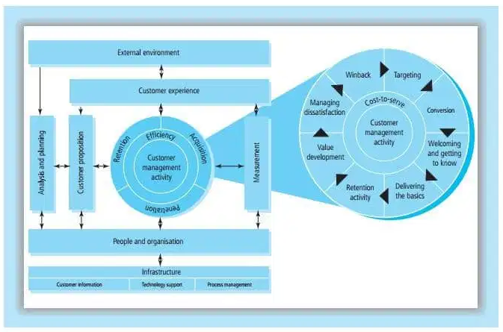
Figure 4. The QCI model
Source: (Head et al., 2018)
Advantages of the QCI model:
- Accelerate the procedure: This approach can help Sainsbury's in conducting research on their intended consumers so that when they ultimately make contact, it becomes a success.
- Lower regular costing: This model help Sainsbury to lower their cost by centralizing whole data, by this, their productivity goes high (Chinnappa et al., 2021).
Disadvantages of the QCI model:
- Customer experience can affect the whole management process: Bad customer experience can affect the whole management process as it would affect retention, efficiency and acquisition of Sainsbury.
- Model affect organizational culture: This model can affect organizational culture by affecting analysis and planning and rejecting others planning and analysis.
Buttle’s CRM value chain model
The Customer Relationship Management (CRM) value chain model is a model that guides Sainsbury's development and implementation of CRM initiatives. It was created in the year 2004 by Francis Buttle. The main objective of this model is to link internally and externally operations in a business in order to produce content for customers while making a profit. Assessing the portfolio of a consumer is the first step towards good CRM as per this method.
- Identify the probability of a long-term connection
- Assess the level of commitment of a client to the firmefforts on establishing a network
- Network development initiatives
- Develop a proposal for value
- Management cycle control of customers.
Furthermore, the approach stresses developing long partnerships via a culture that acknowledges consumers and their requirements, documents data, and uses IT procedures to keep monitoring of customers' wants and build strong interactions with individuals. The value chain model is established in primary and secondary levels for customer relationship management (Wheatcroft, 2021). The second stage acts as a support to the main stage, and each stages include a number of different processes.
- The primary step of the value chain: The initial step of the value chain consists of different processes. Each has its unique collection of methods and procedures that help the model to be applied. The first phase helps:
- locate the consumer
- Identify their habits
- Interact in order to build a relationship
- They are responsible for providing client service.
Moreover, this technique enables the firm to keep a contact with its clients in order to achieve the customer's aim of establishing a lengthy commitment.
- Portfolio analysis of customers: An organization's primary job is to identify customers, since this aids in the identification of the target group and the development of new products. The selected clients may provide value to the company, and are most suited to a successful business (Illipronti, 2021). The research facilitates the construction and needs of a customer persona. It also helps the firm strategize for effective participation in long-term partnerships, and identify highly valued consumers.
- Development of a network: The establishment of a system requires awhile because a considerable commitment is required at all stages of the connection between the company and its users. In addition, customers must participate in the phases of pre-sales, sale and post-sales.
- Customer lifecycle management: Customers might not have been permanently devoted to a business. The lifespan of a client might extend from when they become a customer and go. However, in other instances, the customer may want to suggest the commodities of the company to his peer network. Furthermore, Sainsbury is continuously looking for methods to turn a client into a champion, therefore prolonging the customer's lifespan.
- Secondary step of the value chain: The CRM value chain model's secondary stage is a supporting stage that offers a framework and assists Sainsbury in performing its core duties. This stage's numerous elements are:
- Culture and leadership: Strong leadership contributes to the development of a strong company’s client Management Value Proposal. It emphasises procedures for customer relationship management.
- Information technology and data: CRM procedures nowadays are heavily based on data and information technology. The insight obtained from the data aids in the acquisition of information about the demands of customers. The use of information technology aids in the analysis of massive amounts of data in order to generate value propositions (Illipronti, 2021). Info of the consumer also drives CRM and aids in the stratification of new procedures that may assist to meet the demands of customers.
- Employees or people: They are a company's most crucial support structure since they engage with customers to understand how CRM should function. They might be salespeople, customer care representatives, manufacturing workers, or delivery workers.
CRM strategies must be useful in order to ensure company success. Buttles CRM's CRM value chain model gives organisations who desire a full CRM strategy a detailed roadmap. However, this technique has a basic problem in that the competition evaluation is not included in its procedure (Illipronti, 2021). Furthermore, the competitors have considerable influence on the sale, revenues and awareness of brands as markets grow more overcrowded and active.

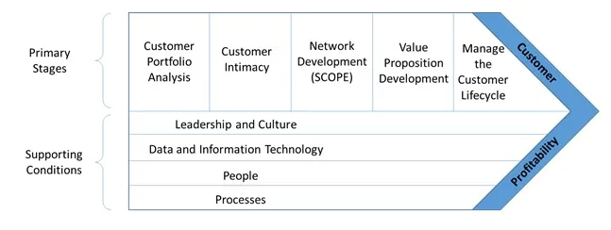
Figure 5. Value chain model of CRM
Source: (Gallardo et al., 2018)
Advantages of value chain model of CRM:
- The aspect of Scalability: This approach is a viable option that will only expand with Sainsbury's. As a result, it is feasible to satisfy the demands of each consumer in an efficient manner.
- Everything is organized in order: This model helps Sainsbury to target their customer base in an organized manner. Factors are organized in an order to reach customers and then to profit (Head et al., 2018).
Disadvantages of value chain model of CRM:
- Limited option to analyse: This model has limited options to reach customers as compared to other models. There are only two stages in the model to reach out customer base.
- Access to the third party: Data can go in hands of a third party in this model. Any third party can get access to sensitive data of customers which is a major issue.

Critically evaluates the benefits and challenges of developing and maintaining good customer relationships
A company's long-term sustainability is determined by the level of client trust it can establish over years. Customers today are continuously assessing their relationships with the companies in their life, and a few errors might result in the company being dropped from their list.
Some key points that will help to develop and maintain a good relationship with customers:
- Sending catchy emails: Every email Sainsbury send is an opportunity to establish a relationship with a possible client. Sainsbury's may become a part of their lives as a result of this. Nobody wants to get a call from someone they haven't spoken from, who only wants money. Similarly, Sainsbury should not just contact their consumers when they have stuff to sell to them (Gallardo et al., 2018). Instead, keep them informed about what's going on in the company or sector, give them unique offers related to the goods or services they're most involved in, and keep reaching them regularly. When customers feel the need, they will reach the company automatically.
- Checking feedbacks and reach customers: Customer opinion is crucial for long-term success, because it enables the firm to receive consumer input on what does and doesn't work. Customers sometimes laid feedback (comments, posts or any other means ) on the company's social accounts, and check whether their suggestions are being implemented or not (Gallardo et al., 2018).
- Maintain consistency and punctuality in dealings: Continuity is important to customers. They will not be harsh, indifferent, or incapable of keeping promises. Consumers would like the firm to often connect with them. Nobody likes to be left out of the loop and approached when the company, i.e., Sainsbury have the stuff to offer. Creating a policy in business that specifies how frequently they respond to clients will help.
- Construct confidence: Being honest and transparent, especially when it isn't popular, is key to establishing trust. It is important for Sainsbury to keep in mind that delivery of product should be on time, this will help to gain them more trust of the customers (Hassan et al., 2019). In most cases a consumer might enjoy keeping them up-to-date. Keep them in the knowledge of promotes confidence.
- Rewarding loyal customers: Finding a method to say thank you to loyal customers and conveying to them that they are an important asset to the company can help. Sainsbury can develop a loyalty programme and give free donations, samples or incentives to top consumers. They may also provide special offers, discounts or exclusive entry to new products. Once others learn about these incentives, they want to take part in the activity, too. They should consider these incentives as a long-term investment in client retention.
Though it is a long procedure, so it has some advantages and disadvantages too. Some of them are discussed below:
The benefit of developing and managing customer relation management:
- Allows a company to find new consumers more easily: Good CRM help in the identification of potential consumers. They maintain a record of preexisting customer data and can utilise them to identify whom to approach for best results (Hassan et al., 2019). New consumers are a sign of future expansion. Expansion is only necessary if existing consumers are well managed, even if new possibilities are recruited.
- Increases income from customers: CRM information assures that marketing initiatives are well-coordinated. It's feasible to sort data so that offers don't get to those who have already bought certain goods. Sainsbury may also utilise the information to create loyalty programmes that help them retain more customers.
- Assists salespeople in completing transactions more quickly: A good CRM helps to conclude transactions faster by making consumer inquiries and data more rapid and effective answers (Head et al., 2018). When customers receive fast responses to their queries, they are more likely to convert their inquiries into sales.
Challenges of developing and managing customer relation management:
- Communication gap: Implementation processes are made by Sainsbury's senior leadership due to the financial and process changes. This choice and the procedure next has to be conveyed to all personnel and over the implementation process, senior management must be supportive of the strategy. In the minds of the workers, there may be anxieties and mental barriers due to a lack of communication. Breakdown in communication also occurs when the CRM is installed and the salesforce is unable to amend the CRM in reality.
- Clearly defining goals: Occasionally, firm fail to recognise and articulate the precise depiction of why they require a CRM system. This renders it impossible to determine the ROI or major benefits of the solution. It is a crucial aspect of CRM application development and management. As a result, it's important to assess plans, including short- and long-term objectives, while also addressing organisational demands.
- Selecting the Correct System: One of the most difficult problems to overcome is deciding which system to use to develop and maintain CRM. It might lead to significant interruptions if an existing system was replaced with one that is unsuitable for the business (Hassan et al., 2019). It is important to examine if the system fits the present and future CRM requirements of the Company. It is also important to evaluate its interoperability with the company's previous systems

Conclusion
After the massive outbreak of covid-19, it became very important for firms like Sainsbury to rethink their CRM policies. The report has discussed it in detail. The report has highlighted the key marketing theories like the Ansoff matrix and Boston Consulting Group matrix. The report further discussed the prime models of CRM like the IDIC model, QCI model and value chain model to regenerate its customer relationship in the post covid era. The models gave an in-depth review of how to approach the customer base in this situation. The report also highlighted the advantages and drawbacks of developing and maintaining a good customer relationship with loyal and regular customers.

References
Ana-Gabriela, B. and CECILIA-IRINA, R.Ă.B.O.N.Ț.U., 2020. THE STATE OF ADOPTING CRM SOFTWARE-SOLUTIONS AS PART OF THE ENTERPRISES’INTERNAL PROCESSES INTEGRATION–A CLUSTER ANALYSIS AT THE LEVEL OF THE EU-MEMBER STATES JUST PRIOR TO THE COVID-19 PANDEMIC. Annals of'Constantin Brancusi'University of Targu-Jiu. Economy Series, 20(5).
Ashcroft, J., Wilkinson, A. and Khan, M., 2021. A Systematic Review of Trauma Crew Resource Management Training: What Can the United States and the United Kingdom Learn From Each Other?. Journal of Surgical Education, 78(1), pp.245-264.
BEULA, M.D.S., VELMURGAN, V. and JANARDHANAN, K., 2020. CUSTOMER RELATIONSHIP MANAGEMENT STRATEGIES IN LIC-COVID 19. MANAGEMENT STRATEGIES TO COMBAT COVID19 AFTERMATH, p.92.
Birafane, M., Liu, W. and Khalikov, S., 2020. The Strategic Positioning of Moroccan Seaports: An Application of the Boston Consulting Group Growth-share Matrix. The Open Transportation Journal, 14(1).
Brooks, N.A., Puri, A., Garg, S., Nag, S., Corbo, J., El Turabi, A., Kaka, N., Zemmel, R.W., Hegarty, P.K. and Kamat, A.M., 2021. The association of Coronavirus Disease-19 mortality and prior bacille Calmette-Guerin vaccination: A robust ecological analysis using unsupervised machine learning. Scientific reports, 11(1), pp.1-9.
Chinnappa, T.B., Karunakaran, N. and Kumar, K.A., 2021. Customer relationship management vs Consumerism: in post Covid-19 period. Journal of Management Research and Analysis, 8(1), pp.32-34.
Dayal, M.G., Thakur, M.D.J. and Verma, P., Analysis of CRM with New Era of Digital Market Innovation During COVID-19 Pandemic Situation.
Duque, J., Varajão, J. and Filipe, V., 2018, June. From CRM to CzRM—Fundamental concepts. In 2018 13th Iberian Conference on Information Systems and Technologies (CISTI) (pp. 1-6). IEEE.
Finola, C.F., Nugraha, Y., Suprijono, S.A., Larrantuka, A., Kanggrawan, J.I. and Suherman, A.L., 2020, November. Analysis of public complaint reports during the COVID-19 pandemic: a case study of Jakarta’s citizen relations management. In 2020 International Conference on ICT for Smart Society (ICISS) (pp. 1-6). IEEE.
Gallardo, G., Hernantes, J. and Serrano, N., 2018. Designing SaaS for enterprise adoption based on task, company, and value-chain context. IEEE Internet Computing, 22(4), pp.37-45.
Hassan, A., Parvez, M. and Ekiz, E., 2019, July. Technology Induced Loyalty Schemes for Customer Relationship Management and Positive Purchase Decisions.
Head, H.R., Kurnik, C.W., Schroeder, D. and Cutchin, K., 2018. Energy Auditor and Quality Control Inspector Competency Model (No. NREL/TP-7A40-71001). National Renewable Energy Lab.(NREL), Golden, CO (United States).
Illipronti, R.G., 2021. Improving survival of micro & small firms in Latin America during COVID-19 via SRM and CRM strategies.
Jaya, I.K., Simanullang, H.G. and Gea, A., 2020. APLIKASI E-ULOS DENGAN KONSEP CUSTOMER RELATIONSHIP MANAGEMENT UNTUK MEMBANGUN LOYALITAS PELANGGAN. Jurnal Informatika Kaputama (JIK), 4(1), pp.20-26.
Karaarslan, E. and Erkmen, T., 2021. The impact of the COVID-19 pandemic on Crew Resource Management (CRM) attitudes: A comparison between cabin crews’ attitudes before COVID-19 and during the COVID-19 process. Business & Management Studies: An International Journal, 9(2), pp.472-485.
Kaul, D., 2017. Customer relationship management (CRM), customer satisfaction and customer lifetime value in retail. Review of professional management, 15(2), pp.55-60.
Kinnett, S.J. and Steinbach, T.A., 2021. A Case Study in the Use of a Gamified Learning Platform to Teach a Course in CRM Implementation.
Loredana, E.M., 2017. The use of Ansoff matrix in the field of business. Annals-Economy Series, 2, pp.141-149.
Maheshwari, P. and Kushwah, B.S., Customer Loyalty Approach of CRM.
Matrix, A. and Ansoff, I., Tools for Generating Strategic.
Mayland, C.R., Hughes, R., Lane, S., McGlinchey, T., Donnellan, W., Bennett, K., Hanna, J., Rapa, E., Dalton, L. and Mason, S.R., 2021. Are public health measures and individualised care compatible in the face of a pandemic? A national observational study of bereaved relatives’ experiences during the COVID-19 pandemic. Palliative Medicine, p.02692163211019885.
Nguyen, B., Jaber, F. and Simkin, L., 2020. A systematic review of the dark side of CRM: the need for a new research agenda. Journal of strategic marketing, pp.1-19.
Pratiwi, M. and Arsyah, U.I., 2021, June. The Effectiveness of the Concept of CRM Application for SMEs during the COVID-19 Pandemic. In Journal of Physics: Conference Series (Vol. 1933, No. 1, p. 012026). IOP Publishing.
Rajaraman, S., Sornapudi, S., Alderson, P.O., Folio, L.R. and Antani, S.K., 2020. Analyzing inter-reader variability affecting deep ensemble learning for COVID-19 detection in chest radiographs. PloS one, 15(11), p.e0242301.
Russo, V., Pafundi, P.C., Rapacciuolo, A., D’Andrea, A., de Devitiis, M., Volpicelli, M., Ruocco, A., Nigro, G. and D’Onofrio, A., 2020. Arrhythmogenic syncope leading to cardiac rhythm management procedures during COVID-19 lockdown. Expert Review of Medical Devices, 17(11), pp.1207-1210.
Singh, D., COVID-19: Its Implications with a Focus on the Aviation Industry and How CRM and BI Can Play A Role.
Tosun, P., 2020. CRM in retail banking from salespeople’s perspective in the Covid-19 outbreak. Effects of the Covid 19.
Verasophon, P., CRM and the critical analysis of database marketing: a case study of Sainsbury Clubcard.
Wheatcroft, J., 2021. A study of how kitchen companies in Sweden have utilized multichannels of CRM under the Covid-19 pandemic.
Wright, R.S., 2020. How COVID-19 Will Change Your CRM Platform… For Good. Research-Technology Management, 63(6), pp.52-53.
Yun, S.Y. and Hong, T., 2021. A Study on the Social CRM adoption in SMEs impacted by COVID-19: Based on the TOE Framework.
Zhang, Y.C., Gong, X.Z., Liu, Y. and Zhou, L.W., 2021. Screening of Energy-Saving Technologies for Cement Production Based on Boston Consulting Group Matrix. In Materials Science Forum (Vol. 1035, pp. 988-998). Trans Tech Publications Ltd.

