
University of Wales Trinity Saint David
Institute of Inner-City Learning – London Campus

Master of Business Administration (MBA)
LCMB7035 – Dissertation

The Impact of Mobile Application Experience on Customer Satisfaction & Retention in the UK Food Delivery Industry

Submitted by:
Md Forhad Hossen Rony
Student ID: 2433472

Supervisor:
Dr Jean Wang

A dissertation submitted in partial fulfilment of the requirements for the degree of Master of Business Administration (MBA) at the University of Wales Trinity Saint David.
Word Count: 15506
Date of Submission: 25 September, 2026
Declaration
I, Md Forhad Hossen Rony, declare that this dissertation has been composed by myself, that the work contained herein is entirely my own except where explicitly stated otherwise in the text, and that this work has not been submitted for any other degree or qualification, in whole or in part, except as specified.


Signature: ………………………………............................
Date: 24 September, 2026

AI Use Acknowledgement
I acknowledge the use of Grammarly to support the proofreading of this dissertation. Grammarly was used to identify and correct spelling, grammar, punctuation and sentence-level clarity issues in my own writing.
I confirm that I have not presented any AI-generated text as my own work. I confirm that I have copies of my drafts, notes and other resources used before and after using Grammarly, which I may be asked to provide as evidence.

Acknowledgements
I would like to express my sincere gratitude to my supervisor for the guidance, constructive feedback and academic support provided throughout this research. I am also grateful to the academic staff who contributed to the development of my knowledge and research skills during my studies. Special thanks are extended to all participants who voluntarily completed the questionnaire, as their contribution made this research possible. Finally, I would like to thank my family and friends for their encouragement, patience and support throughout the completion of this dissertation.

Abstract
This study examines the impact of mobile application experience on customer satisfaction and retention in the UK food delivery industry. The study investigates whether positive digital experiences contribute to customer satisfaction and retention within a highly competitive market. The study conceptualised mobile application experience as a multidimensional construct comprising usability, interface quality, convenience, reliability and personalisation and interpreted the proposed relationships through an ECT-informed framework. A cross sectional and quantitative research design was employed with a structured questionnaire to gather primary data from 120 consumers who use food delivery apps in the UK. The data were analysed using descriptive statistics, reliability analysis, Pearson correlation, regression and PROCESS mediation analysis. The results confirmed that mobile application experience had a significant positive effect on customer satisfaction, supporting H1. However, customer satisfaction did not significantly predict customer retention, resulting in H2 being unsupported. In addition, the indirect effect of mobile application experience on retention via customer satisfaction was not significant, thus failing to support H3. The findings provide partial support for the proposed conceptual model and offer context-specific evidence relevant to an ECT-informed framework. The study concludes that a positive mobile application experience can increase customer satisfaction, although satisfaction alone may be insufficient to ensure customer retention. The findings highlight the need for managers and future research to consider additional factors influencing continued platform use.
Keywords: Mobile Application Experience; Customer Satisfaction; Customer Retention; Food Delivery Applications; Expectation-Confirmation Theory; United Kingdom.

Table of Contents
1 Chapter One: Introduction and Rationale 1
1.1 Research Background 1
1.2 Research Rationale 3
1.2.1 Theoretical Justification 3
1.2.2 Practical Justification 5
1.3 Research Contribution and Motivation 6
1.3.1 Theoretical Contribution 6
1.3.2 Empirical Contribution 7
1.3.3 Practical Contribution 7
1.3.4 Originality and Research Motivation 7
1.4 Research Aim, Objectives and Questions 8
1.4.1 Research Aim 8
1.4.2 Research Objectives 8
1.4.3 Research Questions 8
1.5 Dissertation Structure 9
2 Chapter Two: Literature Review 10
2.1 Introduction 10
2.2 Mobile Application Experience in Food Delivery Platforms 10
2.2.1 Usability 13
2.2.2 Interface Quality 13
2.2.3 Convenience 13
2.2.4 Reliability 14
2.2.5 Personalisation 14
2.3 Customer Satisfaction as a Consequence of Mobile Application Experience 15
2.3.1 Critical Evaluation 18
2.4 Customer Retention in the UK Food Delivery Industry 18
2.4.1 Critical Evaluation 21
2.5 Integrating Mobile Application Experience, Customer Satisfaction and Customer Retention: Critical Synthesis 21
2.6 Research Gap 22
2.7 Theoretical Foundation and Contribution 23
2.7.1 Expectation-Confirmation Theory (ECT) as the Theoretical Foundation 23
2.7.2 Customer Satisfaction as a Mediator (why mediator) 24
2.7.3 RFM Analysis and Customer Retention 25
2.7.4 Justification for the Theoretical Choice 26
2.7.5 Theoretical Contribution 26
2.8 Conceptual Framework 26
2.9 Hypotheses 27
2.10 Conclusion 28
3 Chapter Three: Methodology 29
3.1 Introduction 29
3.2 Research Philosophy, Approach and Research Design 29
3.2.1 Research Philosophy 29
3.2.2 Research Approach 30
3.2.3 Research Design 30
3.3 Justification for Quantitative Research Methodology 31
3.4 Sampling Strategy and Participant Selection 32
3.5 Data Collection Procedure 33
3.6 Data Analysis Approach 33
3.7 Research Quality and Rigour 34
3.8 Ethical Considerations 34
3.9 Chapter Summary 35
4 Chapter Four: Data Analysis and Results 36
4.1 Introduction 36
4.2 Demographic Analysis 36
4.2.1 Food Delivery Application Usage Analysis 38
4.2.2 RFM-Informed Behavioural Analysis 40
4.3 Reliability Analysis 42
4.4 Construct Validity: Exploratory Factor Analysis 44
4.5 Descriptive Statistics 44
4.6 Normality and Regression Assumption Testing 45
4.7 Regression Residual Diagnostics 50
4.8 Pearson Correlation Analysis 52
4.9 Simple Linear Regression 53
4.9.1 H1: Mobile Application Experience has a positive and significant effect on Customer Satisfaction. 53
4.9.2 H2: Customer Satisfaction has a positive and significant effect on Customer Retention. 54
4.10 Mediation Analysis 55
4.10.1 H3: Customer Satisfaction mediates the relationship between Mobile Application Experience and Customer Retention. 55
4.11 Chapter Summary 57
5 Chapter Five: Discussion and Analysis 58
5.1 Purpose and Positioning 58
5.2 Analytical Framework and Logic 58
5.3 Cross-Case Synthesis: Compare and Contrast with Literature 58
5.3.1 Mobile Application Experience and Customer Satisfaction 58
5.3.2 Customer Satisfaction and Customer Retention 59
5.3.3 Customer Satisfaction as a Mediating Mechanism 60
5.3.4 Overall Theoretical and Contextual Synthesis 61
5.4 Integration to Conceptual Model or Propositions 61
5.5 Robustness Considerations 62
5.6 Practical Synthesis: Bridge to Chapter 6 62
5.7 Chapter Summary 63
6 Chapter Six: Conclusion 64
6.1 Introduction 64
6.2 Brief Summary of Key Findings 64
6.3 Theoretical Implications 64
6.3.1 Contribution 1: Implications for Expectation-Confirmation Theory 64
6.3.2 Contribution 2: Boundary Conditions and Contingencies 65
6.3.3 Contribution 3: Mechanism and Construct Insights 65
6.3.4 Contribution 4: Refinement of the Conceptual Model 65
6.4 Managerial Implications 66
6.5 Limitations and Directions for Future Research 66
6.6 Closing Statement 67
7 References 68
8 Appendices 77
8.1 Appendix A: Ethic Form 77
8.2 Appendix B: Participant Information Sheet 79
8.3 Appendix C: Consent Form 79
8.4 Appendix D: Questionnaire 80
8.5 Appendix E: Survey Link 84
8.6 Appendix F: Raw Data 84
8.7 Appendix G: SPSS Analysis 85
8.8 Appendix H: Exploratory Factor Analysis 85

List of Figures
Figure 1: Market value of foodservice delivery in the United Kingdom from 2015 to 2024 (Statista, 2025) 2
Figure 2: Number of orders from Just Eat Takeaway.com worldwide from 2019 to 2024, by region (in millions) (Statista, 2025a) 2
Figure 3: Conceptual Framework of the Study 28
Figure 4: Research Onion (Saunders, Lewis and Thornhill, 2019). 32
Figure 5: Age Distribution of Respondents 37
Figure 6: UK Residency of Respondents 38
Figure 7: Previous Use of Food Delivery Applications in the UK 38
Figure 8: Most Frequently Used Food Delivery Application 39
Figure 9: Gender Distribution of Respondents 39
Figure 10: Employment Status of Respondents 40
Figure 11: Length of Food Delivery Application Usage 41
Figure 12: Recency of Food Delivery Application Usage 41
Figure 13: Frequency of Food Delivery Application Usage 42
Figure 14: Monetary Spending per Food Delivery Order 43
Figure 15: Histogram of Mobile Application Experience 46
Figure 16: Detrended Normal Q-Q Plot of Mobile Application Experience 46
Figure 17: Boxplot of Mobile Application Experience 47
Figure 18: Histogram of Customer Satisfaction 47
Figure 19: Detrended Normal Q-Q Plot of Customer Satisfaction 48
Figure 20: Boxplot of Customer Satisfaction 48
Figure 21: Histogram of Customer Retention 49
Figure 22: Detrended Normal Q-Q Plot of Customer Retention 49
Figure 23: Boxplot of Customer Retention 50

List of Tables
Table 1: Reliability Analysis – Usability 43
Table 2: Reliability Analysis – Interface Quality 43
Table 3: Reliability Analysis – Convenience 44
Table 4: Reliability Analysis – Application Reliability 44
Table 5: Reliability Analysis – Personalisation 44
Table 6: Reliability Analysis – Overall Mobile Application Experience 44
Table 7: Reliability Analysis – Customer Satisfaction 44
Table 8: Reliability Analysis – Customer Retention 44
Table 9: Descriptive Statistics 45
Table 10: Tests of Normality 45
Table 11: Pearson Correlation Analysis 50
Table 12: Model Summary 51
Table 13: ANOVA 51
Table 14: Regression Coefficients 52
Table 15: Model Summary 52
Table 16: ANOVA 53
Table 17: Regression Coefficients 53
Table 18: PROCESS Model 4 – Effect of Mobile Application Experience on Customer Satisfaction 53
Table 19: Regression Coefficients for Customer Satisfaction 54
Table 20: PROCESS Model 4 – Effects on Customer Retention 54
Table 21: Regression Coefficients for Customer Retention 54
Table 22: Direct Effect of Mobile Application Experience on Customer Retention 54

Chapter One: Introduction and Rationale

Research Background
The UK food-delivery industry has become increasingly platform-based, with mobile applications acting as a primary interface between consumers, restaurants and delivery networks. Alongside restaurant availability and pricing, major platforms such as Just Eat, Uber Eats and Deliveroo increasingly compete on the quality of the digital experience they provide (IBISWorld, 2025). This reflects the scale of digitalisation, with Food Standards Agency research indicating that 55% of respondents had ordered food or drink online using a food or drink ordering and delivery service, like Just Eat, Deliveroo or Uber Eats (Armstrong et al., 2023). According to industry data, the value of the foodservice delivery market was estimated at around £13.87 billion in the UK in 2024 and is projected to reach £15.8 billion by 2028 (Statista, 2025b). At the same time, Just Eat Takeaway.com received 242 million orders in the UK and Ireland during 2024 – showing the scale on which consumers use app-based food delivery services (Statista, 2025a). These figures demonstrate that food-delivery applications have become an established component of the UK's digital service economy.
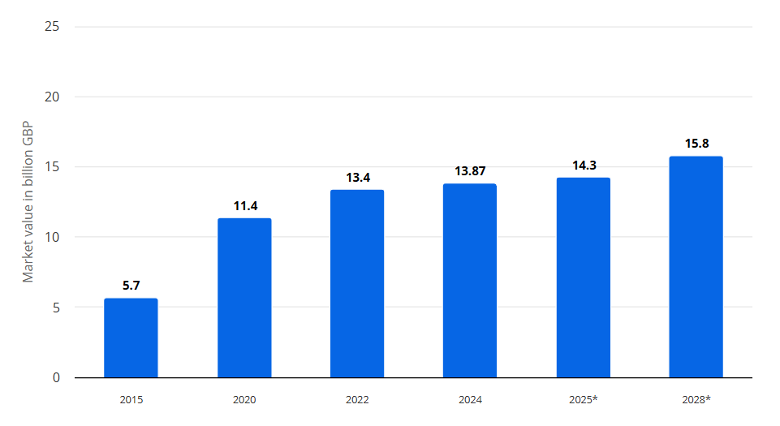
Figure 1: Market value of foodservice delivery in the United Kingdom from 2015 to 2024 (Statista, 2025b)
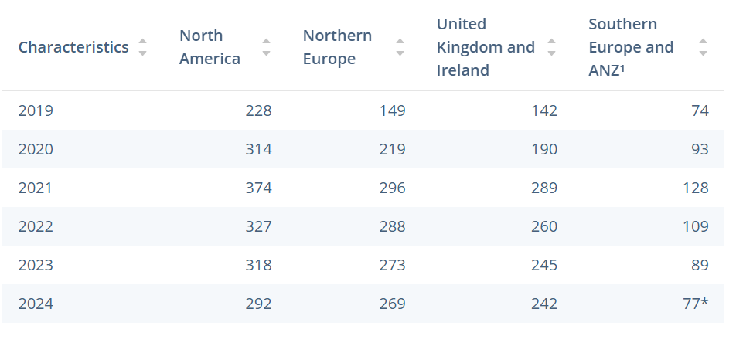
Figure 2: Number of orders from Just Eat Takeaway.com worldwide from 2019 to 2024, by region (in millions) (Statista, 2025a)
Competition within these marketplaces has increased the strategic importance of mobile application experience. There are no barriers to consumers switching between competing platforms that have similar restaurants and delivery services. Indeed, low fees, restaurant selection and ease of use have been found to be among the top factors that affect UK consumers' decisions on which delivery platform to use (Ecker and Strüver, 2022). As a result, the level of usability, interface quality, convenience, reliability and personalisation may be important areas of differentiation. This is particularly important because the customer journey extends beyond placing an order to browsing menus, evaluating information, making payments, tracking orders and interacting with the platform at multiple touchpoints (Rane, Achari and Choudhary, 2023). Issues at these digital touchpoints may therefore negatively affect customer satisfaction, even when the underlying food and delivery service remains competitive.
Academic evidence similarly suggests that digital and service experiences are consequential for post-adoption consumer behaviour. Annaraud and Berezina (2020) concluded that dimensions such as perceived control, service convenience, service delivery and service support could affect satisfaction, and satisfaction significantly affects behavioural intentions toward online food delivery. Recent studies show that foodservice mobile-app quality factors such as transaction accuracy, content quality and contextual offers significantly impact customer satisfaction (Ahn, Slevitch and Sung, 2023). Additionally, expectation-confirmation research places user satisfaction as a key determinant in the future use of digital food delivery services following initial adoption (Chanda et al., 2024). Therefore, enhancing the user experience goes beyond just technical design considerations; it can be a strategic way of building satisfaction and keeping users.
However, the relationship remains unsettled, with findings from online food-delivery platforms remaining fragmented, as shown in a recent meta-analysis by Amit et al. (2024) which found there were contextual and methodological moderators. The results of individual studies also differ; some satisfaction and service quality dimensions are found to be significant predictors of continued use, while some usability dimensions such as navigational design and perceived ease of use are not significant predictors of satisfaction and loyalty in specific contexts (Prasetyo et al., 2021). The vast majority of the empirical evidence that is currently available is also from non-UK markets, although the UK sector is mature and competitive. This creates a need to understand whether a broader mobile application experience, incorporating usability, interface quality, convenience, reliability and personalisation, contributes to customer satisfaction and retention among UK food-delivery-app users, and whether satisfaction provides the mechanism connecting application experience with continued use. This unresolved relationship provides the basis for the theoretical and practical rationale developed in the following section.

Research Rationale

Theoretical Justification
Existing literature establishes that mobile application experience is an important antecedent of post-adoption customer evaluations in digital services. Mobile app experience goes beyond the aspect of usability, and can be considered as a multidimensional phenomenon, including usability, interface quality, convenience, reliability and personalisation, that can impact the customer's interaction with food delivery applications (Madhuritha and Nedumaran, 2025; Chen and Prentice, 2024). Intuitive interfaces and ease of use can improve user evaluations, while convenience and reliability may reduce effort and uncertainty in digital transactions. The use of personalisation also enhances the application experience, with recommendations and promotions being more relevant and appealing to users (partly depending on their level of trust, usefulness, and transparency) (Romeo and Conti, 2025; Ahire, 2025). The most prevalent theoretical framework to explain post-adoption evaluation is Expectation Confirmation Theory (ECT) (Oliver, 1980) which suggests that satisfaction is a function of the comparison of expectations with actual performance and Bhattacherjee (2001) takes the idea further to information systems by introducing the concept of satisfaction as a key factor in determining post-adoption continuance intentions. This makes ECT particularly appropriate for food-delivery applications because the concern is not simply why consumers initially adopt an application, as emphasised by the Technology Acceptance Model (Davis, 1989), but how their subsequent application experience translates into satisfaction and continued usage (Bhattacherjee, 2001; Sandu et al., 2025).
Despite this established foundation, the evidence remains fragmented and theoretically ambiguous. Previous studies have often examined individual aspects of mobile application experience, such as usability, service quality, convenience, interface design or AI-driven personalisation instead of considering mobile application experience as a multidimensional construct (Madhuritha and Nedumaran, 2025; Chen and Prentice, 2024). Although satisfaction is associated with retention, continued use may also depend on service reliability, convenience, trust, emotional engagement and competing alternatives; therefore, satisfaction does not necessarily guarantee retention (Khuc and Vu, 2025; Ahmad, Ghani and Hamid, 2025). The debate around personalisation is especially heated, as AI-driven suggestions can make the shopping experience more relevant and convenient, but the lack of transparency, privacy concerns, and limited user control over these algorithms can undermine customer trust and satisfaction ( Chen and Prentice, 2024; Ahire, 2025). These ambivalences are exacerbated by methodological and contextual constraints. The available evidence is largely based on cross-sectional designs and from Asian or other developing markets and cannot easily be generalised to the more mature and competitive food-delivery landscape in the UK (Janice et al., 2023; Maha and Rahardja, 2025).
Consequently, the specific theoretical gap addressed by this study concerns the limited understanding of how overall mobile application experience influences customer retention through customer satisfaction among UK food-delivery-app users. Existing studies have not sufficiently examined usability, interface quality, convenience, reliability and personalisation as an integrated application-experience construct, alongside satisfaction as the psychological mechanism linking application experience to retention (Madhuritha and Nedumaran, 2025; Zariman, Humaidi and Abd Rashid, 2022). Theoretically this is an important omission because treating experience dimensions or behavioural outcomes independently will not give much understanding of the relationship between digital experiences and ongoing customer relationships. To tackle this issue, ECT has been put forward, which suggests that satisfaction is a result of comparing actual experience with expectations, and that this satisfaction, in turn, affects continuance behaviour (Oliver, 1980; Bhattacherjee, 2001). Its explanatory usefulness in a more complex context of a UK food delivery application is not well established. Accordingly, this study applies ECT to examine whether customer satisfaction acts as the mechanism through which multidimensional mobile application experience influences customer retention among UK food-delivery-app users, thereby addressing the identified theoretical, contextual and empirical gaps in the existing literature.

Practical Justification
From a practical perspective, understanding how mobile application experience contributes to satisfaction and retention is strategically important because food-delivery platforms operate in a large and highly competitive digital marketplace. In 2024, the UK foodservice delivery market was worth around £13.87 billion and is expected to be worth £15.8 billion in 2028, meaning that the market remains highly commercial (Statista, 2025). In 2024, consumers worldwide made more than 242 million orders on Just Eat Takeaway.com in the UK and Ireland alone (Statista, 2025a). Furthermore, evidence from the Food Standards Agency (FSA) suggests that 55% of respondents had placed food or drink orders with an online ordering and delivery service, highlighting the high prevalence of this service (Armstrong et al., 2023).
For platform managers, however, market growth does not guarantee customer retention. Consumers can easily switch from one application that has similar restaurants and delivery services to another, so the quality of digital interactions will be a key potential differentiator. Therefore, managers need to make decisions on investment in usability, interface design, convenience, reliability and personalisation. If the satisfaction and retention effects of these dimensions are not integrated and illuminated, then resources might be allocated to technically advanced features that are not necessarily useful for increased retention. This is especially pertinent to the use of AI for personalisation, where customised recommendations can boost relevance, but a high degree of personalisation, or personalisation that is not clearly explained, can raise issues with privacy, transparency and trust ( Chen and Prentice, 2024; Romeo and Conti, 2025; Ahire, 2025).
The practical considerations relate to managers' lack of evidence that is specific to their application which can be used to identify the aspects of the overall application experience that they should focus on to enhance satisfaction and then retention among UK users. Closing this gap can provide evidence to guide app-development and customer-experience investments while lowering the opportunity cost of investing in features that improve functionality without strengthening customer relationships.

Research Contribution and Motivation

Theoretical Contribution
This study contributes theoretically by extending Expectation-Confirmation Theory (ECT) to the post-adoption use of mobile food-delivery applications in the UK. According to ECT, customers compare actual experiences with their expectations and if they are confirmed, they will have a sense of satisfaction which will increase their willingness to continue their experience with the company (Oliver, 1980; Bhattacherjee, 2001). Previous studies on food delivery have, however, tended to focus on either usability, service quality, convenience or personalisation individually and fail to treat the application experience as a combined entity. As a result, this study adopts the multidimensional conceptualisation of mobile application experience through usability, interface quality, convenience, reliability and personalisation, and utilises ECT. Rather than assuming that favourable application features directly generate retention, the study examines customer satisfaction as a potential mechanism leading to continued-use intentions. In doing so, the research assesses the explanatory applicability of ECT within a mature, competitive UK platform-service context and examines whether the expected satisfaction–retention pathway holds when multiple dimensions of digital experience are considered collectively.

Empirical Contribution
Empirically, the study provides primary quantitative evidence from UK consumers who have used mobile food-delivery applications. This is important because much existing evidence has been generated in Asian and other developing-market contexts, limiting its direct generalisability to UK consumers and competitive conditions. The study uses a structured questionnaire to measure the five dimensions of mobile application experience as well as customer satisfaction and retention. This allows the proposed relationships to be statistically evaluated in the context of the overall empirical model, instead of by application characteristics alone. The analysis thus offers specific evidence to support or challenge the hypotheses that overall application experience is predictive of satisfaction, that satisfaction is predictive of retention, and that satisfaction is a mediator between overall application experience and retention. This directly addresses the fragmentation identified in the existing literature.

Practical Contribution
The research is also motivated by its potential managerial value. Managers of food-delivery platforms must determine how to allocate resources across interface enhancements, usability, convenience, reliability and increasingly sophisticated personalisation. The study can offer a proof of whether the overall experience of the mobile application will be associated with higher satisfaction and whether this will lead to better retention. This evidence can help drive application development priorities, customer-experience plans and those investments that are necessary to retain customers, especially in situations where managers need to consider innovation alongside the customers need for reliability, transparency and control.

Originality and Research Motivation
The originality of the study lies in integrating five dimensions of mobile application experience with customer satisfaction and retention within a single ECT-informed framework. Evidence is scattered across constructs and geographical areas. Therefore, the research is driven by a desire to provide a more integrated and context-specific understanding of the link between digital application experiences and longer-term customer outcomes, rather than the belief that individual technological advances always result in customer retention.

Research Aim, Objectives and Questions

Research Aim
The aim of this research is:
- To examine the influence of mobile application experience on customer satisfaction and retention among users of food-delivery applications in the UK, with particular attention to the mediating role of customer satisfaction.
The five dimensions of mobile application experience are usability, interface quality, convenience, reliability and personalisation. This is a conceptualisation that goes beyond considering individual features of the application as separate predictors.

Research Objectives
The study has the following three objectives:
- To examine the influence of mobile application experience, comprising usability, interface quality, convenience, reliability and personalisation, on customer satisfaction among UK food-delivery-app users.
- To assess the relationship between customer satisfaction and customer retention among UK food-delivery-app users.
- To evaluate whether customer satisfaction mediates the relationship between mobile application experience and customer retention.
These objectives operationalise the proposed relationships among mobile application experience, customer satisfaction and customer retention, enabling each component of the conceptual model to be empirically examined.

Research Questions
- RQ1: To what extent does mobile application experience influence customer satisfaction among UK food-delivery-app users?
- RQ2: How does customer satisfaction contribute to customer retention and mediate the relationship between mobile application experience and customer retention among UK food-delivery-app users?
These questions provide the basis for the hypotheses and statistical analyses undertaken in the subsequent chapters.

Dissertation Structure
The remainder of this dissertation is organised into five further chapters. Chapter Two critically reviews literature concerning mobile application experience, customer satisfaction and customer retention, establishes Expectation-Confirmation Theory as the theoretical foundation, identifies the research gap and develops the conceptual framework and hypotheses. Chapter Three explains and justifies the quantitative methodology, including research philosophy, approach, survey design, sampling, data collection, measurement, statistical analysis and ethical considerations. Chapter Four presents the empirical findings, including sample characteristics, descriptive statistics, reliability analysis, correlation, regression and mediation analysis. Chapter Five critically discusses the findings in relation to previous literature, ECT, the research questions and hypotheses. Finally, Chapter Six presents the conclusions, theoretical and practical implications, recommendations, limitations and directions for future research.

Chapter Two: Literature Review

Introduction
This chapter critically reviews the academic literature relevant to examining the effect of mobile application experience on customer satisfaction and customer retention in the UK food delivery market. It is used to identify the existing knowledge, analyse the conflicting viewpoints and raise issues that will need further investigation to provide a theoretical and empirical basis to the study. The review is guided by the research problem identified in Chapter 1: the limited understanding of how multidimensional mobile application experience influences customer satisfaction and retention in the UK context. The chapter includes literature about mobile application experience, customer satisfaction, customer retention and Expectation-Confirmation Theory (ECT), and excludes literature that only discusses technology adoption, not post adoption behaviour. The chapter ends with a conceptual framework which will guide the empirical investigation to be presented in the following methodology chapter.

Mobile Application Experience in Food Delivery Platforms
The experience of mobile applications has become one of the key factors in the success of online food delivery services and has influenced customers' perceptions, interactions and reviews during their experience with a digital platform (Pourazad, Simmonds and Bellman, 2025). While earlier research had considered FODA only as a transactional tool for placing orders, the food delivery app experience is now considered as a multi-faceted construct with the dimensions of usability, interface quality, convenience, reliability, personalisation and interactive engagement (Madhuritha and Nedumaran, 2025). This shift reflects the digital transformation of food-delivery platforms, where retaining customers is no longer just about service quality but about creating a pleasant and hassle-free experience.
Davis (1989) and Lee, Ramasamy and Subbarao (2025) examined mobile application experience using the Technology Acceptance Model (TAM), suggesting that perceived usefulness and perceived ease of use are the key factors that affect technology uptake. Ahluwalia (2026) discovered that user-friendly interfaces and effortless navigation play a vital role in enhancing users' intentions to adopt food delivery apps. Likewise, Janice et al., (2023) argue that the use of the application has a positive impact on the users' behavioural intentions because of the increase in the perceived usefulness of the application. These studies draw on established theoretical frameworks and quantitative methods, providing empirical evidence on technology adoption. However, their main concern is the initial technology adoption and not on the customer experience and retention (Ahluwalia, 2026; Janice et al., 2023; Lee, Ramasamy and Subbarao, 2025). Thus, TAM primarily explains initial technology adoption and provides more limited insight into post-adoption retention.
The more recent research goes beyond usability and posits that the experience of a mobile application is much broader. Mobile applications are not merely transactional, but experience platforms that value a customer at every stage of their journey, argue Mittameedi, Dogra and Sayal (2025). Similarly, Hsiao (2026) claim that the aesthetics, direct appeal, interactivity and emotional experiences of the interface are critical for customers' perception of the application quality. Their results contradict the previous technology-focused viewpoints, showing that customers assess apps based not just on their practicality but also emotional and experiential features (Hsiao, 2026). However, most of this evidence comes from mobile commerce ecosystems in general, and not necessarily in the food delivery sector, so that the findings cannot be directly translated to platforms that specialise in food delivery with time-sensitive services and high competition.
The advent of AI has also revolutionized the mobile app experience. AI-driven capabilities such as personalised food suggestions, intelligent search, predictive order entry, and tailored promotions boost the relevance and convenience of customer interactions, thereby improving the overall customer experience, according to Chen and Prentice (2024). Likewise, Jošt and Taneski (2025) pointed out that the development of cross-platform mobile technologies has been increasing the responsiveness of applications, as well as their consistency and performance across different devices, which enhances user satisfaction. Romeo and Conti (2025) also warn against the potential for a loss of customer trust if the personalisation is overdone and if the customer has no visibility into or understanding of how the AI is making its decisions. This discovery challenges previous studies that tend to equate technological progress with a positive customer experience and suggests that, depending on perceived levels of transparency and control, AI implementation can lead to both beneficial and detrimental customer behaviors (Dwi and Aimin, 2026; Romeo and Conti, 2025).
Another ever-present facet of mobile app experience is convenience. Convenience and delivery speed and application reliability have a larger impact on the intention to continue using an application than price-related promotional activities (Harter, Stich and Spann 2024). Gao, Peinkofer and Griffis (2025) also find similar conclusions; convenience and reliability of applications are key elements to customer retention. On the other hand, Nwabekee, Okpeke and Onalaja (2025) argue that while some features like GPS tracking, integrated payment systems and order history help to enhance the functionality of the operations, the empirical evidence directly linking these technological capabilities to customer retention is limited. However, their scoping review shows that many of the studies that exist provide a description of the features of the application but fail to address the psychological mechanisms that underlie their impact on behavioural outcomes. This methodologic restriction limits the ability to know whether increased functionality is enough to keep customers loyal.
There are several inconsistencies in the literature, although huge strides have been made. Most of the empirical studies are conducted in a cross-sectional survey manner, and primarily in the Asian context, and this would not be broadened to the UK food delivery market where the expectations and competitive situation are different (Janice et al., 2023; Lee, Ramasamy and Subbarao, 2025, Harter, Stich and Spann, 2024). Furthermore, current research focuses on usability and convenience and AI personalisation and interface quality separately, not as a holistic multidimensional phenomenon. As a result, there has been a lack of research into how overall mobile application experience affects customer satisfaction and customer retention in the food delivery sector in the UK (Madhuritha and Nedumaran, 2025; Chen and Prentice, 2024).

Usability
Usability refers to how easily the users can learn and use the application effectively and with least effort. This includes things like smooth navigation, simple menus, simple ordering processes and ease of performing transactions. From a technology acceptance perspective, perceived ease of use has consistently been associated with favourable user evaluations (Davis, 1989). Recent studies have demonstrated that intuitive design of applications can improve users’ behavioural intentions and evaluations (Ugwuegbu et al., 2026; Lim et al., 2026). User-friendliness is particularly important in the food-delivery context as users usually expect to order food quickly and easily. However, usability alone cannot explain the overall application experience. An application may be user-friendly but inconsistent, visually confusing or lacking in relevant personalisation and thus not live up to customers’ expectations. Therefore, in this study usability is considered as one aspect of a broader mobile application experience and not the entire construct.

Interface Quality
Interface quality is the visual and interactive features that customers interact with when using the application. This covers layout, look and feel, clarity of information, consistency and interactivity. The recent literature suggests that the interface characteristics affect the customer perception of the digital service quality. Hsiao (2026) states that interfaces' aesthetic and psychological characteristics can affect the engagement of users. Urdea, Constantin and Purcaru (2021) stress the importance of visual appeal and interactive experiences in the digital customer relationships. But there is a distinction between functional usability and interface quality. Usability is how easy the application is to operate. Interface quality is how well the application’s visual and interactive design supports the customer experience. A critical review therefore implies that both dimensions should be studied separately but acknowledging that they may interact in the formation of customer satisfaction.

Convenience
Convenience refers to the extent to which an application reduces the time and effort required from customers when ordering food. The food ordering process can be simplified with convenience features such as search for restaurants, saved addresses, integrated payment, order history and real-time tracking. Research has also found that convenience and delivery-related factors can affect continued use and repurchase behaviour (Harter et al., 2024; Gao et al., 2025) showing the importance of convenience. In contrast, some research shows that technological features do not guarantee long-term retention (Nwabekee, Okpeke and Onalaja, 2025). Thus, convenience should not be defined solely by the number of features available. The real question is whether customers really feel that those features reduce effort and enhance their overall experience. This distinction legitimises the adoption of convenience as a dimension of perception of mobile application experience.

Reliability
Reliability refers to the capacity of the application and related service processes to function accurately and predictably. It may consist of such things as accurate information, application stability, reliable payment processing, accurate order information and effective order tracking. Reliability is particularly important for food-delivery applications, because customers make time-sensitive decisions based on the information provided thru the application. The electronic service quality literature has identified the importance of system reliability as an element of customer satisfaction (Chandra et al., 2025). Gao et al. (2025) also state that reliability enhances the quality of digital service processes. However, in some technology acceptance research, reliability has been less attended while focusing mainly on ease of use and usefulness. This is a limitation for studying post-adoption food delivery behaviours. Existing users of an application may prefer the consistency of application performance to the ease of operation.

Personalisation
Personalisation is the degree to which the application customises content, recommendations, promotions or interactions to the individual preferences of the customer. Artificial intelligence (AI) tools have advanced the capability of food delivery applications to provide personalised recommendations and targeted offers (Chen and Prentice, 2024; Yin, Qiu and Wang, 2025). Personalisation can increase convenience and perceived relevance, as customers may be given recommendations based on their past behaviour. However, the literature presents a more complex picture than a uniformly positive relationship. There are also potential concerns around privacy and consumer trust (Ahire, 2025). Furthermore, excessive automation might generate negative perceptions when customers cannot comprehend or control algorithmic decisions (Romeo and Conti, 2025). Therefore, the current study considers personalisation as a dimension of application experience, acknowledging that its impact may depend on customer perceptions about usefulness, transparency and trust. This critical perspective becomes especially important as AI-powered personalisation is a relatively new development in food delivery apps.

Customer Satisfaction as a Consequence of Mobile Application Experience
Customer satisfaction is known to be one of the most critical results of mobile application experience, as it indicates whether the user's experience is equal to or better than what they expected from the app (Lu et al., 2025). Consistent with the expectation-confirmation perspective, satisfaction reflects customers’ positive evaluation of whether the application experience meets or exceeds their prior expectations (Oliver, 1980). Regarding food delivery applications, positive experiences associated with usability and interface design, convenience, reliability and personalisation are likely to lead to positive evaluations and further use of the platform. While ECT offers a solid theoretical framework for understanding post-purchase behaviour, recent researchers have called for more comprehensive conceptualization of customer satisfaction that exceeds expectation confirmation in today's digital age, which features artificial intelligence (AI), personalized recommendations, and real-time interactions (Bhatnagr and Rajesh, 2024).
Empirical studies generally indicate that mobile application experience positively influences customer satisfaction. Maha and Rahardja’s (2025) systematic literature review found that in online food delivery platforms, the usability of the application, the quality of the information and service responsiveness and simplicity of the interface always has a positive impact on customer satisfaction. Similarly, Chandra et al. (2025) revealed that the dimensions of electronic service quality (E-SERVQUAL), namely responsiveness, system reliability and ease of use, significantly boost users' satisfaction with digital service platforms. Rushan and Huda (2025) found similar positive results—psychological loyalty to mobile apps is bolstered by positive online experiences, leading to higher satisfaction and trust among customers. Collectively, these studies indicate that satisfaction is not solely driven by the functionality of the application but by various factors of the digital experience (Chandra et al., 2025; Maha and Rahardja, 2025; Rushan and Huda, 2025). Yet many of these studies aggregate the evidence from various industries of digital services or across geographical areas, diluting their capacity to explain customer satisfaction in the UK context of food delivery services.
Previous empirical studies mostly considered the importance of usability as the key determinant of customer satisfaction. Ugwuegbu et al. (2026) revealed that perceived usefulness and perceived ease of use play a significant role in increasing satisfaction as users can make transactions easily without much mental effort. In a similar fashion, Lim et al. (2026) showed how an intuitive application design positively affected perceived service quality, leading to higher customer satisfaction and behavioural intentions. This finding indicates that the technical functionality continues to be an important factor of satisfaction. Both studies, however, are predominantly based on the Technology Acceptance Model (TAM), which focuses on the adoption of technology rather than experiences following adoption (Davis, 1989; Lim et al., 2026). They therefore lack a degree of explanatory value when it comes to understanding customer satisfaction over time as they fail to account for emotional engagement, personalised experiences and evolving customer expectations that are more significant after initial adoption.
Recent studies state that customer satisfaction is related to not only functional quality but also emotional and experiential aspects of mobile applications. Urdea, Constantin and Purcaru (2021) proposed that aesthetic and visual appeal, interactivity and pleasant experiences of the user in the interface play a major role in engaging and satisfying the customer during the customer service journey, as they create positive emotions. In this similar sense, Roggeveen and Sethuraman (2020) suggest that mobile apps are to be considered as platforms for customer experience, continuously, before, during and after the purchase of the product. These viewpoints contribute to the extension of the traditional technology acceptance theories, as satisfaction is considered as a multidimensional psychological consequence that is influenced by cognitive evaluations and emotional experiences (Roggeveen and Sethuraman, 2020; Urdea et al., 2021). However, many of these articles are based on the general mobile commerce environment rather than food delivery apps, meaning they lack the context of operational considerations such as delivery speed and delivery accuracy.
The rapid integration of AI has also influenced how customer satisfaction is shaped within mobile applications. AI can also be used to create customised offerings and promotions that resonate with individual customers, enhancing satisfaction and convenience, as suggested by Yin, Qiu and Wang (2025). Similarly, Kothapalli (2022) proposes that technological advancements improving the responsiveness of the app, cross-platform capabilities and system performance have a positive impact on user experience. In contrast, Ahire (2025) warns that AI systems can generate dissatisfaction if the algorithms governing recommendation are not transparent or when there is a lack of user control over personalised recommendations. In a similar fashion, Bonina et al. (2021) claim that too much automation could lead to a deteriorating customer experience, due to ethical issues related to transparency, fairness and data privacy. These opposing results suggest that while AI can improve satisfaction, its success must strike a balance between technology and transparency and users' trust in AI.
While there is a consensus that the customer experience associated with mobile applications has a positive impact on customer satisfaction, there are several limitations. The findings of most studies are limited by the cross-sectional survey design and are mostly conducted in Asian markets; therefore, their findings cannot be applied directly to the UK food delivery context, given that consumer expectations and digital behaviours are different (Chandra et al., 2025; Maha and Rahardja, 2025; Rushan and Huda, 2025). Moreover, previous studies have mainly focussed on either usability or service quality or emotional engagement, and AI supported personalisation without considering the multifaced approach. Therefore, it is necessary to conduct more empirical studies to investigate the impact of integrated mobile application experience on customer satisfaction in the UK food delivery sector.

Critical Evaluation
Although the existing literature generally indicates a positive association between mobile application experience and customer satisfaction, the evidence remains fragmented. The current research tends to focus on usability, service quality, interface design or personalisation individually, as opposed to viewing them as a part of an overall application experience. Moreover, the results of general digital-service and non-UK settings might not be applicable to the time-sensitive, competitive environment of the UK food delivery platforms. There is also conflicting evidence in the literature about AI-enabled personalisation that can enhance relevance and convenience but decrease satisfaction with transparency, privacy and user control violated (Ahire, 2025; Bonina et al., 2021). Consequently, a closer look at usability, interface quality, convenience, reliability and personalisation would be a more potent foundation to comprehend customer satisfaction in the UK food delivery scenario.

Customer Retention in the UK Food Delivery Industry
In the digital age, the cost of acquiring new customers in the food delivery sector can be significantly higher than retaining existing ones, making customer retention a strategic priority. Customer retention is the process by which a company can build long-term relationships with customers by making them repeat their purchases from the same platform (Espuela, Reina and Sevilla, 2023). While customer satisfaction is a single-point, post-consumption assessment, customer retention is a longer-term measure of behavioural intentions, including repeat purchases, ongoing use of the application and reluctance to switch competitors. Thus, the current literature makes the case for a multi-faceted approach to comprehending customer retention, including technological, psychological and relational aspects (Basu et al., 2023; Reinartz, 2025).
There is a significant volume of literature which considers customer satisfaction as the best predictor of customer retention in online food delivery service. Oliver (1980) states that if a customer is satisfied, they are more likely to form positive behavioural intentions which will lead to repeat purchases. Urdea, Constantin and Purcaru (2021) confirmed the theoretical proposal, because they identified that customer experience impacts on customer satisfaction and trust, which in turn have an indirect effect on long-term customer loyalty, and satisfaction serves as a psychological mechanism between customer experience and long-term customer buying behaviour. Likewise, Khuc and Vu (2025) found that positive application experiences have a significant effect on customer retention as they feel more value, more convenient and reliable from the food delivery platform. The systematic review by Cunha et al. (2026) also finds that one of the most significant factors for the persistence of application usage is customer satisfaction in all online food delivery apps. While all these studies confirm the importance of satisfaction, many of them are conducted using a cross-sectional survey design that asks customers for their perceptions of satisfaction at only one point in time, making it difficult to decide about whether customers' satisfaction leads to continued behavioural retention over longer periods of time. Nevertheless, satisfaction may translate into long-term retention when repeated positive experiences reduce customers’ motivation to switch and strengthen repurchase intentions (Oliver, 1980; Khuc and Vu, 2025). However, service failures, competing offers and declining trust may weaken this relationship. Thus, satisfaction is an important, although not sufficient, antecedent of continued use, providing theoretical support for H2.
Other researchers argue that customer retention depends not solely on satisfaction but also on several behavioural and relational factors. According to Mulya et al. (2026), the effects of convenience, delivery speed and platform reliability are more significant than promotional discounts and pricing incentives in influencing the ongoing use of the platform, indicating that service consistency is more important than financial incentives for customers. Likewise, Stecuła, Wolniak and Aydın (2024) pointed out capabilities like GPS tracking, integrated payment methods and order history as key factors that drive user satisfaction and repeat use. However, they also recognise that evidence linking these technological capabilities to long-term customer retention remains limited. This finding is contrary to previous studies that often assume that the technological functionality is directly connected to the loyalty of customers, without providing adequate information related to the mechanisms of behaviour in the decision to stay or go (Mulya et al., 2026; Stecuła, Wolniak and Aydın, 2024).
Trust has also been a topic of great interest in the context of the retention of customers using digital platforms. Ahmad, Ghani, and Hamid (2025) suggest that trust can enhance the connection between customer experience and customer loyalty by decreasing the uncertainty of online transactions. Likewise, Velasco et al. (2024) contend that ethical customer experience management, transparency and consistent service delivery enhance long-term customer relationships by increasing consumer confidence in digital platforms. Nevertheless, Virvou (2023) warn that AI can provide personalised recommendations and intelligent customer interactions, but overdependence on opaque algorithms can erode customer trust if they feel that the recommendation systems are intrusive or not transparent enough. The latter contrasts with the former, suggesting that technological innovation is not sufficient for customer retention; rather, building trust and transparency, along with ensuring ethical data management, are crucial to the success of customer retention (Velasco et al., 2024; Virvou, 2023).
The growing body of literature further proposes that emotional involvement and the quality of customer experience have become important factors to promote customer retention. According to Shakoor (2024), appealing interface design, interactive capabilities and fun user experiences create more emotional bonds with customers and mobile apps, thus leading to higher probability of repeat use. Likewise, Brown, Johnson and Wilson (2024) suggest that mobile applications should be thought of not as a transactional tool, but as a continuous experience platform that provides value over the entire customer journey. Mohd Hairi et al. (2026), on the other hand, believe that the aspect of electronic service quality (ESQ) is more significant, as reliability, responsiveness, and efficient customer support continue to play a role in retention beyond just emotional engagement. These contrasting perspectives show that some researchers emphasise experiential and emotional factors, whereas others regard service quality as the primary determinant of repeat purchasing. As a result, there has been no definitive opinion on which dimensions have the biggest impact on retaining customers.
Although a vast amount of research has been done there are some limitations in the current literature. Most of the empirical research has been carried out in developing economies; thus, the generalizability of the findings is limited to the UK food delivery market that has unique consumer expectations, competition and levels of digital maturity (Khuc and Vu, 2025; Mulya et al., 2026; Ahmad, Ghani and Hamid, 2025). Furthermore, previous studies often focus on customer satisfaction, customer trust, service quality or emotional involvement as isolated determinants, but not in a comprehensive framework. In addition, the use of cross-sectional survey designs limits knowledge of long-term retention behaviour. Thus, there is a need for further research to investigate the issue of customer retention through the prism of the overall experience of using a mobile application in the UK food delivery sector.

Critical Evaluation
Although existing literature generally associates positive application experiences and customer satisfaction with stronger customer retention, the evidence is not conclusive regarding the most influential factors. Some studies emphasise satisfaction and trust, whereas others prioritise convenience, reliability, service quality and emotional engagement (Khuc and Vu, 2025; Mulya et al., 2026; Ahmad, Ghani and Hamid, 2025). A further limitation is that much of the evidence relies on cross-sectional perceptions and continued-use intentions rather than observable long-term customer behaviour. This makes it difficult to determine whether stated intentions result in actual repeat purchasing. Therefore, customer retention should be considered through both psychological factors, particularly satisfaction, and behavioural indicators of continued customer activity within food delivery platforms.

Integrating Mobile Application Experience, Customer Satisfaction and Customer Retention: Critical Synthesis
The literature collectively shows that there is a strong relationship between mobile application experience and customer satisfaction as well as customer retention, but the mechanisms through which this occurs are still unclear. One thing that is consistently found in the literature is that a positive mobile application experience improves customer satisfaction, leading to repeat usage and long-term retention (Maha and Rahardja, 2025; Khuc and Vu, 2025; Cunha et al., 2026). This relationship is broadly consistent with ECT, although the literature indicates that satisfaction and retention may also depend on trust, service reliability and the wider customer experience. However, there is no consensus in the literature concerning which of the mobile app experience aspects are most important for these outcomes.
One stream of literature emphasises functional characteristics such as usability, perceived usefulness and service quality as determinants of customer satisfaction and ongoing use (Lee, Ramasamy and Subbarao, 2025; Ugwuegbu et al., 2026; Lim et al., 2026). However, there is also evidence from newer research that suggests that experiential factors such as interface aesthetics, emotional responses, and interactivity, along with AI-driven personalisation, are just as significant in determining customer satisfaction and retention (Hsiao, 2026; Urdea, Constantin and Purcaru, 2021; Chen and Prentice, 2024). Moreover, although the works of Yin, Qiu and Wang (2025), Romeo and Conti (2025), Ahire (2025), and Virvou (2023) point to positive impacts of AI-powered personalisation on customer experience, there is a potential risk of loss of trust and reduced retention rates if the personalisation feels too automated and the algorithms are not transparent. The differences in these results indicate that technological innovation does not replace the importance of customer trust and transparency in maintaining customer relationship.
In the same manner, there is no unanimous view among the researchers with regards to the factors affecting customer retention. Others suggest that customer satisfaction is the primary indicator (Khuc and Vu, 2025; Cunha et al., 2026), while some say that customer satisfaction, convenience, service reliability, trust, emotional engagement and application experience are all contributing factors to repeat purchases (Mulya et al., 2026; Ahmad, Ghani and Hamid, 2025; Shakoor, 2024). Overall, the evidence suggests that customer retention does not result from a single determinant but from an interaction of technological, psychological and relational factors. In general, there is a positive correlation between the experience with the mobile application, customer satisfaction and customer retention; however, integrated relationships are still poorly understood.

Research Gap
While there is increasing research on the food delivery applications, there are several important gaps. First is that the majority of studies focus on one specific construct separately such as usability, service quality, trust, AI personalisation or customer satisfaction, instead of viewing mobile application experience as a multidimensional construct consisting of the aforementioned dimensions (Madhuritha and Nedumaran, 2025). Secondly, much of the empirical evidence comes from Asian and other developing markets, making it difficult to apply it to the UK food delivery service as there are significantly different consumer behaviours and expectations of digital services (Janice et al., 2023; Maha and Rahardja, 2025; Mulya et al., 2026). Lastly, there is sparse research that has investigated the relationship between overall mobile application experience, customer satisfaction and customer retention simultaneously in a coherent fashion. This study therefore aims to fill these theoretical, contextual and empirical gaps by examining these relationships between food delivery app users in the UK.

Theoretical Foundation and Contribution

Expectation-Confirmation Theory (ECT) as the Theoretical Foundation
This study adopts an ECT-informed theoretical framework based on Oliver (1980) Expectation-Confirmation Theory (ECT), which explains how customers’ post-purchase evaluations influence satisfaction and future behavioural intentions. Expectations are created prior to consumption of a product or service and then compared with the actual consumption experience, according to ECT. Consumers are more satisfied when perceived performance is at or above expectations (confirmation) and less satisfied when it is below expectations (disconfirmation) (Oliver, 1980). Bhattacherjee (2001) later expanded ECT to the information systems context by proving that the users' satisfaction is a major determinant of continuance intention, making the theory more relevant to the context of digital platforms and mobile applications. As a result, ECT has been applied in various research contexts over the years, including research on e-commerce, mobile commerce and online service environments, which focuses on understanding why users continue to use a digital service after they have adopted it and not just on adoption behaviour (Sandu et al., 2025).
The ECT recommends that customers assess if features of the mobile app, such as usability, interface quality, convenience, reliability, and personalisation with AI, meet their expectations within the food delivery sector. Positive evaluations lead to higher customer satisfaction, which in turn boosts the chances of reusing the applications and retaining customers (Lu, Qu, and Chen, 2025; Maha, and Rahardja, 2025). Hence, ECT is a suitable theoretical lens to understand the relationship between mobile application experience, customer satisfaction and customer retention. However, the present study does not operationalise the full ECT process because expectation and confirmation are not directly measured. ECT is therefore used as an informed theoretical foundation for examining the relationships between mobile application experience, customer satisfaction and customer retention.

Customer Satisfaction as a Mediator (why mediator)
Customer satisfaction is positioned as a mediator because it provides the psychological mechanism through which mobile application experience can influence customer retention. Expectation-Confirmation Theory (ECT) suggests that customers compare their actual experience with prior expectations, and confirmation or positive performance evaluations subsequently generate satisfaction (Oliver, 1980). Bhattacherjee (2001) extends this argument to information systems by demonstrating that satisfaction is an important determinant of continuance intention. Therefore, the proposed mechanism is:
Mobile Application Experience → Customer Satisfaction → Customer Retention
However, a positive mobile application experience should not be assumed to produce retention automatically. Features such as usability, convenience, reliability, interface quality and personalisation may enhance the experience, but their contribution to retention depends on how customers evaluate that experience. This distinction is supported empirically by Urdea, Constantin and Purcaru (2021), who indicate that customer experience can influence satisfaction and trust, which subsequently contribute to longer-term customer relationships. More directly, Zariman, Humaidi and Abd Rashid (2022) found that customer satisfaction performs a mediating role between mobile commerce application service quality and customer loyalty intention. Similarly, Khuc and Vu (2025) identify customer satisfaction as an important factor associated with continued use of food delivery applications. Collectively, these findings support the proposition that satisfaction is not simply an outcome of application experience but can function as an intervening mechanism through which positive digital experiences translate into retention-related outcomes. Nevertheless, satisfaction cannot fully explain retention because continued behaviour may also be influenced by trust, service reliability and other behavioural factors. Therefore, treating satisfaction as a mediator rather than assuming a simple direct relationship provides a more theoretically grounded explanation of how and why mobile application experience may contribute to customer retention.

RFM Analysis and Customer Retention
While Expectation-Confirmation Theory (ECT) explains how customer satisfaction can influence continued use, the Recency, Frequency and Monetary (RFM) model provide a behavioural approach for understanding customer retention. RFM analyses the customers based on their purchasing behaviour and can be used to identify who are active customers and who are relatively high-value customers from less active customers (Handojo et al., 2023). This is applicable to the food delivery business as retaining is not just about customers' willingness to stay an app but also about their repeat buying habits.
The RFM model is made up of three dimensions. Recency (R) is the timeframe in which a customer last ordered from a food delivery company, where a shorter time frame signifies that the customer is more actively engaged with the company now. Frequency (F) is the number of times a customer orders in each period, indicating repeat engagements with the platform. Monetary value (M): It is the value of money that a customer spends on the platform during a certain period. These dimensions can be combined and used to segment customers based on their purchasing behaviour and determine the differences between the relatively active segments (those who buy frequently and spend large sums) and less active customer segments (Handojo et al., 2023).
For this study, RFM is used conceptually to inform the understanding of customer retention rather than as a separate transactional analysis. While ECT provides the theoretical foundation for understanding customer evaluations and satisfaction, the RFM dimensions provide behavioural indicators that can inform how continued customer engagement is understood.

Justification for the Theoretical Choice
The use of ECT is especially relevant in this research as the focus is on post-adoption customer behaviour, instead of initial technology acceptance. The Technology Acceptance Model (TAM) has been successful in explaining why customers adopt mobile applications based on two factors: perceived usefulness and perceived ease of use (Davis, 1989) but is lacking in explaining the satisfaction and ongoing use of applications. On the other hand, ECT explicitly incorporates a psychological assessment process whereby customers evaluate their expectations against the actual experiences with application and is more appropriate to explain customer satisfaction and retention in the UK food delivery industry (Bhattacherjee, 2001). As a result, ECT offers a more robust theoretical foundation to explore long-term customer relationships in digital service platforms.

Theoretical Contribution
This study has several contributions to the ongoing development of ECT. First, it applies ECT to the UK food delivery industry, where the use of mobile food delivery services is booming but the context is relatively under-researched. Second, in contrast to most previous works that studied usability or service quality or AI personalisation separately, the current study views mobile application experience as a multidimensional construct which includes usability, interface quality, convenience, reliability and personalisation. This wider conceptualisation allows a more holistic view of the various dimensions of experience and how they work together to create customer satisfaction and customer retention. Third, the study contributes by empirically investigating the relationship between overall mobile application experience and customer satisfaction as the mechanism that influences customer retention, thus giving a more holistic explanation of post-adoption customer behaviour. The study therefore provides context-specific empirical evidence relevant to an ECT-informed framework in the UK food delivery market, rather than claiming a substantial theoretical extension of ECT.

Conceptual Framework
The conceptual framework developed a structured representation illustrating the relationships found in the literature review that will form the basis of the present study. Combines the central concepts of mobile application experience, customer satisfaction, and customer retention to understand how customers' assessment of food delivery apps drives their future intentions to behave. Based on the Expectation-Confirmation Theory (Oliver, 1980), the model suggests that the Mobile Application Experience (usability, interface quality, convenience, reliability and personalisation) has a positive impact on customer satisfaction that, in turn, leads to customer retention. Past research shows that there is a positive relationship between application experience and satisfaction (Maha and Rahardja, 2025; Chandra et al., 2025), positive relationship between satisfaction and customer retention (Khuc and Vu, 2025; Cunha et al., 2026). Given that, the framework will be used as a foundation for the empirical analysis which will explore the relationships between these constructs in the context of the UK food delivery industry. It is used as a basis for the development of the hypothesis and may be modified after the empirical results of the study.
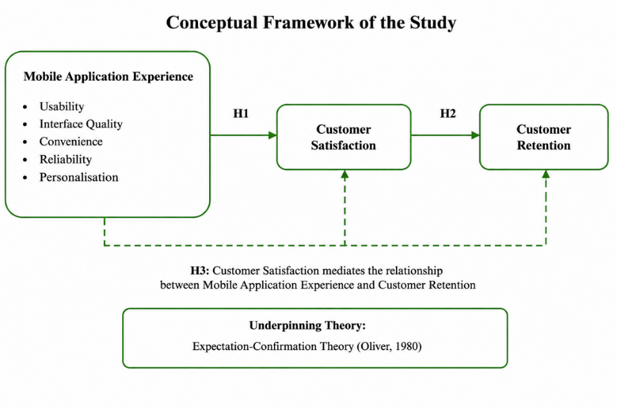
Figure 3: Conceptual Framework of the Study

Hypotheses
- H1: Mobile application experience has a positive and significant effect on customer satisfaction among users of food delivery applications in the UK.
- H2: Customer satisfaction has a positive and significant effect on customer retention among users of food delivery applications in the UK.
- H3: Customer satisfaction mediates the relationship between mobile application experience and customer retention among users of food delivery applications in the UK.

Conclusion
This chapter critically examined the literature pertaining to mobile application experience, customer satisfaction, and customer retention, and presented a theoretical and empirical relationship between the constructs. This review revealed a number of gaps that included the lack of a coherent analysis of the characteristics of individual applications, the lack of evidence from outside the UK and the lack of a combined analysis of customer satisfaction and customer retention. Expectation-Confirmation Theory was determined to be the most suitable theory to be used as a lens when explaining customer behaviour post adoption. The conceptual framework brings together these insights and is used to build the structure for the study. The methodology used to empirically test the proposed framework by using quantitative primary research in the UK food delivery sector is presented in the next chapter.

Chapter Three: Methodology

Introduction
This chapter outlines and rationalises methodological choices made in the analysis of how users' experiences of using mobile apps will affect customer satisfaction and customer retention in the UK food delivery sector. The methodological framework presented in this chapter is designed to enable the research aim, research objectives and the research questions explored in Chapter 1 to be answered by using the appropriate methodological approach for collecting and analysing the empirical evidence. It is a quantitative study with statistical analysis as it aims to explore measurable relationships between well-defined variables. Before summarizing the methodological choice to inform the empirical enquiry, the chapter addresses the research philosophy, research approach, research design, sampling strategy, data collection procedures, data analysis techniques, research quality and research ethics.

Research Philosophy, Approach and Research Design
Saunders, Lewis and Thornhill (2019) Research Onion (RO) was used to ensure methodological decisions aligned with the aims of a research project, as per philosophical assumptions, methodological choices and analytical techniques. The Research Onion is used to show how the different steps of the research process are interconnected and will be affected by each other. The current study employs a positivist philosophy, a deductive research approach and a quantitative cross-sectional research design to collectively facilitate the objective measurement of the relationships between mobile application experience, customer satisfaction, and customer retention as shown in Figure 4.

Research Philosophy
The research is framed in the positivist paradigm which considers that the social phenomena can be studied in an objective way through evidence that can be seen and measurable (Park, Konge and Artino, 2020). The aim of this study is not exploring the individual levels of meaning or the subjective interpretation but the examination of an objectively taken position, which is statistically whether the experience that the customer gains during the use of the mobile application increases Customer satisfaction and the retention of the customer. Using numerical data from a sufficiently large sample eliminates researcher bias and increases the reliability of findings as the results of hypotheses can be tested by using reflectiveness (Chirkov and Anderson, 2018). Ali (2024) also assert that positivism approach is specifically relevant when researcher is interested to explain an association between variables through quantitative analysis, which are determined explicitly in the research.

Research Approach
The deductive approach was used because the investigation is not exploratory but rather it uses a theory as the base. The research hypotheses are derived from the conceptual framework, represented by existing literature and Oliver (1980) Expectation-Confirmation Theory, along with several previous empirical studies. To investigate these theoretical relationships in the context of the UK food delivery industry therefore, data collection is undertaken. Where there are measurable variables and statistical testing involved, particularly in relation to existing theories that are explored in new contexts, deductive reasoning is appropriate (Casula, Rangarajan and Shields, 2021).

Research Design
This study adopted the quantitative cross-sectional survey design to collect data from many the users of food delivery apps at a single given time by using a structured questionnaire. In marketing and consumer behaviour studies, cross-sectional surveys are commonly used as the method of choice to effectively and consistently analyse the relationship between variables (Maier et al., 2023). The numerical values of the results can serve as alternative material for reliability test, correlation and regression modelling to be objective in carrying out the research objectives.
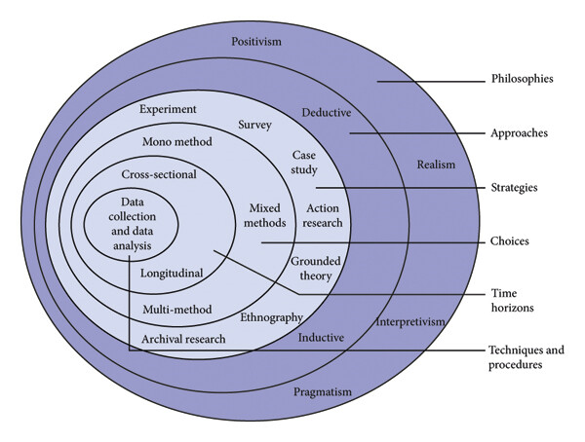
Figure 4: Research Onion (Saunders, Lewis and Thornhill, 2019).

Justification for Quantitative Research Methodology
The objectives of the research were to investigate from an empirical perspective if customer satisfaction and customer retention are an effect of the customer having mobile application experience and how strong this relationship is among mobile application consumers in the context of the UK food delivery sector. The achievement of the objectives needs numerical evidence, which can be analysed objectively, not in terms of individual experiences. Therefore, a quantitative methodology will be the most suitable foundation for the methodology. The standardisation of measurement helps to reduce the influence of the researcher in the measurement of the data, and to compare it in the same dimension among the respondents, while the respondents evaluate the same constructs under equivalent conditions (Schäfer, 2025).
Another important consideration is that the investigation is theory oriented. Based on some previous empirical research and the conceptual framework derived from Expectation-Confirmation Theory, measurable relationships between mobile application experience, customer satisfaction and customer retention are proposed. Testing these relationships requires statistical methods capable of assessing both the strength and direction of associations between variables. Quantitative methods also provide increased reliability due to the method of standardisation and allow objective testing of hypotheses using statistical evidence (Ghanad, 2023). Although qualitative methods could provide richer descriptions of individual customer experiences, they would not permit the statistical analysis required to test the proposed relationships and hypotheses (Tenny, Brannan and Brannan, 2022).

Sampling Strategy and Participant Selection
The target population included adults (18 years and over) with prior experience of using at least one of the food delivery mobile applications in the United Kingdom. Only participants with first-hand experience of platforms such as Deliveroo, Uber Eats or Just Eat were eligible to participate, as only through such first-hand experience can the potential of a mobile app experience and customer satisfaction and customer retention be judged (Kalimuthu, 2020). Those who had never used a food delivery application, or who lived outside of the United Kingdom were excluded, due to answers not being representative of the context explored within this research.
Given that there was no sampling frame readily available within the United Kingdom for all users of food delivery applications, it was decided to use a non-probability convenience sampling technique. Probability sampling generally increases the level of representativeness, but this is often impractical in studies of consumers, as a complete list of population members is seldom available (Zrineh, Al‐Usta and Alwawi, 2026). Convenience sampling enabled efficient data collection within the available time and resources while generating sufficient observations for the planned statistical analyses. A sample of 120 questionnaires were targeted to be sufficient for descriptive statistics, the determination of reliability, Pearson correlation and simple linear regression and PROCESS Model 4 mediation analysis. (Andersson, Boateng and Abos, 2024). This sample size provided a practical balance between analytical requirements and the resource constraints of a master’s-level study.

Data Collection Procedure
A structured online questionnaire was administered through Google Forms to collect primary data. Online administration was chosen as it ensured that the questions and the same question wording were given to each person, which is helpful to increase consistency when gathering the responses (Saunders, Lewis and Thornhill, 2019); also, to ensure an even spread of people across the United Kingdom, all of whom could answer the questions with ease. There were two parts to the questionnaire. The first collected demographic and behavioural information, including age, gender, food delivery application experience and RFM-informed indicators relating to ordering recency, frequency and spending. The second assessed the key research variables: mobile application experience, customer satisfaction and customer retention.
To enhance content validity, the measurement items were adapted from scales used in previous relevant studies in the literature to ensure consistency with previous empirical studies. The five-point Likert scale (Strongly Disagree (1) to Strongly Agree (5)) was used to record the responses, as five-point scales are widely recognized as the most effective means of recording attitudes and perceptions in behavioural studies (Koo and Yang, 2025). After the survey period, responses from the questionnaires were edited for completeness and directly downloaded from Google Forms into IBM SPSS Statistics and data prepared for descriptive and inferential statistical analysis.

Data Analysis Approach
Data analysis process was carried out step by step following the process ensuring that the research findings are accurate, reliable and correspond with the research objectives. Google Forms responses were initially exported to IBM SPSS Statistics in which the data set was explored for incomplete questionnaires, any duplicate answers and missing values were found and statistical analysis began. Then, the data was descriptively summarized to gain a general picture of the data distribution for every study variable, as well as respondents' demographic characteristics to enhance the overall data quality (Rahman and Muktadir, 2021). This step is to get understanding of the sample prior to exploring relationships between constructs.
The internal consistency of the measurement scales was then assessed by Cronbach's alpha, as reliable instruments are crucial for generating reliable statistical results (Taber, 2018). After reliability was determined, Pearson correlation analysis was carried out to explore associations between mobile-app experiences, customer satisfaction and customer retention (Huma et al., 2024). Lastly, the mobile app experience's impact on customer retention, about customer satisfaction, was measured by performing multiple regression analysis. This analytical sequence treats directly the research goals, from data preparation to the relation test, and at the last step, to the evaluation of hypotheses.

Research Quality and Rigour
To enhance the quality of the study and to develop confidence in the results several procedures have been built in. The measurement items were adapted from previously established measures identified in the relevant literature to support content validity and ensure alignment between the questionnaire items and the intended constructs. (Koo and Yang, 2025). Additionally, standardised administration of questionnaires helped minimise variation in measurements as all participants responded to the same questions under equal circumstances. Data was then screened for completeness of responses and possible sources of error that could impact results before the statistical analysis was performed. In order to evaluate the reliability of each scale of measurement, which was part of the assessment of internal consistency, Cronbach's alpha was used before the hypothesis testing process began (Taber, 2018). As a whole, these methods enhance the credibility, consistency and total robustness of the quantitative results.

Ethical Considerations
The study was completely voluntary, with informed consent obtained prior to the questionnaire. All information was de-identified to maintain participant anonymity and confidentiality during the entire research process. The electronic data were safe stored and utilized only for academic purposes before analysed with IBM SPSS Statistics. Data management was adhered to according to the General Data Protection Regulation (GDPR) and University research ethics requirements. To ensure academic integrity and prevent plagiarism, all published sources were properly cited.

Chapter Summary
This chapter has shown justification for the methodological choices of this study such as research design, sample, data collection techniques, data analysis and safeguarding ethical concerns. The next chapter displays the statistics results obtained from the questionnaire and also interprets the results with regard to the research objectives.

Chapter Four: Data Analysis and Results

Introduction
This chapter presents the empirical findings from the quantitative analysis of 120 responses collected from UK food delivery application users. It reports demographic and usage characteristics, reliability analysis, descriptive statistics, normality assessment and Pearson correlations. Inferential analysis is then undertaken using simple linear regression and PROCESS Model 4 mediation to test the three hypotheses concerning Mobile Application Experience, Customer Satisfaction and Customer Retention.

Demographic Analysis
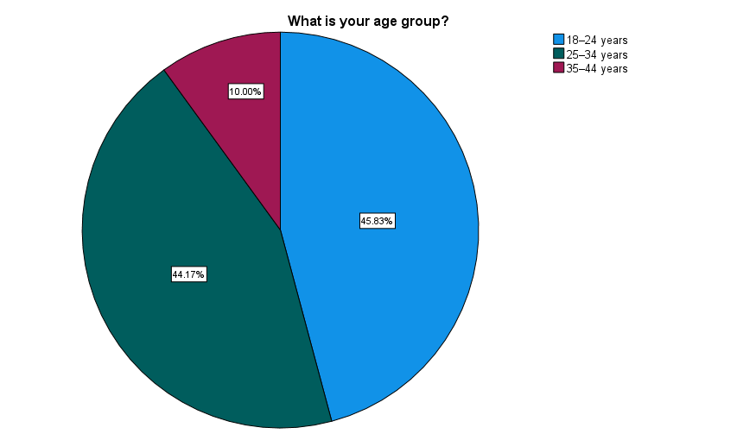
Figure 5: Age Distribution of Respondents
Figure 5 shows that 45.83% of respondents were aged 18–24, followed closely by 44.17% aged 25–34, while 10.00% were aged 35–44. Thus, the sample was strongly concentrated among younger respondents, with 90.00% falling within the 18–34 age range. All respondents were aged 18 or above, consistent with the eligibility criteria specified in Section 3.4.
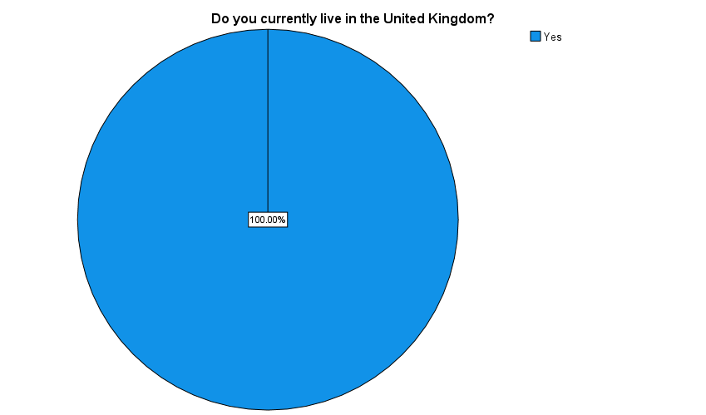
Figure 6: UK Residency of Respondents
As shown in figure 6, 100% of the 120 respondents currently lived in the United Kingdom. As a result, the sample meets the geographical requirement for research, as it is aimed at users in the UK food delivery sector. Not having non-UK respondents also means that subsequent analysis is based on the experiences within the geographical context set by the study.
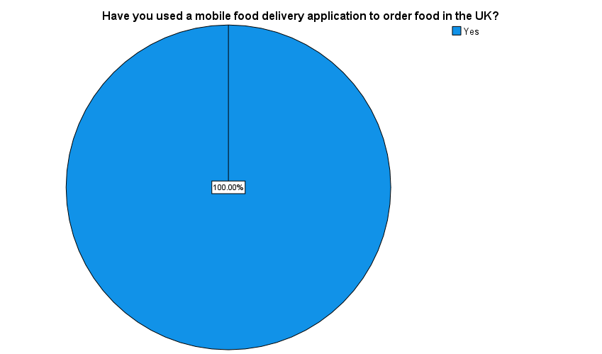
Figure 7: Previous Use of Food Delivery Applications in the UK
Figure 7 illustrates that all respondents said they had used a mobile food ordering app to order food in the UK. This was to ensure that the service context under study had experience with all participants. Therefore, the questions related to application experiences, satisfaction and retention were asked of people who have had first-hand experience with mobile food delivery apps in the UK.

Food Delivery Application Usage Analysis
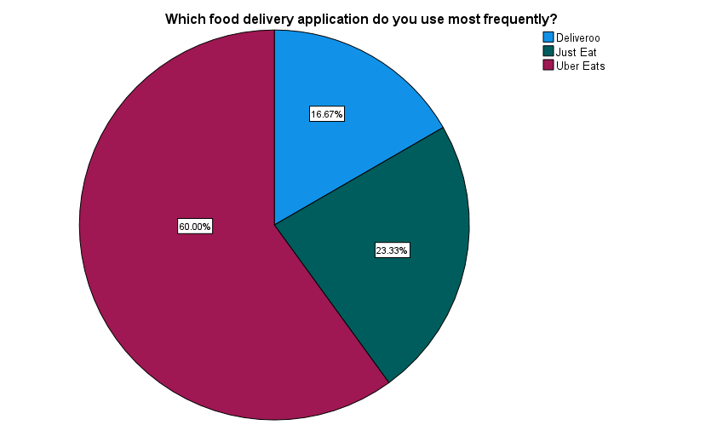
Figure 8: Most Frequently Used Food Delivery Application
Figure 8 indicates that Uber Eats was the most frequently used food delivery application, selected by 60.00% of respondents. This was followed by Just Eat at 23.33% and Deliveroo at 16.67%. The results therefore show that Uber Eats was the dominant food delivery application within the sample, although respondents also reported frequent use of Just Eat and Deliveroo.
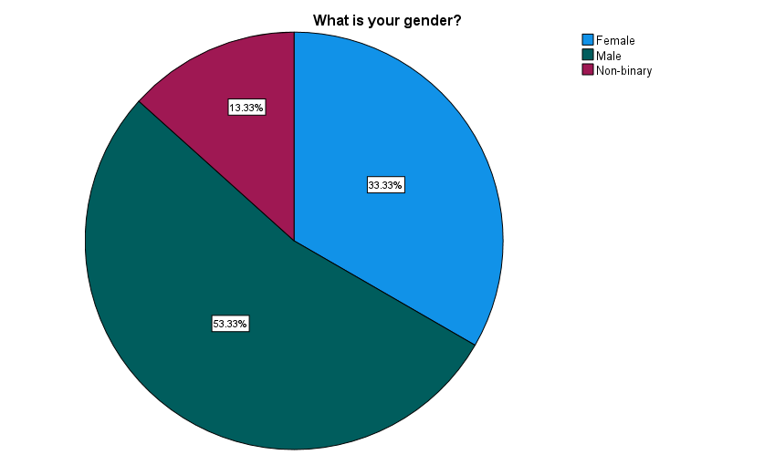
Figure 9: Gender Distribution of Respondents
Figure 9 indicates that 53.33% of respondents were male, making this the largest gender group. Female respondents represented 33.33%, while 13.33% identified as non-binary. The sample therefore included respondents from different gender groups, although males constituted slightly more than half of participants. This demographic information provides useful context for interpreting the overall study findings.
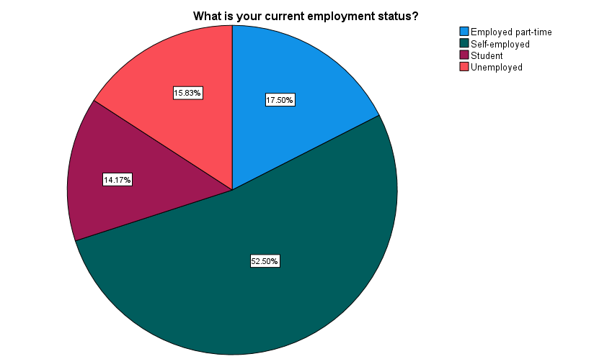
Figure 10: Employment Status of Respondents
The highest employment group was self-employment (52.50%) as illustrated in Figure 10. There were 17.50% who were working part-time, 15.83% were unemployed and 14.17% were students. The figures show that there was some variation in the employment situation of those participating, but that the majority were self-employed. This gives background on the food delivery app user's socio-economic profile that were interviewed.
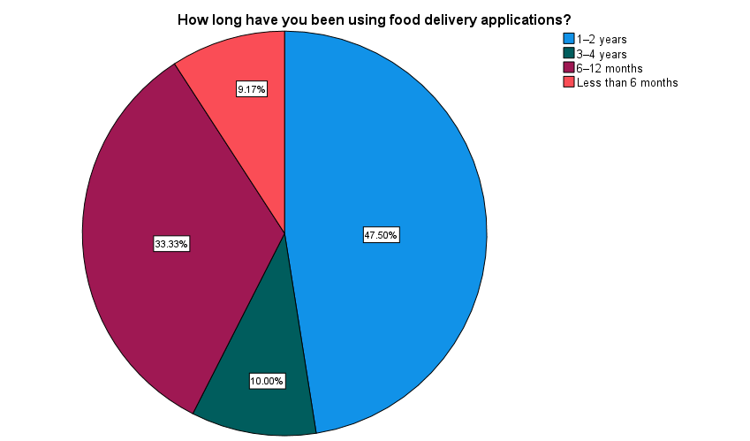
Figure 11: Length of Food Delivery Application Usage
Figure 11 shows that 47.50% of the respondents had been using food delivery apps for 1-2 years and 33.33% used them for 6-12 months. Another 10.00% had been using them for 3 - 4 years, and 9.17% for less than 6 months. On an overall basis, most respondents had adequate pre-experience with mobile applications to assess their experiences with these applications.

RFM-Informed Behavioural Analysis
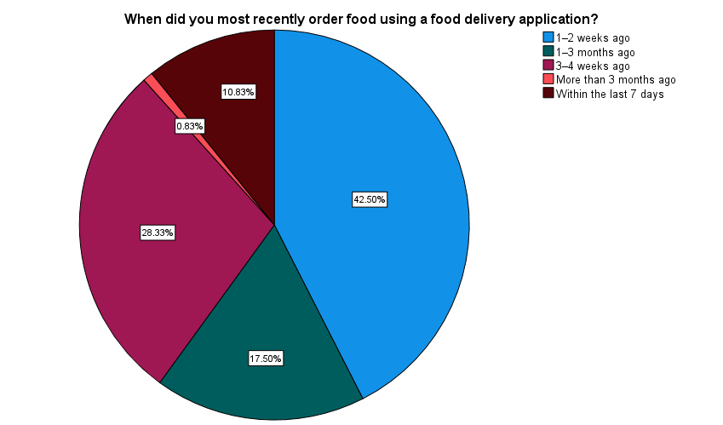
Figure 12: Recency of Food Delivery Application Usage
Figure 12 presents the Recency dimension. The largest proportion (42.50%) had ordered 1–2 weeks ago, followed by 28.33% at 3–4 weeks ago and 17.50% at 1–3 months ago. 10.83% had ordered within the last seven days, whereas only 0.83% reported more than three months ago, indicating generally recent application usage.
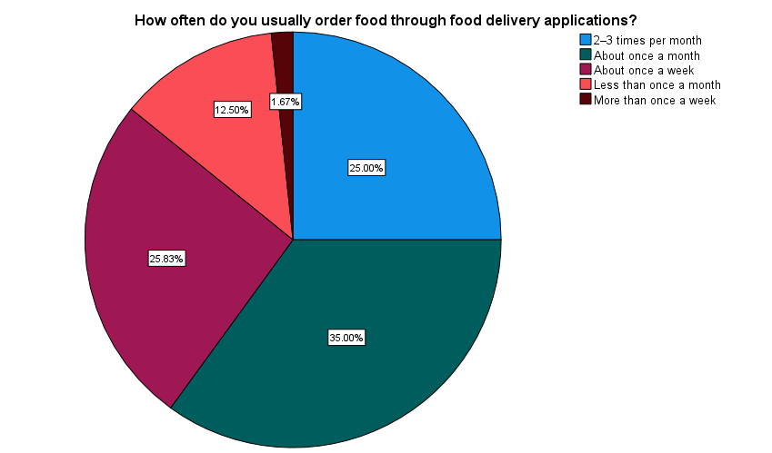
Figure 13: Frequency of Food Delivery Application Usage
The Frequency dimension is shown in Figure 13. About one-third of respondents (35.00%) ordered food once a month, about 1/4 of the respondents (25.83%) ordered food 2–3 times per month and 25.00% ordered food once a week. Some 12.50% ordered less than once a month, while 1.67% ordered more than once a week, showing different ordering frequencies.
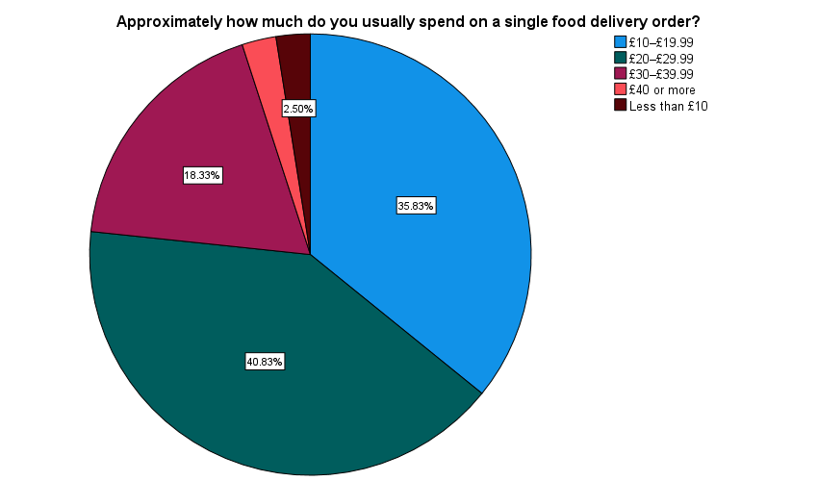
Figure 14: Monetary Spending per Food Delivery Order
Figure 14 presents the Monetary dimension. The largest group (40.83%) usually spent £20–£29.99 per order, followed by 35.83% spending £10–£19.99. 18.33% spent £30–£39.99, while the remaining respondents were distributed between £40 or more and less than £10, with the figure showing 2.50% for the latter category.

Reliability Analysis
Table 1: Reliability Analysis – Usability

Table 2: Reliability Analysis – Interface Quality

Table 3: Reliability Analysis – Convenience

Table 4: Reliability Analysis – Application Reliability

Table 5: Reliability Analysis – Personalisation

Table 6: Reliability Analysis – Overall Mobile Application Experience
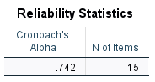
Table 7: Reliability Analysis – Customer Satisfaction

Table 8: Reliability Analysis – Customer Retention

The reliability analysis indicated acceptable internal consistency across all study constructs. Cronbach’s alpha values were .710 for Usability, .706 for Interface Quality, .730 for Convenience, .713 for Application Reliability and .701 for Personalisation. The overall Mobile Application Experience scale achieved .742, while Customer Satisfaction and Customer Retention achieved .749 and .755, respectively. All values exceeded .70. However, Cronbach’s alpha assesses internal consistency rather than construct validity; therefore, construct validity was examined separately using Exploratory Factor Analysis, as reported in Section 4.4.

Construct Validity: Exploratory Factor Analysis
Exploratory Factor Analysis (EFA) was conducted using Principal Axis Factoring with Direct Oblimin rotation to assess construct validity. The value for the KMO was .622, which is adequate for sampling. Bartlett's Test of Sphericity was significant, χ²(351) = 1523.475, p < .001, thus confirming that the data was suitable for factorization. Initially 9 factors were identified having eigenvalues greater than 1, accounting for 59.487% of the cumulative variance after factor extraction. Communalities for items were not uniform, with some greater than .40, but some were less, such as .265 for the overall-quality satisfaction item. The Pattern Matrix revealed high loadings on several factors suggesting a multidimensional structure with some cross-loading. Overall, the EFA provides exploratory evidence of construct structure, but the results should be interpreted cautiously. Full EFA outputs, including communalities, variance explained, scree plot and Pattern Matrix, are provided in the Appendix.

Descriptive Statistics
Table 9: Descriptive Statistics

The descriptive results showed that all three constructs contained 120 valid observations. Mobile Application Experience recorded the highest mean (M = 2.8644, SD = .81526), ranging from 1.00 to 5.00. Customer Satisfaction had a mean of 2.8319 (SD = 1.07612), ranging from 1.33 to 5.00, while Customer Retention recorded M = 2.8056 (SD = 1.03246), ranging from 1.17 to 5.00. Overall, average scores remained slightly below the scale midpoint of 3.

Normality and Regression Assumption Testing
Table 10: Tests of Normality
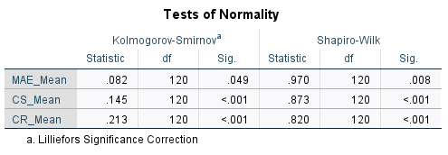
The normality tests showed that the tests were statistically significant from the normal distribution. Shapiro–Wilk results were significant for MAE_Mean (W = .970, p = .008), CS_Mean (W = .873, p < .001), and CR_Mean (W = .820, p < .001). Kolmogorov–Smirnov tests were also statistically important for all three of the variables. Hence, it was not a strong assumption to assume that the distribution is strictly univariate normal.
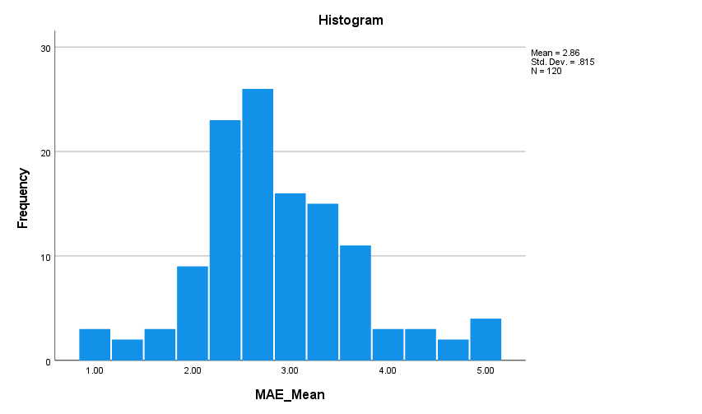
Figure 15: Histogram of Mobile Application Experience
The MAE histogram is grouped with the middle of the scale and has M = 2.86 and SD = .815 (N = 120). The responses are clustered around 2-4 but some observations are at the extremes. The distribution is therefore somewhat skewed from the normal bell-shaped distribution.
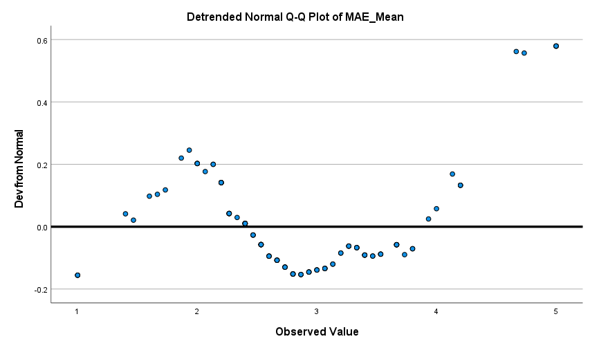
Figure 16: Detrended Normal Q-Q Plot of Mobile Application Experience
The detrended Q-Q plot of the MAE_Mean does not reveal random variation and close approximation to the zero-reference line in the observations. Systematic deviations are more obvious in the upper end of the distribution. This is consistent with the large Shapiro–Wilk result and gives further proof that the distribution of Mobile Application Experience is not exactly normal distribution.
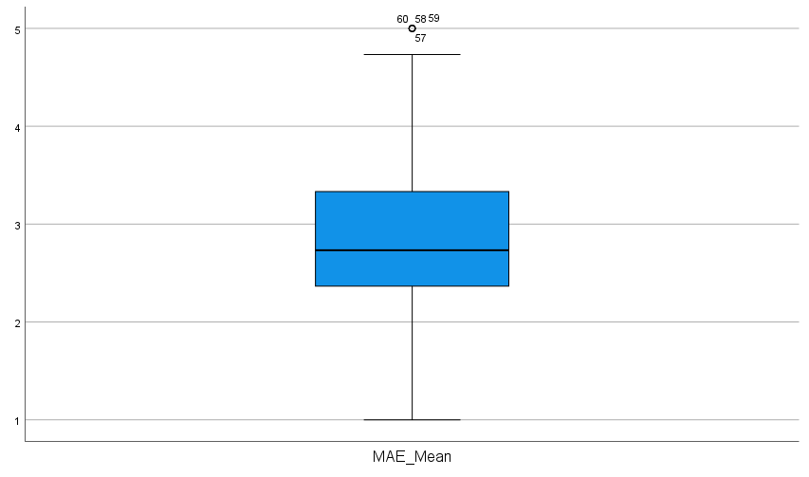
Figure 17: Boxplot of Mobile Application Experience
The majority of observations are clustered at the center of the measurement scale, as indicated by the median of the MAE_Mean boxplot (around 2.7–2.8). There are several observations that are potential upper outliers around the value of 5.00. However, most responses lie within the “whiskers” suggesting the absence of extreme observations.
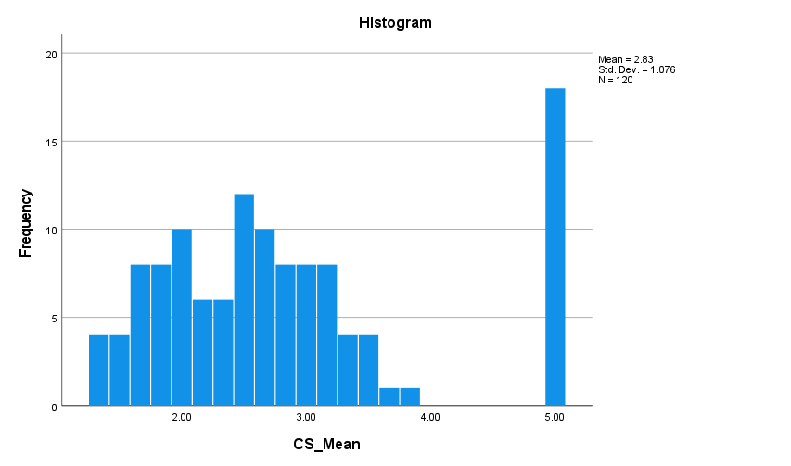
Figure 18: Histogram of Customer Satisfaction
The Customer Satisfaction histogram shows M = 2.83, SD = 1.076 and N = 120. The majority of observations are in the band 1.5 – 4.0 and there is a significant grouping of observations at the highest score of 5.00. This clustering results in an obvious deviation from the bell-shaped curve that is shown by the significant formal normality test.
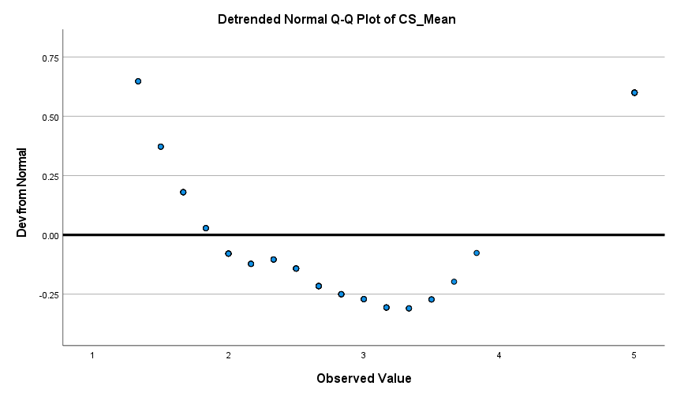
Figure 19: Detrended Normal Q-Q Plot of Customer Satisfaction
The plot of Q-Qs for CS_Mean shows systematic deviations from the zero reference line, especially at the lower and upper tail of the distribution. The pattern shows that observations are not close to the values that are expected when assuming normality. The Shapiro–Wilk result (W = .873, p < .001) is supported by this visual evidence, which shows a lack of normality.
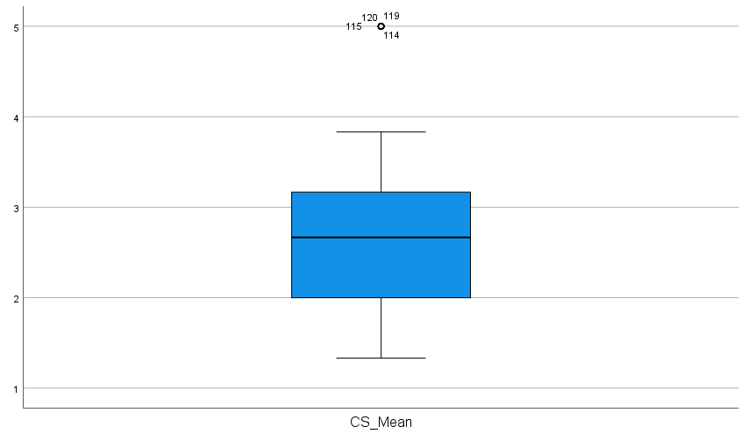
Figure 20: Boxplot of Customer Satisfaction
The Customer Satisfaction boxplot shows a median of approximately 2.7, with the central 50% of observations concentrated broadly between 2.0 and 3.2. Several cases at the maximum score of 5.00 are identified as potential upper outliers. This concentration of maximum scores helps explain the departure from normality identified by the formal and graphical assessments.
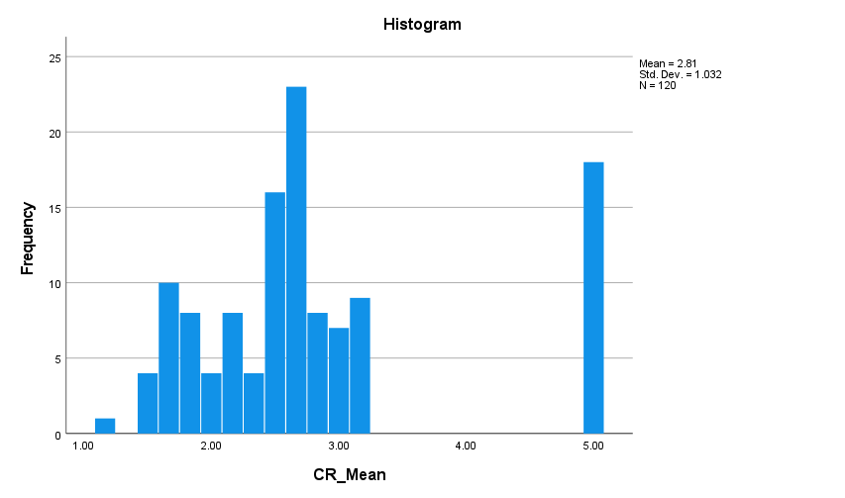
Figure 21: Histogram of Customer Retention
The Customer Retention histogram reports M = 2.81, SD = 1.032 and N = 120. The responses are largely clustered between about 1.5 and 3.3, with a significant proportion at the highest score of 5.00. As a result, the distribution does not show a typical bell-shape, justifying the Shapiro–Wilk normality result.
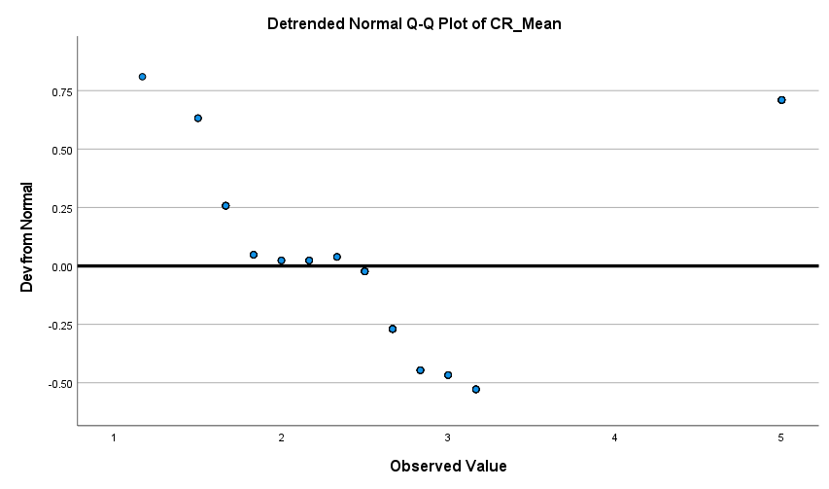
Figure 22: Detrended Normal Q-Q Plot of Customer Retention
In the case of CR_Mean the detrended Q-Q plot exhibits significant systematic deviations from the zero line, especially at the lower, middle and upper ends of the distribution. These deviations show that Customer Retention is not very close to a normal distribution. This is a consistent finding graphically as indicated by a significant Shapiro–Wilk test (W = .820, p < .001).
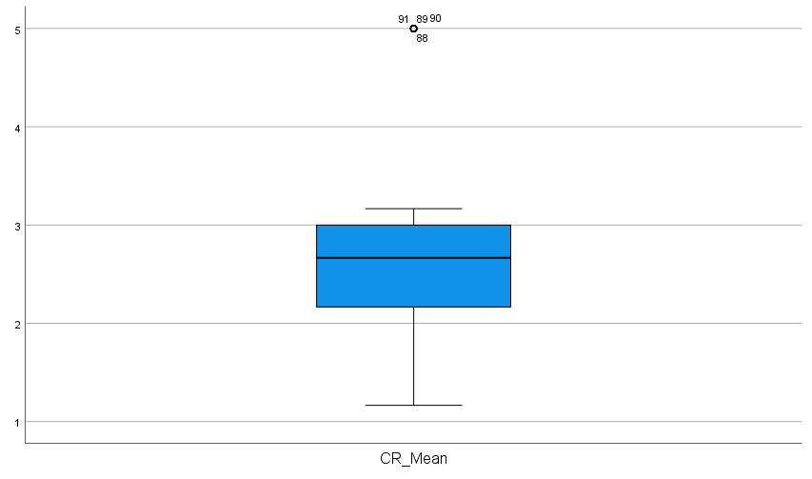
Figure 23: Boxplot of Customer Retention
The Customer Retention boxplot indicates a median of approximately 2.7, with most observations concentrated between approximately 2.2 and 3.0. Several observations at 5.00 appear as potential upper outliers. The remaining observations are relatively concentrated within the whiskers, while the upper extreme cases correspond with the non-normal distribution observed in the histogram and Q-Q plot.

Regression Residual Diagnostics
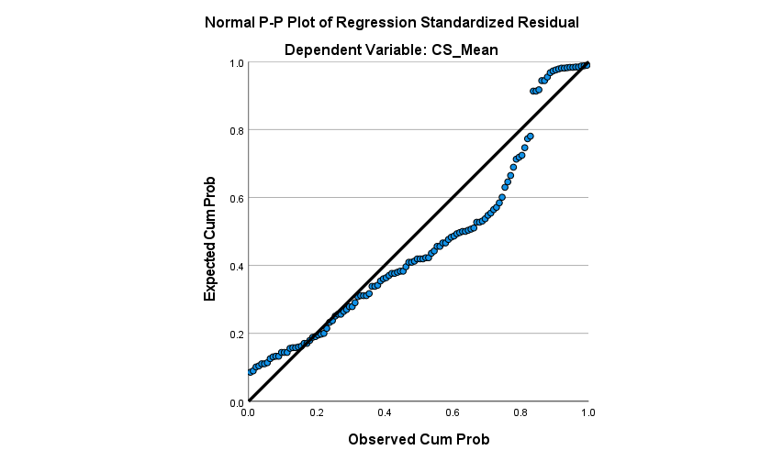
Figure 24: Normal P–P Plot of Regression Standardized Residuals for Customer Satisfaction
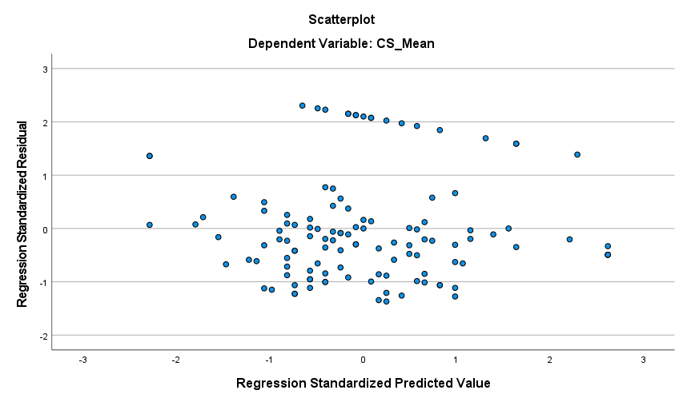
Figure 25: Standardized Residuals versus Standardized Predicted Values for Customer Satisfaction
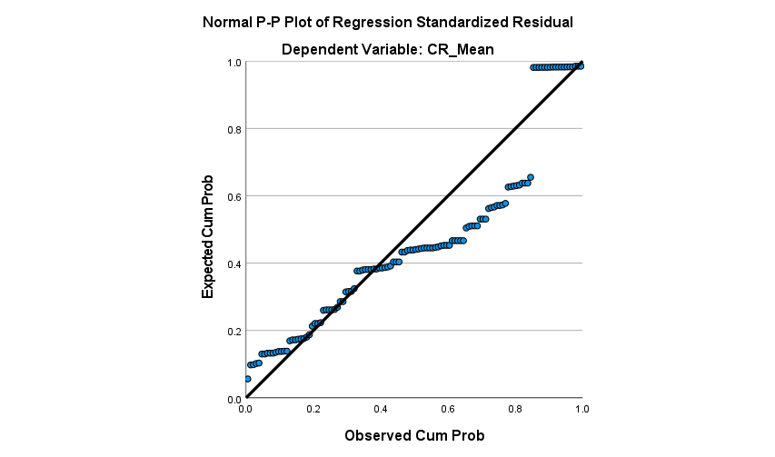
Figure 26: Normal P–P Plot of Regression Standardized Residuals for Customer Retention
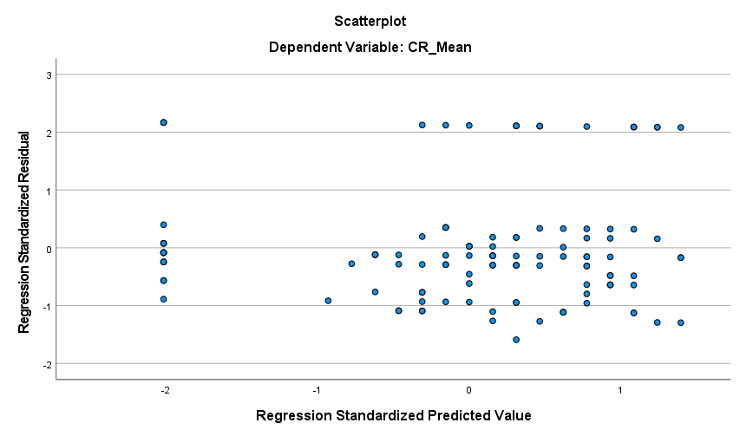
Figure 27: Standardized Residuals versus Standardized Predicted Values for Customer Retention
Regression assumptions were assessed using P–P plots and standardized residual-versus-predicted plots. Some departures from residual normality and clustering were observed, although no clear funnel pattern or extreme residuals exceeding ±3 appeared. Therefore, linearity and homoscedasticity were considered approximately satisfied, but regression results were interpreted cautiously. Bootstrapping supported the mediation analysis.

Pearson Correlation Analysis
Table 11: Pearson Correlation Analysis
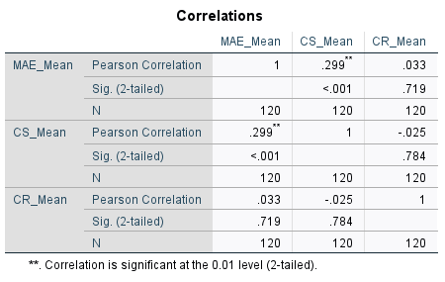
The results of Pearson correlation analysis indicated that there was a positive and statistically significant correlation between the Mobile Application Experience and Customer Satisfaction (r = .299, p < .001, N = 120), suggesting that the higher the Mobile Application Experience the higher the satisfaction level. Mobile Application Experience, on the other hand, showed a very low positive non-significant correlation with Customer Retention (r = .033, p = .719). There was also a very weak and non-significant negative correlation between Customer Satisfaction and Customer Retention (r = −.025, p = .784). Therefore, statistically significant relationship was found between Mobile Application Experience and Customer Satisfaction.

Simple Linear Regression

H1: Mobile Application Experience has a positive and significant effect on Customer Satisfaction.
Table 12: Model Summary
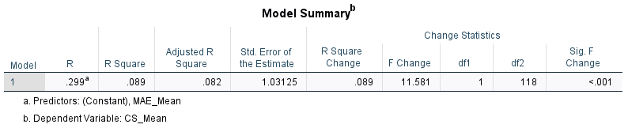
The H1 regression model produced R = .299, R² = .089 and adjusted R² = .082. This indicates that Mobile Application Experience explained approximately 8.9% of the variance in Customer Satisfaction. The standard error of the estimate was 1.03125, showing that the model had modest explanatory power for variations in satisfaction.
Table 13: ANOVA
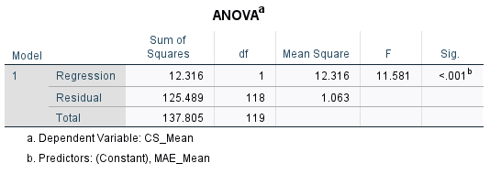
The ANOVA results showed that the H1 regression model was statistically significant (F(1,118) = 11.581, p < .001). Based on this, the overall regression relationship was considered to be statistically meaningful within the sample of 120 respondents, with the prediction of Customer Satisfaction also being improved significantly by the use of Mobile Application Experience as the predictor.
Table 14: Regression Coefficients
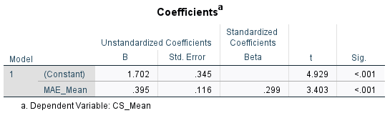
Mobile Application Experience had a positive and statistically significant impact on Customer Satisfaction (B = .395, SE = .116, β = .299, t = 3.403, p < .001). Thus, Customer Satisfaction increased with the increases in Mobile Application Experience. The findings, therefore, are statistically good support for H1 and support the hypothesis.

H2: Customer Satisfaction has a positive and significant effect on Customer Retention.
Table 15: Model Summary
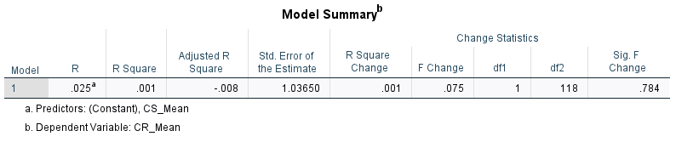
The H2 regression produced R = .025, R² = .001 and adjusted R² = −.008, indicating that Customer Satisfaction explained only approximately 0.1% of the variance in Customer Retention. The standard error of estimate was 1.03650. Thus, Customer Satisfaction provided virtually no explanatory power for Customer Retention within the analysed sample.
Table 16: ANOVA
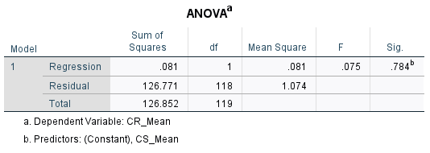
An ANOVA revealed that the H2 regression model was not significant, F(1,118) = .075, p = .784. Thus, there was no significant relationship between Customer Satisfaction and Customer Retention. The model did not offer evidence that satisfaction’s variations were systematically related to variations in the respondents' intentions to continue using their food delivery application.
Table 17: Regression Coefficients
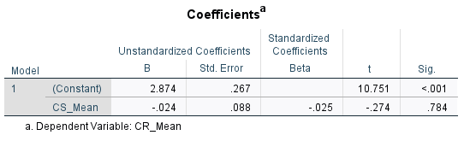
Customer Satisfaction had a very small negative and statistically non-significant effect on Customer Retention (B = −.024, SE = .088, β = −.025, t = −.274, p = .784). The direction also contradicts the hypothesised positive relationship. Therefore, the findings provide no statistical support for H2, and the hypothesis is not supported.

Mediation Analysis

H3: Customer Satisfaction mediates the relationship between Mobile Application Experience and Customer Retention.
Table 18: PROCESS Model 4 – Effect of Mobile Application Experience on Customer Satisfaction
Outcome Variable | Predictor | R | R² | MSE | F | df1 | df2 | p
Customer Satisfaction (CS_Mean) | Mobile Application Experience (MAE_Mean) | .2990 | .0894 | 1.0635 | 11.5810 | 1 | 118 | .0009
Table 19: Regression Coefficients for Customer Satisfaction
Predictor | B | SE | t | p | LLCI | ULCI
Constant | 1.7016 | .3452 | 4.9289 | <.001 | 1.0180 | 2.3853
Mobile Application Experience (MAE_Mean) | .3946 | .1160 | 3.4031 | .0009 | .1650 | .6242
Table 20: PROCESS Model 4 – Effects on Customer Retention
Outcome Variable | Predictors | R | R² | MSE | F | df1 | df2 | p
Customer Retention (CR_Mean) | MAE_Mean, CS_Mean | .0496 | .0025 | 1.0815 | .1443 | 2 | 117 | .8658
Table 21: Regression Coefficients for Customer Retention
Predictor | B | SE | t | p | LLCI | ULCI
Constant | 2.7482 | .3823 | 7.1882 | <.001 | 1.9910 | 3.5053
Mobile Application Experience (MAE_Mean) | .0567 | .1225 | .4625 | .6446 | −.1860 | .2994
Customer Satisfaction (CS_Mean) | −.0371 | .0928 | −.3992 | .6905 | −.2209 | .1468
Table 22: Direct Effect of Mobile Application Experience on Customer Retention
Effect | SE | t | p | LLCI | ULCI
.0567 | .1225 | .4625 | .6446 | −.1860 | .2994
Table 23: Indirect Effect of Mobile Application Experience on Customer Retention Through Customer Satisfaction
Mediator | Indirect Effect | BootSE | BootLLCI | BootULCI
Customer Satisfaction (CS_Mean) | −.0146 | .0396 | −.0959 | .0656
The mediation analysis was conducted using Hayes’ PROCESS v5.0, Model 4, with 5000 bootstrap samples and 95% bootstrap confidence intervals. Mobile Application Experience significantly predicted Customer Satisfaction (B = .3946, SE = .1160, p = .0009). The indirect effect on Customer Retention through Customer Satisfaction was −.0146 (BootSE = .0396), with a 95% bootstrap confidence interval of [−.0959, .0656]. As the interval included zero, the indirect effect was not statistically significant; therefore, H3 was not supported. The direct effect was also non-significant (B = .0567, p = .6446).

Chapter Summary
This chapter presented the statistical findings and tested all three research hypotheses. Mobile Application Experience significantly and positively predicted Customer Satisfaction, supporting H1. However, Customer Satisfaction did not significantly predict Customer Retention; therefore, H2 was not supported. PROCESS Model 4 further showed that the indirect effect of Mobile Application Experience on Customer Retention through Customer Satisfaction was non-significant, meaning H3 was not supported. Overall, only H1 received empirical support.

Chapter Five: Discussion and Analysis

Purpose and Positioning
This chapter critically interprets the empirical findings presented in Chapter 4 through the theoretical constructs and empirical evidence reviewed in Chapter 2. The results of the statistics are not repeated but discussed in terms of their implications and implications for the existing knowledge about mobile application experience, customer satisfaction and customer retention. Special emphasis is placed on “Expectation-Confirmation Theory” (ECT) and the hypothesized intervening construct of customer satisfaction. The analysis is made by synthesizing results from all objects of the study and the hypotheses, which aims to find out the areas of convergence and divergence with previous studies, then to be theoretically explained.

Analytical Framework and Logic
The analysis is structured around the study’s conceptual model, which is grounded in Expectation-Confirmation Theory (ECT) (Oliver, 1980; Bhattacherjee, 2001). The theoretical perspective utilized by ECT to analyse the evaluation of a customer's experience with their mobile application and how it affects their satisfaction and retention is examined. Three constructs are included in the model: mobile application experience(MAE) which is incorporated by usability, interface quality, convenience, reliability, and personalisation; customer satisfaction; and customer retention, where customer satisfaction is assumed to be a potential mediating variable. The discussion is organized around the construct- and hypothesis-based structure, starting out with the relationship between application experience and satisfaction, satisfaction and retention, and finally the proposed mediation effect. Every finding is critically contrasted with previous empirical findings and is explained in terms of ECT.

Cross-Case Synthesis: Compare and Contrast with Literature

Mobile Application Experience and Customer Satisfaction
The first theme concerns whether the overall mobile application experience contributes to customer satisfaction. Chapter 2 established that usability, interface quality, convenience, reliability and personalisation collectively shape customers’ evaluations of digital services. The previous studies mostly found positive relationships between usability, information quality, responsiveness and simplicity of the interface with satisfaction (Maha and Rahardja, 2025; Chandra et al., 2025). From a functional perspective, usability is also a key factor that will affect the customer's satisfaction, while from an experiential perspective, other elements such as visual appeal, interactivity and emotional aspects will also play a role in the satisfaction of the customer (Ugwuegbu et al., 2026; Lim et al., 2026; Urdea, Constantin and Purcaru, 2021). However, the literature also suggests that while individual technologies can make a difference to customer evaluations, personalisation can also raise issues of transparency, privacy and control.
The results of the present study are very consistent with the prevailing literature. The relationship between Mobile Application Experience and Customer Satisfaction was positively correlated (r = .299, p < .001), and regression analysis showed that there was a significant positive effect (B = .395, β = .299, p < .001). This accounted for 8.9% of the variance in satisfaction and H1 was supported. This is consistent with the findings of ECT as positive evaluations of actual application experiences should result in higher satisfaction if the service is delivered as, or better than, users expected (Oliver, 1980; Bhattacherjee, 2001). However, the modest R² indicates that application experience is only one component of satisfaction. Other application experience factors not measured here, which may contain the quality of food, delivery, and pricing/customer support, can also influence customers' general evaluations. The fine-tuned insight is that a good application experience across multiple dimensions significantly influences satisfaction, but it does not account for most of the variance in satisfaction.

Customer Satisfaction and Customer Retention
The second theme produces a more substantial divergence from existing literature. ECT and previous empirical research generally position satisfaction as an important antecedent of continuance behaviour. According to Oliver (1980), positive post-consumption evaluations foster positive behavioural intentions, and Bhattacherjee (2001) found satisfaction to be the key factor in information-system continuance. Studies on food delivery also link satisfaction to ongoing usage of the application (Vu and Khuc, 2025; Cunha et al., 2026). But Chapter 2 also highlighted other explanations for retention, which indicates that convenience, reliability, trust, emotional involvement, competitive offers and service consistency can also lead to retention, without satisfaction.
The empirical evidence corroborates this more conservative reading. Customer Satisfaction was almost not correlated with Customer Retention (r = −.025, p = .784) and was very weak negative. No significant regression was detected (B = −.024, β = −.025, p = .784) and satisfaction accounted for only about 0.1% of the variance in retention. H2 was not supported, therefore. It is not to suggest that being satisfied with an application is unimportant in general; in this UK sample, it was not enough to account for intentions to stay with an application. The discovery could reflect the competitive landscape of food-sharing apps, in which users are able to use two apps even if they're happy with one. It also fits the literature that highlights trust, reliability, convenience and alternatives as other factors influencing retention. The interim conclusion is that satisfaction should not be treated as an automatic proxy for retention in the UK food-delivery context.

Customer Satisfaction as a Mediating Mechanism
The third theme concerns the central theoretical mechanism proposed by the conceptual framework. As suggested in Chapter 2, satisfaction is considered an intervening mechanism, which implies that users assess their experience, derive satisfaction from the assessment, and generate continuance intention from the satisfaction. Urdea, Constantin and Purcaru (2021) believe that customer experience is linked to customer satisfaction and future relationships, while Zariman, Humaidi and Abd Rashid (2022) noted that customer satisfaction serves as a mediation between the quality of mobile-commerce service and customer loyalty intention. Thus, this study proposed a mediating model between the mobile application experience and mobile application retention, which is satisfaction.
The results only corroborate the first step in this mechanism. The results of PROCESS Model 4 indicated that the size of the beta for Mobile Application Experience was significant in predicting Customer Satisfaction (B = .3946, p = .0009). But in the full mediation model neither satisfaction nor Mobile Application Experience significantly influenced retention. The most important effect was through satisfaction, which was −.0146 (95% BS CI: [−.0959, .0656]). Since this interval contained 0, H3 was not supported.
This is a key aspect of the original ECT framework. The results were consistent with ECT's hypotheses that positive post-adoption experiences are correlated with satisfaction and that satisfaction does not necessarily lead to retention. While the evidence suggests that ECT cannot be completely removed from the food delivery platform context, it does suggest that there may be a boundary condition in its implementation for platforms in the UK: continuance intentions might need one more mechanism other than satisfaction. Trust, switching behaviour, competitive alternatives, service reliability and perceived value are plausible explanations identified in Chapter 2, although they were not tested in the present model and therefore cannot be confirmed by these data.

Overall Theoretical and Contextual Synthesis
Overall, the findings provide partial support for the conceptual framework, with H1 supported but H2 and H3 unsupported. The findings reveal that the experience of mobile application has a significant impact on customers' satisfaction, but they also suggest that the satisfaction is not a predictor nor a mediator of customer retention. This suggests that ECT explains customer satisfaction more effectively than continued-use behaviour within the UK food-delivery context. Users may value usability, interface quality, convenience, reliability and personalisation without necessarily remaining committed to a single platform. Therefore, the translation of satisfaction into retention may depend on additional factors such as trust, perceived value, service reliability and competitive alternatives.

Integration to Conceptual Model or Propositions
The findings provide partial support for the ECT-informed conceptual model developed in Chapter 2. H1 was supported, as Mobile Application Experience had a significant positive relationship with Customer Satisfaction. However, H2 was not accepted because Customer Satisfaction did not have a significant influence on Customer Retention; H3 was rejected because the relationship between Mobile Application Experience and Customer Retention mediated by Customer Satisfaction was not significant. Therefore, it is necessary to improve the original conceptual model. The results demonstrated a significant relationship between Mobile Application Experience and Customer Satisfaction; however, no significant relationship was established between Customer Satisfaction and Customer Retention. There may be other factors that influence Customer Retention, including Trust, Service Reliability, perceived Value and competing alternatives, but these were not tested in this study. The overall results indicate that ECT is a better predictor of customer satisfaction than is customer retention in the UK food delivery market.

Robustness Considerations
Several considerations qualify the findings. Customer retention may depend on factors beyond satisfaction, including trust, convenience, service reliability, emotional engagement and competing alternatives. The non-significance of the satisfaction–retention relationship might be attributed to their exclusion from the model but cannot be substantiated with this study. This study has relied on self-reported, cross sectional questionnaire data from 120 food delivery app users in the UK and cannot infer causality and/or temporality due to the risk of response bias. Furthermore, normality tests revealed that three key constructs were not normally distributed. Nevertheless, confidence in the findings is strengthened by consistency across analytical techniques. The positive relationship between Mobile Application Experience and Customer Satisfaction remained significant across correlation and regression analyses, whereas the satisfaction–retention relationship remained non-significant across correlation, regression and PROCESS mediation analysis. The results therefore show analytical consistency but are not necessarily generalisable beyond them.

Practical Synthesis: Bridge to Chapter 6
The findings generate several practice-ready implications for UK food-delivery platforms. First, managers should prioritise the overall mobile application experience because improvements in usability, interface quality, convenience, reliability and personalisation are associated with greater customer satisfaction. Second, satisfaction should not be treated as sufficient evidence of retention, since it explained virtually none of the variation in retention within this sample. Third, retention strategies should therefore extend beyond application design and examine measurable factors such as trust, service reliability, perceived value and switching behaviour. Finally, managers should monitor satisfaction and retention separately rather than assuming that improvements in satisfaction automatically generate continued use. These findings provide the empirical foundation for the managerial implications and recommendations developed in Chapter 6.

Chapter Summary
This chapter critically interpreted the findings through ECT and the previous literature. The significant relationship between Mobile Application Experience and Customer Satisfaction supported H1, whereas H2 and the proposed mediation in H3 were unsupported. The results thus partially corroborate the conceptual model, indicating that the model of ECT provides a better explanation of satisfaction than retention. The resulting theoretical and managerial implications are developed in Chapter 6.

Chapter Six: Conclusion

Introduction
This chapter concludes the study by synthesising the key findings and presenting their theoretical and managerial implications, limitations and directions for future research. The study examined how mobile application experience influences customer satisfaction and retention among UK food-delivery-app users through a primary quantitative survey, with the findings statistically analysed and critically interpreted in Chapters 4 and 5.

Brief Summary of Key Findings
The findings provide partial support for the proposed conceptual model. Mobile Application Experience significantly and positively predicted Customer Satisfaction, supporting H1 and corroborating literature linking positive digital experiences with favourable customer evaluations. However, Customer Satisfaction did not significantly predict Customer Retention; therefore, H2 was unsupported. Satisfaction also failed to mediate the relationship between Mobile Application Experience and Customer Retention, resulting in rejection of H3. These results qualify the conventional ECT expectation that satisfaction contributes to continuance behaviour. Overall, the results suggest that enhancing usability, interface quality, convenience, and reliability and personalisation can have a positive impact on satisfaction, but satisfaction cannot be considered enough to ensure retention. Other factors that can impact continued use include trust, perceived value, service reliability and competitive alternatives.

Theoretical Implications

Contribution 1: Implications for Expectation-Confirmation Theory
The main theoretical implication is the provision of context-specific evidence relevant to an ECT-informed framework in the UK food-delivery-app context. According to ECT, post-adoption evaluations influence satisfaction, which in turn is expected to promote continuance behaviour (Oliver, 1980; Bhattacherjee, 2001). The significant positive relationship between Mobile Application Experience and Customer Satisfaction supports the first stage of this theoretical reasoning and is consistent with the findings of studies that found there was a correlation between positive digital experience and satisfaction (Maha and Rahardja, 2025; Chandra et al., 2025). However, the satisfaction–retention relationship was non-significant, qualifying ECT by demonstrating that satisfaction does not necessarily translate into retention within highly competitive platform markets.

Contribution 2: Boundary Conditions and Contingencies
The findings indicate that the satisfaction–retention relationship may not be universal. Chapter 2 also found that trust, convenience, service reliability, emotional engagement and competing alternatives were other influences on retention (Khuc and Vu, 2025; Ahmad, Ghani and Hamid, 2025). With consumers easily able to switch to other food-delivery apps, satisfaction with one app may not be enough to foster repeated use. These factors were not tested as moderators in the present study and should therefore be regarded as potential boundary conditions for future investigation.

Contribution 3: Mechanism and Construct Insights
The study also contributes by conceptualising Mobile Application Experience as an integrated construct comprising usability, interface quality, convenience, reliability and personalisation, rather than examining isolated application features. The findings demonstrate that this broader experience significantly contributes to satisfaction, but satisfaction does not provide the expected mechanism through which experience generates retention.

Contribution 4: Refinement of the Conceptual Model
Consequently, the original conceptual model requires refinement. The proposed satisfaction–retention and satisfaction–mediation relationships are unsupported while the relationship between Mobile Application Experience and Customer Satisfaction is empirically supported. In addition to pathways that are already tested as established pathways, the refined interpretation introduces trust, perceived value, reliability, and competitive alternatives as potential future explanatory variables. Generally speaking, the theoretical implications are most relevant in digitally mature, competitive, platform-service settings, such as the food-delivery industry in the UK; caution should be exercised when attempting to generalise to other settings.

Managerial Implications
The findings offer several practical implications for UK food-delivery platform managers. First, managers should prioritise usability, interface quality, convenience, reliability and personalisation, as the study found that overall mobile application experience significantly improves customer satisfaction. This supports investment in intuitive navigation, accurate information, stable payment processes and relevant recommendations. Second, managers should not assume that satisfied customers will automatically remain with the platform, particularly where competing applications provide similar services. Retention strategies should therefore also address trust, perceived value, service reliability and competitive alternatives. Third, personalisation should remain useful and transparent to minimise privacy and trust concerns. Finally, managers should separately monitor customer satisfaction, repeat-order rates, app usage, transaction failures and switching behaviour, enabling resources to be directed towards improvements that strengthen both experience and continued use.

Limitations and Directions for Future Research
There are several limitations to this study. The cross-sectional, self-report questionnaire design does not permit causal analysis and measures intentions for retention, not actual long-term behaviour. In addition, convenience sampling and a limited sample of users of food delivery apps on the UK, again, limits generalisability. Longitudinal and mixed method designs, and more representative samples should be used in future research to test for the possibility of satisfaction building to actual retention over time. Further studies could be conducted on other mechanisms, such as trust, perceived value, service reliability and switching behaviour, as well as comparing platforms and/or national markets. Integrating the survey-based information with the behaviour like order frequency, recency and spending would further enhance the understanding of customer retention. A further theoretical limitation is that the study does not directly measure expectation or confirmation; therefore, it applies an ECT-informed framework rather than testing the complete ECT model.

Closing Statement
This study demonstrates that mobile application experience contributes significantly to customer satisfaction, but satisfaction alone does not necessarily secure customer retention. By providing context-specific evidence relevant to an ECT-informed framework, the research provides theoretical and managerial insight while highlighting the need to consider additional relational, service-related and competitive factors when explaining continued platform use.

References
Ahire, D.S. (2025). AI-Driven personalization and its effect on consumer trust and perceived privacy risk. International journal of Research &amp; technology, 13(S4), pp.20–29. doi:10.64882/ijrt.v13.is4.647.
Ahluwalia, A. (2026). Hunger, emotion, and app design in Online food ordering: A systematic literature review and the HEA framework. International journal of Economic practices and theories, [online] 2026, pp.4134–4171. doi:10.52783/ijept.639.
Ahmad, A., Ghani, N.A. and Hamid, S. (2025). Examining the predictors of Consumer trust and social commerce engagement: A systematic literature review. Journal of Theoretical and applied electronic commerce research, 20(3), p.247. doi:10.3390/jtaer20030247.
Ahn, J., Slevitch, L. and Sung, K.S. (2023). Foodservice mobile application quality determinants’ impact on customer satisfaction and repeat usage intentions: The role of perceived risk. Tourism and Hospitality Research, 25(3), pp.323–338. doi:10.1177/14673584231213219.
Ali, I.M. (2024). A guide for Positivist Research Paradigm: From philosophy to methodology. Idealogy Journal, 9(2), pp.187–196. doi:10.24191/idealogy.v9i2.596.
Amit, S., Jebarajakirthy, C., Haroon Iqbal, M., Nayal, P., Aman, K. and Krishnan, C. (2024). Why do consumers choose online food delivery services? A meta-analytic review. International Journal of Hospitality Management, [online] 123, p.103921. doi:10.1016/j.ijhm.2024.103921.
Andersson, M., Boateng, K. and Abos, P. (2024). Validity and reliability: The extent to which your research findings are accurate and consistent. [online] ResearchGate. Available at: https://www.researchgate.net/publication/384402476_Validity_and_Reliability_The_extent_to_which_your_research_findings_are_accurate_and_consistent [Accessed 7 Aug. 2026].
Annaraud, K. and Berezina, K. (2020). Predicting satisfaction and intentions to use online food delivery: What really makes a difference? Journal of Foodservice Business Research, 23(4), pp.305–323. doi:10.1080/15378020.2020.1768039.
Armstrong, B., King, L., Clifford, R., Jitlal, M., Ibrahimi Jarchlo, A., Mears, K., Parnell, C. and Mensah, D. (2023). Food and you: Wave 5. [online] doi:10.46756/sci.fsa.fqq357.
Basu, R., Lim, W.M., Kumar, A. and Kumar, S. (2023). Marketing analytics: The bridge between customer psychology and marketing decision‐making. Psychology & marketing, [online] 40(12), pp.2588–2611. doi:10.1002/mar.21908.
Bhatnagr, P. and Rajesh, A. (2024). Artificial intelligence features and expectation confirmation theory in digital banking apps: Gen y and z perspective. Management decision. doi:10.1108/md-07-2023-1145.
Bhattacherjee, A. (2001). Understanding information systems continuance: An expectation-confirmation model. MIS quarterly, 25(3), pp.351–370. doi:10.2307/3250921.
Bonina, C., Koskinen, K., Eaton, B. and Gawer, A. (2021). Digital platforms for development: Foundations and research agenda. Information systems journal, [online] 31(6), pp.869–902. Available at: https://onlinelibrary.wiley.com/doi/full/10.1111/isj.12326 [Accessed 25 July 2026].
Brown, W., Johnson, O. and Wilson, G. (2024). Examining the role of Mobile applications in transforming retail marketing strategies. Preprints.org. [online] doi:10.20944/preprints202407.2372.v1.
Casula, M., Rangarajan, N. and Shields, P. (2021). The potential of working hypotheses for deductive exploratory research. Quality & Quantity, 55(1), pp.1703–1725. doi:10.1007/s11135-020-01072-9.
Chanda, R.C., Zadeh, A.V., Syafrizal, N.A. and Hanifah, H. (2024). Investigating customers” continuous use of online food delivery services in the post-pandemic world: Extended technology continuance theory. International Journal of Productivity and Quality Management, 42(4), pp.485–518. doi:10.1504/ijpqm.2024.140601.
Chandra, F., Marlina Widiyanti, Wahab, Z. and Maulana, A. (2025). The effect of E-Service quality and ease of Use on customer satisfaction of Digital customer service machine users at PT bank central asia, tbk KCP a. rivai. Journal of Management economic and financial, [online] 3(4), pp.283–290. doi:10.46799/jmef.v3i4.139.
Chen, Y. and Prentice, C. (2024). Integrating artificial intelligence and customer experience. Australasian marketing journal, [online] 0(0). doi:10.1177/14413582241252904.
Chirkov, V. and Anderson, J. (2018). Statistical positivism versus critical scientific realism. A comparison of two paradigms for motivation research: Part 1. A philosophical and empirical analysis of statistical positivism. Theory & Psychology, [online] 28(6), pp.712–736. doi:10.1177/0959354318804670.
Cunha, A.L.C.M., Freire, M.T. de A., Pigatto, G. and Silva, V.L. (2026). Closing the loop in online food delivery: A systematic literature review of consumer behavior toward post-consumption waste. Frontiers in sustainable food systems, 9. doi:10.3389/fsufs.2025.1700028.
Davis, F.D. (1989). Perceived usefulness, perceived ease of use, and user acceptance of information technology. MIS quarterly, [online] 13(3), pp.319–340. doi:https://doi.org/10.2307/249008.
Dwi, U., Ristianawati and Aimin, W. (2026). Balancing personalization, privacy, and value: A systematic literature review of AI-Enabled customer experience management. Information, [online] 17(2), p.115. doi:10.3390/info17020115.
Ecker, Y. and Strüver, A. (2022). Towards alternative platform futures in post-pandemic cities? A case study on platformization and changing socio-spatial relations in on-demand food delivery. Digital Geography and Society, 3, p.100032. doi:10.1016/j.diggeo.2022.100032.
Espuela, N.D., Reina, D. and Sevilla, C. (2023). Social networks and customer loyalty: Review of loyalty keys and main social networks publications’ characteristics. Frontiers in psychology, 14. doi:10.3389/fpsyg.2023.1286445.
Gao, C., Peinkofer, S.T. and Griffis, S.E. (2025). Are we delivering what customers want? Charting logistics service quality Research—A process view. Journal of Business logistics, 47(1). doi:10.1111/jbl.70050.
Ghanad, A. (2023). An overview of quantitative research methods. [online] ResearchGate. Everant Journals. Available at: https://www.researchgate.net/publication/373370007_An_Overview_of_Quantitative_Research_Methods [Accessed 7 Aug. 2026].
Harter, A., Stich, L. and Spann, M. (2024). The effect of Delivery time on repurchase behavior in Quick commerce. Journal of Service research, [online] 28(2). doi:10.1177/10946705241236961.
Hsiao, M.-H. (2026). Beyond functionality: How psychological needs shape affordance perception and motivated engagement in human-AI interaction. Journal of psychology and AI, 2(1). doi:10.1080/29974100.2026.2676070.
Huma, S., Ahmed, W., Ikram, M. and Najmi, A. (2024). Influence of mobile application service quality and convenience on young customer retention. Spanish Journal of Marketing - ESIC. [online] doi:10.1108/sjme-11-2023-0310.
IBISWorld (2025). Online food ordering & delivery platforms in the UK - market research report (2015-2030). [online] Ibisworld.com. Available at: https://www.ibisworld.com/united-kingdom/industry/online-food-ordering-delivery-platforms/14618/ [Accessed 17 Sept. 2026].
Janice, Ma., Jeann, F., Taranee, K., Fatima, L. and Chastine, A. (2023). Antecedents of Waze mobile application usage as a solution for sustainable traffic management among gen z. 15(13), pp.10186–10186. doi:10.3390/su151310186.
Jošt, G. and Taneski, V. (2025). State-of-the-art cross-platform mobile application development frameworks: A comparative study of market and developer trends. Informatics, [online] 12(2), pp.45–45. doi:10.3390/informatics12020045.
Kalimuthu, Dr.M. (2020). A study on customers satisfaction towards uber eats online food delivery services with special reference to Coimbatore City. [online] 7(4), pp.37–41. Available at: https://www.researchgate.net/publication/373772264_A_STUDY_ON_CUSTOMERS_SATISFACTION_TOWARDS_UBER_EATS_ONLINE_FOOD_DELIVERY_SERVICES_WITH_SPECIAL_REFERENCE_TO_COIMBATORE_CITY [Accessed 7 Aug. 2026].
Khuc, D.L. and Vu, T.D. (2025). Customer retention in Food delivery applications. International journal of E-Services and mobile applications, [online] 17(1), pp.1–24. doi:10.4018/ijesma.393668.
Koo, M. and Yang, S.-W. (2025). Likert-type scale. Encyclopedia, 5(1), pp.18–18. doi:10.3390/encyclopedia5010018.
Kothapalli, M. (2022). Performance enhancements in customer experience platforms. Zenodo (CERN european organization for Nuclear research). [online] doi:10.5281/zenodo.12789521.
Lee, A.T., Ramasamy, R.K. and Subbarao, A. (2025). Understanding psychosocial barriers to Healthcare technology adoption: A review of TAM technology acceptance model and unified theory of Acceptance and use of Technology and utaut frameworks. Healthcare, 13(3), p.250. doi:https://doi.org/10.3390/healthcare13030250.
Lim, H., Han, Y., Lee, D. and Hwang, J.-H. (2026). Effects of user experience on satisfaction and behavioral intentions in Metaverse model houses. Buildings, [online] 16(2), p.268. doi:10.3390/buildings16020268.
Lu, G., Qu, S. and Chen, Y. (2025). Understanding user experience for mobile applications: A systematic literature review. Discover applied sciences, 7(6). doi:10.1007/s42452-025-07170-3.
Madhuritha, M. and Nedumaran, G. (2025). Online food delivery apps in the modern era: A contemporary perspective. ComFin research, 13(1), pp.1–12. doi:10.34293/commerce.v13i1.8357.
Maha, V.A. and Rahardja, B.V. (2025). The impact of Online consumer purchase intention on shopee FOOD application: A systematic literature review. International journal of Economics and business studies, [online] 2(1), pp.1–13. doi:10.1234/ijebs.v2i1.105.
Maier, C., Thatcher, J.B., Grover, V. and Dwivedi, Y.K. (2023). Cross-sectional research: A critical perspective, use cases, and recommendations for IS research. International Journal of Information Management, 70(70), p.102625.
Mittameedi, S.K., Dogra, V. and Sayal, A. (2025). Customer experience in E-Commerce: A systematic review of Metrics, models, and the role of AI. IEEE access, [online] pp.1–1. doi:10.1109/access.2025.3600729.
Mohd Hairi, M.A., Nursal, A.T., Aziz, K.A., Harahap, A.Z.M.K., Osman, A.A. and Fauzi, M.A.F. (2026). What drives automotive customer satisfaction?: A systematic literature review. PaperASIA, [online] 42(3b), pp.311–324–311–324. doi:10.59953/paperasia.v42i3b.1090.
Mulya, J., Wardi, Y., Abror, A. and Dwita, V. (2026). Perceived value as a mediator of customer loyalty to Food delivery adoption. Digital marketing, consumer behavior, and economic trends journal, [online] 2(1), pp.40–48. doi:10.70865/dmcbej.v2i1.208.
Nwabekee, U., Okpeke, F. and Onalaja, A. (2025). Technology in operations: A systematic review of its role in Enhancing efficiency and customer satisfaction. [online] Available at: https://worldscientificnews.com/wp-content/uploads/2025/05/WSN-203-2025-374-386-1.pdf [Accessed 25 July 2026].
Oliver, R. (1980). A cognitive model of the antecedents and consequences of satisfaction decisions. Undefined. [online] Available at: https://www.semanticscholar.org/paper/A-Cognitive-Model-of-the-Antecedents-and-of-Oliver/c27f62ac265a098e16b1582fb5e73c14df76908d [Accessed 25 July 2026].
Park, Y.S., Konge, L. and Artino, A.R. (2020). The positivism paradigm of research. Academic Medicine, [online] 95(5), pp.690–694. doi:10.1097/ACM.0000000000003093.
Pourazad, N., Simmonds, L. and Bellman, S. (2025). Promotional strategies for Standalone apps: A systematic review and research agenda. Australasian marketing journal. doi:10.1177/14413582251358508.
Prasetyo, Y.T., Tanto, H., Mariyanto, M., Hanjaya, C., Young, M.N., Persada, S.F., Miraja, B.A. and Redi, A.A.N.P. (2021). Factors affecting customer satisfaction and loyalty in online food delivery service during the COVID-19 pandemic: Its relation with open innovation. Journal of Open Innovation: Technology, Market, and Complexity, [online] 7(1), p.76. Available at: https://www.mdpi.com/2199-8531/7/1/76 [Accessed 17 Sept. 2026].
Rahman, A. and Muktadir, G. (2021). SPSS: An imperative quantitative data analysis Tool for Social Science Research. [online] ResearchGate. www.researchgate.net. doi:10.47772/IJRISS.2021.51012.
Rane, N., Achari, A. and Choudhary, S.P. (2023). Enhancing customer loyalty through quality of service: Effective strategies to improve customer satisfaction, experience, relationship, and engagement. [online] ResearchGate. Available at: https://www.researchgate.net/publication/370561455_Enhancing_customer_loyalty_through_quality_of_service_Effective_strategies_to_improve_customer_satisfaction_experience_relationship_and_engagement [Accessed 17 Sept. 2026].
Reinartz, W.J. (2025). Customer relationship management: Past, present, and future. International journal of Research in Marketing. doi:10.1016/j.ijresmar.2025.12.001.
Roggeveen, A.L. and Sethuraman, R. (2020). Customer-Interfacing retail technologies in 2020 & Beyond: An integrative framework and research directions. Journal of Retailing, [online] 96(3), pp.299–309. Available at: https://www.sciencedirect.com/science/article/pii/S0022435920300439 [Accessed 25 July 2026].
Romeo, G. and Conti, D. (2025). Exploring automation bias in human–AI collaboration: A review and implications for explainable AI. AI & society. doi:10.1007/s00146-025-02422-7.
Rushan, M.R.I. and Huda, S.S.M.S. (2025). Demystifying the effect of Flow experience for Mobile App-Based E-Services:. International journal of E-Services and mobile applications, [online] 14(1). doi:10.4018/IJESMA.285548.
Sandu, A., Cotfas, L.-A., Ioanăș, C., Cișmașu, I.-D. and Delcea, C. (2025). E-Commerce meets emerging technologies: An overview of Research characteristics, themes, and trends. Journal of Theoretical and applied electronic commerce research, 20(4), p.320. doi:10.3390/jtaer20040320.
Saunders, M.N.K., Lewis, P. and Thornhill, A. (2019). Research Methods for business students. 8Th edition, Pearson, New York. - References - scientific research publishing. [online] www.scirp.org. Available at: https://www.scirp.org/reference/referencespapers?referenceid=2907709 [Accessed 7 Aug. 2026].
Schäfer, T. (2025). The use and interpretation of unstandardized and standardized effect sizes in psychology: Current practices and challenges. Humanities and Social Sciences Communications, [online] 13(1). doi:10.1057/s41599-025-06436-w.
Shakoor, A. (2024). The impact of emotional design in UX. [online] ResearchGate. Available at: https://www.researchgate.net/publication/378329432_The_Impact_of_Emotional_Design_in_UX [Accessed 25 July 2026].
Statista (2025a). Just eat takeaway: Total order volume by region 2024. [online] Statista. Available at: https://www.statista.com/statistics/690645/number-of-orders-from-takeawaycom-by-country/ [Accessed 17 Sept. 2026].
Statista (2025b). UK takeaway delivery market value 2019. [online] Statista. Available at: https://www.statista.com/statistics/1110682/uk-takeaway-delivery-market-value/ [Accessed 17 Sept. 2026].
Stecuła, K., Wolniak, R. and Aydın, B. (2024). Technology development in online grocery shopping—from shopping services to virtual reality, metaverse, and smart devices: A review. Foods, 13(23), p.3959.
Taber, K.S. (2018). The use of cronbach’s alpha when developing and reporting Research Instruments in science education. Research in Science Education, 48(6), pp.1273–1296.
Tenny, S., Brannan, J. and Brannan, G. (2022). Qualitative study. [online] National Library of Medicine. StatPearls Publishing. Available at: https://www.ncbi.nlm.nih.gov/books/NBK470395/ [Accessed 7 Aug. 2026].
Ugwuegbu, P., Mercy, A., Ibrahim Gaddafi and Oyibe, A. (2026). A conceptual review of e-commerce components and customer satisfaction: Integrating utaut and TRA. Impact international journals and publications, [online] 2(issue 1), pp.644=655–644=655. doi:10.1016/S0022-4359(03)00016-3.
Urdea, A.-M., Constantin, C.P. and Purcaru, I.-M. (2021). Implementing experiential marketing in the digital age for a more sustainable customer relationship. Sustainability, 13(4), p.1865. doi:10.3390/su13041865.
Velasco, C., Reinoso‐Carvalho, F., Escobar, F.B., Gustafsson, A. and Petit, O. (2024). Paradoxes, challenges, and opportunities in the context of ethical customer experience management. Psychology & marketing, 41(10). doi:10.1002/mar.22069.
Virvou, M. (2023). Artificial intelligence and user experience in reciprocity: Contributions and state of the art. Intelligent decision technologies, 17(1), pp.1–53. doi:10.3233/idt-230092.
Yin, J., Qiu, X. and Wang, Y. (2025). The impact of AI-Personalized recommendations on clicking intentions: Evidence from chinese E-Commerce. Journal of theoretical and applied electronic commerce research, [online] 20(1), pp.21–21. doi:10.3390/jtaer20010021.
Zariman, N.F.M., Humaidi, N. and Abd Rashid, M.H. (2022). Mobile commerce applications service quality in enhancing customer loyalty intention: Mediating role of customer satisfaction. Journal of Financial services marketing. doi:10.1057/s41264-022-00190-9.
Zrineh, A., Al‐Usta, M. and Alwawi, A. (2026). Sampling methods and sample size determination in clinical research: An educational review. Journal of General and Family Medicine, 27(1). doi:10.1002/jgf2.70096.

Appendices

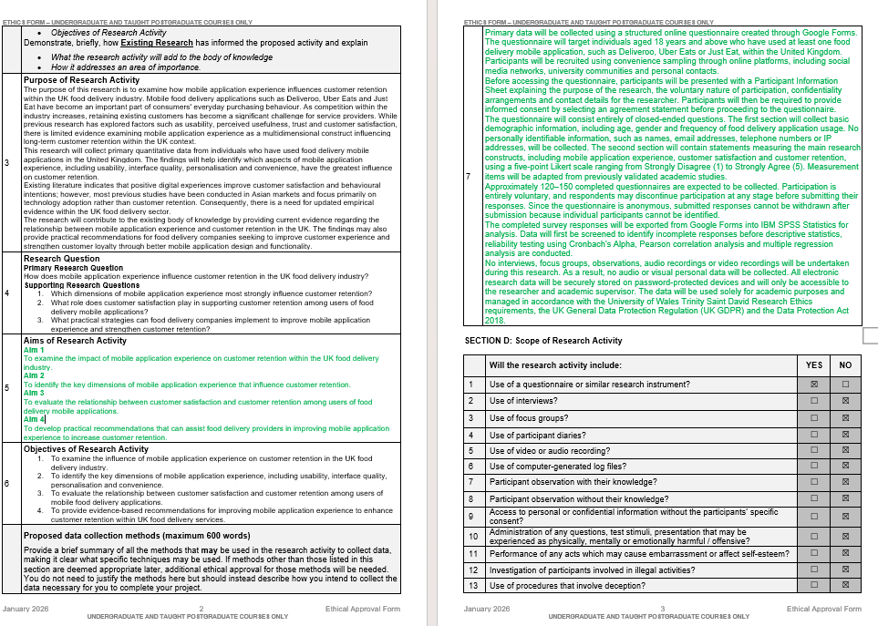
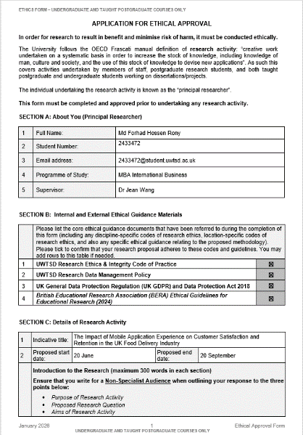
Appendix A: Ethic Form

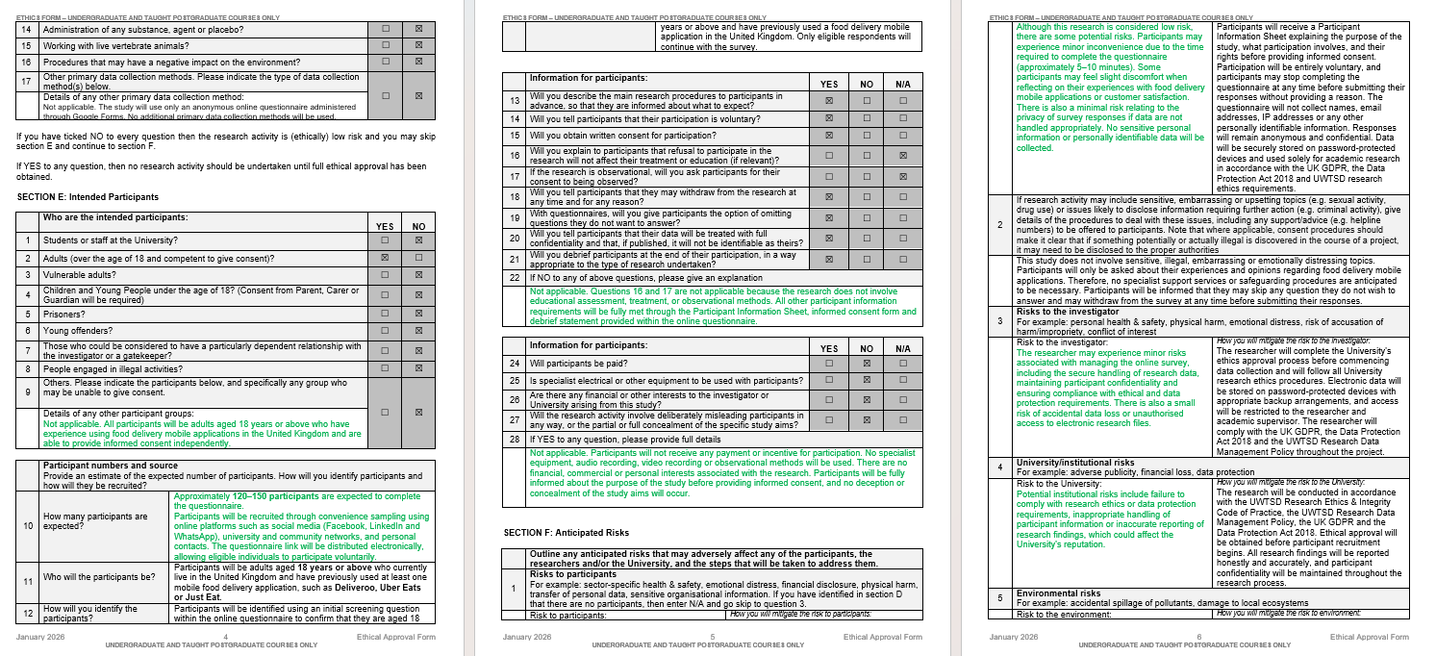
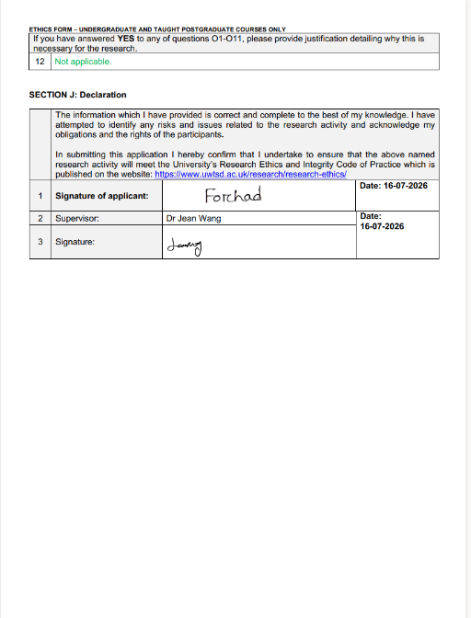
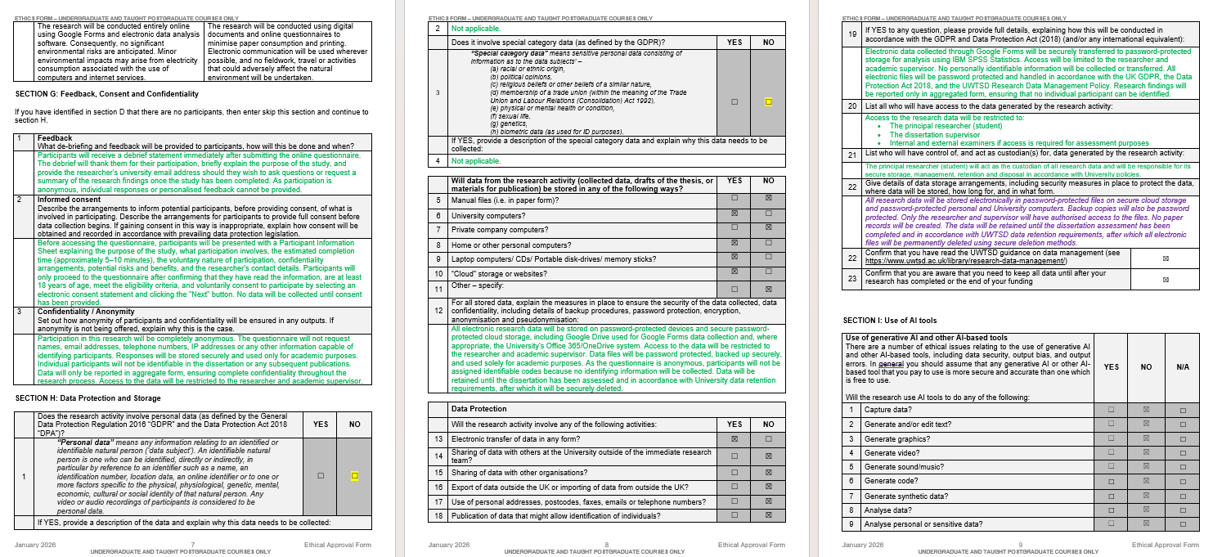

Appendix B: Participant Information Sheet
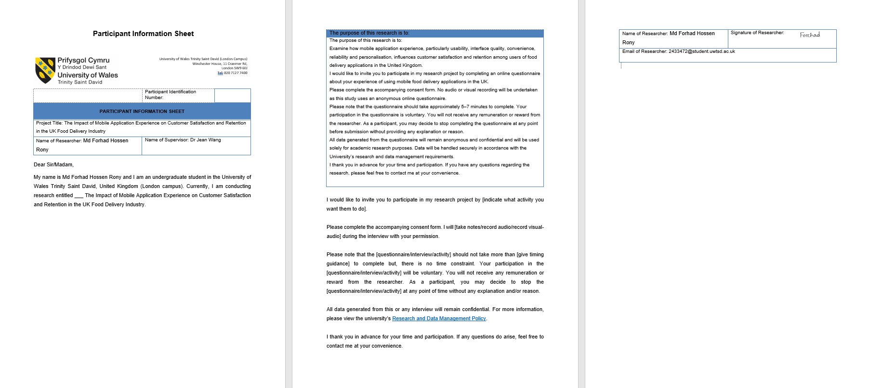

Appendix C: Consent Form
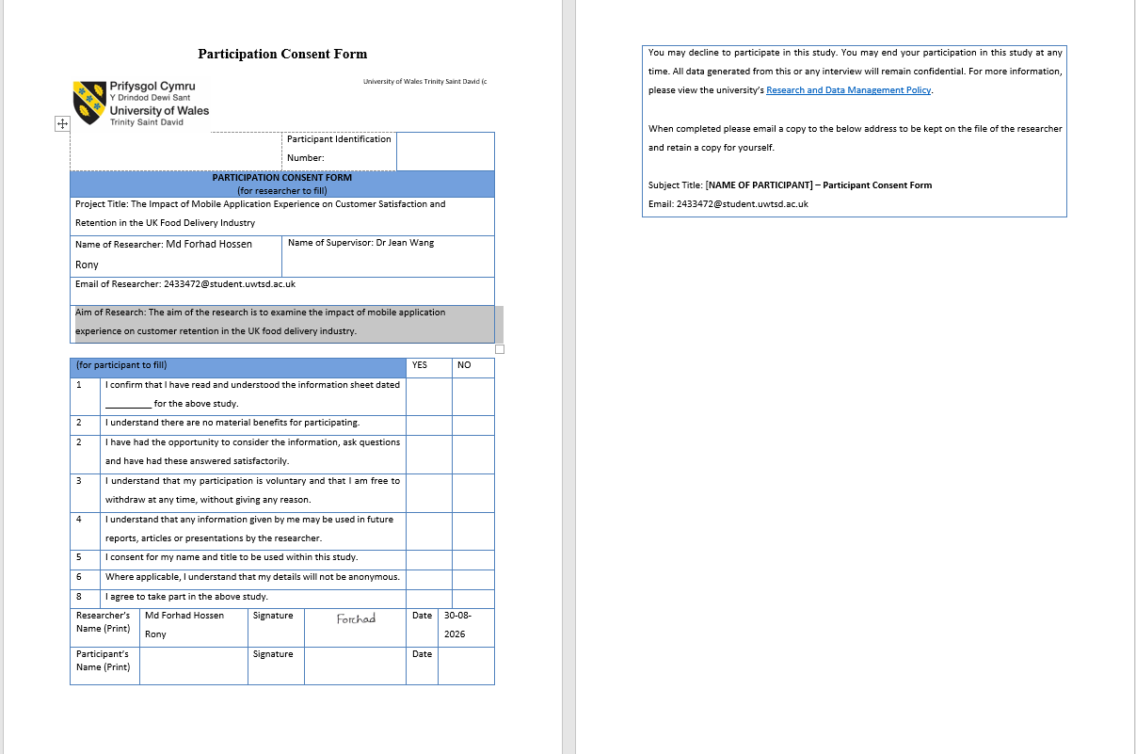

Appendix D: Questionnaire
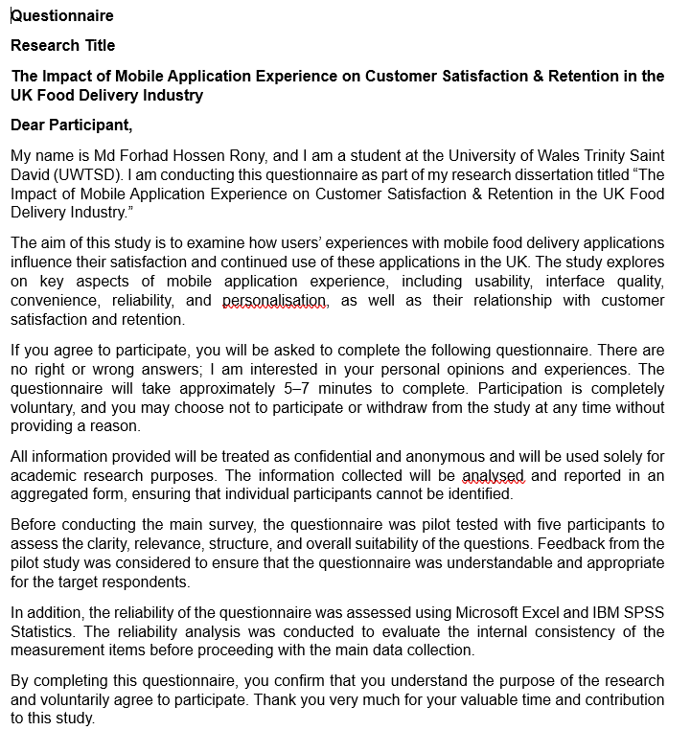
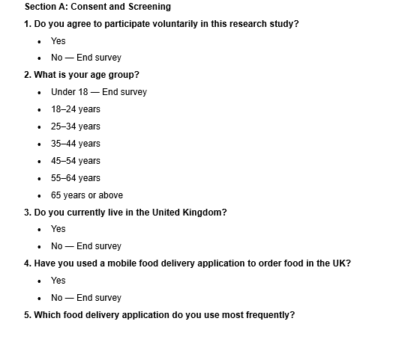
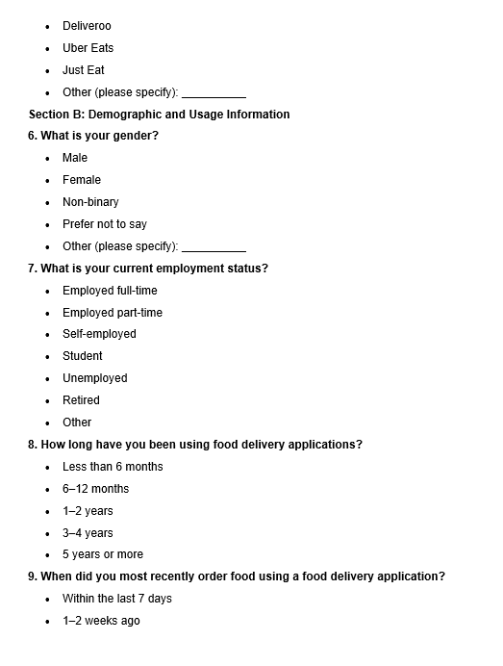
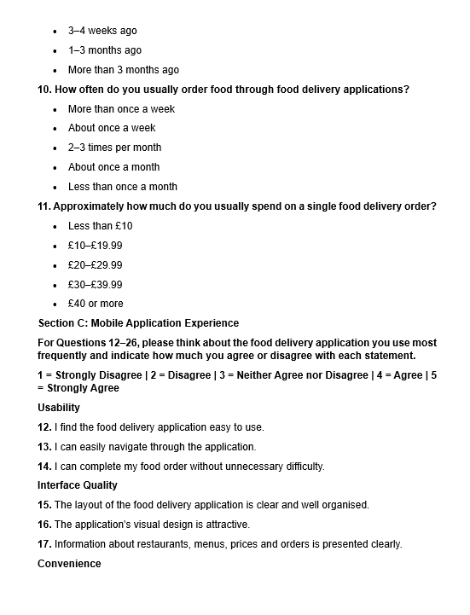
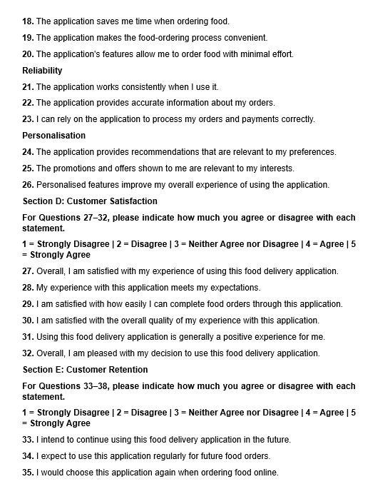
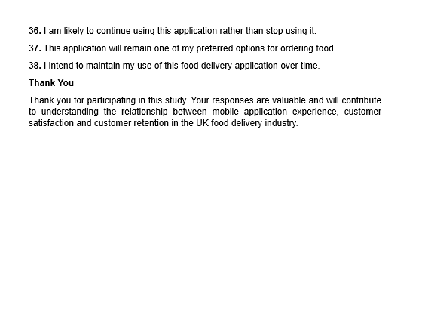

Appendix E: Survey Link
https://forms.gle/dCr1BaX1QS4ZwWBG7

Appendix F: Raw Data
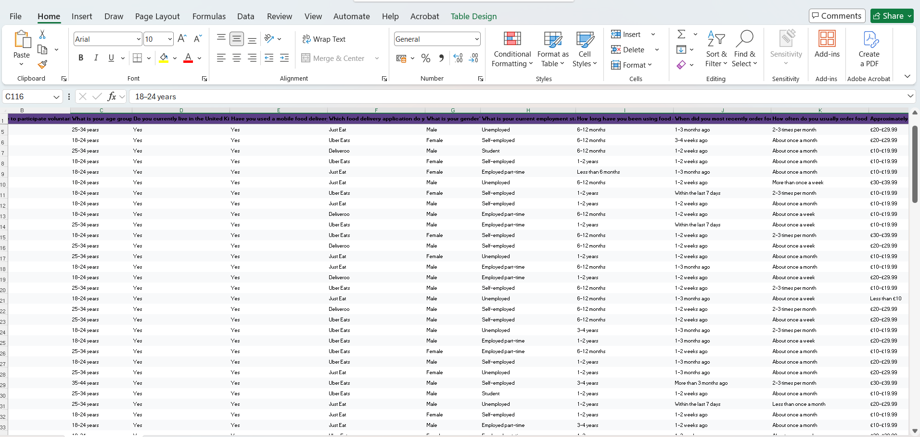

Appendix G: SPSS Analysis
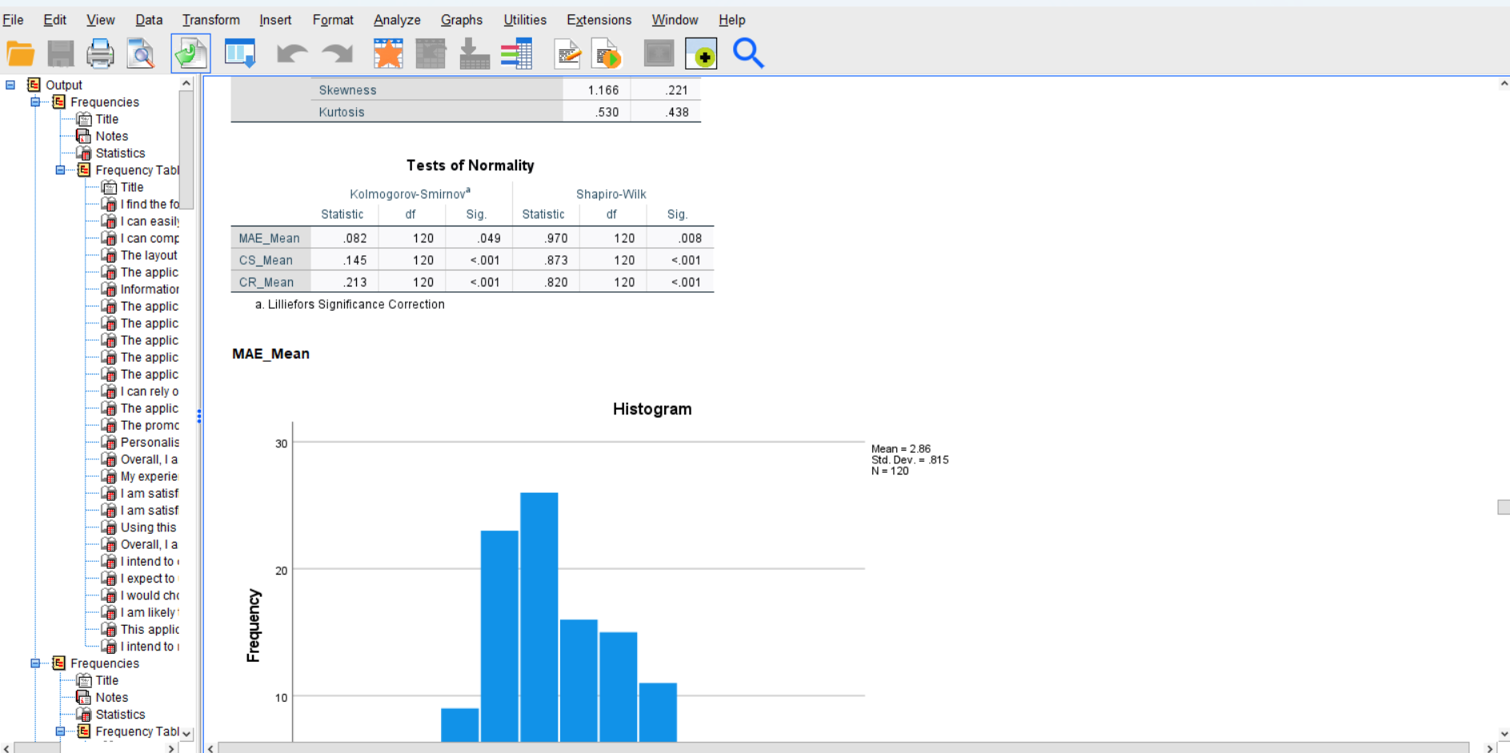

Appendix H: Exploratory Factor Analysis




