DEVELOPING RELATIONSHIPS AND WORKPLACE ACHIEVEMENT

MOHAMMED NASIR

Table of Contents

Introduction 3
Task 1 4
Task 2 11
Task 3 19
Conclusion 23
Reference 24

Introduction

It is very important for an organisation to motivate the employees in order to achieve the company’s future goals and objectives. This assignment has been explored about 4 development vehicle such as training, appraisal, performance management and motivation. The aim of this paper is to critically evaluative what development vehicles available to an organization, and critically assess the potential benefits to the organization as well as the individual.
In addition, this paper also highlights the concept of development vehicle and motivation theories used by the companies British Gas and Nuclear Decommissioning Authority (NDA). At the end of this essay we will make a development plan to meet the identified development needs and expectations of an individual.

TASK 1

Employees are the key aspects of organisation and key to success. Moreover, employees are able to develop organisation performance and help organisation to enhance the productivity through which organisation can gain sustainability. (Aisha Gupta, 2013)
Training, appraisal, performance management and motivation are key aspects to engage employees with work effectively through which employees are able to put their best afford and enhance organisation productivity. These aspects are help employees to improve their skill as well as performance. In the same context, it is also help to build a better relationship with employees and ensure them that they are valuable aspects for company.

Motivation
Motivation is refers to the process of simulating people to actions to accomplishing goals. In business context, motivation is key development vehicle, which is required for motivating the employees through which they can produce effective work for the organisation. (kenan business school, 2015)
Further, motivation helps employees to encourage pursuing and attaining goals. There various theories and models have been discussed below for evaluating its impact within organisation.
Motivation is one of the key development vehicles of an organisation as it helps the organisation to operate their services with high quality. In the same context, motivation in workplace referred to the high level efforts made by each employee towards their job roles and responsibilities (Leary and Baumeister, 2017).

Appraisal

Performance appraisal is the systematic process evaluation of the performance of employees and this is process of understand the abilities of person for further growth and development. In business context, appraisal has been use to provide employees a valuable wages they which might gain confidence their work and put best afford to achieving organisational goals. Further, Richard Lazarus illustrate that stress is two way process it involves the production of stressor by the environment and the response of an individual subjected to the stressor. In order to reduce the stress it is responsibility of the organisation (LePine et al. 2016). To provide appraisal to the employees in terms of wages or money through which they can motivated or put their best afford towards the work. however, it has been countered that performance based appraisal is essential but it is essential for the organisation to evaluate the right person for appraisal as overconfidence in employees also leads to negative impact on performance.

Training

Training is another key driver for encouraging employees for the works. Training is process in which employees are able to build their skill and re polishes their skill. In the same context, training and develop also help employees to work according to organisational goals. Theory of learning Gagne emphasized on their learning of intellectual skill through which they can develop their performance. Training and development is one of the main vehicles of development as it is help employees to develop their performance (Miyato et al. 2016).

The Gagne illustrate in theory of learning that every individual must know the information about purpose of training. In order to learn more effectively it is impotent to use the appropriate observation method. In the next step employees must exercise what they learn and develop their personality for improving. It has been counters by few authors that it is not necessary that each and every employees who are participating in training and development program develop their performance.
However, it can be said that training and development is essential for guiding the employees in appropriate way through which they can understand organisational goal and plan. (Bratton, J. and Gold, J., 2017)

Performance management

Performance management process of evaluating employees performance, as well guide employees in an effective manner through which they can produce effective performance for the company. In this process executive of organisation guide employees and provide them all the necessary guide to develop their skill (Mone and London, 2018). Further, performance evaluation of employees has been occurred to provide for determining their skill. Further, performance management means by which an organisation ensures their employees understand how they can contribute to the organisational goals. Edwin Locke made goal setting theory this theory in the year of 1968. This theory illustrates that employee individual goal help to motivating him for superior performance. Further, performance management help to guide employees to in a way in which they can enhance their performance. (Tyson, 2014).

- There are some motivation theories in management which is used by organisations. Implement those theories organisation always gets benefited as well as it benefited for individual. These theories are:
- Maslow’s Hierarchy of Needs
- Herzberg’s Hygiene Factors
- Vroom’s Expectancy theory
- Edwin Locke goal setting theory

- Maslow’s Hierarchy of Needs theory

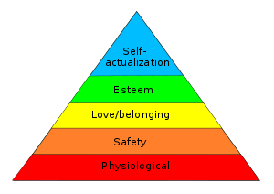
Figure 1: Maslow’s Hierarchy of needs
(Source: Jeston, 2014)

  - Self-actualisation needs- According to the self-actualisation needs, an organisation must fulfil the needs and demands of the employees. This strategy will help the company to enhance the performance of an employee. Moreover, an employee will also be able to work in an effective way for the development of the company.
  - Esteem needs- According to the esteem needs, it is very important for an organisation to appreciate and respect the employees. This strategy will help the organisation to maintain a sustainable environment within their business process.
  - Social needs- It is also very important for the Managers of the company to help the employees in maintaining their social needs. The employees will be able to work in an effective way by maintaining their social needs.
  - Safety needs- It is very important for an organisation to maintain a safe environment within their business process. It can be financial security, health and wellness, safety against injury and accidents of the employees.
  - Basic needs- The organisation must satisfy the basic needs of the employees by providing proper food, water, homeostasis and others. (Einstein et al. 2016)

- Herzberg’s Hygiene Factors theory

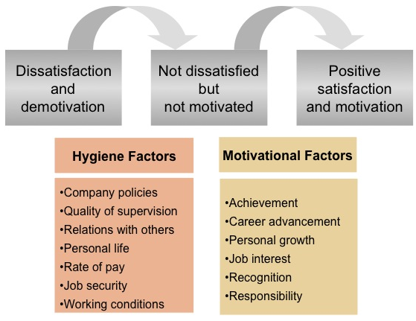
Figure 2: Herzberg’s Hygiene Factors
(Source: uwtsd moodle, developing relationship and workplace achievement)

In 1959, Frederick Herzberg, a behavioral scientist proposed a two-factor theory. (MSG, 2018)
According to Herzberg two factor theories illustrates the hygiene factors and motivational factors (Bassous, 2015). The hygiene factors describes that an organisation must have an efficient payment structure, an effective policies and administration. Moreover, the hygiene factors also illustrates that a company must have physical working conditions, must maintain the status of employees, must provide job security to the employees.

- Vroom’s Expectancy theory

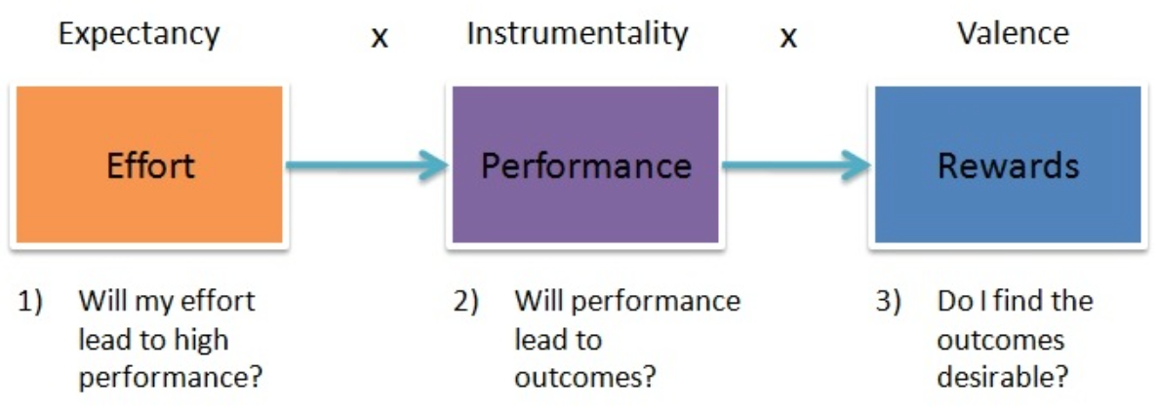
Figure 3: Vroom’s Expectancy theory
(Source: modernmilitaryleader.com)

Whereas Maslow and Herzberg look at the relationship between internal needs and the resulting effort expended to fulfill them, Vroom's expectancy theory separates effort (which arises from motivation), performance, and outcomes. (yourcoach,2009-2018)

According to Vroom’s when an employee gives their best effort and perform well, they expect a better result and better reward from organization. Organization should recognize his or her hard work.

- Edwin Locke goal setting theory
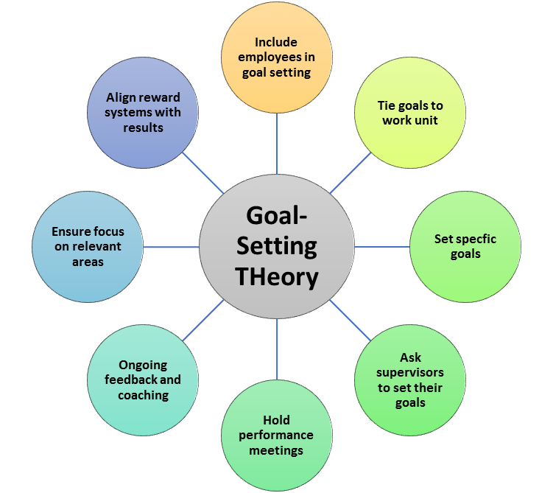
Figure 4: Goal setting theory
(Source: Lepper and Greene, 2015)

In 1990, Locke and Dr. Gary Latham published “A Theory of Goal Setting and Task Performance” in which they identified five principles that were important in setting goals that will motivate others. These principles are: clarity, challenge, commitment, feedback, and task complexity.(bookboon, 2012)

- Clarity: the goal must be clear. If the organisation make clear goal for employees, outcome will be more quick and economical.
- Challenge: according to Locksmith if the goal is challenging and achievable, the result can be better.
- Commitment: when employees work in a team they must have their commitment. Origination and employee must show their commitment each other.
- Feedback: employee must get feedback from manager while they are doing any task.
- Task complexity: Task complexity will help the employee and the company to easily achieve the goal.

Task 2

In this task we will demonstrate three companies what development vehicles they implement. How they get benefited as an organisation as well as individual. We will use class case study of two companies which was given to us. These are; (given by tutor in class)
- British gas
- Nuclear Decommissioning Authority (NDA).

We also use another company for further explanation of how development vehicle help to improve their productivity and improve employee’s skills.
To improve employee’s skills and improve productivity British gas and Nuclear Decommissioning Authority (NDA) has adopted some development vehicles. It has also been evident that the company’s British gas and nuclear decommissioning authority has got several benefits by implementing motivated workforce. The benefits that the employees of the companies has got such as job satisfaction, enhancement of productivity, learning, discipline, dynamism and others. (Boyd et al. 2017).

British Gas
(Source: The times 100)

British Gas has implemented the training and development program in order to develop the skills of the employees. Therefore, with the help of this strategy, the employees of British gas will be able to perform in an effective way for the development of the firm. Moreover, the company will be able to satisfy the needs and demands of the customers. This strategy will also help the firm to develop a sustainable position with the business market of UK. Moreover, the company will also be able earn a huge of amount of revenue from the business market of UK by providing training and development program to the employees. The company British Gas will get several benefits from training and development program such as increased productivity, less supervision, reduction of flaws and errors, job satisfaction, reduction of employee turnover, addressing the weakness of the employees, skills development, team spirit, resource utilisation and others.
The British gas not only provides the gas supply to the customers the company also maintenance the gas installation process. The company British gas does not only supply the gas but it is also deals with installation and maintenance of domestic central heating and appliance. Further, it provides a maintenance and breakdown service for electrical white goods home writing. Therefore, the company needs skilled employees and effective workforce. In order to meet the satisfaction of the customers the company use the training and development program in which the company the effective training to the electrical engineers. In the same context, the company also adopt the various strategies to manage the workforce within the company for enhancing the employee's performance. The company also adopt the effective selection process in which company can recruit the effective employees for the company and meet the company's expectation. Further, the company also provide the training and development to the employees according to the company’s goals and aims. (source: class moodle)
- It has been evident that the company British Gas has implemented the training and development program for developing the skills of the employees. Therefore, the management team of the firm British Gas can follow the goal setting theory of performance management system in order to develop the skills of the employees. There is various goal settings theory such as challenging, commitment, feedback and task complexity. (Tyson, 2014).

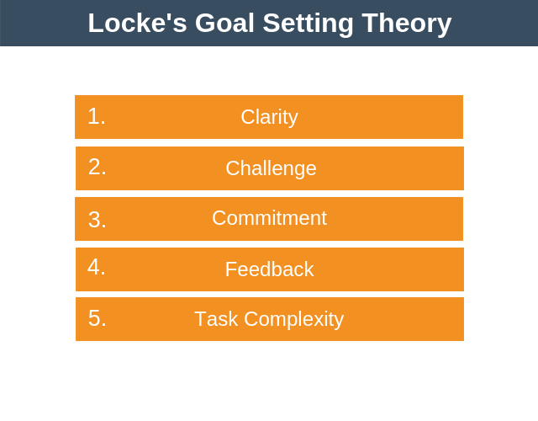
Figure 5: Locks goal setting theory
(source:EPM 2009)

Clarity- It is very important for the company British Gas to provide a specific timeline to the employees in order to achieve their individual goals. This strategy will help the company to meet the future goals and objectives of the company. Moreover, the company must provide a measurable goal to each and every employee by which the employees will be able to perform in an effective way. Furthermore, the management team of the company British Gas must adopt advanced technologies within their working culture which will help the workers to innovate new products and services. This strategy will also help the organisation to achieve its future goals and objectives.

Challenge- In order to achieve the goals, the employee of British Gas can face many difficulties. Therefore, it is very necessary for the management team of the firm to motivate the employees in order to achieve their goal successfully. In addition, the motivation will also help the employees of the company to perform in an effective manner. Moreover, the management team of the firm will also be able to identify the skill gaps of the employees with the help of training and development program. Furthermore, the employees will be able to gain some knowledge about the working culture of the organisation with the help of training program. (Wang et al. 2015).

Commitment- It is very important for the managers and the employees to be committed to their individual work. Moreover, the managers and employees must put deliberate efforts in order to achieve the future goals and objectives of the company British Gas. This strategy will also help the firm to earn more profits from the business market of UK. It is very important that for the managers of the company to help the employees for performing well in the organisation. Furthermore, the company can also implement the performance appraisal system within their business process in order to motivate the employees.

Task- complexity- Task complexity will help the company to easily achieve the goal. Therefore, the employees must focus on their individual work for completing their task in an effective way (Hsu and Lawler, 2018). Moreover, the employees can also work as a team in order to achieve the goals of the British Gas. Furthermore, the management team of the company British Gas must adopt advanced technologies within their working culture which will help the firm to complete their tasks. With the help of technologies, the management team of the company will also be able to achieve the future goals and objectives of the firm.

Feedback- It is very important for the management team of the organisation to give feedback to the employees according to their performance. This strategy will help the employees to identify their flaws and errors. It will also help the firm to motivate the employees. Therefore, the employees will also be able to set their individual goals according to the feedback.

The Nuclear Decommissioning Authority (NDA)
(Source: The times 100)

The Nuclear Decommissioning Authority uses the motivational tool for enhancing the performance of the company. In the year of 1994 the UK Atomic Energy began work on building and running nuclear reaction and research facilities. Further, in 1980 environmental problem has raised due to the nuclear waste moreover, it is become issues for the UK government. In order to maintain the environment safety the government brought work under National Decommissioning Authority (NDA). In the same context, the NDA does not directly manage the UK’s nuclear. Further, the aim of the company to reduce the nuclear waste which affects the environment. Moreover, the each of the objective can mitigate by the employees of the organization therefore, the employees were start to follow the HR strategy which help the company to fulfil the aim. Moreover, NDA also focus on the motivation to the employees as through the motivation employees can show their commitment with an individual or groups performance. Most importantly organisation also provides the rewards to motivate the employees. Moreover, the NDA Adopt the organisational culture which encourage people towards their work for gaining the desired outcome. In the same context, motivation affects the every aspects of business organization as it is increase the outputs and drive the low cost. By applying the various aspects of motivation on employee NDA fulfil their objective.

In addition, for enhancing the performance efficiency of employees the Nuclear Decommissioning Authority use various theories of motivation. Moreover, the institution applies Maslow- hierarchy theory and Herzberg- two factors theory for motivating employees of the organisation. According to the Maslow theory, the companies need to fulfil the basic requirements of employees. Further, this theory provide the hierarchy of human needs and stated that a human beings start fulfilling their needs form the bottom levels of the pyramid (Stoyanov, 2017). These pyramids have five levels related to human satisfaction, and four levels relating to physiological needs, while the top level of the pyramid marks the growth needs. In the same context, in order to satisfied it is important to satisfy the lower level of pyramid. The theory further highlights the very fact of any deficiency to result for the lack of satisfaction among the employees of the workforce. Moreover, to increase the productivity and efficiency of employees the company needs to fulfil their basic requirements.
In addition, the application of Herzberg theory is also effective when applied within the workforce. According to this theory employee motivation can be sustained by appraising and rewarding the efforts and dedication given by each of the employees. Moreover, this theory also illustrate the very fact that employees are the key assets of an organisation therefore, it is the responsibility of a company to take care of its employees by providing the safety and quality workplace in which employees might focused on their work. According to Liu et al. (2015) workplace safety and rewards are the more essential than fulfilling the basic requirements of employees. However, it has been evident that basic requirements and rewards both play key role to enhance the performance of the employees. Further, the UK Automatic energy applies both the theories of motivation to engage the employees for enhancing their performance for fulfilling the organization goal.
NDA also can use “Locks goal setting theory” to improve their employee’s performance and confidence. (Albrecht et al. 2015)

Sainsbury
In order to gain Sustainability Company use training and development vehicles which help business organisation to operate their business more effectively.in 2015 company failed to produce maximum productivity in which they also failed to generate profitability which give negative impact on organisation operation. Due to this company, also sell their share for gaining the sustainability and in order to operate business in way is more effective. In order to manage all employees performance as well generating the maximum profitability company conducts a training and development program. Further, the HRM department provide training and development to each organisation for better performance. Before conducting training and development, company set their goals and objective. Moreover, the training has been provided by considering the objective and goals of organisation. The training and development program has been conduct for 6 month and after that program, it has been evident that company raise their profitability and productivity. Further, it has been seen training and development help to develop the employee’s skill for doing the task more effectively. further, this training and development provide new working framework through which they work accordingly organisational goals and objective.
This training and development process help executive and employees to build their relationship more effective way in which employees and executive work together for gaining the organisational goal and objective. Most importantly, it is work for the organisation and helps to increase productivity and generate the maximum profitability.( ukessay, 2016)

TASK 3

Identifying what development plan companies like British gas, NDA Sainsbury applied:
The performance appraisal system is a strategy used by the organisations to motivate the employees. In addition to this, the companies British Gas and NDA have implemented this strategy in order to motivate the employees of the firm. The purpose of implementing this strategy is to boost the confidence of the employees. Moreover, the performance appraisal system will also help the employees of the company to achieve the future goals and objectives of the firm. It has been evident that there are several components of performance management system such as performance planning, performance communication, data gathering, appraisal meetings, performance coaching and others. Moreover, the companies British Gas and NDA need the performance appraisal system in order to help the employees for performing in an effective way. With the help of this strategy, the management team of the company will be able to achieve the future goals and objectives of the company. Furthermore, it is very important for the management team of the organisation to give feedback to the employees according to their performance. This strategy will help the employees to identify their flaws and errors. It will also help the firm to motivate the employees. Therefore, the employees will also be able to set their individual goals according to the feedback.
In addition to this, the training and development program will help the companies British Gas and NDA to motivate the employees. Moreover, the employees will also be able to develop their personal skills and communication skills. Communication skill is one of the most important elements in an organisation. With the help of the communication skills, the employees will be able to communicate with each other in an effective way. In addition, the management team of the company British Gas and NDA will also be able to communicate with their shareholders in an effective way with the help of communication skills. Moreover, the companies will also be able to identify the needs and demands of the employees. Furthermore, the training and development program will also help the employees to work as a team in order to solve the critical problems. The training and development program will also help the employee to adopt the new technologies in order to innovate new products and services for the company. These strategies will also encourage the employees of the firm to enhance the productivity of the company. Therefore, the company will be able to maintain a sustainable position by providing training and development program to the employees. It will also help the companies to enhance its business process within the global market.

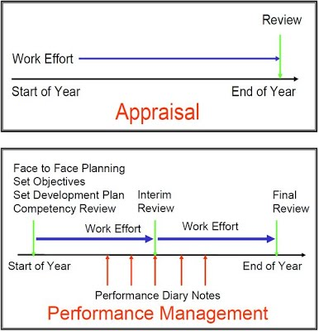
Figure 5: performance management
(Source:Wentzel, 2016)

Personal development plan
Objectives | Measures | Priority | Support & development |  | Review/  terget  date | Other comments
Objectives | Measures | Priority | Internal | External | Review/  terget  date | Other comments
To gain confidence in talking to larger group about my own work | Practice / attend seminar or practice in small group | H | Practice | Attend seminar/practice in small group | Every month | Assign briefs which entitle us to present or speak about our work
Technical training | Join relevant course / rent out equipment haven’t used before and practice | H | Rent out equipment haven’t used before and practice | Join relevant course | Every month | Get support from online, online videos. Get help from others
Hygienic course | Find nearest course centre | L | Learn online | Find nearest course centre | Find out suitable time | Ask or get help from those who already done
Learn more about the Microsoft office | Find a college or training centre | H | Buy books/ use online | Find a college or training centre | Every month/  Next available date | Join government free courses
Learn how to get my work out there | Attend guest speakers, create a website, twitter account, business card etc | H | create a website, twitter account, | Attend guest speakers, business card  etc | Every month | Meet new people
Time management | Practice | H | Write all appointment dates | Use reminder / set priority | Every month | Watch motivational videos about time management

Above table illustrate the development plan process and various aspects which needs to consider for developing the effective skill of the employees. In order to develop an employee performance it is important to fix the objective of the plan. In personal development plan objective basically refers to process of improving the personal skill of the employee. In order to fulfil the objective the employee must discuss with the larger groups about his own work and gain confidence about his work. Most importantly the employees learn more and identify the criteria which help to fulfil the requirements of an employee (LePine et al. 2016). Further, the employee also provided by the technical training for improving the personal skill.
In order to fulfil the objectives a person should follow the various activities practices to improve the personal plan. In the same context, the employees also use various experiment and practices which help employees to understand the effective criteria to meet the expectation of the employees.
Moreover, the person also does research, read for gaining the various knowledge to improve the personal skill.
For improving the personal skill of the employees must consult with their executive and leader as they only help them to improve their personal skill. Moreover, the effective way to develop the personal skill is to focus on their own development and evaluate that how effectively they improve their skill. For example if an employee's week in communication skill then that person needs to increase this communication with the fellow employee as he fellow employees can help detect and rectified (Munn et al. 2014). Further, attending the seminar and meeting and power print presentation will also help an employee to improving his communication skill.
Moreover, it is also important for a person to focus on other skills, which help a perversion to become effecting on work. In the same context, the person needs to set his goals and objective in an effective way which help the company top gain the effective outcomes. In order to fulfil the requirements of the goals the person might take all the essential steps, which help him to fulfil his goals and objective. In addition, determining the own weakness is one of the effective thing which help a person to improving his personal skill and the skill which he does not have. In order to gain the specific skill a person must make a specific time schedule and fixed the task for accomplishing the task in an effective manner. From this development plan speaking in audience can be number 1 priority, technical training can be 2 priorities, and other objective can be third priorities.

Conclusion
The above report is based on development vehicles are the important aspects which help the company to gain the desired outcomes. In this report motivation, appraisal, performance management, training considered as a development drivers. In order to understand that role of development driver three case studies has been consider. Further, various aspects of development vehicle explored in this report. From the above report it can be concluded that motivation and other development vehicle are the crucial aspects for the company and it help the company to gain the competitive advantage within the competition market by providing the best quality product to the customers.

Reference

- Albrecht, S.L., Bakker, A.B., Gruman, J.A., Macey, W.H. and Saks, A.M., 2015. Employee engagement, human resource management practices and competitive advantage: An integrated approach. Journal of Organizational Effectiveness: People and Performance, 2(1), pp.7-35.

- Aisha Gupta (2013) Employees are Valuable Assets of an Organization and the Key to Success. Available at : https://blogs.ramco.com/employees-valuable-assets-organization-key-success

- Bassous, M., 2015. What are the factors that affect worker motivation in faith-based nonprofit organizations?. VOLUNTAS: International Journal of Voluntary and Nonprofit Organizations, 26(1), pp.355-381.

- Börekçi, N.A., Kaygan, P. and Hasdoğan, G., 2016. Concept development for vehicle design education projects carried out in collaboration with industry. Procedia CIRP, 50, pp.751-758.

- MSG management study guide(2018) Herzberg’s Two-Factor Theory of Motivation. Available at: https://managementstudyguide.com/herzbergs-theory-motivation.htm

- Bratton, J. and Gold, J., 2017. Human resource management: theory and practice. Palgrave.

- Einstein, A., Addams, J. and Roosevelt, E., 2016. Maslow's hierarchy of needs.

- Yourcoach(2009-2018) Vroom expectancy motivation theory. Available at : https://www.yourcoach.be/en/employee-motivation-theories/vroom-expectancy-motivation-theory.php

- Jeston, J., 2014. Business process management.Routledge.

- Lepper, M.R. and Greene, D. eds., 2015. The hidden costs of reward: New perspectives on the psychology of human motivation.

- Tyson, S., 2014.Essentials of human resource management.Routledge.
Van Dooren, W., Bouckaert, G. and Halligan, J., 2015. Performance management in the public sector.Routledge.

- Wang, S., Ma, K., Yeganeh, H., Wang, Z. and Lin, W., 2015. A patch-structure representation method for quality assessment of contrast changed images. IEEE Signal Processing Letters, 22(12), pp.2387-2390.

- Wentzel, K.R. and Miele, D.B., 2016. Culture and Motivation: The Road Travelled and the Way Ahead RONNEL B. KING AND DENNIS M. Mc INERNEY. In Handbook of Motivation at School (pp. 287-311).Routledge.

- Leary, M.R. and Baumeister, R.F., 2017. The need to belong: Desire for interpersonal attachments as a fundamental human motivation. In Interpersonal Development (pp. 57-89).Routledge.

- Stoyanov, S., 2017.A theory of human motivation. Macat Library.

- LePine, M.A., Zhang, Y., Crawford, E.R. and Rich, B.L., 2016. Turning their pain to gain: Charismatic leader influence on follower stress appraisal and job performance.Academy of Management Journal, 59(3), pp.1036-1059.

- Munn, Z., Moola, S., Riitano, D. and Lisy, K., 2014. The development of a critical appraisal tool for use in systematic reviews addressing questions of prevalence.International journal of health policy and management, 3(3), p.123.

- Mone, E.M. and London, M., 2018. Employee engagement through effective performance management: A practical guide for managers. Routledge.

- Miyato, T., Dai, A.M. and Goodfellow, I., 2016.Adversarial training methods for semi-supervised text classification.

- Hsu, I.C. and Lawler, J.J., 2018. An investigation of the relationship between gender composition and organizational performance in Taiwan—The role of task complexity. Asia Pacific Journal of Management, pp.1-30.

- UNC kenan- flagler business school (2015) The role of motivation in the workplace. Available at : http://execdev.kenan-flagler.unc.edu/blog/the-role-of-motivation-in-the-workplace

- Bookboonblog(2012) The 5 golden principles of goal setting. Available at : https://bookboon.com/blog/2012/05/the-5-golden-principles-of-goal-setting/

- EPM expart program management(2009) Lockes goal setting theory. Available at: https://expertprogrammanagement.com/2018/10/lockes-goal-setting-theory/

- UKessays(2016) Factor that affect the motivation of employees at sainsburys.
Available at: https://www.ukessays.com/essays/management/motivation-of-employees-at-sainsburys-management-essay.php

