Rebecca Ellis – BMDP7003

Proposed/Working Title:
Crazy for You: Exploring the female gaze as a response to 1980s cinema - A visual thesis using artefacts to explore 1980s cinema from the perspective of the female as bearer of the look.

Research Question:
In what ways did female spectators experience and respond to feelings of desire to films from the 1980s?

Part 1 - Background & Context:
A common trend within academic research has been the acknowledgement of the ‘male gaze’ – a theoretical perspective on spectatorship, first put forward by John Berger’s work ‘Ways of Seeing’ (1972) in which he argues that within visual media culture ‘men look at women. Women watch themselves being looked at’ (54:1972). Laura Mulvey supports these ideas in her seminal text ‘Visual Pleasure and Narrative Cinema’ (1975). Here, Mulvey argues that cinema is dominated by the objectifying ‘male gaze’ in which the active powerful male character looks at the passive female object. These and further critical perspectives define the male gaze as ‘a way of viewing visual media from the perspective of a male’ (Tatsenko 234:2022). These patterns of active male viewer and passive female object become problematic as they have a tendency to reflect the power dynamics of the wider gender politics of society. There is minimal acknowledgement within historical academic research of the viewing perspectives of the female spectator. Even recent studies such as the work of Tatsenko (2022) suggest that when it comes to visual culture, ‘there is either little or no space for a woman as a viewer of it, but only for a woman as an object in it’. (236:2022). Porter argues that whilst the Hollywood film industry is overwhelmingly controlled by men at the level of production, it has historically been inherently driven by women at the point of consumption (128:2023). If this is true, why have female spectators not had a voice within academic research?

My research investigation aims to explore the viewing experiences of the female spectator. Contemporary research highlights the need for further investigation into the experience of the female viewer of visual culture to address the monopoly of the active male viewer and associated assumptions of the passive female spectator. The experiences of female viewers have been largely dismissed and the concept of a desiring female gaze is still fairly new. This project aims to centralise the female viewer by exploring their lived experiences as desiring audiences of visual film culture.

Daniels outlines that the part of her research projects she has appreciated the most has been ‘assisting with the dislocating of a public arena construct of women as subservient, docile, fragile, and domesticated, and to expand that construct to be inclusive of women as individual agents and active role players in society too’ (11:2010). This project hopes to give a voice to the experiences of women as active bearers of the female gaze, dismantling assumptions of the passive female viewer, instead inviting them to talk about their response and reaction to 1980s film culture, stars, characters and thus their own identity as female spectators.

Part 2 - Aims & Objectives:
The aims of this project are:
- To gain insights into the experiences of the female spectator as a viewer of films from the 1980s.
- To explore the concept of film spectatorship during the 1980s from a female perspective
- To establish any trends and themes of female desire as a response to films from the 1980s in relation to female identity
- To create a visual celebration of female spectatorship and desire in the 1980s

The proposed research questions are:
- In what ways did female spectators experience and respond to feelings of desire to cinema from the 1980s?
- What are the trends and themes can be observed in relation to female desire in the 1980s?
- How can artefacts be used as a point of exploration of the concept of female spectatorship and desire?
- How can creative collaboration be used as a tool to explore and analyse the concept of woman as bearer of ‘the look’?

The project aims to empower female audiences by discussing their own lived experiences of cinematic enjoyment during this era. It is hoped that the insights derived from this work could contribute to the wider knowledge base about female spectatorship in specific relation to desire and the female gaze. This will be a participatory project, which aims to fully involve the female audiences as co-researchers, to empower their voices as well as contributing to a greater awareness of the experience of the female pleasures to be gained from film.

The 1980’s has been chosen as the temporal context as the project will be approached from an autobiographical perspective, using my own experiences as a young teenager during this period as a jumping off point. I have included some imagery here of cultural moments from that time, not all filmic, where I felt, looking back, that I was the bearer of the look and empowered by a female gaze.

The project hopes to create an inclusive collaborative and creative environment where participants will bring in artefacts or images from that period as an initial starting point for discussion. The project aims to empower female audiences to discuss their own lived experiences of cinematic enjoyment and their experiences as bearers of ‘the look’ this time. It is hoped that the insights derived from this work could contribute to the wider, often side-lined knowledge base about female spectatorship in specific relation to desire and the female gaze.

The project will comprise of two key stages:

STAGE 1 of the project will invite female participants from Generation X (Born between 1965-1980) to bring in an artefact or image of their object of desire from 1980s cinema to a group discussion where a series of question prompts will be provided. At this stage, participants can also contribute digitally to a ‘virtual teenage bedroom wall’ hosted on Padlet or Pinterest or similar visual platform. The analysis of trends and themes from the discussions and question prompts will form the main findings of the research.

STAGE 2 of the project will be the curation of a collaborative exhibition of the artefacts. Central to the exhibition will be the creation of a participatory collage of images of cinematic hunks or crushes from that era, chosen by participants (Working Title: The Hunk Show). Visiting members of the public will be able to contribute and more anecdotal evidence will be captured. Ademolu (2021) argues that the use of visual research methods allows participants ‘a creative space and opportunity to articulate (and appropriate meaning from) their introspective worldviews’ (1:2021). This participatory project stage will therefore allow researcher and researched alike to derive meaning from the creative contributions to the project.

Sorensen and Eriksson (2022) reflect on how their collaborative art project Stitches Beyond Borders, created a strong sense of community and cultivated creative agency within the female contributors. Their project, which invited women to participate in a large-scale collective embroidery across 7 different sites, ‘activated the collective female memory of embroidering, creating a strong sense of community and drawing attention to female self-expression, as well as giving a voice to the women behind the stitches’ (1:2022). The findings of their project comprised of observations and semi short, structured interviews with 38 participants using open ended questions alongside questions with countable answers. My project in some respects attempts to mirror the goals behind this methodology, specifically to activate collective female memory of a specific time period in relation to desire as a response to 1980s cinema; create a sense of collective identity as a female viewer and to give a voice to the female participants.

Collage will be used as the artistic medium for this project as there is no requirement for the participants to have existing artistic skills or come from creative backgrounds. It is hoped that this will broaden the scope for participants from a diverse range of backgrounds. The medium also gives life to the 1980s aesthetic of the teenage bedroom wall or the sticker covered diary or schoolbook, allowing the medium to enhance the message of the research. Reflections and photographic imagery will be captured from participants engaged in this stage of the project. Together the project will combine the findings from Stages 1 and 2 in a visual thesis combining images and analysis.

Two projects that help me to shape these aims and objectives are William Knight’s Geordies exhibition (2025) and Gauntlett’s ‘Drawing Celebrity’ project (2003). Knight’s Geordies exhibition pays homage to Newcastle's football culture and its passionate fanbase. The exhibit was built as a visual thesis on belief and belonging, intended to reflect on and celebrate the lived experiences as a Geordie was paramount. The exhibition uses the work of local artists and photographers to create the celebratory imagery. The idea of the ‘visual thesis’ and the participation of a creative collective leading to a celebratory output of visual identity is appealing in terms of my own research objectives.

Gauntlett’s research project, ‘Drawing Celebrity’ (2003), explores the idea of using participatory visual research methods to understand self-identity. Gauntlett states that ‘creative and artistic production will almost inevitably tell us something about the creator’ (8:2005). The project considers both changing perceptions of gender identity and young people’s views of the concept of celebrity, also measuring the impact of celebrity on their lifestyle aspirations. A hundred participants were given the prompt ‘draw a celebrity you would like to be’ and the drawn responses were subsequently analysed. As a researcher who hopes to use visual materials and creative production as a research method, this project struck me as of particular interest. Not least for Gauntlett’s post-project observations in which he admits to experiencing difficulty as a researcher in interpreting the standalone images and as such conducted a post-task questionnaire for participants to analyse the work themselves. This allowed me to conclude that the project should be in two parts to allow for both an exploration of female response via questioning and focus groups (Stage 1) as well as a creative visual research stage (Stage 2).

Part 3: Literature Review -
Porter argues that throughout history, women have always been ‘pivotal to the consumption of film culture’ (128:2023). Yet the male gaze is the main focus of much academic research in relation to cinema and other aspects of media and visual culture. The two key historical theoretical perspectives on spectatorship are those of Berger (1971) and Mulvey (1975). Both arguments endorse the belief that within visual culture, women are the spectacle and men are the spectators, or as Berger puts it, ‘Men act and women appear. Women watch themselves being looked at’ (47:1972). Contemporary researchers have also theorised how the male viewer’s perspective dominates many areas of the mass media and as such ‘has the power to promote patriarchal values in society’ (Tatsenko 239:2022).

Mulvey uses a psychoanalytic framework to explore erotic and visual pleasure in film, theorising that ‘the image of woman (acts) as passive raw material for the active gaze of man’ (815:1975). The female figure is ‘coded for strong visual and erotic impact’ acting as vehicle for the male viewer to project his own fantasy. (808:1975). Mulvey argues that the male star’s characteristics are ‘not those of the erotic object of the gaze’, instead, he commands the stage, articulates the look and commands the action (810:1975), whilst on the other hand, the female star’s appearance connotes ‘to-be-looked-at-ness’ (809:1975). Mulvey’s argument leaves no room for exploration of pleasurable experiences for the female spectator.

Jackie Stacey (1993) problematises that neither Mulvey nor Berger consider a female perspective in relation to images of femininity on screen, offering an alternate perspective which acknowledges the existence of the female spectator beyond that of passive viewer watching sexualised female star through the eyes of the male gaze. Whilst Stacey recognises the gendered split of surveyor and surveyed stating that ‘Hollywood cinema has been a key source of idealised images of femininity in this culture’ (4:1993), the study also considers the pleasures of escapism, identification and consumption as key sources of engagement for female audiences. The research is formulated upon how women respond to images of femininity within film and asks the question ‘If the images we see on the cinema screen are produced for the ‘male gaze’, how do female spectators relate to such representations?’ (4:1993).

Stacey’s methodology moves away from textual analysis of women as image on film, using an ethnographic approach which focuses on the lives and memories of actual film spectators as opposed to film texts with the main site of research occurring through ‘the woman in the audience who brings to the film her particular history and social identity’ (7:1993). Stacey investigates the relationship between female spectators and female stars looking at what pleasures and readings can be gained from images of women produced for the male gaze (5:1993), exploring how our understanding of female spectatorship can be transformed by the accounts offered by women in the cinema audience (4:1993).

Stacey's theoretical objective is to counter the aguments of psychoanalytic feminist film study by leaning away from textual analysis and, instead, towards female spectator interest in and the pleasures to be gained from female Hollywood stars. Stacey uses ethnographic artefacts such as letters combined with interviews with British women who recalled their experiences watching Hollywood films from the 1940s and 50s in their youth. Stacey’s outcomes suggest further scope for the research of female spectators in terms of female stars as subjects of female aspiration and identification when approached from the study of the lives and aspirations of ordinary women.

Feminist film theory continues to address issues of female representation such as ‘the shaping of women's identities and images by patriarchal culture…the gender stereotypes in film, and other social issues.’ Feng (308:2023). More recently, research finds a place for the desiring female gaze, challenging ideas of feminine passivity and restraint and instead focusing on female agency. Perfetti-Oates recognises that there has been enough progress towards gender equality within contemporary Hollywood cinema that one can observe ‘reverse subject and object positions’ between men and women (6:2015). Perfetti-Oates’ study (2015) looks at female response to the representation of male stars primarily within the chick flick or romantic comedy sub-genre, finding that ‘the main visual pleasure these men offer their audience members lies in admiration of their faces rather than the rest of their bodies’ (2:2015). This highlights how the desiring gaze is not uniform and differs according to gender. These intricacies appear worthy of deeper exploration. Perfetti-Oates’ research calls for renewed conversations on male sexual objectification on film within wider frameworks, which implicitly proposes new and emerging conversations about female pleasure as a response to Hollywood’s packaging of male stars.

Feng (2023) suggests that within mainstream Hollywood cinema, male characters are not packaged with a female audience in mind at all. Instead, the powerful male protagonist acts as an object for which the male audience can project their own self-image, as Feng puts it - ‘they are often the more perfect, attractive and powerful ideal selves’ (310:2023). This stands in direct contrast to the female character who is weak, passive and powerless by comparison. Together these forces combine to give the male viewer ‘a great sense of narcissistic identification and solace’ (310:2023), again leaving little room for female audiences to respond positively to such dynamics as the female stars have been ‘stylized to carry male desire and passively become objects to be seen’ (310:2023).

Feng argues that the emergence of more feminist narratives has occurred within contemporary film. Feng suggests that these films offer another potential avenue of pleasure for female viewers which comes from the inclusion of a female protagonist. Feng identifies contemporary case studies where the female figure becomes the subject rather than the object of the film narrative in turn appealing to female audiences. Within the case studies Feng presents, ‘the female figure has moved from its original subordinate position to a dominant one’ opening up new paths for narrative, representation and audiences of what Feng deems ‘feminist cinema’ (312:2023). Feng suggests that these films employ a ‘poetic audio-visual language to sublimate the emotional expression and narrative level of the film, deliberately abandoning the male perspective’. (312:2023) Feng concludes that future research should attempt to collate the views of range of different women on feminist films, to grasp the impact of films on women (312:2023).

Anifantis argues that whilst ‘it is omnipresent that women are objectified within modern media, while men are the subjects of such gaze’ (1:2021), in recent decades, objectification is changing with some film texts positioning masculinity as a source of visual pleasure. Anifantis uses the film Dirty Dancing (Dir. Ardolino, 1987) as a case study example of what she describes as a ‘cultural reset’ in which Baby acts as ‘a stand-in for all of the women in the audience’ (2:2021). The study uses textual analysis of particular sequences to explore how elements of the film such as cinematography, camera and costuming present lead male star Patrick Swayze as spectacle. She argues that the film ‘offers female viewers a space where their own pleasures and desires are taught and fulfilled.’ Antifas identifies that within this and other contemporary film texts, a common accentuation of masculine body image is achieved which caters to female audiences. Antifas argues that as a result, ‘these films successfully sexualized their male characters and created space for a female gaze in an industry typically more accustomed to the male gaze.’ (4:2021)

In the study ‘Looking at Men’ (2022) Jenner also examines the visual framing of the male lead in relation to an assumed heterosexual female gaze using case study material from 1980s television. Jenner argues that this time period contextually embraces women’s culture ‘which includes a focus on the male object and an objectifying gaze directed towards the male’ (60:2022). The study provides analysis of gender representation looking at the visual emphasis on male heroes as sex symbols in terms of their ‘main narrative function’ as ‘objects of romantic fantasy’ (61:2022). Jenner contextualises the visual politics of the 1980s surrounding objectification of men with an exploration of the cultural and social positioning of the chosen texts.

The study recognises that the ‘hard body type’ of actors such as Sylvester Stallone had dominated much of the decade due to the genre trend of action cinema (67:2022) but uses the example of Magnum PI (1981-1988) to discuss the objectification Tom Selleck as a prominent male sex symbol of this decade. Jenner states that ‘the characters’ status as a man without a name and an unknown past deliberately places him as object of fantasy, a cardboard cut-out onto which the female lead (and viewers) can project her desires’ (75:2022). The study goes on to explore how televisual aesthetics emphasize the male body and how the visual focus on the male hero suggests a targeting of a (heterosexual) female and therefore evolving ‘bearer of the look’. Jenner states that ‘the centrality of romance and fantasy’ (75:2022) holds appeal for female viewers, implying that genre and narrative as well as representation play a key role in positioning texts towards female audiences. Jenner reveals that critics dismissed the text as ‘nothing more than a hunk show’ (78:2022). I wish to use this concept of the ‘hunk show’ within Stage 2 of my research, to subvert the concept of this critique into something more positive in relation to female agency within spectatorship.

Part 4: Proposed Methodology -
This project uses mixed research methods and has a subjective ontological approach. It combines autobiographical research with visual ethnography and group interviews as the main methods of data collection. It is hoped that these research methods will provide quantitative data to inform exploratory findings. This will be a participatory project, defined as one which is collaboratively produced between the researcher and the participants who have an active involvement in the project. Buckingham (2009) outlines that a new interest in more visual research methods such as drawing, photography and video, has come from ‘qualitative researchers seeking to move beyond what are seen as the limitations of talk-based methods such as interviews and focus groups’ (233:2009). The methodology proposed within this project takes a composite approach where findings from focus groups will be interpreted alongside a visual exhibition and creative output in order to move beyond these perceived limitations.

Feminist Epistemology
The study will use an interpretivist feminist epistemology. Daniels defines the concept of feminist epistemology as an approach which is ‘concerned with the ways in which gender influences conceptions of knowledge’ (5:2010). Daniels argues that a feminist epistemology is useful in challenging both the invisibility of women as well as the distortion of the female experience (11:2010). By centring women within the research, Daniels highlights that the benefits of this approach include the empowerment of those who participate within the project (5:2010). This feels particularly relevant to my research project as I hope to empower and give a voice to the female participants and their personal experiences. Daniels also offers that ‘the personal narratives of women can provide a portrait of gender arrangements that are invisible in the dominant discourse.’ (9:2010) This approach will therefore help me to fulfil my aims of providing a detailed exploration of female identity in relation to the context of gender attitudes within the 1980s.

Autoethnography
The research study will be both participatory and autobiographical. Bagnoli states that ‘a participatory inquiry relies on a view of knowledge as inescapably grounded in the researcher’s own subjectivity’ (1:2004): the 1980s has been chosen as the temporal context for which to frame the project due to my experiences as a teenager growing up in this era and my ability as a researcher to bring my perspective of this time to the project as female bearer of the look.

Fellow researchers have found many advantages to autoethnography as a research method due its reflexive nature, including personal growth for both the researched and the researcher (Bagnoli, 2004) and the scope to provide participants with ‘an expressive channel to voice their inner stories’ (Literat 85:2013). Both of these values are central to the project.

Visual Ethnography
Contemporary research methods across several disciplines have successfully incorporated visual methods into their research studies to explore abstract concepts extract intangible thoughts. Daniels advocates for the use of visual imagery as a profound source of research data, stating that ‘the power of the visual image is warranted over any other form of communication since it can facilitate discussion, documentation, and analysis of social issues universally’ (10:2010).

There are numerous advantages cited by researchers using visual research methods include inclusivity, innovation and enjoyability for participants (Literat, 2013), the opportunity for reflective, creative self-expression (Gauntlett, 2005) and the ability to capture rich descriptions (Baumann et al. 2020). Literat argues that ‘images also hold the inherent potential to generate metaphorical representations of identities and concepts, and thus stimulate abstract and creative thought.’ (88:2013)

Buckingham states that ‘the method should follow the object - hence that research on visual media should be employing visual methods’ (634:2009). Since this research is centred on images from the medium of film, the study will use visual ethnography as an exploratory tool. Bagnoli (2004) illustrates how visual methodology links well to autobiographical studies as it allows the researcher to engage with documents of life which provide an insight into people’s lives and experiences. These documents might include, for example, diaries, letters, photographs and personal possessions.

Collaborative Making
Buckingham argues that the employment of such methods, asking people to ‘create’ media – can ‘reach the parts that other methods have failed to reach’ (634:2009). Creation is central to Stage 2 of the project where participants co-create the collaborative ‘Hunk Show’ collage. Gauntlett outlines that ‘creative tasks have a longer engagement time, meaning participants have time to think about what they are producing … as opposed to the initial gut reaction that responding to an interview question, for example, may lead to. (2:2005). Literat agrees that the act of creating gives ‘additional time for reflection … which is more difficult to achieve linguistically in a brief interview or survey’ (88:2013). This composite approach should therefore provide a more meaningful experience for both participants and lead to more in-depth research outcomes.

Part 5: Ethical Considerations -
Negotiating Relationships
Negotiating relationships between the researcher and the participants appears to be a key ethical concern for a project of this nature. As Pelias argues: ‘writing about others, particularly those who have shared experiences with you, is always an ethical test’ (132:2019).

Kelly identifies that ‘Participatory research encourages reducing the hierarchy between the researcher and the researched (Kelly 40:2006)’. Other researchers have pointed out that ‘when a trusting relationship has been established between researcher and participant, people easily disclose their lives far more than they originally might have intended to and, quite likely, also information of a sensitive nature.’ (Bagnoli 12:2004)

Therefore, one should remain aware of the reduced hierarchy and the implications this could have for the researcher and put subsequent actions in place. Bagnoli advises how important is to clearly distinguish one’s own role as a researcher from any other projected roles’ (13:2004). This could be achieved by outlining my role and the objectives of the project from the outset.

Anonymity and Confidentiality
One of the central ethical issues confronting visual researchers is how to manage anonymity and confidentiality in relation to the sharing of personal stories, anecdotes and visual material. Wiles (2008) states that ‘personal information should be treated confidentially, and participants anonymised unless they choose to be identified’. This could be difficult with my project as it will involve the sharing of personal stories and artefacts that will form the basis of the research findings.

The use of personal artefacts may also become an ethical problem as they may contain information that might reveal the identity of a participant – a photograph for example.
Removing identifiers from the data such as names or doctoring images to protect identity may be a potential solution here. Alternatively, obtaining consent for the subsequent use of images or artefacts in relation to the research project could be negotiated with the research participants with the production and completion of a transparent consent form.

Researchers have highlighted other issues that they have encountered in relation to research which focuses on how visual material owned, or in the possession of, research participants may contain photos taken by others, and therefore in copyright terms, not ‘owned’ by the research participant. (16:2008). Wiles et al. (2008) suggest gaining consent to photograph the photographs as a potential solution to these types of copyright issues.

Group Sizes
Literat states the importance of logistical considerations with a project of this nature, due to the sometimes highly personal nature of this type of research, arguing that ‘it is inherently unfit for use with large groups of participants’ which can result in small sample sizes in terms of data collection (93:2013). I hope to use small focus groups to ensure comfort of participants but multiple groups in order to avoid having a sample size too small to interpret trends and themes.

Reciprocity
Reciprocity is a concept worth considering in a project such as this. Pink, for example, describes ethnography as often ‘a “hit and run” act’ (2001: 44) and suggests ‘giving something back’. It is hoped that Stage 2 of the project – the collective exhibition will allow participants to feel empowered and celebrated as a result of the process. Kelty argues that the participatory process is often either understood as ‘a matter concerning power, agency and discursive impact, or a practice that concerns social cohesion and being part of something bigger than oneself’ (22:2015). This project hopes to generate creative agency and a strong sense of community amongst the female participants, allowing for a reciprocal outcome in terms of giving something back to the researched.

Heteronormativity/Intersectionality
Whilst the literature consulted as part of this review focuses on an assumed heterosexual male or female viewer, this study hopes to move beyond the heteronormative. It is important to consider intersectionality amongst the participants. I do not wish to consult only heterosexual females within the study but invite a wide cross section of female spectators of all backgrounds and sexualities to understand a fuller picture of female desire in relation to the project aims.

Part 6: Research Proposal Presentation – Copy of Slides

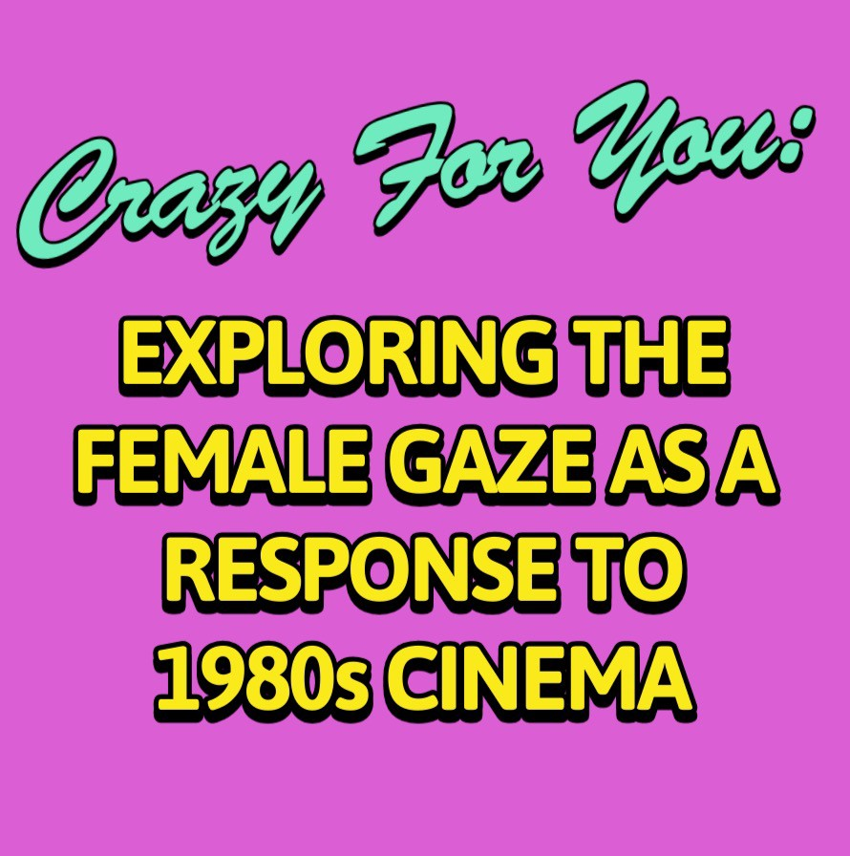
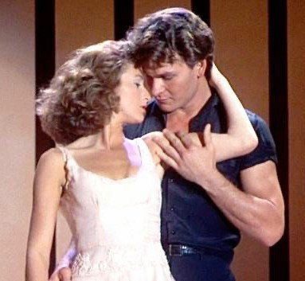
1

By Rebecca Ellis


2

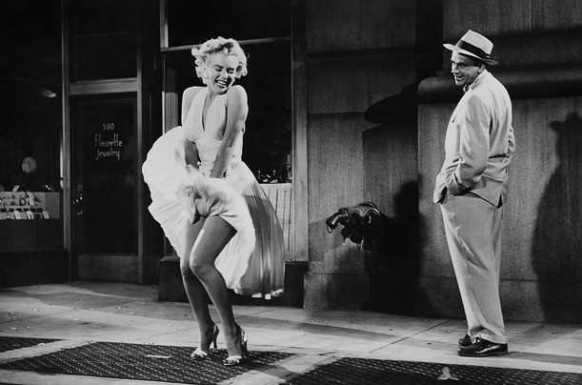
3
(236:2022) Tatsenko
‘When it comes to visual arts, there is either little or no space for a woman as a viewer of it, but only for a woman as an object in it’.


4


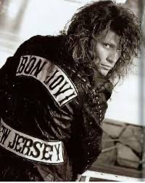
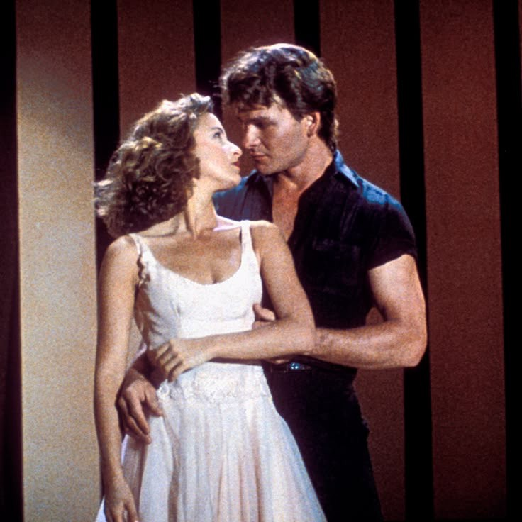

- To gain insights into the experiences of the female spectator as a viewer of films from the 1980s
- To explore the concept of film spectatorship during the 1980s from a female perspective
- To establish any trends and themes of female desire as a response to films from the 1980s in relation to female identity
- To create a visual celebration of female spectatorship in the 1980s

5

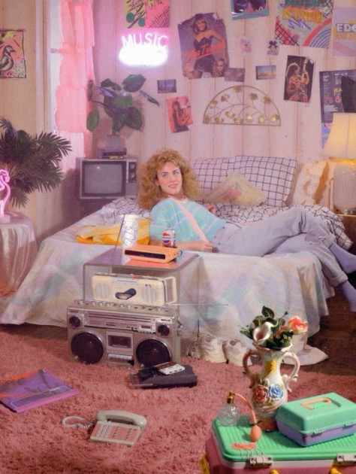


6
- Collaborative creative space
- Crazy for You Exhibition
- Group Interviews
- Sharing of artefacts
- Virtual teenage bedroom
- In Depth Analysis





7
William Knight (Curator)
Baltic Centre for Contemporary Art, Newcastle


8


The male star’s characteristics are ‘not those of the erotic object of the gaze’, instead, he commands the stage, articulates the look and commands the action.

Mulvey (810:1975)
The female figure is ‘coded for strong visual and erotic impact’ acting as vehicle for the male viewer to project his own fantasy.
Mulvey (808:1975)

9


‘Because I had auburn hair in my younger days, I related to stars with red hair… but I preferred stars unlike me because you wanted to see stars different from everyday people … so it was easy to believe you were in some way like a star’

(Respondent from Jackie Stacey’s ethnographic study 1993)

10

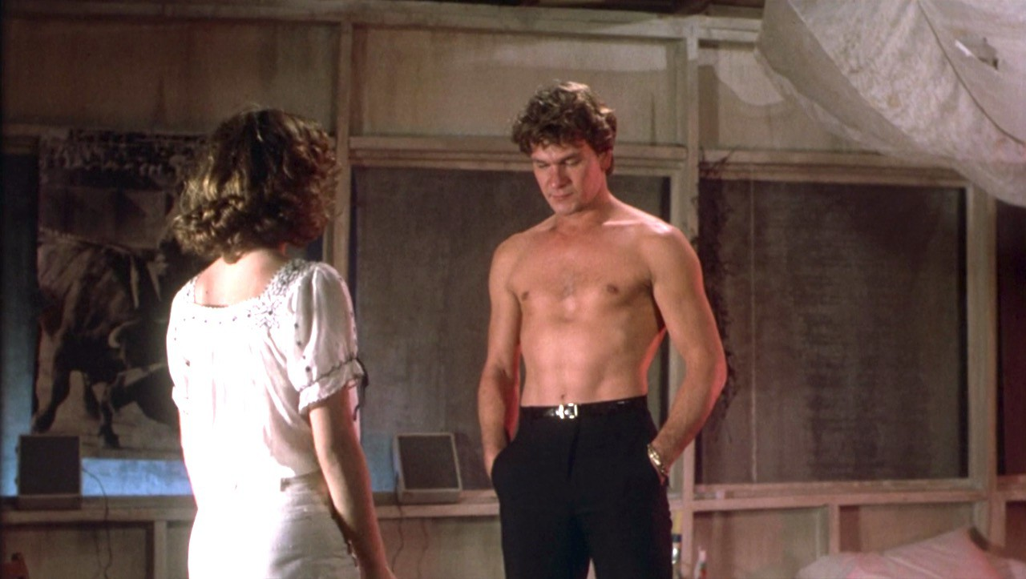
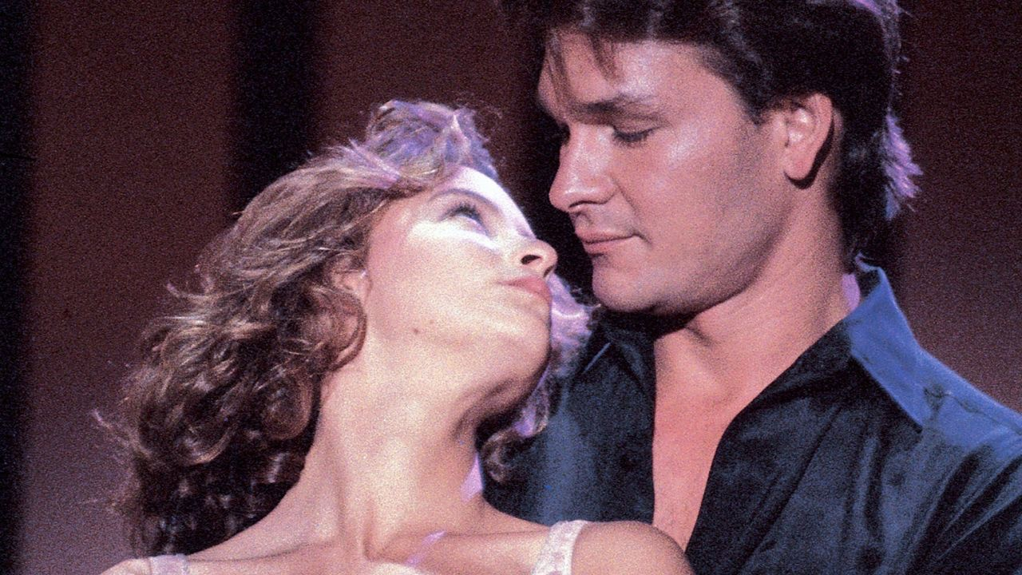
11
‘These films successfully sexualized their male characters and created space for a female gaze in an industry typically more accustomed to the male gaze.’
(Antifantis, 2:2021)


12

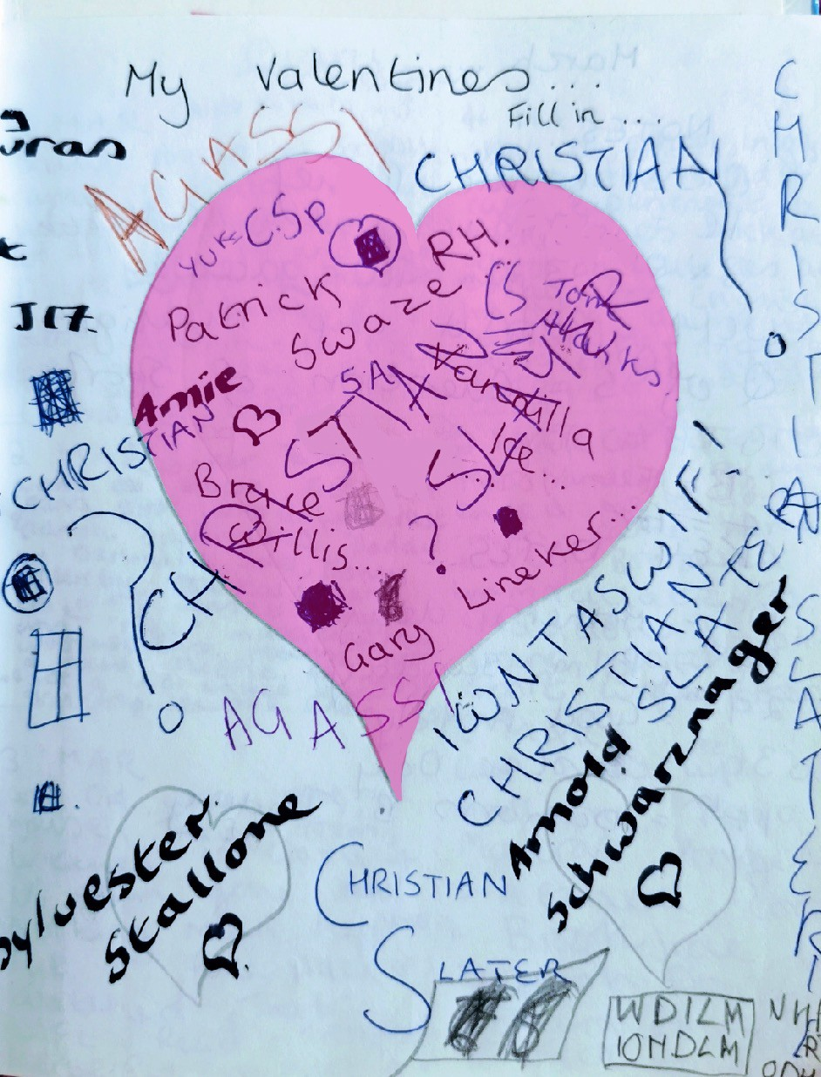
13

- Feminist Epistemology
- Autoethnography
- Participatory Enquiry
- Group interviews & discussion
- Visual Ethnography
‘Making (external things).. gives the person opportunity to reflect upon their selfhood’.
(7:2005, Gauntlett)


14

‘Writing about others,  particularly those who have shared experiences with you, is always an ethical test’  Pelias (132:2019) |  | - Negotiating Relationships  - Anonymity & Confidentiality  - Group Sizes
 |  | 4. Reciprocity
15




16

Part 7: References

ADEMULO, E., (2021): A pictured Africa: drawing as a visual qualitative research methodology for examining British African Diaspora imaginings of their ancestral ‘home’, Visual Studies, DOI: 10.1080/1472586X.2021.1942187

ANIFANTIS, G., (2023, April 21). Pleasure Principles + Raunchy Rhythms: Depictions of dance and the female gaze in Magic Mike and Dirty Dancing. Spotlight: Romance, Issue V. Retrieved from https://www.spotlightjournal.org/issue-v/pleasure-principles-raunchy-rhythms-depictions-of-dance-and-the-female-gaze-in-magic-mike-and-dirty-dancing, accessed 17 Sept. 2025.

BAGNOLI A., (2009). Beyond the standard interview: the use of graphic elicitation and arts-based methods. SAGE Publications.

BAGNOLI, A., (2004). Researching Identities with Multi-method Autobiographies. Sociological research online, 9(2), pp. 1–15.

BERGER, J., (2008). Ways of seeing. Penguin Modern Classics. London, England: Penguin Classics.

BUCKINGHAM, D., (2009). Creative' visual methods in media research: possibilities, problems and proposals. Media, culture & society, 31(4), pp. 633–652.

DANIELS, D., (2010). Telling My Story: Being a Feminist Researcher in Higher Education. South African journal of higher education, 24(1), pp. 5.

DUNAGAN, C, and FENTON, R L., 'Dirty Dancing: Dance, Class, and Race in the Pursuit of Womanhood', in Melissa Blanco Borelli (ed.), The Oxford Handbook of Dance and the Popular Screen(2014; online edn, Oxford Academic, 2 Oct. 2014), https://doi.org/10.1093/oxfordhb/9780199897827.013.010, accessed 17 Sept. 2025.

FENG, Y., (2023). "The Research on the Gaze Theory and Feminist Film." BCP Education & Psychology, CEPC 8: 308–311.

GAUNTLETT, D., (2005) Using creative visual research methods to understand media audiences MedienPädagogik: Zeitschrift für Theorie und Praxis der Medienbildung 9, pp.1-32

HOVE SØRENSEN, T. L., & ERIKSSON, B. (2024)., Threads of Participation: Crafting Female Agency in a Collaborative Art Project in Denmark. Conjunctions. Transdisciplinary Journal of Cultural Participation, 9(1), 1–16. https://doi.org/10.2478/tjcp-2022-0003

JENNER, M. (2022)., Looking at men: 1980s middlebrow TV and visual culture. Journal of Popular Television, 10(1), 59-78. https://doi.org/10.1386/jptv_00070_1
KELLY, PJ., (2005) Practical suggestions for community interventions using participatory action research. Public Health Nurs. 2005 Jan-Feb;22(1):65-73. doi: 10.1111/j.0737-1209.2005.22110.x. PMID: 15670327.

LITERAT, I., (2013). A Pencil for your Thoughts: Participatory Drawing as a Visual Research Method with Children and Youth. International journal of qualitative methods, 12(1), pp. 84–98.

MOORE, P., (2005) ‘We are the Geordies: A new exhibition gets to the creative core of Newcastle United’ https://www.itsnicethat.com/articles/jimmy-turrell-joonho-b-ko-ewan-spencer-will-knight-graphic-design-illustration-project-210825 accessed 20/09/2025

MULVEY, L., (1975) Visual Pleasure and Narrative Cinema, Screen, Volume 16, Issue 3, Autumn 1975, Pages 6–18, https://doi.org/10.1093/screen/16.3.6

PERFETTI- OATES, N., (2015). Chick Flicks and the Straight Female Gaze: Sexual Objectification and Sex Negativity in New Moon, Forgetting Sarah Marshall, Magic Mike, and Fool's Gold.

PELIAS, R., (2019). The creative qualitative researcher: Writing that makes readers want to read. London: Routledge.

PINK, S., (2014). Digital–visual–sensory-design anthropology: Ethnography, imagination and intervention. Arts and humanities in higher education, 13(4), pp. 412–427.

PORTER, L. (2023). “Please the women or die”: silent cinema and the construction of female desire. Early Popular Visual Culture, 21(1), 127–151. https://doi.org/10.1080/17460654.2023.2160417

SPARKES, A. C. (2024). Autoethnography as an ethically contested terrain: some thinking points for consideration. Qualitative Research in Psychology, 21(1), 107–139. https://doi.org/10.1080/14780887.2023.2293073

STACEY, J. (1993). Star Gazing: Hollywood Cinema and Female Spectatorship. Routledge. https://doi.org/10.4324/9781315003504

TATSENKO, P. and TATSENKO, N., (2022). A journey through the female gaze: media and art perspective. British and American studies : B.A.S, 28(28), pp. 233–240.

WILES, R., Prosser, J., Bagnoli, A, Clark, A. Davies, K., Holland, S., Renold, E. (2008) Visual Ethics: Ethical Issues in Visual Research, ESRC National Centre for Research Methods Review Paper, http://eprints.ncrm.ac.uk/421/1/MethodsReviewPaperNCRM-011.pdf

Part 8: Bibliography

ANSELMO, D.W., (2022). Picture Pain: Anti-heteronormative Female Fandom in Early Hollywood. JCMS : Journal of cinema and media studies, 62(1), pp. 7–35.

ANSELMO, D.W., (2019). Bound by Paper: Girl Fans, Movie Scrapbooks, and Hollywood Reception during World War I. Film history (New York, N.Y.), 31(3), pp. 141–172.

ANSELMO-SEQUEIRA, D., (2015). Screen-Struck: The Invention of the Movie Girl Fan. Cinema journal, 55(1), pp. 1–28.

BAUMANN, S.E., MERANTE, M., FOLB, B.L. and BURKE, J.G., (2019). Is Film as a Research Tool the Future of Public Health? A Review of Study Designs, Opportunities, and Challenges. SAGE Publications.

BENSON-ALLOTT, C., (2017). No such thing not yet; questioning television’s female gaze. Film Quarterly, 71(2), pp. 65–71.

BOLIN, G., (2015). Passion and nostalgia in generational media experiences. European Journal of Cultural Studies, 19(3), pp. 250.

BRAND-FISHER, S., (2021). Proto-cinephilia: retheorizing working class women's moviegoing pre-1920. Early popular visual culture, 19(4), pp. 301–323.

BUSETTO, L., WICK, W. and GUMBINGER, C., (2020). How to use and assess qualitative research methods. Springer Science and Business Media LLC.

COBB, S. and WILLIAMS, L.R., (2020). Histories of now: listening to women in British film. Women's history review, 29(5), pp. 890–902.

COHEN, J., (2001). Defining Identification: A Theoretical Look at the Identification of Audiences With Media Characters. Mass communication & society, 4(3), pp. 245–264.

FAZEKAŠ, A., (2018). I Love Dick: A Pop-Cultural Investigation of Desire and the Female Gaze. AM, Art + Media : journal of art and media studies, (17), pp. 89–102.

GAINER, J.S., (2010). Critical Media Literacy in Middle School: Exploring the Politics of Representation. Journal of adolescent & adult literacy, 53(5), pp. 364–373.

GATT, A., (2022). Is There Really Equality in the Art World, or Is History Repeating Itself?: The Art and Market of Cecily Brown. The international journal of social, political and community agendas in the arts, 17(2), pp. 19–34.

GINIS, K., STEWART, S.E. and KRONBORG, L., (2023). Gender and Artistic Creativity: The Perspectives and Experiences of Eminent Female Visual Artists. The Journal of Creative Behavior, 57(4), pp. 622–649.

IRWIN, R.L., BEER, R., SPRINGGAY, S., GRAUER, K., XIONG, G. and BICKEL, B., (2006). The Rhizomatic Relations of A/r/tography. Studies in art education, 48(1), pp. 70–88.

MCKEE, A.L., (2021). To Have and to Hold: The Possessive Spectator, the Spinster Narrative, and Katharine Hepburn in David Lean’s Summertime (1955). Journal of film and video, 73(2), pp. 26–45.

MITCHELL, C., (2008). Getting the picture and changing the picture: visual methodologies and educational research in South Africa. South African journal of education, 28(3), pp. 365–384.

MURRAY, L. and NASH, M., (2017). The Challenges of Participant Photography: A Critical Reflection on Methodology and Ethics in Two Cultural Contexts. Qualitative health research, 27(6), pp. 923–937.

NOOR, H., (2007). Assertions of identities through news production: News-making among teenage Muslim girls in London and New York. European journal of cultural studies, 10(3), pp. 374–388.

ORGERON, M., (2003). Making "It" in Hollywood: Clara Bow, Fandom, and Consumer Culture. Cinema journal, 42(4), pp. 76–97.

ORWIN, A., (2002). Women's stories, women's films: Integrating women's studies and film production. Women's Studies Quarterly, 30(1/2), pp. 271–284.

PINK, S., (2014). Digital–visual–sensory-design anthropology: Ethnography, imagination and intervention. Arts and humanities in higher education, 13(4), pp. 412–427.

POWER, T., JACKSON, D., WEAVER, R., WILKES, L. and CARTER, B., (2012). Autobiography as genre for qualitative data: A reservoir of experience for nursing research. Collegian (Royal College of Nursing, Australia), 19(1), pp. 39–43.

ROSE, G., (2014). On the relation between 'visual research methods' and contemporary visual culture. The Sociological review (Keele), 62(1), pp. 24–46.

SCAHILL, A., (2012). "Wonderful, Heavenly, Beautiful, and Ours": Lesbian Fantasy and Media(ted) Desire in Heavenly Creatures. Journal of lesbian studies, 16(3), pp. 365–375.

SCHEFLAN-KATZAV, H., (2021). Visual literacy and gender sensitivity: teaching art from a feminist perspective. Journal of visual literacy, 40(3-4), pp. 170–188.

WHITEHEAD, K., (2024). How should feminist studies in the United States mobilize for action? WSQ: Women's Studies Quarterly, 52(1-2), pp. 85–92.

