Writing Module: Data Handling and Business Intelligence

Student Name: Renaldo Jose Juman

Student ID: 2114362

Module Code: LCBB5000

Tutor: Dr. Zahra Mohammadnazari

Assignment Title: Report 2 on Coffee Consumption

Table of Contents
Introduction 4
Report on Coffee Consumption and Effects Analysis 4
Excel Analysis 5
Excel Data Presentation 9
Using SPSS Software to Perform Correlation Analysis 12
SPSS Scatter Plot for Data Presentation. 14
Conclusion 17
Section 2 Excel 18
Advantages 18
Disadvantages 19
Section 2 SPSS 20
Advantages 20
Disadvantages 20
Section 2 Tableau 21
Advantages 21
Disadvantages 21
Data Mining Cycle 22
Importance of Data Mining Cycle 22
References 23

Figure 1: Selecting the different functions from the formulas tab in Excel. 5
Figure 2: Adding the ranges for data selection in excel. 6
Figure 3: The standard deviation formulas in excel. 6
Figure 4: Formula for variance in excel. 7
Figure 5: Excel worksheet with the answer's values. 7
Figure 6: Using IF formula to compare the variances and the standard deviations. 8
Figure 7: Inserting chart in excel. 10
Figure 8: Excel chart (Scatter chart) for the data presentation. 11
Figure 9: Performing a bivariate correlation on SPSS (Selection of Variables). 12
Figure 10: Bivariate correlation output. 13
Figure 11: Inserting a scatter plot in SPSS graphs. 14
Figure 12: Selecting simple scatter plot in SPSS. 14
Figure 13: Setting the X and Y axis for the Scatter Plot. 15
Figure 14: Scatter Plot output screen in SPSS. 15
Figure 15: Data Visualization (Collins, 2019). 18

Introduction

Report on Coffee Consumption and Effects Analysis

The analysis aimed to compare parallel statistical features using Excel and SPSS programs on the dataset named 'Coffee_Consumption_and_Effects_2024. The first step involves calculating the mean, median, and mode of coffee consumption per day among the people who took part in the survey which based on the results, identifying the typical and most common amounts of coffee consumed daily. Additionally, we found the standard deviation of the scores in the health index sector, which was used to measure the variation in the outcomes of health in the dataset. This allowed them to get a grasp of the level of health of the participants.
Moreover, we also observed the standard deviations with two standard deviations of data analysis and noted that the one with the higher or lower value told which data had more range, whereas the other told the dispersion. Finally, the discussions were carried out regarding the conclusions by analyzing different aspects, and we realized the effects of coffee consumption on human health, including the consumption pattern and possible consequences on health outcomes. By means of these questions, we gather total know-how about the link between coffee intake and human health effects by using a dataset for analysis of the first order.

Excel Analysis

In this section, I conducted an in-depth analysis on the dataset.
"Coffee_Consumption_and_Effects_2024", focusing on the relationship between coffee consumption and health index scores. We make use of statistical software such as Excel and SPSS in our research to do various analyses so as to get a grasp of those identified variables. First, we apply Excel, which helps us compute the mean, median, and mode of daily coffee consumption. The mean coffee consumption is computed using the formula: The mean coffee consumption is computed using the formula: mean = AVERAGE (B2:B42). As to computing, the mean coffee consumption is 3.625 cups per day, which gives an average intake among participants and a daily amount among all participants. Furthermore, the middle median coffee consumption, which represents half of the accumulated data from the least to the highest [(n+1)/2], is 3.5 cups/day, a finding that offers an idea about the central tendency of the database (Sez, 2023). Additionally, by determining the mode of coffee consumption that represents the most frequently recorded value and finding it to be 2 cups per day.
Here is the procedure of adding the different functions.
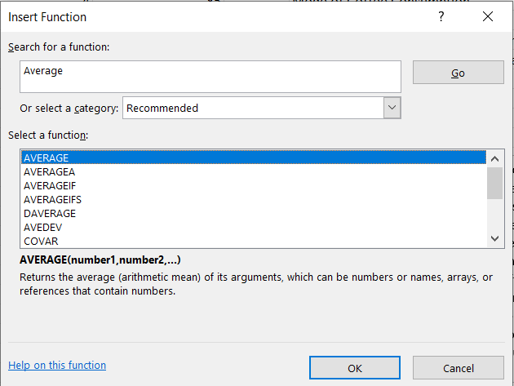
Figure 1: Selecting the different functions from the formulas tab in Excel.
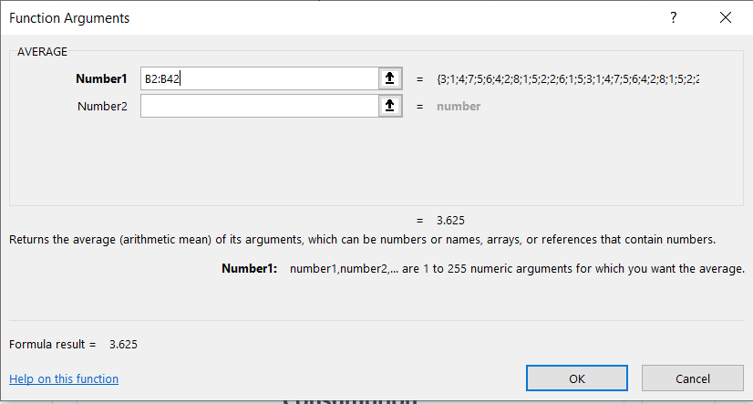
Figure 2: Adding the ranges for data selection in excel.

After that, we computed the standard deviations for the health index scores in the dataset as a measure of variability in the health outcomes. Standard Deviation = STDEV (C2:C42). On completion of the computation, we found the standard deviation to be 13.24365414, which shows the scatter or dispersion of health indices among the participants. Additionally, the standard deviation was calculated for coffee intake and found to be 2.057759704.
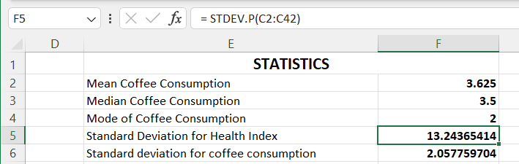
Figure 3: The standard deviation formulas in excel.

When looking at the standard deviations, we saw the larger standard deviation for the health index (13.24365414), which means that the health outcomes are affected by more variability than coffee consumption (2.057759704). Additionally, the difference in variances showed that the health index score (175.394375) has a larger variance compared to coffee consumption (4.234375), which indicated greater variability in outcomes.
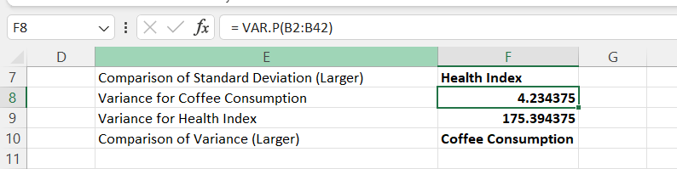
Figure 4: Formula for variance in excel.

Here are the different formulas that I used for my analysis.
- Mean value for coffee consumption (in cups) per day = AVERAGE (B2:B42)
- Median value for coffee consumption (in cups) per day = MEDIAN (B2:B42)
- Mode of coffee consumption (in cups) per day = MODE.SNGL (B2:B42)
- Standard deviation for effects on the human body (based on a health index score) = STDEV.P (C2:C42)
- Standard deviation for coffee consumption (in cups) per day = STDEV.P(B2:B42)
- Comparison of standard deviation = IF (F5 > F6, "Health Index", IF (F5 < F6, "Coffee Consumption", "Equal"))
- Variance for Coffee Consumption = VAR.P(B2:B42)
- Variance for Health Index = VAR.P(C2:C42)
- Comparison of variance = IF(F8> F9, "Health Index", IF (F8 < F9, "Coffee Consumption", "Equal"))
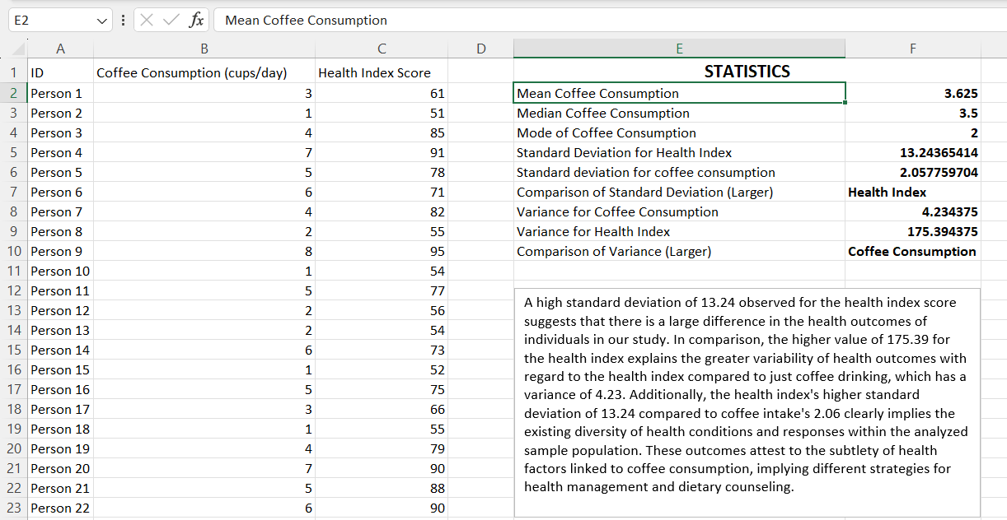
Figure 5: Excel worksheet with the answer's values.
A high standard deviation of 13.24 observed for the health index score suggests that there is a large difference in the health outcomes of individuals in our study (Guerrero, Guerrero & Rauscher, 2019). In comparison, the higher value of 175.39 for the health index explains the greater variability of health outcomes regarding the health index compared to just coffee drinking, which has a variance of 4.23.
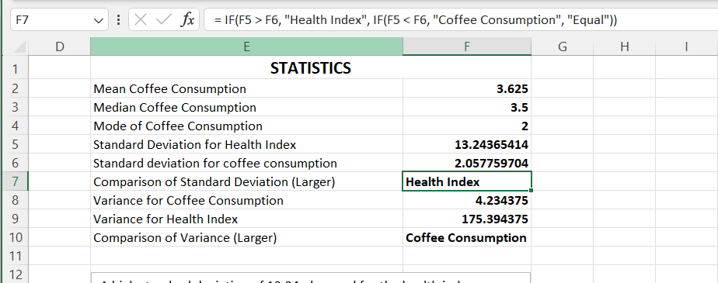
Figure 6: Using IF formula to compare the variances and the standard deviations.

Additionally, the health index's higher standard deviation of 13.24 compared to coffee intake's 2.06 clearly implies the existing diversity of health conditions and responses within the analyzed sample population. These outcomes attest to the subtlety of health factors linked to coffee consumption, implying different strategies for health management and dietary counseling.
This type of analysis gave us important insights into the patterns and correlations between the coffee consumption behavior and its effect on human health contained in this data. Using statistical formulas in Excel, the data was examined robustly, enabling the cell to draw the right conclusions and give sound recommendations.

Excel Data Presentation

To represent the link between the coffee drinking and health index score in my data set, I decided to use a scatter chart. By using this type of chart, the individual data points of each participant, plotted on a horizontal axis of coffee consumption levels and health index scores on a vertical axis, can be effectively displayed. The scatterplot acts as the perfect tool for visually displaying the connection between coffee consumption and the health index score. Through visualizing the distribution of data points and discovering any groupings or patterns, researchers can gather the related associations between these variables. Through this depiction, one can gain a deeper understanding of the data at hand and then develop future research ideas to decipher the intricate connection between coffee consumption and health outcomes. Through depicting the data in such a way, I want to find out whether there are any existing connections between the two variables or if I am observing any other patterns. Every data point that is shown on the scatter chart corresponds to one person, which makes it possible to compare and analyze the impacts of coffee consumption on health parameters.

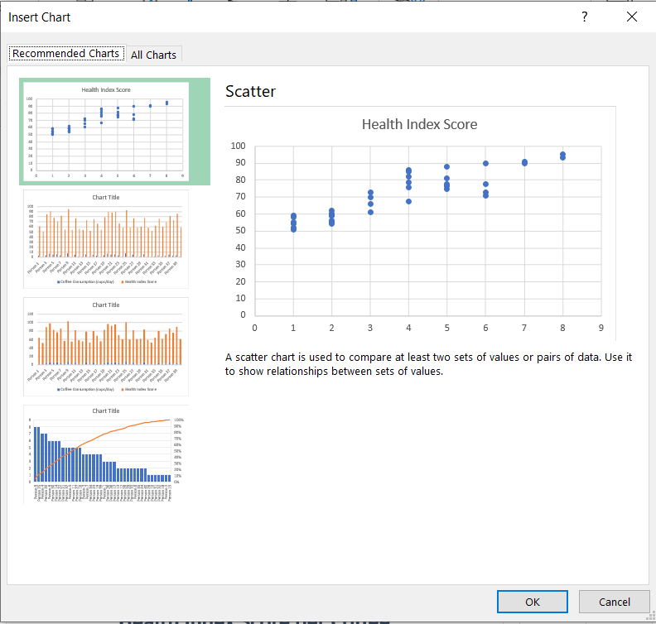
Figure 7: Inserting chart in excel.

Having chosen the right data interval, I drew the scatter plot in Excel to graph the connection between coffee consumption and health index scores. This included the steps that involved going to the "Insert" tab, selecting "Scatter" from the Chart group, and choosing the plot type. After the chart was created, I did the formatting for it to have better readability and visual appeal. This consisted of adding axis titles, adjusting the scale, and finally applying suitable styles and colors to the chart to make data points clear and specific. After the scatter chart was formatted, I checked the distribution of the data points and sought for any observable patterns and/or correlations. The scatter plot, on the other hand, made it possible for us to see the relation between coffee consumption and health index scores clearly, so we could do the analysis effectively. By means of this visual representation, I managed to receive relevant information about the relationship between drinking coffee and health indicators within the dataset.

Figure 8: Excel chart (Scatter chart) for the data presentation.

Each data point on the chart stood for one of the participants, and their coffee consumption level was marked on the horizontal axis and then matched with their corresponding health index score on the vertical axis. By doing such an analysis, we can make several observations. There seemed to be a certain tendency for rising health index scores to depend on the levels of coffee intake, which marked a possible link between these variables. Nonetheless, what was also worth noting was a case where participants with lower coffee consumption levels attained higher health index scores; this evidently shows that some other factors affected health indicators. On the scatter plot, there seemed to be data points clustering in some areas, especially around specific levels of coffee intake. This clustering defined a few particles that were common in participants who were alike in terms of coffee intake and health index scores.

Using SPSS Software to Perform Correlation Analysis

I ran a correlation analysis using the data, evaluating the connection between the coffee intake and the health index numbers. I discovered a strong positive correlation with an R value of 0.905. This implies that as my daily cups of coffee get higher, my health index scores also get better. The significance level attached to the correlation coefficient was 0.000, which translates to statistical significance at the 0.01 level (2-tailed). The findings from this experiment, which had a sample size of 40, are very important evidence of the correlation between coffee consumption and health outcomes in our dataset.
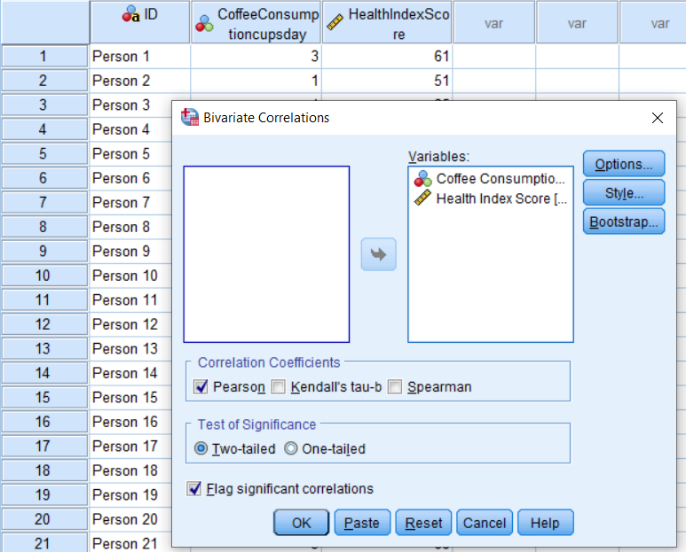
Figure 9: Performing a bivariate correlation on SPSS (Selection of Variables).
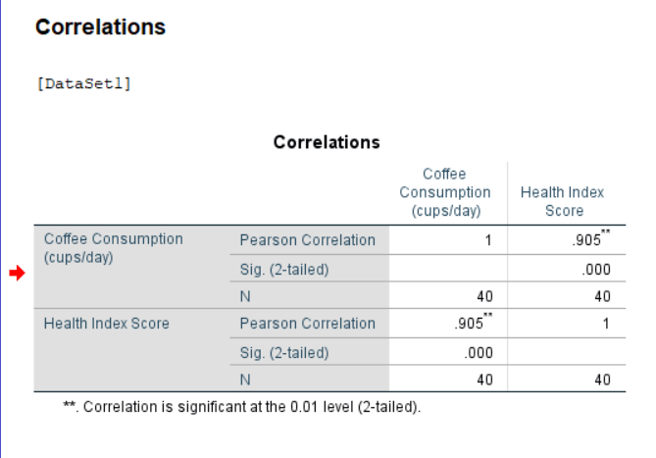
Figure 10: Bivariate correlation output.

The analysis of correlation coefficients reveals a correlation between coffee consumption and health index scores, which are important factors in chronic diseases. Highlighting the strong linear relationship between the two variables is the Pearson correlation coefficient (0.905). Such implication occurs with people who drink more coffee showing higher health index scores, while those taking less coffee have lower health index scores. While the magnitude of the correlation coefficient showed it, it was still a substantial trend in the data that registered a consistent relationship between coffee intake and health outcomes. The correlation coefficient of 0.905 (Pearson’s r) demonstrates a strong linear relationship between the two variables (Pallant, 2020). This implies that people drinking more coffee usually have higher health indices, while those drinking less coffee usually have lower health indices among them.
Moreover, the p-value (Sig.) attached to the correlation coefficient is 0.000, denoting statistical significance at the 0.01 interval (2-tailed). Easy-to-say, this points to the high probability of randomness behind such a strong correlation. Therefore, the conclusion is formulated because of a sample size of N = 40, which depicts the number of data points (participants) considered to be included in the analysis. These results overall show a connection between coffee drinking habits and health index outcomes in this data set, implying that coffee drinking has an impact on the level of health of individuals.

SPSS Scatter Plot for Data Presentation.

Using the given data about coffee drinking (cups/day) and Health index scores, we are testing the correlation between these two factors. Through consideration of the association between coffee consumption and health index rates, we cannot find any pattern. A scatter plot of correlation visually represents the data in the form of points indicating the direction and strength of the correlation (Roni & Djajadikerta, 2021).
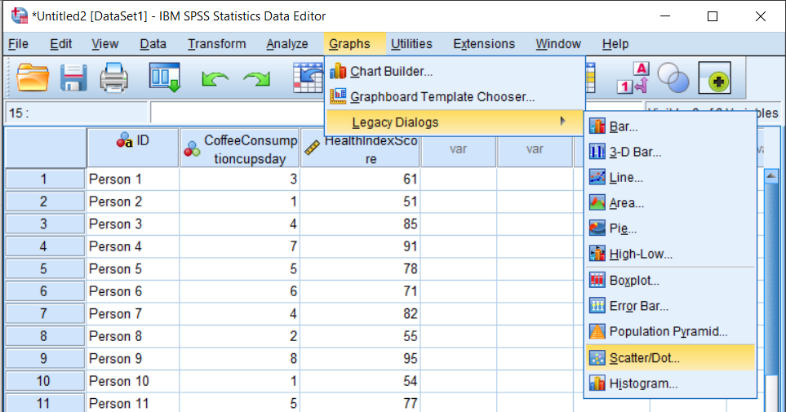
Figure 11: Inserting a scatter plot in SPSS graphs.
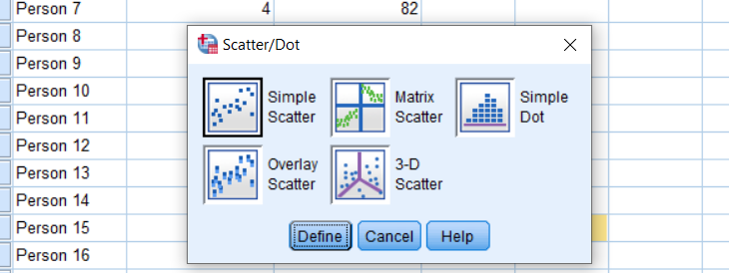
Figure 12: Selecting simple scatter plot in SPSS.
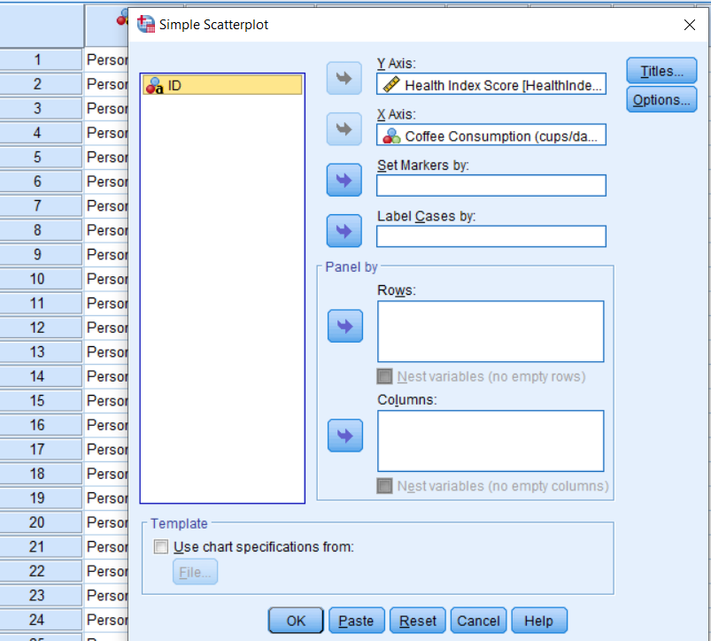
Figure 13: Setting the X and Y axis for the Scatter Plot.
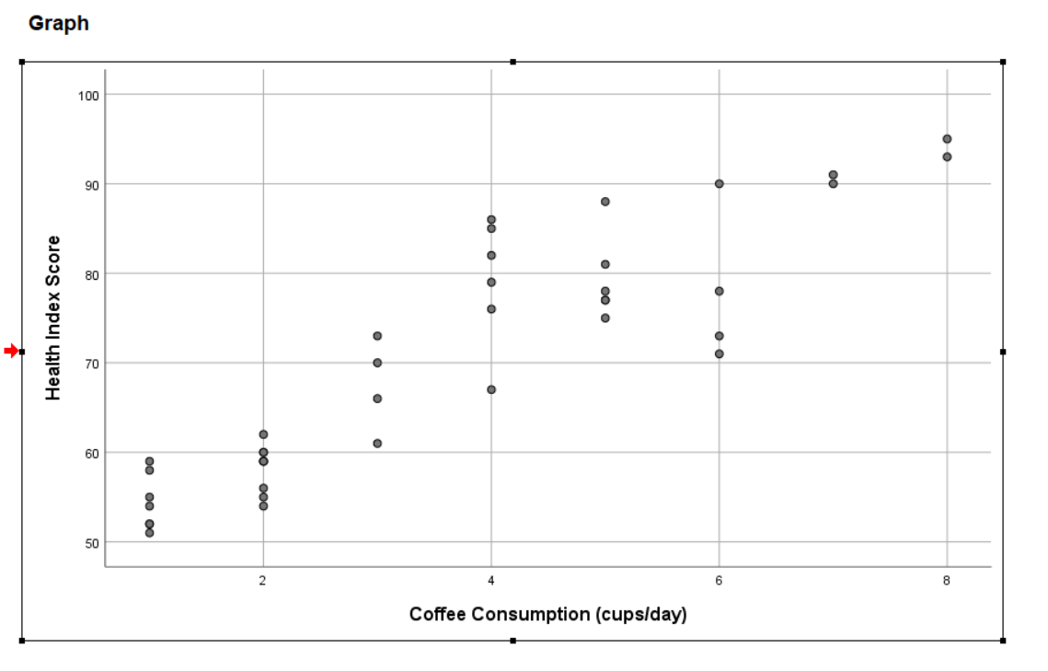
Figure 14: Scatter Plot output screen in SPSS.

The given data suggests that coffee consumption may have a positive correlation with health scores. Since the more coffee (cups per day) consumers take, their health index scores keep rising. It therefore means that there could be some benefits associated with higher coffee intake for health outcomes that are reflected in the health index. It's also worth pointing out that correlation is not the same as causation. Other factors that are not covered in this dataset might affect both the coffee-drinking behavior and health index scores. Thus, although the data implies a link between them, more research is needed to find a reason for this and how the connection works.

Conclusion

In this in-depth analysis of the impact of coffee consumption on health, we applied the static methods and software available to investigate the interaction between these variables. Via Excel and SPSS analysis, we were able to see relevant trends that explain the relationship between coffee intake and health results. In our analysis of the data set, the following were the major findings: Firstly, we calculated the mean, the median, and the mode of coffee consumed per day, providing useful information regarding the typical and most consumed amounts of coffee among the participants. Further, the estimated standard deviation for the health index scores was determined to emphasize the variations in health outcomes in the data set.
The standard deviations and variances compared were another method that helped to understand the differences in variability between coffee consumption and health index scores. A larger standard deviation and variance noted on the health index scores indicated the many health outcomes experienced by the participants. A visual interpretation of the association between coffee consumption and health index scores was represented using scatterplot analysis in both Excel and SPSS. While the correlation analysis showed a high positive correlation between these variables, the scatter plot indicated patterns and trends that might need a deeper examination. Using statistical methods and visualization techniques, we discovered valuable trends that may help formulate future directions in public health and dietary guidelines.

Section 2 Excel

Advantages

In high schools, the Microsoft Office Suites which Excel is a part of is taught as an introduction to computer packages. This indicates that most of the people are well-versed with the software, so they can use it conveniently. Excel supports work sharing feature that allows users to share files, and edit with the ability to track who made changes in a particular tab. It is also very convenient to use, the interface is user-friendly so it can do its job without needing any specialist’s knowledge. It is in the ribbon that all the Excel commands are found, some of which even have a visual representation of what these commands are meant for. This makes Excel usable even for the users that know little or nothing about it. Furthermore, it can process data and produce more details like means, totals and linear regression and so, businesses can quickly know how their total revenue changes. Small-scale businesses mainly rely upon using Excel to analyze their financial data because it can produce graphs and other visual representations that are easy to understand by anyone.

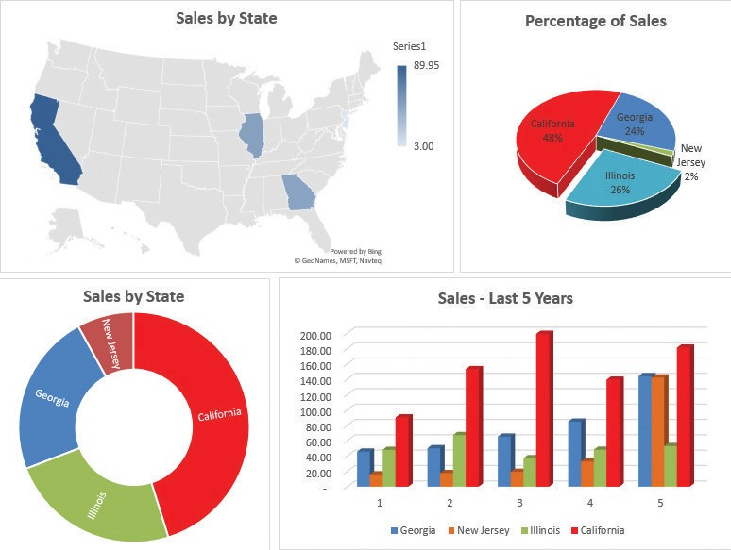
Figure 15: Data Visualization (Collins, 2019).

Disadvantages

Excel cannot handle large sets of data, as this will derail its performance and efficiency in doing calculations and may even crash. It is also not suitable for concurrent editing, where multiple users are editing at the same time, unlike other software that can work efficiently in a collaborative environment such as Google Sheets. The collaborative environment of Excel involves each user editing during their shift, and tracking has to be done manually. Since, in most cases, the data in Excel files is stored locally on a computer or laptop, this data can be easily corrupted by one user. Also, in a situation where the computer crashes, the Excel files are lost, leading to huge data loss. This is unlike other analysis software that has a centralized data storage platform where users can access it, ensuring users, for example, in an organization, have consistent data as when changes are made, they reflect in the centralized data file.

Section 2 SPSS

Advantages

SPSS is software that is designed specifically for data analysis and has a wide range of statistical capabilities, such as descriptive statistics, inferential statistics, factor analysis, and regression analysis, among others. It can handle large sets of data and can perform advanced statistical modeling such as multiple regression, logistic regression, ANOVA, MANOVA, and more. Just like Excel, SPSS provides a variety of graphical data presentations and visualizations, thus enhancing easy data interpretation. Finally, it is possible to automate repetitive tasks by using syntax (Rippey, 2021). A practical example is when a financial analyst analyzing financial data can identify trends in the data and make a forecast. This is possible since SPSS can conduct time-series analysis, regression analysis, and Monte Carlo simulations, which can be used in financial modeling and making financial decisions as well.

Disadvantages

The SPSS license is quite expensive, as it requires a monthly subscription of $99. This means it is limited to only those who can afford the license. Similarly, usage is limited to those who have software knowledge (Rippey, 2021). Learning how to use SPSS takes a lot of time compared to other software, such as Excel. Finally, it has poor graphical presentation and visualization capabilities, hence limiting data interpretation.

Section 2 Tableau

Advantages

If dealing with large datasets, then Tableau is the software to use. It is designed to handle large data sets efficiently. Similarly, it can be integrated with other statistical tools and programming languages, enabling its users to incorporate advanced analytics and predictive modeling into their visualizations (Kar, 2023). Finally, it allows customization, where an organization can tailor its visualization to match their brand.

Disadvantages

While Tableau is one of the most advanced data analysis tools, it requires users to undergo thorough training to master its capabilities and be able to use it smoothly. Similarly, handling large data sets reduces its efficiency and performance as compared to handling small datasets (Kar, 2023). Finally, it requires the use of other statistical analysis tools and programming languages, which, if a user is not familiar with them, may not fully utilize their capabilities.

Data Mining Cycle

Data mining cycle is a multistep process that aims to come up with finer data details that can be used in making critical decisions. It involves defining the problem that needs to be solved, collecting data relating to the problem, analyzing that data to find finer details such as means, correlations, and regression, and even using graphical and visualization methods that are available for ease in data interpretation and modeling solutions (Singh, 2023).

Importance of Data Mining Cycle

In every business, the data mining cycle plays a key role in establishing trends in its revenue and, hence, the ability to model it to increase the revenue it generates and minimize its expenses. Similarly, it helps in analyzing consumer behaviors and, hence, attaining better results in marketing advertisements (Singh, 2023). A good example is when, after data analysis, it is established that the product is preferred mostly by youth. The business can use this information in their marketing strategies to focus on one target audience and, hence, achieve maximum returns.
The data mining cycle is essential in establishing patterns and trends hidden in large data sets that traditional data mechanisms cannot establish. Through this, business managers and stakeholders can make informed decisions based on the finer details they have acquired after analysis (Singh, 2023). This can help in risk management, as investments that have a negative trend can be abandoned while more capital can be directed to those that have positive trends. Finally, through the analysis of financial data within an organization, fraud schemes can be easily identified, and mitigation measures can be adopted to minimize losses in revenue as well.

References

Collins, J. (February 1, 2019). Microsoft Office: Tips for Excel-based financial reports. Journal of Accountancy. https://www.journalofaccountancy.com/issues/2019/feb/excel-based-financial-reports.html
Guerrero, H., Guerrero, R., & Rauscher. (2019). Excel data analysis. Springer International Publishing. https://doi.org/10.1007/978-3-030-01279-3
Kar, U. (October 11, 2023). Pros & Cons of Using Tableau For Your Projects. Knowledge Hut. https://www.knowledgehut.com/blog/business-intelligence-and-visualization/tableau-advantages-disadvantages
Mehar, A. (December 14, 2023). What are the Advantages and Disadvantages of MS Excel? Alma Better. https://www.almabetter.com/bytes/articles/advantages-and-disadvantages-of-ms-excel
Pallant, J. (2020). SPSS survival manual: A step by step guide to data analysis using IBM SPSS. McGraw-hill education (UK).
Rippey, P. (September 21, 2021). Pros & Cons of SPSS. Doing Social Research. https://doingsocialresearch.com/pros-cons-of-spss/
Roni, S. M., & Djajadikerta, H. G. (2021). Data analysis with SPSS for survey-based research. Singapore: Springer. https://doi.org/10.1007/978-981-16-0193-4
Sez, S. (2023). Introduction to Data Analysis with Excel: 2-Hour Training Tutorial [Video]. Www.youtube.com; Simon Sez IT. https://www.youtube.com/watch?v=kghcAk7l6eA

Singh, A. (January 24, 2023). What is Data Mining and why is it Important - Benefits, Applications, Techniques. Koening Solutions. https://www.koenig-solutions.com/blog/what-is-data-mining-and-why-is-it-important-benefits-applications-techniques#:~:text=Data%20mining%20ensures%20that%20useful,helps%20in%20forecasting%20customer%20behavior

