Introduction
In this report I will be explaining my journey so far within my career. I will discuss my personal career development plan. I will carry out a SWOT analysis on myself including theories I have used in my own development. Reflecting often on my career will help me to develop a career strategy, planning my objectives and putting steps to achieve them. A career development plan provides a benchmark which helps to create a clear picture of where I am heading, therefore allowing me to monitor my progress. A plan will aid me to recognise my strengths and weakness and reach out for the opportunities that I may find along the journey. Furthermore, I want to establish employment goals. Grow my confidence to be able to attend an interview and express myself in the best possible way.
Self-Evaluation
I would say the main difficulty for me has been confidence and this is due to English being my second language. I was really shy and nervous. I was not sure how to speak to my lecturer and more importantly my fellow students. I feared I would be ridiculed due to not being able to conversate with them. I also most felt intimidated by my surroundings. The unfamiliar faces all staring at me waiting for me to say something wrong. These moments made me feel very low and insecure. Each day I would go home and sit down deep in my thoughts. What could I do differently. Whom should I speak to regarding the way I feel. Having been in this country since 2010 and having done all my education back in Bangladesh this was the biggest challenge I have faced in my life so far. How will I overcome this? A question that circulated in my mind for the first few months. However, as time gradually passed and weeks became months and all the work I had done at home to overcome this barrier, I made sure I always conversated in English with my partner and kids to further progress my presenting skills and enhance my credence.
I have had the ultimate golden chance throughout this year to work equal with fellow students on a group presentation. Lucky for me this was not required at the beginning of my academic year as this would have a daunting experience had it been at the beginning. How would I be able to work with these strangers when I struggle to articulate. I was always conscious of my surroundings. Would my peers frown upon me when they realised my English is not that great. This has undoubtedly situated me in a place of testing myself further in developing my communication skill. I will continue to focus on progressing my transmission skills a bit more. I am strong-willed independent that explosively fells the greatest way ahead for this is to organize when the right set of circumstances appears workshops or classes. Becoming a good communicator will have effective impression on my exclusive community based association.
Johari Window: “The Johari Window model is a simple and useful tool for illustrating and improving self-awareness, and mutual understanding between individuals within a group. The Johari Window model can also be used to assess and improve a group's relationship with other groups. Today the Johari Window model is especially relevant due to modern emphasis on, and influence of, 'soft' skills, behaviour, empathy, cooperation, inter-group development and interpersonal development.”
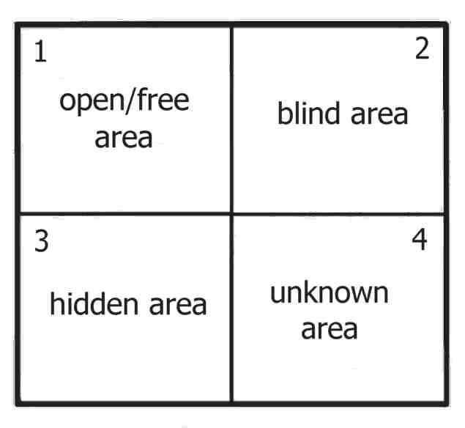

Four regions
- “What is known by the person about him/herself and is also known by others - open area, open self, free area, free self, or 'the arena'
- What is unknown by the person about him/herself, but which others know - blind area, blind self, or 'blind spot'
- What the person knows about him/herself that others do not know - hidden area, hidden self, avoided area, avoided self or 'facade'
- What is unknown by the person about him/herself and is also unknown by others - unknown area or unknown self.”
www.businessballs.com
Self-Motivation
“Motivation is one of the forces that lead to performance. Motivation is defined as the desire to achieve a goal or a certain performance level, leading to goal-directed behaviour. When we refer to someone as being motivated, we mean that the person is trying hard to accomplish a certain task. Motivation is clearly important if someone is to perform well; however, it is not enough. Ability or having the skills and knowledge required to perform the job is also important and is sometimes the key determinant of effectiveness.”
https://saylordotorg.github.io/text_organizational-behavior-v1.1/s09-theories-of-motivation.html
Initially it was really difficult for me to motivate myself to continue as the struggles were mounting up. I kept doubting myself. Did I make the right choice? How will I fit in? I had to make the first move. I made the first approach to a fellow student, introducing myself and trying to build a connection and friendship. This was the first step in the right direction. Someone to talk to, share my thoughts and concerns. Eventually to create a momentum and gather motivation and enthusiasm. Day by day I was getting more involved in my classes. I could feel the motivation growing within me.
The was an eagerness to attend my classes and continue to nurture my confidence. My new friend gave me this added belief that I should not look back n more. I am heading in the right direction. Self-belief was now evident.
“Learning is the process whereby knowledge is created through the transformation of experience”
(Kolb, 1984, p. 38)
“David Kolb published his learning styles model in 1984 from which he developed his learning style inventory. Kolb's experiential learning theory works on two levels: a four-stage cycle of learning and four separate learning styles. Much of Kolb's theory is concerned with the learner's internal cognitive processes. Kolb's experiential learning style theory is typically represented by a four-stage learning cycle in which the learner 'touches all the bases.”

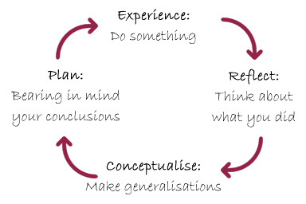
“Experience - a new experience or situation is encountered, or a reinterpretation of existing experience).
Reflective - of particular importance are any inconsistencies between experience and understanding).
Conceptualization - reflection gives rise to a new idea, or a modification of an existing abstract concept the person has learned from their experience).
Plan - the learner applies their idea(s) to the world around them to see what happens).”
(Saul Mcleo, 2017.)

“Honey and Mumford Learning Styles: Honey and Mumford learning styles were developed by Peter Honey and Alan Mumford in 1986. Their work is inspired from and built upon Kolb’s learning styles model (Leaver, 2005). however, they produced their own Learning Styles Questionnaire (LSQ) because it was found that Kolb’s LSI had low validity with managers.
Therefore, instead of asking people directly how they learn, as Kolb’s LSI does, Honey and Mumford gave a questionnaire that probes general behavioural tendencies. The rationale behind this is that most people have never consciously considered how they really learn. And to be an effective learner, individuals must know about their learning styles or preferences and find ways to learn using those methods.”

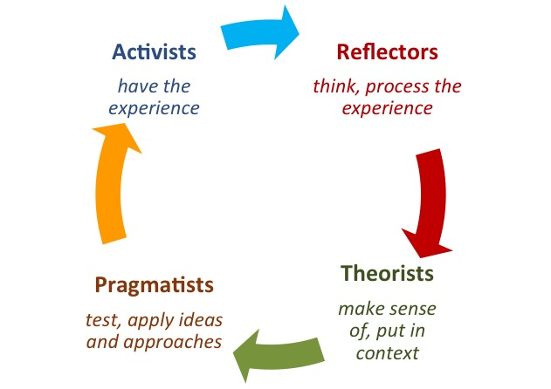
Ruby Rumson 2019 https://resources.eln.io/honey-and-mumford-learning-styles

“Honey & Mumford had mentioned that: -
“Our description of the stages in the learning cycle originated from the work of David Kolb. Kolb uses different words to describe the stages of the learning cycle and four learning styles…
…The similarities between his model and ours are greater than the differences.
Even though the use of different name for the stages that differentiate the work of Kolb and Honey & Mumford, the meaning of these stages tends to be similar.
- Activist = Accommodating = (to feel\to do)
- Reflector = Diverging = (to feel\to watch)
- Theorist = Assimilating = (to think\to watch)
- Pragmatist = Converging = (to think\to do)”
Personal Development Plan
MY | PERSONAL | DEVELOPMENT | PLAN
To be Developed | Expected Goal | Actions I will Make | Success Criteria | Application
Public Speaking | Overcome nervousness | Practice with friends & family | Able to speak confidently in front of crowd | For presentations  and reporting
Read more books & journals | Grow confidence | Visit library regularly | Read books online as well | Broaden my  vocabulary

“A personal development plan is an action plan designed to improve knowledge and abilities. These are typically developed for career planning, performance management or general self-improvement purposes. In some cases, goals and objectives are planned using a formal analysis technique such as a swot analysis.”
simplicable.com
Advantages of PDP | Disadvantages or Limitations of PDP
Career prospects | Lack of impartiality
Self-development | Lack of mindfulness
Job fulfilment | External intervention
Promotions | Difficulty in measuring success
Personal growth | No scope in advancement
Loyalty towards work and towards the organization | Lack of flexibility
Effective communication | Time factor
Efficient career planning | Unsuitable for workplace
Assistance and guidance
Feasible objectives

Chitra Reddy 2016 content.wisestep.com
The expectation of employers is that all potential candidate is confident on the following areas as these are the foundation of a competent individual. These are the necessary skills that are required to be able to carry out a role in any career paths one chooses.
Communication
“The capacity to communicate successfully with colleagues, bosses and team members is vital, no matter what business you work in. Employees in the digital must know how to efficiently convey and receive messages in person as well as via phone, email and social media. Good communication skills will help one to get hired, deliver promotions and hopefully be successful throughout their career”.
(ALISON DOYLE thebalancecareers.com 2018)
Being an active perceiver is most likely identified as the principal form of transmission. It allows one to realised and make sense of the circumstances. It is essential to settle down with consciousness to what the other individual is saying, inquire more comprehensible questions and especially more clearly or convincingly what the person says to make sure understanding so therefore giving the suitable reply. Body language, eye contact, hand gestures and tone of voice are all key feature to distribute the notification. A stress-free open approach and a friendly tone will make you look hospitable and will motivate others to talk flagrantly with you. Eye contact is very determining; you regularly want to conserve eye contact to make sure you are centre of attention on the person and the discussion.
“Our eyes the way we move our eyebrows, the amount of eye contact we give and the extent to which we smile all send messages to others. The challenge is to ensure that the message is interpreted in the way we intend. There are around 250,000 different facial expressions, meaning that the brain has to work very quickly to recognise the signal being sent by others”.
MORGAN, P. (The Business Students Guide to Study & Employability, 2017)
It is essential to be self-assured in your relationship with others. Self-assured manifest that you have confidence in what you’re precepting and will come after in time. A superior communicator should gain access to any discussion with a adjustable, anti-discrimination.
A passage for listening and fellow feeling the other person's point of view, rather than straightforwardly come in to possession of your memorandum across. Being prepared to brust in to a conversation, even with people within the bounds whom you fail to agree, you will be allowed to have extra truthful, high yielding discussion.
People will regularly be open to conversating if they sense their field of vision and proposal are being admire. Usually simple actions like acknowledging a person's name, making eye contact, and energetic listening when a person talk will make the person feel admired. On the phone, keep away from distractions and remain concentrated on the discussion.
Having successful communication skills authorize one to have more supplementary direction for innovation. It helps to near the interval between two people or groups. Moreover, it could help to stimulate innovation. However, on the twist side it can rip up people apart as everyone is individual to one another and have separate levels of interpretation. Communication can be difficult to explain at times. This makes misapprehension more likely simply for the reason that there are so many determined attempts to communicate with another now a days.
Teamwork
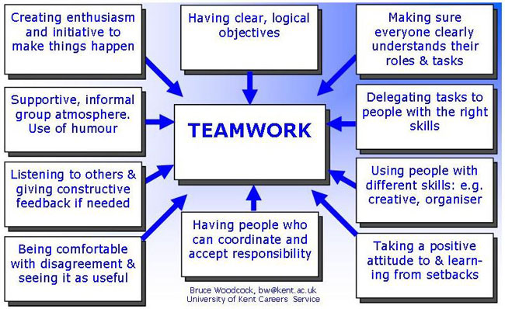
(BRUCE WOODCOCK, University of Kent Career Service)
It is very significant that all member of staff has the same approach of being part of a team and always make an effort to be team players. Teamwork is compulsory for almost every organisation, regardless of whichever sector one is in. In a particular job you may carry out responsibilities by yourself, however there may still be a time when you would have to follow out a task alongside other members of the team. This would at last test your team establishment skills and furthermore your attitude to see how you are when positioned in an environment where you must work with others.
It will confrontation with you to see if you have the capability to look at the bigger picture and reach the goals set by the organisation.
(ALISON DOYLE thebalancecareers.com 2018)
The benefit of teamwork is that everyone is working towards the common goal. You have the advantage of sharing plans and information. As the saying goes “two heads are better than one” (C.S. Lewis). Improved effectiveness as with more people thinking, working and searching for ideas, things are likely to get done faster. But the genuine climax is in the capacity for various people to distinguish flaws about a specific result or idea. This helps eliminate errors and slipups that an individual may fail to notice when working alone.
There are usual encounters when working as a team. Common one is differences between team members. Within every group or team there are identical personalities, backgrounds etc. Team members could well simply start falling out, consolidate with unproductive communication, arguments are certain to emerge. If none of those having lack of agreements will try to work out the issue, any group work will not result in anything at all. Also, when someone no longer feels pleasant about working as a team, the centre of attention wears off. This would let the team down, to stay away from this from happening, it is critical that all the members admire each other’s views and suggestions. If there is lack of agreement, then it should be talk to a mutual and respectful manner. Everyone must be willing to pay attention and co-operate with each other. If circumstances are getting out of hand, the group must take a break to investigation the matter.
(JOSEPH CHRIS, Driving Business Connections 2018)
I have the absolute golden chance during last semester to work alongside fellow students on a group presentation. This will intelligibly place me in a position of challenging myself of how well I do work as a member of a team. Allocate ideas and grasp to help assist our group and reach the goals and aim that we all thoroughly want to execute.
Time Management
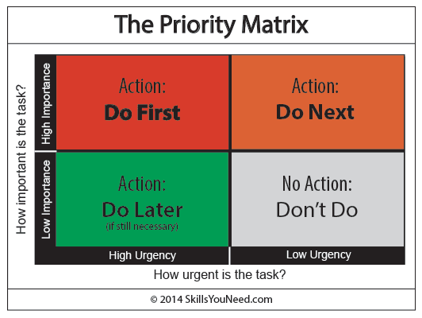
All possible mission or action we aspire to carry out should be put in these for simple pace as highlighted in the chart above. This will allow us to prioritise what needs to be finalized in the order of time. Furthermore, this eliminates spending needless time on task that may be of less seriousness given the time you have on hand. The benefit of time management is it can bring out your imagination, allowing you to juggle tasks. To helps you to understand yourself better manage your time more effectually.
You obtain things done more swiftly as you set aside a time frame for each task therefore being in control of your plan. However, the disadvantage is not always better. Conquering that to-do list may make you feel substantial but be sure to keep it all in balance. No matter how methodical our system, we are never really creating more time. Don’t become a slave to the list. You started those lists to create more time to live. Take some unintended time to do that!
(www.skillsyouneed.com/ps/time-management.html)
Planning & Organising
“Planning and Organising is a method which helps you to focus your ideas and decide on the steps you need to take in order to achieve a particular goal. Planning is vital at all levels in the work place”.
(www.thebigchoice.com)
“Planning and organisation skills are crucial if you want to achieve your goals – they help keep you focussed on doing the right tasks, help you set your priorities and gives you the confidence that you heading in the right direction and eventually reach your desired destination. Organisation skills are also essential for surviving this thing called life – and particularly in today’s hectic world with so many time pressures”.
“Good planning skills can greatly help reduce the stress associated with today’s society, make you feel more in control of your life and help you manage your time better”.
(www.achieve-goal-setting-success.com/planning-and-organisation.html)
Preparation allow us to have a formation put in to position. It authorized us to look which way we are going and are we in the right of way to reach what we have set ourselves. When movements are ultimate and determined it could guide to more effectual result. Detailed plans provide more lucidity more commitment and most importantly more stimulation. People are often motivated when they have straightforward goals and understand how these goals will be attained. Good plan make it easier to lessen doubt and specifies what is look forward to be achieve at the end. People behave more coherently when they have a transparent picture of the target that they are working towards. Plans set performance standards. Planning expresses chosen outcomes as well as signposts to describe progress. These provide a standard for assessing when things are progressing and when they need correction. Potential weaknesses are plans can sometimes prevent flexibility. Although good plans can lead to flexibility, the opposite can also occur. “Mid- and lower-level managers may feel that they must follow a plan even when their experience shows it is not working. Instead of reporting problems to upper managers so changes can be made, they will continue to devote time and resources to ineffective actions. Plans hinder creativity. People may feel they will be judged by how well they complete planned tasks, then creativity, initiative, and experimentation will be inhibited. Success often comes from innovation as well as planning, and plans must not prevent creativity in the organization”.

(lumenlearning.com)

SWOT Analysis

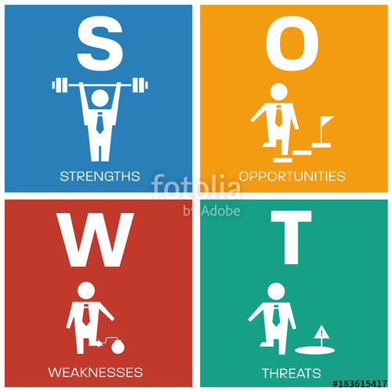

“Strengths and Weaknesses relate to the current delivery of the course (assessing what exists now), Opportunities and Threats focus on the future developments, resulting either from voluntary changes (including some suggested by students) or by evolutions out of our control (student loan system, demographics, etc.)”.
Strengths  e.g. What I liked about the course | Weaknesses  e.g. What I think could be done better about the course
Gives a real insight in to what is expected in the working world and how well prepared I should be by the end of this course.  On completion of this course walk out with a sense of achievement. | Possibly share knowledge and experience from previous students.
Opportunities  e.g. What I think could be included in their course | Threats  e.g. What I think could have a negative impact on the course
Possibly have a work placement or work experience to attain the feeling of reality in the workplace.  More career workshops to increase employability perspectives. | Some course materials were difficult to understand as English is not a first language for all.

Conclusion
In conclusion I firmly believe these four skills are essential, Communication, Teamwork, Time Management and Planning and Organising, which are highly respected by employers. Devising is essential, by taking note my weaknesses and strengths I can formulate a plan on how I can enhance my skill sets. Therefore, I will positioning myself in a superior place to attain the relevant career or job. Creating a Personal Development Plan and SWOT analysis has allowed me to understand and channel my areas of focus. These are truly very important and effective tools which enables me to set a clear direction on what I need to do differently and how I can make it happen. I feel this academic year has given the confidence to have a positive mindset and belief within myself that will optimistically grasp me in good margin to hunt for golden job opportunities.

I intend to focus on my focal point and move on enlarge my communication skills a bit more. I also wish to make certain that I can evaluate my problem solving and decision-making skills which will consistently be of exceptional significance in the years frontwards in both my academic and life in the working world. I am well built-minded independent that strenuously believes the greatest way onwards for this is to be there at when the lucky chance become apparent workshops or classes that may become accessible. I will also focus at the national careers website equal with pay a visit to the local job centre. Edification, vocational training and life-long studying are main pillar of employability. I exist myself into and out of both face to face and online communication. Becoming an expert communicator is an effective clash on my unique social interconnection.

By inspecting face to face and online communication skills, I perceive my strength and weakness and progress a particular plan on how to enhance my employability skills to become more learned. Most significantly I will stare at ways to raise my faith as that is the underpinning that is need to make the commencing step in generate a successful and flourishing future forwards.

References
www.businessballs.com [Accessed on 25th April 2019]
https://saylordotorg.github.io/text_organizational-behavior-v1.1/s09-theories-of-motivation.html [Accessed on 27th APRIL 2019.]
(Kolb, 1984, p. 38)
Saul Mcleod 2017 www.simplypsychology.org [Accessed on 1st May 2019.]
Ruby Rumson 2019 https://resources.eln.io/honey-and-mumford-learning-styles
simplicable.com [Accessed on 2nd May 2019.]
Chitra Reddy 2016 content.wisestep.com [Accessed on 3rd May 2019.]
(ALISON DOYLE thebalancecareers.com 2018) [Accessed on 30th April2019.]
MORGAN, P. (The Business Students Guide to Study & Employability, 2017)
(BRUCE WOODCOCK, University of Kent Career Service)
(JOSEPH CHRIS, Driving Business Connections 2018)
(www.skillsyouneed.com/ps/time-management.html) [Accessed on 3rd May 2019.]
(www.thebigchoice.com) [Accessed on 3rd MAY 2019.]
(www.achieve-goal-setting-success.com/planning-and-organisation.html) [Accessed on 2nd May 2019 (lumenlearning.com)[Accessed on 4th May 2019.]

