Task 1
Introduction
The importance of teachers using Welsh to communicate both in and out of the classroom is acknowledged by Estyn (2017). For this to happen effectively Welsh Government (2017, p.19) recognise that it is crucial practitioners ensure that Welsh skills are being updated and developed continuously in order to provide the most effective pedagogy. Consequently, it is important to reflect on practice in order to identify strengths and areas that could be improved.

Reflection
Within the session most words and phrases I used were correctly pronounced. However, despite using the correct pronunciation during the session, the vocabulary within the book was basic and when asking questions prompts were used. Within the session the children were exposed to the sentence pattern ‘beth ydy hwn?’ in various ways, they heard, wrote, spoke, and saw the pattern. However, when reading the book there needed to be more expression and alteration of tone, in order to model the Welsh language for the children effectively.
When reading the book, I asked multiple valuable questions which stimulated the learning and made the children refer to sentence patterns and knowledge they had obtained prior to this session. These opportunities to recap prior knowledge were provided through questions such as ‘pa liw ydy hwn?’. To improve the session, I should only use Welsh and English when introducing the children to a new sentence pattern as occasionally, I said phrases in English and Welsh that the children were familiar with. Consequently, by doing this I am limiting the opportunity for the children to recap previous knowledge for themselves.
During both the reading of the book and the activity, feedback was provided to the children and I was responding to their work. However, the feedback given was very basic and mostly adjectives such as ‘bendigedig’. To make the feedback more valuable, I should try to be more constructive so the learning can be moved forward, and the children are able to progress. This book provided a perfect opportunity to incorporate role play within the session, for example receiving gifts at a birthday party, and this would have given the children a chance to apply what they were learning to a real-life context.

Oral
With regards to oral ability in Welsh, the video shows me speaking welsh correctly, overall, while discussing the book, asking questions to the children and using simple sentences. From the video and other practice undertaken it could be suggested that I am currently at the foundation stage regarding my oral level of Welsh (Welsh Government, 2019).
Since then one of the ways that I have worked on developing my confidence and fluency of speaking Welsh is by speaking as much general communicational Welsh as possible. It is important to be able to converse with the children both inside and outside of Welsh lessons and this is supported by (Estyn, 2013a, p.4), as one of the elements that Estyn look for within inspections is teachers using Welsh as a means of communication in and out of lessons. The ability for the children and myself to converse in all areas of the curriculum is essential as it is stated by Welsh Government (2020, p.30), that the future Welsh curriculum should reflect the bilingual nation we live in by encouraging opportunities to use Welsh in all aspects of school life.
In order to progress to the intermediate stage, I will need to undertake more extended conversation with wider groups of people. Also, I will need to use a range of simple and complex sentences (Welsh Government, 2019). In order to do this and develop my Welsh speaking ability I will continue my exposure in speaking Welsh through applications such as Duolingo. Additionally, it is important that I focus on extending sentences to give explanations and extend points, in order to contribute to conversations more effectively.

Listening
Regarding listening I am currently at the foundation stage however, I would suggest that I am currently developing elements of the intermediate level (Welsh Government, 2019). The video did not necessarily show my interaction with listening and responding in Welsh, however in other elements of my teaching practice this has been identified.
Listening skills are likely to be improved by being exposed to Welsh and hearing the language. It is noted by Estyn (2013b, p.17) that the use of songs and rhymes can be very useful to teachers as it is often something that children enjoy and allows children to use and repeat complex sentence patterns. In future practice the use of songs and rhymes with the children will help to improve my pedagogy for Welsh, while also providing the opportunity to practice listening and speaking Welsh myself. Bower (2014, p.130), suggests the use of rhythm, rhyme and song is highly valuable to children’s and adults literacy learning in English, as information is likely to be more memorable in this format, and this perspective can be applied to Welsh language learning.
In order to progress to the intermediate stage, I will need to conduct group discussions in Welsh quite fluently with increasing confidence and extend the manner in which I respond to others (Welsh Government, 2019). I can achieve this by listening to others speak Welsh as it is likely to not only develop my ability to understand others, but also to be able to speak the language myself. This can be done by listening to Welsh radio stations and television programmes, as exposure to the language will allow development. This is supported by Brock and Rankin (2008, pp.1-4), as they state that the modelling of language is key for young children and adults as it provides vocabulary and scaffolds their learning. This can be equated to Welsh language learning as it is important to use others as a model for my own language development so that I can model correct language for the children and recognise the children’s errors.

Reading
From the video it could be suggested that I am between the foundation and intermediate stages for reading (Welsh Government, 2019). Overall, I read with correct pronunciation although I was reading a very basic vocabulary book. Also, with the children I was able to discuss the content of the book, however I think I was over reliant on my accompanying notes and this resulted in a less expressive tone in my reading and speech. I developed this while on placement by becoming more familiar with Welsh words and the vocabulary within books that I intended on reading, so that the storytelling flows naturally. The importance of this is noted by Whitehead (2007, p.41), who acknowledges a book may not have the intended affect if the storyteller does not convey the book effectively to the listeners.
In order to progress into the intermediate stage, I will need to become less reliant on notes to guide sessions and upskill myself to read higher ability texts. In order to do this, I will use reading books more in sessions as I have not used reading in Welsh sessions enough previously. It is identified by Hood and Tobutt (2009, p.74), that reading stories to the children is a tool that should be utilised in the classroom, which can help children develop their language skills as they are more likely to cope with more challenging text when it is in the form of a story, due to clues and prompts within the illustrations. However, to use readings and stories with the children it is important that I can read a range of texts with increasing difficulty to challenge and move the children along in their learning. This is important as Baker (2014, p.41) suggested language is ‘caught rather than taught’, among young children.

Writing
I am currently between entry and foundation stages for my writing in Welsh (Welsh Government, 2019). I can write different sentence types, and also provide written feedback to tasks. Also, I am becoming more confident in using different patterns, questions and statements both positive and negative. One of the ways I have been improving and extending my writing is by re-introducing myself to the written form of different tenses. This way I will be extending my vocabulary and consequently will be able to write about things in more depth and detail. For example, understanding the future tense patterns as explained by Jones (2010, p.160), will help me to talk in more detail about things that will happen.
In order to progress to the intermediate stage, I will need to be able to extend my writing into longer paragraphs. Also, I will need to be able to start recognising common errors within written work (Welsh Government, 2019). For future development it is important to recognise that progression in other areas is likely to benefit my writing ability. This is supported by Donavan (2016) who suggests, reading and writing can complement each other and by upskilling your reading ability, your writing is likely to improve. Therefore, by extending my ability to read different Welsh texts I will obtain new vocabulary which could be implemented within my writing. This in turn is the same for the children I will be teaching, so it is important to develop all aspects of Welsh.

Conclusion
In conclusion, there are many elements of my Welsh language teaching that could be improved, however since my second professional teaching experience, I believe that I have been able to develop my abilities to teach Welsh across the Foundation Phase and Key Stage 2. It is important that pedagogy is effective to assist children in becoming ambitious capable learners who can communicate in both Welsh and English effectively in different settings (Donaldson, 2015, p.31). Therefore it is vital that I continue to develop in all areas of my Welsh teaching and also in Welsh generally as the more I know and can do, the more confident I will feel in delivering Welsh across the curriculum.

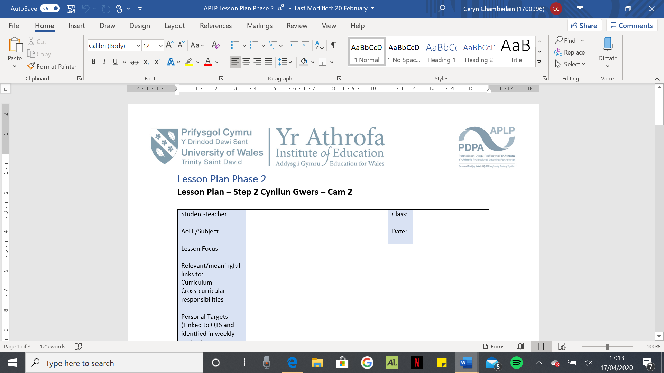
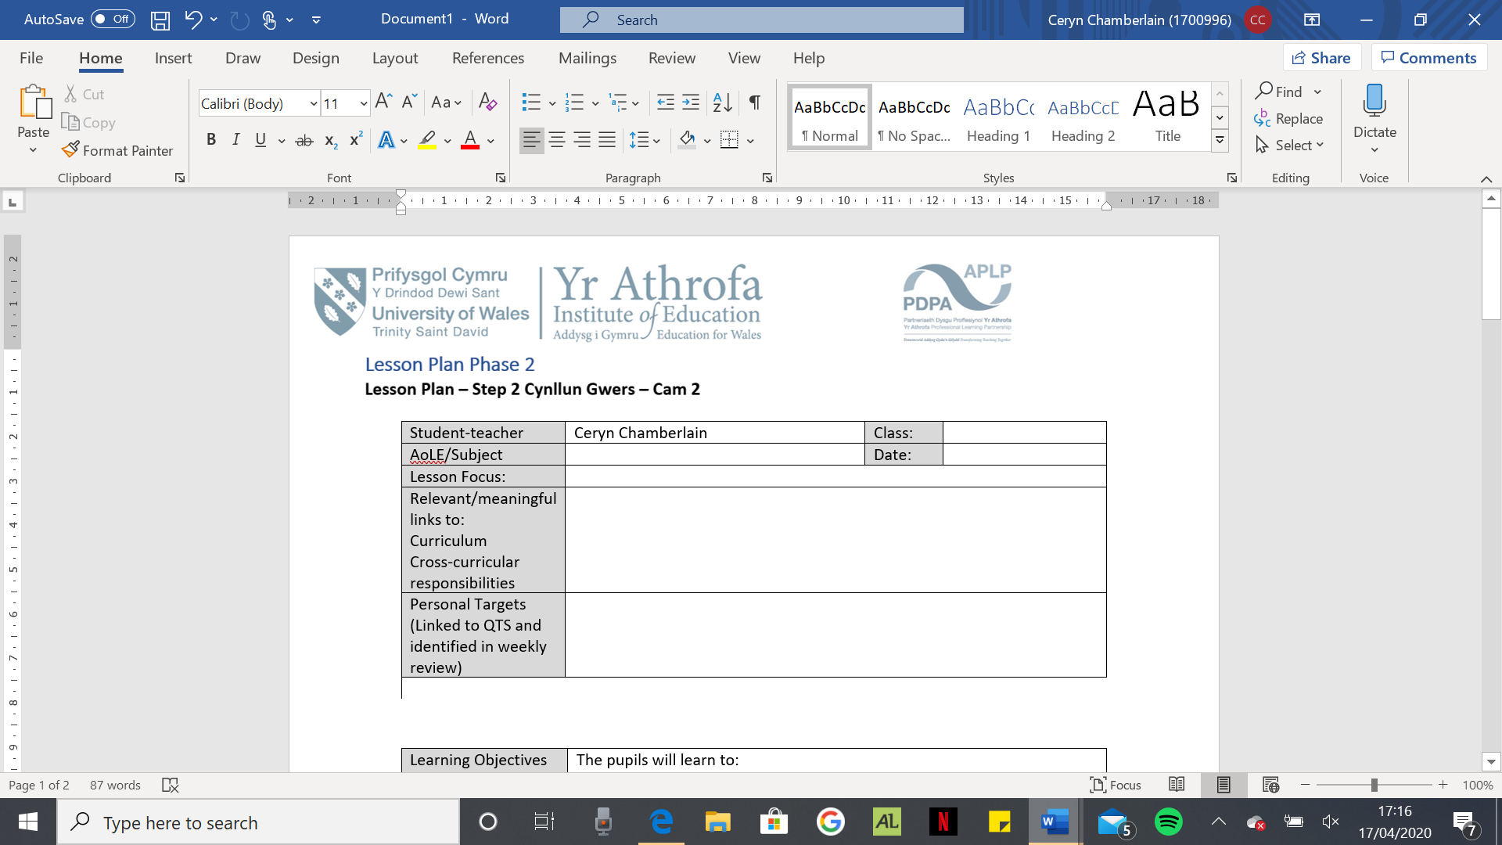
Task 2

Lesson Plan 1
Student-teacher | Ceryn Chamberlain | Class: | Year 5
AoLE/Subject | Welsh | Date: | 22/04/2020
Lesson Focus: | Gather and/or recap a range of vocabulary relating to food.  Be able to discuss different foods.
Relevant/meaningful  links to:  Curriculum  Cross-curricular responsibilities | Curriculum Coverage (range, skills)  Welsh  Oracy  - View and listen carefully responding orally, in writing and non-verbally.  - Communicate clearly and confidently and use intelligible Welsh pronunciation and intonation.  - Reinforce Welsh syntax by the accurate use of a variety of: vocabulary, phrases, questions, sentence pattern.  - Work independently, in pairs, in groups and as a member of a class  Reading  - Use different strategies to establish meaning and gather information in texts including: skimming, scanning, detailed reading, predicting, using context and knowledge of language to establish meaning.  - Read their own and others’ work: confidently, meaningfully, with enjoyment.  - Read in a variety of situations including reading in pairs.  Writing  - Use and link a variety of phrases, questions and sentences accurately, reinforcing Welsh syntax and using paragraphs as appropriate.  - Present their work appropriately by developing legible handwriting in accordance with convention.  - Write for a variety of purposes including to express opinions.
Personal Targets  (Linked to QTS and identified in weekly review) | The teacher demonstrates a knowledge and understanding of the needs of all learners in planning, preparation and teaching, ensuring that the four purposes are the drivers for learners’ experiences.

Learning Objectives (Focus on Learning) | The pupils will learn to:  - Know and discuss a variety of different foods in Welsh.  - Talk and write about your opinion on different foods.
Success Criteria (process/product) | Generate SC with the pupils  I can… /By the end of the lesson I will be able to …  - I can listen to and understand information about a variety of topics, recall it and summarise the main points in my language of choice.  - I can use a variety of cues to predict the general meaning in a variety of familiar and unfamiliar spoken contexts.  - I can read texts, choosing strategies which best help me understand them.  - I can develop my vocabulary and pronunciation through listening and reading and use new words and phrases in a variety of contexts.  - I can use and adapt familiar language, varying vocabulary and tone to suit the audience.

Key Resources Health & Safety | The children will be provided with flashcards with the written form of the foods and pictures that correspond with the words.  The children will also have scripts provided to read in their pairs. The children can change the script that they are working with if they feel the difficulty is too challenging or not challenging enough.

Time | Content, Pedagogy & Assessment Opportunities (key teaching points and questions)
Links to Previous  Learning | The children have had experience of talking about their likes and dislikes using the sentence patterns:  Rydw i’n hoffi…  Dydw i ddim yn hoffi…  Mae’n gas gyda fi…  Rydw i’n mwynhau…  Fy hoff… ydy…  Rydw i’n dwlu ar…
Opening Phase  15 mins | To start we are going to sing the song Deryn Melyn (Appendix 1).  There will then be various flashcards with both pictures of foods and the written form of those foods (Appendix 2). Each child will have a card and they must find the corresponding card to their own. Essentially, they must match the picture with the word. The children will need to work as a whole class in order to complete this activity. This will allow us to discuss the vocabulary of different foods.
Teaching & Core Learning  40 mins | The children will then be given a script, they must read the script in pairs (Appendix 3). There are three different scripts for different abilities. As the children are working in pairs they will be encouraged to work together and support each other through the activity. After they have read through the script they need to read through the script and identify the foods within the script by drawing a picture of the food above the word. Once they are confident in reading the script the children can perform in front of the class with their partner.
Plenary  15 mins | The children can then write a small paragraph explaining the foods that they like, and they dislike using the sentence patterns they already know.

Lesson Plan 2
Student-teacher | Ceryn Chamberlain | Class: | Year 5
AoLE/Subject | Welsh  Personal and Social Education | Date: | 22/04/2020
Lesson Focus: | Use of the future tense to talk about things that will happen.  Reinforcing the features of a healthy balanced diet.
Relevant/meaningful  links to:  Curriculum  Cross-curricular responsibilities | Curriculum Coverage (range, skills)  Welsh  Oracy  - View and listen carefully responding orally, in writing and non-verbally.  - Respond by asking questions and offering comments.  - Reinforce Welsh syntax by the accurate use of a variety of: vocabulary, phrases, questions, sentence patterns.  - Communicate for a variety of purposes including: asking questions and offering simple comments.  Writing  - Use and link a variety of phrases, questions and sentences accurately, reinforcing Welsh syntax and using paragraphs as appropriate.  - Spell simple words correctly, check spelling by using various methods, including ICT.  - Develop accuracy by: using verb forms (tense and person).  Personal and Social Education  - Understand: the features and physical and emotional benefits of a healthy lifestyle, e.g. food and fitness.
Personal Targets  (Linked to QTS and identified in weekly review) | The teacher demonstrates a knowledge and understanding of the needs of all learners in planning, preparation and teaching, ensuring that the four purposes are the drivers for learners’ experiences.

Learning Objectives (Focus on Learning) | The pupils will learn to:  - Ask what others will eat for meals in the future using the future tense.  - Write sentences about what others will eat for various meals next week using the future tense.  - Consider healthy meal choices.
Success Criteria (process/product) | Generate SC with the pupils  I can… /By the end of the lesson I will be able to …  - I can explain the importance of a balanced diet and nutrition and the impact my choices have on my physical health and well-being.  - I can listen to and understand information about a variety of topics, recall it and summarise the main points in my language of choice.  - I can adapt and manipulate language and make appropriate choices about vocabulary, idiomatic language and syntax in order to express myself with fluency and clarity.  - I can use spoken language for different purposes.  - I can ask and answer questions and exchange ideas and information.

Key Resources Health & Safety | There will be food and plates, so that we can create a meal, however the food will need to be checked beforehand to ensure no child has any allergies to certain as they may be in close contact with the food when we are sorting the food onto the plates.  Children will be provided with a Welsh mat with the question, sentence patterns and names of foods in order to support them when they are asking and answering each other’s questions and writing their responses (Appendix 4), (Appendix 5).  iPad available for children to check spelling of vocabulary using apps that are pre-downloaded (e.g ApGeiriaduron). Also, Welsh dictionaries will be available for the children to check spellings.

Time | Content, Pedagogy & Assessment Opportunities (key teaching points and questions)
Links to Previous  Learning | As a class we previously discussed what a healthy balanced diet is and why it is important for us to include various food groups within our diet. Also, we investigated what a balanced diet means for our bodies.  Obtained some of the vocabulary of different foods in Welsh. Also, the children are able to use the sentence pattern ‘Bydda i’n …’
Opening Phase  20 mins | There will be a plate for breakfast, dinner and tea on the floor as well as different food items. As a class we will decide what food we think creates a healthy balanced diet for each meal on the plate which we will eat in the future.  We will do this using the sentence patterns;  Bydda i’n bwyta _____ am brecwast.  Bydda i’n bwyta _____ am cinio.  Bydda i’n bwyta _____ am te.  Explanation of main task.
Teaching & Core Learning  40 mins | The children will go around the class and ask 3 of their peers individually the question ‘Beth fyddet ti’n fwyta am (frecwast/cinio/te) ar (Dydd Llun, Dydd Marwth etc)?  The children will respond to the question that has been asked using the sentence pattern ‘Bydda i’n fwyta ____ am (frecwast/cinio/te) ar (Dydd Llun, Dydd Marwth etc).  I will remind the children to consider what we know about a healthy diet when they are answering their peers.  Children will note the answers in a table which has been pre-prepared before the session (Appendix 6).  After the children have collected responses from 3 different peers, they will then turn the responses gathered into written sentences. They will do this using the sentence patterns;  Bydd e’n fwyta… am (frecwast/cinio/te) ar (Dydd Llun, Dydd Marwth etc)  Bydd hi’n fywta… am (frecwast/cinio/te) ar (Dydd Llun, Dydd Marwth etc)  Bydd (name) yn fwyta… am (frecwast/cinio/te) ar (Dydd Llun, Dydd Marwth etc)  Extension – for children who complete this sentence they can extend the by adding a reason for their choice e.g achos mae’n iachus.
Plenary  10 mins | The children will feedback their sentences one by one on what their peers will eat for breakfast tomorrow and we will enter this data into a spreadsheet.

Reference List
Baker, C. (2014) A Parents’ and Teachers’ Guide to Bilingualism. 4th ed. Bristol: Multilingual Matters.
Bower, V. (2014) ‘Rhythm, rhyme and repetition’, in Bower, V. (ed.) Developing Early Literacy 0 to 8. London: SAGE Publications Ltd.
Brock, A. and Rankin, C. (2008) Communication, Language and Literacy from Birth to Five. London: SAGE Publications Ltd.
Donaldson, G. (2015) Successful Futures. Crown Copyright.
Donavan, M. (2016) Sneak Peek at “10 Core Practices for Better Writing” – Read More and Write Better. Available at: https://www.writingforward.com/better-writing/read-more-write-better (Accessed: 22nd April 2020).
Estyn (2013a) Supplementary guidance: Welsh. Cardiff: Crown.
Estyn (2013b) Welsh Language Development in the Foundation Phase. Cardiff: Crown.
Estyn (2017) Supplementary guidance: Welsh. Cardiff: Crown.
Hood, P. and Tobutt, K. (2009) Modern Languages in the Primary School. London: SAGE Publications Ltd.
Jones, C. (2010) Essential Welsh Grammar. London: Hodder Education.
Welsh Government (2017) Welsh in education: Action plan 2017-21. Cardiff: Welsh Government.
Welsh Government (2019) Welsh Language Competency Framework for Education Practitioners. Cardiff: Welsh Government.
Welsh Government (2020) Curriculum for Wales guidance. Cardiff: Welsh Government.
Whitehead, M. (2007) Developing Language and Literacy with Young Children. 3rd edn. London: Paul Chapman Publishing.

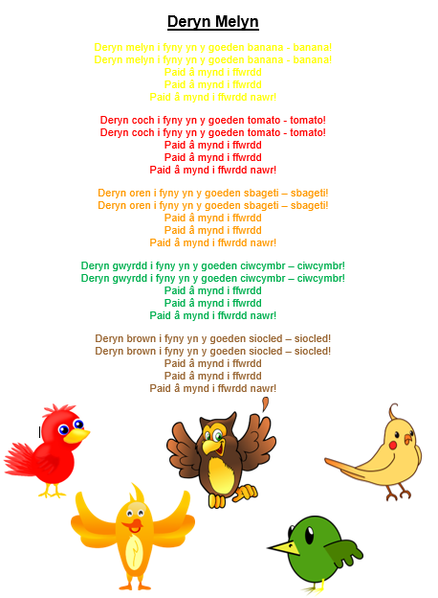
Appendix 1
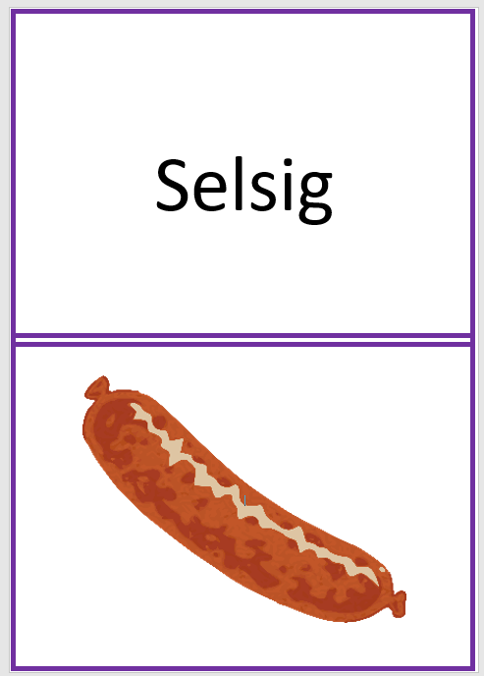
Appendix 2
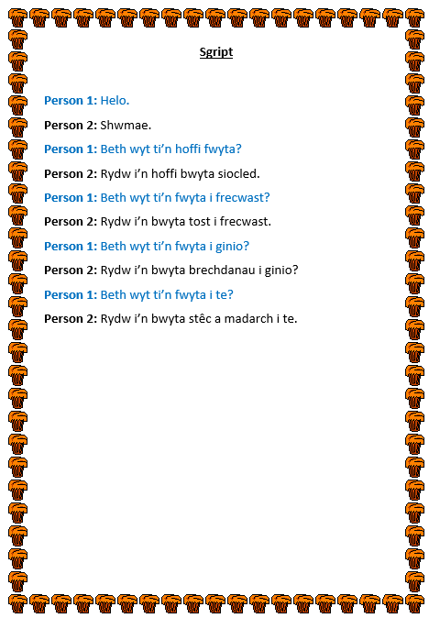
Appendix 3
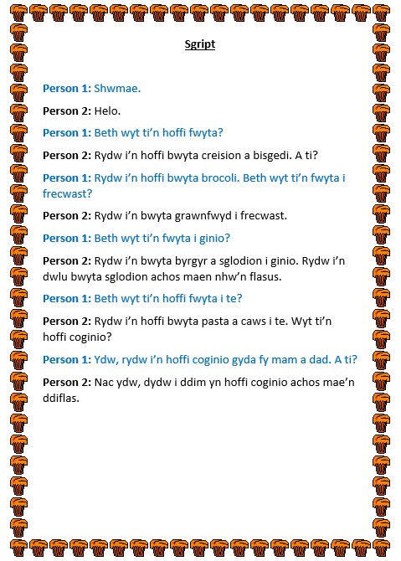
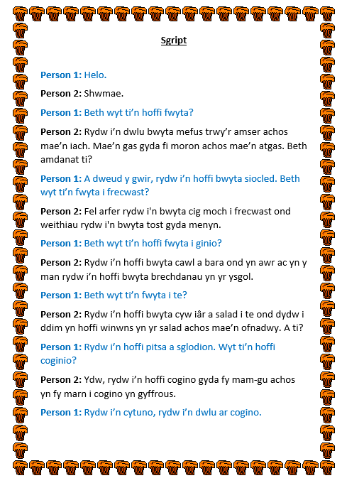
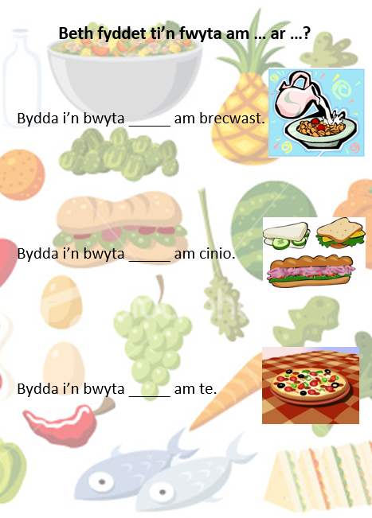
Appendix 4

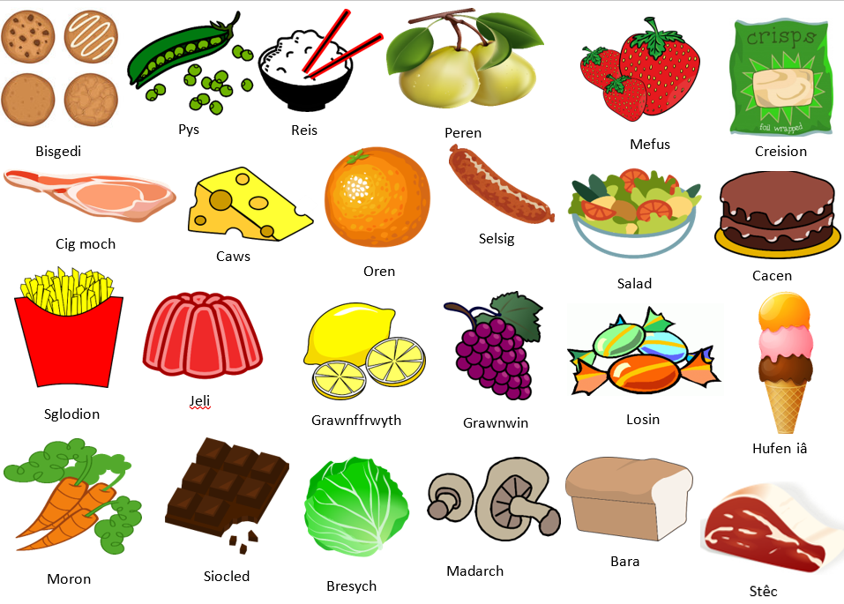
Appendix 5
Appendix 6



